

|  |
| --- |
| **Order Decision** |
| Site visit on 19 March 2020 |
| **by Sue Arnott fiprow** |
| **an Inspector appointed by the Secretary of State for Environment, Food and Rural Affairs** |
| **Decision date: 27 August 2021** |

|  |
| --- |
| **Order Ref: ROW/3224385M ‘Order A’** |
| * This Order is made under Section 53(2)(b) of the Wildlife and Countryside Act 1981. It is known as the Lancashire County Council (Cob Lane/Cockhill Lane to Kelbrook Wood) Definitive Map Modification Order 2015[1]. |
| * The Order is dated 30 December 2014. It proposes to modify the definitive map and statement for the area by adding a public bridleway in Foulridge parish, as shown on the Order map and described in the Order schedule. |
| * There was one objection outstanding when Lancashire County Council submitted the Order for confirmation to the Secretary of State for Environment, Food & Rural Affairs. * In accordance with Paragraph 8(2) of Schedule 15 to the Wildlife and Countryside Act 1981 I have given notice of my proposal to confirm the Order with modifications. |
| **Summary of Decision: The Order is confirmed subject to modifications previously proposed.** |
| **Order Ref: ROW/3224387M ‘Order B’** |
| * This Order is made under Section 53(2)(b) of the Wildlife and Countryside Act 1981. It is known as the Lancashire County Council Definitive Map and Statement of Public Rights of Way Kelbrook Wood, Foulridge to Castle Road, Laneshaw Bridge (Definitive Map Modification) Order 2013. |
| * The Order is dated 27 November 2013. It proposes to modify the definitive map and statement for the area by upgrading to bridleway status a series of footpaths in the parishes of Foulridge and Laneshaw Bridge, as shown on the Order map and described in the Order schedule. |
| * There was one objection outstanding (and one representation in support) when Lancashire County Council submitted the Order for confirmation to the Secretary of State for Environment, Food & Rural Affairs. * In accordance with Paragraph 8(2) of Schedule 15 to the Wildlife and Countryside Act 1981 I have given notice of my proposal to confirm the Order with modifications. |
| **Summary of Decision: The Order is confirmed subject to modifications previously proposed.** |

Reasons

1. If confirmed with the modifications set out in paragraphs 73 and 74 of my interim Order Decision issued on 29 June 2020, the Orders would record on the definitive map and statement a restricted byway rather than the public bridleway originally proposed. Further, limitations would be omitted from both Orders, descriptions of the width of the route(s) would be clarified and other incidental adjustments included.
2. There have been no objections to these proposed modifications to the Orders.

**Conclusion**

1. Having regard to the above and to all other matters raised in the written representations, I conclude that both Orders should be confirmed subject to the modifications that have been advertised and as set out below.

**Formal Decision**

1. I confirm **Order A** subject to the following modifications[2]:

On the Order map

* In the key, amend “Bridleway to be added A-B” to read “Restricted Byway to be added” and amend notation depicting A-B;

In the Order

* In line 3 of Article 3, amend “2015” to “2014”.

In the Order schedule

* Delete the word “Bridleway” wherever it occurs and substitute the words “Restricted Byway”;

PART I MODIFICATION OF THE DEFINITIVE MAP:

DESCRIPTION OF PATH OR WAY TO BE ADDED

* In lines 2- 4 delete “being 6 metres wide for 160 metres, then varying between 4 metres and 7.5 metres according to the width between the walls for 320 metres, and then 3 metres wide for 50 metres,”
* In line 6 delete 530 metres and substitute “560 metres”;

PART II MODIFICATION OF THE DEFINITIVE STATEMENT:

VARIATION OF PARTICULARS OF PATH OR WAY

* For Foulridge 67:
* In “Position”: delete (from lines 6 & 7) “then runs downhill to pass through stone gateposts 3 metres apart at SD 9114 4307” and (from lines 9 & 10) “pass through a field gate at SD 9118 4308, and then continues a short distance to terminate at”;
* In line 11 delete “SD 9119 4308” and substitute “SD 9121 4308”;
* In “Width”: delete existing entry and substitute:
  + - “SD 9066 4305 to SD 9074 4305 – 6 metres
    - SD 9074 4305 to SD 9081 4304 – 3.5 metres
    - SD 9081 4304 to SD 9095 4305 – 6 metres
    - SD 9095 4305 to SD 9113 4307 – 5 metres
    - SD 9113 4307 to SD 9121 4308 – 3.5 metres
* In “Other particulars”: delete all limitations listed
* In “Length” delete “0.53 km” and substitute “0.56 km”;
* For Foulridge 44:
* In “Position”: add “*Part upgraded to public bridleway – DMMO (No.8) Order 1997 confirmed on 24 September 2002”;

1. I confirm **Order B** subject to the following modifications:

On the Order maps

* In the key, amend “Order route” (B-E etc) to read “Order route: Restricted Byway” and amend notation depicting Order routes B-E, E-F-V-W, W-X-G-Y and Y-H-J;

In the Order schedule

* Delete the word “Bridleway” wherever it occurs and substitute the words “Restricted Byway” with the exception of (1) reference to Colne Bridleway 228 in the entry for Colne 8 and (2) anywhere in the entry for Colne 228 other than the reference to Colne bridleway 8;

PART I MODIFICATION OF THE DEFINITIVE MAP:

DESCRIPTION OF PATH OR WAY TO BE UPGRADED

* In paragraph 2 line 6 delete “through a gate and”;
* In paragraph 3 line 2 delete “a gate at”; in line 7 delete “to a gate”; in line 10 delete “through a gate”;
* In paragraph 4 line 3 delete “passes through a gate and”; in lines 6 and 7 delete “there is a stone wall.” and “passes through a gate and”; in line 8 delete “rising” and “-wards a stone boundary wall and gate at”; in line 14 delete “a gate in a wall at”; in line 20 delete “to a gate” and in line 22 delete “and a gate”;

PART II MODIFICATION OF THE DEFINITIVE STATEMENT:

VARIATION OF PARTICULARS OF PATH OR WAY

* In line 1 delete “added for Foulridge 67 and”, and delete “44, 44A and 44B substituting “67”;
* For Foulridge 67:
  + In “Position”: amend grid references to read (in line 3) SD 9073 4305 and (in line 4) SD 9082 4305; delete from line 7 “through a 3 metre wide gate”, from lines 7 & 8 “to a gate 3 metres wide”; and from line 11 “through a 3 metre wide gate at SD 9147 4308 and”;
  + In “Other particulars”: delete all limitations listed;
* Delete individual entries for Foulridge 44, 44A and 44B;
* For Colne 19:
  + In “Position”: delete from lines 2 & 3 “through a gate at SD 9169 4308 and”;
  + In “Other particulars”: delete all limitations listed;
* For Colne 18:
  + In “Position”: delete from line 2 “through a gate at SD 9189 4313” and from line 3 “through a gate”;
  + In “Other particulars”: delete all limitations listed;
* For Colne 16:
  + In “Position”: delete from line 2 “through a gate”, from line 4 “a gate with stone step stile alongside at”, and in line 6 “a gate at”;
  + In “Other particulars”: delete all limitations listed;
* For Colne 14:
  + In “Position”: delete from line 4 “a gate in a wall”
  + In “Other particulars”: delete all limitations listed;
* For Colne 8:
  + In “Position”: delete from lines 2 & 3 “a gate in a fence at” and from line 5 “and a gate”;
  + In “Other particulars”: delete all limitations listed.

Sue Arnott

**Inspector**

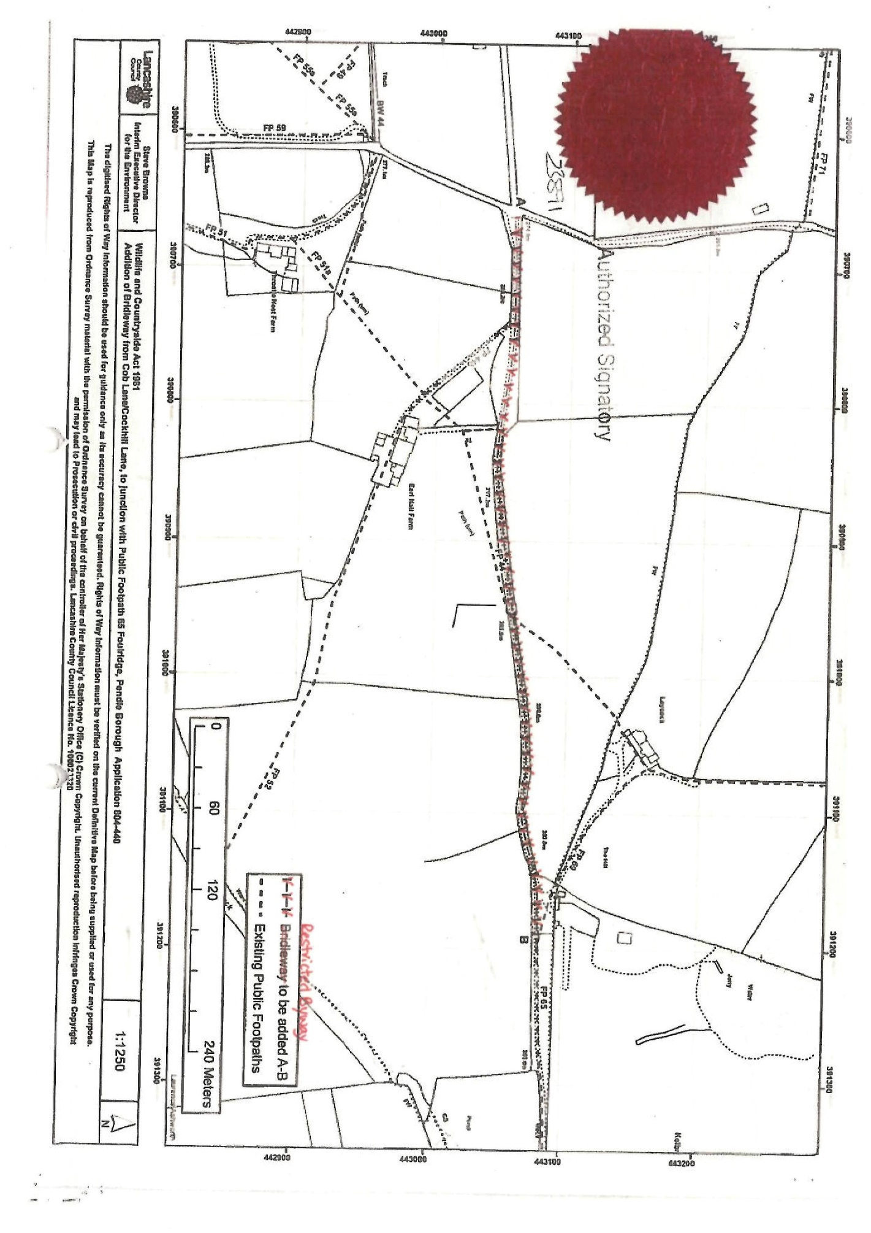

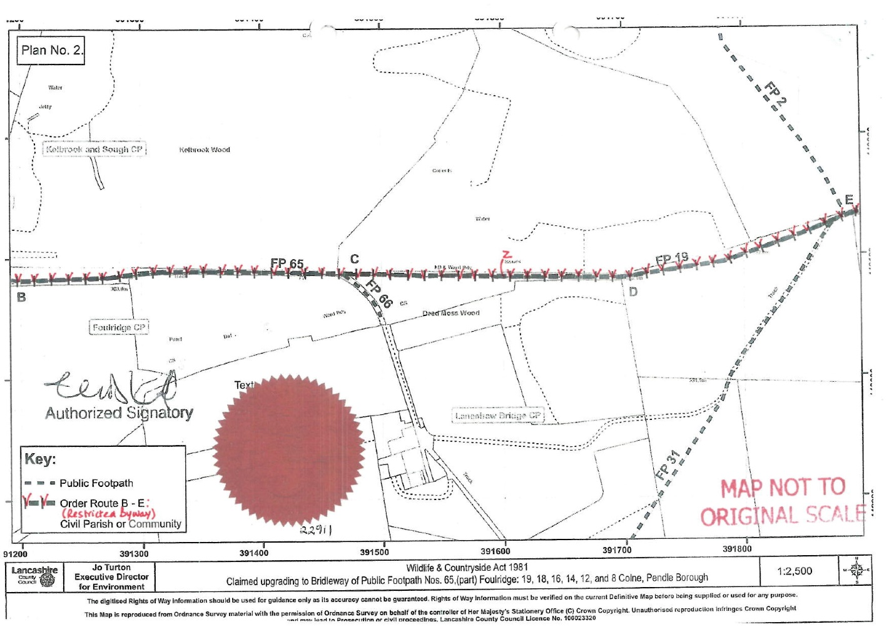

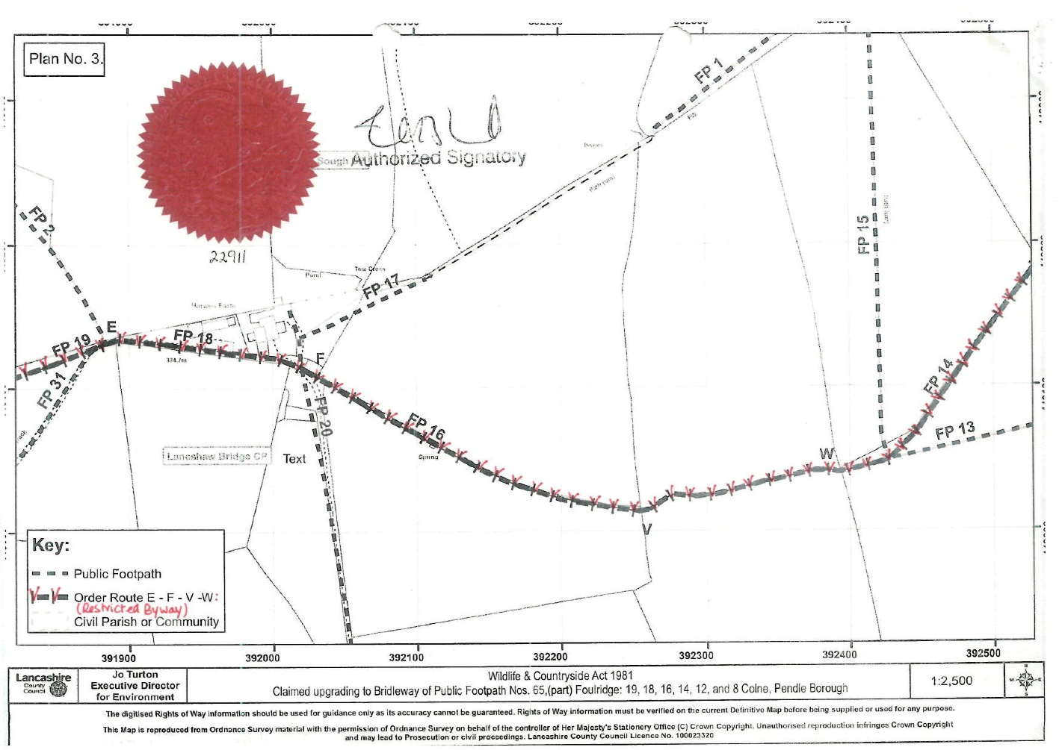

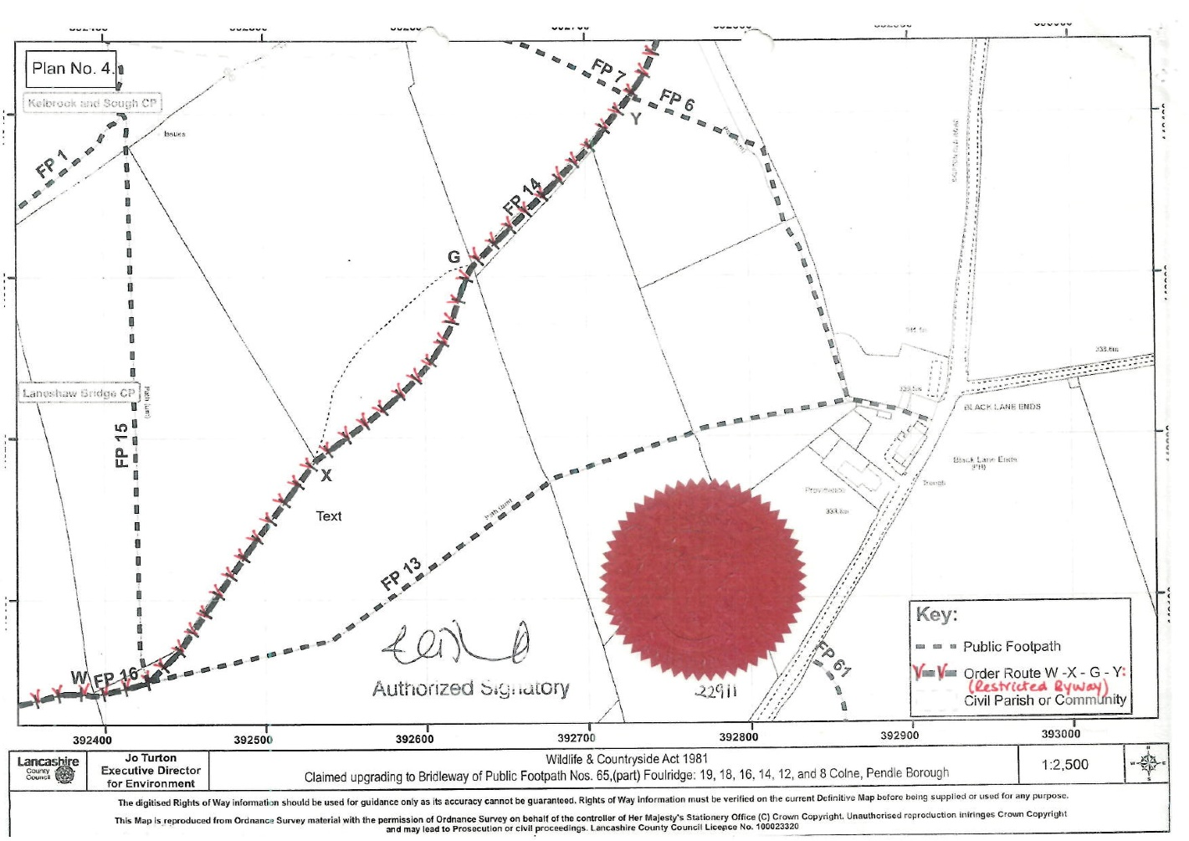

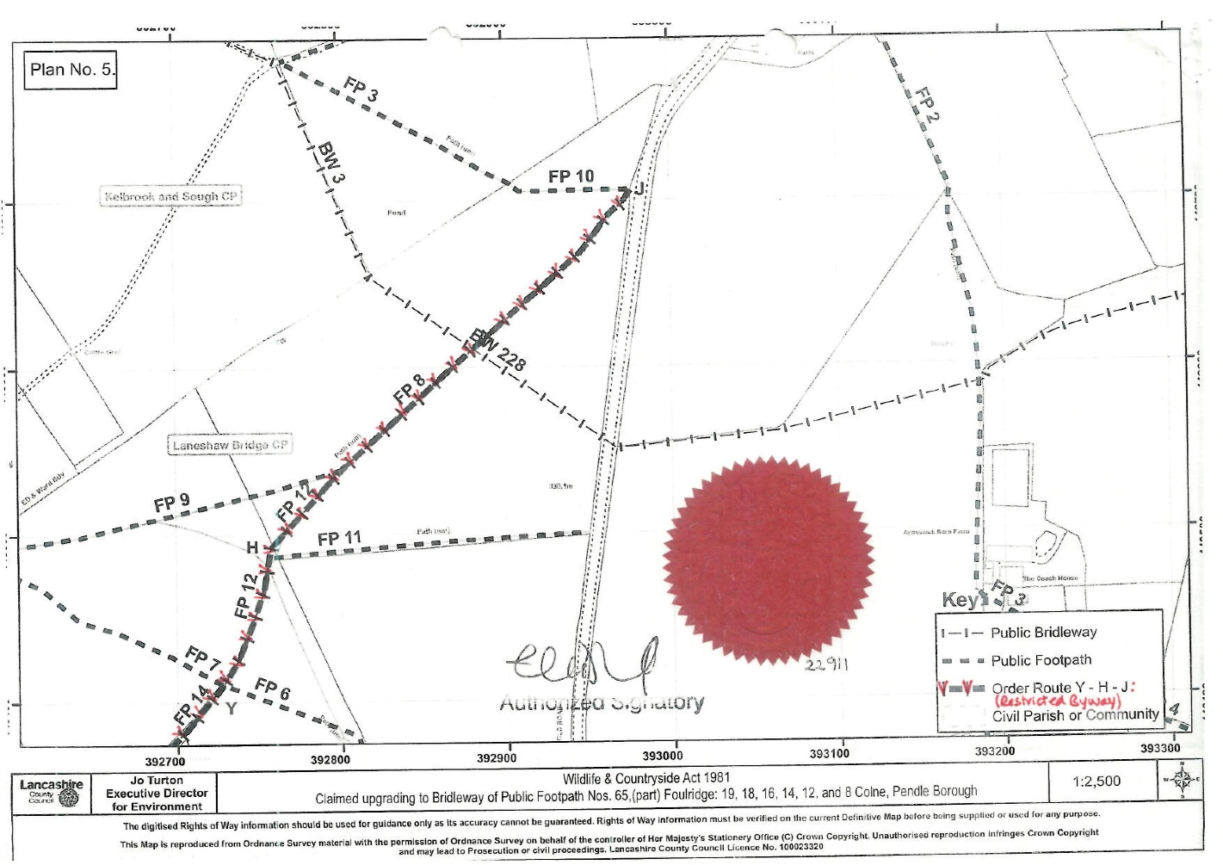

1. As noted immediately below, the Order is dated 30 December 2014.
2. For clarity, I have underlined the amended text