

|  |
| --- |
| **Appeal Decision** |
|  |
| **by Sue M Arnott FIPROW** |
| **an Inspector on direction of the Secretary of State for Environment, Food and Rural Affairs** |
| **Decision date: 6 October 2021** |

|  |
| --- |
| **Appeal Ref: ROW/Z1585/14A/21** |
| * This appeal is made under Section 53(5) and Paragraph 4(1) of Schedule 14 of the Wildlife and Countryside Act 1981 against the decision of Essex County Council not to make an order under Section 53(2) of that Act. |
| * By application dated 22 January 2019, Mr A Eardley claimed that a route connecting the play area near Vernons Close, Henham, with two public footpaths should be added to the definitive map and statement for the area as a public footpath. |
| * The application was refused by Essex County Council under its delegated procedures and the appellant was formally notified of the decision by letter dated 28 October 2020. |
| **Summary of Decision: The appeal is allowed.** |
|  |

Preliminary Matters

1. I have been directed by the Secretary of State for Environment, Food and Rural Affairs to determine this appeal under Section 53(5) and Paragraph 4(1) of Schedule 14 of the Wildlife and Countryside Act 1981 (the 1981 Act) on the basis of the papers submitted. In this case, I am satisfied I can reach a reliable decision without visiting the site.
2. The appellant, Mr Eardley, requests that the Secretary of State directs Essex County Council (ECC) to make a definitive map modification order under Schedule 15 of the 1981 Act to record the route which is the subject of this appeal as a public footpath.
3. In addition to the submissions from the appellant and ECC, I have before me representations made on behalf of Henham Parish Council and from Mr J Edwards who, in December 2018, had made an application to record the southern part of Mr Eardley’s claimed route[1]. I have considered all these documents in forming my conclusions.
4. A report[2] prepared by ECC explained that the plan submitted by the appellant showed his claimed route leading northwards from definitive Footpath 2 (Henham), skirting the Vernons Close play area, then heading broadly eastwards to join Footpath 4. This was referred to as Route A. Through its investigation, it concluded that the evidence tended to support variations of this route, identifying these as Route B (from Footpath 2 to the play area), Route C (from Footpath 4 to the play area) and Route D (a link between Route B and C that does not directly connect with the play area). Routes A, B, C and D are shown on ECC’s plan listed in its report as Appendix 1b. For reference here, I will refer to these routes as indicated.

Main issues

1. The main issue in this case is whether the evidence is sufficient to show that, in the past, the appeal route (and/or variations thereof) have been used in such a way and on such terms that public rights of way on foot can be presumed to have been established over them.

**Legal framework**

1. Section 53(2) of the 1981 Act requires the surveying authority (in this case ECC) to make orders to modify its definitive map and statement in consequence of certain specified events as set out in Section 53(3).
2. Sub-section 53(3)(b) describes one such event as “*the expiration … of any period such that enjoyment by the public of the way during that period raises a presumption that the way has been dedicated as a public path*”.
3. Another event is set out in sub-section 53(3)(c)(i): “*the discovery by the authority of evidence which (when considered with all other relevant evidence available to them) shows … that a right of way which is not shown in the map and statement subsists or is reasonably alleged to subsist over land in the area to which the map relates …"*.
4. The statutory test to be applied to evidence under sub-section 53(3)(c)(i) therefore comprises two separate questions, one of which must be answered in the affirmative before an order is made: has a right of way been shown to subsist on the balance of probability or has a right of way been reasonably alleged to subsist? Both these tests are applicable when deciding whether or not an order should be made, but even if the evidence shows only the lesser test is satisfied, that is still sufficient to justify the making of the modification order[3] requested by the appellant.
5. The issue was addressed in the High Court case of *R v Secretary of State for the Environment ex parte Mrs J Norton and Mr R Bagshaw [1995][4]* and later clarified in *R v Secretary of State for Wales ex parte Emery [1998][5]*: when considering whether a right of way subsists (Test A) clear evidence in favour of the appellant is required and no credible evidence to the contrary. However, when considering whether a right of way has been reasonably alleged to subsist (Test B), if there is a conflict of credible evidence but no incontrovertible evidence that a way cannot be reasonably alleged to subsist, then the answer must be a public right of way has been reasonably alleged.
6. For the purposes of this appeal, I need only be satisfied that the evidence meets the lesser test (B), although the higher test (A) would be applicable if the matter fell exclusively under sub-section 53(3)(b).
7. As regards the evidence of use by the public, Section 31 of the Highways Act 1980 (the 1980 Act) sets out the requirements for presumed dedication under statute. Firstly, there must be sufficient evidence of use of the claimed route by the public, as of right and without interruption, over the twenty-year period immediately prior to its status being brought into question in order to raise a presumption of dedication. This presumption may be rebutted if there is sufficient evidence that there was no intention on the part of the landowner during this period to dedicate the route as a public right of way.
8. Alternatively, if the case is not made out under statute, the evidence may be considered under the common law. In this case the issues to be addressed would be whether, during any relevant period, the owners of the land in question had the capacity to dedicate a public right of way; whether there was express or implied dedication by the owners, and whether there is evidence of acceptance of the claimed right by the public.

Reasons

1. In its report dated 28 October 2020, and after assessing the evidence in this case, ECC concluded that there is insufficient evidence to show that the claimed route(s) have been dedicated and accepted as public rights of way.
2. The report addressed a number of sources of historical and documentary evidence, but this did not reveal any support for a public way of any antiquity. The case rests entirely on satisfying the test set out in Section 31 of the 1980 Act on the basis of use by the public in the very late twentieth and early twenty first centuries.
3. The appellant provided evidence from nineteen people with the earliest claimed usage dating back to 1974. Some of these people are current or former residents of Vernons Close but ECC accepted that this does not prevent them from representing ‘the public’ in this context. There is no suggestion that the use claimed was by force or carried out in secret, nor did it take place on the basis of permission. It therefore seems clear that the use that took place was ‘as of right’.
4. There is a question over the exact route(s) used by the claimants. From ECC’s careful analysis, it appears that use of routes B, C and D are supported by evidence from the 2010 aerial photograph whereas the appellant’s route (A) differs in the vicinity of the play area.
5. This playing field is owned and maintained by the Vernons Close Residents’ Association and has been bounded by a chain link fence since the facility was first provided. A gap has existed in this fence at the point route B joins since the late 1980s (at least) to enable balls to be retrieved from the adjacent field. When the chain link fence was replaced in the 1990s, a second gap was left, this time at the point where route C joins.
6. Some people claim to have walked from the play area, through these gaps, to or from Footpaths 2 and 4, whilst others connected the two definitive paths using routes B, D and C without entering the play area. None of the claimants were ever challenged whilst doing so.
7. The land affected by the claimed paths was in agricultural use but has not been cultivated since 2003 when the tenancy came to an end. Evidence provided by the owners of the land makes reference to a lease, an option agreement with Persimmons Homes relating to the area between the play area and the school, and to three (unsuccessful) planning applications for development.
8. It also includes a statement by a Mr Cooper who was appointed to make regular visits to ensure the land was secure. He challenged a dog-walker during his first on 16 September 2010 and three others when visiting again on 11 October 2010 to fix notices on trees at several points around the site. These stated that the land was private and there was no public right of way or access. On his final visit on 4 January 2011, he challenged two dog-walkers and found all the signs had disappeared.
9. ECC noted that Mr Cooper’s evidence is not supported by the 2010 aerial photograph or by any of the claimants but it is nonetheless *some* evidence of a lack of intention to dedicate public rights of way over the land.
10. Although some details of the various planning applications lack clarity, it appears these were mostly focussed on land to the north of the claimed routes, effectively between the play area and the school. It was only the applications submitted in 2015, and eventually determined following a public inquiry in 2017, that included proposals outside of that site: a new school playing field and site drainage provisions which would have affected the claimed rights of way. This is said to indicate the landowners’ lack of intention to dedicate the paths in question as highways for the use of the public.
11. In its analysis of the evidence, ECC concluded that the extent of the public’s rights was brought into question in December 2018 when Heras-style fencing was erected around the site, physically preventing use of the claimed paths.
12. Although other potential incidents were considered, in particular Mr Cooper’s notices, the personal challenges made by him in 2010/2011, and the various planning applications, these were not regarded as sufficient to ‘bring into question’ the legal status of the paths.
13. The relevant period for the purposes of examining use by the public is therefore December 1998 to December 2018. ECC concluded that routes B, C and D had been used by the public, that this use was unquestionably ‘as of right’ and continuous, and that routes C and D could technically qualify as highways since they terminate at the play area, this being accepted as a place of public resort.
14. ECC noted that there was a degree of conflict between the usage claimed in the early years of the relevant period and the 2000 aerial photo which does not clearly show any discernible tracks through the cultivated land. Nevertheless it accepted that the evidence was sufficient to raise a presumption of dedication.
15. However, Mr Cooper’s evidence was considered insufficient to clearly demonstrate the landowners’ lack of intention to dedicate public paths but judged the planning applications sufficient to do so and thereby rebut the presumption. ECC therefore declined to make the order requested by the appellant.

*Summary and conclusions*

1. As I have noted above, in order to justify the making of a definitive map modification order to add a public right of way under sub-section 53(3)(c)(i) of the 1981 Act it is necessary only to provide sufficient evidence to ‘reasonably allege’ the existence of a public path.
2. There are clearly conflicts between the claimants’ evidence of use provided by the appellant and the 2000 aerial photograph. Similarly, there is a conflict between Mr Cooper’s evidence, supplied by the landowners, and the supporting evidence from the claimants. There is also a question over the degree to which the planning applications offer evidence of a lack of intention to dedicate the claimed footpaths on the part of the landowners.
3. I find no incontrovertible evidence here that would inevitably defeat the claim that rights of way have been established. The evidence provided in support and against that claim is all credible, although in some areas further information is required to fully illuminate important details that would assist in resolving the conflicts that are apparent.
4. I have noted at paragraph 10 above the guidance from the Courts applicable when deciding whether an order should be made. Where, as here, there is a conflict of credible evidence but no incontrovertible evidence that a way cannot exist, then the answer is that a public right of way has been reasonably alleged to subsist. Since that is the threshold that must be reached in order to make (though not confirm) an order, I conclude that in this case the evidence is sufficient to justify an order being made.

Conclusion

1. Having regard to these and all other matters raised in the written representations I conclude that the appeal should be allowed in respect of the routes identified on ECC’s plan as B, C and D.

Formal Decision

1. In accordance with Paragraph 4(2) of Schedule 14 to the 1981 Act, Essex County Council is directed to make an order under Section 53(2) and Schedule 15 of the Act to modify the definitive map and statement for the area by adding public footpaths as requested by the application dated 22 January 2019 but later modified[6].
2. This decision is made without prejudice to any decision that may be issued by the Secretary of State in accordance with his powers under Schedule 15 of the 1981 Act.

Sue Arnott

**Inspector**

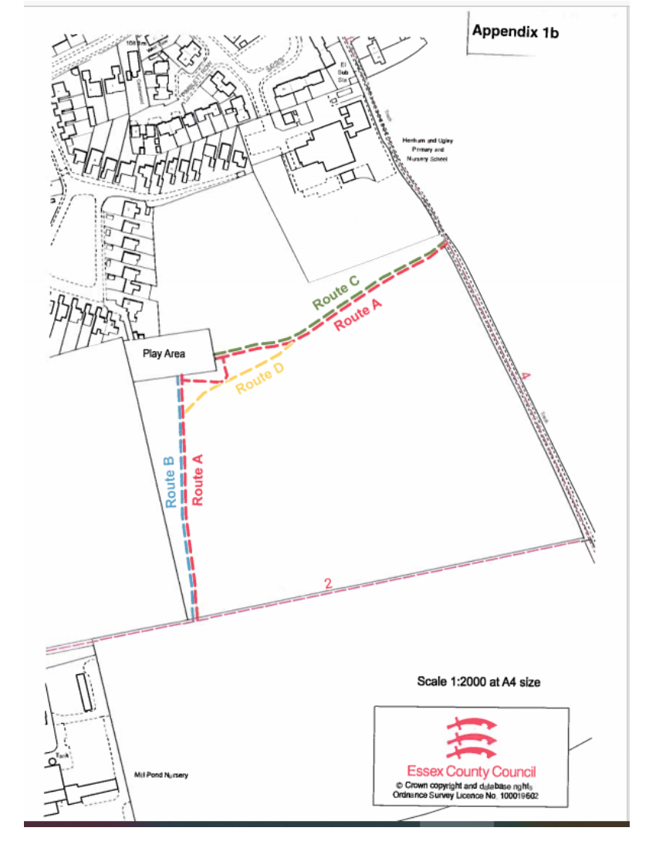

1. This was supported by a statement from Mr Edwards himself and two maps.
2. A report dated 28 October 2020
3. The higher test would need to be satisfied to justify confirmation of an order.
4. R v SSE ex parte Bagshaw and Norton (QBD)[1994] 68 P & CR 402, [1995] JPL 1019
5. R v SSW ex parte Emery (QBD) [1996] 4 All ER 1, (CA)[1998] 4 All ER 367, [1998] 96 LGR 83
6. Shown as Routes B, C and D on Appendix 1b of the Report dated 28 October 2020.