Appeal Decision
by Grahame Kean B.A. (Hons), Solicitor HCA
an Inspector appointed by the Secretary of State for Environment, Food and Rural Affairs
Decision date: 25 August 2021

Appeal Ref: FPS/J1155/14A/24
- The appeal is made under Section 53(5) and Paragraph 4(1) of the Wildlife and Countryside Act 1981 (the “1981 Act”) against the decision of Devon County Council (the “Council”) not to make an order under s53(2) of that Act.
- The Application dated 4 September 2018 was refused by the Council on 16 November 2020.
- The Appellants claim that the definitive map and statement of public rights of way should be modified by adding a footpath (shown B – C) on the attached plan.

Summary of Decision: The appeal is dismissed.

_________________________________________________________________

Preliminary matters
- I have been directed by the Secretary of State for Environment, Food and Rural Affairs to determine this appeal under Section 53(5) and paragraph 4(1) of Schedule 14 to the 1981 Act.
- The appeal is based on the papers submitted. I have not visited the site, but I am satisfied that I can make my decision without such a visit.
- Since the Appellants made their application and appeal, Mr Paton has recently passed. Mrs Paton has continued the appeal and indeed from my knowledge of the considerable history of this matter it appears that she has led the charge against the Council and left no stone unturned in her efforts to modify the Definitive Map and Statement (DMS) in accordance with this and a previous application. I extend my condolences to her in relation to her loss.

Background
- As noted in my colleague’s Direction Decision following the request by the Appellants to the Secretary of State to direct the Council to reach a timeous decision on the application, there is an alleged conflict between the Definitive Map and the Statement in relation to Footpath 3, Northlew (FP3).
- A map is attached to this Decision showing the alleged alignment variation and existing FP3. The Appellants claimed that the true line of FP3 ran over B – C, in place of the line B – X – A recorded on the definitive map. They claimed that the owners of the Glebe Yard land could not have dedicated and could not be presumed to have dedicated the route X – A as that land was not owned by them, therefore the path shown B – X – A on the definitive map had been diverted from its true line B – C. The earlier application requested B – X – A be deleted from the map. This application is confined to the addition of the line B – C albeit that it is implicit in the case made by the Appellants that B – X – A should be deleted.

Main issue
- Section 53 (3) (c) (i) of the 1981 Act states that a modification order should be made on the discovery of evidence which, when considered with all other relevant evidence available, shows that a right of way which is not shown in the map and statement subsists or is reasonably alleged to subsist over land in the area to which the map relates.
- The main issue is whether the available evidence shows that, on the balance of probabilities the appeal route is a public footpath which should be recorded by way of a modification to the DMS.
- If I consider that an order should be made, paragraph 4(2) of Schedule 14 enables me on behalf of the Secretary of State to “give to the authority such directions as appear to him necessary for the purpose”.

Reasons
- The basis of the claim remains the same as the application to the Council made in July 2009 that also sought to delete section B – X – A of FP3. That application was refused by the Council in November 2014 and an appeal against that decision to the Secretary of State was dismissed by Inspector Beckett on 11 June 2015. Considering that he had wrongly applied a presumption in favour of the Definitive Map at the expense of its Statement and failed to give proper consideration to the Statement, the Appellants challenged his decision in the High Court. Initially this was refused on the papers by His Honour Judge Jarman QC on 22 September 2015. Undeterred, the Appellants renewed their application for judicial review in person before Mr Justice Dove. That challenge was not successful and an application for permission to appeal was refused by the Court of Appeal on 8 April 2016 as being totally without merit.
- In the meantime the Appellants had deployed a separate mechanism, perfectly legitimate, to establish whether their claimed route was in fact a highway. In March 2011 they made a complaint to the Crown Court under section 56(2) of Highways Act 1980 for an order requiring the Council to put the claimed highway into proper repair. There was a three-day hearing by Recorder Abbott who issued his decision on 19 January 2012. I shall return to this below.
- The Appellants appealed the recorder’s decision to the High Court, which appeal also failed. In his judgment of 16 January 2013 Mr Justice Burton was “completely unpersuaded that the Recorder [in the Crown Court] erred in law in his primary conclusion that he was not satisfied that there was a path” along the claimed route. The Appellants maintained that the Crown Court asked itself the wrong legal question and there was a discrepancy giving rise to an unlawful situation which the Council was bound to correct.
- The Council gave consideration to the current application in its report to the Public Rights of Way Committee in November 2020. It refused to make an order, considering the evidence not to be sufficient reasonably to allege that that a public right of way existed over the alleged route. Although the report fails to recognise this application was only to add, rather than as before to add and delete sections of FP3, nothing hangs on this error.
- The statutory wording of s53 of the 1981 Act implies that it is at least necessary to show that it is reasonable to allege on the balance of probabilities that a right of way subsists. However the burden of proof lies with an applicant.
- This appeal entails a full merits consideration of the issue as to whether or not the modification should be made, including a review all of the evidence to reach factual findings and a decision as to whether or not the order should be made. I have reviewed the substantial documentary evidence and correspondence supplied by the Appellants in this case. However because it deals with the same subject matter I have a duty to make a decision consistent with that of Inspector Beckett unless there is good reason to depart from it. That his own findings on the circumstances then existing are unassailable is apparent from the unsuccessful judicial review proceedings taken by the Appellants in the High Court and Court of Appeal.
- In my view there has been no material change in circumstances since the earlier appeal decision of Inspector Beckett. The Council’s report of November 2020 deals with the main points of the renewed application thoroughly and I find no reason to disagree with their conclusion that it has not been demonstrated on the balance of probability that a right of way subsists or is reasonably alleged to subsist between points B – C.
- Several grounds of appeal are raised against the Council’s decision. Additional material is supplied together with case law, much of it repetitive but all of which I have taken into account and reviewed.
- I said I would return to the s56 proceedings. I do not propose to become embroiled in the complaint that the Appellants had over whether the wrong questions were asked of itself by the tribunal or the court, or whether the decisions are a nullity. If it is of any comfort and having read those decisions, I can see where it might be argued that the questions were not formulated in a way that would have best served the precise issues that needed to be resolved, but I emphasise that is not a matter for me. The precise issues that fall to be considered in this appeal are those relating to the 1981 Act, not s56 HA1980.
- As to the grounds of this appeal, firstly it is said that the description of FP3 in the Definitive Statement controls. Whilst it may be correct that generally the particulars of the statement as to position and width are conclusive at the relevant date, I find no necessary or meaningful inconsistency with the route as depicted on the Definitive Map, either from a direct comparison between the two, reading them both together, or taking into account also, the totality of the evidence submitted.
- It is useful that the appellants have now confirmed that (as I have myself inferred from a close examination of the evidence), the Chapel referred to in the Definitive Statement is likely to be the Church Room currently used as a post office. Where the statement reads “opposite the Chapel in Northlew and proceeds westwards through the Glebe Yard”, clearly it cannot go immediately from opposite the chapel to the Glebe Yard, it must go either some way along County Road/Station Road to Point C as claimed, or across the bottom of Queen Street where it intersects with County Road, along the line A – X - B. The land between Point X and Queen Street may never have been in Glebe Yard, but to my mind the Definitive Statement is consistent with a route through that land and is consistent with the Definitive Map. Nothing in the extrinsic evidence causes me seriously to doubt that such was the historic route of the path.
- The second and third grounds of appeal repeat matters in the first ground or relate to the s56 HA1980 proceedings with which I am not concerned. However it is asserted that prior decisions have misapplied evidential presumptions regarding the DMS (citing Norfolk County Council, R (on the application of) v Secretary of State for Environment, Food & Rural Affairs).
- Norfolk and the other cases cited in the appeal establish that for the purposes of s56 of the 1981 Act, the definitive map is the primary source document. If the definitive statement does not give particulars of its position, the map prevails and a degree of tolerance is permissible. At review stage neither the map nor statement is conclusive evidence of its content. An irreconcilable conflict between the map and statement implies no evidential presumption in favour of the map but would indicate an error in their preparation. This implication of error displaces the presumption in Trevelyan v Secretary of State for Environment, Transport and the Regions [2001] EWCA Civ 266 that a right of way marked on a definitive map in fact exists. The map and statement would then be accorded weight according to the documents and circumstances at the relevant date.
- So the starting point is that the map and statement are assumed to be prepared following correct procedures. On review, as here, neither the statement nor the map gives rise to any presumption but the cogency of each is evaluated with available evidence to decide which, if either, describes the correct route. If it assists, I regard the presumption referred to by Inspector Beckett and by Dove J as a reflection of s56(1)(a) which states that where the map shows a footpath, the map shall be conclusive evidence that there was at the relevant date a highway as shown on the map. However as was concluded in Norfolk (Paragraph [57]):

“subject to modification, the definitive map must be regarded as authoritative. It does not, in my view, follow that there must be a presumption in favour of the map at the expense of the statement during the process of review.”
- And yet, in this appeal the definitive route shown on the Map and as described in the Statement are, as I have said, in my view consistent one with the other. I find no conflict. Firstly, because the Statement can be read as referring to a route that includes the land between Point X and Queen Street, and secondly, insofar as there may be said to be a difference in the starting point (Point A on the Map, and “opposite” the Chapel in the Statement), in my opinion that is a degree of difference that can permissibly be tolerated. I note in passing that the same cannot be said of the difference between either Point A or directly opposite the Chapel, and Point C which is considerably further down County/Station Road. The Definitive Statement in my view can properly be interpreted as describing the same footpath as that shown on the Map.
- Fourthly it is said that the Council disregarded the principle “once a highway, always a highway”. I am sure the Victorian judge John Maynard Byles would have marvelled at the number of times this phrase, which he is reputed to have coined in Dawes, has appeared in the papers in this appeal. Undoubtedly the “grundnorm” of highways law, it has been called to arms down through the years by members of the public (“liege subjects of our Lady the Queen” as Byles J called them) and public authorities alike.
- In modern parlance the principle amounts to this:

“it is a clear and well established common law rule that, once a highway is dedicated to the public, the public's right of way cannot be lost (or downgraded from, say, a right of cartway to a bridleway or footway) by disuse or abandonment; it can only be ended by one of the recognised procedures for doing so.” (Loder v Timothy Roger Gaden, Vera Anne Gaden and Thomas Gaden (1999) 78 P. & C.R. 223)
- The Appellants on this ground took issue with what they regarded as an obstruction of the true course of FP3 and drew a parallel with Dawes because of the alleged unlawful diversion which, in the current appeal, was said to be along the current alignment in the Definitive Map, first perpetrated by the public from around 1951. I disagree that this appeal is “directly comparable” to Dawes. The fundamental distinction is that the alleged diversion of B – C is not a diversion of any ancient highway that has been established to exist.
- Byles J saw the facts in that case as “very consistent with the exercise of a public right of deviation during the temporary obstruction of a road, but inconsistent with the permanent dedication to the public of a new way”. He also held that “there was no reasonable evidence to be submitted to the jury that the alleged new road ever had existed. It is clear that there can be no dedication of a way to the public for a limited time, certain or uncertain. If dedicated at all, it must be dedicated in perpetuity.”
- The case has prompted me to consider whether the existence of B - C as a highway could itself be posited in consequence of a necessary diversion. A barrier of some sort at the exit to Queens Road might arguably have led users to find another route. However I agree with Inspector Beckett that the solid line across the exit, for example in the 1885 OS map, is likely to be a gate. Moreover the dotted lines proceed right to the exit, not to any particular property within or abutting Glebe Yard.
- The 1885 map shows a pond or the like over or in close proximity to this line (the use of which was attested to more recently by some residents). The scattered layout of the buildings depicted at various times according to the OS maps makes it possible to conjecture that a way was found from time to time from Station Road into Glebe Yard at a more convenient, oblique angle (a “desire line” if you will) whether to access or egress the pond or for other purposes altogether. But it is no more than that, conjecture. The more pronounced dog-leg turn into and out of B – C as claimed seems conveniently marked in light of modern ownerships and development that has proceeded apace adjacent to this line. But at any rate there is simply no persuasive evidence that the B – C line was ever used such as would provide evidence from which it would be reasonable to infer dedication to the public.
- Indeed, the lack of user evidence as to the existence of the alleged right of way is striking. On the other hand the parish council supplied fairly detailed statements from long standing residents who recalled a way into Glebe Yard from Queen Street but not at all from Station Road at Point C. The statements are not sworn documents and the makers were not questioned by the Appellants. Nevertheless I have no reason to disbelieve the contents, and they add support the conclusion that no such public way into Glebe Yard has been established.
- I say “has been” rather than “can be” established because, as the Appellants well and truly impressed upon me, “once a highway always a highway”. In other words if, in the fullness of time evidence is discovered that makes it reasonable to allege a right of way existed on the claimed route, it is conceivable that an application to modify the DMS may be made out. However I regret I can find no persuasive evidence that B – C was either a diversionary route or part of the original line of FP3 and none that would substantiate the existence of a highway from Point C or its environs through to Glebe Yard.
- The fifth ground of appeal reiterates matters I have dealt with above. I agree that there is a duty on review to render the Definitive Map and Statement consistent with each other, but I am unpersuaded on the evidence that they are inconsistent.
- It has been a central claim in the appeal that if the path started at Glebe Yard it would have to start at a point where Glebe Yard connected with the public road, namely point C on Station Road. However I agree with Inspector Beckett’s analysis and findings on this issue, that there is no evidence to support the contention that there was historically a means of public access to Glebe Yard from Station Road. His finding that “the absence of a known landowner for the gap between Clome Cottage…and its outbuildings is no bar to dedication being deemed or presumed to have occurred through a period of long use” was quoted by Dove J and not dissented from. I would agree.
- I have considered the additional evidence and case law submitted in this appeal and reviewed the evidence presented in the first application. On this material I it cannot be reasonably alleged that a public right of way subsists over the claimed route B – C.

Conclusion
- Having regard to the above and all other matters raised in the written representations, I conclude that the appeal should be dismissed.

Formal Decision
- I dismiss the appeal.

Grahame Kean

INSPECTOR

APPENDIX – Footpath 3 at Northlew

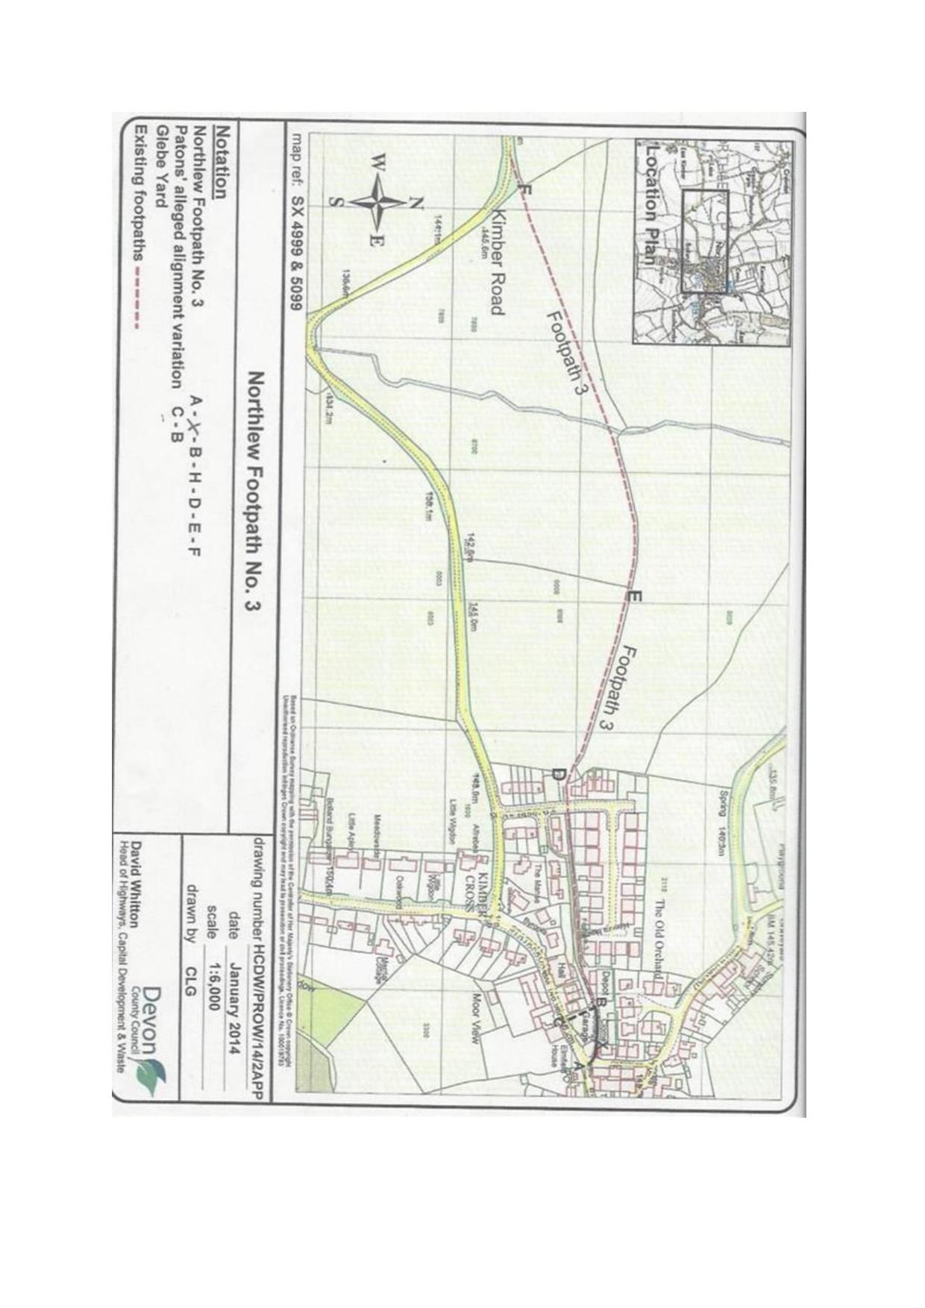

MAP NOT TO SCALE

FPS/J1155/14D/7, 25 February 2020.
FPS/J1155/14A/4, 11 June 2015.
William Gardiner Paton and Tina Sharon Paton v Secretary of State for Environment Food and Rural Affairs CO/3848/2015, 12 November 2015 (CO/3848/2015).
Order of Lord Justice Gross, Ref C1/2015/4123
Cf Dove J in CO/3848/2015, paragraph [8].
[2005] EWHC 119 (Admin)
This “Treveylan” presumption is a reflection of s56(1)(a). Cf paragraph 38 of that judgment “Where the Secretary of State or an inspector appointed by him has to consider whether a right of way that is marked on a definitive map in fact exists, he must start with an initial presumption that it does.”
Paragraph [9] of the judgment.
Dawes v Hawkins (1860): “It is also an established maxim,—once a highway always a highway: for, the public cannot release their rights, and there is no extinctive presumption or prescription.”
Clome Cottage, most recently occupied by the Appellants is a Grade II listed building situated just off the main square in the historic and attractive village of Northlew. Interestingly, a clome (or cloam) oven is understood to be a type of masonry oven with a removable clay or cast-iron door, fitted in kitchen fireplaces in Devon. Indeed the listing entry for the interior describes a stone fireplace with timber bressumer and clome oven built into the southern wall (https://historicengland.org.uk/listing/the-list/list-entry/1147494).

