

|  |
| --- |
| **Application Decision** |
|  |
| **by Richard Holland** |
| **Appointed by the Secretary of State for Environment, Food and Rural Affairs** |
| **Decision date: 10 September 2021** |

|  |
| --- |
| **Application Ref: COM/3272509**  **The Severn Ham & Mill Avon and River Swilgate, Tewkesbury, Gloucestershire**  Register Unit No: CL21 and CL379  Commons Registration Authority: Gloucestershire County Council |
| * The application, dated 1 April 2021, is made under Section 38 of the Commons Act 2006 (the 2006 Act) for consent to carry out restricted works on common land. * The application is made by Fisher German LLP for the Environment Agency (EA). * The works of approximately 6 months duration to install a permanent eel pass comprise i) temporary access trackway (approx. 630m long);   ii) isolating the Abbey Mill sluice gate (potentially by temporary dam);  iii) dewatering the temporary dam;  iv) installation of concrete base in the water course at the bottom of the inclined eel pass;  v) installation of pre-fabricated eel pass;  vi) excavation behind the existing wall and installation of below ground eel pass; and  vii) temporary 2m high Heras fencing enclosing approximately 11,283m² around a works area, a works compound and the access trackway during the works period. |

Decision

* 1. Consent is granted for the works in accordance with the application dated 1 April 2021 and submitted plans subject to the following conditions:
     + - 1. the works shall begin no later than 3 years from the date of this decision; and
         2. all fencing shall be removed and the land shall be fully reinstated within six months from the completion of the works.
  2. For the purposes of identification only, the location of the proposed works at CL21 is shown on the first attached plan and the location of the proposed works at CL379 is shown on the second attached plan.

**Preliminary Matters**

* 1. I have had regard to Defra’s Common Land Consents Policy[1] in determining this application under section 38, which has been published for the guidance of both the Planning Inspectorate and applicants. However, every application will be considered on its merits and a determination will depart from the policy if it appears appropriate to do so. In such cases, the decision will explain why it has departed from the policy.
  2. Common land units CL21 and CL379 are contiguous. The location of the land included in CL379 is not certain as the records kept by Gloucestershire County Council Commons Registration Authority (the CRA) do not include a CL379 register map with a clearly marked boundary. However, I am satisfied from the records provided by the CRA that all the works the subject of the application are within one of the two units and that the small area of works said to be within CL379 are likely to be so.
  3. This application has been determined solely on the basis of written evidence. I have taken account of the representations made by Natural England (NE) and the Open Spaces Society (OSS).
  4. I am required by section 39 of the 2006 Act to have regard to the following in determining this application:-

1. the interests of persons having rights in relation to, or occupying, the land (and in particular persons exercising rights of common over it);
2. the interests of the neighbourhood;
3. the public interest;[2] and
4. any other matter considered to be relevant.

Reasons

***The interests of those occupying or having rights over the land***

* 1. The application land includes areas in three separate ownerships. The temporary works areas are largely owned by Tewkesbury Town Council (the Council) and Corbally Group (Tewkesbury) Ltd. Both were formally consulted about the application and informally consulted at the pre-application stage but have not commented on the proposals. There is no evidence before me to suggest that their interests as landowners will be harmed by the proposed works. The rest of the application land is owned by EA (the applicant), including the area the subject of the permanent eel passage works, and it follows that the works are in their interest.
  2. The commons register records the Trustees of Tewkesbury Commons as the only holders of rights of common over CL21. The right relates to grazing over the whole of the common at certain times of the year. The applicant advises that the Trustees let the right to graze livestock between 13 August and 20 November. All stock is then removed in line with an agreement between the Trustees and the Council in relation to a Higher Level Stewardship scheme and the required management of the sward on Severn Ham. The Trustees were consulted about the application but have not commented on it. The applicant advises that discussions with them are ongoing to ensure that any disturbance to grazing rights is minimised and that any temporary mitigation required can be implemented.
  3. The commons register for CL379 records the exclusive right to fish from the water comprised in the register unit in favour of the Mayor, Alderman and Burgesses of the Borough of Tewkesbury. The applicant advises that fishing rights will be unaffected by the works, which will impact on only a 40m² area of the common. There are no fishing platforms at the location and access is via a steep embankment and concrete wall so it is unlikely to be used by anglers.
  4. I am satisfied that the interests of persons having rights in relation to, or occupying, the land (and in particular persons exercising rights of common over it) are unlikely to be harmed by the proposals.

***The interests of the neighbourhood and protection of public rights of access***

* 1. The applicant has a legal obligation to provide improved eel passage at Abbey Mill sluice to comply with the Eels (England and Wales) Regulations 2009 and is working to deliver improved passage at the confluence between the River Avon and the River Severn. The existing redundant eel pass at Abbey Mill was a pumped system within a building, whereas the proposed new eel pass system will work using gravity. It will be more effective and require far less maintenance. The interests of the neighbourhood test relates to whether the works will unacceptably interfere with the way the common land is used by local people and is closely linked with the interests of public access.
  2. NE advises that CL21 is subject to rights of access under section 193 of the Law of Property Act 1925, which includes a right to access on horseback. However, no party has said that the application land is used for horse riding and there is no evidence before me to suggest that it is.
  3. The proposed temporary works area, works compound and access trackway at CL21 are necessary to facilitate the permanent eel passage works at CL379. The temporary works areas, totalling approximately 11,283m², will be enclosed by fencing and closed to public access for the duration of the works, which is expected to be around six months. The fencing will also isolate a strip of common between the trackway and the eastern boundary of CL21 where it follows the line of the River Avon. Since the application was made, the applicant has confirmed that two pedestrian crossing points will be installed in the fence line to provide access onto the strip; one at each end of the trackway (although only one crossing point is shown on the plan attached to this decision). A Temporary Traffic Order to temporarily close a number of public footpaths on CL21 has been issued, which is likely to have the effect of discouraging pedestrians from using areas of the common near the trackway. Nevertheless, the public right to walk over the common remains and I am satisfied that the two crossing points will be adequate to allow access through the trackway to the eastern strip.
  4. The temporary fencing is required to protect members of the public and livestock from the enclosed area, where there will be machinery and site vehicle movements. I consider the proposals to be a proportionate measure to maintain public and livestock safety and rights of public access over the common during the works period.
  5. Whilst the boundaries of CL379 are not clear, its area is recorded in the common land register as 21 acres (8.5 hectares) or thereabouts. The applicant advises that the eel passage works will affect 40m² of CL379, which equates to about 0.05% of the total area of the common. I am satisfied that the works on CL379 will have a negligible impact on the interests of the neighbourhood and public rights of access.

***Nature conservation***

* 1. The application land lies within the Severn Ham Tewkesbury Site of Special Scientific Interest (SSSI). NE advises that it is presently classed as being in favourable condition and recognises that the proposed works will be of value to the wider environment. No party has suggested that the proposed works will have a detrimental impact on the SSSI and I am satisfied that they will not.
  2. The applicant advises that the works will contribute to making a 26.7km reach of the River Avon and its tributary, Carrant Brook, accessible to eel species and that increasing connectivity for fish also supports the 2015 Severn River Basin Management Plan’s aim for water bodies to achieve good ecological status or potential by 2027. NE notes that the works are proposed to allow for the safe migration of European Eels (Anguilla anguilla) in and out of the river systems in order to complete their life cycles and hopes that the proposed eel pass will significantly improve such passage. NE confirms that the European Eel is a notified species of the Severn Estuary Special Area of Conservation (SAC), Specially Protected Area (SPA) and RAMSAR sites and is currently classed as critically endangered due to sharp declines in numbers since the 1990s.
  3. I conclude that the proposed works are in the interests of nature conservation.

***Landscape***

* 1. The applicant advises that the visual impact of the proposed eel pass works will be minimised by having the top of the structure flush with the ground and by painting the above water sections black to match the colour of the existing sluice gate. The below ground/water sections will not be visible from Abbey Mill or from across the Severn Ham.
  2. The applicant confirms that the proposed fencing will be removed as soon as the eel pass works are completed. The timing of the proposed works will coincide with separately consented pipe replacement works being carried out on CL21 by Severn Trent Water and the applicant advises that responsibility for post-works reinstatement of the land will be shared with it.
  3. I am satisfied that the permanent works at CL379 will not detrimentally impact on the landscape and that the application land at CL21 will be reinstated to its original condition following removal of the temporary fencing, which can be required by attaching a suitable condition to the consent.

***Archaeological remains and features of historic interest***

* 1. The applicant engaged with Historic England (HE) at the pre-application stage when it was determined that the proposed works and working method do not need listed building consent. HE was also consulted at the post-application stage but has not commented. I am satisfied that HE has had a full opportunity to raise any concerns about the proposals and that there is no evidence to suggest that any historical remains or features of historic interest are likely to be harmed by the proposed works.

Conclusion

* 1. I conclude that the proposed works will not unacceptably harm the interests set out at paragraph 6 above. Indeed, they will benefit the conservation of the endangered European Eel by providing passage through the River Severn and River Avon systems. Consent is therefore granted for the works subject to the conditions set out in paragraph 1.

**Richard Holland**

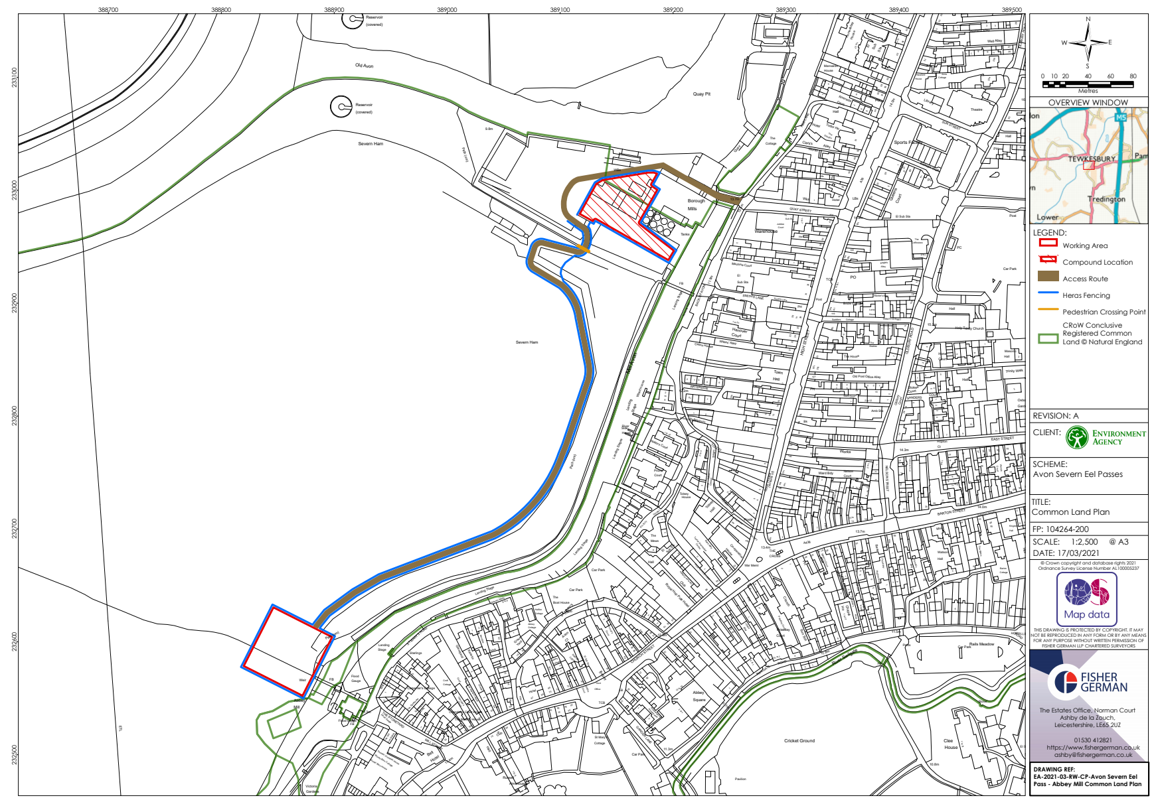

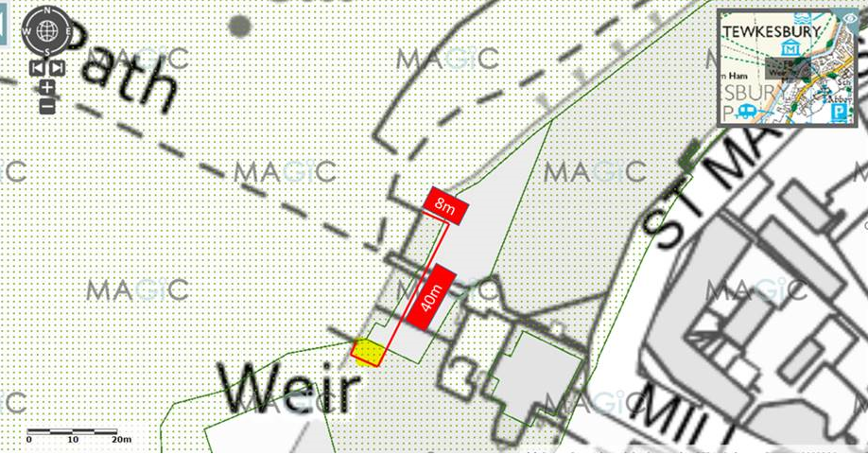

1. Common Land Consents Policy (Defra November 2015)
2. Section 39(2) of the 2006 Act provides that the public interest includes the public interest in; nature conservation; the conservation of the landscape; the protection of public rights of access to any area of land; and the protection of archaeological remains and features of historic interest.