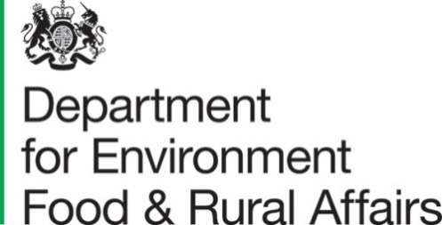
Published 9th September 2021

Farmer Opinion Tracker for England – April 2021

This report contains estimates from the Farmer Opinion Tracker providing a snapshot of views and opinions towards Defra’s vision for farming at this time. Farmers were asked questions about business planning, relationships with farming organisations and Defra and the future of farming.

Key Messages for April 2021
- Farmers on 67% of holdings said they either fully (5%) or roughly (62%) understood Defra’s vision for farming, an overall increase from 63% in 2020.
- Farmers on 60% of holdings indicated that they will need to make changes to their farm business in the next 3 to 5 years, an increase from 54% in 2020 and 52% in 2019.
- Farmers on 88% of holdings said that Defra paying for environmental outcomes will be very (62%) or moderately (26%) important to their business in the future.
- Farmers on 38% of holdings would describe their relationship with Defra (including Defra agencies) as an inspection and enforcement relationship. On the other end of the scale, only 6% felt they had no relationship.
- Over half of farmers (53%) feel positive about the future of farming (with 7% saying they felt very positive and 46% somewhat positive). This is an overall increase from 51% in 2020 and 48% in 2019.
Farmers were offered the opportunity to express opinions and their thoughts on farming i.e. what was on their mind at the time of filling in the survey. Below is a summary of their comments. The open text comments analysis in section 2 provides context around the statistics.
- Defra’s vision for the future of farming received mixed opinion - both positive and negative. There was some optimism about the upcoming changes, whereas others thought the vision lacked direction. The importance of getting the changes right was highlighted, including taking a regional and flexible approach.
- Many responded with reference to the proposed Environmental Land Management (E.L.M.) schemes including the importance of schemes being simple to implement and financially viable (with many emphasising the need for profit). Respondents were hoping for tailored advice, clear targets, and a user friendly, partnership approach. There were concerns about the lack of clarity, eligibility, uptake, and recognition of existing environmental work.
- Also, at the time of the survey (before the announcements on E.L.M. schemes), the lack of clarity about upcoming changes was affecting business planning. There was a sense of urgency in some comments for details about payment rates, what future schemes will involve, and eligibility.
- The importance of small, family, and upland farms for maintaining the environment and rural community was highlighted. However, there was concern about their survival as direct payments are removed. Tenant farms suggested they were experiencing challenges from high rental costs and short-term tenancies were making it difficult to plan and invest.
- Many comments were from respondents who viewed themselves as food producers first. They were concerned about food security and the focus on environmental priorities. In comparison, some (although fewer) respondents viewed themselves primarily as custodians of the environment.
- There was praise for the environmental work that current agri-environmental schemes enabled. However, some expressed frustrations about complexity, late and low payments, inspection errors, disproportionate penalties, and a lack of flexibility to make changes.
- Some commented that they regarded regulation as ‘heavy handed’ and it was suggested that the inspection experience was impacting uptake of other schemes and causing stress for some farmers – these past experiences were likely to have impacted current views of, and trust in, Defra and its Arm’s Length Bodies (ALBs).
- Where comments were made on Defra’s relationship with the farming community, there was consensus that there was still room to improve. Some respondents thought Defra undervalued farmers and did not understand farming life. There were requests for more partnership working and join up between government organisations, with some criticising the presence of mixed messages. Communication and customer service from Defra and its ALBs could be improved by being made simpler and quicker.
- There were concerns about leaving the EU in December 2020 and trade deals leading to competition from imported food with lower welfare and environmental standards. There were requests for a level playing field, fair food prices, and more support for British produce.
- Weather and climate change were mentioned as impacting farming practices, profitability, yields, and regulation compliance. The role of farming in climate change, both as a culprit and a solution, was highlighted.
- Many of these key points and concerns were said to be influencing how farmers were feeling and wellbeing issues such as stress and fear were revealed.
Contents
What you need to know about this release 5
Section 1 – Detailed results 6
1.1 Vision 6
1.2 Changes 7
1.3 Groups 12
1.4 Environment 14
1.5 Relationships 16
Section 2 – Open Text Comments 19
2.1 Future Farming Vision 19
2.2 The Agricultural Transition Period and Environmental Management 19
2.3 Regulation and Enforcement 21
2.4 Relationships and Communication 21
2.5 Markets, Food Standards, and Food Prices 21
2.6 The Reality of Farming Life ‘On the Ground’ 22
2.7 Miscellaneous Themes 23
2.8 What’s Different Now? (Comparison to 2019 and 2020 Results) 24
Section 3 – About these statistics 25
3.1 Methodology 25
3.2 Data analysis 25
3.3 Accuracy and reliability of the results 25
3.4 Uses and Users 25
3.5 Definitions 26
3.6 Future publications 26

What you need to know about this release

Contact details

Responsible social researcher: Hannah Baker
Team: Future Farming Insights and Evaluation - Department for Environment, Food and Rural Affairs
Email: Farming.Research@defra.gov.uk

Responsible statistician: Emma Howat
Team: Farming Statistics - Department for Environment, Food and Rural Affairs
Email: farming-statistics@defra.gov.uk
Telephone: 03000 600 170

Official Statistics

Official statistics are produced to the high professional standards and comply with the United Kingdom Statistics Authority’s Code of Practice for Statistics. The Code of Practice for Statistics sets the standards that producers of official statistics should commit to. Compliance with the Code gives you confidence that our published statistics have public value, are high quality, and are produced by people and organisations that are trustworthy.

Section 1 – Detailed results

1.1 Vision
Defra is setting out what they think the future for farming would look like. In this vision, England’s farmers improve the health of our environment and animals as part of a sustainable, productive agricultural sector. When asked if they know what Defra’s vision meant for farming, farmers on 67% of holdings said they either fully (5%) or roughly (62%) understood Defra’s vision (see Figure 1). Whilst overall this is a slight increase from 63% of holdings in 2020, fewer farmers fully understand the vision than in previous years. In 2021, a further 29% said they didn’t know but would be interested to know more. Farmers on the remaining 4% of holdings didn’t need to know what the future vision meant for farming.
Figure 1: Proportion of holdings that understand Defra’s vision for farming, 2019 to 2021
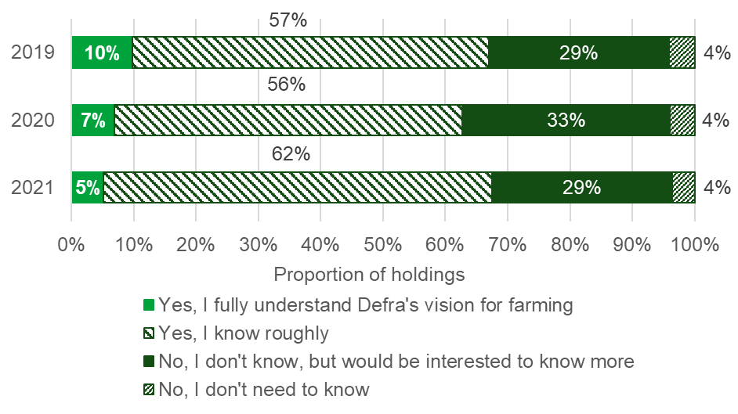

1.2 Changes
In 2021, DEFRA started the transition away from the EU Common Agriculture Policy which will involve changes to the payments farmers receive and the regulations their businesses must follow. Farmers were asked whether they had all the information they needed at this point to help with their business planning (see Figure 2). Farmers on 40% of holdings said they had all (4%) or most (36%) of the information they required. This proportion has increased overall from 30% in 2020 and 27% in 2019. In 2021, a further 19% indicated that didn’t have any information but knew where they could find it. Farmers on nearly a third (32%) of holdings said they didn’t have any of the information they needed for their business planning and were unsure where to find it. The remaining 9% of all holdings didn’t know if they had all the information they needed.
Figure 2: Proportion of holdings that have the information they need to inform business planning, 2019 to 2021
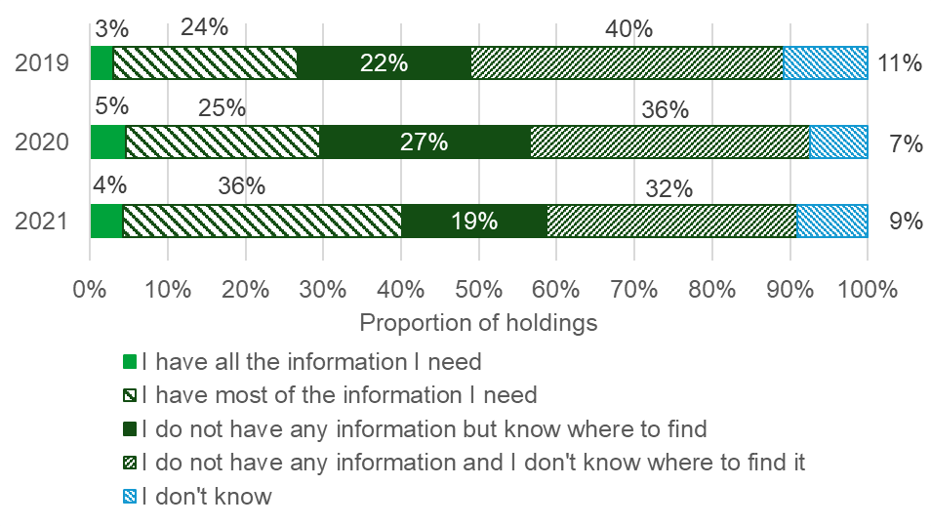
Farmers on 60% of holdings believe they will need to make changes to their farm business in the next 3 to 5 years (an increase from 54% in 2020 and 52% in 2019). This proportion varied over farm size, increasing to 70% of large holdings and 71% of medium holdings compared to 52% of smaller holdings (see Figure 3). Approximately 10% of farmers on all holdings indicated that they don’t need to make any changes to their farming business and nearly a third (30%) don’t know what changes they need to make.

Figure 3: Proportion of holdings that need to make changes to their farm business in the next 3 to 5 years, by farm size
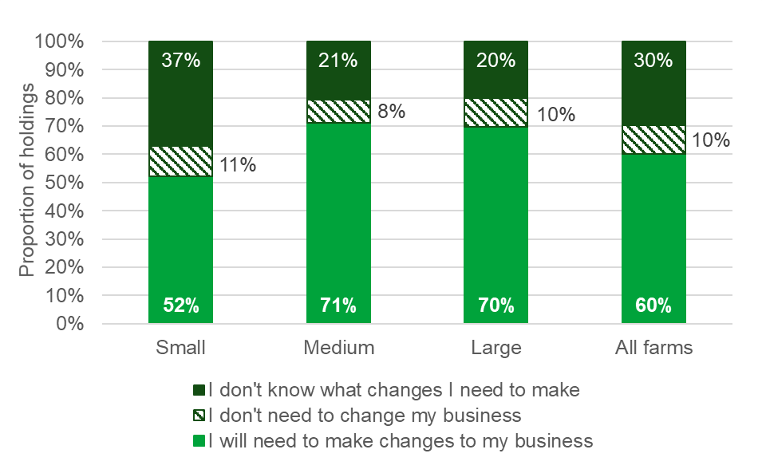
Farmers who answered that they will need to make changes to their farm business in the next 3 to 5 years were then asked what changes they will need to make (see Figure 4). Farmers are most likely to stay farming but diversify their business into non-farming areas with 42% of farmers on all holdings selecting this option. Over a quarter (27%) will stay farming but increase productivity and farmers on 26% of holdings would change their core agricultural enterprises. Fewer farmers indicated that they would leave farming, as 10% are planning on retiring or passing the farm onto the next generation and 6% would leave farming for other reasons. Farmers on 3% of holdings stated other changes they plan to make to their farm business which include stay farming but reduce costs and maximise environmental schemes.

Figure 4: Changes to farm business
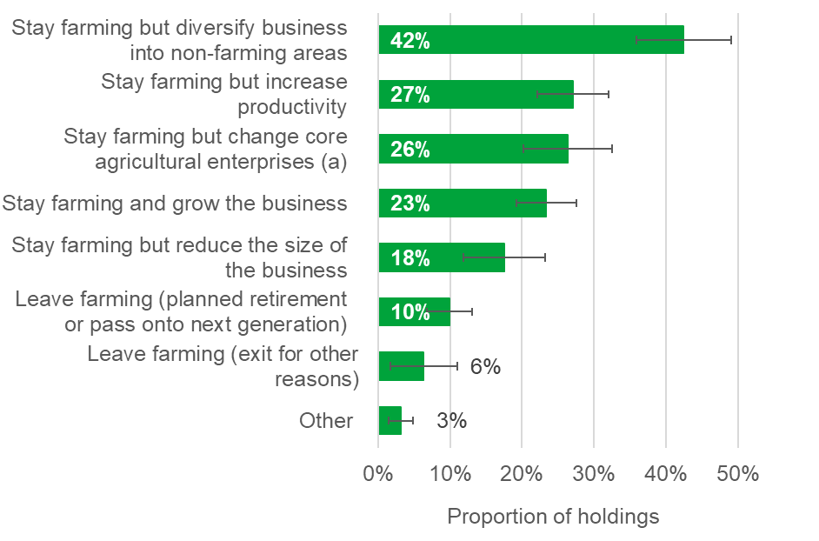
Note: Farms could select more than one option.
- for example, change crops and/or livestock

These proportions varied quite significantly across farms. Compared to 27% of all holdings, a higher proportion (36%) of other crops holdings intend to stay farming but increase productivity. Whereas farmers on lowland grazing livestock holdings and dairy holdings are less likely to make this change in the next 3 to 5 years (17% and 18% of holdings respectively).
Farmers in the South East including London (60%) are more likely to stay farming but diversify their business into non-farming areas in the next 3 to 5 years (see Figure 5). This option was not as popular for farmers in the North East or in Yorkshire and the Humber, with just over a quarter of all holdings making this selection.
Farmers on nearly a quarter (23%) of all holdings intend to stay farming and grow their business in the coming years, this is unchanged on last year. However, this varied across farm size, with 38% of larger holdings and 34% of medium holdings selecting this option compared to 10% of small holdings (see Figure 6).
Figure 5: Proportion of holdings that plan to stay farming but diversify their business into non-farming areas, by English region
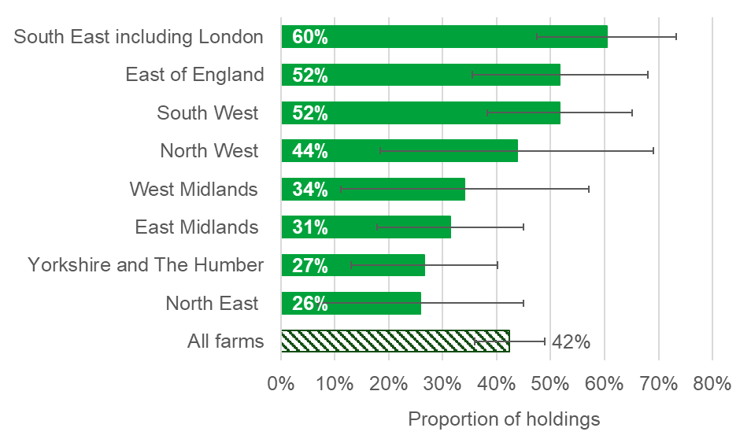
Note: Farms could select more than one option.

Figure 6: Proportion of holdings that plan to stay farming and grow the business for 2020 to 2021, by farm size
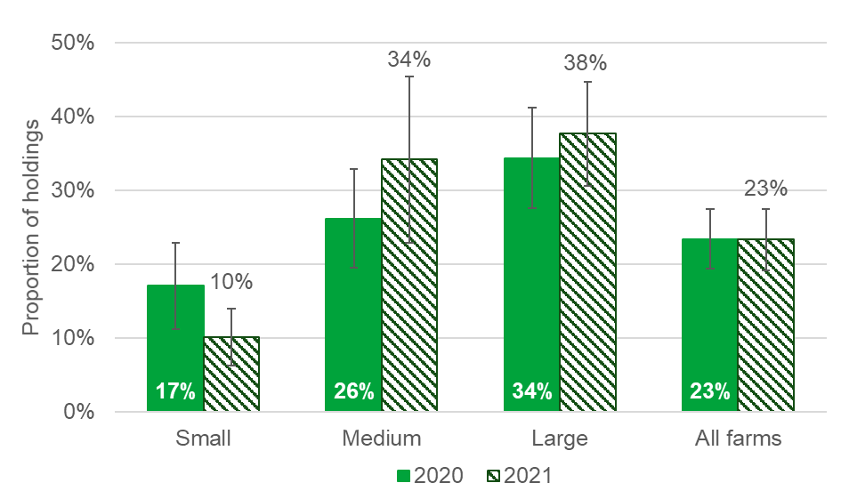
Note: Farms could select more than one option.

Farmers on 54% of holdings were either very (9%) or somewhat (45%) confident that they could respond to any changes that are needed, this is an overall decrease from 61% in 2020. In 2021 this proportion varied across English regions, as three quarters (75%) of farmers on North East holdings are confident they can make changes compared to 29% of North West holdings. Approximately 37% of farmers in the North West are unsure whether they can respond to changes, compared to 19% across all holdings. The remaining farmers on 27% of all holdings are not at all confident they can respond to the changes that they will need to make (see Figure 7).
Figure 7: Proportion of holdings that are confident they can respond to changes, by English region
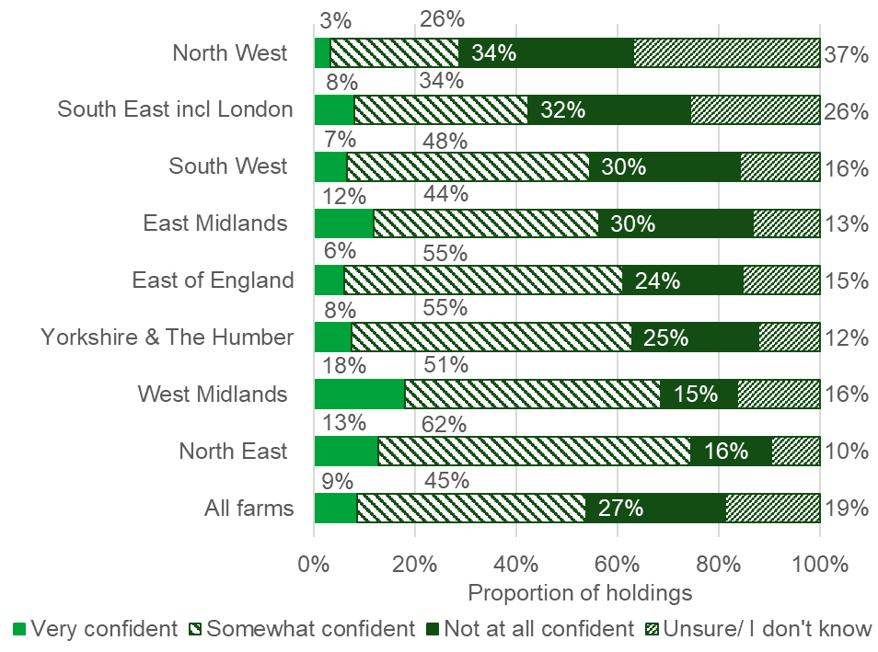

1.3 Groups
Farming organisations and advisors have a role in helping farm businesses to adapt to the changes needed. Farmers on 31% of holdings agreed that these organisations were helping them to make changes, with an additional 4% strongly agreeing (down from 34% and 5% on last year respectively). Just under half of farmers neither agreed or disagreed and a further 17% said they either disagreed (12%) or strongly disagreed that these organisations were helping them to make changes (see Figure 8).
Figure 8: Proportion of holdings that agree farming organisations and advisors are helping them make changes to their business
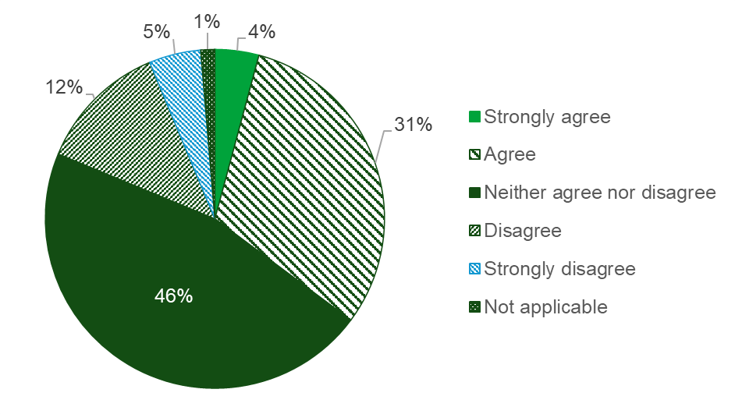

The future vision for farming involves farm businesses responding to both existing and new market demand for produce. Farmers on two thirds of holdings (67%) said that producing for the end market would currently be very important for their farm business with a further 24% indicating that it would be moderately important (see Figure 9). Only 5% said that it was not at all important.
Looking to the future, producing for the end market was said to be very important by 68% of holdings and 17% indicated that it would be moderately important Only 6% said it was not at all important and farmers on the remaining 8% of holdings were unsure.
Figure 9: Proportion of holdings that believe producing for the end market is important for their business
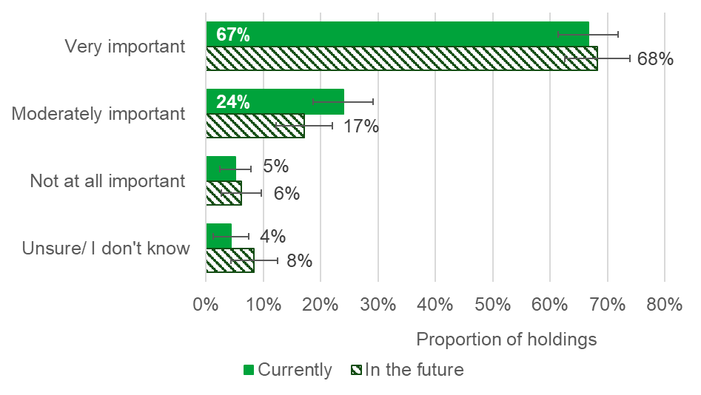

1.4 Environment
Defra's vision for farming involves providing environmental outcomes. Farmers on 82% of holdings said Defra paying for environmental outcomes was currently very (43%) or moderately (39%) important for their business (see Figure 10). A further 14% said that it was currently not at all important.
When asked how important it will be in the future for Defra to pay for environmental outcomes, farmers on 62% of holdings said it would be very important. A further 26% believed it would be moderately important and only 5% said that Defra paying for environmental outcomes in the future was not at all important (see Figure 10).
Figure 10: Proportion of holdings that believe Defra paying for environmental outcomes would be important for their business
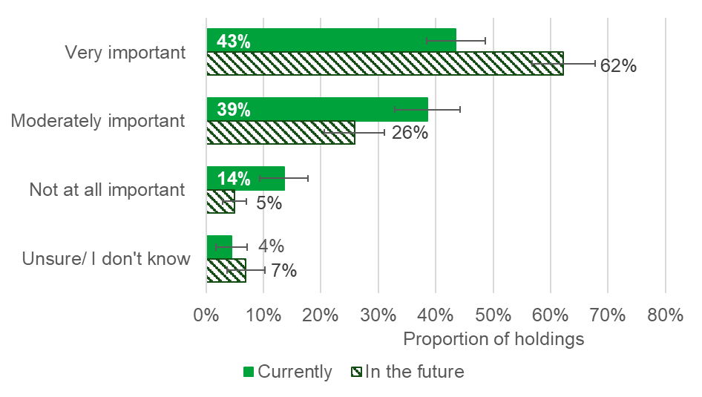

Environmental safeguards and standards in farming are maintained by both enforcing regulations and empowering individual responsibility. Farmers on 37% of holdings either agreed (34%) or strongly agreed (3%) that the current approach balances enforcement with individual responsibility (see Figure 11). Farmers on 41% of holdings neither agreed nor disagreed with the statement. A further 14% disagreed that the current approach balances enforcement with individual responsibility and 4% strongly disagreed.
Figure 11: Proportion of holdings that agree the current approach balances enforcement with individual responsibility
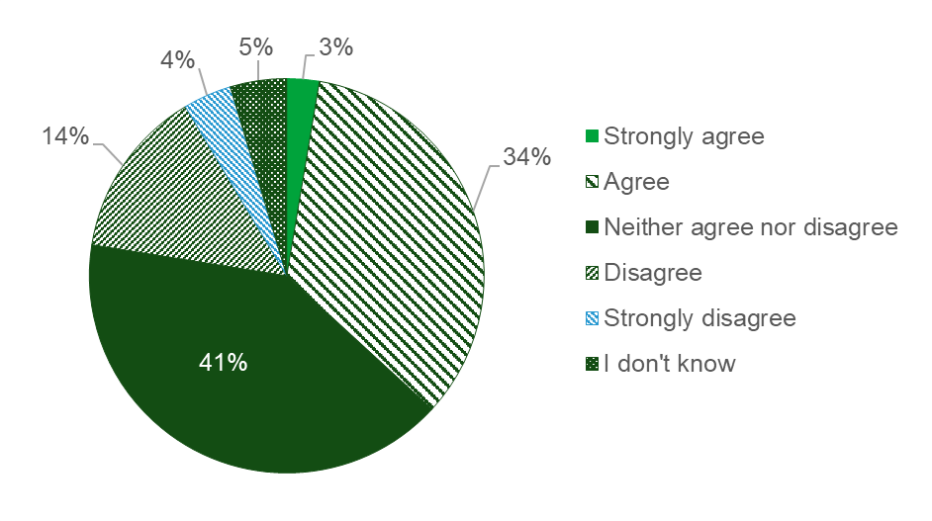

1.5 Relationships
Farmers were asked how they would best describe their current relationship with Defra, including Defra agencies such as the Rural Payments Agency (RPA), the Animal and Plant Health Agency (APHA), Natural England and the Environment Agency. Farmers on 38% of holdings described their current relationship with Defra and Defra agencies as an inspection and enforcement relationship, where Defra inspect and regulate their business (see Figure 12).
Figure 12: Farmer’s current relationship with Defra and Defra agencies
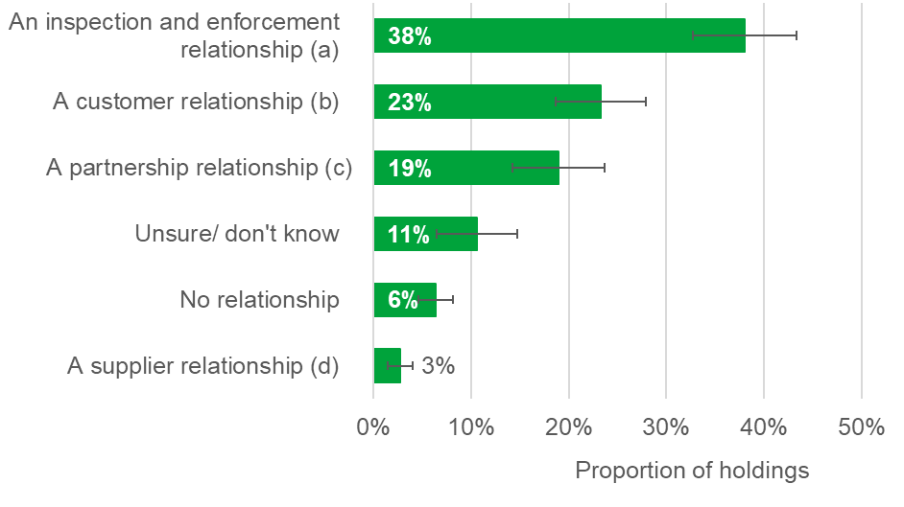
- where Defra inspect and regulate my business
- where Defra deliver services like payments to my business
- where Defra work with my business
- where Defra buy services (such as environmental goods) from my business

Just under a quarter of holdings (23%) said they have a customer relationship where Defra delivers services such as payments to their business. Farmers on 19% of holdings described their relationship with Defra as a partnership, where Defra works with their business (this has increased from 16% in 2020 and 13% in 2019). A further 6% said they have no relationship with Defra and only 3% indicated that they have a supplier relationship, where Defra buys services such as environmental goods from their business. Approximately 11% of holdings don’t know how they would describe their relationship with Defra.

Farmers on approximately 40% of holdings are not at all confident that their relationship with Defra and Defra agencies will develop positively in the future. Whilst this is lower than 2020 (44%) and 2019 (48%), this is actually an improvement on both years (see Figure 13). In 2021, approximately 46% of holdings are either very (4%) or somewhat confident (42%) that relationships with Defra will improve. The remaining farmers on 14% of all holdings don’t know if their future relationship with Defra will be positive.
Figure 13: Proportion of holdings that believe their relationship with Defra and Defra agencies will develop positively in the future, 2019 - 2021
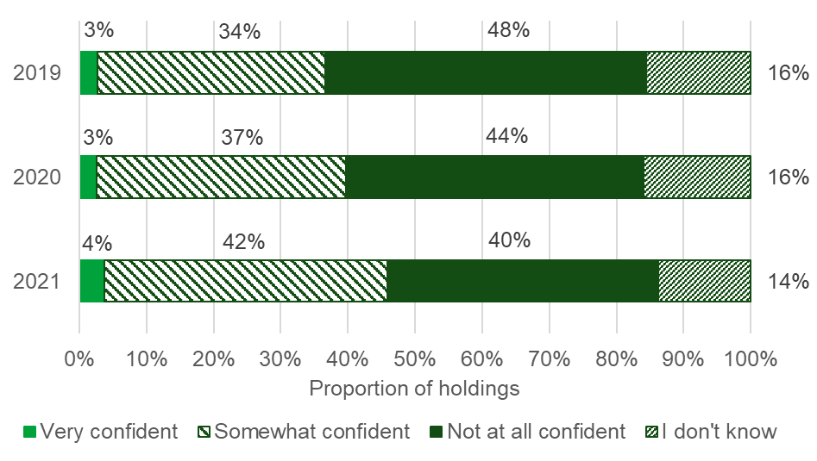
Over half (53%) of farmers on all holdings felt positive about the future of farming (7% very positive; 46% somewhat positive). This is a 5% point increase on 2019 and a 2% point increase on 2020. In 2021, a further 38% said they are not at all positive about the future of farming and the remaining 9% are unsure. This varied across farm type, as 21% of pigs and poultry holdings are unsure about the future of farming compared to only 3% of other crops holdings (see Figure 14).

Figure 14: Proportion of holdings that feel positive about the future of farming, by farm type
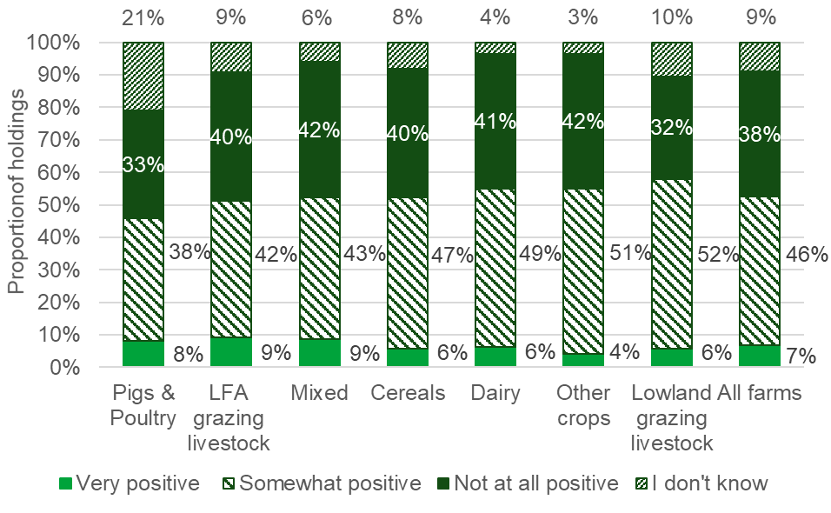

Section 2 – Open Text Comments

390 comments were provided from a variety of farm sectors, sizes, tenures, and locations.
It should be noted that people with strong views are more likely to comment. This can potentially result in negative comments appearing more prevalent than might be the case i.e. respondents who are relatively content are less likely to provide comments.
A variety of themes were covered. The most commonly mentioned themes were about Environmental Land Management (E.L.M.) schemes, the relationship between the farming community and Defra, and differing farming styles (production and environmental).

2.1 Future Farming Vision

High Level Vision Feedback and Sentiment
This theme provided a snapshot of reactions to Defra’s vision for the future of farming. There were both positive and negative reactions. Some respondents thought the vision lacked direction or balance and was “blurred” or “muddled”. A variety of reasons contributed to this, including a perceived conflict between environmental priorities and domestic food production, issues from importing food with lower welfare and environmental standards, the cheap price of food, small profit margins, and a lack of detail about the “end goal” of the vision and how it will be achieved. This explained why some respondents were “worried” about the future of farming.
There was a small amount of optimism and confidence with some respondents feeling “excited” about the future. This tended to be linked with stipulations for future support, the importance of getting the changes right, and advice for policymaking such as taking a regional and flexible approach which accounts for different farm sectors.

2.2 The Agricultural Transition Period and Environmental Management

Environmental Land Management (E.L.M.) Schemes
Feedback about E.L.M. schemes was a major theme; mentioned in over a third of all comments. Some respondents were optimistic and excited for the new schemes and challenges ahead. Many others were less optimistic, citing reasons such as the lack of detail (e.g. who will be paid, how much, and for what), previous experiences of scheme delivery, eligibility questions (e.g. for organic, dairy, tenant, small farms, plus those not located in areas with protected natural features), and how existing environmental work would be recognised. This linked to a theme about uptake and the importance of E.L.M. schemes needing to be simple to implement and financially viable (including making a profit) for farmers to participate. Other barriers to uptake included a perceived higher risk, expense, and inaccessibility for small farms; a lack of land to set aside for environmental work; and an unwillingness to change for farmers close to retirement.
Many respondents made suggestions for developing E.L.M. schemes (e.g. payment rates, transitioning between schemes, and ideas for grant funding). They were hoping for tailored advice, clear targets, and a user friendly, partnership approach. Public money for public goods was referenced a few times, especially views about what should constitute a public good. The Sustainable Farming Incentive (SFI) was mentioned a few times, focussing on the payment rates, the time to work out what is relevant to the farm, and how it will replace direct payment income.

Business Viability
Quite a few respondents stated that they were reliant on the Basic Payment Scheme (BPS) to make a living, with a particularly high dependence mentioned among small, family farms and hill farms. Removal of BPS was a prominent theme and linked with language around “suffering” and “survival”. It was noticeable that both small and large farms described concern about business viability. It was suggested that a gap in funding between BPS and E.L.M. schemes could impact profitability, succession plans, the ability to diversify, as well as the wider supply chain. Some comments described the potential impact on the countryside if certain businesses did not survive (e.g. intensified farming could increase, and environmental benefits could be lost). Business viability was also stated to be impacted by a variety of factors such as production costs, labour cost and availability, regulation, market prices, the weather, and receiving high enough payments and support on time. A few respondents were more positive about their future and one respondent stated that they had already built resilience into their business.

Farming Styles
A range of farming styles emerged as a major theme; mentioned in over a quarter of all comments. These included a common style focussing on farmers’ roles as food producers first. Closely linked to this was concern and confusion about the prioritisation of environmental management, potentially to the detriment of productive farming and food security. Those focussed on food production emphasised the need for profitability and included some support for the removal of subsidies in favour of a free market with fair prices. There was a perception from a few respondents that Defra was accommodating environmental pressure groups and not listening to the voices of farmers.
Some comments were more nuanced suggesting that although food production should be a priority, it could be achieved alongside environmental management. Some (although fewer) comments represented a more environmental style, emphasising farmers’ role as custodians of the environment. They acknowledged existing work to manage and enhance the countryside. However, some respondents felt undervalued and suggested this environmental style did not automatically link to support for the proposed E.L.M schemes.

Experiences of Current Agri-Environmental Schemes (AES)
A few respondents explained their experiences of current AES. There was some praise for how the schemes benefitted the farms and environment. However, other feedback stated application processes and scheme manuals (e.g. for Countryside Stewardship) were “too complex” and off-putting. There were comments about the delivery of schemes as a whole and challenges were highlighted from late and low payments, mistakes in inspections, disproportionate penalties, and a lack of flexibility to make changes.

2.3 Regulation and Enforcement

The RPA and Experiences of Inspections
Some comments addressed customer service from the RPA, especially in relation to application enquiries, appeals and chasing payments. Regulation was referred to as a “regime” in a few comments and inspections were described as “nit picking” and “heavy handed”. Unfair penalties and the inflexibility of some rules had caused expensive issues for a few respondents. It was suggested that the inspection experience was impacting uptake of other schemes and causing stress for some farmers.

2.4 Relationships and Communication

Defra’s Relationship with the Farming Community
The role of Defra and the relationship with the farming community was a major theme; mentioned in over a quarter of all comments. Many comments expressed a need for a partnership or 2-way relationship, where Defra and farmers work together for a profitable and sustainable future. It was suggested that the existing relationship (and associated trust) had been impacted by the focus on imports, environmental objectives, previous performance of delivering agri-environmental schemes, and moving policy/scheme goalposts. There was a perception from some respondents that Defra overlooked the competence and preferences of farmers (making them feel undervalued), and Defra also lacked understanding of the realities of farming life. Relationships between the farming community and Defra’s Arm’s Length Bodies (ALBs) were varied and a lack of join-up between, and mixed messages from, government organisations was negatively impacting farmers’ feelings and experiences.

Defra’s Communication with the Farming Community
Quite a few comments described the impact from a lack of information and clarity available about the upcoming policy changes. The uncertainty was reducing respondents’ abilities to make decisions and plan for the future. It was suggested that paperwork for schemes and regulations needed to be reduced and simplified. Contacting Defra and its ALBs needed to be easier and quicker. Advice was highlighted with criticisms about the costs involved for using advisors and the lack of tailored information available about future support for different farm characteristics (e.g. type, size, tenure, location, age).

2.5 Markets, Food Standards, and Food Prices

Leaving the EU, Trade Deals, and Food Standards
There were mixed views about leaving the EU. Some respondents expressed regret leading to some negative sentiment. Only one respondent was explicitly positive, discussing the potential opportunities from domestic schemes. Other respondents described the impact of leaving the EU on trade, in particular concerns about trade deals leading to imported products which do not meet the same high standards required by English farmers (“double standards”). Respondents felt they could be disadvantaged by competition from cheaper and lower quality imports and competing with farmers receiving higher financial support in other countries (not a “level playing field”). There were also a few calls for the government to do more to promote and support British brands and produce.

Animal Welfare
There was a small theme addressing animal welfare. This linked to concerns from respondents around the quality of imports not meeting the same high welfare standards that are adhered to by English producers. At no point did respondents suggest that English standards should be reduced to compete, but instead imports should be required to meet English standards. There was pride in the standards of animal welfare and the quality of farming in England. Specific diseases such as bovine tuberculosis (e.g. issues with testing) and sheep scab were mentioned.

Supply Chains, Supermarkets and Food Prices
Some respondents had concerns about food prices, whether this was being subsidised by low farmgate prices and how this made them dependent on financial support. There were requests for fair prices which reflected the “true cost of production”. Frustration about the power of supermarkets and “big businesses” was highlighted, including their role in driving down prices to a level only sustainable with the support of subsidies.

2.6 The Reality of Farming Life ‘On the Ground’

Business Planning and Decision Making
At the time of the survey (before the announcements on E.L.M. schemes), some comments explained that the lack of clarity about upcoming changes was affecting business planning (both short and long term). Many respondents stated they would not be making changes or investments until more information was available. Business planning was referred to as “nigh on impossible” and there was a sense of urgency in some comments for details about payment rates, what future schemes will involve, and eligibility. The lack of detail led to a few requests for the direct payment reductions to be delayed. Business planning was also said to be impacted by changing policies, price volatility, trade deals, and by personal circumstances such as approaching retirement and succession.

Weather and Climate Change
This was a smaller theme where a few stories revealed the impact of weather on compliance with regulations; on incomes and profitability; on everyday farming practices; and on yields/harvests. A few comments described drought conditions (April 2021), the impact of flooding, and a lack of financial support to deal with extreme weather events.
A few comments acknowledged that climate change and extreme weather were impacting farming practices and increasing costs. There was some detail about carbon footprints and food miles, especially the benefit of British produce versus imported produce where the environmental impacts are “exported abroad”. The role of farming in climate change, both as a culprit and a solution, was highlighted. A few respondents felt farmers were “easy targets” for the cause of climate change. Other comments revealed the benefits of agriculture and soil carbon sequestration. A few comments provided advice for Defra, including joining up government thinking about public health, the environment and farming; changing Defra structures to provide more cabinet support for climate change; and avoiding intensification of farming to make up for lost income when direct payments are reduced.

Wellbeing
Wellbeing was a cross cutting theme linked to many other themes. A variety of factors such as the lack of focus on domestic food production, uncertainty about future support, low incomes, scheme complexity, direct payment reductions, and competition from low quality imports were said to be affecting how respondents were feeling and causing stress for a few farmers. There were references to feeling “worried”, “fearful” and “unhappy” in these “very difficult times”. However, a few comments revealed their “love” for the land, animals, and lifestyle in farming, as well as a few references to taking control and forming a positive view towards the upcoming changes.

Specific Challenges for Different Farm Types
Farm specific challenges were cross cutting amongst many of the other themes.
There was concern from some respondents about the ability of small, family farms and upland farms to survive without direct payment. This led to a few respondents advocating specific government support otherwise there were risks these farms could be “finished”. Comments suggested they face unique challenges such as less ability to adapt farming practices or fund advice and equipment. Some comments revealed small farms felt they were unable to compete with larger farming businesses. The importance of small and upland farms for maintaining the environment and rural community was highlighted. Respondents from small farms described issues around uncertainty, business planning, farming styles, wellbeing, and their relationship with Defra.
Tenanted farms said they were experiencing challenges from high rental costs and short-term tenancies were making it difficult for them to plan and invest. For a few respondents, diversification enabled them to “prop up” their business, remove land from production and further enhance the environment. However, other diversified farms were still finding it “tough”, were reliant on direct payments, and had struggled with planning applications. It was highlighted that “not every farmer is able to diversify”.
There was a small theme around age, particularly in relation to a perception that older farmers may not benefit from future support or experience the “problems to come”. A few comments described the need to encourage younger people onto the “farm ladder”.

2.7 Miscellaneous Themes

Covid-19
There was a small theme around covid-19. The impact of covid-19 on farm businesses was revealed by a few comments and this was used to justify a request for delaying direct payment reductions. The experience of covid-19 was also used by a few respondents to justify that Defra should focus on domestic food production and supply chains rather than importing food. A few comments revealed concern about the security of government funding for future farming because of the covid-19 debt incurred.

Survey Comments
There was a small group of comments which provided feedback on the survey itself, including reactions to the questions. Without more clarification about the upcoming changes the survey was described as “premature” and “very hard to answer”. A couple of respondents were not sure what the survey was hoping to achieve. A few respondents explained having different relationships with different ALBs but the question did not enable this breakdown to be captured. This question will be adapted for the next survey.

2.8 What’s Different Now? (Comparison to 2019 and 2020 Results)
Themes in the April 2021 comments were similar to the themes identified in the 2019 and 2020 Farmer Opinion Tracker findings. However, some small changes were evident. In 2021, there was an increased focus on past and present agri-environmental schemes, more emphasis on the importance of supporting British brands, and a few new requests to delay the reductions in direct payments.
Respondents continued to have concerns about international trade and unfair competition on the international market. A few comments referred specifically to the Australian free trade deal in May 2021. Compared to comments from 2019, more comments were received in 2021 on the importance of domestic food production and there were reactions to the outcome of leaving the EU.
Calls were made in both the 2019 and 2020 comments for further information and increased clarity in relation to the future farming vision and future/E.L.M. schemes. This continued to be a major theme in May 2021 (before the announcements on E.L.M. schemes had been made). This was still impacting business planning and creating uncertainty for many farm businesses (especially small, family, hill, and tenant farms).
Similarly to 2019 and 2020, respondents continued to request a more collaborative relationship with Defra and thought that Defra lacked understanding about the practicalities of farming life. Comments in 2021 emphasised new concerns around mixed messages from different government organisations.

Section 3 – About these statistics

3.1 Methodology
The 2021 Farmer Opinion Tracker provides a snapshot of views and opinions towards Defra’s vision for farming as at April 2021. Farmers were asked questions about Defra’s vision for farming, business planning, relationships with farming organisations and Defra and the future of farming.
The results provided in this report are based on surveys sent to a representative sub-sample of the farming community in England, approximately 6,000 holdings. The survey was voluntary and 1,135 responses were received (including some partial responses), resulting in a response rate of 19%.
To be included in the main sample, holdings had to have at least 50 cattle, 100 sheep, 100 pigs, 1,000 poultry or 20 hectares of arable crops or orchards. Therefore, all results given in this statistical report reflect just over 60 thousand holdings that exceed these thresholds out of the total English population of almost 107 thousand commercial holdings.

3.2 Data analysis
Results have been analysed using a standard methodology for stratified random surveys to produce national estimates. With this method, all of the data are weighted according to the inverse sampling fraction.

3.3 Accuracy and reliability of the results
We show 95% confidence intervals against the results. These show the range of values that may apply to the figures. They mean that we are 95% confident that this range contains the true value. They are calculated as the standard errors (se) multiplied by 1.96 to give the 95% confidence interval (95% CI). The standard errors only give an indication of the sampling error. They do not reflect any other sources of survey errors, such as non-response bias.

3.4 Uses and Users
The survey was set up to collect farmer opinion on the future for farming in England prior to, and during, the Agricultural Transition. The aim is to be open and transparent about what we are hearing from the farming community and then acknowledge and respond to areas where we need to improve. The data collected via this survey will be used to create a baseline dataset of farmer opinion which can then be monitored over time to see how it is changing as we move through the agricultural transition period.

3.5 Definitions

Region
This refers to the NUTS1 regions in England, for the purposes of this analysis we have combined the South East with London.

Farm type
This refers to the ‘robust type’, which is a standardised farm classification system. Farms are split into Dairy, Grazing Livestock Less Favoured Areas (LFA), Grazing Livestock Lowland, Mixed, Other crops, Cereals and Pigs & Poultry (Specialist Pigs and Specialist Poultry combined).

Farm sizes
This is based on the estimated labour requirements for the holding, rather than its land area. The farm size bands used within the detailed results tables which accompany this publication are shown in the table below. Standard Labour Requirement (SLR) is defined as the theoretical number of workers required each year to run a holding, based on its cropping and livestock activities.
Farm size | Definition
Small | Less than 2 SLR
Medium | 2 to less than 3 SLR
Large | 3 or more SLR

Farm ownership
This is based on data from the June Survey of Agriculture and Horticulture. The types are split into:
- Owned - all area on the holding is owned
- Tenanted - All area on the holding is rented under a Full Agricultural Tenancy, Full Business Tenancy, Other agreement or is seasonally rented in (364 days or less)
- Mixed - area on the holding is a mixture of owned and tenanted

3.6 Future publications
The Farmer Opinion Survey for England was first run in Autumn 2019. The survey was set up to collect opinion prior to, and during, the agricultural transition which is the period of the Future Farming and Countryside Programme. Therefore, it is expected
the survey will run every 6 months until 2028. Please note, only one survey was run in 2020 as Covid disrupted data collection.

The next survey will be run in autumn 2021. The publication date will be announced on the research and statistics webpage on gov.uk.

