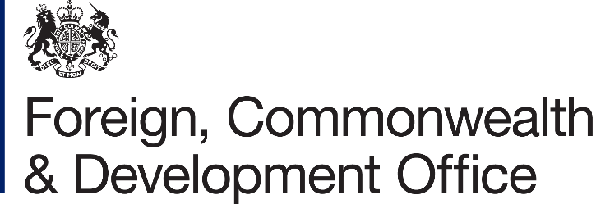

Information Rights Unit
WH 2.177
King Charles Street
London
SW1A 2AH
Email: information.rights@fcdo.gov.uk

1st July 2021

FREEDOM OF INFORMATION ACT 2000 - REQUEST REF: FOI2021/14809

Thank you for your email of 07/06/2021 asking for information under the Freedom of Information Act (FOIA) 2000. You asked:

I would be most grateful if you would provide me, under the Freedom of Information Act, details in respect to the contract below.

Support Team:

https://eur03.safelinks.protection.outlook.com/?url=https%3A%2F%2Fwww.contractsfinder.service.gov.uk%2FNotice%2F4f803f51-6e24-4716-9a3b-0fabc81adf05&data=04%7C01%7CEve.Bamford%40fco.gov.uk%7C8cd8f0edf62a4e45d62808d92a7d7736%7Cd3a2d0d37cc84f52bbf985bd43d94279%7C0%7C0%7C637587540615142314%7CUnknown%7CTWFpbGZsb3d8eyJWIjoiMC4wLjAwMDAiLCJQIjoiV2luMzIiLCJBTiI6Ik1haWwiLCJXVCI6Mn0%3D%7C1000&sdata=B6zI%2FCVQVknlnzyrJny089OhVJUv1NlqSfvaC2aiMBo%3D&reserved=0

The details we are looking for are:
- Name of the framework?
- Start date & duration of the framework?
- Actual spend on this framework is?
- If there is any, what is/are the qualification criteria to be a part of the framework?
- How do you become a potential supplier to the framework?
- Can you please tell us what contracts have been awarded under this framework, who the successful supplier was and what the value of each award was?

I am writing to confirm that we have now completed the search for the information which you requested.

I can confirm that FCDO Services does hold some information relevant to your request.
The Call-Off for the Support Team was awarded via a Crown Commercial Service (CCS) framework and not one of our own frameworks. Therefore, we are only able to answer some of the questions. For further information a separate FOI will need to be submitted to CCS/ the Cabinet Office. The link for which can be found here Crown Commercial Services.

Name of the framework? Management Consultancy Framework Two (MCF2).

Start date & duration of the framework? The start date was September 4th 2018, the end date is September 3rd 2021 with the option to extend for 1 x 12 month period.

Actual spend on this framework is? Information not held by FCDO Services. This question will need to be submitted to the CCS/Cabinet Office.

If there is any, what is/are the qualification criteria to be a part of the framework? Information not held by FCDO Services. This question will need to be submitted to the CCS/Cabinet Office.

How do you become a potential supplier to the framework? Information not held by FCDO Services. This question will need to be submitted to the CCS/Cabinet Office.

Can you please tell us what contracts have been awarded under this framework, who the successful supplier was and what the value of each award was? Information not held by FCDO Services. This question will need to be submitted to the CCS/Cabinet Office.

Once an FOI request is answered, it is considered to be in the public domain. To promote transparency, we may now publish the response and any material released on gov.uk in the FOI releases section. All personal information in the letter will be removed before publishing.

The copies of information being supplied to you continue to be protected by the Copyright, Designs and Patents Act 1988. You are free to use it for your own purposes, including any non-commercial research you are doing and for the purposes of news reporting. Any other re-use, for example commercial publication, would require the permission of the copyright holder. Most documents supplied by the FCDO will have been produced by government officials and will be protected by Crown Copyright. To reuse Crown Copyright documents please consult the Open Government Licence v3 on the National Archives website.

Information you receive which is not subject to Crown Copyright continues to be protected by the copyright of the person, or organisation, from which the information originated. You must ensure that you gain their permission before reproducing any third party (non-Crown Copyright) information.

If you wish to make a complaint or if you would like a review of our decision, please write to the Information Rights Unit, Foreign, Commonwealth & Development Office, Room WH 2.177, King Charles Street, London, SW1A 2AH. E-mail: information.rights@fcdo.gov.uk. You have 40 working days to do so from the date of this letter.

If you are not content with the outcome of your complaint, you may then apply directly to the Information Commissioner for a decision. Generally, the Information Commissioner cannot make a decision unless you have exhausted the complaints procedure provided by the FCDO. The Information Commissioner can be contacted at: Information Commissioner's Office, Wycliffe House, Water Lane, Wilmslow, Cheshire SK9 5AF, or online at: https://ico.org.uk/make-a-complaint/

Yours sincerely,

FCDO Services

For information about how the FCDO handles personal information please see our Personal Information Charter

