**Increasing selected court fees and Help with Fees income thresholds by inflation equalities impact assessment**

**1. Background**

1.1. HMCTS administers the courts and tribunals system, allowing people to execute and defend their rights. It is the role of the Lord Chancellor to ensure that the courts system is efficient and effective, while protecting access to justice. A large number of people use the services of HMCTS every year. Whether it be separated parents in a family court, a vulnerable witness to a crime, or someone appealing a benefits decision, people interact with HMCTS at some of the most difficult times in their lives.

1.2. Fees in civil and family cases are an important source of funding for the courts, and a reasonable means of making resources available to secure access to justice. An effective court service needs to be funded appropriately in order to protect access to justice during Covid-19 recovery and in the longer term.

1.3. The Lord Chancellor has a personal, statutory duty to ensure there is an efficient and effective system in place to support the business of the courts. In setting fees, the Lord Chancellor is also required to take into account the common law right of access to justice – ensuring that those who need to access the courts are not denied this right.

1.4. To fulfil these obligations, the Lord Chancellor has the power to charge and prescribe fees in relation to anything done by the courts and tribunals. The power to charge fees in the courts of England and Wales is set out in several pieces of primary legislation. The key fee setting power is at section 92 of the Courts Act 2003, which provides the Lord Chancellor with a power to, with Treasury consent, prescribe the fees payable in respect of anything dealt with by the Senior courts, family court, county courts and Magistrates’ courts. When setting fees under this power, the Lord Chancellor must have due regard to the principle that access to the courts must not be denied. Most court fees are set under section 92 and are charged at the cost of the service or below it. These are known as non-enhanced fees.

1.5. Certain court fees, including some of the fees included in the proposal, are set above the cost of the service. These are known as enhanced fees and can only be set at such a rate with explicit parliamentary approval. Enhanced fees are set under the power provided in section 180 of the Anti-Social Behaviour Crime and Policing Act 2014 (the Act).

1.6. The power provided under s.180 requires that, before setting a fee at an enhanced level, the Lord Chancellor must have regard to:

a. the financial position of the courts and tribunals including any costs not being met by current fee income; and

b. the competitiveness of the legal services market.

**2. Policy objective**

2.1. The policy proposal is to uplift selected court fees by inflation backdated to August 2016 (or the date of the last fee change if more recent), and also to uplift the income thresholds in the Help with Fees means test by inflation, also backdated to August 2016. This policy, along with details of the specific fee changes, is described in the consultation document Proposal for reform: Increasing selected court fees and Help with Fees income thresholds by inflation. Available at https://consult.justice.gov.uk/digital-communications/increasing-selected-court-fees-income-thresholds.

2.2. The following table outlines each jurisdiction and the number of fees that will be inflated:

**Table 1: Jurisdictions and number of fees affected.**

|  |  |
| --- | --- |
| **Jurisdiction** | **Number of fees affected** |
| Magistrates’ Courts Fees Order 2008 No 1052 | 67 |
| Court of Protection Fees Order 2007 No 1745 | 43 |
| Magistrates’ Courts Fees Order 2008 No 1052 | 17 |
| Court of Protection Fees Order 2007 No 1745 | 3 |

2.3. The objective of the policy is to protect access to justice by ensuring that HMCTS is adequately resourced, reducing the overall cost to the taxpayer; while maintaining people’s ability to access the courts.

2.4. As part of the Lord Chancellor’s duty to protect access to justice, a fee remission scheme called ‘Help with Fees’ (HwF) operates. To ensure that access to justice is maintained for those on the lowest incomes, it is also proposed that, at the same time the inflationary increases to fees are implemented, HwF income thresholds will be uplifted in line with CPIH inflation, backdated to August 2016 through to the start of the 2021/22 financial year The current and proposed thresholds are given in Table 2 below.

2.5. No changes are proposed to the HwF capital thresholds (the upper limit of savings an individual can have to qualify for HwF) or the passporting arrangements (if an applicant receives certain benefits, they automatically qualify under the income test).

**Table 2: Current and proposed HwF Income Thresholds (gross monthly values)**

|  |  |  |  |
| --- | --- | --- | --- |
|  | **Single Threshold** | **Couple Premium** | **Child Premium** |
| **Current** | £ 1,085 | £ 160 | £ 245 |
| **Proposed** | £ 1,170 | £ 175 | £ 265 |

2.6. More detail on both of these policy proposals can be found in the following document: The Government response to the consultation on ‘Increasing selected court fees and Help with Fees income thresholds by inflation’. Available at: https://consult.justice.gov.uk/digital-communications/increasing-selected-court-fees-income-thresholds.

**3. Equality Duty**

3.1. Section 149 of the Equality Act 2010 (“the Act”) requires Ministers and the Department, when exercising their functions, to have ‘due regard’ to the need to:

* eliminate unlawful discrimination, harassment, victimisation and any other conduct prohibited by the Act;
* advance equality of opportunity between different groups (those who share a relevant protected characteristic and those who do not); and
* foster good relations between different groups (those who share a relevant protected characteristic and those who do not).

3.2. Paying “due regard” needs to be considered against the nine “protected characteristics” under the Act, namely: race, sex, disability, sexual orientation, religion and belief, age, marriage and civil partnership, gender reassignment, pregnancy and maternity.

**4. Methodology to determine discrimination potential**

4.1. Direct discrimination occurs when a person is treated unfairly because of a protected characteristic.

4.2. Our assessment is that the proposed increases in fees, and changes to HwF, would not be directly discriminatory within the meaning of the Equality Act as they would apply to all claimants and are not considered to result in people being treated less favourably because of their protected characteristic. This applies for all jurisdictions.

4.3. However, although we do not think that there is direct discrimination, there could be instances where there is indirect discrimination because a group with a particular characteristic is more likely to attend a certain court and therefore, more likely to pay the relevant fees compared to the general population.

4.4. In order to assess whether the fee changes might lead to indirect discrimination, fees have been grouped into different court jurisdictions. As each court will have a different user group, this will allow us to determine whether there is a discrimination potential for each jurisdiction. The jurisdictions are as follows:

* County civil and High courts
* Public family law
* Private family law
* Divorce
* Magistrates courts
* Court of Protection (CoP)

4.5. In the majority of cases, the claimant will be responsible for paying the fee, unless it is specified that it is the defendant who must pay - some fees that are initially payed by claimants may, at the conclusion of the case, be passed on to a defendant, for example in the case of civil money claims. In most cases, we are interested in the characteristics of the claimant.

4.6. In many cases, the claimant will be a business or other organisations, rather than an individual, in which case they would not be relevant to the analysis of protected characteristics.

4.7. Increasing court fees is likely to have a greater impact on individuals who are on a lower income, as these individuals are likely to have less disposable income with which to meet the additional cost of fees. However, this impact is mitigated by the proposed increase to HwF income thresholds, as this will increase the number of people eligible for a full or partial remission of a court fee. This assessment, therefore, also assesses the characteristics of those in the lower income quintiles, as these individuals are likely to be affected most by both the fee changes and the changes to HwF.

**5. Data Sources**

5.1. Data is not routinely collected on characteristics of court applicants and we therefore have had to look at other data sources to look at characteristics of users in different jurisdictions. The data sources used are:

* Civil Court User Survey (CCUS) 2014-2015: while the CCUS is now over five years old, it provides robust information on the characteristics and experiences of civil court claimants in England and Wales, and on how the profile of claims differs between those made by businesses and those made by individuals.
* Households below average income (HBAI) 1994/95 to 2019/20: provides estimates on the number and percentage of people living in low-income households based on disposable income. Figures are also provided for children, pensioners, working-age adults and individuals living in a family where someone is disabled.
* ONS Divorce Statistics 2019: Divorces taking place covering dissolutions and annulments of marriage by previous marital status, sex and age of persons divorcing, children of divorced couples, fact proven at divorce and to whom granted.
* ONS “Families and households” statistics 2019: Trends in living arrangements including families (with and without dependent children), people living alone and people in shared accommodation, broken down by size and type of household.
* ONS Population estimates for UK, England and Wales, Scotland and Northern Ireland: Mid-2001 to mid-2019 detailed time series.
* Cafcass data on characteristics of service users for private law proceedings for the financial year 2018-2019.
* Legal problem and resolution survey 2014 to 2015: measures people’s experiences of everyday problems that may have a legal solution through the civil court or tribunal system.

**6. Analysis**

6.1. Our assessment, based on the information available, is that there is likely to be an over representation of people with certain protected characteristics among court users who pay fees. Therefore, it is more likely that individuals with those protected characteristics could be disproportionately affected by the fee changes.

6.2. This section will analyse in more depth which court users may be disproportionately affected by the fee changes by each jurisdiction in order to assess whether indirect discrimination could occur as a result of the policy.

6.3. Before looking at each jurisdiction separately, we analysed findings from the Legal problem and resolution survey 2014 to 2015. This survey measures people’s experiences of everyday problems that may have a legal solution through the civil justice or tribunal system. We have specifically looked at the prevalence of a range of civil, administrative and family legal problems across the adult (aged 18 and over) population of England and Wales. While these individuals may not proceed to court, it provides an approximation of the characteristics of those that could potentially be affected by the proposals.

6.4. Respondents to the survey were asked whether they experienced any civil, administrative or family problems in the 18 months before the interview. A summary of the findings is in Table 3 below.

6.5. The proportion of men and women who had experienced at least one legal problem in the 18 months before the interview was 32% for both.

6.6. In terms of age, individuals aged 25 to 44 and 18 to 24 were more likely to have experienced a legal problem (42% and 37% respectively) compared to other age groups.

6.7. BME individuals were more likely to have experienced at least one legal problem compared to white individuals (38 % compared to 31%).

6.8. Those with a long-standing illness or disability that limits their activities were more likely to have experienced a problem compared to adults with disabilities that do not limit their activities and adults without any disabilities (40%, 31% and 27% respectively).

6.9. Individuals who were married or in a civil partnership (29%) or widowed (14%) were less likely to have experienced a legal problem compared to people in other marital status groups, such as divorced, single, separated and cohabitating (35 – 47%).

**Table 3: Percentage of individuals who reported experiencing at least one legal problem in the previous 18 months, Legal Problem Resolution Survey 2014-15**

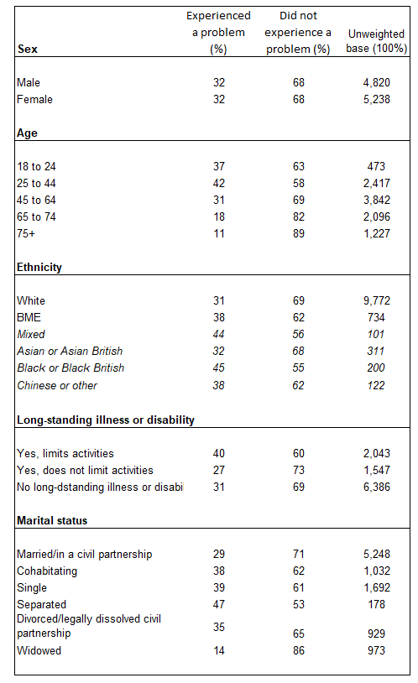

**County Civil and High courts**

6.10. To determine who will be impacted the most by an increase in fees for civil proceedings in county and High courts, we examined data from the Civil Court User Survey (CCUS) 2014-2015.

6.11. The sample for the survey was taken from the HMCTS case management system. An initial sample of 21,334 claims was selected from the number of claims made in May and June 2014.

6.12. During a screening and profiling stage, claims were identified based on whether they were made by a business, an individual or whether they were invalid. Individuals (aged 16 and above) were then required to fill in a questionnaire. The final sample consisted of 2,212 completed questionnaires with a response rate of 26%.

6.13. Before making an assessment, it is important to note the data limitations. The survey was conducted over five years ago and it is possible that the profile of court users has changed over the course of the last few years. However, it is the latest data available on civil county court users and we consider it to be adequate for the purpose of this analysis.

6.14. Another limitation is that the response rate of 26% to the postal survey is low and therefore, the data may not reflect the true views and experiences of the population of court users. However, weighting has been applied to try and correct for any known biases, although it should be kept in mind that there may be unknown biases that may have not been considered.

6.15. Table 4 summarises the results from the survey.

**Table 4: Summary of the demographic profile of individual claimants[1] in May-June 2014, Civil Court User Survey**

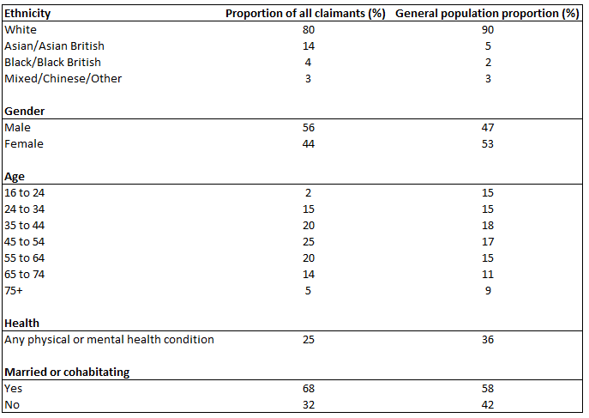

*Note: General population figures are from: Families and Households, 2013; Family Resources Survey 2012-2013; Adult Health in Great Britain, 2013;*

6.16. The survey concludes that, in comparison with the national adult (16+) population profile, individual claimants were more likely to be: male; aged 45 to 54; of Asian ethnicity; self-employed; without health problems; and married or cohabitating.

6.17. To give more context to the results above, we are comparing each group to the general population, not comparing the proportion of each group against each other. For example, claimants from a white ethnic background had the majority of claims at 80%. However, comparing that to the general population, those of white ethnic background make up 90% of the general population, and therefore they are not over-represented in civil courts. By comparison, claimants from an Asian ethnic background make up 14% of all claimants, which is higher than the proportion in the general population of 5%. This indicates that individuals from Asian ethnic backgrounds may be over represented within civil court users. The same logic has been used to make the conclusions detailed above.

6.18. Keeping in mind the data limitations mentioned earlier, the survey findings indicate that individuals with certain protected characteristics (in this case race, age and gender) are likely to be over represented amongst court users. This also assumes that the population and user profile has remained somewhat similar to what it was in 2014-2015. We therefore conclude that men; those of Asian ethnicity; those in the 45 to 54 age band; and those married, or cohabitating may be disproportionately affected by these fee changes.

6.19. The survey does not contain any information on some protected characteristics, such as sexual orientation, religion and belief, gender reassignment, pregnancy and maternity. As a result, we are unable to make any conclusions on whether individuals may be disproportionately affected because of these characteristics.

6.20. However, there is also the possibility that the profile of court users may not be the same as the profile of those affected by the fee change. Out of all claimants in the survey, only 38% paid a fee (mostly specified money and possession claims) - so only a proportion of court users paid a fee; a high proportion of unspecified money claimants had a no win no fee agreement in place and in some cases, somebody else had paid for them or had their court fee waived/reduced. We do not know the specific demographics of those who paid a fee so it is possible that it might not exactly match the profile of court users. While this does not mean that the conclusion should be ignored, it may show that the inflation of fees here may not affect all civil court users in the same way.

**Public Family Law**

6.21. Public family law cases usually involve a local authority making an application for an order to safeguard the welfare of a child. The most common cases are care orders, emergency protection orders, supervision orders and secure accommodation orders. As these fees mainly affect local authorities, the burden of the increase in fees will not fall on individuals with protected characteristics. A breakdown of public family law court users has not been provided as a result.

**Private Family Law**

6.22. A private family law case is when a court deals with family disputes between individuals. This includes, but is not limited to, adoption cases, disputes over a child and matters involving the break-up of a relationship.

6.23. Data is not routinely collected on users of family courts. However, Cafcass (the Children and Family Court Advisory and Support Service) collects data regarding the characteristics of applicants involved in cases regarding children (where Cafcass is involved). We have used this data, for England for the 2018-2019 financial year, as a proxy to understand more about users of family courts, in relation to private family law proceedings. Hence Cafcass data will only be about those families where they are involved in the case due to safe guarding concerns disclosed by the applicant that are then investigated by Cafcass and presented to HMCTS for the court to consider in a safe guarding letter. The data is summarised in Table 6 below.

6.24. Looking at the data, we can see that, when it comes to age, the proportion of applicants aged 18-29 (22%), 30-39 (41%) and 40-49 (26%) were all over-represented in family courts when comparing to the general population (15%, 13% and 13% respectively).

6.25. Male applicants were over-represented (63% of the applicants) when compared to the general population (49%).

6.26. In terms of ethnicity, applicants from a black ethnic background (6%) were over-represented when compared to the general population (3%).

6.27. Applicants were also more likely not to have any disability compared to the general population, as 92% of applicants have reported to not have one, compared to 82% in the general population.

6.28. Regarding religion, individuals with no religion (44%) were over-represented compared to the general population (25%).

6.29. Based on this data, there may be some groups with protected characteristics (in this case, race, age, gender and religion) that are over represented in private family law cases. However, it is worth keeping in mind that this conclusion is based on data that only looks at cases involving children where there are safe guarding concerns. Furthermore, for some protected characteristics, such as religion and ethnicity, there was a large percentage of unknown/unrecorded responses in the data. This needs to be taken into account when making conclusions about these characteristics.

6.30. Data on sexual orientation; marriage and civil partnership; pregnancy and maternity; and gender reassignment was not available.

**Table 6: Cafcass private family law applicant characteristics[2] in England, 2018-2019**

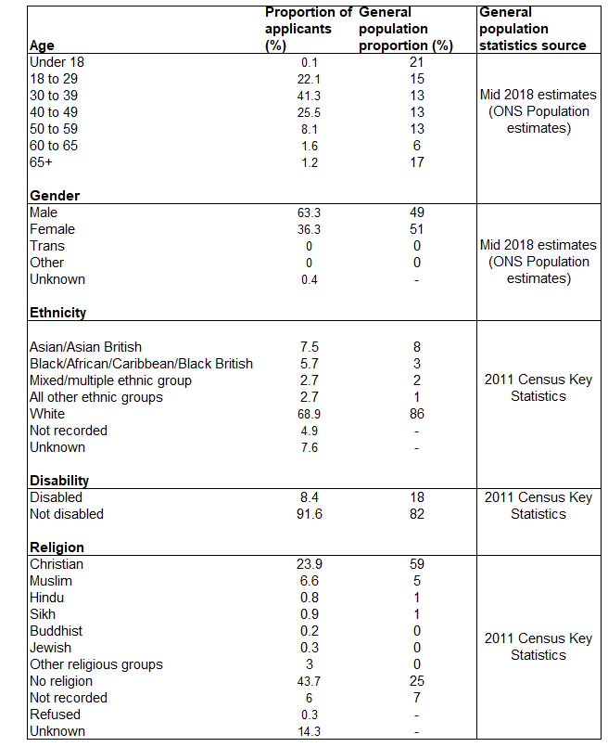

**Divorce**

6.31. Although divorce cases fall under private family law, we believe that it is worth looking at these separately due to the nature of the fees and who they primarily affect.

6.32. According to ONS divorce statistics[3], in 2019, there were 107,599 divorces of opposite sex couples by all decrees. 66,986 (62%) of these were petitioned by women and 40,613 (38%) were petitioned by men. This is in line with the trend from previous years that women make up for the majority of individuals applying for divorce in courts.

6.33. For same-sex couples, in 2019 there were 822 divorces. 589 (72%) were petitioned by female couples and 233 (28%) were petitioned by male couples.

6.34. In terms of age in opposite-sex couples, the average age of men at divorce was 45.3 whereas for women, it was 47.7. For same sex couples, the average age of men at divorce was 40.8 and for women it was 39.5.

6.35. Compared to the general population (excluding people under 18), where men’s average age is 48.1 and women’s is 49.7, the average age for both men and women at divorce was slightly lower for opposite-sex couples whereas for same-sex couples, the averages were substantially lower.

6.36. As a result, we can conclude that an increase in divorce fees will disproportionately affect women, regardless of whether they are in an opposite-sex or same-sex couple. In terms of age, when looking at opposite-sex couples, younger age groups (both men and women) are disproportionately affected. 6.37. Data on some protected characteristics such as race, disability, religion and belief, gender reassignment, pregnancy and maternity were not available. We are unable to make any conclusions on discrimination of individuals with these protected characteristics.

**Magistrates’ courts**

6.39. The majority of civil proceedings in the Magistrates’ Courts will be initiated by public authorities. Some examples include police (applying for football banning orders or sexual harm prevention orders), local authorities (council tax enforcement) and HMRC (forfeiture/seizure orders).

6.40. However, individuals and/or private companies can also bring civil proceedings in Magistrates’ courts. For example, applications for abatement of statutory nuisance, appeals of local authority decisions regarding liquor licensing, and certain family proceedings (particularly regarding child support). Warrants of entry are usually applied for by utility companies.

6.41. Data is not available on the characteristics of individuals paying Magistrates’ court fees; however, as the majority of these fees are paid by organisations rather than individuals, we conclude that the proposed increase to Magistrate court fees should not adversely affect individuals with protected characteristics.

**Court of Protection (CoP)**

6.42. The CoP makes decisions, and appoints representatives, on financial and wellbeing matters for people who cannot make a decision at the time they need to be made (they lack “mental capacity” to do so).

6.43. In the CoP, fees are payable by the person making the application. In many cases, however, the fees are ultimately recoverable from the person the application is about (the protected person).

6.44. When applying for HwF regarding a CoP fee, the person whose finances are assessed depends on what type of application is being made. For applications for a deputyship for property and affairs, the finances of the protected person are assessed. For health and personal welfare deputyship applications, the finances of the person making the application are assessed.

6.45. As CoP fees relating to deputyship may be payable by the protected person, it is likely that CoP fee changes will disproportionately impact those with a disability and/or those of an older age. However, as data is not collected on the characteristics of those paying CoP fees, it is not possible to conclude whether individuals sharing other protected characteristics are likely to be disproportionally affected.

**7. Mitigation**

7.1. The court and tribunal fees remission scheme (HwF) is designed to protect access to justice. Eligibility for a fee remission is based on an individual’s ability to pay, and the scheme is targeted towards those in households on low incomes and those who are in receipt of certain state benefits. Eligibility is also subject to an assessment of the value of the applicant’s disposable capital (e.g. savings) with a higher threshold applying to those aged 61 and over, or those with a partner aged 61 and over.

7.2. Furthermore, in exceptional cases where the applicant does not qualify for HwF and they are not able to pay the fee because it would affect their day-to-day life, the Lord Chancellor’s Exceptional Power (LCEP) is available, at the discretion of court and tribunal delivery managers, to further safeguard access to justice.

7.3. Just as certain fees are proposed to be increased by inflation, the income threshold required for applicants to qualify for a fee remission is also proposed for increase to reflect historical inflation. The proposed thresholds are outlined in Table 7 below.

**Table 7: HwF current and proposed income thresholds (gross monthly values)**

|  |  |  |  |
| --- | --- | --- | --- |
|  | **Single Threshold** | **Couple Premium** | **Child Premium** |
| **Current** | £ 1,085 | £ 160 | £ 245 |
| **Proposed** | £ 1,170 | £ 175 | £ 265 |

7.4. Using the Household Below Average Income (HBAI) data, we are able to compare the HwF income thresholds to the quintile distribution of income for individuals to examine the characteristics of households who may be most likely to be affected by these changes. This is set out in Table 8 below.

7.5. If a household has a gross monthly income below this threshold (or is in receipt of certain benefits), they would automatically quality for a full fee remission. Households might be eligible for a partial remission if their income is above the threshold: £5 is deducted from the fee remission for every £10 of income above the threshold. Households with an income above the current threshold and close to the new threshold will therefore benefit from the proposed changed to HwF.

**Table 8: Gross monthly money values of quintile medians in average 2019/2020 prices (before housing costs)**

|  |  |  |  |  |  |  |
| --- | --- | --- | --- | --- | --- | --- |
|  | Quintile 1 | Quintile 2 | Quintile 3 | Quintile 4 | Quintile 5 | Proposed HwF income threshold |
| Single with no children (1) | £1,055 | £2,205 | £3,088 | £4,104 | £6,271 | £1,170 |
| Single with children (2) | £1,100 | £1,616 | £2,043 | £2,540 | £3,528 | £1,435 |
| Couple with no children | £1,584 | £3,062 | £4,050 | £5,349 | £8,292 | £1,340 |
| Couple with children (3) | £1,240 | £2,087 | £2,839 | £3,846 | £6,499 | £1,605 |
| All individuals | £1,221 | £2,119 | £2,948 | £4,031 | £6,634 |  |

1. *“Single with no children” is an average for men and women.*
2. *“Single with children” – the number of children in this household type will vary, but the HwF thresholds used as a comparator assumes one child in the household*
3. *“Couple with children” – the number of children in this household type will vary, but the HwF thresholds used as a comparator assumes one child in the household.*

*Note: net income has been converted to gross using an online tax calculator[4].*

7.6. The figures in Table 8 are in terms of equivalised income. The HBAI uses net disposable household income which is adjusted for household size and composition as an assessment for material standards of living. This makes comparisons between different household compositions possible. To allow for better comparisons with the HwF income thresholds, the figures have been recalculated in terms of gross income.

7.7. When it comes to households with children, we are unable to make exact comparisons with the HBAI data as it does not specify the average number of children in each family. For the purpose of this analysis, we have presented the HwF thresholds for a household with one child as a comparator; however, if the household has more than one child the threshold will be higher. While this means that we are not able to do a proper like-for-like comparison, the HBAI data does provide information about income distribution by different characteristics. It therefore allows us to get a better understanding of which groups might benefit from the changes to HwF.

7.8. Table 8 shows that the median income for single households with no children and couples with children in quintile 1 was below the current HwF income threshold. A majority of these households would already quality for a full remission and should therefore not be affected by the changes to HwF, or the fee increases.

7.9. However, for both single and couple households with children, the proposed HwF income threshold (assuming one child) lies between the median income for quintile 1 and quintile 2. Individuals at the top of quintile 1 and quintile 2 are therefore most likely to be impacted by the fee changes, but also most likely to benefit from the proposed changes to the HwF scheme, as these households would be more likely to receive either a full remission or a greater partial remission.

7.10. The only exception in this case is for couples with no children. In this case the proposed HwF threshold of £1,340 is lower than the average gross income in quintile 1 of £1,584. For couple households without children, it is those in quintile 1 that are therefore most likely to benefit from the changes to HwF.

7.11. Table 9 below summarises the quintile distribution of income by various characteristics from the HBAI statistics. As households in quintile 1 and quintile 2 have a lower income with which to pay fees, but yet benefit from the increased threshold of the means-test, we examine how the characteristics of these income quintiles compare with the general population.

7.12. Individuals in quintile 1 were more likely to be from either an Asian (32%), Black (31%) or other ethnic background (32%) than a White (18%) or Mixed (23%) ethnic background. They were more likely to live in a household where there is a disabled working age adult (28%) and they are also more likely to be single with children (38%) or a single pensioner (29%), especially a female pensioner (32%).

7.13. The data suggests that individuals in quintile 2 were more likely to be either from an Asian (22%) or Black (24%) ethnic background. They were more likely to be living with a disabled child (29%) as well as being either single with children (35%) or a single pensioner (30%).

7.14. To conclude, the proposed changes to the HwF scheme are likely to be of most benefit to those whose income is above the current HwF income threshold, but close to the new threshold as these individuals will now receive a larger remission than would otherwise have been the case, even with the increases to selected court fees. These individuals would be most likely to be at the top of quintile 1 and in quintile 2, except for couples with no children whose median income in quintile 1 is higher than the proposed HwF income threshold.

7.15. In terms of discrimination, this may have an indirect positive effect on individuals with protected characteristics, in this case, mainly with regards to race, disability and age as these groups of people make up for the majority of quintile 1 and quintile 2.

**Table 9: Quintile income distribution by various characteristics**



**Sex and adulthood**

**8. Conclusion**

8.1. From our analysis, we believe that the proposed increase in court fees will not lead to direct discrimination. These fees will apply to every court user and will not discriminate against individuals because of their protected characteristics.

8.2. However, evidence suggests that there is likely to be over-representation of people with certain protected characteristics amongst court users compared to the general population.

8.3. For both civil and high courts and private family law, the main affected characteristics are gender, age and race.

8.4. For Magistrates’ courts and in public family law proceedings, the main parties affected are organisations rather than individuals. As a result, we do not expect court fee changes to create any meaningful indirect discrimination towards individuals with protected characteristics.

8.5. When looking at divorce, women; and younger age groups will be the most affected by the changes. Data was only available on age and gender. Data on other protected characteristics such as race, disability, pregnancy were not available.

8.6. Changes to fees regarding the Court of Protection are likely to disproportionately impact the elderly and those with a disability, as fees relating to deputyship are paid by the protected person. However, as data is not collected on the characteristics of users in these courts, we are not able to give a definite conclusion as to whether any characteristic is over-represented.

8.7. The proposed changes to the HwF scheme will most likely benefit those whose income is above the current HwF income threshold, but close to the new threshold as these individuals would now receive a larger remission than previously, even with the increases to selected court fees. Based on the data examined, there are certain groups of protected characteristics such as race, disability and age that are likely to be over-represented. Therefore, the proposed changes to the HwF scheme will result in positive impact on individuals with these protected characteristics as they will be the majority of people benefitting.

8.8. Overall, we consider that the fee increases for those over-represented will be unlikely to cause a particular disadvantage through an inability to pay as these changes do not reflect an increase in real terms. These changes constitute a proportionate means of achieving the legitimate aim of ensuring that HMCTS is adequately resourced and taxpayer subsidies are reduced for HMCTS. Furthermore, HwF ensures that access to justice is maintained for those with few savings and who are on a low income or in receipt of certain benefits.

1. Percentages may not add to 100% due to the effects of rounding.
2. Percentages may not add to 100% due to the effects of rounding.
3. https://www.ons.gov.uk/peoplepopulationandcommunity/birthsdeathsandmarriages/divorce/datasets/divorcesinenglandandwales
4. https://www.thesalarycalculator.co.uk/