

Statistical Digest of Rural England
July 2021 Edition
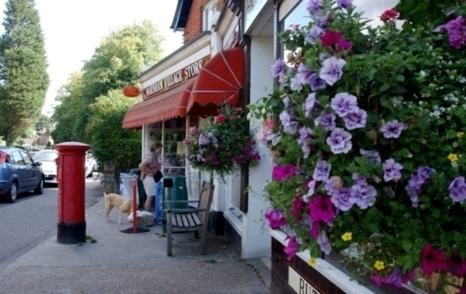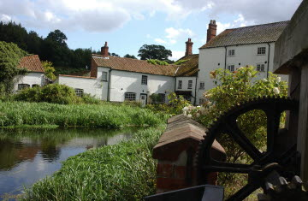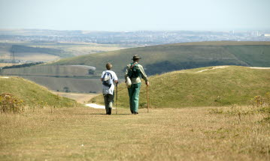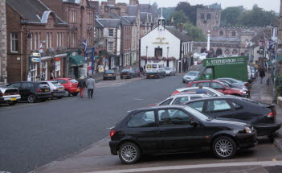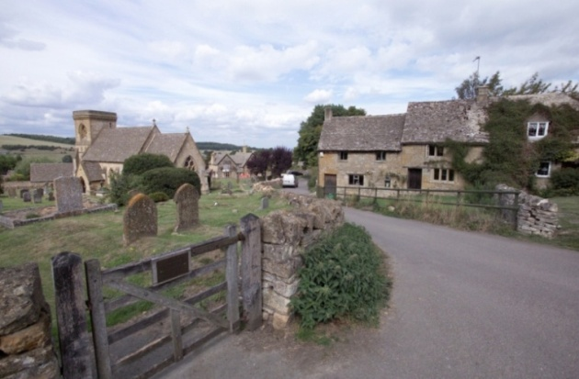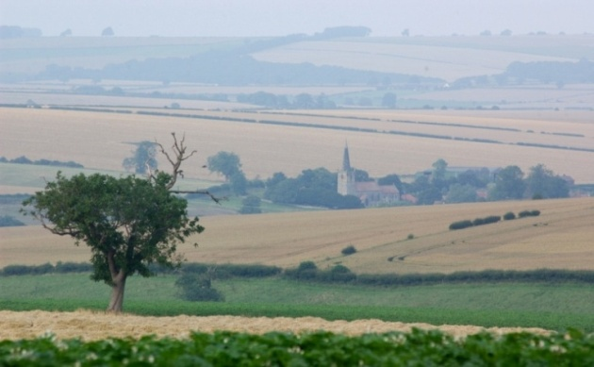

© Crown copyright 2021
You may re-use this information (excluding logos) free of charge in any format or medium, under the terms of the Open Government Licence v.3. To view this licence visit www.nationalarchives.gov.uk/doc/open-government-licence/version/3/ or email PSI@nationalarchives.gsi.gov.uk
This publication is available at www.gov.uk/government/publications
Any enquiries regarding this publication should be sent to us at
rural.statistics@defra.gov.uk
PB14687
www.gov.uk/defra

Contents
Sections of the Digest are updated throughout the year. In this edition the following section(s) have been updated:

- Productivity measured by Gross Value Added (GVA) – industry level analysis
Statistical Digest of Rural England 1
Official Statistics 5
Defining rural areas 6
Rural population and migration 11
Mid-year population 2019 11
Population by age 12
Average age of the population 15
Population change 16
Ethnicity 18
Population at local authority level 19
Internal migration 23
Internal migration by age 25
Rural economy 27
Employment and earnings 27
Employment rate 28
Unemployment rate 29
Economic inactivity 30
Earnings 32
Home working 35
Productivity measured by Gross Value Added (GVA) 38
Contribution to England's Gross Value Added (GVA) 39
Gross Value Added (GVA) per Workforce Job 41
Contribution to England's Gross Value Added (GVA) by Industry 43
Businesses 46
Business composition 46
Businesses by industry type 48
Employment by industry type 52
Businesses by size band 54
Small and medium businesses 56
Business count 63
Business start-ups 64
Innovation and investment 65
Businesses engaged in innovation 65
Capital investment per employee 67
Rural accessibility 69
Transport and travel 69
Distance travelled 70
Trips made 75
Journey to School 77
Accessibility to services 82
Average minimum travel times 83
Access to key services 85
Average number of key services available 87
Overall measure of accessibility of services 89
Broadband 97
Broadband speed 98
Broadband coverage 99
Tourism 102
Gross Value Added (GVA) from Tourism 102
Tourism: business counts and employment 102
Rural living 104
Housing 104
Housing completions 104
Net additions to housing stock 107
Residential housing transactions 108
Additions to affordable housing stock 111
Housing and accommodation affordability 113
Housing affordability 113
Homelessness and temporary accommodation 115
Household expenditure 117
Nominal expenditure and disposable income 117
Expenditure on commodity or service groups 119
Deprivation 122
Poverty 125
Fuel poverty 130
Education and skills 132
Childcare provision 132
Secondary education 137
Pupils leaving school with English and Maths at A* to C grades at GCSE level, based on residency of pupils 137
Pupils leaving school with English and Maths A* to C grades or equivalent at GCSE level, based on Income Deprivation Affecting Children Indices (IDACI) decile and residency of pupils 138
Pupils leaving school with English and Maths at 9 to 4 pass at GCSE level, by Local Authority District areas based on residency of pupils 140
Pupils leaving school with English and Maths A* to C grades or equivalent at GCSE level, based on school location 143
School inspection outcomes, based on school location 144
Higher education 145
Full-time entrants to higher education 145
Part-time entrants to higher education 146
Skills 147
Workplace based skills 147
Residence based skills 151
Apprenticeships 154
Health and Wellbeing 155
Life expectancy 156
Potential years of life lost (PYLL) 158
Infant mortality rate 159
Wellbeing 160
Crime 166
Commercial Victimisation Survey 169
Crime Survey for England & Wales 170

Introduction
The Statistical Digest of Rural Statistics is a collection of statistics on a range of social and economic subject areas. The statistics are split by rural and urban areas, allowing for comparisons between the different rural and urban area classifications. The Digest includes high level statistics which present an overall picture for England. However, there is likely to be considerable variation in individual towns, villages and hamlets.
The Digest starts with a section on the rural and urban populations in England. This is followed by a rural economy section containing indicators on economic activity, earnings, productivity as well as a selection of indicators relating to economic growth. The Rural accessibility section includes data on transport, measuring accessibility to services and broadband. The final section of the Digest includes a selection of rural living statistics on housing, household expenditure, poverty, education, health and crime.
Sections of the Digest are updated throughout the year. In this edition the following section(s) have been updated:
- Productivity measured by Gross Value Added (GVA) – industry level analysis

Official Statistics
These statistics have been produced to the high professional standards set out in the Code of Practice for Official Statistics, which sets out eight principles including meeting user needs, impartiality and objectivity, integrity, sound methods and assured quality, frankness and accessibility.
More information on the Official Statistics Code of Practice can be found at http://www.statisticsauthority.gov.uk/assessment/code-of-practice/index.html.
This publication has been compiled by Rural Evidence (Statistics), within Rural Policy in Defra:
Stephen Hall
Sarah Harriss
Ruth Dickson
Tasmia Choudhury
Fergus Walden
rural.statistics@defra.gov.uk
There is a special Census 2011 version of the Digest which looks at the data from the 2011 census and where possible makes comparisons to the 2001 census results.
This can be found at https://www.gov.uk/government/statistics/2011-census-results-for-rural-england

Defining rural areas
Wherever possible, the Rural-Urban Classification is used to distinguish rural and urban areas. The Classification defines areas as rural if they fall outside of settlements with more than 10,000 resident population.
Census Output Areas - the smallest areas for which data are available from the 2001 and 2011 Censuses - are assigned to one of four urban or six rural categories:

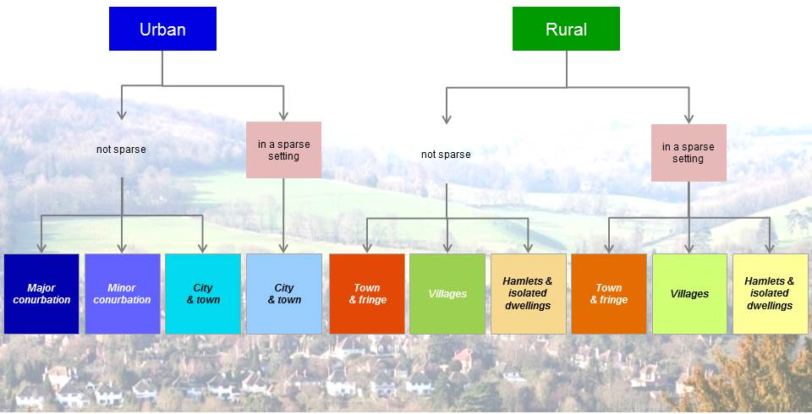

Those described as “in a sparse setting” reflect where the wider area is remotely populated.
A map is shown overleaf.
When data are not available at a small enough geographical scale, it may be possible to apply the Rural-Urban Local Authority Classification. This classification categorises districts and unitary authorities on a six-point scale from rural to urban. It is underpinned by rural and urban populations as defined by the Classification.
However, the Local Authority Classification also considers some urban areas as Hub Towns (with populations of between 10,000 and 30,000). These Hub Towns have met statistical criteria to be considered hubs for services and businesses for a wider rural hinterland and their populations are therefore classified as effectively rural for the purposes of the Local Authority Classification.
Under the classification each Local Authority District is assigned to one of six categories on the basis of the percentage of the total resident population accounted for by the combined rural and Hub Town components of its population and its 'conurbation context'.
The local authority categories are:
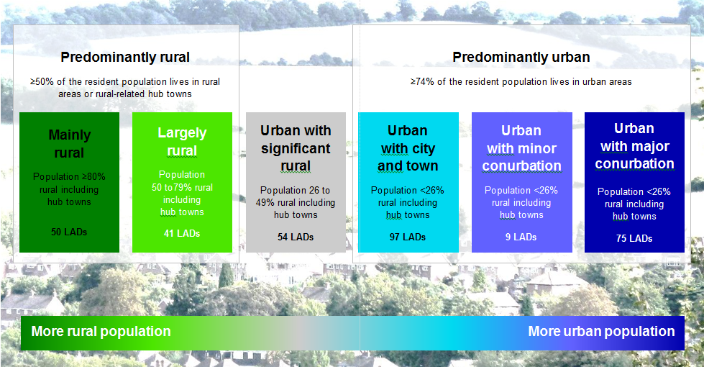

The categories are frequently aggregated to ‘Predominantly Rural’, ‘Urban with Significant Rural’ and ‘Predominantly Urban’ as shown.
It should be noted that the classifications are based on populations and settlement patterns, not on how much countryside there is. Authorities classified as urban may have wide areas of countryside and may have sizeable rural populations. The classification has been made according to the proportions of the population residing in urban settlements and outside urban settlements.
A 2011-based Local Authority Classification was published in December 2014 based on the 2011 Census and the detailed 2011 rural-urban classification of Census Output Areas (published in 2013) and this replaces the previous 2001-based Local Authority Classification. The Digest is not updated in its entirety according to the 2011-based classification. Some sections will refer to the previous 2001-based classification.
The 2011-based Rural Urban Local Authority Classification, or RUCLAD11, has fewer Local Authorities categorised as being Largely or Mainly ‘rural’. This is due to an overall increase in population, plus an expansion of certain settlements and the density of those built up areas. The classification is based on the proportion of people living in settlements defined as ‘rural’ (below 10,000 population), or living in certain ‘hub towns’ (populations between 10,000 and 30,000) that have been identified as having the potential to serve the wider rural areas. The impact of population changes and settlement patterns is that fewer settlements are defined as ‘rural’ when compared with the previous Census, and hence proportionately fewer people are regarded as living in rural areas. In some cases, this means that Local Authorities which were regarded as ‘rural’ in the previous classification are no longer classed as ‘rural’.
The table below shows the 2001-based Local Authority Classification and its categories on the left, and the 2011-based Local Authority Classification 2011 on the right to show how the categories align for comparison of figures.
2001-based Local Authority Classification | Broader classification | 2011-based Local Authority Classification | Broader classification
London | London | London | London
Major Urban | Predominantly Urban excl. London | Urban with Major Conurbation | Predominantly Urban excl. London
Large Urban | Predominantly Urban excl. London | Urban with Minor Conurbation | Predominantly Urban excl. London
Other Urban | Predominantly Urban excl. London | Urban with City and Town | Predominantly Urban excl. London
Significant Rural | Significant Rural | Urban with Significant Rural | Urban with Significant Rural
Rural-50 | Predominantly Rural | Largely Rural | Predominantly Rural
Rural-80 | Predominantly Rural | Mainly Rural | Predominantly Rural
England | England | England | England
More information on the classifications can be found at:
https://www.gov.uk/government/organisations/department-for-environment-food-rural-affairs/series/rural-urban-definition

2011 Rural-Urban Classification for Census Output Areas in England
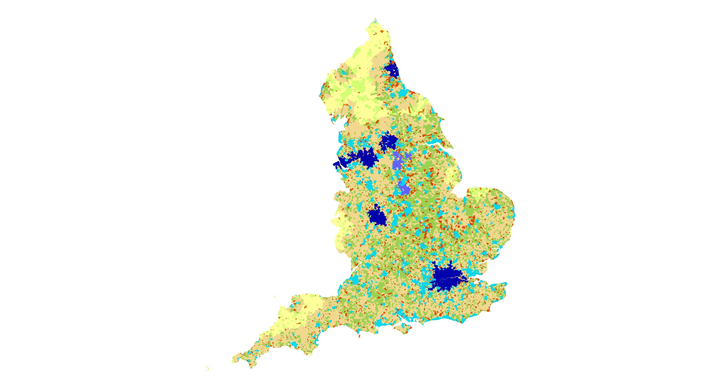
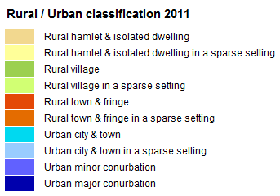

© Crown Copyright and database rights 2021
Ordnance Survey Licence No. 100022861
2011 Rural-Urban Classification for Local Authorities in England

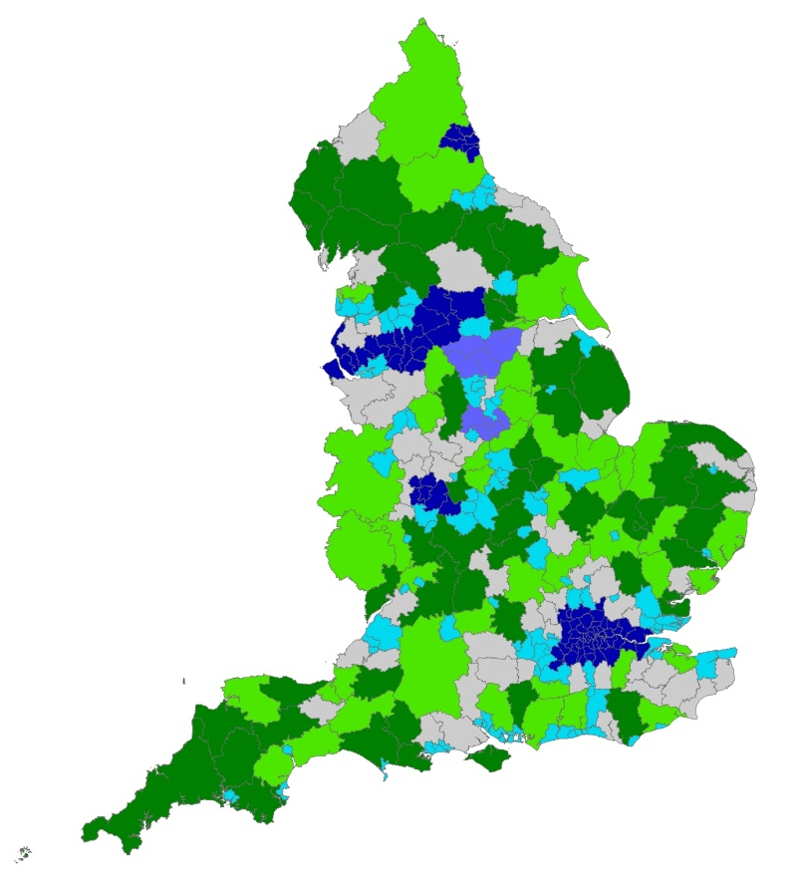

Rural / Urban classification 2011

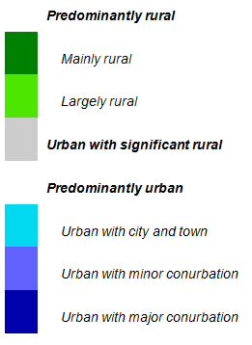

© Crown Copyright and database rights 2021
Ordnance Survey Licence No. 100022861

Rural population and migration

Mid-year population 2019
- In 2019 the mid-year population estimate (based
on Lower Super Output Are as, LSOAs) for England was 56.3 million, of which 9.6 million (17.1 per cent) lived in rural areas and 46.7 million (82.9 per cent) lived in urban areas.
9.6 million people live in rural areas; that is 17% of England’s population
- In 2011 the more detailed Census output area-based rural population was 9.3 million (17.6 per cent) while the mid-year population estimate based on LSOAs was 9.1 million (17.2 per cent). Further explanation can be found in footnote 1
- In comparing population estimates at LSOA level there was an increase in the rural population from 9.1 million in 2011 (LSOA-based) to 9.6 million in 2019 (LSOA-based), however the proportion of the total population has fallen from 17.2 per cent to 17.1 per cent over the same time period, as the urban population has increased at a faster rate.
- Within rural areas, 0.5 million people lived in sparse settings in 2019.
2019 Mid-year population estimates
 | Population | Proportion (%)
Rural | 9,608,200 | 17.1
Rural Town and Fringe | 5,202,300 | 9.2
- those in a sparse setting | 197,200 | 0.4
Rural Village and Hamlet | 4,405,900 | 7.8
- those in a sparse setting | 303,400 | 0.5
Urban | 46,678,700 | 82.9
Urban Major Conurbation | 20,193,000 | 35.9
Urban Minor Conurbation | 2,018,500 | 3.6
Urban City and Town | 24,467,200 | 43.5
- those in a sparse setting | 91,700 | 0.2
England | 56,287,000 | 100.0

- 9.6 million people, or 17.1 per cent of the population, lived in rural areas in 2019.
- Around 500,600 people, or 0.9 per cent of the population lived in rural settlements in a sparse setting.
- A further table of the mid-year population estimates broken down by detailed rural-urban classification covering 2012 to 2019 is available in the rural living supplementary data tables.

Population by age
Percentage of population within age bands by rural-urban classification (LSOA) in England, 2019
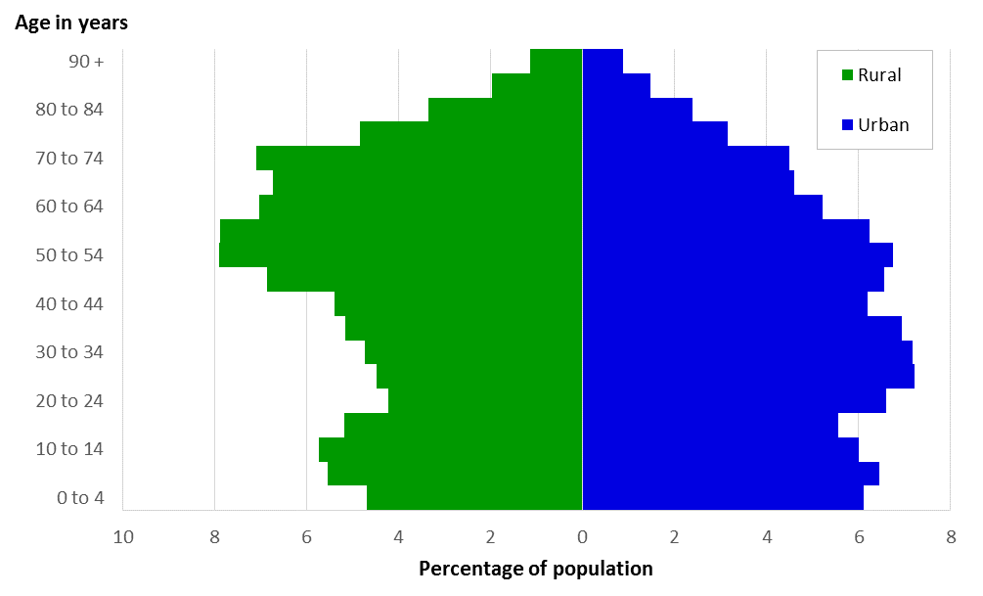

- The population in rural areas has a higher proportion of older people compared with urban areas.
- In 2019, the most prominent age groups in rural areas are ‘50 to 54’ and ‘55 to 59’ with 7.9 per cent of the rural population, while the most prominent age groups in urban areas are ‘25 to 29’ and ‘30 to 34’ with 7.2 per cent of the urban population.
- A table of 2019 mid-year population estimates broken down by age band and detailed rural-urban classification is available in the rural living supplementary data tables.
Percentage of population aged 65 and over by rural-urban classification (LSOA) in England, 2019
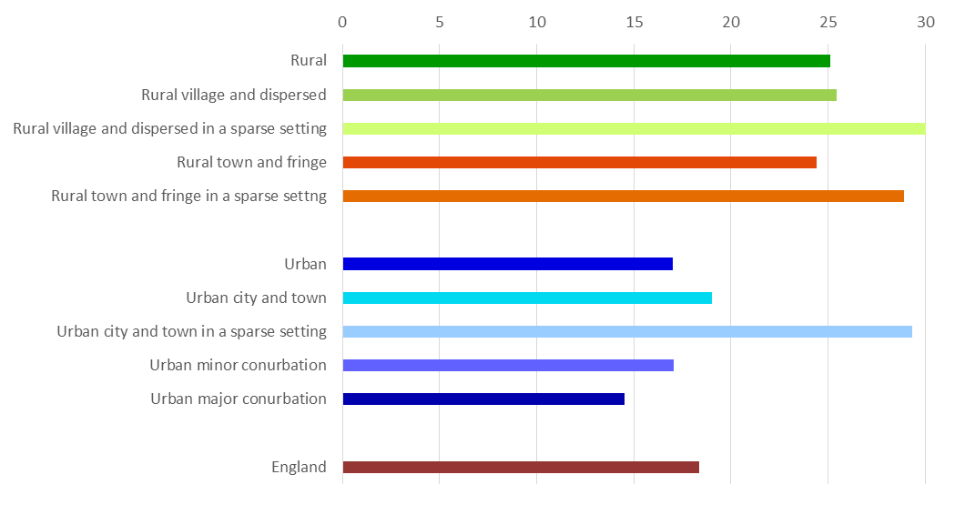
- The rural population has a higher proportion of those aged 65 and over, at 25.1 per cent, compared with the urban population where 17.0 per cent are 65 and over.
25.1% of the rural population is aged 65 or over
17.0% of the urban population is aged 65 or over

- The population of areas in a sparse setting have the highest proportion of those aged 65 and over, in particular settlements that are Rural Village and Dispersed in a sparse setting have 30.2 per cent of the population aged 65 and over.
Population aged 65 and over as a percentage of total 2019 mid-year population
 | Population aged 65 and over | Proportion aged 65 and over (%)
Rural | 2,415,400 | 25.1
Rural town and fringe | 1,221,600 | 24.4
- those in a sparse setting | 57,000 | 28.9
Rural village and hamlet | 1,045,100 | 25.5
- those in a sparse setting | 91,600 | 30.2
Urban | 7,938,300 | 17
Urban major conurbation | 2,933,400 | 14.5
Urban minor conurbation | 344,600 | 17.1
Urban city and town | 4,633,400 | 19
- those in a sparse setting | 26,900 | 29.3
England | 10,353,700 | 18.4

Maps showing the geographic relationship between the rural and urban populations at lower super output area level (LSOA) and areas where the percentage of population of over 65-year olds are most concentrated
Lower super output area classification of England (2011) Percentage of population over the age of 65 years (2019)
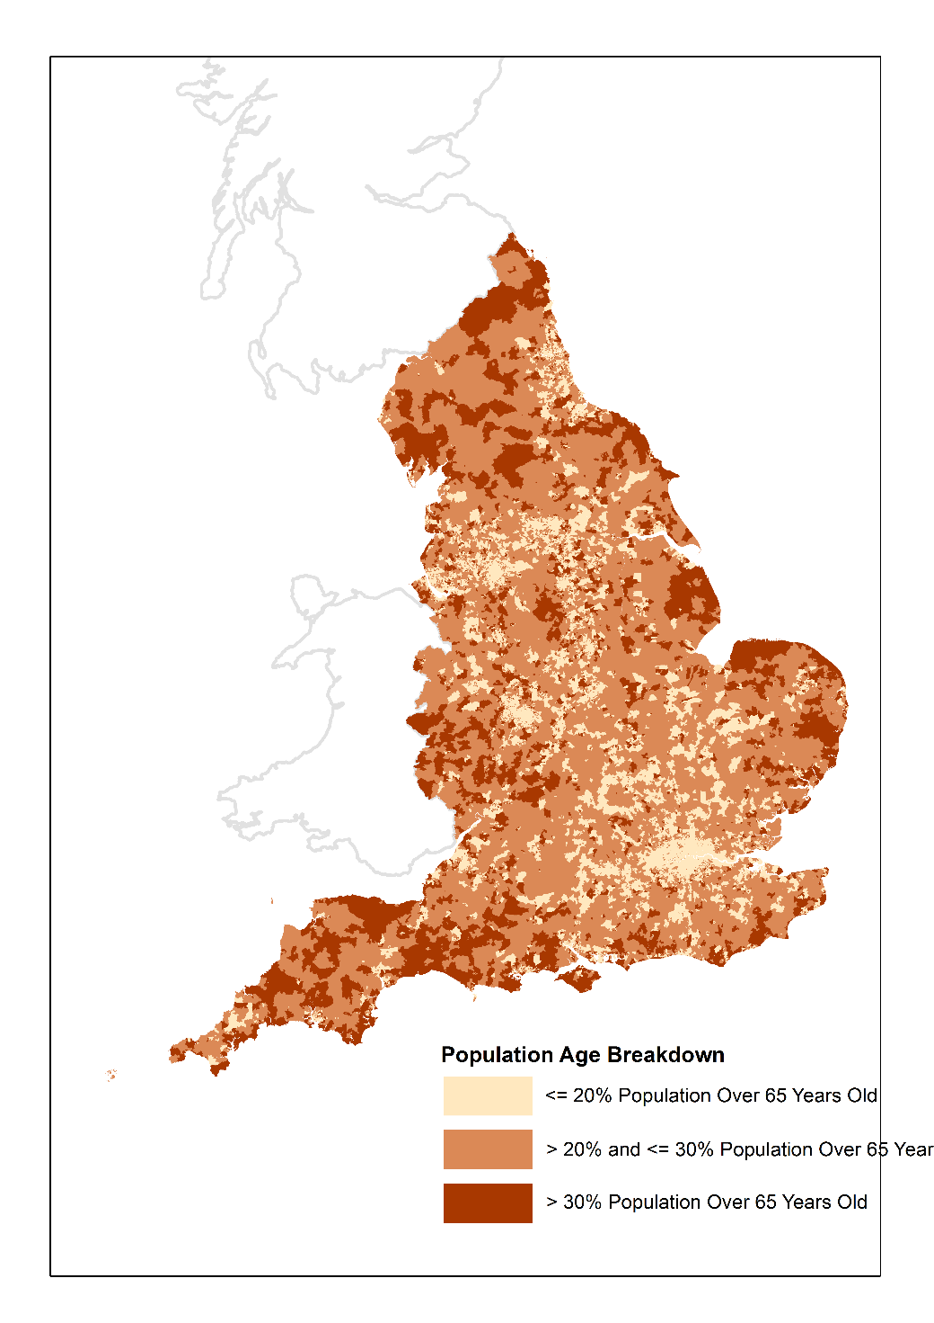
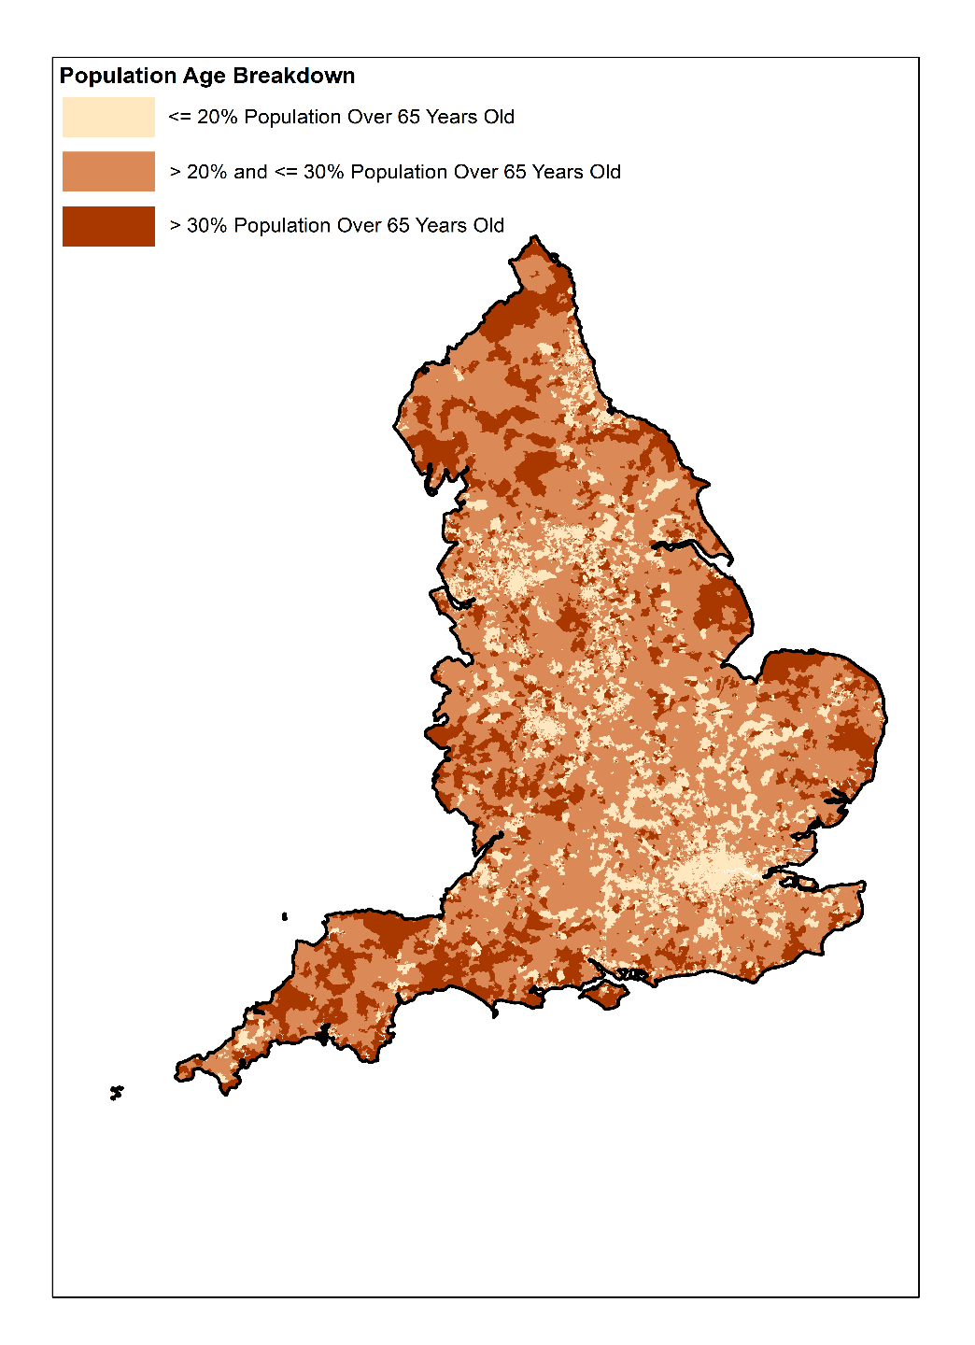
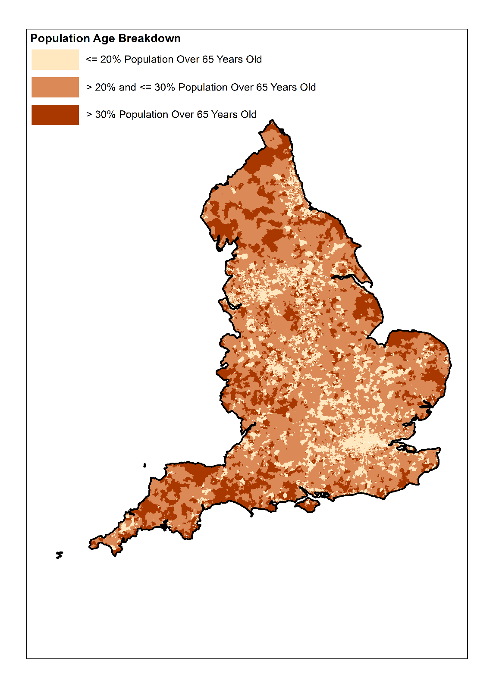

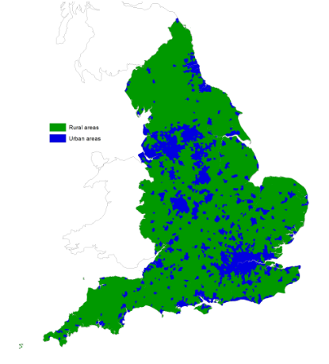
Source: ONS, Defra , RUC2011 Source: ONS, Defra, Mid-year population estimates for 2019 at LSOA level
© Crown Copyright and database rights 2021, Defra, No. 10002286

Average age of the population
Average age in rural and urban areas in England, 2002 to 2019
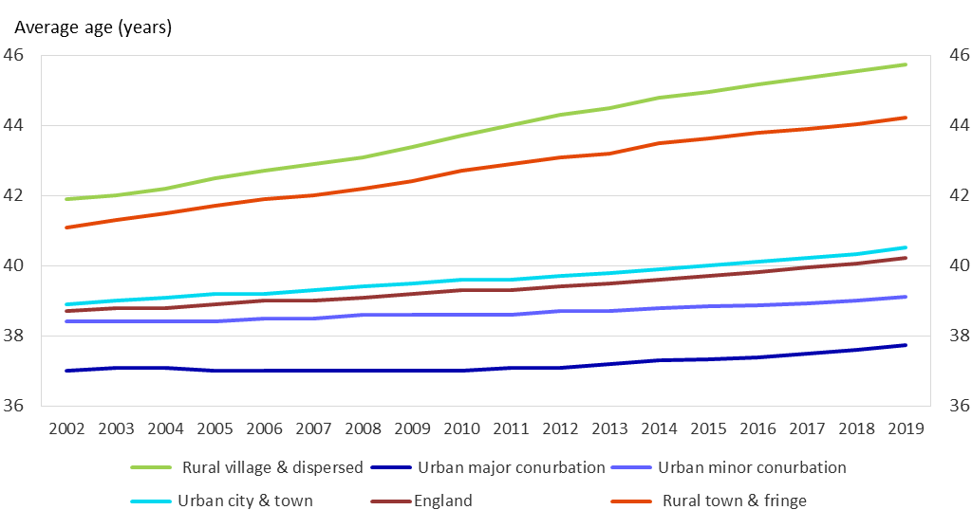
- The average age in rural areas is higher and has increased faster than in urban areas.
- In 2019, the average age of the population in Rural Village and Dispersed areas was 45.7 years and in Rural Town and Fringe areas it was 44.2 years, compared with the average for England of 40.2 years.
- The average age was lowest in Urban with Major Conurbations at 37.7 years.
- The average age in rural areas was 44.9 years in 2019, 5.7 years older than in urban areas. The gap in average ages between rural and urban areas widened from 3.4 years in 2002.
- The average age in England increased by 1.5 year between 2002 and 2019, but in Rural Town and Fringe areas it increased by 3.1 years and in Rural Village and Dispersed areas by 3.8 years.
- A table of average age broken down by detailed rural-urban classification covering 2002 to 2019 is available in the rural living supplementary data tables.

Population change
Index of population change, 2011 to 2019, 2011 = 100
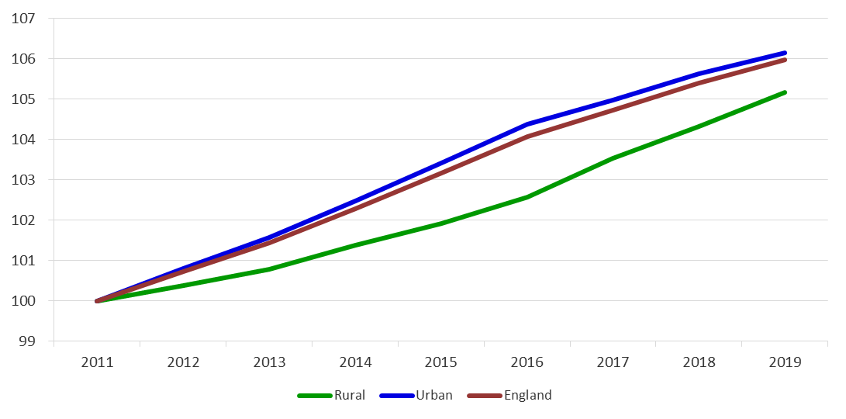

Index of population change in rural areas, 2011 to 2019, 2011 = 100
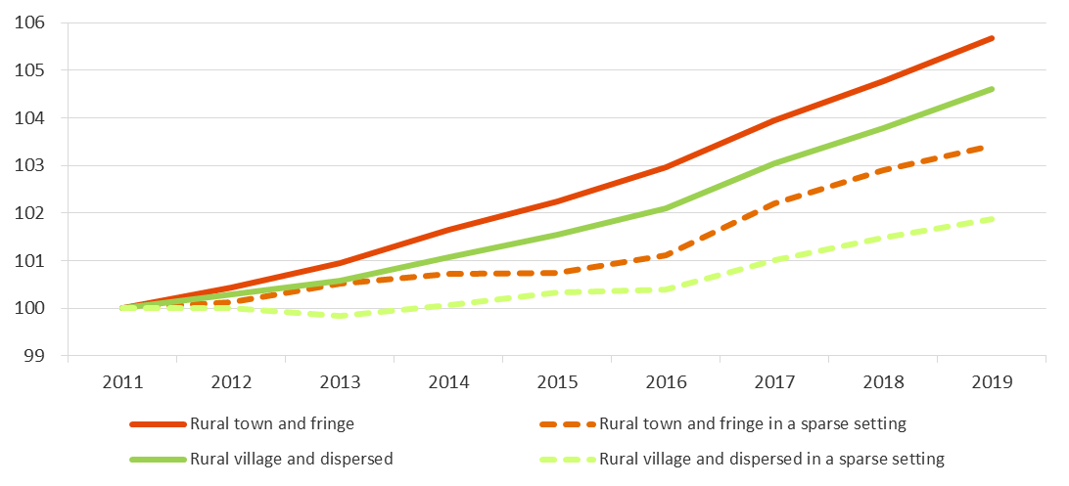
- Both rural and urban areas have seen an increase in overall population between 2011 and 2019. Rural has increased by 5.2 per cent and urban by 6.2 per cent.
- Within rural areas, the greatest rate of population increase was in Rural Town and Fringe areas (5.7 per cent), within urban areas it was in Urban with Major Conurbation (6.9 per cent).
- Rural Villages and Hamlets in sparse settings showed the smallest rate of population increase within rural areas (1.9 per cent), in urban areas it was Urban with City and Town in a sparse setting (1.2 per cent).
- A table of indexed population change broken down by detailed rural-urban classification covering 2012 to 2019 is available in the rural living supplementary data tables.

Ethnicity
- Overall, ‘white’ is the majority ethnic group in both rural and urban areas, however urban areas are more ethnically diverse than rural areas.
- In 2019, the ‘white ethnic’ group accounted for 97.1 per cent of the rural population, compared with 81.0 per cent in urban areas.
- The proportion of ‘minority ethnic’ groups has risen slightly over the last 5 years in both rural and urban areas, rising by 0.8 and 1.4 percentage points respectively since 2015.
- Diversity of ‘minority ethnic’ groups differs between rural and urban areas. The ‘Asian ethnic’ group is the second largest group in both rural and urban areas, however in rural areas proportionally more of the ‘minority ethnic’ group population are of ‘mixed race’ and ‘Chinese, Arab and other’ origin than in urban areas, while urban areas have a proportionally greater ‘black, African, Caribbean or black British’ population in the ‘minority ethnic’ group population.

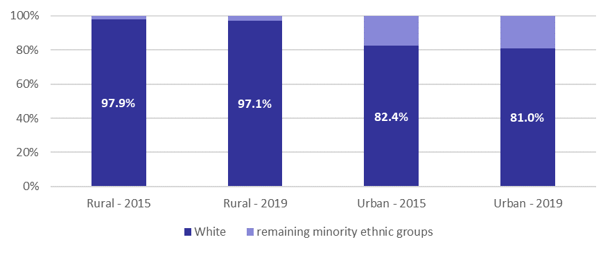
Ethnic groups as a percentage of population in rural and urbans areas, England, 2015 and 2019

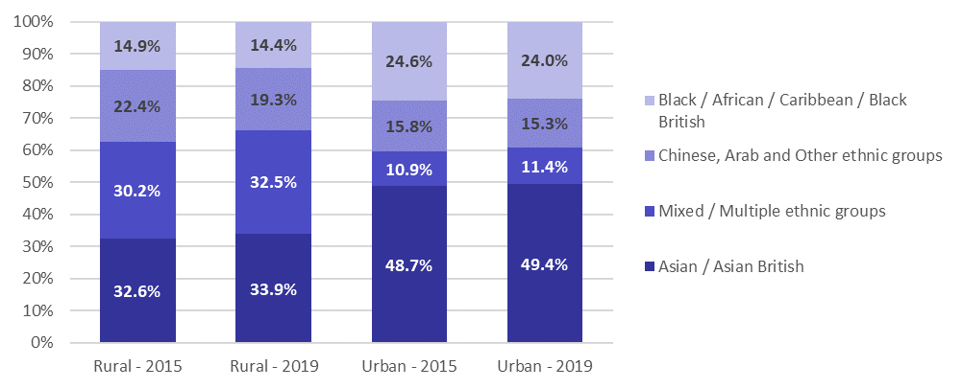
Detail for all minority ethnic group population in rural and urban areas, England, 2015 & 2019

- Ethnic diversity decreases the more sparsely populated the area is. In 2019 ‘minority ethnic’ groups accounted for 1.0 per cent of those in rural areas in a sparse setting.
- Tables detailing ethnic groups in rural and urban areas in 2015 and 2019, and a more detailed rural-urban breakdown for 2019 are available in the rural living supplementary data tables.

Source: Office for National Statistics, Labour Force Survey, via Annual Business Inquiry (abi2@ons.gov.uk)

Population at local authority level
Often statistics have to be compiled at the local authority level, when that is the level of the original data, and the rural urban classification for local authorities is used, as defined by April 2020 Local Authority boundaries.

This is different from looking at the population using the more detailed rural-urban classification as it is based on whole local authorities. The whole population in an authority will be attributed to the class assigned to the authority. So an authority that is Mainly Rural or Largely Rural and hence classed as Predominantly Rural will have the whole population counted as being in a Predominantly Rural area, even those living in an urban settlement within that authority, while all those living in a rural area but within an authority classed as Urban with Significant Rural or Predominantly Urban will not be counted in the Predominantly Rural figure.

- In 2019, 12.1 million people lived in a Predominantly Rural area, 21.6 per cent of the England population.
- 52 per cent of the population in Predominantly Rural areas are over the age of 44, which is the same as in 2018.
- In comparison, 40 per cent of the population in Predominantly Urban areas are over the age of 44, which is the same as in 2018 as well.
- The population in Predominantly Rural areas has increased by 5.9 per cent between 2011 and 2019, compared with 6.0 per cent for England as a whole and 6.2 per cent in Predominantly Urban areas.
- However, it is longer-term comparisons that highlight significant shifts in the age structure. Comparisons have been made between 2001 and 2015 to show this.
- Predominantly Rural areas have proportionately seen large falls in the population aged 30 to 39 and higher proportional increases in the older population.
- The population aged 65 and over increased by 37 per cent in Predominantly Rural areas between 2001 and 2015, compared with 17 per cent in Predominantly Urban areas.
- Predominantly Rural areas have seen an increase of 7 per cent in infants (0 to 4-year olds) compared with a 22 per cent increase in Predominantly Urban areas.
2019 Local Authority population estimates
 | Population | Proportion (%)
Mainly Rural | 4,692,000 | 8.3
Largely Rural | 7,448,000 | 13.2
Urban with Significant Rural | 6,940,000 | 12.3
Urban City and Town | 14,786,000 | 26.3
Urban Minor Conurbation | 2,217,000 | 3.9
Urban Major Conurbation | 20,204,000 | 35.9
Predominantly Rural | 12,140,000 | 21.6
Predominantly Urban | 37,207,000 | 66.1
England | 56,287,000 | 100

- Further tables broken down by detailed local authority rural-urban classification covering 2011 to 2019 and broken down by age band for 2019 are available in the rural living supplementary data tables.
The charts below show longer-term changes in the populations for Predominantly Rural and Predominantly Urban areas, by age band, comparing 2001 and 2015.

Population in Predominantly Rural and Predominantly Urban areas by age bands, 2001 and 2015, England
(scales in the charts differ and so are not directly comparable)
Predominantly Rural areas : Predominantly Urban areas:

- A table broken down by broad local authority rural-urban classification and age bands for both 2001 and 2015 and the change between the two years is available in the rural living supplementary data tables.
Population in Predominantly Rural and Predominantly Urban areas by age bands, 2001 and 2015, England
(combined chart showing rural and urban at the same scale)

A table broken down by broad local authority rural-urban classification and age bands for both 2001 and 2015 and the change between the two years is available in the rural living supplementary data tables.
Percentage change in population in Predominantly Rural and Predominantly Urban areas by age bands, between 2001 and 2015, England
Predominantly Rural areas : Predominantly Urban areas:
A table broken down by broad local authority rural-urban classification and age bands for both 2001 and 2015 and the change between the two years is available in the rural living supplementary data tables.

Internal migration
In the analysis presented below internal migration refers to population migration occurring between local authorities within the UK and the outcome is shown for local authorities in England, including the results of migration to and from the rest of the UK. Migration between the same class of authority will have no net effect on the population for that class and is excluded.

As the analysis is using data for local authority areas, it does not distinguish the type of settlement a migrant has moved to. So, in the case of migration to an authority classed as a Predominantly Rural area this could be migration to an urban settlement within that authority. Similarly, migration to an authority classed as a Predominantly Urban area could be migration to a rural settlement within that Predominantly Urban area.
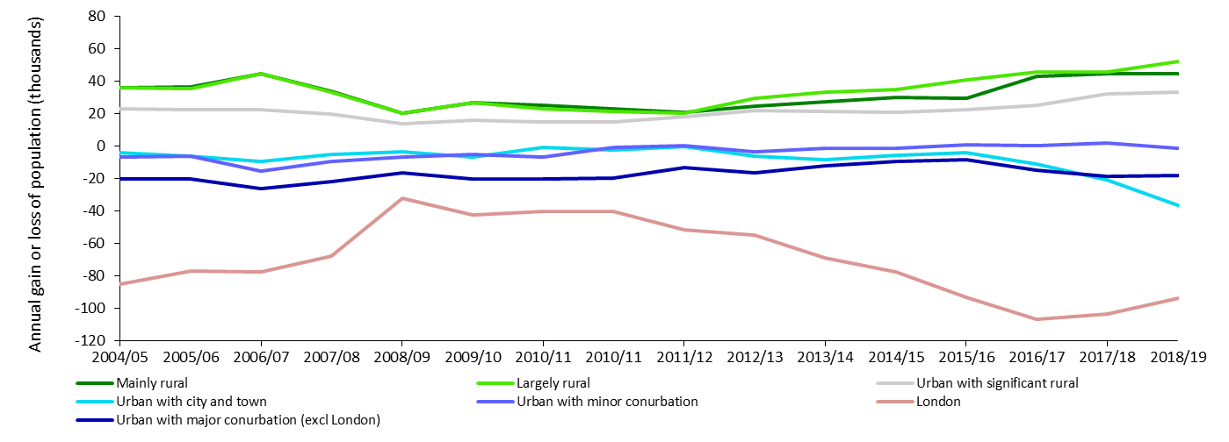
Internal migration, England, 2004/05 to 2018/19
Net outward migration
Net inward migration
Note: The RUC01 for Local Authorities has been applied to all data up to 2009/10. Data for 2010/11 has been classified using both RUC01 and RUC11 to show the comparison. From 2011/12 onwards the RUC11 for Local Authorities has been applied.
- Between 2004/05 and 2008/09 the general trend for internal migration in England was for net migration to Predominantly Rural areas and net migration from Predominantly Urban areas, although the extent of net migration to Predominantly Rural areas was falling.
- Since 2008/09 there has been an increase in the rate of net migration to Predominantly Rural areas.
- For 2018/19 in Predominantly Rural areas there was net internal migration inwards of 96,700 people. Within that Largely Rural areas saw net internal migration inwards of 52,300 people and Mainly Rural areas saw net internal migration inwards of 44,400 in 2018/19 (which would include migration between these two categories).
- In contrast, for Predominantly Urban areas there was net internal migration outwards of 149,700. This included net internal migration outwards from London of 93,600 (including to other Predominantly Urban areas).
- A table of internal migration figures broken down by detailed local authority rural-urban classification covering 2004/05 to 2018/19 is available in the rural living supplementary data tables.
The table below provides a matrix of the internal (within UK) migration movements between the different classes of authority in 2018/19.
Internal (within UK) migration between different classes of authority, 2018/19
 | Inward |  |  |  |  | thousands
Outward | Predominantly Rural | Urban with Significant Rural | Predominantly Urban | Rest of the UK | Total outwards | Net migration
Predominantly Rural |  | 72.5 | 286.4 | 27.7 | 386.6 | -96.7
Urban with Significant Rural | 89.5 |  | 196.4 | 17.1 | 303.0 | -33.0
Predominantly Urban | 370.7 | 249.7 |  | 77.7 | 698.1 | 149.7
Rest of the UK | 23.1 | 13.7 | 65.6 |  | 102.4 | -20.0
Total inwards | 483.3 | 336.0 | 548.4 | 122.4 |  | 0.0
Note: excludes migration within the same class of authority

Net internal (within UK) migration between Predominantly Rural and Predominantly Urban areas and other classes of authority
 | thousands |  |  | thousands
Urban with Significant Rural | 17.0 |  | Predominantly Rural | -84.3
Predominantly Urban | 84.3 |  | Urban with Significant Rural | -53.4
Rest of the UK | -4.6 |  | Rest of the UK | -12.0
Net migration for Predominantly Rural areas | 96.7 |  | Net migration for Predominantly Urban areas | -149.7

- In 2018/19 Predominantly Rural areas saw net migration from Predominantly Urban areas of 84,300 people (370,700 inwards less 286,400 outwards), and from Urban with Significant Rural areas of 17,000 people (89,500 inwards less 72,500 outwards). There was a net outward migration from Predominantly Rural areas to the rest of the UK of 4,600 people (23,100 inwards less 27,700 outwards).
- Net inward migration to Predominantly Rural areas in 2018/19 increased the Predominantly Rural population by 0.8 per cent, compared with a 0.4 per cent increase in 2010/11.
- Net outward migration from Predominantly Urban areas in 2018/19 reduced the Predominantly Urban population by 0.4 per cent, compared with a 0.2 per cent reduction in 2010/11.

Notes: Internal migration is defined as residential moves between local authorities. Moves within a single local authority are excluded, as are international moves into or out of the UK. These statistics are based on a combination of administrative data and represent the best available source of information on internal migration. Further information on the data sources and methods, and their limitations, is available via the ONS internal migration methodology webpage (www.ons.gov.uk/ons/guide-method/method-quality/specific/population-and-migration/internal-migration-methodology/index.html).
Source: Defra analysis of ONS data - Annual internal Migration within the United Kingdom to June 2019. www.ons.gov.uk/peoplepopulationandcommunity/populationandmigration/migrationwithintheuk/datasets/internalmigrationbyoriginanddestinationlocalauthoritiessexandsingleyearofagedetailedestimatesdataset

Internal migration by age
- For some years there has been net internal migration (within the UK) inwards to Predominantly Rural areas. This has been the case across all age bands except for 17 to 20-year olds. In 2018/19 within the overall net internal migration to Predominantly Rural areas of 96,700, there was net internal migration outwards of 17 to 20 years olds of 38,000.


- Net outward migration of 17 to 20 years olds can be anticipated as these are the ages when students are most likely to move from home for higher education, with the likelihood that higher education establishments will be mostly found in the more urban areas.
In 2018/19 net migration of 17 to 20-year olds = 38,000

- The pattern of inward migration to Predominantly Rural areas has been consistent from at least 2011 onwards (the earliest year currently analysed by age band).
Net internal (within the UK) migration for Predominantly Rural and Predominantly Urban areas, by age band, mid-year 2019, England
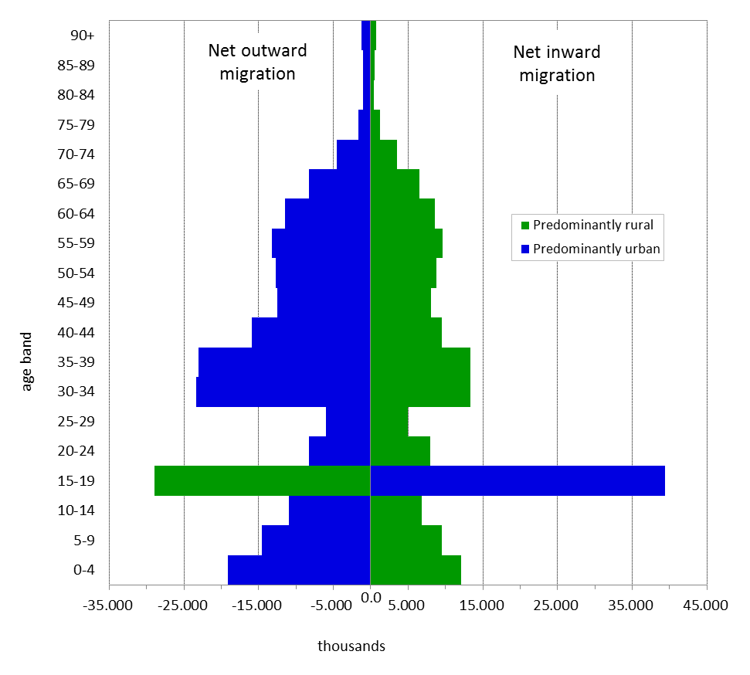

Net internal migration (within UK) to Predominantly Rural areas by age bands, mid-year 2011 to mid-year 2019, England
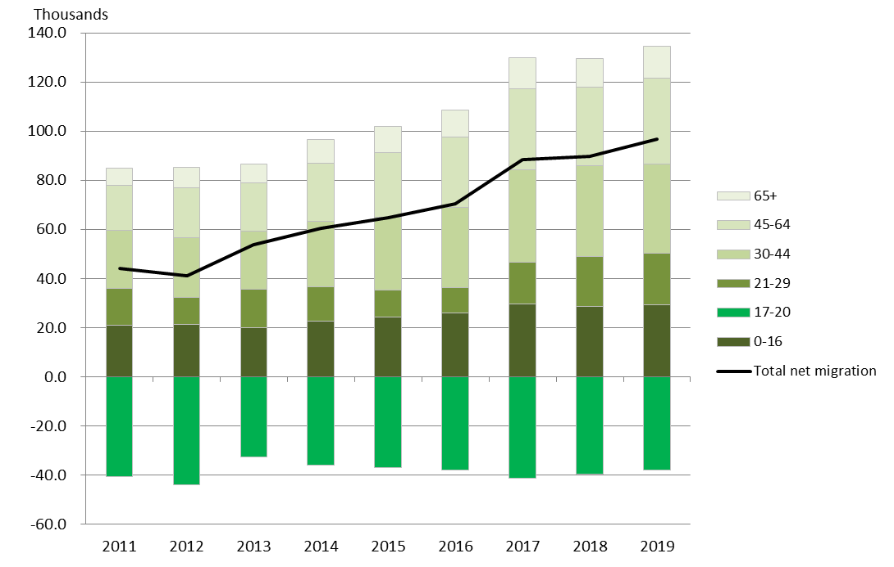

- Breaking the migration patterns down to equal 5-year age bands, in 2018/19 there was net outward migration for 15 to 19-year olds from Predominantly Rural areas of 29,000 which would include, as above, students moving elsewhere for higher education. For the 20 to 24-year old age bracket the pattern of movement reverts to net inward migration of 7,900 to Predominantly Rural areas. There was net inward migration for 25 to 29-year olds of around 5,000.
- The largest net inward migration to Predominantly Rural areas for adults occurred for 30 to 34-year olds (13,400 people) and 35 to 39-year olds (13,300 people). Net inward migration for the age bands from 40 to 44-year olds - 65 to 69-year olds, was between 6,500 and 9,600 people for each five-year age band.
- Migration occurred between Predominantly Rural areas and Urban with Significant Rural areas and the rest of the UK, but the largest net inward migration to Predominantly Rural areas was from Predominantly Urban areas. Not surprisingly, the opposite migration patterns were therefore seen for Predominantly Urban areas. Indeed, for most age bands the equivalent opposite net migration was greater, reflecting migration also occurring between Predominantly Urban areas and Urban with Significant Rural areas and the rest of the UK.
- A table of internal migration figures for rural areas broken down by broad age bands covering 2011 to 2019 is available in the rural living supplementary data tables. A table using more detailed age bands is also available broken down by broad local authority rural-urban classification for 2019.

Notes: Internal migration is defined as residential moves between local authorities. Moves within a single local authority are excluded, as are international moves into or out of the UK. These statistics are based on a combination of administrative data and represent the best available source of information on internal migration. Further information on the data sources and methods, and their limitations, is available via the ONS internal migration methodology webpage (www.ons.gov.uk/ons/guide-method/method-quality/specific/population-and-migration/internal-migration-methodology/index.html)
Source: Defra analysis of ONS data - Annual internal Migration within the United Kingdom to June 2019. www.ons.gov.uk/peoplepopulationandcommunity/populationandmigration/migrationwithintheuk/datasets/internalmigrationbyoriginanddestinationlocalauthoritiessexandsingleyearofagedetailedestimatesdataset

Rural economy

Employment and earnings
- Employment: The percentage of working age people in employment (employment rate) in 2019 was 75 per cent in urban settlements and 79 per cent in rural settlements. This employment rate is based on where people live and not where they work. People living in rural settlements may travel to work in larger urban settlements and vice versa for urban residents.
- Unemployment: The percentage of economically active people age 16 and over who were unemployed (unemployment rate) in 2019 was 4.2 per cent in urban settlements and 2.6 per cent in rural settlements.
- Economic inactivity: The percentage of working age people who are not available for work or not seeking work (economic inactivity rate) in 2019 was 21 per cent in urban settlements and 19 per cent in rural settlements.

Employment as a percentage of working age population (age 16 to 64 years), in rural areas of England, 2015 to 2019
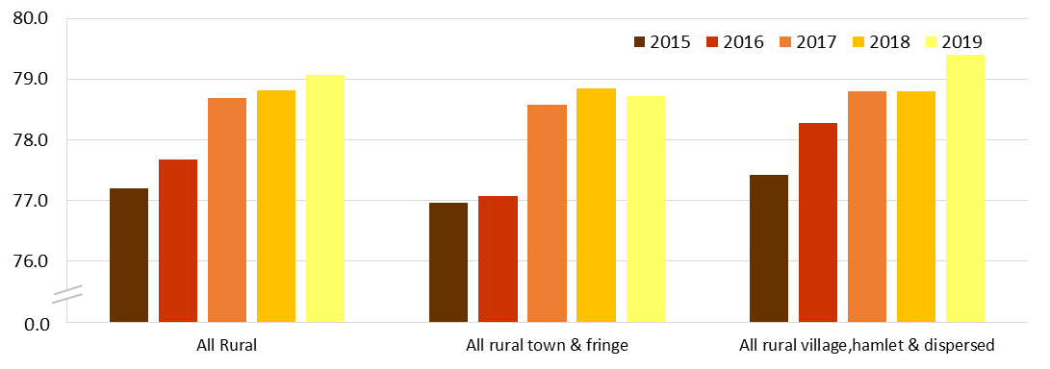

Unemployment as a percentage of economically active age 16 and over (age 16+), in rural areas of England, 2015 to 2019

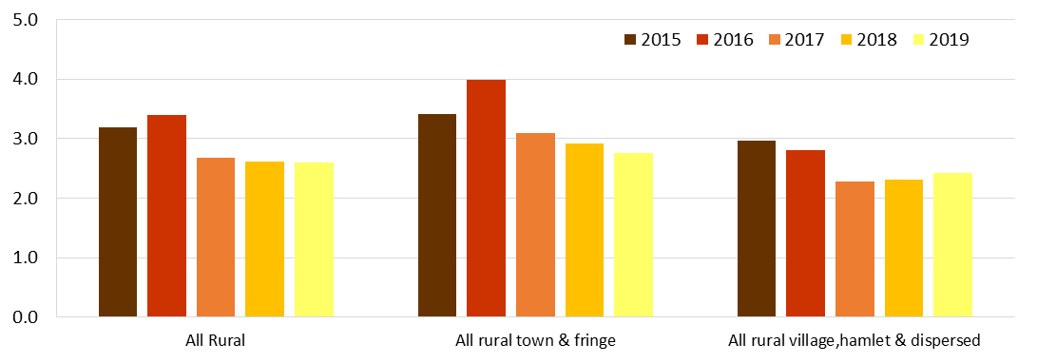

Employment rate
Employment as a percentage of working age population (age 16 to 64 years), by rural-urban classification in England, 2019
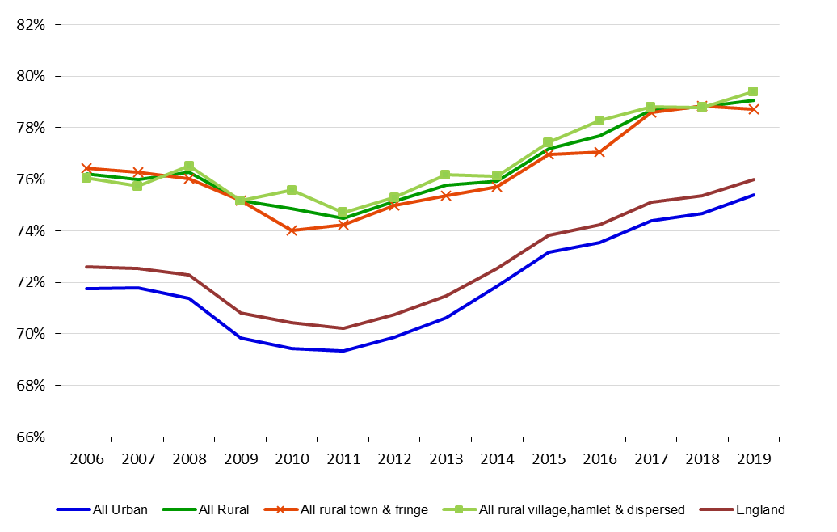
- The employment rate in 2019 was higher in all types of rural areas compared with urban areas with an average employment rate of 79.1 per cent for All Rural areas.
- The overall employment rate for the working age population in England has steadily increased year-on-year since 2011. In 2019 the employment rate for England is 76.0 per cent.
- The latest England employment rate for May to July 2020 was 77.0 per cent, up 0.2 percentage points from February to April 2020 and up 0.5 percentage points on a year earlier1a. It is not yet possible to analyse these later figures in terms of settlement type.
- The most recent figure available for rural employment is 78.3 per cent for April to June 2020, which covers the initial period of Covid-19 and the national lockdown.1b

Percentage of working age population (age 16 to 64 years) who are employed, by rural-urban classification in England, 2011 to 2019
 | 2011 | 2012 | 2013 | 2014 | 2015 | 2016 | 2017 | 2018 | 2019
All Urban | 69.3 | 69.9 | 70.6 | 71.9 | 73.2 | 73.6 | 74.4 | 74.7 | 75.4
All Rural | 74.5 | 75.1 | 75.8 | 75.9 | 77.2 | 77.7 | 78.7 | 78.8 | 79.1
those in a sparse setting | 72.2 | 74.1 | 75.4 | 73.0 | 76.5 | 77.4 | 78.2 | 75.8 | 78.5
All rural town & fringe | 74.2 | 75.0 | 75.4 | 75.7 | 77.0 | 77.1 | 78.6 | 78.8 | 78.7
All Rural Village & hamlets | 74.7 | 75.3 | 76.2 | 76.1 | 77.4 | 78.3 | 78.8 | 78.8 | 79.4
England | 70.2 | 70.8 | 71.5 | 72.5 | 73.8 | 74.2 | 75.1 | 75.4 | 76.0
See note 2 for an explanation of Rural Urban Classification and its application to the analysis
Data table is also available in ODS format in the rural economy supplementary data tables.

Unemployment rate
Unemployment as a percentage of economically active age 16 and over (age 16+), by rural-urban classification, in England, 2006 to 2019
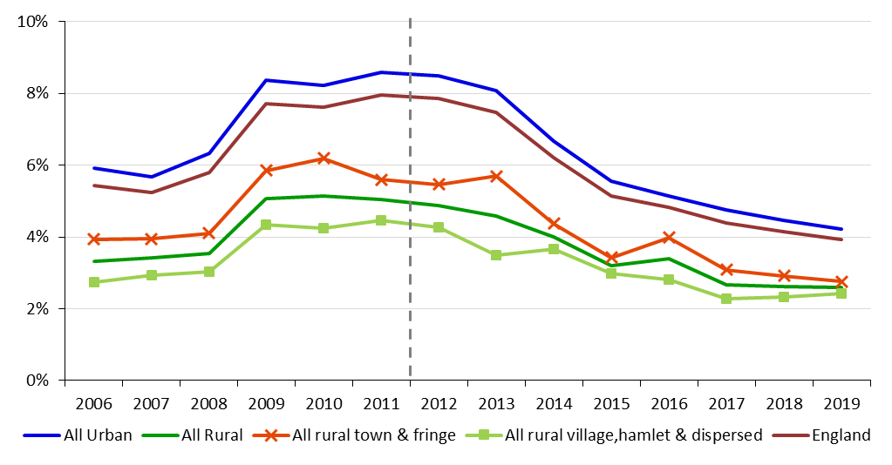
Note: The RUC01 has been applied to all data up to and including 2010. From 2011 onwards the RUC11 has been applied.

- In 2019 the average unemployment rate in rural areas was 2.6 per cent.
- The unemployment rate in rural areas has almost halved since 2011, when it was 5.0 per cent, although it has plateaued since 2017 at its current level.
- In 2019 the average unemployment rate in urban settlements was 4.2 per cent, which is 1.6 percentage points higher than the average rural unemployment rate.
- The latest England unemployment rate for May to July 2020 was 4.1 per cent, up 0.2 percentage points on February to April 2020 and up 0.3 percentage points on a year earlier1a. It is not yet possible to analyse these more recent figures in terms of detailed settlement type.
- The most recent figure available for rural unemployment is 3.3 per cent for April to June 2020, which covers the initial period of Covid-19 and the national lockdown.1b

Percentage of economically active age 16 and over (age 16+) who are unemployed, by rural-urban classification in England, 2011 to 2019
 | 2011 | 2012 | 2013 | 2014 | 2015 | 2016 | 2017 | 2018 | 2019
All Urban | 8.6 | 8.5 | 8.1 | 6.7 | 5.5 | 5.1 | 4.8 | 4.5 | 4.2
All Rural | 5.0 | 4.9 | 4.6 | 4.0 | 3.2 | 3.4 | 2.7 | 2.6 | 2.6
those in a sparse setting | 5.4 | 3.6 | 4.0 | 3.6 | 3.7 | 3.5 | 2.5 | 1.4 | 2.3
All rural town & fringe | 5.6 | 5.5 | 5.7 | 4.4 | 3.4 | 4.0 | 3.1 | 2.9 | 2.8
All Rural Village & hamlets | 4.5 | 4.3 | 3.5 | 3.7 | 3.0 | 2.8 | 2.3 | 2.3 | 2.4
England | 8.0 | 7.9 | 7.5 | 6.2 | 5.1 | 4.8 | 4.4 | 4.1 | 3.9
See note 2 for an explanation of Rural Urban Classification and its application to the analysis
The unemployed rate previously reported those aged 16 to 64 but now reports age 16+. See note 4 for further details.
Data table is also available in ODS format in the rural economy supplementary data tables.

Economic inactivity
Percentage of working age population (16 to 64 years) who are economically inactive, by rural-urban classification in England, 2019
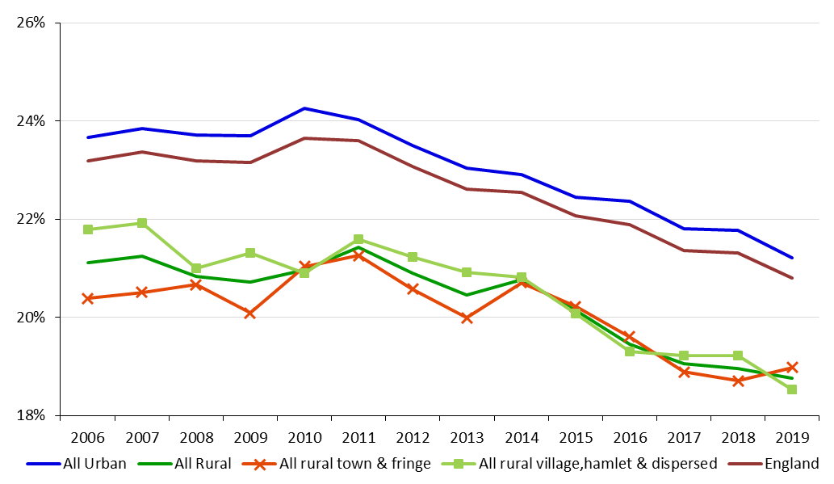
- People who are economically inactive are not available for work or not seeking work and will include students, retirees and those unable to work due to sickness or disability. People who are officially unemployed are considered to be economically active.
- In 2019, the rate of economic inactivity in urban areas was 2.5 percentage points greater than the rate of economic inactivity in rural areas of 18.8 per cent of working age people. Within rural areas, the percentage of economic inactivity was highest in rural in a sparse setting at 19.5 per cent of the working age population.
- Economic inactivity as a percentage of working age population has shown an overall decline since 2011 in both rural and urban areas.
- The latest England inactivity rate for May to July 2020 was 19.6 per cent, down 0.3 percentage points on February to April 2020 and down 0.8 percentage points on a year earlier1a. It is not yet possible to analyse these later figures in terms of settlement type.
- The most recent figure available for rural economic inactivity is 39.4 per cent for April to June 2020, which covers the initial period of Covid-19 and the national lockdown.1b

Percentage of working age population (age 16 to 64 years) who are economically inactive, by rural-urban classification in England, 2011 to 2019
 | 2011 | 2012 | 2013 | 2014 | 2015 | 2016 | 2017 | 2018 | 2019
All Urban | 24.0 | 23.5 | 23.0 | 22.9 | 22.4 | 22.4 | 21.8 | 21.8 | 21.2
All Rural | 21.4 | 20.9 | 20.5 | 20.8 | 20.2 | 19.5 | 19.1 | 19.0 | 18.8
those in a sparse setting | 23.4 | 23.0 | 21.4 | 24.2 | 20.6 | 19.6 | 19.5 | 23.0 | 19.5
All rural town & fringe | 21.3 | 20.6 | 20.0 | 20.7 | 20.2 | 19.6 | 18.9 | 18.7 | 19.0
All village & hamlets | 21.6 | 21.2 | 20.9 | 20.8 | 20.1 | 19.3 | 19.2 | 19.2 | 18.5
England | 23.6 | 23.1 | 22.6 | 22.6 | 22.1 | 21.9 | 21.4 | 21.3 | 20.8
See note 2 for an explanation of Rural Urban Classification and its application to the analysis
Data table is also available in ODS format in the rural economy supplementary data tables.
Notes: 1a) ONS Labour Market Statistics September 2020, see table 22 of the dataset: https://www.ons.gov.uk/employmentandlabourmarket/peopleinwork/employmentandemployeetypes/datasets/summaryoflabourmarketstatistics
1b) Labour Force Survey, Q2 2020 (April – June 2020)
2) The RUC01 has been applied to all data up to and including 2010. From 2011 onwards the RUC11 has been applied. Although a key difference between the 2001 and 2011 version of the classification is that a distinction between major conurbations, lesser conurbations and other urban areas has been introduced, the urban categories are comparable in concept. Similarly, the rural 2001 and 2011 categories are comparable in concept. However, the classification of a settlement may have changed between 2001 and 2011 owing to changes in population and settlement pattern.
3) In 2009 and before, working age was defined as 16-64 for males and 16-59 for females. In September 2010 the definition for working age was altered to be 16-64 for both males and females. The statistics shown here have been adjusted to this new definition for all years shown.
4) Unemployment rate is expressed as a percentage of the economically active ‘age 16 and over’ population, this is a departure from previous analyses and is consistent with ONS Labour Market Statistics. The employment rate and economically inactive rate are expressed as a percentage of the entire working age population. Therefore, the rates should not be expected to sum to 100%.
Source: Office for National Statistics, Annual Business Inquiry via abi2@ons.gov.uk

Earnings
- Average annual employee earnings (based on the median value, or middle of the earnings distribution) give an indication of living standards people can enjoy through their disposable income (see Expenditure).
- As people do not necessarily work in the same settlement as they live, workplace and residence based average earnings may differ.
- For example, average residence-based earnings are lower than workplace-based earnings in major urban areas, whilst average residence-based earnings in rural areas are higher than workplace earnings because people living in rural areas may work in urban areas in higher paid jobs.
- Average workplace-based earnings are lowest in Mainly Rural areas along with Urban with Minor Conurbation areas and highest in the London area.
- All areas have seen an increase in workplace-based median earnings in 2019, with a 4.2 per cent increase in Predominantly Urban areas (excluding London) and a 3.4 per cent increase in Predominantly Rural areas in comparison with 2018. These compare with a change in the Consumer Price Index including housing costs (a measure of inflation) of 1.8 per cent in the year ending March 2019.
In April 2019 there were some changes to Local Authorities boundaries where some Local Authority Districts merged to form single Unitary Authorities. This reduces the number of Local Authorities Districts and Unitary Authorities in England from 326 to 317. The impact of these changes on rural urban comparisons is that some Local Authority Districts originally categorised as Urban with City and Town or Urban with Significant Rural now form part of Unitary Authorities categorised as Largely Rural. This change has been applied to figures from 2018 onwards.
Workplace based median gross annual earnings (current prices), 2009 to 2019
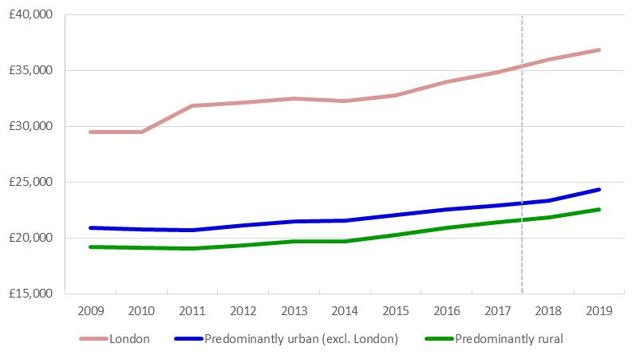
£0
Note: Data to 2017 uses the Rural Urban Classification (RUC) based on 327 Local Authority Districts (LAD’s) and Unitary Authorities (UA’s). From 2018 the RUC is based on revised boundaries as at April 2019, reducing the number of LAD’s and UA’s from 326 to 317.
- In 2019, median workplace-based earnings in Predominantly Urban areas (excluding London) were £24,300 while Predominantly Rural areas were lower at £22,500.
- Between 2009 and 2019 median workplace-based earnings increased for all settlement types. Excluding London, the rate of increase was greatest for workplaces in Mainly Rural areas, increasing by 18.8 per cent, followed by Largely Rural areas (16.8 per cent).
- The rate of increase was lowest in Urban with Minor Conurbation areas where median earnings increased by 12.4 per cent in the same period.
- For England, the rate of increase between 2009 and 2019 was 16.0 per cent.
- Over the same time period (2009 to 2019) the Consumer Price Index (including housing costs) has increased by 20 per cent.
- A table of workplace-based earnings broken down by detailed local authority rural-urban classification covering 2009 to 2019 is available in the rural economy supplementary data tables.
Residence-based median gross annual earnings (current prices), 2009 to 2019
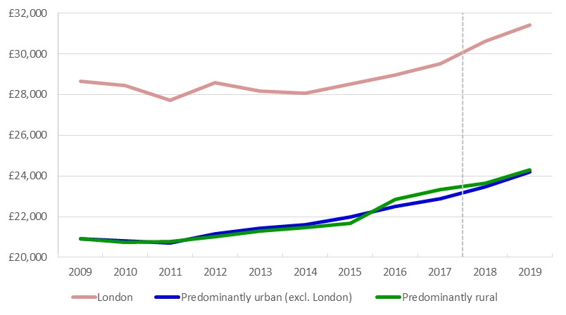
£0
Note: Data to 2017 uses the Rural Urban Classification (RUC) based on 327 Local Authority Districts (LAD’s) and Unitary Authorities (UA’s). From 2018 the RUC is based on revised boundaries as at April 2019, reducing the number of LAD’s and UA’s from 326 to 317.

- In 2019, median residence-based earnings in Predominantly Urban areas (excluding London) were £24,200 while Predominantly Rural areas were higher at £24,300.
- Between 2009 and 2019 median residence-based earnings increased for all settlement types. The rate of increase was greatest for residence-based earnings in Mainly Rural areas, increasing by 17.3 per cent, followed by Urban with City and Town (16.5 per cent).
- Excluding London, the rate of increase was lowest in Urban with Minor Conurbation where median earnings increased by 12.3 per cent in the same period.
- For England, the rate of increase between 2009 and 2019 was 15.9 per cent.
- Over the same time period (2009 to 2019) the Consumer Price Index (including housing costs) has increased by 20 per cent.
- A table of residence-based earnings broken down by detailed local authority rural-urban classification covering 2009 to 2019 is available in the rural economy supplementary data tables.
Notes: 1 Full time-series from 2009 are available on the ‘Rural economy – statistical indicators’ page: www.gov.uk/government/collections/rural-economy-statistical-indicators
2018 figures are revised, 2019 are provisional.
Source: Office for National Statistics, Annual Survey of Hours and Earnings: Table 7: Place of Work by Local Authority and Table 8: Place of Residence by Local Authority: www.ons.gov.uk/employmentandlabourmarket/peopleinwork/earningsandworkinghours/bulletins/annualsurveyofhoursandearnings/2019/relateddata
Figures in the tables have been rounded to the nearest £100. Figures are on a current prices basis and have not been adjusted for inflation. Results for rural – urban categories have been weighted by the number of people employed aged 16-64 based on Annual Population Survey and Annual Population Survey – workplace analysis: www.nomisweb.co.uk/articles/1066.aspx
Consumer Price Index: www.ons.gov.uk/economy/inflationandpriceindices/timeseries/d7bt/mm23

Home working
- Of the 27.51 million people in work in England in 2019, 4.1 million (15 per cent) were home workers2 (those who usually spend at least half of their work time using their home, either within their grounds or in different places or using it as a base).
- The highest rate of home workers was found in rural hamlets and dispersed areas, at 32 per cent, compared with 13 per cent in urban areas. Overall rural areas had a higher rate of home working compared with urban areas (22 per cent).
- According to the Office for National Statistics, home workers are more likely to be working in higher skilled roles and earn on average a higher hourly wage3, however this will vary across rural areas.




- Work patterns will be of course now fundamentally different as a result of the Covid-19 pandemic, with much, much higher proportions of people working from home.
1.1m (22%) home workers in rural areas
3.0m (13%) home workers in urban areas
3.8m (78%) working somewhere separate to home in rural areas
19.6m (87%) working somewhere separate to home in urban areas
The 27.5 million workers in England in 2019 were made up of:

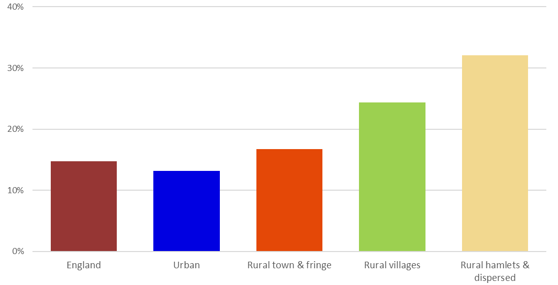
Home workers as a percentage of all those employed (age 16 and over), by rural-urban classification in England, 2019
- The highest rate of home workers was found in rural hamlets and dispersed areas, at 32 per cent, compared with 13 per cent in urban areas.
- Overall, all types of rural areas had a higher rate of home working compared with urban areas.
Percentage of home workers from all those employed and age 16 or over, by rural-urban classification, in England (2006 to 2019)
2019 homeworking rate:
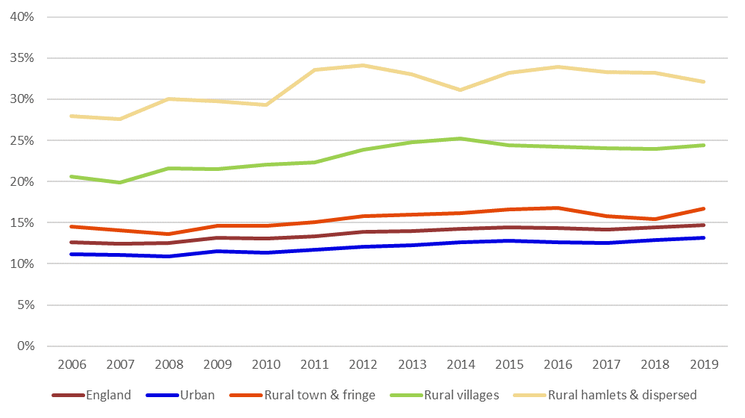
Note: 2006 to 2010 data are classified using the Rural Urban Classification 2001. Data from 2011 are classified using the Rural Urban Classification 2011.

- In 2019 there were 1,072,000 home workers in rural areas, accounting for 22 per cent of all workers living in rural areas. There were 2,978,000 home workers in urban areas, accounting for 13 per cent of all workings living in urban areas.
- Between 2006 and 2019 the rate of home working increased across all areas. The highest increase was in rural hamlets and dispersed areas at 4.1 per cent and the lowest increase was in urban areas at 2.0 per cent. However, it should be known that the classification of settlements was updated for 2011 onwards, and some settlements would have changed category.
- A table of homeworking figures broken down by rural-urban classification covering 2006 to 2019 is available in the rural economy supplementary data tables.

Percentage of home workers by industry and rural-urban classification, in England, 2019
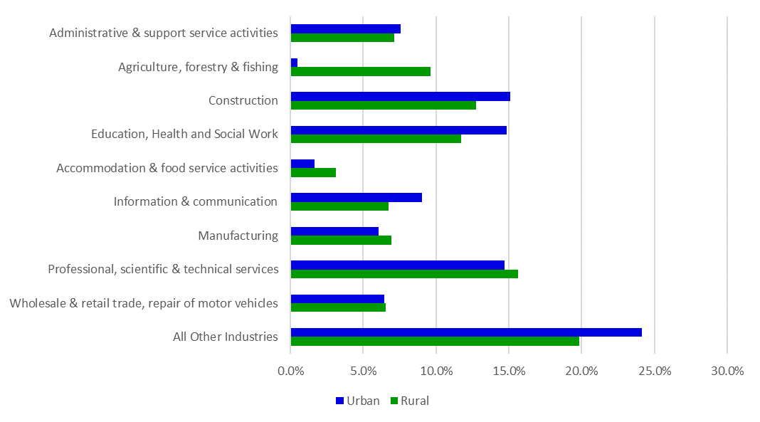
- The greatest difference in industry split home worker proportions occurs in “Agriculture, forestry & fishing”, where there is a 9.1 per cent difference in favour of rural areas, and “Education, Health and Social Work”, where there is a 3.1 per cent difference in favour of urban areas.
- The largest contributor to home workers in urban areas is “Construction” at 15.1 per cent and in rural areas is “Professional, scientific & technical services” at 15.6 per cent.
- A table of 2019 rural and urban homeworking figures broken down industry is available in the rural economy supplementary data tables.

Notes: 1) This figure is for all those who reported their working status. It differs slightly from the total number employed as some respondents have not reported their home working status.
2) Home workers are defined as those who usually spend at least half of their work time using their home, either within their grounds or in different places or using it as a base. Home workers will include both those who are employees of organisations and those who are self-employed. The category for home workers includes the following; those who work within their home; those who work in the same grounds or buildings of their home; and those who work in different places but use their home as a base.
3) Further information can be found in the ONS document, Characteristics of Home Workers, 2014
4) The levels and rates are based on people age 16 and over who are in employment.
5) The RUC01 has been applied to all data up to and including 2010. From 2011 onwards the RUC11 has been applied. Although a key difference between the 2001 and 2011 version of the classification is that a distinction between major conurbations, lesser conurbations and other urban areas has been introduced, the urban categories are comparable in concept. Similarly, the rural 2001 and 2011 categories are comparable in concept. However, the classification of a settlement may have changed between 2001 and 2011 owing to changes in population and settlement pattern.
Source: Office for National Statistics, Labour Force Survey, via Annual Business Inquiry (abi2@ons.gov.uk)

Productivity measured by Gross Value Added (GVA)
Productivity measures are often used to indicate how well a country can use its human and physical resources to generate economic growth. Strong economic growth will generally mean an improvement in living standards. However, productivity alone does not tell us everything about the economic wellbeing of different areas. The potential of any given place depends on the mix of industries, the infrastructure and the size of settlements there. Based on these circumstances, even an area with low productivity might be performing as well as it can.
Gross Value Added (GVA) measures the contribution to the economy of each individual producer, industry or sector. Simplistically it is the value of the amount of goods and services that have been produced, less the cost of all inputs and raw materials that are directly attributable to that production.
In previous years the ONS have produced two separate measures of GVA, one based on income and one based on production. These two measures have been weighted and combined to produce a new balanced measure of GVA.
In April 2020 and April 2021 there were further changes to Local Authorities boundaries where some Local Authority Districts merged to form single Unitary Authorities. This reduces the number of Local Authorities Districts and Unitary Authorities in England from 317 to 309. The impact of these changes on rural urban comparisons is that some Local Authority Districts originally categorised as Mainly Rural or Largely Rural or Urban with City and Town now form part of Unitary Authorities categorised as Urban with Significant Rural. This change has been backdated across the full time-series.

- In 2019, GVA from Predominantly Rural areas contributed 15.3 per cent of England’s GVA, and was worth an estimated £260 billion. This compares with 44.7 per cent from Predominantly Urban areas (excluding London) (£761 billion), 27.5 per cent from London (£468 billion) and 12.5 per cent from Urban with Significant Rural areas (£213 billion).

- The proportional contribution from Predominantly Rural areas to England’s GVA has declined slightly between 2001 and 2019 (from 16.6 per cent to 15.3 per cent).

- However, this has been affected by an increase in London’s contribution. The proportional contribution of Predominantly Rural areas to the GVA of England excluding London has shown a much smaller decline between 2001 and 2019 (from 21.8 per cent to 21.1 per cent).

- In 2019, the GVA per workforce job in Predominantly Rural areas was £45,500 and in Predominantly Urban areas (excluding London) it was £50,900 (provisional estimates).

- In 2019, the productivity of Predominantly Rural areas was around 83 per cent of that for England as whole (provisional estimate). This had fallen from 90 per cent in 2001 but it is affected by the increase in London’s contribution to England’s overall productivity.

Contribution to England's Gross Value Added (GVA)
Contribution to England’s Gross Value Added (GVA), by local authority rural-urban classification in England (data broadly at county level apportioned at local district level), 2019 (provisional)
2011 Local Authority Classification | GVA (£m) | share | Broader classification | GVA (£m) | share
London | 468,170 | 27.5% | London | 468,170 | 27.5%
Urban with Major Conurbation | 290,120 | 17.0% | Predominantly Urban excl. London | 760,720 | 44.7%
Urban with Minor Conurbation | 46,600 | 2.7% | Predominantly Urban excl. London | 760,720 | 44.7%
Urban with City and Town | 424,000 | 24.9% | Predominantly Urban excl. London | 760,720 | 44.7%
Urban with Significant Rural | 213,090 | 12.5% | Urban with Significant Rural | 213,090 | 12.5%
Largely Rural | 158,990 | 9.3% | Predominantly Rural | 260,100 | 15.3%
Mainly Rural | 101,110 | 5.9% | Predominantly Rural | 260,100 | 15.3%
England | 1,702,080 | 100.0% | England | 1,702,080 | 100.0%
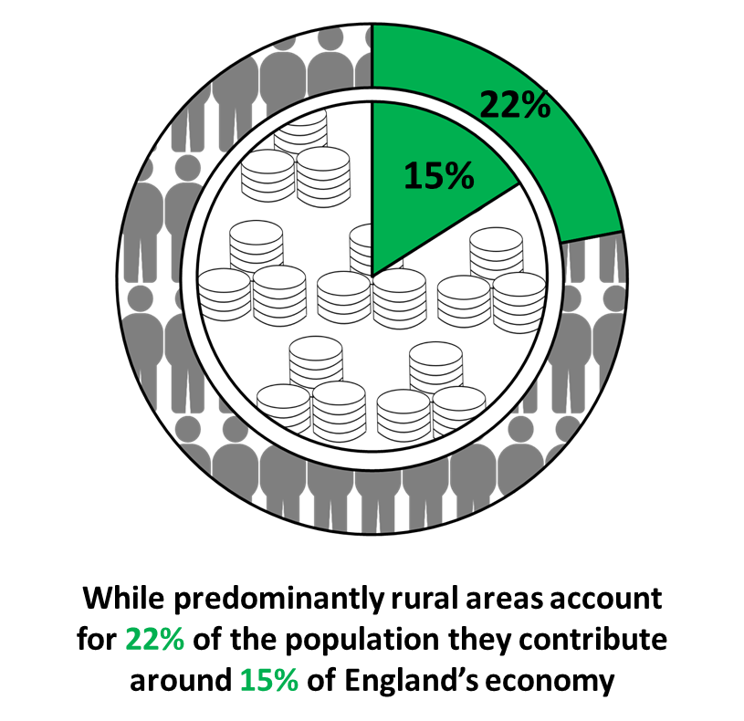
- Predominantly Urban areas (excluding London) make the largest contribution to England’s GVA, estimated at £761 billion (44.7 per cent), followed by London’s £468 billion (27.5 per cent). Predominantly Rural areas contributed an estimated £260 billion (15.3 per cent) in 2019.
- These GVA figures are based on GVA at broadly county level apportioned at local district level to provide a more refined analysis of GVA across the local authority classification. The total GVA for rural and urban areas in the table above is different to the industry breakdown following this (based on 2018 data) and is less finely detailed being based on data at broadly county level.

Gross Value Added (GVA) by Local Authority Classification as a percentage of England GVA, 2001 to 2019 (provisional)
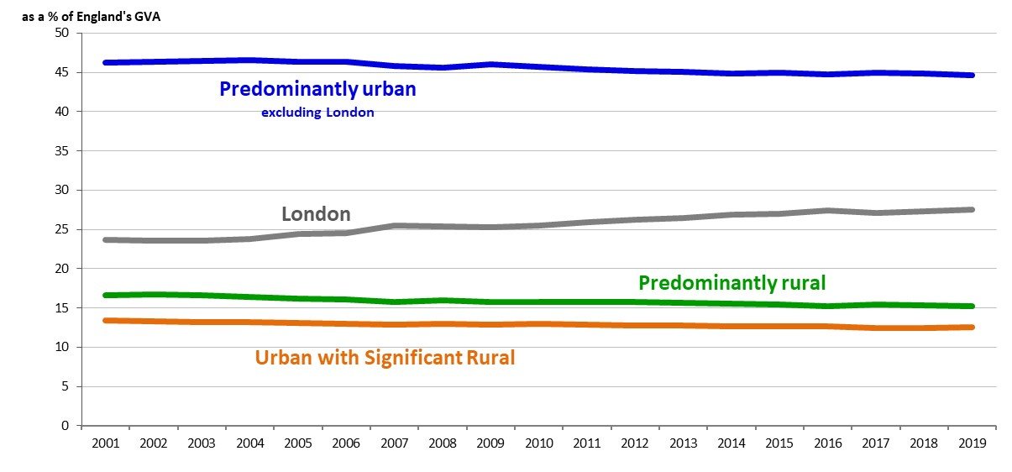
- Overall productivity (the rate of output per workforce) is lower in Predominantly Rural areas than in Predominantly Urban areas, with rural productivity as a percentage of England’s overall productivity having fallen since 2001.
The productivity rate in Predominantly Rural areas fell from 90% of the England average to 83% between 2001 and 2019.

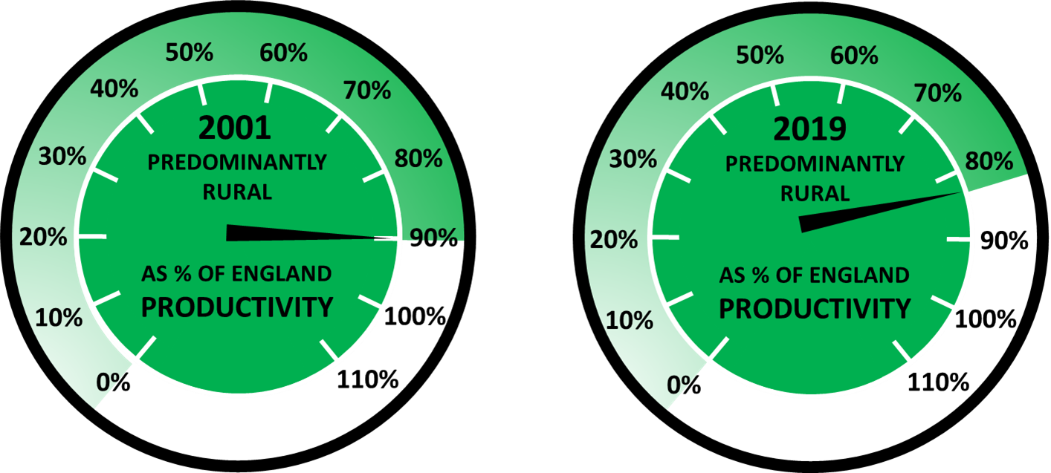
- The fact that rural areas have not kept pace with economic growth elsewhere in the country partly reflects urban growth in the financial services sector, especially in London – and other factors such the size of economic sectors in rural areas and the size of businesses – rather than a decline in rural productivity as such.
- A table of GVA figures broken down by broad local authority rural-urban classification covering 2001 to 2019 (provisional) is available in the rural economy supplementary data tables.

Notes: The GVA figures are based on GVA at broadly county level apportioned at local district level to provide a more refined analysis of GVA across the local authority classification. Data have been recalculated based on ONS Local Authority GVA figures.
www.ons.gov.uk/economy/grossvalueaddedgva/datasets/nominalregionalgrossvalueaddedbalancedperheadandincomecomponents
www.ons.gov.uk/economy/grossvalueaddedgva/datasets/regionalgrossvalueaddedbalancedlocalauthoritiesbynuts1region
Balanced GVA uses the income approach and the production approach for estimating GVA. It takes the strengths from both approaches to produce a new balanced measure of regional GVA. This gives users a single measure of economic activity within a region.
Source: Defra analysis. Office for National Statistics, Gross Value Added at NUTS3 and LAD level.

Gross Value Added (GVA) per Workforce Job
GVA per workforce job (£), by Local Authority Classification compared with England as a whole, 2001 to 2019 (provisional)
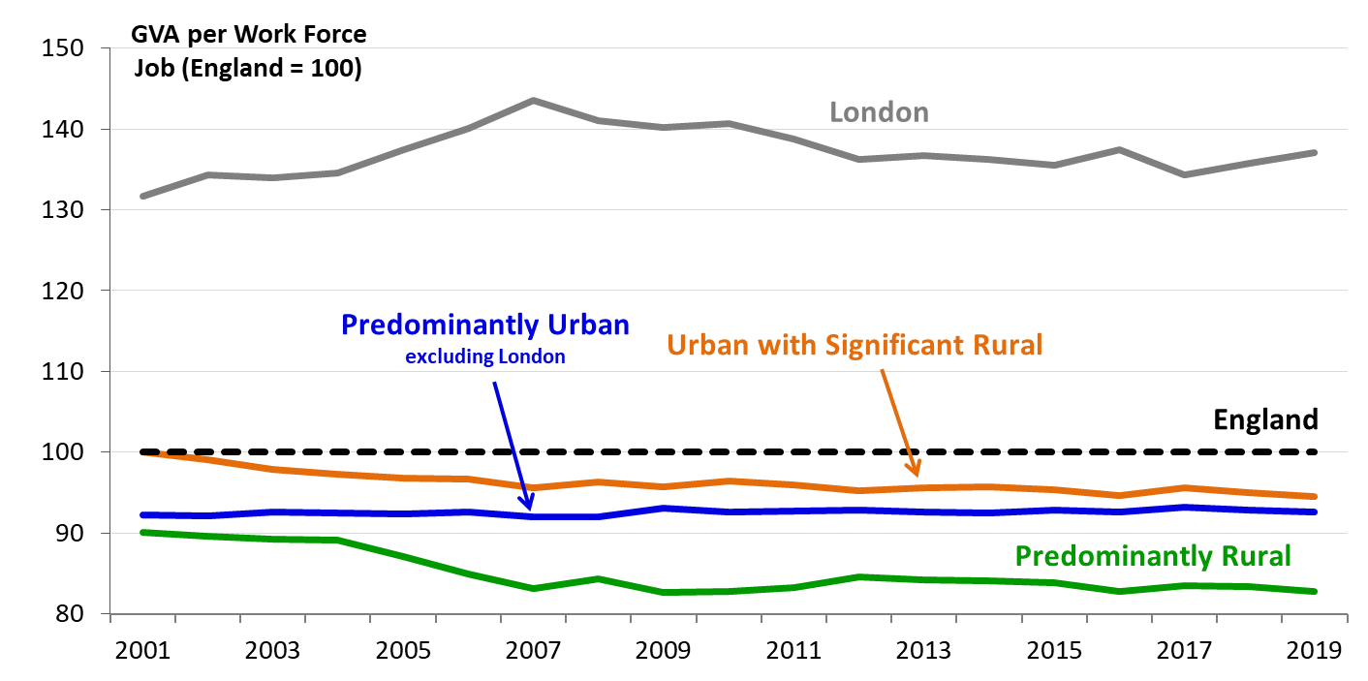
Gross Value Added (GVA) per workforce job (WFJ) (£ and as percentage of England level), by Local Authority Classification in England, 2019 (provisional)
 | £ |  | As percentage of England level
London |  | 75,200 | 137
Urban with Major Conurbation |  | 49,800 | 91
Urban with Minor Conurbation |  | 44,100 | 80
Urban with City and Town |  | 52,500 | 96
Urban with Significant Rural |  | 51,900 | 95
Largely Rural |  | 45,800 | 83
Mainly Rural |  | 45,000 | 82
Predominantly Urban (excl. London) |  | 50,900 | 93
Predominantly Rural |  | 45,500 | 83
England |  | 54,900 | 100

- The nominal GVA per workforce job is highest in London at around £75,200 per workforce job in 2019 (provisional estimate). After London, Urban with City and Town areas had the highest values per workforce job (around £52,500).
- For 2019, the GVA per workforce job in Predominantly Urban areas (excluding London) areas was £50,900 and in Predominantly Rural areas it was £45,500.
- In 2019 the productivity of Predominantly Rural areas was around 83 per cent of that for England as a whole (provisional estimate). This had fallen from 90 per cent in 2001 but is affected by the increases in London’s contribution affecting England’s overall productivity.
- A table of GVA per workforce job figures broken down by broad local authority rural-urban classification covering 2001 to 2018 (provisional) is available in the rural economy supplementary data tables.

Notes: GVA per workforce job is a measure of GVA divided by the workforce number.
It is important to note that there is currently no official way of deflating nominal GVA figures to reflect underlying differences in price levels between places. This means that figures may exaggerate the variation in real GVA per job between different areas because we would expect prices (property and other living expenses) to be highest in areas of high productivity such as London. Rather than report the absolute figures the variations in productivity are shown in relation to the level for England as a whole for each year.
The analysis uses the 2011 Local Authority Rural Urban Classification for all years to allow comparison.
Source: Defra analysis. Workforce jobs series via Nomis (Jobs Density Total Jobs) (www.nomisweb.co.uk/Default.asp).

Contribution to England's Gross Value Added (GVA) by Industry

Percentage breakdown of Gross Value Added (GVA) by industry, and by Local Authority Classification in England, 2019 (provisional)
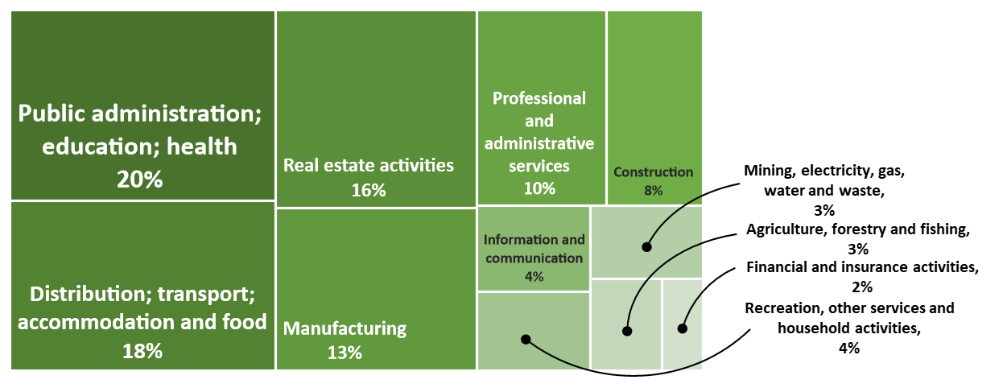
Predominantly Rural areas:
Predominantly Urban areas (excl. London):
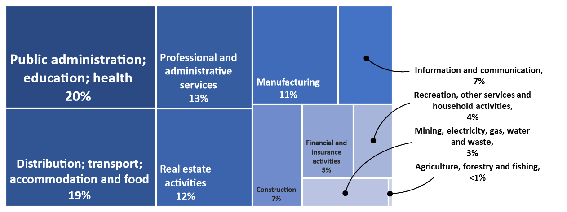

- The industrial breakdown is broadly similar across Predominantly Rural areas and Predominantly Urban areas (excluding London) with the combined sectors of ‘Distribution, transport, accommodation and food’ and ‘Public administration, education, and health’ each contributing about a fifth of GVA in each area type.
- The sectors where differences in contributions are more significant are ‘Financial and insurance activities’ (2 per cent in Predominantly Rural, 5 per cent in Predominantly Urban areas (excluding London), and 14 per cent in London), ‘Information and communication’ (4 per cent in Predominantly Rural, 7 per cent in Predominantly Urban areas (excluding London), and 12 per cent in London) and ‘Professional and administrative services’ (10 per cent in Predominantly Rural, 13 per cent in Predominantly Urban areas (excluding London), and 19 per cent in London). Whilst these types of specialised businesses do exist in Predominantly Rural areas, they are more prevalent in cities and larger towns.
- ‘Agriculture, forestry and fishing’ contributed 3 per cent or £6.3 billion to Predominantly Rural GVA. See below for further detail on the contribution this sector makes to Predominantly Rural areas.
- The industry breakdown is based on the lowest level of geography available which is broadly at county level.
- The totals for GVA for Predominantly Rural and Predominantly Urban areas are different from the headline figures for GVA earlier in this section. This is because the industrial breakdown is calculated using a courser rural-urban classification which will tend to increase the areas classed as Predominantly Urban. For the total GVA of each type of area the headline figures should be used.
- A table of 2019 (provisional) GVA figures broken down by industry and broad local authority rural-urban classification is available in the rural economy supplementary data tables.

Notes: Gross Value Added measures the contribution to the economy of each individual producer, industry or sector in the country. However, there are some gaps in the coverage of the Annual Business Survey; agriculture for example is only partially covered and self-employment is not included in the data. This may lead to underestimations of economic value. Gross Value Added data by industry is only available at NUTS3 (broadly county) level, and so a broad rural-urban classification is applied. Predominantly Rural areas are those with at least half of their population living in rural settlement or large market towns.
The 2011 rural urban classification for local authorities has been applied
Source: Defra analysis. Office for National Statistics, Gross Value Added (Balanced) at NUTS3 by SIC07 industry at current basic prices
- In 2019 ‘Agriculture, forestry and fishing’ contributed 3 per cent or £6.3 billion to GVA in Predominantly Rural areas. The ‘Agriculture, forestry and fishing’ sector has previously been reported as contributing 2 per cent. This does not represent a genuine growth in these sectors, rather a change in methodology1 has resulted in a reallocation of GVA. The reallocation means that ‘Agriculture, forestry and fishing’ sectors account for around 3 per cent of the GVA in Predominantly Rural areas since 2001 instead of the 2 per cent previously reported.
- The following chart and table show that sectoral contributions to GVA in Predominantly Rural areas have changed very little since 2001.

Industry sector contribution to Gross Value Added (GVA) in Predominantly Rural areas only, 2001 to 2019
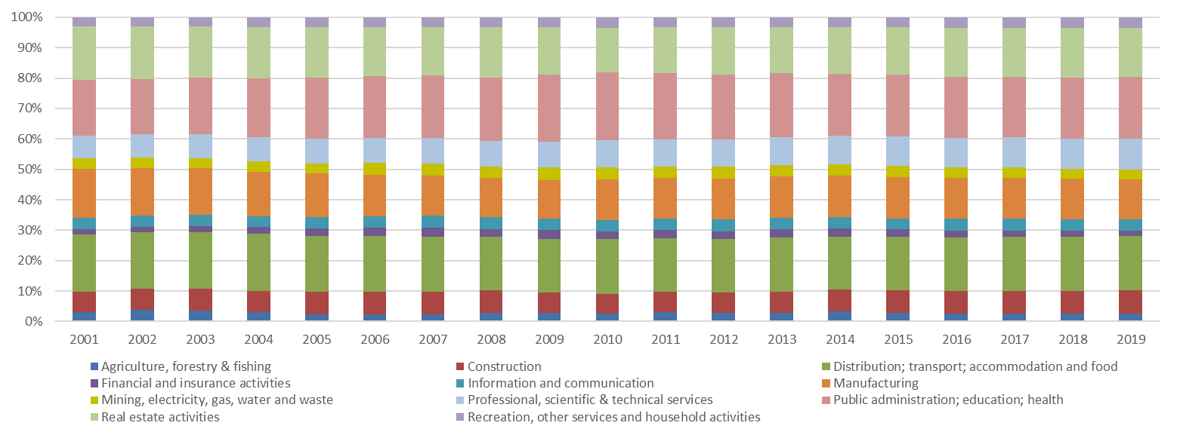

- A percentage breakdown of GVA figures by industry for each broad local authority rural-urban classification covering 2001 to 2018 is available in the rural economy supplementary data tables.
Notes: 1The Office for National Statistics (ONS) has reviewed the methodology used to produce detailed industry-level GVA at NUTS3 level and revised their method to use industry-based administrative data which is almost 100% representative to allocate GVA down to the NUTS3 level. In addition, the UK-level figures have been revised upwards across all years, by an average of 9%, due to changes introduced in the National Accounts Blue Book 2019; this will affect all lower-level regions, proportionate to their share of the UK total.

Businesses
- In 2019/20 there were 551,000 businesses registered in rural areas, accounting for 23 per cent of all registered businesses in England.
- Businesses registered in rural areas employed 3.7 million people, accounting for 13 per cent of all those employed by registered businesses in England.
- There are more registered businesses per head of population in Predominantly Rural areas than in Predominantly Urban areas (excluding London).
- There are proportionately more small businesses in rural areas.
- In 2019 there were 56 registered business start-ups per 10,000 population in Predominantly Urban areas (excluding London) compared with 45 per 10,000 population in Predominantly Rural areas.

Business composition
Important note: ‘Business composition’ is based on Enterprises, which is the level at which businesses are registered for Value Added Tax and or PAYE. In the case of a business operating at only one address, it will be registered at that address, but for businesses operating in several locations, it will be the location of the headquarters that is registered. If a business has branches in rural areas, but the headquarters are registered within an urban area, then the statistics for all the outlets will be registered at the headquarters, and not counted as “rural”. The later sections on ‘Businesses by industry type’, ‘Employment by industry type’ and ‘Businesses by size band’ are based on Local Unit data, which distinguishes the location of branches.
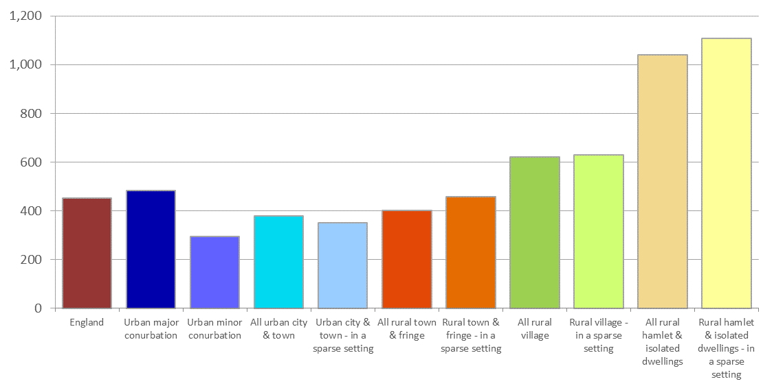
Number of registered businesses (single-site or headquarters) per 10,000 population, by rural-urban classification, in England, 2019/20
Average turnover per person employed, by rural-urban classification, in England, 2019/20
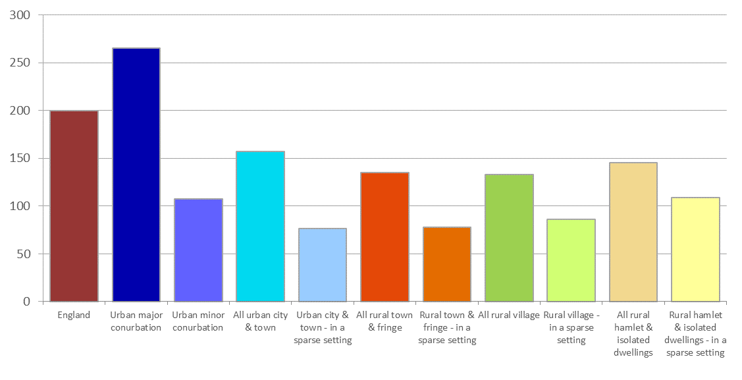
- In 2019/20 there were 551,000 businesses registered in rural areas, accounting for 23 per cent of all registered businesses in England.
- Businesses registered in rural areas employed 3.7 million people, accounting for 13 per cent of all those employed by registered businesses in England.
- There are more registered businesses (single-site or headquarters) per head of population in rural areas than in urban areas. The more ‘rural’ an area is, the higher the number of registered businesses per head of population.
- The average turnover per person employed is greater in urban areas, especially Urban Conurbations, and lower in rural areas, especially those in a sparse setting.
- A table containing further key 2019/20 statistics on registered businesses including number of registered businesses, number of people employed and turnover is available broken down by detailed rural-urban classification in the rural economy supplementary data tables.

Notes:
On the Inter-Departmental Business Register (IDBR), the enterprise is the statistical unit that most closely equates to a business. It holds aggregated information gathered from administrative and statistical sources within that enterprise to give an overall picture of what is going on in the business. An enterprise carries out one or more activities at one or more locations. An enterprise may be a sole legal unit.
Turnover relates to income received by a business from the ‘sale of goods and or services charged to third parties’. The IDBR does not include businesses whose turnover is below the tax threshold. As turnover is reported at the enterprise level it is affected by where businesses report their headquarters to be. As such there can be variation from year to year as a result of businesses relocating
Further information: see this ONS document about the Inter-Departmental Business Register
Source: ONS, Inter Departmental Business Register (IDBR), 2019/20

Businesses by industry type
Important note: ‘Businesses by industry type’ and ‘Businesses by size band’ are based on Local Unit. This better reflects the make-up of rural businesses as there can be many local business units in rural areas whose headquarters are elsewhere (although this can apply vice versa).
Percentage of local unit registered businesses by industry, by rural-urban classification, in England, 2019/20
All rural areas:
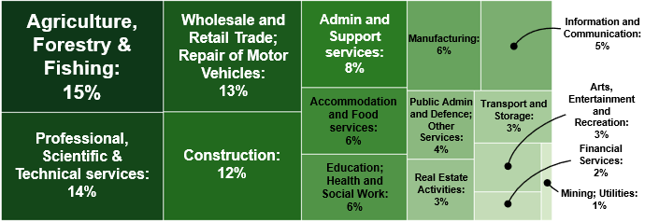
All urban areas:
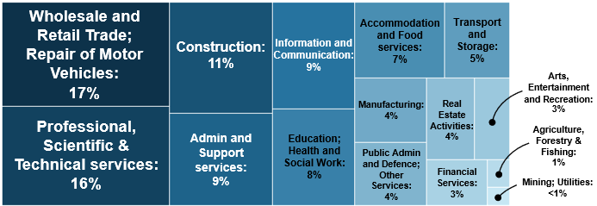
Agriculture, Forestry & Fishing businesses as a percentage of total local units of registered businesses by rural-urban classification, in England, 2019/20
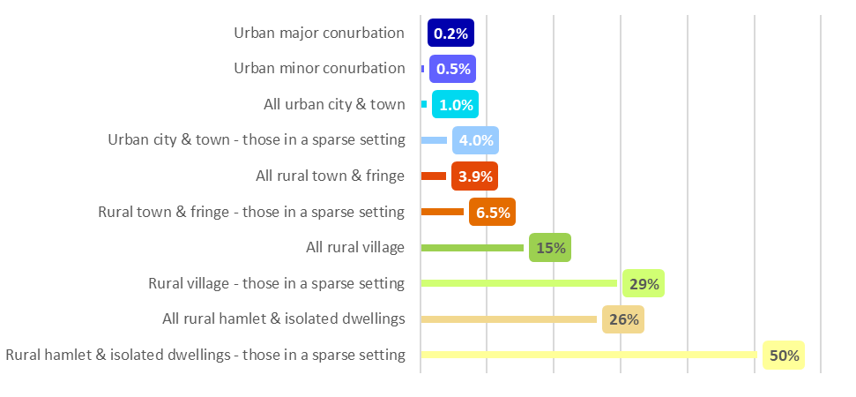
- In 2019/20 ‘Agriculture, forestry & fishing’ accounts for 15.0 per cent of the local units of registered businesses in rural areas overall (31.9 per cent in Rural areas in a sparse setting). They are dominant sectors in rural hamlets and Rural Villages. In Rural Hamlets & Isolated Dwellings in a sparse setting, just over half the registered businesses are in these industries. In England overall the ‘Agriculture, forestry & fishing’ sector accounts for 3.7 per cent of the local units of registered businesses.
- Other prominent sectors in rural areas are: ‘Professional, scientific & technical services’ (14.5 per cent of businesses), ‘Wholesale & retail trade; repair of motor vehicles’ (12.7 per cent) and ‘Construction’ (12.4 per cent).
- A table of 2019/20 business figures broken down by industry and detailed rural-urban classification is available in the rural economy supplementary data tables.
Numbers of local units of registered businesses in rural and urban areas by industry between 2011/12 and 2019/20, in England
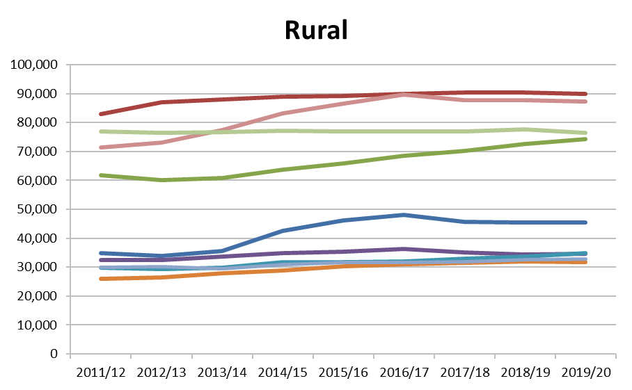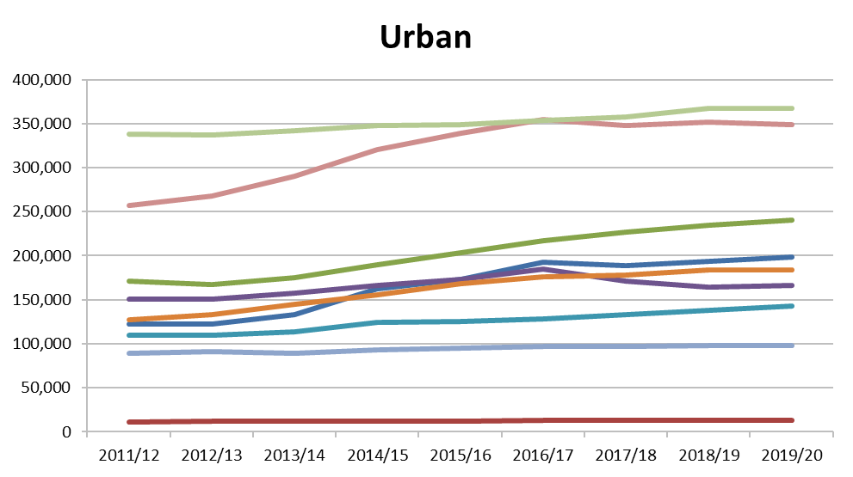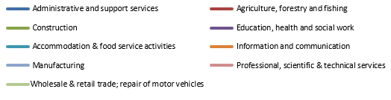

- Please note, scales differ for the charts shown below as numbers of businesses are considerably higher in urban areas.
- A table of rural and urban business figures broken down by industry for 2011/12 to 2019/20 is available in the rural economy supplementary data tables

Index (2011/12 = 100) of change in numbers of local units of registered businesses in rural and urban areas by industry between 2011/12 and 2019/20, in England
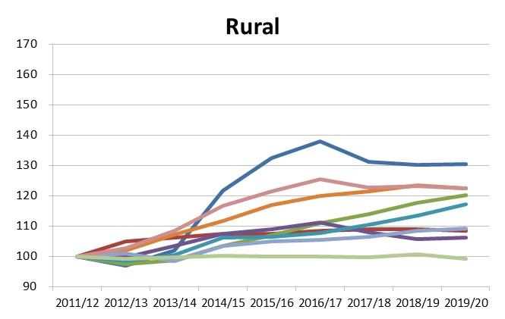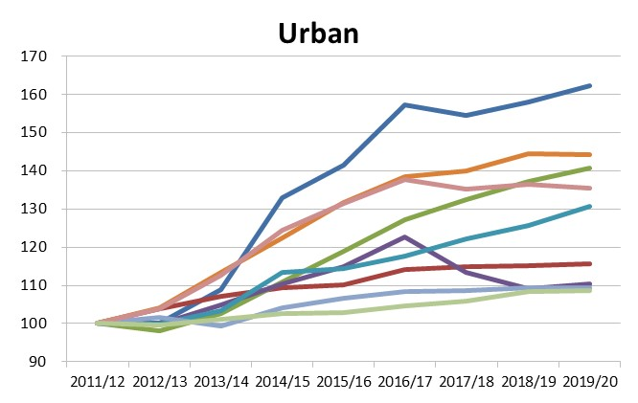
- Various sectors saw a rise in local unit numbers between 2018/19 and 2019/20, in both rural and urban areas. In rural areas the rise has been greatest for the ‘Accommodation & food service activities’ where local unit numbers have risen by 4 per cent (compared with a rise of 5 per cent in urban areas).
- An indexed table of rural and urban business figures broken down by industry for 2011/12 to 2019/20 is available in the rural economy supplementary data tables.

Employment by industry type
The number of employees refers to the number of people working within the business under a contract of employment in return for a wage or salary. A business can have no employees, if all the business is conducted by people classed as being working proprietors (i.e. sole traders or partnerships).
The number of people employed is a sum of employees and self-employed people who run the business.

Percentage of employment within local units of registered businesses by industry, by rural-urban classification, in England, 2019/20
All rural areas:
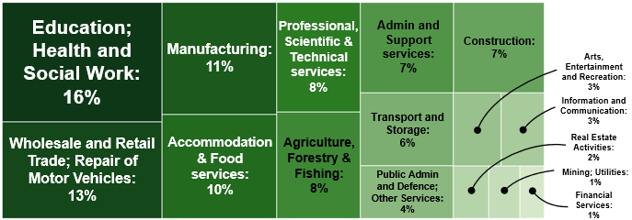
All urban areas:
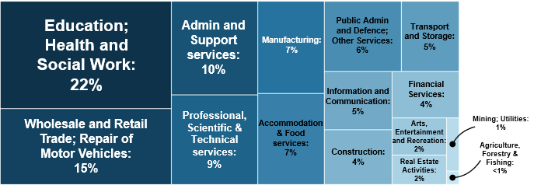

Employment in Agriculture, Forestry & Fishing businesses as a percentage of total employment in local units of registered businesses by rural-urban classification, in England, 2019/20
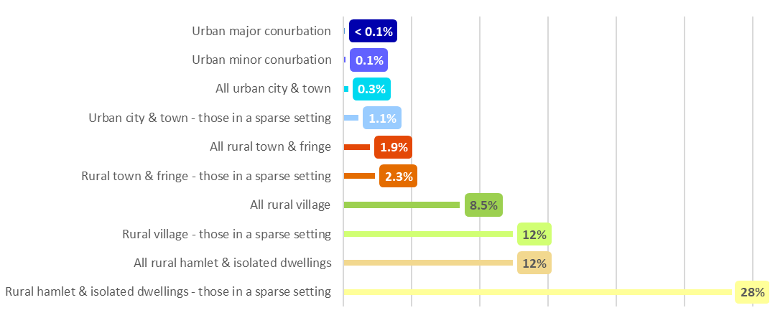
- The three sectors with the highest percentages of employment in rural areas are ‘Education, health & social work’, ‘Wholesale and retail trade; repair of motor vehicles’ and ‘Manufacturing’ (16.3 per cent, 13.2 per cent and 11.0 per cent respectively).
- ‘Agriculture, forestry & fishing’ is the only sector that is greater in terms of actual employment numbers in rural areas than urban areas, with employment figures of 312,000 in rural areas compared with 46,000 in urban areas. All other sectors have greater employment numbers in urban areas than rural areas
- A table of 2019/20 employment figures broken down by industry and detailed rural-urban classification is available in the rural economy supplementary data tables.

Businesses by size band
The number of employees refers to the number of people working within the business under a contract of employment in return for a wage or salary. A business can have no employees, if all the business is conducted by people classed as being working proprietors (i.e. sole traders or partnerships).
The number of people employed is a sum of employees and self-employed people who run the business.
Percentage of people employed within local units by size bands of registered businesses and rural-urban classification, in England, 2019/20
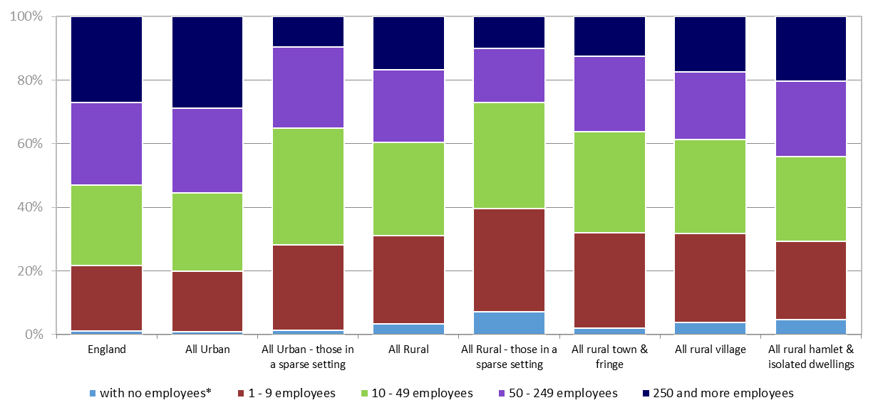
* ‘With no employees’ comprises mainly sole proprietorships and partnerships. This category also includes around 22,580 businesses classed as ‘Other’ – with no employees and no employment (about 0.8 per cent of the total business count).
- In urban areas 28.9 per cent of people employed in the local units of registered businesses are employed in those businesses with 250 or more employees overall, and in rural areas the proportion is 16.8 per cent.
- In regard to smaller businesses, in urban areas 19.2 per cent of people employed in local units of registered businesses are employed in micro businesses (those with between 1 and 9 employees overall), whilst in rural areas the proportion is 27.7 per cent.

Sole traders or partnerships
3%
1%
Micro businesses
28%
19%
Small businesses
29%
25%
- When looking at numbers of local units of registered businesses the category with the greatest proportion of total businesses is those with between 1 and 9 employees, with 77.2 per cent of businesses in this size band in urban areas and 71.1 per cent in rural areas.
- In urban areas 7.0 per cent of businesses have no employees (e.g. sole traders and partnerships), compared with 17.0 per cent in rural areas.

- A table of 2019/20 employment figures and businesses numbers broken down by business size band and detailed rural-urban classification is available in the rural economy supplementary data tables.

Notes: The statistics are based on individual business units rather than the location of the headquarters of the enterprise. There may be many local business units in rural areas whose headquarters are elsewhere, and vice versa.
Source: ONS, Inter-Departmental Business Register (IDBR) 2019/20.

Small and medium businesses

- Small and Medium Enterprises (SMEs) are businesses employing fewer than 250 people.

- In England, there are 2.4 million SMEs registered for PAYE and/or VAT, providing employment for 12.4 million people.

- However, it is estimated that in England there are an additional 2.7 million unregistered businesses i.e. those who are not registered for VAT and do not have employees registered for PAYE. Such businesses are estimated to provide employment for 2.9 million people and are likely to be mainly one person traders.

- For registered businesses, information is available on their location, principal activity, employment and turnover, and for those who operate on multiple sites, the location and employment in individual business units. Information on registered SMEs is presented below.

- Less is known of unregistered businesses and in particular hitherto there have been no estimates of how many are based in rural areas. However new analysis of data from the Longitudinal Small Business Survey, which included unregistered businesses, provides further insights on SMEs in rural areas. Some results from the analysis are presented later in this section. These suggest that 73 per cent of SMEs in rural areas have no employees (including both registered and unregistered businesses).

Registered Small and Medium Enterprises

- Enterprises are considered rural registered businesses if their single site of operation or their headquarters, as registered for PAYE (Pay-As-You-Earn tax) and/or VAT (Value Added Tax) purposes, are located in a rural area. Enterprises where the headquarters are in an urban area are regarded as urban registered businesses, even if some business units are in rural areas.

- In 2019/20, there was 550,000 registered rural SMEs, representing 99.8 per cent of all registered rural enterprises, and 23 per cent of all registered SMEs in England. In urban areas SMEs represent 99.6 per cent of registered businesses.

- In 2019/20, 2.6 million people were employed in registered rural SMEs, representing 71 per cent of all those employed by registered rural enterprises. SMEs account for 41 per cent of those employed in registered urban enterprises.

Number of registered small and medium enterprises, employment and turnover, by rural urban classification, in England, 2019/20
 | Number of registered SMEs1 | Employment by registered SMEs1 | Employment by SMEs as a percentage of all employment by registered enterprises | Average turnover per person employed £000s
All urban | 1,831,445 | 9,783,735 | 41.4 | 208
those in a sparse setting | 3,105 | 19,785 | 86.1 | 78
All rural | 550,065 | 2,596,505 | 70.6 | 122
those in a sparse setting | 33,655 | 154,530 | 83.8 | 87
England | 2,381,515 | 12,380,240 | 45.4 | 190
SMEs are Small and medium enterprises (employing fewer than 250 people)

- Although almost all registered businesses are small or medium enterprises (SME) in both rural and urban areas, a much higher proportion of people employed by rural registered businesses are employed by SMEs (71 per cent) than in urban areas (41 per cent).
- Average turnover per person employed is lower in rural registered SMEs (£122,000) than in urban registered SMEs (£208,000), which is dominated by those in Urban with Major Conurbations (£292,000). The average for registered SMEs in settlements in a sparse setting are somewhat lower and in particular is £77,000 per person employed in Rural Town and Fringe in a sparse setting.
- A breakdown of the table above using a more detailed rural-urban classification is available in the rural economy supplementary data tables.
- A further table that breaks SME’s down by business size band and detailed rural-urban classification is also available.

Percentage of registered small and medium enterprises by industry and rural-urban classification, in England, 2019/20
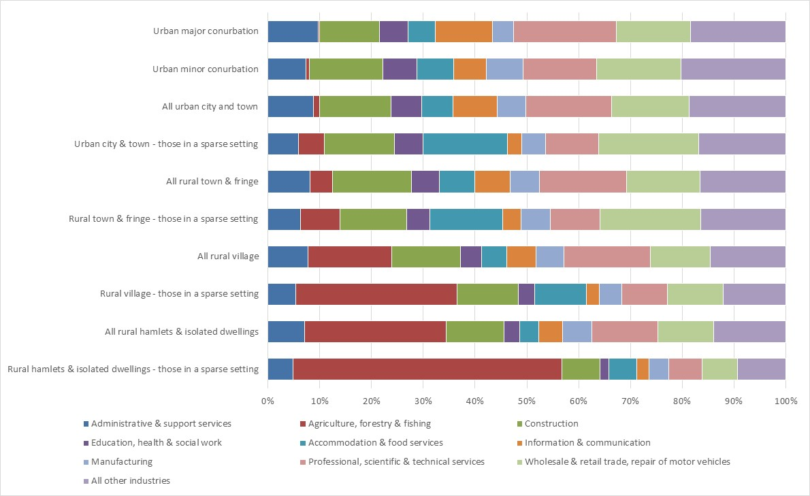

- SMEs in ‘Agriculture, forestry and fishing’ sectors account for 15.8 per cent of rural registered SMEs rising to 34.6 per cent of SMEs registered in rural areas in a sparse setting. These percentages are slightly higher than when considering the sector representation at a local business unit level (see Businesses)
- Others sectors that are dominant at the local business unit level are similarly dominant at the SME level, such as ‘Professional, scientific and technical services’ (15.5 per cent), ‘Wholesale and retail trade; repair of motor vehicles’ (12.2 per cent), and ‘Construction’ (13.3 per cent).
- 18.3 per cent of rural registered SMEs have no employees, compared with 8.3 per cent of urban registered SMEs. The majority of rural registered SMEs (73.1 per cent), have 1 to 9 employees, though this is lower than for urban registered SMEs (81.7 per cent).
- 31.1 per cent of registered SMEs in rural areas in a sparse setting have no employees
- A table of 2019/20 rural and urban business figures broken down by is available in the rural economy supplementary data tables.
Analysis of small and medium enterprises from the Longitudinal Small Business Survey

The Longitudinal Small Business Survey (LSBS) was commissioned by the Department for Business, Energy and Industrial Strategy (BEIS) and the Governments in Scotland, Wales and Northern Ireland.
Over 13,400 SMEs were interviewed in England in 2015, including over 3,500 (26.5 per cent) in rural areas. The Rural Enterprise UK team at Newcastle University’s Centre for Rural Economy and Business School have undertaken additional rural-urban analysis of the data and some of their findings are presented below.
Comparisons between statistics on rural and urban businesses can be difficult to interpret and in particular it is difficult to identify whether any differences reflect variations in the profile of urban and rural economies in terms of business sectors, ages and sizes or factors related to their location. The analysis attempts to match similar rural and urban businesses to take account of this where practicable.

LSBS: Number of responses from small and medium enterprises with percentage by size and rural-urban classification, England excluding London, 2015
 | with no employees |  | 1 - 9 employees |  | 10 - 49 employees |  | 50 - 249 employees |  | Total
 | Number | % | Number | % | Number | % | Number | % | Number | %
Urban | 6,361 | 77.7 | 1,480 | 18.1 | 300 | 3.7 | 49 | 0.6 | 8,190 | 100.0
Rural | 2,687 | 73.3 | 828 | 22.6 | 133 | 3.6 | 19 | 0.5 | 3,667 | 100.0
Total | 9,048 | 76.3 | 2,308 | 19.5 | 433 | 3.7 | 68 | 0.6 | 11,857 | 100.0

- The proportion of businesses with no employees is considerably higher for both rural, 73.3 per cent, and urban areas, 77.7 per cent, in the LSBS sample compared with the proportions represented as registered businesses with no employees (19.8 per cent and 9.3 per cent respectively).
- However, this is consistent with Business population estimates suggesting that enterprises with no employees, whether registered or unregistered, account for around 76 per cent of enterprises in England.
- The survey suggests that enterprises with no employees are proportionately fewer in rural areas (73.3 per cent) compared with urban areas (77.7 per cent), but that enterprises with 1-9 employees are proportionately higher in rural areas (22.6 per cent) compared with urban areas (18.1 per cent).

LSBS: Number of responses from small and medium enterprises with percentage by broad sector and rural-urban classification, England excluding London, 2015
 | Production & construction |  | Transport, retail & food, accommodation |  | Business services |  | Other services |  | Total
 | Number | % | Number | % | Number | % | Number | % | Number | %
Urban | 2,095 | 25.6 | 1,451 | 17.7 | 2,660 | 32.5 | 1,984 | 24.2 | 8,190 | 100.0
Rural | 1,085 | 29.6 | 775 | 21.1 | 1,099 | 30.0 | 708 | 19.3 | 3,667 | 100.0
Total | 3,180 | 26.8 | 2,226 | 18.8 | 3,759 | 31.7 | 2,692 | 22.7 | 11,857 | 100.0

- In the survey rural enterprises were more likely to be in production and construction sectors, and transport, retail and food, and accommodation sectors, while urban enterprises were slightly more likely to be providing business and other services.

LSBS: Number of responses from small and medium enterprises with percentage by level of turnover, whether profitable and rural-urban classification, England excluding London, 2015
Turnover
 | Less than £82,000 |  | More than £82,000 |  | Don't know / refused |  | Total
 | Number | % | Number | % | Number | % | Number | %
Urban | 5,279 | 64.5 | 1,938 | 23.7 | 973 | 11.9 | 8,190 | 100.0
Rural | 2,011 | 54.8 | 1,192 | 32.5 | 464 | 12.7 | 3,667 | 100.0
Total | 7,290 | 61.5 | 3,130 | 26.4 | 1,437 | 12.1 | 11,857 | 100.0
Profit
 | Yes |  | No |  | Don't know / refused |  | Total
 | Number | % | Number | % | Number | % | Number | %
Urban | 6,258 | 76.4 | 1,461 | 17.8 | 471 | 5.8 | 8,190 | 100.0
Rural | 2,907 | 79.3 | 536 | 14.6 | 224 | 6.1 | 3,667 | 100.0
Total | 9,165 | 77.3 | 1,997 | 16.8 | 695 | 5.9 | 11,857 | 100.0

- The survey results would initially suggest that rural enterprises were more likely to have an annual turnover of more than £82,000 than urban enterprises and were more likely to report a profit.
- However, this is in part likely to reflect differences in the characteristics of businesses in rural and urban areas. When similar businesses are compared analysis shows that rural enterprises were likely to have similar levels of turnover to their urban counterparts, though they were still more likely to report a profit.
- The study speculates that rural enterprises could be more likely to be profitable owing to a number of factors including lower wage levels, a higher proportion of home-based enterprises, lower rents/rates, and less local competition.

LSBS: Number of responses from small and medium enterprises by age, whether family-owned and rural-urban classification, England excluding London, 2015
Age
 | 0 -5 years |  |  |  | 6 - 10 years |  |  | 11 - 20 years |  |  | More than 20 years |  |  |  | Don't know |  |  | Total
 | Number |  | % |  | Number | % |  | Number |  | % | Number |  | % |  | Number |  | % | Number |  | %
Urban | 1,281 |  | 15.6 |  | 1,527 | 18.6 |  | 1,977 |  | 24.1 | 3,374 |  | 41.2 |  | 31 |  | 0.4 | 8,190 |  | 100.0
Rural | 410 |  | 11.2 |  | 663 | 18.1 |  | 857 |  | 23.4 | 1,732 |  | 47.2 |  | 6 |  | 0.2 | 3,668 |  | 100.0
Total | 1,691 |  | 14.3 |  | 2,190 | 18.5 |  | 2,834 |  | 23.9 | 5,106 |  | 43.1 |  | 37 |  | 0.3 | 11,858 |  | 100.0
Family ownership
 |  | Yes |  |  |  |  | No |  |  |  |  | Don't know / refused |  |  |  | Total
 |  | Number |  | % |  |  | Number |  | % |  |  | Number |  | % |  | Number |  |  | %
Urban |  | 7,036 |  | 85.9 |  |  | 1,122 |  | 13.7 |  |  | 32 |  | 0.4 |  | 8,190 |  |  | 100.0
Rural |  | 3,185 |  | 86.9 |  |  | 464 |  | 12.7 |  |  | 18 |  | 0.5 |  | 3,667 |  |  | 100.0
Total |  | 10,221 |  | 86.2 |  |  | 1,586 |  | 13.4 |  |  | 50 |  | 0.4 |  | 11,857 |  |  | 100.0

- The surveyed rural enterprises were more likely than urban enterprises to be more than 20 years old.
- The majority of enterprises were family owned but there was no significant difference between rural and urban enterprises. 86.9 per cent of rural enterprises were family owned.

LSBS: Number of responses from small and medium enterprises and percentage by major obstacles to businesses in general at the England level, by rural urban classification, England excluding London, 2015
 |  | Urban | Rural | Total
Competition in the market | Number | 3,788 | 1,476 | 5,264
Competition in the market | % | 46.3 | 40.3 | 44.4
Regulations / red tape | Number | 2,841 | 1,671 | 4,512
Regulations / red tape | % | 34.7 | 45.6 | 38.1
Taxation, VAT, PAYE, National Insurance, Business rates | Number | 2,297 | 1,157 | 3,454
Taxation, VAT, PAYE, National Insurance, Business rates | % | 28.0 | 31.6 | 29.1
Late payment | Number | 2,239 | 1,037 | 3,276
Late payment | % | 27.3 | 28.3 | 27.6
Staff recruitment & skills | Number | 1,348 | 718 | 2,066
Staff recruitment & skills | % | 16.5 | 19.6 | 17.4
Obtaining finance | Number | 1,375 | 663 | 2,038
Obtaining finance | % | 16.8 | 18.1 | 17.2
Availability / cost of suitable premises | Number | 1,295 | 534 | 1,829
Availability / cost of suitable premises | % | 15.8 | 14.6 | 15.4
Workplace pensions | Number | 898 | 409 | 1,307
Workplace pensions | % | 11.0 | 11.2 | 11.0
Any other major issues or obstacles | Number | 943 | 479 | 1,422
Any other major issues or obstacles | % | 11.5 | 13.1 | 12.0
None of these | Number | 1,634 | 594 | 2,228
None of these | % | 20.0 | 16.2 | 18.8
Total | Number | 8,190 | 3,667 | 11,857
Enterprises could give responses to multiple options
- When asked to identify major obstacles to businesses, rural enterprises were more likely than urban enterprises to cite ‘Regulations / red tape’, ‘Taxation, VAT, PAYE, National Insurance, Business rates’, and ‘Staff recruitment and skills’.

The above is a selection of findings from the Newcastle University study. For more details and analysis refer to the full study report (see below).

Notes: On the Inter-Departmental Business Register (IDBR), the enterprise is the statistical unit that most closely equates to a business. It holds aggregated information gathered from administrative and statistical sources within that enterprise to give an overall picture of what is going on in the business. An enterprise carries out one or more activities at one or more locations. An enterprise may be a sole legal unit. Turnover relates to income received by a business from the ‘sale of goods and or services charged to third parties’. The IDBR does not include businesses whose turnover is below the tax threshold.
Further information: www.ons.gov.uk/aboutus/whatwedo/paidservices/interdepartmentalbusinessregisteridbr
Source: ONS, Inter Departmental Business Register (IDBR), 2015/16
Small Business Survey reports: www.gov.uk/government/collections/small-business-survey-reports
Business Population Estimates: https://www.gov.uk/government/collections/business-population-estimates
Phillipson J, Gorton M, Maioli S, Newbery R, Tiwasing P, Turner R. (2017) Small rural firms in English regions: analysis and key findings from the UK Longitudinal Small Business Survey, 2015. Newcastle upon Tyne: Newcastle University Centre for Rural Economy and Business School, September 2017 update: //research.ncl.ac.uk/ruralenterpriseuk/

Business count

Registered businesses per 10,000 population by Local Authority Classification, in England, 2007 to 2019

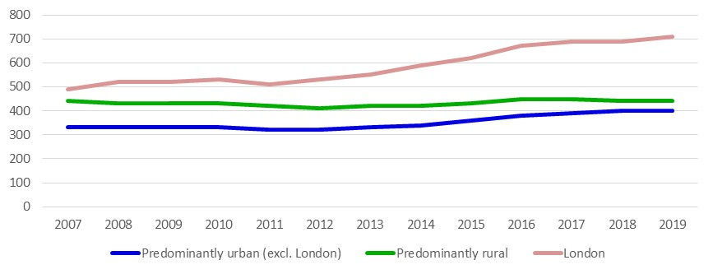
- The number of registered businesses per head of population is higher in Predominantly Rural areas (440 per 10,000 population in 2019) than in Predominantly Urban areas (excluding London) (400 per 10,000 population).

- Between 2018 and 2019 the number of businesses per head of population remained the same in both Predominantly Rural areas and Predominantly Urban areas (excluding London). The rate of increase longer term (since 2011) has been higher for Predominantly Urban areas (excluding London).
- A table of business figures per 10,000 population broken down by detailed local authority rural-urban classification for 2007 to 2019 is available in the rural economy supplementary data tables.

Notes: The data come from Business Demography, which includes businesses that are PAYE registered but not VAT registered. Registered businesses are based on the location of the registered head office, if in multiple locations.
Source:
ONS - VAT Registrations and De-Registrations, ONS - Business Demography 2019: Enterprise Births, Deaths and Survivals, Tables 1.1 and 3.1

Business start-ups
Registered business start-ups per 10,000 population by Local Authority Classification, in England, 2007 to 2019

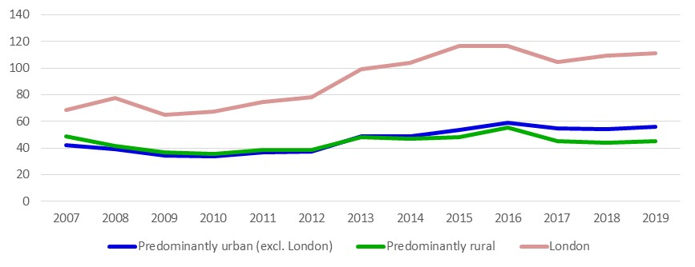
- During the last decade the numbers of registered business start-ups were initially higher (in relative terms) in Predominantly Rural areas than in Predominantly Urban areas (excluding London). However, in recent years, the numbers of start-ups in Predominantly Urban areas (excluding London) have overtaken those in Predominantly Rural areas.
- In 2019 there were 56 registered business start-ups per 10,000 population in Predominantly Urban areas (excluding London) compared with 45 per 10,000 population in Predominantly Rural areas. These numbers show a small increase on 2018 start-ups. Business start-ups have generally increased since 2010, with some fluctuation.
- A table of business start-up figures per 10,000 population broken down by detailed local authority rural-urban classification for 2007 to 2019 is available in the rural economy supplementary data tables.

Notes: The data come from Business Demography, which includes businesses that are PAYE registered but not VAT registered.
Source:
ONS - VAT Registrations and De-Registrations, ONS - Business Demography 2019: Enterprise Births, Deaths and Survivals, Tables 1.1 and 3.1
Research on ‘Drivers of rural business employment growth, decline and stability’ can be found at the following link: //randd.defra.gov.uk/Default.aspx?Module=More&Location=None&ProjectID=18782

Innovation and investment

Businesses engaged in innovation
- Broader innovation activities were undertaken by 58 per cent of rural businesses and 57 per cent of urban businesses surveyed between 2012 and 2014.
- This suggests that being situated in a rural or urban settlement had little effect on the innovation practices of businesses surveyed.
- There is a higher proportion of businesses involved in broader innovation located in areas of Rural Town and Fringe than in areas of Rural Village and Hamlet.
Percentage of businesses in England engaged in broader innovation-related activities, 2012 to 2014

Business involvement with broader-innovation-related activities, 2012 to 2014
 | Broader innovators | Not broader innovators
Urban | 57% | 43%
Rural Town and Fringe | 61% | 39%
Rural Village and Hamlet | 56% | 44%
Rural total | 58% | 42%
England total | 57% | 43%

Notes: These results are based on the unweighted sample of businesses surveyed for England only (therefore the England percentage totals may not match the weighted results published by BEIS). The sample mainly includes enterprise units (i.e. headquarters of businesses) but also has a small number of local units (i.e. sites belonging to enterprises).
BEIS sampling methodology is described in their report and accompanying statistics: https://assets.publishing.service.gov.uk/government/uploads/system/uploads/attachment_data/file/506953/bis-16-134-uk-innovation-survey-2015.pdf. Owing to the small sample sizes achieved after application of the rural-urban definition, this analysis has been presented as the unweighted results from the surveyed sample. Some settlement types were underrepresented in the sample and should be treated with caution: rural town & fringe and Rural Village & hamlet. Furthermore, percentage totals for England may not match those published by BEIS due to minor discrepancies with postcode data.
The description of innovation activity in the chart and table above includes businesses that were engaged in any of the following:
- introduced a new or significantly improved product (good or service) or process
- engaged in innovation projects that have been abandoned or are not yet complete
- undertaken new and significantly improved forms of organisation, business structures or practices, and marketing concepts or strategies
- undertaken activities in areas such as internal research and development, training, acquisition of external knowledge or machinery, and equipment linked to innovation activities
A business engaged in any of the activities 1 to 4 is described as a ‘broader innovator’.
Data from the 2015 UK Innovation Survey may not be directly comparable with data from previous surveys due to changes in survey mode, methodology, sampling approach, questionnaire design and response rate. The rural-urban analyses presented here were performed by applying RUC11 to the data, RUC01 had been used previously for the 2011 UK Innovation Survey. As a result, a comparison cannot be made with previous rural-urban innovation analyses
Source: BEIS UK Innovation Survey 2015 covering innovation activity during 2012 to 2014.

Capital investment per employee
- Companies undertake ‘capital investment’ when spending money on fixed assets (typically land, buildings or machinery) with the expectation that productivity will increase as a result of the investment.
- Continuing recent trends, capital investment per employee in 2018 was highest in London.
- In 2018 capital investment per employee in Predominantly rural areas was around 92 per cent of the level for England as a whole. This compares with 95 per cent in Predominantly urban areas (excluding London).
- Capital investment in absolute terms is only available at current prices so caution should be used when comparing over time. Comparisons below are presented as an index in relation to the level for England as whole.
- Tables of investment per employee, both in current prices and as a percentage of the level for England, broken down by detailed local authority rural-urban classification for 2007 to 2018 are available in the rural economy supplementary data tables.
Capital investment per employee as a percentage of the level for England, by local authority classification in England, 2007 to 2018
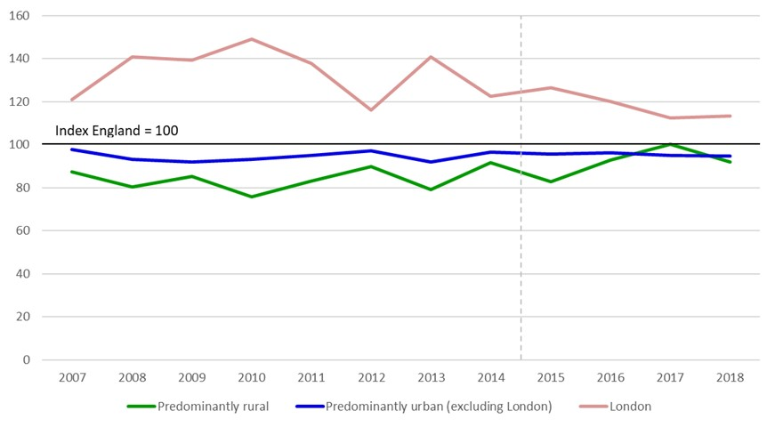
Dashed line: From 2015 employee numbers include estimates from businesses that are solely PAYE based with employment counts less than 20. These businesses were excluded from estimates of employee numbers in earlier years. This has had minimum impact on the data presented.

- Overall capital investment per employee in predominantly rural areas has been consistently lower than in other areas, except in 2017.
- In 2018, investment per head in London was around £5,800, compared with £4,900 in predominantly urban areas excluding London, and £4,700 in predominantly rural areas.
Notes: Total net capital investment is calculated as total proceeds from disposals subtracted from the total cost of acquisitions. The data is at current prices, so it has already taken account of inflation.
Caution should be taken when interpreting this measure as capital investment is difficult to attribute at local authority level. The estimates are produced by taking data at a higher geographical level and apportioning it at local authority level based on employment levels. As ONS are not wholly confident that there is a sufficient correlation between investment and employment, they do not release the data as a National Statistic below National level.
London has been separated out to allow a fair comparison of major urban against all other area classifications.
Source: Bespoke data request from the ONS, Annual Business Inquiry, and Business Register and Employment Survey (classified data); via Nomis (www.nomisweb.co.uk).

Rural accessibility

Transport and travel
- In 2018/19 people living in the most rural areas travelled almost twice as far per year than those in the most urban areas.
- In 2018/19 in the most rural areas 87 per cent of travel was made using a car (as a driver or passenger) compared with 67 per cent in the most urban areas.
- In 2018/19 10 per cent of households in rural areas had no access to a car or van compared with 27 per cent in urban areas.

Travel behaviour
Average number of trips and total distance travelled per person per year, time spent travelling and average trip length in 2018/19, by settlement type, in England
 | Trips  per person | Distance travelled (miles) per person | Travelling time (hours) per person | Trip length (miles)
Urban Conurbation | 894 | 5,037 | 366 | 5.6
Urban City and Town | 1,013 | 6,772 | 368 | 6.7
Rural Town and Fringe | 1,023 | 8,596 | 401 | 8.4
Rural Village, Hamlet and Isolated Dwelling | 1,030 | 9,756 | 404 | 9.5
England | 969 | 6,515 | 373 | 6.7
Source: DfT National Travel Survey Table NTS9903, Table NTS9904, Table NTS9913, Table NTS9910
- The average number of trips is only 6 per cent higher than the national average in rural areas and travelling time per person is only 8 per cent higher. However, the average total distances travelled are much higher for people living in Rural Town and Fringe areas (32 per cent higher) and in Rural Villages, Hamlets and Isolated Dwellings (50 per cent higher).

Notes: The sample size for one year is too small to produce robust results so this analysis combines data from two years.
Trips include those made on foot, by private car or van as both a driver and passenger, by bicycle, motorcycle, private hire bus and other modes of private transport, by local bus, by rail and London Underground, and by non-local bus, taxi / minicab and other modes of public transport (air, ferries and light rail).
The results are weighted. Weights are applied to adjust for non-response to ensure the characteristics of the achieved sample match the population and for the drop off in trip recording. The survey results are subject to sampling error.
Further information: https://www.gov.uk/government/collections/national-travel-survey-statistics
Source: DfT, National Travel Survey, Email: national.travelsurvey@dft.gov.uk

Distance travelled
Average total distance travelled, per person per year, by mode and settlement type, in England,
2018/19
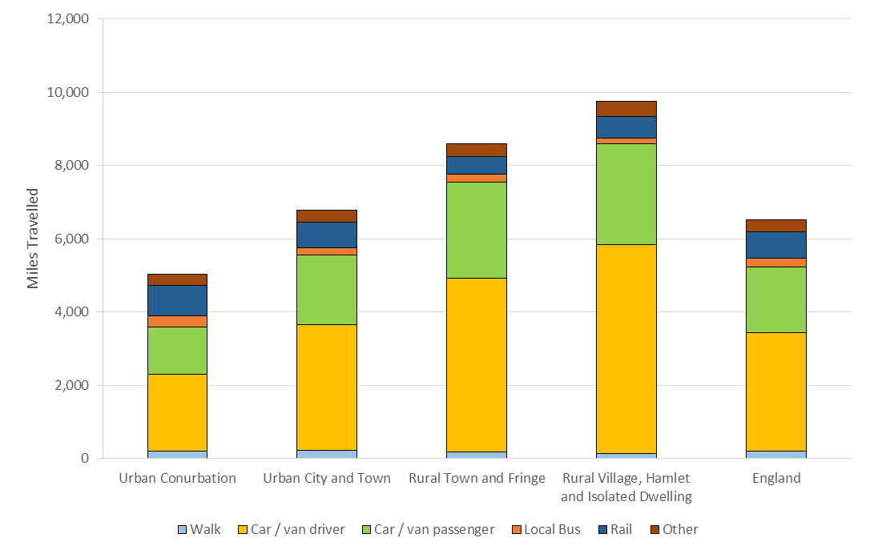
- In 2018/19 people living in Rural Villages, Hamlets and Isolated Dwellings travelled 9,756 miles on average compared with 5,037 in Urban Conurbation and 6,515 in England as a whole.
- When travel as both a car driver and passenger are taken together, 87 per cent of the distance travelled by people living in Rural Villages, Hamlets and Isolated Dwellings was made by car compared with 67 per cent in Urban Conurbations and 77 per cent in England as a whole.
Average total distance travelled, per person per year, by mode and settlement type, in England, 2018/19
 |  |  |  |  | Miles per person per year
 | Walk | Car/van driver | Car / van passenger | Local bus |  | Rail | Other | All modes
Urban Conurbation | 212 | 2,096 | 1,277 | 311 |  | 837 | 303 | 5,037
Urban City and Town | 223 | 3,434 | 1,910 | 178 |  | 702 | 326 | 6,772
Rural Town and Fringe | 183 | 4,741 | 2,612 | 238 |  | 477 | 344 | 8,596
Rural Village, Hamlet and Isolated Dwelling | 131 | 5,715 | 2,750 | 153 |  | 599 | 408 | 9,756
England | 207 | 3,225 | 1,798 | 233 |  | 726 | 326 | 6,515
Source: DfT National Travel Survey Table NTS9904

Average total distance travelled, per person per year, by mode of transport and settlement type, in England, 2009/10 to 2018/19
Note: The scales (y-axis) in charts below differ and this should be considered when making cross-modal comparisons

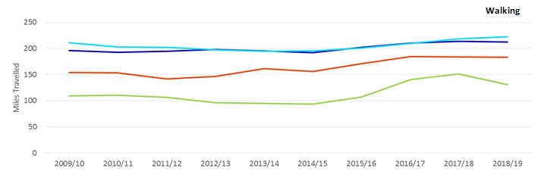
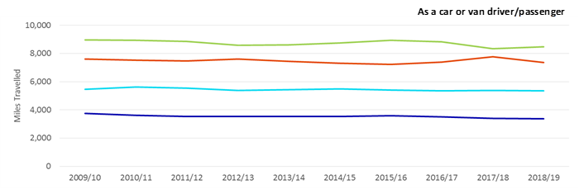
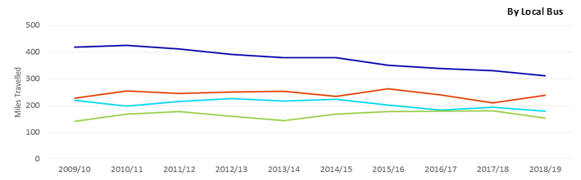
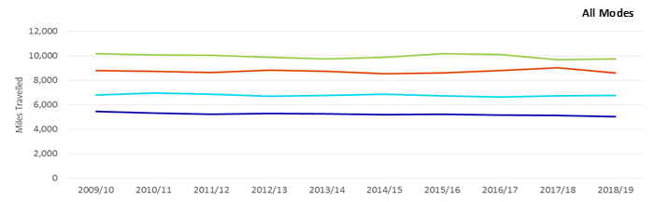
- The miles travelled by walking has increased more in Rural areas than in Urban areas over the period 2009/10 to 2018/19. Average distance travelled by those from Rural Villages, Hamlets and Isolated Dwellings has increased by 22 miles (17 per cent) and by those living in Rural Town and Fringe by 29 miles (16 per cent).
- The miles travelled by local bus has decreased by 107 miles per person per year Urban Conurbations over the period 2009/10 to 2018/19. Miles travelled by local bus has increased slightly in rural areas over the same time period.
- The distance travelled by car has remained stable over the period 2009/10 to 2018/19 across all settlement types.
- Tables of the average total distance travelled per person per year broken down by mode of transport and rural-urban classification for 2009/10 to 2018/19 are available in the rural living supplementary data tables.

Notes: The sample size for one year is too small to produce robust results so this analysis combines data from two years.
Distance by mode is based on stage distance.
Local Bus includes London buses. Rail includes London Underground. Other includes: bicycle, motorcycle, private hire bus, other modes of private transport, non-local bus, taxi / minicab and other modes of public transport (air, ferries, light rail).
These data are available broken down into these more discrete categories in the accompanying Excel document but were presented in this manner in the digest for clarity - https://www.gov.uk/government/statistics/national-travel-survey-2019- National Travel Survey: 2019 Tables, Table NTS9904 .
The results are weighted. Weights are applied to adjust for non-response to ensure the characteristics of the achieved sample match the population and for the drop off in trip recording. The survey results are subject to sampling error.
Further information: https://www.gov.uk/government/collections/national-travel-survey-statistics
Source: DfT, National Travel Survey, Email: national.travelsurvey@dft.gov.uk

Average trip length (miles), by settlement type, in England, 2002/03 and 2018/19
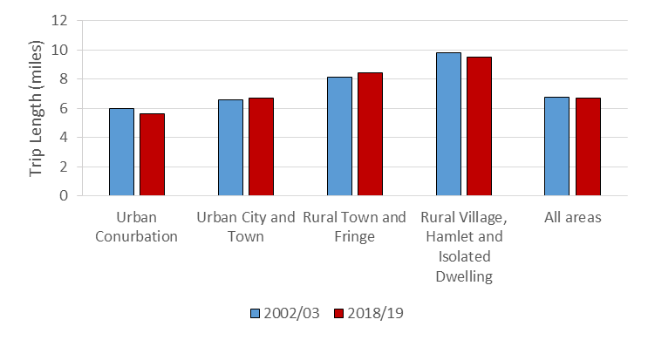
- There has been a small decrease in the average trip length for both Urban Conurbation (6 per cent decrease from 6.0 to 5.6 miles) and Rural Village, Hamlet and Isolated Dwelling (4 per cent decrease from 9.8 to 9.5 miles) between 2002/03 and 2018/19.
- There has been a small increase in the average trip length for Rural Town and Fringe (3 per cent increase from 8.1 to 8.4 miles) and Urban with City and Town (1 per cent increase from 6.6 to 6.7 miles) between 2002/03 and 2018/19.
- The average trip length for was 6.6 miles in both 2002/03 and 2017/18.

Average trip length (miles), by settlement type, in England, 2002/03 and 2018/19
 | Average trip length (miles)
 | 2002/03 | 2018/19
Urban Conurbation | 6.0 | 5.6
Urban City and Town | 6.6 | 6.7
Rural Town and Fringe | 8.1 | 8.4
Rural Village, Hamlet and Isolated Dwelling | 9.8 | 9.5
England | 6.8 | 6.7
Source: DfT National Travel Survey Table NTS9910

Notes: The sample size for one year is too small to produce robust results so this analysis combines data from two years.
For a full time series from 2002/03 to 2018/19 please see the original DfT dataset https://www.gov.uk/government/statistics/national-travel-survey-2019 - National Travel Survey: 2019 Tables, Table NTS9910
The results are weighted. Weights are applied to adjust for non-response to ensure the characteristics of the achieved sample match the population and for the drop off in trip recording. The survey results are subject to sampling error.
Further information: https://www.gov.uk/government/collections/national-travel-survey-statistics
Source: DfT, National Travel Survey, Email: national.travelsurvey@dft.gov.uk

Average number of miles travelled, per person per year, by purpose and settlement type, in England, 2018/19
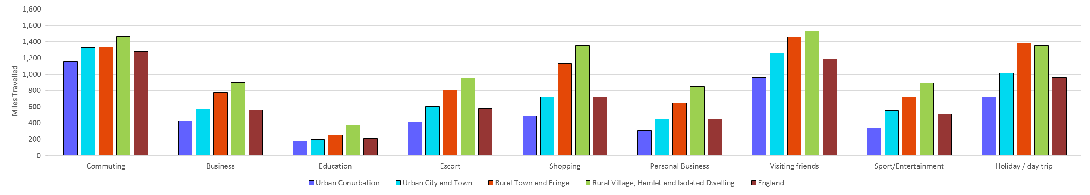
- In 2018/19 those living in rural areas travelled more miles for all purposes than those in urban areas.
- In almost all categories those living in Rural Villages, Hamlets and Isolated Dwellings travelled farther than those in other settlements types. The only journey purpose where this was not the case was ‘holiday/day trip’ (for which those in Rural Town and Fringe travelled farthest).
- For all purposes, those living in Urban Conurbations travelled the fewest miles compared with those living in other settlement types. The only journey purpose where this difference was quite small was ‘education’, where the distance travelled was very similar in Urban Conurbations and Urban with City and Town.
- For the purposes of ‘business’, ‘education’, ‘escort’, ‘shopping’, ‘personal business’ and ‘sport/entertainment’ those living in Rural Villages, Hamlets and Isolated Dwellings travelled more than twice the distance each year when compared to those living in Urban Conurbations.
- A table of the average number of miles travelled per person per year broken down by purpose and rural-urban classification for 2018/19 is available in the rural living supplementary data tables.

Notes: The sample size for one year is too small to produce robust results so this analysis combines data from two years.
The ‘escort’ category contains both escorting to education institutions and other escorting.
The ‘visiting friends’ category contains both visiting friends at a private home and visiting friends elsewhere.
These data are available broken down into these more discrete categories in the accompanying Excel document but were presented in this manner in the digest for clarity -https://www.gov.uk/government/statistics/national-travel-survey-2019 - National Travel Survey: 2019 Tables, Table NTS9907
The results are weighted. Weights are applied to adjust for non-response to ensure the characteristics of the achieved sample match the population and for the drop off in trip recording. The survey results are subject to sampling error.
Further information: https://www.gov.uk/government/collections/national-travel-survey-statistics
Source: DfT, National Travel Survey, Email: national.travelsurvey@dft.gov.uk

Trips made
Average number of trips made, per person per year, by mode and settlement type, in England,
2018/19
- Those living in Rural Town and Fringe make on average 10 more trips per year compared with those in Urban with City and Town and 129 more trips than those living in Urban Conurbations.
- People living in Rural Villages, Hamlets and Isolated Dwellings are less likely to use walking as their mode of transport, making 15 per cent of trips this way compared with 26 per cent for England as a whole.
- When combining journeys made as a car or van driver and those made as a passenger these make up 78 per cent of trips for those in Rural Villages, Hamlets and Isolated Dwellings compared with 61 per cent for England as a whole.
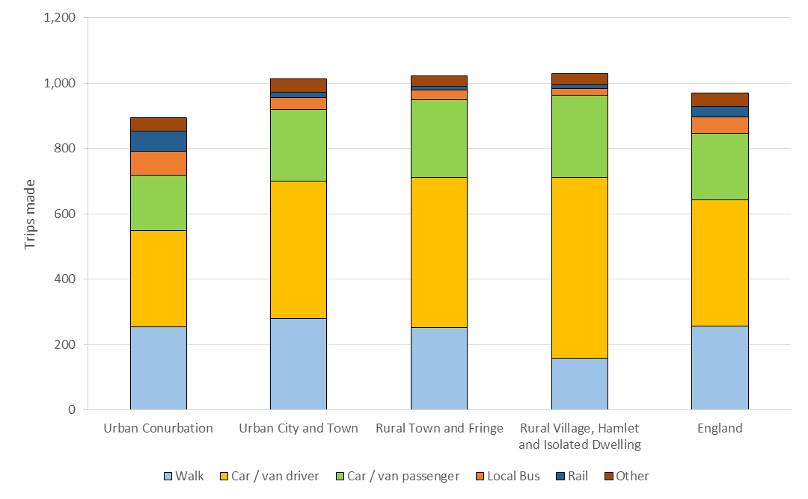
Average number of trips per person per year, by mode and settlement type, in England, 2018/19
 | Trips per person per year
 | Walk | Car/van driver | Car / van passenger | Local bus | Rail | Other | All modes
Urban Conurbation | 254 | 296 | 168 | 75 | 60 | 42 | 894
Urban City and Town | 279 | 421 | 220 | 35 | 18 | 41 | 1,013
Rural Town and Fringe | 252 | 460 | 238 | 29 | 12 | 34 | 1,023
Rural Village, Hamlet and Isolated Dwelling | 158 | 554 | 250 | 21 | 12 | 35 | 1,030
England | 256 | 387 | 204 | 49 | 33 | 40 | 969
Source: DfT National Travel Survey Table NTS9903

- The data in this table and a percentage breakdown are available in the rural living supplementary data tables.

Average number of trips made, per person per year, by mode and settlement type, in England, 2009/10 to 2018/19
Note: The scales (y-axis) in charts below differ and this should be considered when making comparisons

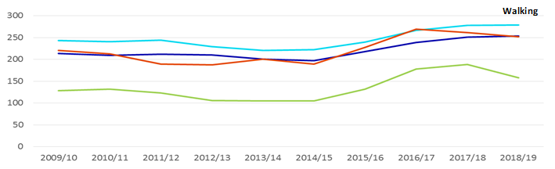
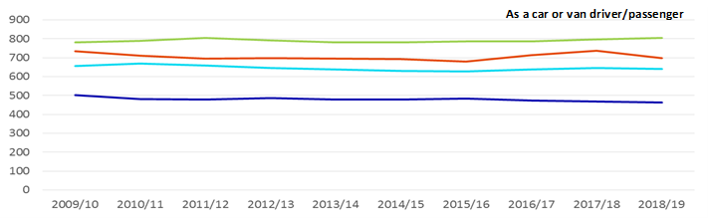
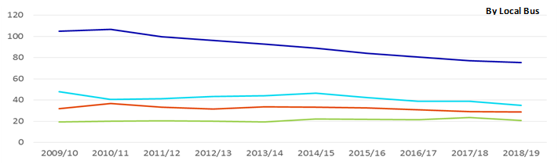
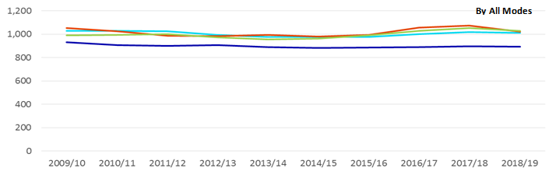
- The number of trips made by walking is lowest for Rural Villages, Hamlets and Isolated Dwellings.
- For the time period of 2009/10 to 2018/19, Rural areas have made fewer than half as many trips per person by local bus as Urban Conurbations.
- The more urban a settlement, the fewer the number of trips made on average by car per person.
- Over the time period people living in Urban Conurbations made fewer trips on average than those living in Urban with City and Town or Rural areas.
- Tables of the average number of trips made per person per year broken down by mode of transport and rural-urban classification for 2009/10 to 2018/19 are available in the rural living supplementary data tables.

Notes: The sample size for one year is too small to produce robust results so this analysis combines data from two years.
Local bus includes London buses.
Rail includes surface rail and London Underground.
Other includes bicycle, motorcycle, private hire bus, non-local bus, taxi/minicab and other modes of public transport (air, ferries, light rail).
These data are available broken down into these more discrete categories in the accompanying Excel document but were presented in this manner in the digest for clarity - https://www.gov.uk/government/statistics/national-travel-survey-2019 - National Travel Survey: 2019 Tables, Table NTS9903
The results are weighted. Weights are applied to adjust for non-response to ensure the characteristics of the achieved sample match the population and for the drop off in trip recording. The survey results are subject to sampling error.
Source: DfT, National Travel Survey, Email: national.travelsurvey@dft.gov.uk
Further information: https://www.gov.uk/government/collections/national-travel-survey-statistics

Journey to School
Average journey length to school by settlement type and age group, in England, 2018/19
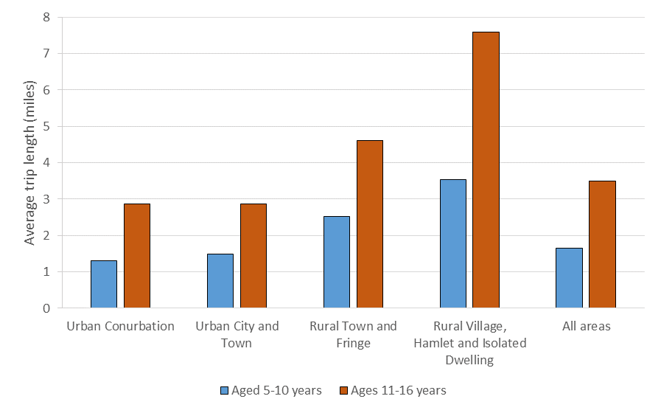
- The average journey length to school is longer for those living in rural areas than urban ones. Those with the longest journey are 11 to 16-year olds living in Rural Villages, Hamlets and Isolated Dwellings who travel 7.6 miles on average, this compares with a journey of 2.9 miles in an Urban Conurbation for the same age group. This means 11 to 16-year olds in Rural Villages, Hamlets and Isolated Dwellings are travelling over 2.5 times as far as those in Urban Conurbations to get to school.

Average journey length (miles) to school by age group and settlement type, in England, 2018/19
 | Average journey length (miles)
 | Aged 5-10 years | Aged 11-16 years
Urban Conurbation | 1.3 | 2.9
Urban City and Town | 1.5 | 2.9
Rural Town and Fringe | 2.5 | 4.6
Rural Village, Hamlet and Isolated Dwelling | 3.5 | 7.6
England | 1.7 | 3.5
Source: DfT National Travel Survey Table NTS9908

Mode of transport used for journey to school by settlement type, in England, 2018/19
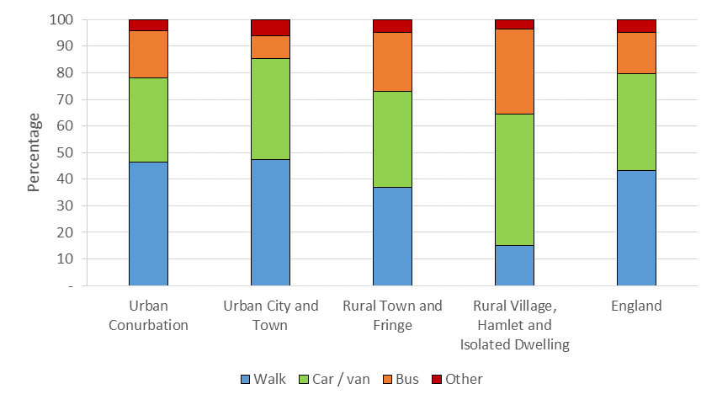
- Children are less likely to walk to school if they live in Rural Villages, Hamlets and Isolated Dwellings. Only 15 per cent of children living in these settlement types walk to school, compared with 37 per cent of those living in Rural Town and Fringe, 47 per cent of those living in Urban with City and Town and Urban Conurbations.
- In comparison, 49 per cent of children living in Rural Villages, Hamlets and Isolated Dwelling make their journey to school by car or van compared with 36 per cent in Rural Town and Fringe, 38 per cent in Urban with City and Town and 32 per cent in Urban Conurbations.

 |  | Percentage
 | Walk |  | Car / van | Bus | Other | All Modes
Urban Conurbation | 47 |  | 32 | 18 | 4 | 100
Urban City and Town | 47 |  | 38 | 9 | 6 | 100
Rural Town and Fringe | 37 |  | 36 | 22 | 5 | 100
Rural Village, Hamlet and Isolated Dwelling | 15 |  | 49 | 32 | 3 | 100
England | 43 |  | 36 | 15 | 5 | 100
Mode of transport used for journey to school by settlement type, in England, 2018/19

Notes: The sample size for one year is too small to produce robust results so this analysis combines data from two years.
Includes trips under 50 miles only.
Bus includes public and private buses (including school buses). Other includes bicycle, rail, other private and public transport.
These data are available broken down into more discrete categories in the accompanying Excel document but were presented in this manner in the digest for clarity - https://www.gov.uk/government/statistics/national-travel-survey-2019- National Travel Survey: 2019 Tables, Table NTS9908
The results are weighted. Weights are applied to adjust for non-response to ensure the characteristics of the achieved sample match the population and for the drop off in trip recording. The survey results are subject to sampling error.
Further information: https://www.gov.uk/government/collections/national-travel-survey-statistics
Source: DfT, National Travel Survey, Email: national.travelsurvey@dft.gov.uk

Car Availability
Household car availability by settlement type, in England, 2018/19
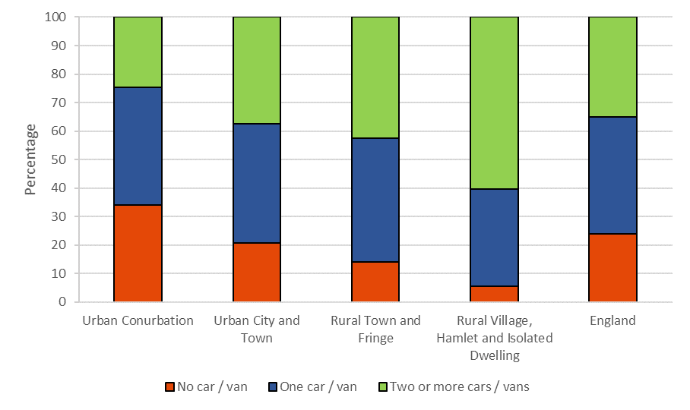
- In 2018/19 the percentage of households with no access to a car or van was lower in rural areas than in urban areas. Only 5 per cent of households in Rural Villages, Hamlets or Isolated Dwellings do not own a car compared with 34 per cent in Urban Conurbations.
- 60 per cent of households in Rural Villages, Hamlets or Isolated Dwellings own two or more cars/vans compared with 25 per cent of those in Urban Conurbations.
- Between 2009/10 and 2018/19, the proportion of households in Urban Conurbations with no car/van was at least 4 times greater than the proportion of households from Rural Villages, Hamlets or Isolated Dwellings.
- In the last 10 years, there has been little change in the % of houses with a car available for any settlement type.
- Tables of household car ownership, broken down by rural-urban classification for 2009/10 to 2018/19 are available in the rural living supplementary data tables.

Notes: The sample size for one year is too small to produce robust results so this analysis combines data from two years.
The results are weighted. Weights are applied to adjust for non-response to ensure the characteristics of the achieved sample match the population and for the drop off in trip recording. The survey results are subject to sampling error.
For a full time series from 2002/03 to 2018/19 please see the original DfT dataset - https://www.gov.uk/government/statistics/national-travel-survey-2019 - National Travel Survey: 2019 Tables, Table NTS9902
Further information: https://www.gov.uk/government/collections/national-travel-survey-statistics
Source: DfT, National Travel Survey, Email: national.travelsurvey@dft.gov.uk

Bus Availability – Updated with most recent data currently available
Bus availability indicator by settlement type, in England, 2002 to 2012
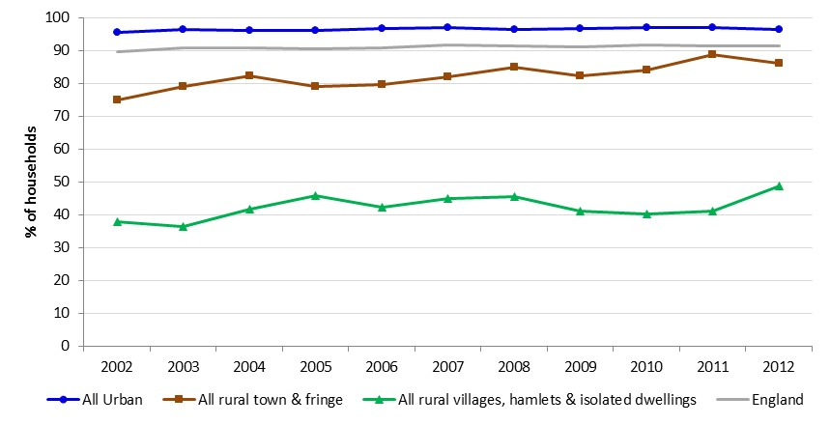
Bus availability is expressed as the percentage of households where nearest bus stop is within 13 minutes’ walk and has a service at least once an hour.
- Between 2002 and 2012 bus availability in Rural Villages, hamlets & isolated dwellings increased from 38 per cent to 49 per cent, with a sharp increase of 8 percentage points between 2011 and 2012. Although bus availability in rural town & fringe increased from 75 to 86 per cent between 2002 and 2012, there was a decrease of 3 percentage points between 2011 and 2012.
- Since 2002 bus availability in urban areas has remained at a stable level of 96 – 97 per cent of households.
- A table of bus availability, broken down by rural-urban classification for 2002 to 2012 is available in the rural living supplementary data tables. This is the most recent data available as Department for Transport ceased calculation of this indicator.

Notes: The results are weighted. Weights are applied to adjust for non-response to ensure the characteristics of the achieved sample match the population and for the drop off in trip recording. The survey results are subject to sampling error.
Further information: https://www.gov.uk/government/collections/national-travel-survey-statistics
Source: DfT, National Travel Survey, Email: national.travelsurvey@dft.gov.uk

Accessibility to services

- Monitoring accessibility is important because it can help identify who has access to, and therefore benefits from, services and who might be disadvantaged. Ways of measuring accessibility include assessing the time taken to travel to particular service locations and the number of services reachable within specified travel times.
- Generally, people living in rural settlements have lower overall levels of accessibility to key service locations compared with people living in urban settlements, while people living in rural areas in a sparse setting have the lowest overall accessibility.
  - The average minimum travel times to reach the nearest key services were longer for people living in rural areas for all services, compared with people living in urban areas.
  - More services were available on average for people living in urban areas for all service types and all journey times compared with those for people living in rural areas, when walking and using public transport.

  - For travel by public transport or walking in 2017:
    - the average minimum travel time to a hospital was a little over one hour in rural areas, compared with a little over half an hour in urban areas.
    - fewer than half the users living in rural areas have access to places with 5,000 or more jobs within 45 minutes, compared with 90 per cent of users living in urban areas.
    - 43 per cent of users living in rural areas do not have access to their nearest hospital within an hour’s travel, compared with 6 per cent of users living in urban areas.
    - the average number of key service locations accessible to people living in rural areas was highest for primary schools and food stores with 9 available within a 60-minute journey time.
    - the services with the lowest average number of service locations available to people living in rural areas within a 60-minute journey time were hospitals (with around one) and places with 5,000 or more jobs available (with around two).

  - For travel by car in 2017:
    - for people living in Rural Hamlets and Isolated Dwellings in a sparse setting, average minimum journey times to centres of employment with 5,000 or more jobs was 47 minutes and it took on average 34 minutes to travel to the nearest hospital.
    - some users in rural areas do not have access to centres of employment with over 5,000 jobs or hospitals within an hour’s travel by car.
    - people living in rural areas had on average two General Practices available within a 15-minute journey compared with eight General Practices available for people living in urban areas.

Average minimum travel times
- For travel by public transport and walking, cycling and by car, the average minimum travel times to reach the nearest key services were longer for people living in rural areas for all services, compared with people living in urban areas.






- For travel by public transport or walking: In rural areas the services with the lowest level of accessibility were hospitals and centres of employment with 5,000 or more jobs. The average minimum travel time to a hospital was a little over one hour in rural areas, compared with a little over half an hour in urban areas. The average travel time to places with 5,000 or more jobs was 56 minutes in rural areas compared with 27 minutes in urban areas. For all key service types, the average minimum rural travel times were around double the average minimum urban travel times.

- For travel by car: For people living in rural areas, making the same journey by car compared with using public transport or walking, had the effect of halving the average minimum journey times. Urban areas also saw a reduction in travel times when comparing travel by car with public transport or walking but the difference was less pronounced. The average minimum travel time across all eight services was 37 per cent higher in rural areas compared with urban areas overall. For people living in Rural Hamlets and Isolated Dwellings in a sparse setting, average minimum journey times by car to centres of employment with 5,000 or more jobs was around 47 minutes and over half an hour to travel to the nearest hospital.

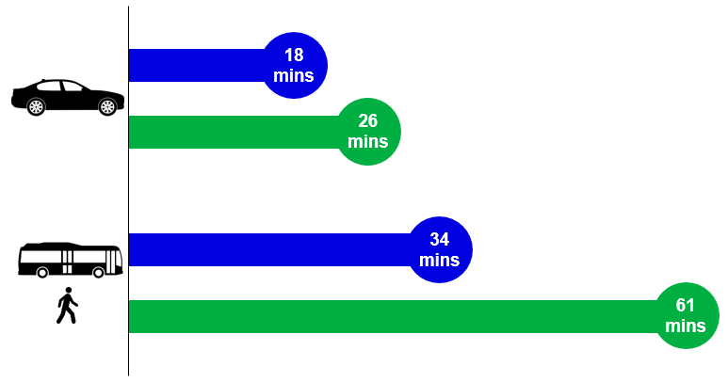
The average travel time in rural areas by public transport to a hospital is more than twice as long as the average travel time in urban areas.

Average minimum travel time to reach the nearest key services by mode of travel, by Lower Super Output Area rural urban classification, in England, 2017

by public transport or walking
Minutes
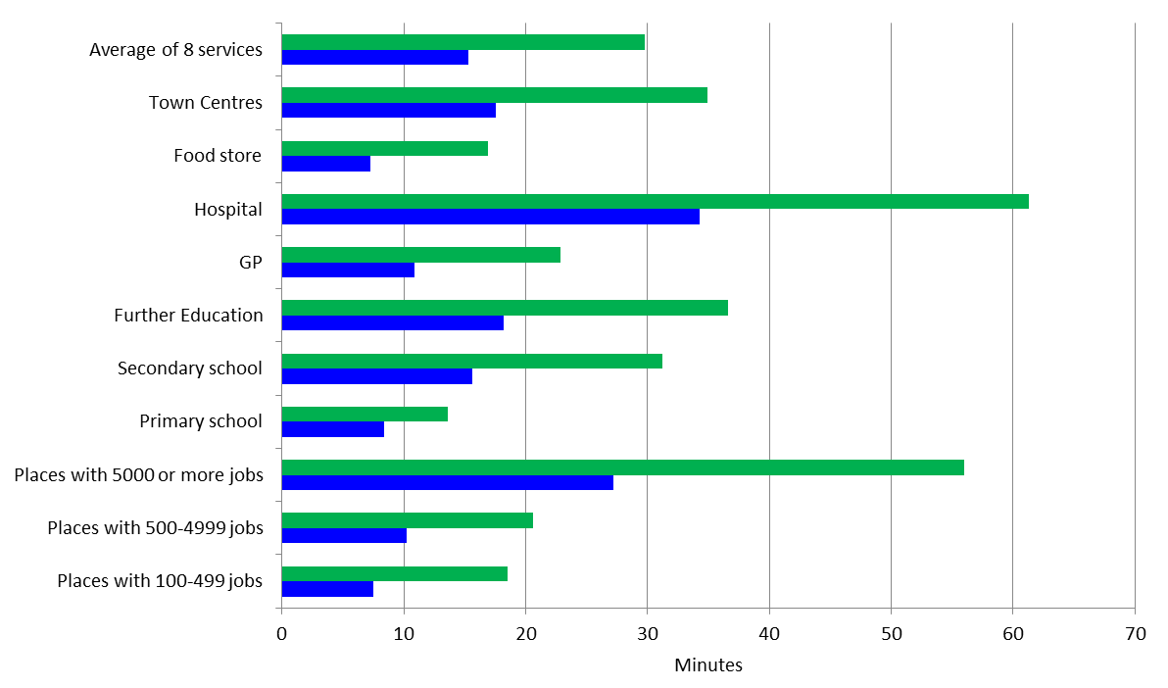

by car
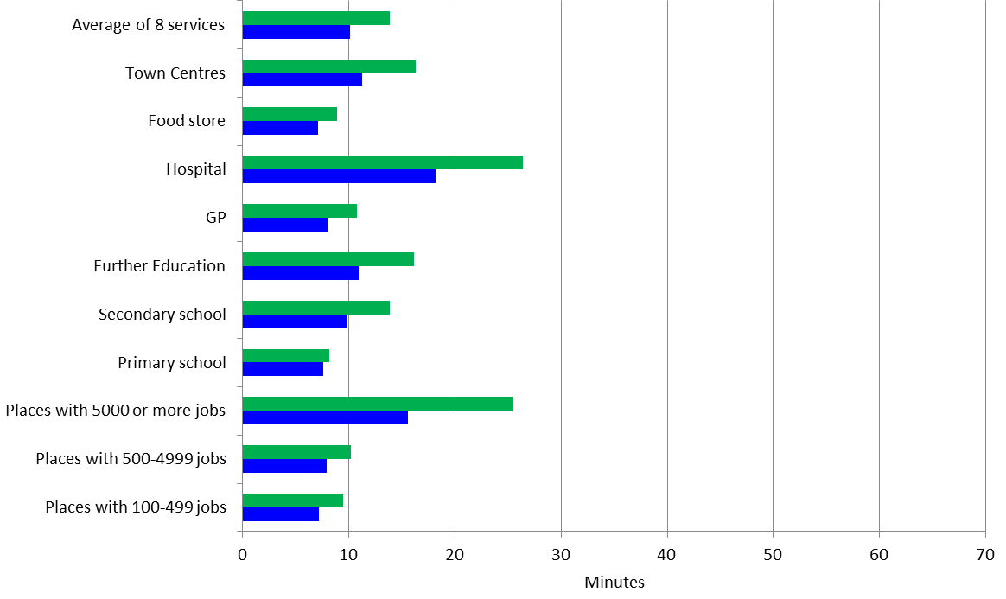

Tables of average minimum travel times to key services, broken down by mode of transport (public transport, car and cycling) and rural-urban classification for 2017 are available in the rural living supplementary data tables.
Note: The average of 8 services is calculated from the minimum journey times to medium sized centres of employment (500-4999 jobs), primary and secondary schools, further education, GPs, hospitals, food stores and town centres.

Access to key services
- For travel by public transport or walking: Fewer than half the users living in rural areas have access to places with 5,000 or more jobs within 45 minutes, compared with around 90 per cent of users living in urban areas. 43 per cent of users living in rural areas do not have access to their nearest hospital within an hour’s travel, compared with 6 per cent in urban areas.

- For travel by car: All service users living in rural areas had access to places with 100 to 499 jobs and 500 to 4,999 jobs, town centres, food stores, General Practices, and key places of education within 60 minutes by car. However small proportions of users in rural areas do not have access to places with over 5,000 jobs or hospitals within 60 minutes by car.


80.9% of rural residents
99.5% of urban residents
80.9 per cent of people living in rural areas have access to a GP within half an hour’s travel using public transport and walking, compared with 99.5 per cent of people living in urban areas.

Percentage of service users with access to key services within selected journey times by mode of travel, by Lower Super Output Area rural urban classification, in England, 2017

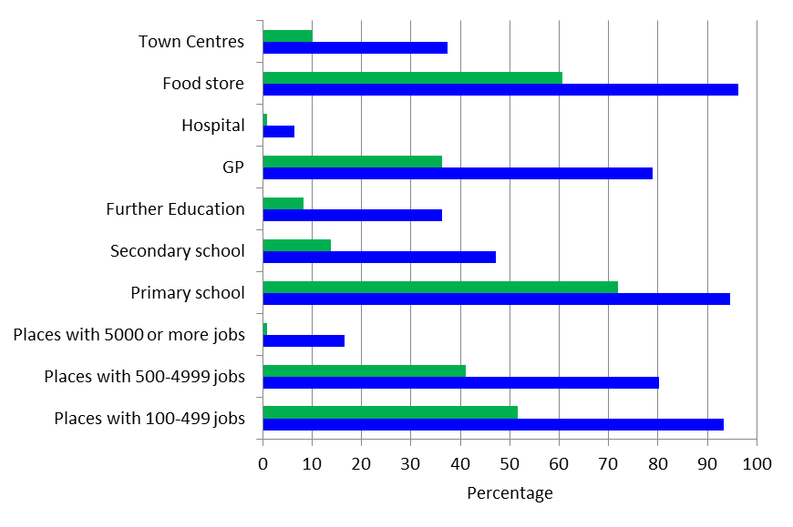
by public transport or walking for journey times within 15 minutes

by car for journey times within 15 minutes
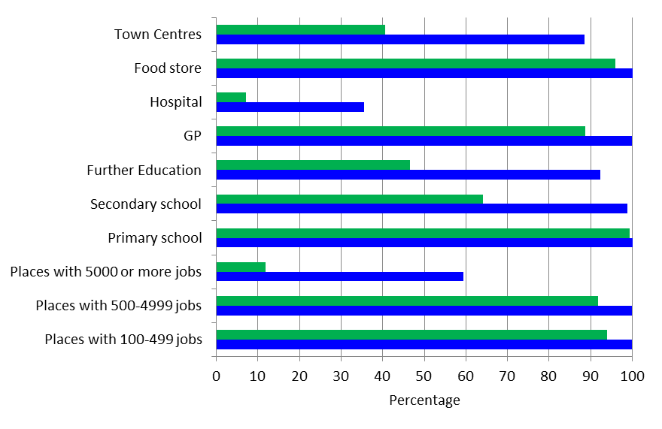
Tables of percentage of service users with access to key services in rural and urban areas, broken down by mode of transport (public transport, car and cycling) for 2017 are available in the rural living supplementary data tables.

Average number of key services available
- For travel by public transport or walking: The average number of key service locations accessible to people living in rural areas was highest for places with 100-499 jobs, places with 500-4999 jobs, primary schools and food stores, with around 9 available within a 60-minute journey time. The services with the lowest average number of service locations available were hospitals and centres of employment with 5,000 or more jobs, with none available for either service within a 30 minute journey time, and one hospital and two places with 5,000 or more jobs available within a 60 minute journey time.

- More services were available on average for people living in urban areas for all service types and all journey times compared with those for people living in rural areas when travelling by public transport or walking, or cycling.

- For travel by car: Similar availability of services can be observed for travel by car. For people living in rural areas the number of General Practices available within a 15-minute journey time by public transport or walking was less than one, however by car this increased to an average of 2.4. For people living in urban areas, the number of General Practices available within a 15-minute journey time by public transport or walking was two and this increased to around eight General Practices when travelling by car.

Average number of sites available within selected journey times, by mode of travel, by Lower Super Output Area rural urban classification 2011, England, 2017

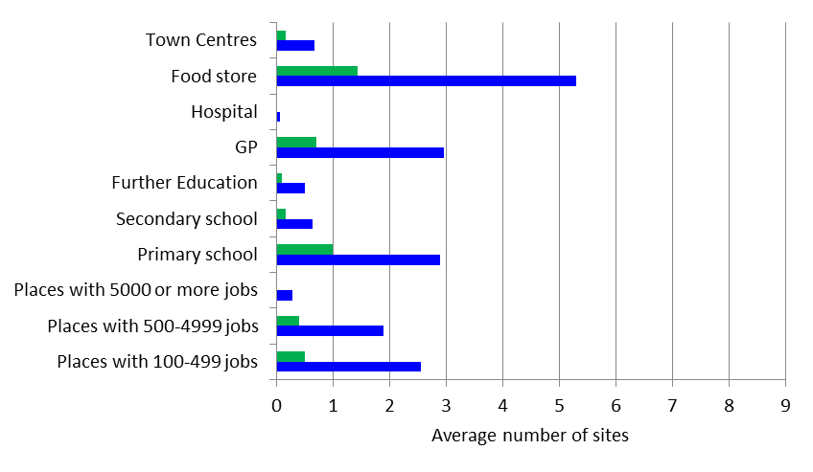
by public transport or walking for journey times within 15 minutes
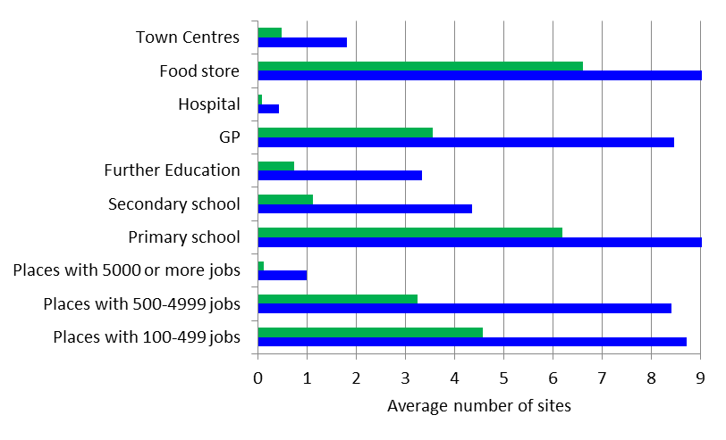
by car for journey times within 15 minutes
Tables of average number of key service sites available within 15, 30, 45 or 60 minutes of travel in rural and urban areas, broken down by mode of transport (public transport, car and cycling) for 2017 are available in the rural living supplementary data tables.
Notes: Technical information on Journey Time Statistics can be found at https://www.gov.uk/government/publications/journey-time-statistics-guidance
Source: DfT Journey Time Statistics: www.gov.uk/government/collections/journey-time-statistics#data-tables (files JTS0102, JTS0202, JTS0302)

Overall measure of accessibility of services
This measure of accessibility of services is determined by looking at average minimum travel times to key services, when travelling by either public transport and walking, or by car.

To get an assessment of service accessibility the average minimum travel time to the following nine types of service have been used:

- medium and large centres of employment (locations where over 500 people are employed across the businesses and services there, such that a range of jobs are likely to be available)
- primary school
- secondary school
- further education
- doctors’ surgery
- hospital
- food store
- town centre
- post office (recent post office data is currently unavailable, so these calculations are using 2016 data for post offices rather than 2017)

For each area an overall accessibility index has been calculated by indexing and weighting the minimum travel times to key services. Travel times were indexed in terms of relative travel times and weighted to take account of the frequency of use of each service. This means that infrequently used but important services (e.g. hospital) if distant do not disproportionately affect the overall index for an area (see notes for more details).

Accessibility to services (derived from minimum travel times) has been presented on maps based on this overall index for travelling by public transport and walking, and for travelling by car. Rural areas are shown in green and urban areas are shown in blue, the darker the area, the poorer the accessibility of services.

- When using public transport and walking rural areas generally have poorer accessibility to services based on minimum travel times than urban areas.
- Unsurprisingly, travelling by car generally reduces travel times to key services, but overall differences in relative travel times are similar to those experienced when using public transport and walking, and rural areas still tend to have poorer accessibility (in terms of minimum travel times), compared with urban areas.

Public Transport and Walking
- When using public transport and walking rural areas generally have poorer accessibility to services based on minimum travel times than urban areas.
- Rural areas tend to have poorer accessibility to services based on minimum travel times than urban areas when using public transport or walking.
  - 51 per cent of the rural population are living in areas that have the poorest accessibility to services (lowest 10 per cent decile) based on minimum travel times, compared with 2 per cent of the urban population).
  - 0.2 per cent of the rural population are living in areas that have the greatest accessibility to services (highest 10 per cent decile) based on minimum travel times, compared with 13 per cent of the urban population.
- As might be expected, sparsely populated areas tend to have poorer accessibility of services based on minimum travel times when using public transport or walking:
  - 9 per cent of the population living in Urban with City and Town areas in a sparse setting have the poorest accessibility to services (lowest 10 per cent decile) services based on minimum travel times, compared with 3 per cent of the population living in Urban with City and Town areas not in a sparse setting.
  - 26 per cent of the population living in Rural Town and Fringe areas in a sparse setting have the poorest accessibility to services (lowest 10 per cent decile) based on minimum travel times compared with 24 per cent of the population living in Rural Town and Fringe areas not in a sparse setting.
- 96 per cent of the population living in Rural Village and Dispersed areas in a sparse setting have the poorest accessibility to services (lowest 10 per cent decile) based on minimum travel times compared with 80 per cent of the population living in Rural Village and Dispersed areas not in a sparse setting.
Proportion of the population within each decile for accessibility of services based on minimum travel times by public transport and walking, by rural-urban classification, England, 2017
 | Poorest accessibility of services |  |  |  |  |  | Greatest accessibility of services
Decile | 1 | 2 | 3 | 4 | 5 | 6 | 7 | 8 | 9 | 10
Urban | 2% | 7% | 9% | 10% | 11% | 11% | 12% | 12% | 12% | 13%
Rural | 51% | 23% | 11% | 6% | 4% | 2% | 1% | 1% | 1% | <1%
Source: Department for Transport (DfT) 2 and Defra analysis, ONS mid-year population estimates 20173

A table showing the proportion of the population within each decile for accessibility of services by public transport and walking in 2017, broken down using a more detailed rural-urban classification is available in the rural living supplementary data tables.

Proportion of population within each decile of accessibility of services based on minimum travel times by public transport and walking, by rural-urban classification and detailed rural classification, England, 2017
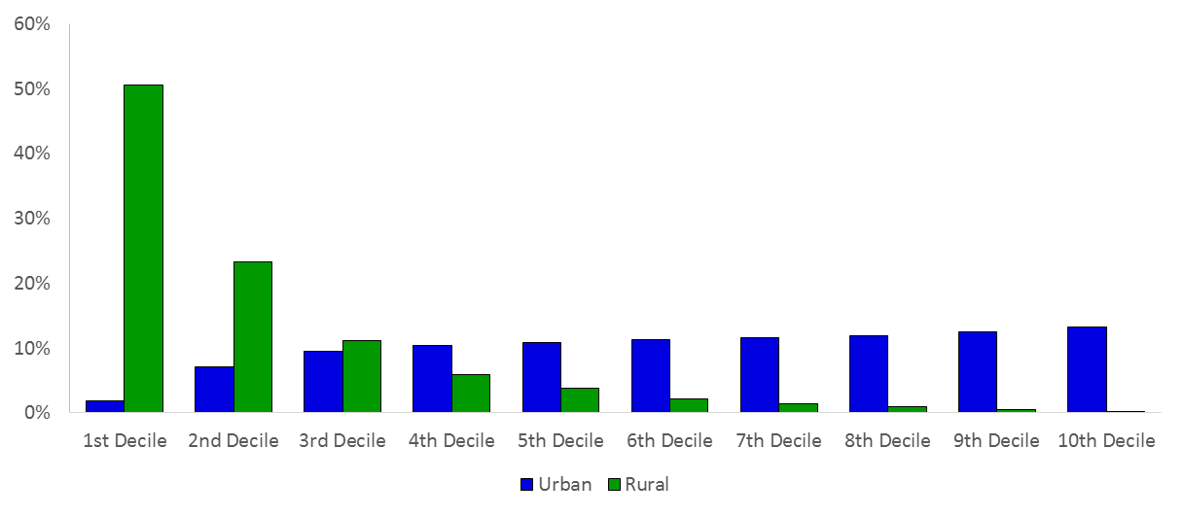
Poorest accessibility / longest travel times)
Greatest accessibility / shortest travel times

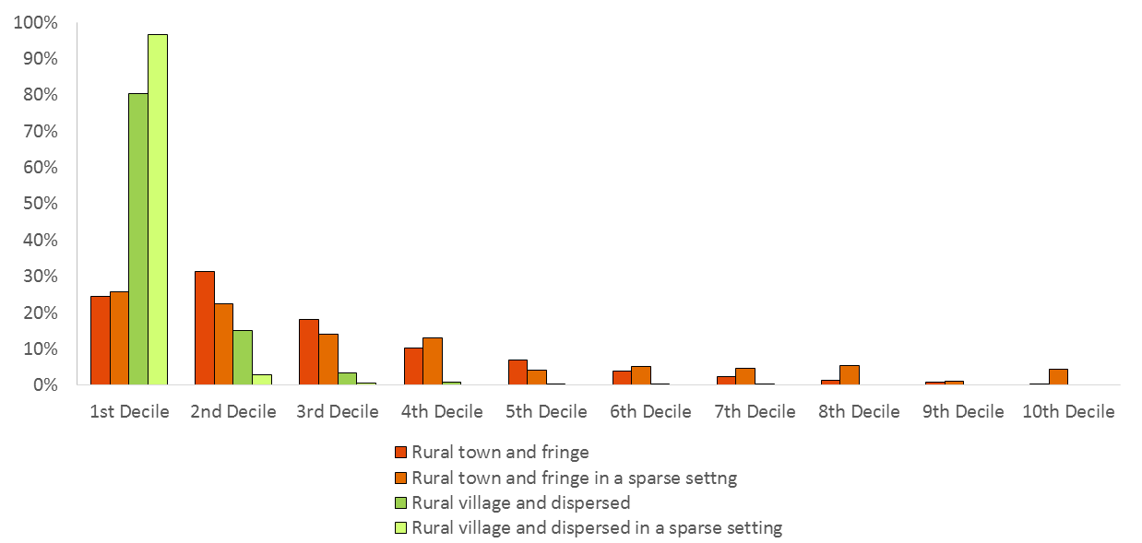
Poorest accessibility / longest travel times)
Greatest accessibility / shortest travel times

As the poorest decile of accessibility of services is predominantly made up of rural LSOAs we were unable to map the data by decile. This is because the map was almost entirely coloured in with the darkest green (denoting poorest accessibility) and therefore showed little information that was not already presented in the graphs above. Because of this we instead mapped the data using Jenks; a method which aims to group data in a way that minimises the variability within each group whilst maximising the variability between groups. A drawback of this method is that the maps cannot be compared to previous years because the thresholds for the 10 groups will not be the same. However, this method does allow the areas with the poorest accessibility to be differentiated from those which are slightly better, and also shows which areas have similar levels of accessibility of services to each other.
Accessibility of services based on minimum travel times using public transport and walking
Accessibility of services based on minimum travel times using public transport and walking, by rural-urban classification (Lower Super Output Areas1), in England (2017)
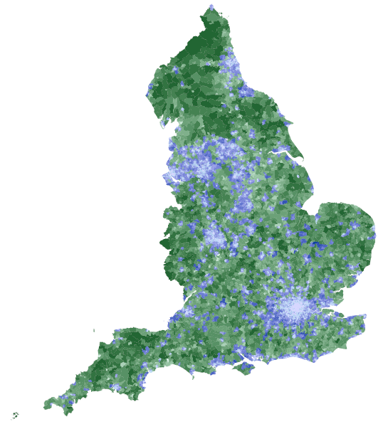
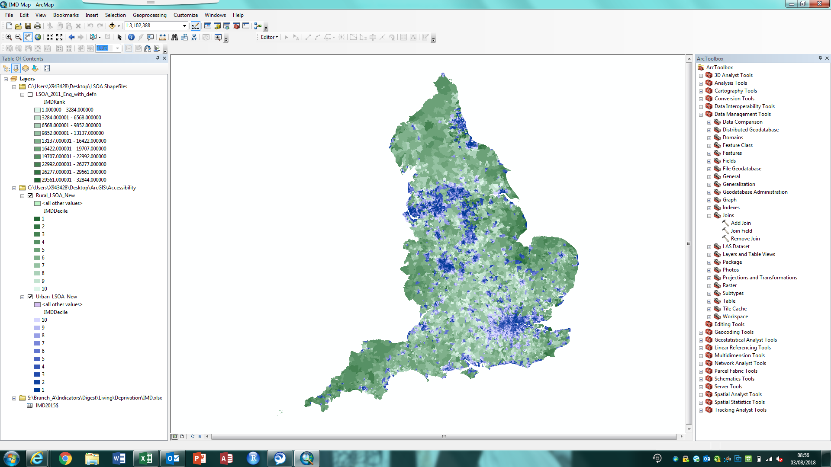
Greatest accessibility of services

Poorest accessibility of services
Urban Rural

Source: Department for Transport (DfT) 2 and Defra analysis
© Crown Copyright and database rights 2021 Ordnance Survey Licence No. 100022861
Car
- Unsurprisingly travelling by car generally reduces travel times to key services compared with public transport and walking, but overall relative differences in travel times are similar to those experienced when using public transport and walking, and rural areas still tend to have poorer accessibility (in terms of minimum travel times), compared with urban areas.
- Rural areas tend to have poorer accessibility to services based on minimum travel times than urban ones based on minimum travel times when using a car:
  - 49 per cent of the rural population are living in areas that have the poorest accessibility to services (lowest 10 per cent decile) based on minimum travel times compared with 2 per cent of the urban population.
  - 0.5 per cent of the rural population are living in areas that have the greatest accessibility to services (highest 10 per cent decile) based on minimum travel times compared with 13 per cent of the urban population.
- As might be expected, sparsely populated areas tend to have poorer accessibility of services based on minimum travel times when using a car:
  - 12 per cent of the population living in Urban with City and Town areas in a sparse setting have the poorest accessibility to services (lowest 10 per cent decile) based on minimum travel times compared with 4 per cent of the population living in Urban with City and Town areas not in a sparse setting.
  - 26 per cent of the population living in Rural Town and Fringe areas in a sparse setting have the poorest accessibility to services (lowest 10 per cent decile) based on minimum travel times compared with 23 per cent of the population living in Rural Town and Fringe areas not in a sparse setting.
  - 94 per cent of the population living in Rural Village and Dispersed areas in a sparse setting have the poorest accessibility to services (lowest 10 per cent decile) based on minimum travel times compared with 79 per cent of the population living in Rural Village and Dispersed areas not in a sparse setting.

Proportion of the population within each decile of accessibility of services based on minimum travel times by car, by rural-urban classification, England, 2017
 | Poorest accessibility of services |  |  |  |  |  | Greatest accessibility of services
Decile | 1 | 2 | 3 | 4 | 5 | 6 | 7 | 8 | 9 | 10
Urban | 2% | 8% | 10% | 10% | 11% | 11% | 12% | 12% | 12% | 13%
Rural | 49% | 21% | 11% | 6% | 4% | 4% | 2% | 1% | 1% | <1%
Source: Department for Transport (DfT),2 and Defra analysis, ONS mid-year population estimates 20173

A table showing the proportion of the population within each decile for accessibility of services by car in 2017, broken down using a more detailed rural-urban classification is available in the rural living supplementary data tables.

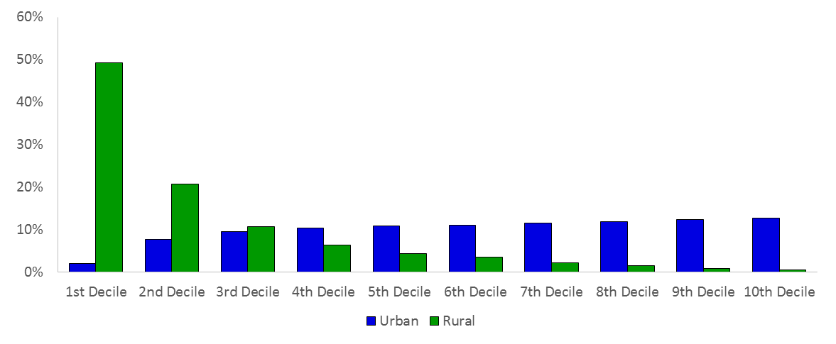
Proportion of population within each decile of accessibility of services based on minimum travel times by car, by rural-urban classification and detailed rural classification, England, 2017
Poorest accessibility / longest travel times)
Greatest accessibility / shortest travel times

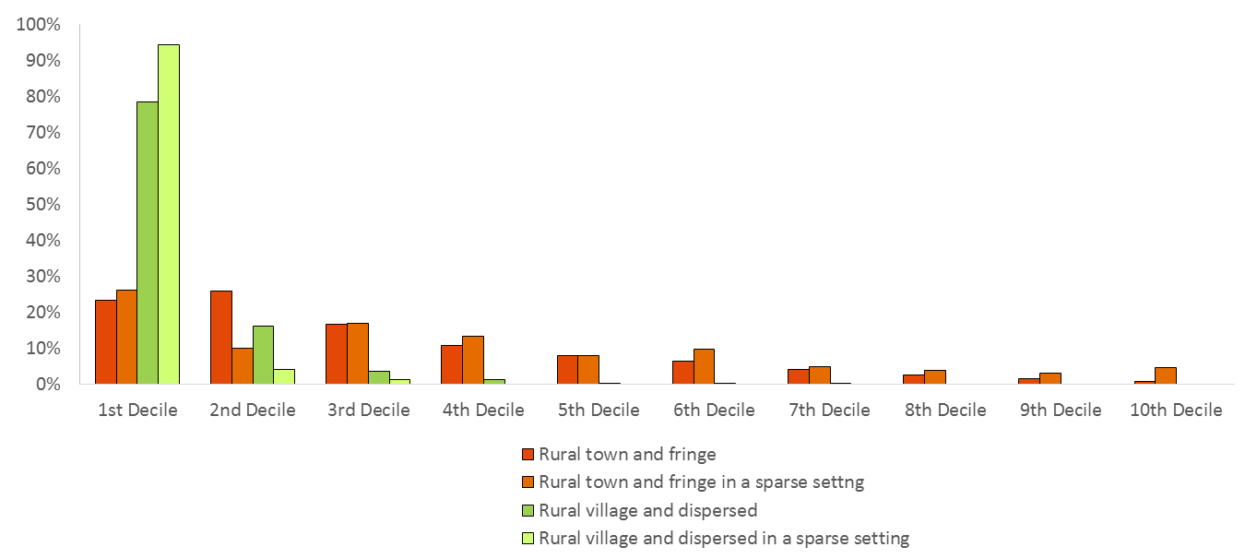
Poorest accessibility / longest travel times)
Greatest accessibility / shortest travel times

Again, as the poorest decile of accessibility of services is predominantly made up of rural LSOAs we were unable to map the data by decile. This is because the map was almost entirely coloured in with the darkest green (denoting poorest accessibility) and therefore showed little information that was not already presented in the graphs above. Because of this we instead mapped the data using Jenks; a method which aims to group data in a way that minimises the variability within each group whilst maximising the variability between groups. A drawback of this method is that the maps cannot be compared to previous years because the thresholds for the 10 groups will not be the same. However, this method does allow the areas with the poorest accessibility to be differentiated from those which are slightly better, and also shows which areas have similar levels of accessibility of services to each other.
Accessibility of services based on minimum travel times using a car
Accessibility of services based on minimum travel times using a car, by rural-urban classification (Lower Super Output Areas1), in England (2017)
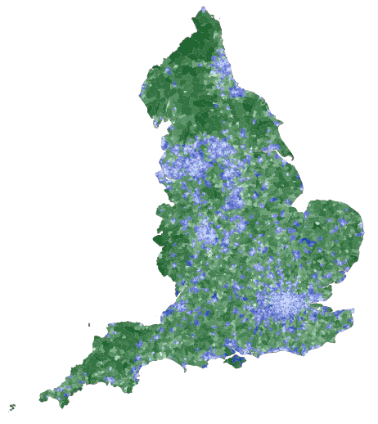
Greatest accessibility of services

Poorest accessibility of services
Urban Rural

Source: Department for Transport (DfT)2 and Defra analysis
© Crown Copyright and database rights 2021 Ordnance Survey Licence No. 100022861

Notes: The table below shows the weightings used for the nine services and the reasons these were chosen. Assumptions have had to be made that will not hold true for every individual. These weightings are simply an attempt at ensuring that services that are typically visited very infrequently although an important service (such as a hospital) do not have undue influence over the final measure if the travel times are much greater than for other services.

Service | Weighting | Reason
Medium and Large Employment Centre | 0.22 | Under the assumption of 240 working days per year, one journey per day
Primary School | 0.18 | Under the assumption of 190 school days per year, one journey per day
Secondary School | 0.18 | Under the assumption of 190 school days per year, one journey per day
Further Education | 0.18 | Under the assumption of 190 school days per year, one journey per day
Doctors’ Surgery | 0.01 | Under the assumption of 6 visits per year4
Hospital | 0.002 | Under the assumption of 2.4 visits per year5
Food Store | 0.10 | Under the assumption of a weekly visit
Town Centre | 0.10 | Under the assumption of a weekly visit
Post Office | 0.05 | Under the assumption of bi-weekly visits
In most cases the weightings are broadly of the same magnitude and hence their use does not result in significant adjustments. Where possible the weightings have been determined using statistical evidence but are otherwise based on best judgements, for example an average person will travel more frequently to their place of work or school than they would to some other services.
The weighted minimum travel times were indexed and then summed to give a single value which was then indexed again. This indexing process was used to ensure that infrequently used services did not disproportionately influence overall accessibility if travel times are large.
As an index, an actual travel time has not been determined, the index is a relative measure.
Footnotes:
- A Lower Super Output Area (LSOA) is a geographic area built up from groups of census output areas. LSOAs were developed (along with Middle Super Output Areas) to help improve the reporting of small area statistics, allowing for greater precision than reporting at Local Authority level. Each Local Authority will be built up of many LSOAs, therefore just because one LSOA scores poorly on accessibility of services it does not mean that this is an issue for the whole Local Authority.
- https://www.gov.uk/government/statistics/journey-time-statistics-2017

The 2011 rural urban classification has been applied to both years to enable comparison
The 2011 rural urban classification has been applied to both years to enable comparison
The 2011 rural urban classification has been applied to both years to enable comparison
For further information see the ONS website: www.consultations.ons.gov.uk/national-accounts/consultation-on-balanced-estimates-of-regional-gva/

