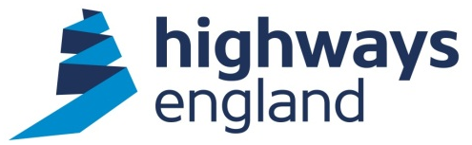  Our ref: 102296  Via email | Highways England  National Traffic Operations Centre  3 Ridgeway  Quinton Business Park  Birmingham  B32 1AF  United Kingdom  16 July 2021

Dear

I refer to your request under the Freedom of Information Act 2000 for information about Tower Hamlets Community Projects.

I am writing to advise you that, following a search of our paper and electronic records, I have established that the information you requested is not held by Highways England.

We believe that the information you require may be held by Transport for London and, if you have not already done so, you may wish to contact them at foi@tfl.gov.uk

If you are unhappy with the way we have handled your request you may ask for an internal review. Our internal review process is available at: https://www.gov.uk/government/organisations/highways-england/about/complaints-procedure

If you require a print copy, please phone the Information Line on 0300 123 5000; or e-mail info@highwaysengland.co.uk. You should contact me if you wish to complain.

If you are not content with the outcome of the internal review, you have the right to apply directly to the Information Commissioner for a decision. The Information Commissioner can be contacted at:

Information Commissioner’s Office
Wycliffe House
Water Lane
Wilmslow
Cheshire
SK9 5AF

If you have any queries about this letter, please contact me. Please remember to quote reference number 102296 in any future communications.

Kind regards

Freedom of Information Team
Highways England | Lateral | 8 City Walk | Leeds | LS11 9AT
Web: www.highwaysengland.co.uk

