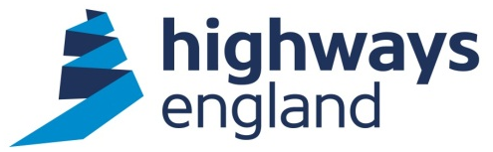  Our ref: 102299  Via email | Highways England  National Traffic Operations Centre  3 Ridgeway  Quinton Business Park  Birmingham  B32 1AF  United Kingdom  22 July 2021

Dear

Thank you for your request for information about our Variable Signs and Signals Policy dated 8 July 2021. This formed part of a Stage 2 Complaint, the response to which was sent to you on 16 July 2021.

We have dealt with your request under the terms of the Freedom of Information Act 2000.

You asked us for:
An up-to-date PDF copy of Highways England’s guidance on the use of variable speed limits.

Please find attached a PDF copy of the guidance as requested. In accordance with Section 40 of the Freedom of Information Act 2000, personal information has been redacted.

If you have any queries about this letter, please contact us by email:
info@highwaysengland.co.uk. Please kindly quote reference number 102299 in any future communications.

If you are unhappy with the way we have handled your request you may ask for an internal review. Our internal review process is available at:
https://www.gov.uk/government/organisations/highways-england/about/complaintsprocedure

If you require a print copy, please phone the Information Line on 0300 123 5000; or email info@highwaysengland.co.uk.

If you are not content with the outcome of the internal review, you have the right to apply directly to the Information Commissioner for a decision. The Information Commissioner can be contacted at:

Information Commissioner’s Office
Wycliffe House
Water Lane
Wilmslow
Cheshire
SK9 5AF

Yours sincerely

Safety Engineering and Standards
Official Correspondence Team

