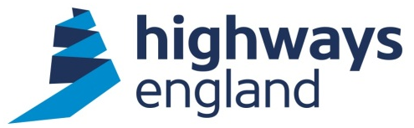  Our ref: 102330  Via email | Highways England  National Traffic Operations Centre  3 Ridgeway  Quinton Business Park  Birmingham  B32 1AF  United Kingdom  3 August 2021

Dear Mr

I am writing to confirm that we have now completed our search for the information, which you requested on 26 July 2021. You requested information on the Commercial & Project Management Services Framework, specifically asking how many requirements have been tendered, awarded or directly awarded to a supplier under Lot 1and 2.

The Commercial & Project Management Services Framework Lot 1 and Lot 2 were awarded 09 March 2021. As of 3rd August 2021, there are:

1 task order out to tender and 1 direct award under Lot 1
12 task orders out to tender (none awarded as yet) under Lot 2

If you are unhappy with the way we have handled your request you may ask for an internal review. Our internal review process is available at:
https://www.gov.uk/government/organisations/highways-england/about/complaintsprocedure

If you require a print copy, please phone the Information Line on 0300 123 5000; or email info@highwaysengland.co.uk. You should contact me if you wish to complain.

If you are not content with the outcome of the internal review, you have the right to apply directly to the Information Commissioner for a decision. The Information Commissioner can be contacted at:

Information Commissioner’s Office
Wycliffe House
Water Lane
Wilmslow
Cheshire
SK9 5AF

If you have any queries about this letter, please contact me. Please remember to quote reference number 102330 in any future communications.

Yours sincerely

