NOTICE OF ORDER

HIGHWAYS ACT 1980 – SECTION 119
DONCASTER BOROUGH COUNCIL
PUBLIC BRIDLEWAY NUMBER 9 CANTLEY (PART) and UNDEFINED PUBLIC BRIDLEWAY DONCASTER
PUBLIC PATH DIVERSION ORDER 2019

Notice is hereby given that the above referenced Order has been submitted to the Secretary of State for Environment, Food and Rural Affairs for determination. An Inspector will be appointed by the Secretary of State to determine the Order.

The start date for the above Order is 05 JULY 2021

Consideration of the Order will take the form of a public local inquiry.

The Inquiry will be held virtually on 06 December 2021 at 10.00am.

The effect of the Order, if confirmed without modifications, will be to divert the entire width of that length of undefined public bridleway running from its junction with Carr Lane vehicle highway at grid reference SE6104 0035, Point A on the order plan, proceeding in a generally south west direction for 49 metres to the south side of the railway, grid reference SE6102 0030, Point B on the plan; and all that width of public bridleway number 9 Cantley from grid reference SE6102 0030, Point B, proceeding in a generally south west direction for 66 metres to grid reference SE6100 0025, Point C on the order plan to a line running from its junction with Carr Lane bridleway at grid reference SE6100 0025, Point C on the order plan, travelling in an east direction for 11 metres to grid reference SE6101 0024, Point D on the order plan, then travelling in a generally north east direction for 39 metres to grid reference SE 6104 0026, point E on the order plan, and for 36 metres to grid reference SE 6106 0029, Point F on the order plan, then travelling parallel with the railway for 87 metres to grid reference SE 6114 0029, Point G on the order plan, then south towards the entrance of the underpass at grid reference SE 6116 0026, Point H on the order plan, then travelling in a generally north west direction for 66 metres, through the underpass to the north side of the railway at grid reference SE6114 0032, Point I on the order plan; then continuing as public bridleway number 21 Doncaster, in a generally north west direction for 73 metres to the junction with Carr Lane at grid reference SE 6108 0036, Point J on the order plan. The bridleway will have a width of 4 metres

Any queries relating to this Order should be referred to:
Clive Richards at The Planning Inspectorate, Rights of Way Section, Room 3/A Eagle Wing, Temple Quay House, 2 The Square, Temple Quay, Bristol, BS1 6PN. Telephone: 0303 4445502. Email: clive.richards@planninginspectorate.gov.uk Please quote reference number ROW/3257801 on all correspondence.

Any person wishing to view the statements of case and other documents relating to this Order may do so by appointment at the offices of Doncaster Borough Council, Civic Office, Waterdale, Doncaster DN1 3BU from 9:00am to 4:30pm Monday to Friday. Contact at Doncaster Borough Council: Ms Julie Guest, Tel: 01302 735047, Email: julie.guest@doncaster.gov.uk
N.B. due to the Covid-19 crisis, you are advised to contact the Council before travelling to view documents.

Timetable for sending in statements of case and proofs of evidence

Within 8 weeks of the start date by [by 30 August 2021]

The Order Making Authority must ensure their statement of case is received by the Secretary of State. As soon as possible after the deadline, the Secretary of State will send a copy (excluding copies of any supporting documents - these will be available to view at the Authority’s offices) to everyone who has made an objection or representation and the applicant and any other person who has written to us in respect of the Order.

Whilst Doncaster Borough Council supports confirmation of the Order, Network Rail will be making the case for confirmation at the Inquiry. As such they will be expected to meet the Councils deadline.
Within the same period the applicant (if applicable) must ensure their statement of case is received by the Secretary of State. As soon as possible after the deadline, the Secretary of State will send a full copy to the Authority. Copies will also be sent to everyone who has made an objection or representation and any other person who has written to us in respect of the Order (excluding copies of any supporting documents - these will be available to view at the Authority’s offices).

Within 14 weeks of the start date [by 11 October 2021]

Everyone who has made an objection or representation and anyone who wishes to give evidence at the Inquiry must ensure their statement of case is received by the Secretary of State. As soon as possible after the deadline, the Secretary of State will send full copies to the Authority. Copies will also be sent to the applicant, every person who has made an objection or representation and any other person who has written to us in respect of the Order (excluding copies of any supporting documents - these will be available to view at the Authority’s offices).

4 weeks before the date of the inquiry [by 08 November 2021]

The Authority, everyone who has made an objection or representation, the applicant (if applicable) and anyone who wishes to give evidence at the Inquiry must ensure their proof of evidence (together with any summary) is received by the Secretary of State. As soon as possible after the deadline, the Secretary of State will send copies of:

- the Authority’s proof of evidence to everyone who has made an objection or representation, the applicant and anyone who has submitted a statement of case (including copies of any supporting documents – although none should be submitted with a proof of evidence);

- the applicant’s proof of evidence to the Authority, everyone who has made an objection or representation and anyone else who has submitted a statement of case (including copies of any supporting documents – although none should be submitted with a proof of evidence); and

- all other proofs of evidence to the Authority, the applicant, everyone who has made an objection or representation and anyone else who has submitted a statement of case (including copies of any supporting documents – although none should not be submitted with a proof of evidence).

All parties must keep to the timetable set out above and ensure that statements of case and proofs of evidence are received by the Secretary of State on time. Late documents will be returned.

We cannot accept any inflammatory, discriminatory or abusive comments. Any documents containing such comments will be returned.

Notice of order for inquiry

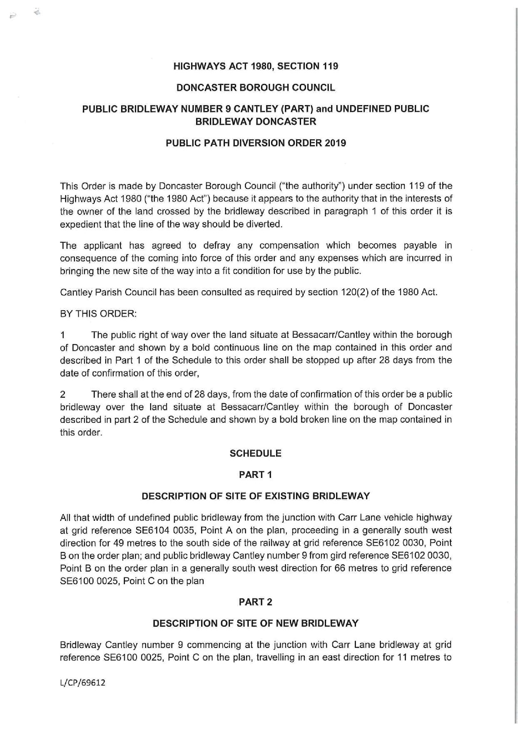

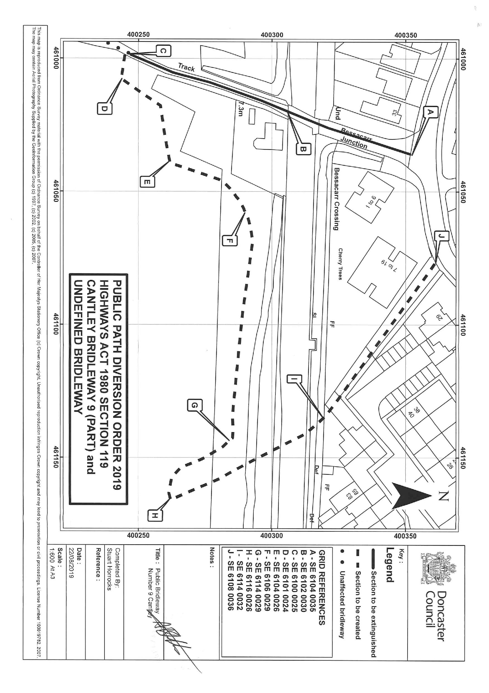

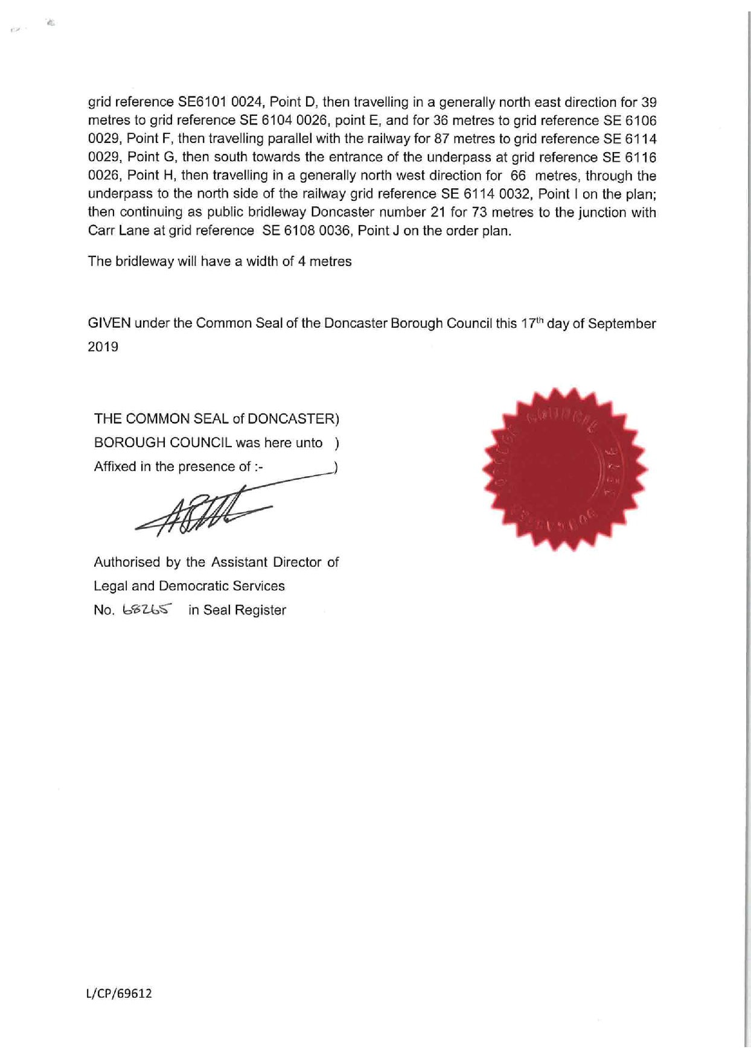

If you wish to make a legal submission, this should be submitted at the same time as your statement of case. Otherwise legal submissions will have to be submitted in writing on the day of the inquiry.

