NOTICE OF ORDER

Wildlife and Countryside Act 1981 – Section 53
Liverpool City Council
Modification No.6 Order 2019
PROW No. 78 Chatsworth Avenue to Lynwood Road

Notice is hereby given that the above referenced Order has been submitted to the Secretary of State for Environment, Food and Rural Affairs for determination. An Inspector will be appointed by the Secretary of State to determine the Order.

The start date for the above Order is 06/07/2021

Consideration of the Order will take the form of a public local inquiry.

The Inquiry will be held as a Virtual Inquiry on 13/12/2021 at 10.00am.

The effect of the Order, if confirmed without modifications, will be to modify the definitive map and statement for the area by adding to them the footpath from Chatsworth Avenue to Lynwood Road. A footpath commencing at the south-eastern boundary of Chatsworth Avenue, adjacent to the property numbered 15 Chatsworth Avenue and extending in a south-easterly direction for a distance of 22 metres with an average width of 3.5 metres, then in a southerly direction for a distance of 178 metres with a width of 2 metres and terminating at the northern boundary of Lynwood Road.

Any queries relating to this Order should be referred to Matthew Williams at The Planning Inspectorate, Rights of Way Section, Room 3/A Eagle Wing, Temple Quay House, 2 The Square, Temple Quay, Bristol, BS1 6PN. Telephone: 0303 444 5452. Email: matthew.williams@planninginspectorate.gov.uk Please quote reference number ROW/3244433 on all correspondence.

Any person wishing to view the statements of case and other documents relating to this Order may do so by appointment only between the hours of 9.00am and 4.00pm on Monday to Fridays inclusive at the City Solicitors Office, Cunard Building, Water Street, Liverpool, L3 1AH. Contact details to book an appointment with our contact at the Council are as follows: Mrs Debbie Metcalfe, Tel No: 0151 233 0465; Email: debbie.metcalfe@liverpool.gov.uk.

As the Authority have indicated that they will not be supporting the Order at the Inquiry, the case for the Order will be presented by the applicant, Mr Anthony Birtill. They will be expected to adhere to the following timetable as if they were the Authority.

Timetable for sending in statements of case and proofs of evidence

Within 8 weeks of the start date by [by 31/08/2021]

The Authority must ensure their statement of case is received by the Secretary of State.
&
The applicant must ensure their statement of case is received by the Secretary of State. As soon as possible after the deadline, the Secretary of State will send a copy (excluding copies of any supporting documents - these will be available to view at the Order Making Authority’s offices) to everyone who has made an objection or representation and the applicant and any other person who has written to us in respect of the Order.

Within 14 weeks of the start date [by 12/10/2021]

Everyone who has made an objection or representation and anyone who wishes to give evidence at the Inquiry must ensure their statement of case is received by the Secretary of State. As soon as possible after the deadline, the Secretary of State will send full copies to the Authority. Copies will also be sent to the applicant, every person who has made an objection or representation and any other person who has written to us in respect of the Order (excluding copies of any supporting documents - these will be available to view at the Authority’s offices).

4 weeks before the date of the inquiry [by 15/11/2021]

The Authority, everyone who has made an objection or representation, the applicant (if applicable) and anyone who wishes to give evidence at the Inquiry must ensure their proof of evidence (together with any summary) is received by the Secretary of State. As soon as possible after the deadline, the Secretary of State will send copies of:

- the Authority’s proof of evidence to everyone who has made an objection or representation, the applicant and anyone who has submitted a statement of case (excluding copies of any supporting documents – although none should be submitted with a proof of evidence);

- the applicant’s proof of evidence to the Authority, everyone who has made an objection or representation and anyone else who has submitted a statement of case (excluding copies of any supporting documents – although none should be submitted with a proof of evidence); and

- all other proofs of evidence to the Authority, the applicant, everyone who has made an objection or representation and anyone else who has submitted a statement of case (excluding copies of any supporting documents – although none should be submitted with a proof of evidence).

All parties must keep to the timetable set out above and ensure that statements of case and proofs of evidence are received by the Secretary of State on time. Late documents will be returned.

We cannot accept any libellous, racist, or abusive comments. Any documents containing such comments will be returned.

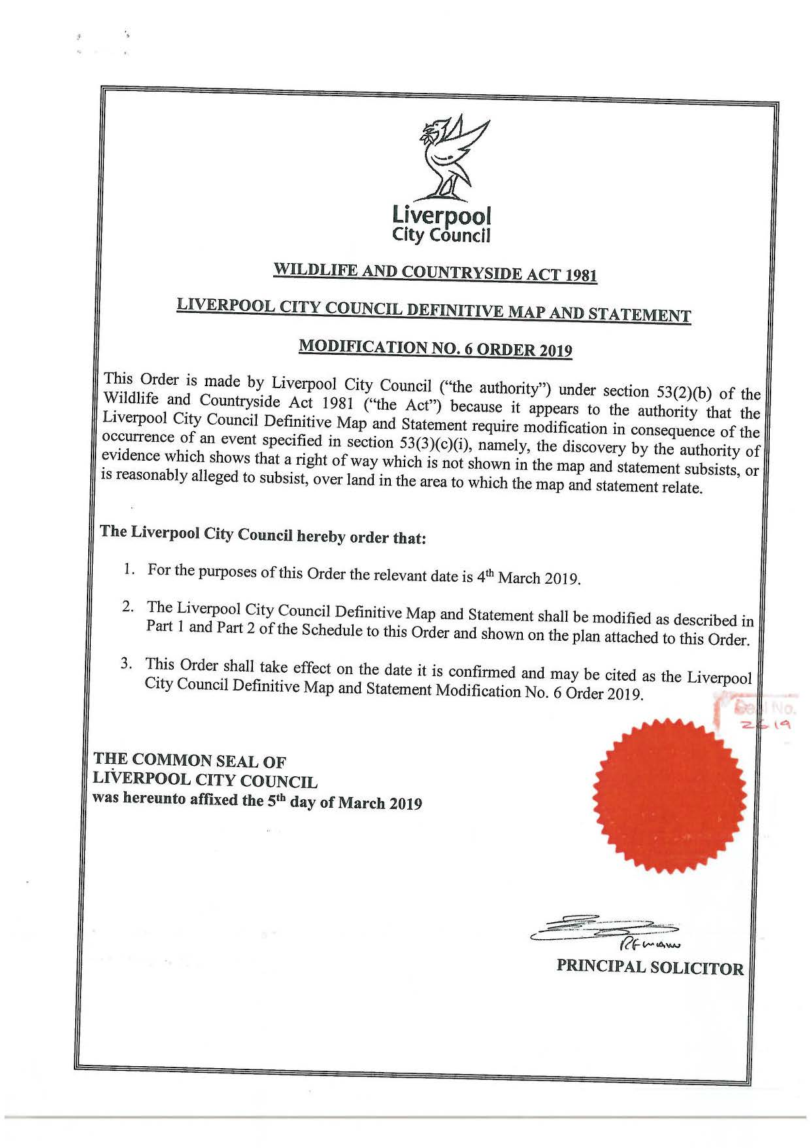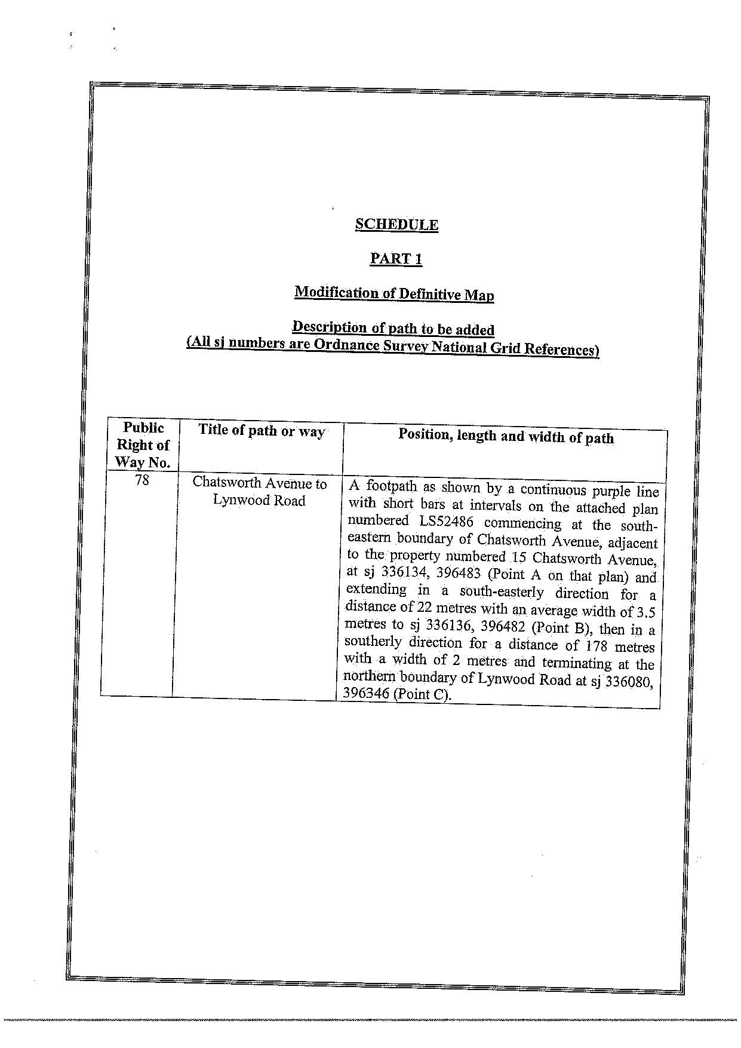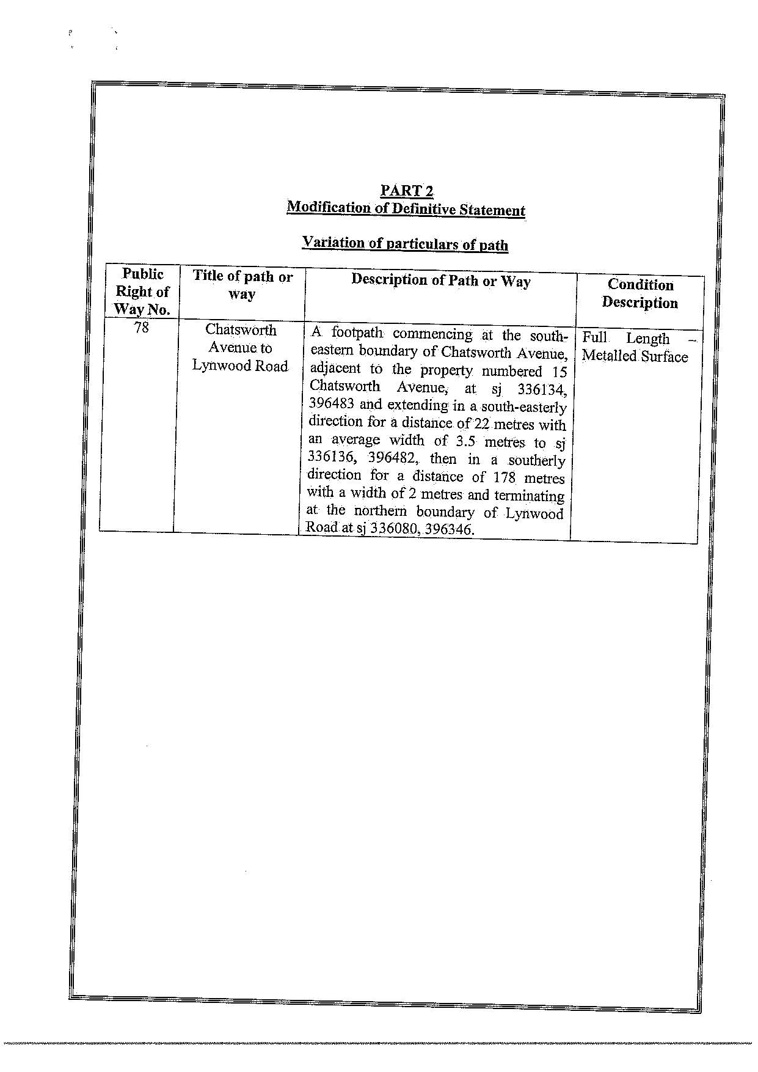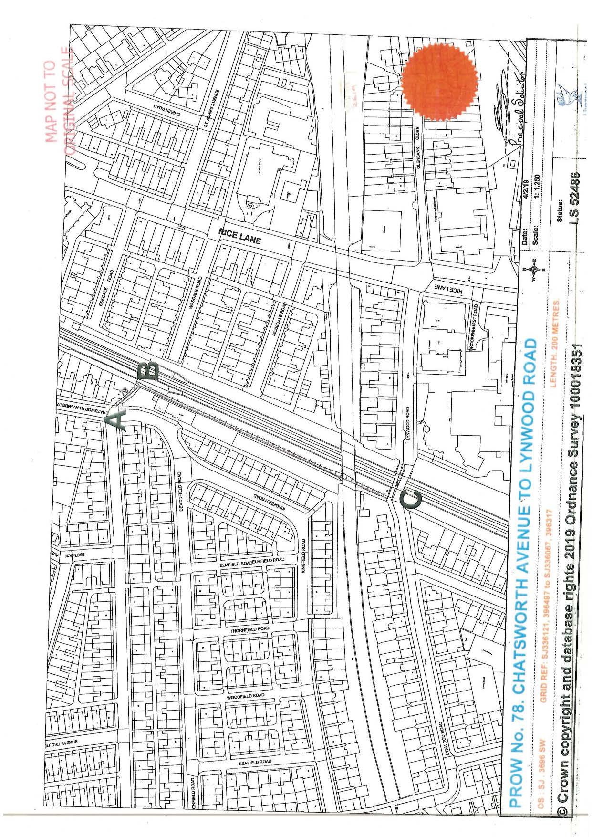

If you wish to make a legal submission, this should be submitted at the same time as your statement of case. Otherwise legal submissions will have to be submitted in writing on the day of the inquiry.

