Mapping climate-health evidence
Using machine-learning to map the links between climate change and health

Author team (*core)

University of Leeds, UK
*Prof Lea Berrang Ford, Priestley Research Chair in Climate and Health
*Mr Anne Sietsma
Prof Tim Ensor
Prof John Walley
Dr Mark Richardson
Mr Daniel Ellis

Mercator Research Institute on Global Commons and Climate Change, Berlin, Germany and University of Leeds, UK
*Prof Jan Minx
*Mr Max Callaghan

Stockholm Environment Institute, Stockholm, Sweden
Dr Neal Haddaway

London School of Hygiene & Tropical Medicine, Centre on Climate Change and Planetary Health, UK
*Dr Pauline Scheelbeek
*Prof Alan Dangour
*Ms Stephanie Jarmul
*Ms Grace Turner
Dr Kristine Belesova
Prof Sir Andy Haines

Acknowledgements and funding statement
We gratefully acknowledge input in protocol development from Dr. Sari Kovats and Professor Paul Wilkinson from the London School of Hygiene & Tropical Medicine. We are grateful to Dr. Kirsty Lewis, Rahi Islam, Dr. Carolyn Sunners and Phil Jones from the Foreign, Commonwealth and Development Office for their support and helpful contributions throughout.

This project was funded by the Foreign, Commonwealth and Development Office [Contract number: PO 40123400]. The views and opinions expressed in this report are those of the authors and do not necessarily reflect the official policy or position of the UK government.

Table of contents
Graphical executive summary 1
Executive Summary 2
Introduction 4
Project aims and objectives 6
Climate and health framework 7
Part A: Using machine learning to map the links between climate change and health 10
Methods 10
Database search 10
Supervised machine learning 11
Text mining 11
Presentation of results 11
Results 12
Key climate and health topics in the literature 15
Evidence heat maps 20
A focus on low and lower-middle income countries and priority regions 21
Part A Strengths and limitations 25
Report 25
Platform 25
Part A Summary 26
Online interactive evidence platform 28
Part B: A focus on assessing the effects on health of adaptation options and responses 30
Methods 30
Approach 30
Assessment 30
Data extraction and synthesis 30
Results 31
Evidence Base 31
Summary findings by A. Health outcome, B. Climate change hazard, C. Adaptation option and response, and D. Vulnerable group 33
Part B Strengths and limitations 43
Part B Summary 43
Quality Assurance 45
Appendices 46
Appendix 1: Protocol for systematic mapping using machine learning ………………………………….…….47
Appendix 2: Machine learning for evidence mapping: lessons, limits, and potential 63
Appendix 3: Technical description of classifier and model performance 67
Appendix 4: Additional figures from Part A 71
Appendix 5: References of included studies from Part B ……………………………………………………… 75
Appendix 6: Annotated key studies from Part B 81
Appendix 7: Results of Part B, by geographical location (continent) 87

Graphical executive summary
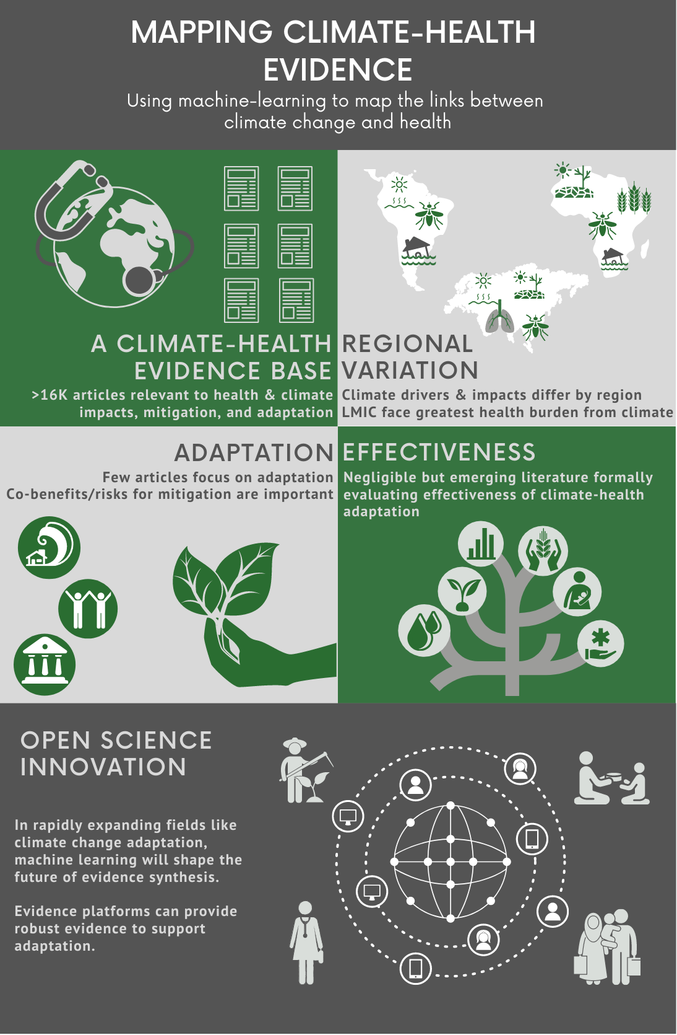

Executive Summary

With the increasing recognition and salience of climate change on public and institutional agendas, systematic synthesis of the available scientific evidence is critical for the formulation of national and international policy. There has recently been substantial growth in the scientific literature documenting the impact on health of climate change and exploring potential mitigation and adaptation options and responses. This report summarises the results of a systematic evidence mapping and synthesis project to:

(A) produce an up-to-date and interactive, computer-assisted systematic map of the published literature on the links between climate change, climate variability, and weather (CCVW), and health (including impacts, adaptation, and mitigation), with a global scope and additional focus on low- and middle-income countries (LMICs), and;

(B) summarise the available published evidence on adaptation options and responses, and their effectiveness in reducing the impacts of CCVW on health in LMICs.

We use machine-learning approaches systematically to map the available published literature (globally, 2013-20) on the relationship between CCVW and health, and produce an online interactive, searchable data platform, with a focus on LMICs. We identified over 15,000 documents relevant to climate and health globally. Low income countries are underrepresented in the climate-health literature and there is a notable underrepresentation of literature from Western Asia and Western Africa. Machine learning approaches were constrained by a common lack of clarity in the definition of the boundaries of ‘health’ and CCVW along multiple complex and often indirect causal pathways. This is to our knowledge the first time scientific literature on climate and health has been systematically and comprehensively synthesised. Our work demonstrates the potential of machine learning approaches to synthesise and update large volumes of evidence effectively and efficiently.

We additionally use an existing dataset systematically generated by the Global Adaptation Mapping Initiative (GAMI) (2013-2019) to collate and synthesise available published evidence on the effect on health of adaptation options and responses in LMICs. We identified 99 studies conducted in 66 LMICs, reporting 174 measurements of human health outcomes or indicators from adaptation options and responses. There are clear biases in the available evidence base, and the quality of the evidence on the impact on health of adaptation actions was generally poor.

Detailed results from the two reviews conducted for this project are provided in the main text, and all identified studies are available in a bespoke online data platform and a searchable database. Key results from this report are as follows:

There is clear evidence from this mapping exercise of clusters of research activity on key CCVW and health topics. Globally, there are foci of research on: hospitalisations and mortality, particularly for infectious diseases, associated with extreme weather events, including droughts, flooding and heat; particulate matter, air quality, and the co-benefits of mitigation; the impacts and adaptation potential of public health systems.

Evidence from lower income nations is largely focused on infectious diseases, particularly malaria and dengue. There is limited available evidence from low income countries on a number of topics where climate may have substantial impacts on health, including mental health, occupational health and injury, maternal and child health, chronic disease, and WASH.

Evidence clearly indicates that there are substantial benefits for health of integrating adaptation with mitigation of fossil fuel emissions.

Public health systems are both impacted by climate change and important mechanisms for adaptation response, playing a key role in disaster preparedness, adaptation policy and governance, and developing community resilience.

In LMICs, the main climate change adaptations that have been evaluated for their impacts on health include behaviour change and infrastructural and technological improvements in response to flooding, rainfall, drought and extreme heat.

Adaptation options and responses in the agricultural sector are extensively reported, in particular assessing the potential of climate smart agriculture (e.g. drought tolerant crops) on food production and food security.

The quality of evidence on effectiveness of adaptation responses is weak, with very few ex ante formal evaluations, and highly heterogeneous (multiple diverse adaptation options and responses among different population groups, with a range of reported health outcomes).

Key research needs identified in this review include:
- Assessment of climate risks to health and adaptation options in under-studied regions, particularly Western Asia and Western Africa.
- Consideration of health pathways other than infectious diseases and health systems, including: mental health; maternal & child health; chronic disease; WASH.
- Explicit emphasis on adaptation options and responses that go beyond impacts and translate vulnerability research into adaptation assessment.
- Integrated assessment of co-benefits and co-risks of mitigation for health, particularly in the context of public health systems.
- Significantly greater consideration of the health outcomes in evaluations of adaptation options and responses, including pre-specified ex ante formal evaluations.
- Specification of standardised approaches and reporting requirements of evaluations of effects on health of adaptation options and responses.
- Understanding of the effect on all-cause mortality as well as cause-specific health outcomes, especially related to vulnerable groups including women and children of adaptation options and responses.
- Greater specifications of potential effects on health (positive, negative, and neutral) of adaptation options and responses, including improved mapping of pathways.
- Economic evaluations of adaptation options and responses that include health outcomes.
- Ongoing synthesis of evidence given a rapidly evolving literature base, in particular the potential of antimicrobial resistance, zoonotic disease, and Covid-19 vis a vis climate change. This may include machine-learning approaches to develop ‘living’ platforms for evidence synthesis.

Introduction

Background – Scientific Literature on Climate Change and Health
Climate change, defined by the Intergovernmental Panel on Climate Change (IPCC) as changes in the mean and/or the variability of climate that persists for an extended period (typically decades or longer), affects population health outcomes in diverse, complex, and interacting ways. These include, for example, the direct effects of changes in meteorological parameters such as temperature and precipitation on health outcomes, including heat stress and risks due to flooding. Many pathways of impact are mediated through ecological or social systems, for example changing crop yields, shifting distribution of infectious diseases, social disruption, migration, and conflict. Human adaptation (the process of adjustment to actual or expected climate and its effects) and mitigation (interventions to reduce the sources of and increase the sinks for greenhouse gas emissions) measures can also directly impact human health. This report focuses on adaptation as a response to the risks and impacts ‒ actual, anticipated, or perceived ‒ of climate variability and change, although mitigation responses are also considered as they frequently represent co-risks and/or co-benefits for health alongside adaptation.
The scholarly literature on the links between climate and health is robust and continues to increase rapidly. The online database Scopus alone retrieves over 50,000 documents using the keywords “climat*” and “health*”, roughly two thirds of which have been published in the past 10 years. However, in reviewing the climate and health literature, it is important to note several important features:
- Very little of the published climate and health literature focuses directly on the causal links between climate variability and change and human health outcomes because of the mismatch between multi-decadal environmental change and shorter-term health data availability. There are a very small number of detection and attribution studies, all of which have been conducted in high income countries, that have sought to determine whether the occurrence of a health outcome has changed (detection) and the extent to which this was caused by climate change (attribution);
- The bulk of the literature focuses instead on the associations of weather (rather than climate change) with health and typically captures only parts of the causal pathway(s);
- Literature relevant to understanding the effects of climate change/variability and weather on health is dispersed across a vast range of possible topics, including climate/weather impacts on environmental processes (e.g. flooding) and environmental impacts on the social determinants of health (e.g. poverty implications of flooding);
- There is only a small body of published literature evaluating the effect of adaptation options and responses designed to reduce the effect of climate variability and change on health, although there is a larger body of non-peer reviewed literature through the multilateral adaptation funds. Indeed, a quick search of Scopus for articles with “climate”, “health”, “intervention”, and “effectiveness” in their title retrieves a single document. There is a much larger literature focused on appraising options and opportunities for adaptation, and constraints to adaptation.
This project provides: a) a comprehensive systematic map of the January 2013 to April 2020 scholarly literature linking climate change/variability and weather (CCVW) to health; and, b) an assessment of the evidence of the effect on health of climate change options and responses in low- and middle-income countries. The review draws on recognised standards for systematic mapping and review, as well as cutting-edge machine learning to provide both breadth and depth.
Recognising that much of the literature relevant to climate and health explores different aspects along climate-health pathways and frequently assesses more local and short-term implications of global climate change (e.g. weather), we use a broad definition to encompass climate change impacts on health in this report. We collectively define climate(-related) hazards as comprising climate change, climate variability, and weather (CCVW).

Project aims and objectives
To meet the specification of the research call from the Foreign, Commonwealth and Development Office (FCDO), and taking into consideration the relative limitations in the available evidence base, the project is split into two separate parts with associated aims and objectives:
Part A: To produce an up-to-date and interactive, computer-assisted systematic map of the published literature on the links between climate change, climate variability, and weather (CCVW), and health (including impacts, adaptation, and mitigation), with a global scope and additional focus on low- and middle-income countries (LMICs).
- To use a machine-learning approach systematically to map the available published literature for the years 2013 to 2020 of the relationship between CCVW and health globally.
- To produce an online, interactive, searchable data platform of the available published literature on CCVW and health, with a global scope and additional focus on LMICs.
Part B: To summarise the available published evidence on adaptation options and responses, and their effectiveness in reducing the impacts of CCVW on health in LMICs.
- Using an existing dataset systematically generated by the Global Adaptation Mapping Initiative (GAMI) (2013-2019) to collate and synthesise available published evidence on the effect on health of adaptation options and responses in LMICs.
- To produce evidence maps of adaptation options and responses, and assess existing evidence of adaptation effectiveness in LMICs.
Part A includes all global literature, highlighting trends for LMICs. Part B focuses exclusively on LMICs.

Climate and health framework
This review uses a framework and definitions adapted from the Intergovernmental Panel on Climate Change (IPCC)’s (Figure 1). Words such as ‘vulnerability’ and ‘risk’ are used differently across the literature. Here, we clarify the definitions and concepts used across this project, based on the most updated IPCC definitions, adapted to the context of health. We include key climate hazards, health impacts and risks, mediating pathways, and adaptation/mitigation options and responses (Box 1). Categories were developed iteratively throughout the project, informed by a priori scoping, literature review, expert consultation, as well as in response to emerging results from this review. Categories and concepts from Figure 1 are used to frame and organise results throughout this report.
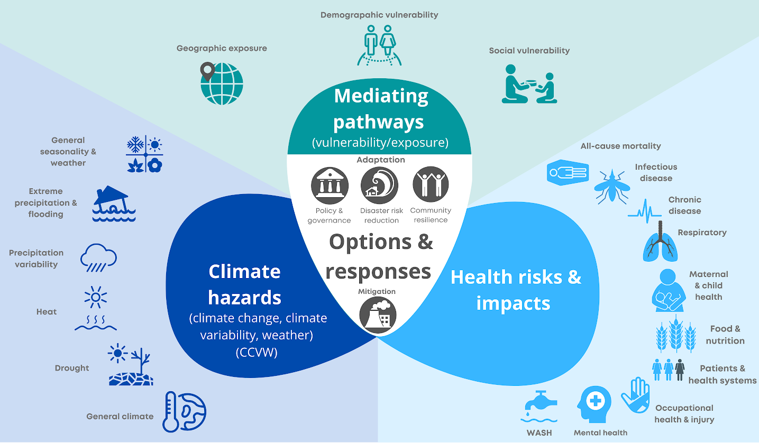Figure 1: Conceptual framework used throughout the review and report
The categories included in Figure 1 are not mutually exclusive nor comprehensive of all possible health risks and impacts. Health risks, for example, interact extensively to create compound risk, such as the role of poor nutrition in driving susceptibility to infectious disease, and maternal health implications for mental health. Notably absent from these categories are zoonotic diseases, antimicrobial resistance, and Covid-19. Zoonotic diseases are included here under the category of infectious disease, so while not excluded, they are not identified as a separate category of health impact with a distinctive literature for review. Antimicrobial resistance represents an important global health concern, with potential biological and presumed policy links to climate change, but for which there is negligible literature. There are certainly compelling reasons by which Covid-19 intersects with climate-health; to-date, however, literature exploring these links is not sufficiently developed to review. These topics reflect potential gaps in the literature that we anticipate may emerge as important over the next 5 years.

Box 1: Key concepts and definitions
Climate hazards are understood as climate-related physical events or trends, or their impacts on biophysical systems. These include the changes in global, regional, and local climate arising from climate change, but also include the changes in local weather and meteorological variability that result from global climate changes, including flooding, droughts, and heatwaves. In some literature, these climate hazards are referred to as exposures. In this report, we define hazards consistent with the IPCC definition, in which changes to global climate and its impacts on meteorological variability and climate-related events are referred to as hazards (rather than exposures). We categorise climate hazards by adapting a list of key climate-induced changes of relevance to human health, including changes in seasonality, extreme precipitation and flooding, precipitation variability, extreme heat or heat variability, and drought.
Mediating pathways determine the magnitude and nature of the effects of climate change on health, and reflect the ways in which climate hazards indirectly impact health via effects on the existing determinants of health. The IPCC refers to these as exposure and vulnerability. We have collectively defined exposure and vulnerability here as mediating pathways to align more closely with how these components are understood within a health context. We consider mediating pathways to comprise the role of non-climatic factors in mediating, effect modifying, and interacting with climate hazards to influence health risks and outcomes.
Exposure reflects the ways in which humans are located and live in places and spaces that put them at greater risk of impact, such as the location and development of infrastructure or social and cultural assets in high-risk areas or settings. The IPCC's definition, however, contrasts with a large portion of the literature, which conceptualises exposure as the climatic and biophysical drivers of climate impacts (referred to as hazards by the IPCC). This confusion persists as a barrier to interdisciplinary communication within climate research. For the purposes of this report, we adopt the IPCC's definition, in which exposure is a function of human geographical factors that mediate risk.
Vulnerability is defined by the IPCC as the propensity or predisposition to be adversely affected, and encompasses a range of factors affecting sensitivity or susceptibility to harm and lack of capacity to cope and adapt. Across the literature, the term vulnerability is often conceptualised to encompass all aspects of risk. Here, we use the narrower definition used by the IPCC, in which vulnerability describes the social, cultural, economic, and demographic factors that mediate how hazards will manifest as impacts.
Mediating pathways are important entry points for adaptation and intervention opportunities.
Our categorisation of mediating pathways was developed iteratively using the results of topic modeling in Part A of this report, and also through team expertise and critical appraisal of key climate-health mediating pathways in the literature. These include geographical exposure, which reflect geographic contexts across scales in mediating risk, including urban and rural environments, differences between spaces and places (e.g. nations), as well as local variation such as differences in building design. Mediating pathways also include demographic variability (e.g. age, sex, ethnicity), and social vulnerability, which encompasses a wide range of social, economic, and cultural factors that mediate health impacts, such as socioeconomic status, health behaviour, health systems, and governance. These categories are not exhaustive or complete, but provide a sense of the breadth of factors mediating how climate hazards result in health risks and impacts. These categories also reflect the clustering of literature emerging from topic modeling in Part A, and thus represent key areas of research in the literature.
Health risks (potential for adverse consequences) and impacts (consequences or outcomes of realised risks) include the wide-ranging health outcomes that are affected by climate change via diverse and often complex causal pathways. We also include the proximal determinants of health outcomes, including air quality, vector habitat, food security, sanitation, and health systems. This combination of health outcomes and their proximal determinants is collectively understood as the health impacts (or health risks) of climate change. This is consistent with the IPCC definition of risk as the potential occurrence and impacts resulting from an interaction of climate hazards, and vulnerability/exposure. Our categorisation of health impacts was developed iteratively, using the results of topic modeling in Part A of this report, and also through team expertise and critical appraisal of key climate-health pathways and impacts in the literature. These categories are not exhaustive or complete, but provide a sense of the breadth of health impacts associated with climate change and present in the literature.
Adaptation/mitigation options and responses include the range of human strategies and measures that can be deployed to minimize the negative health impacts of climate change. These can be in response to real, anticipated, or perceived climate risks and impacts, and may be reactive or proactive. Mitigation responds directly to climate drivers by aiming to reduce greenhouse gases, and therefore focuses intervention on climate hazards. Adaptation, in contrast, aims to minimise the impact of climate hazards on humans and ecosystems of importance to humans by focusing intervention on the pathways that mediate climate impacts (i.e. by reducing vulnerability and exposure). Disaster risk reduction comprises the portfolio of activities undertaken by governments, institutions, and individuals to prepare for, and respond to, extreme events. Development of community resilience reflects a wide range of efforts to increase the ability of communities to cope with and minimise climate impacts, and is primarily focused on decreasing vulnerability and increasing adaptive capacity and resilience to change. Adaptation policy and practice comprises initiatives, primarily within institutional settings, to develop governance structures that facilitate preparedness, resilience, and adaptation. This may include development of policies, frameworks, legislation, coordinating bodies, and monitoring and learning mechanisms to enable and promote adaptation. These categories are not mutually exclusive, however, and reflect the integrative nature of adaptation responses. Adaptation policy might include, for example, development of disaster risk reduction frameworks, or community-level monitoring and learning mechanisms. Our categorisations of adaptation emerged from the clustering of adaptation-related topics in Part A, combined with team expertise. While interacting and overlapping, therefore, these categories reflect the key adaptation topics prevalent in the scientific literature.

Part A: Using machine learning to map the links between climate change and health

Methods
The objective of Part A was to produce an up-to-date and interactive, computer-assisted systematic map of the published literature on the links between CCVW and health, with a focus on low- and middle-income countries, as well as to provide a high-level analysis of these data. Given the volume of this literature and the broad scope of the objective, we draw on machine learning methods both to create the dataset and to analyse it. We use standard methods for formulating research questions and searches in systematic reviews, PICoST. The review population (P) is global, with a focus on low- and middle-income countries in analysis; the focus of interest (I) and context (Co) is the relationship between CCVW human health; and the scope and time (ST) are the published literature base between January 2013 and April 2020. This time period was selected to reflect recent understanding of climate- health relationships, and include literature not already synthesised within the IPCC’s 5th Assessment Report. Our methods comprise four parts (Table 1). A full methodological protocol for Part A is provided in Appendix 1.
Table 1: Process to identify and map the literature on the links between climate and health
Phases of review | Key activities
1. Database search | Develop search string: scoping of relevant search terms; iterative revision of search strings to ensure comprehensiveness. Retrieve title, abstract & meta-data from Scopus, Web of Science, PubMed.
2. Supervised machine learning | Hand-coding to train computer algorithm for screening and an additional algorithm for adaptation/mitigation/impacts; validation of prediction quality.
3. Text mining analysis of included studies | Analysis of meta-data and common topics using computational text analysis; extraction of geographic locations.
4. Presentation of results | Synthesis of main findings from mapping and text analysis; integration into data platform.

Database search
We developed a search string combining terms related to CCVW and terms related to health outcomes based on keystone articles recommended by team leaders, and team expertise. The search string was intentionally broad to minimise bias and identify lesser known or understudied pathways. The search string was further revised after consultation with external experts. The final search string is detailed in Appendix 1. We retrieved documents in April 2020 from three databases of scientific literature: Scopus, Web of Science and PubMed. The former two are general scientific databases whereas the last is aimed primarily at biomedical and life sciences, including public health. For each document, we retrieved title, abstract and meta-data. Full-text analysis was not feasible given the volume of data in this review. Note that there is a significant publication bias in the literature on this topic, particularly based on language and geography. Further bias is introduced by limiting the search to published scientific literature. However, extending the search to include non-English language and grey literature sources would require considerable additional time and financial resources that were beyond the scope of this project. While our search strings were restricted to English, our inclusion and exclusion criteria did not restrict by language. Our review would therefore capture and include articles in all languages as they are typically included in online databases with English translations of title, keywords, and abstract.

Supervised machine learning
To identify relevant documents within the larger set of retrieved documents, we used supervised machine learning (Box 2). This approach involves manually screening (human coding) a subset of documents to ‘teach’ an automated classifier which documents are relevant according to a set of pre-defined criteria, and then use this trained classifier to predict the ‘most likely to be relevant’ literature. To be labelled as relevant, documents needed to include empirical data (qualitative or quantitative) on both CCVW and health. We further distinguished between impacts, adaptation, and mitigation (Appendix 1). A portion of the screened documents was reviewed by multiple team members; the documents in these samples that were labelled differently by different team members were then discussed until consensus was reached, to reduce bias and ensure consistency between team members. The majority of document samples used in screening were drawn at random; however, since these contained a low number of documents that met the screening criteria (4-7%), some non-random samples were added to provide the classifier with more positive examples to learn from. These samples were based on keyword selection and the predictions of a preliminary classifier.

Text mining
To analyse the documents that were predicted to be relevant, we again used machine learning methods. Topic modelling is an unsupervised method (Box 2) that finds clusters of words which frequently occur together. These clusters are used to assign ‘topic scores’ to each document. Topic mapping identifies a pre-specified number of topics. By comparing different models using 40-80 topics, we found n=70 topics to be the most parsimonious for our analysis. These were then aggregated and categorised through team consultation and iterative testing of topic combinations. Topics were allocated to categories of either climate hazards, health risks and impacts, mediating pathways, or mitigation/adaptation options and responses (Figure 1). Finally, we extracted geographic locations using named entity recognition. This approach determines where geographic locations (e.g. city or country names) are mentioned. Not all articles will mention a geographic location, but by analysing the subset that does, we can provide some indication of the global distribution of the literature.

Presentation of results
We deliver a computer-assisted systematic map as an online and interactive database with a graphic interface to visualise and access the available published literature on the links between climate and health. We believe that this is the first attempt to comprehensively map out the literature on climate change/variability and health.

Box 2: Machine learning for evidence mapping - key concepts and terms
Machine learning allows for the analysis of large and diverse literature bases, which can be further analysed on an interactive platform; this platform in turn could be more easily updated later as new literature becomes available. This box provides a ‘snapshot’ introduction to machine learning approaches. A more extensive overview of machine learning for evidence mapping can be found in Appendix 2.
Machine learning means training a computer to conduct some components of the work automatically. There are two main types: Unsupervised machine learning finds structures or patterns in large datasets and can be used to categorise documents. Supervised machine learning requires humans to manually screen or code a sample of data, after which an algorithm uses this sample to classify the rest of the data. In this project, supervised learning is used to predict which articles are relevant to CCVW and health, as well as to predict whether the article is about adaptation, impacts or mitigation. Topic modelling, an unsupervised method, is used in our analysis to identify key themes in the literature.
Performance scores are used to assess how reliable a supervised machine learning method is. Accuracy describes the proportion of all documents that are correctly classified. Precision reflects the proportion of the documents labelled relevant by the algorithm that are actually relevant. Recall describes the proportion of relevant documents that are classified by the algorithm as relevant, and is analogous to diagnostic sensitivity. In practice, there is a trade-off between precision and recall: if a classifier retrieves many documents (high recall) it will likely also retrieve more irrelevant documents (false positives; low precision) and vice versa.
90% accuracy is a common performance goal but may not always be achievable or reasonable. Conceptual complexity may lead to inconsistent coding, which would in turn lead to inconsistent performance of the classifier. In other words, the performance of the classifier tends to be lowest where human classification is hardest. Given inherent ambiguities around terminology in this project (i.e. how to define the boundaries of ‘climate’, ‘adaptation’ and ‘health’), this means that the most relevant documents are more likely to be included, but the classifier may have difficulties selecting borderline relevant cases.
Validation of results is more difficult for unsupervised methods as users have limited control over the kinds of patterns found by the algorithm and there is no ‘ground truth’ in the form of labelled data. As such, expert validation is crucial for these methods.

Results
We retrieved 287,971 documents (title, abstract, and metadata) across the three databases after removal of duplicates. Team members manually screened a total of 3,730 documents, with 425 of these screened by multiple reviewers during iterative quality assurance stages. Of the total, 992 documents were deemed relevant. Machine learning identified 16,078 documents relevant to climate change/variability and health globally between 2013 and April 2020 (Table 2, Figure 2). Further classification found 13,380 articles primarily focused on impacts, 1,189 primarily focused on adaptation, and 1,660 focused on mitigation. Notably, many articles included a combination of these categories, for example discussing both CCVW impacts on health as well as potential adaptation options. For a more detailed and technical description of the classifier, see Appendix 3.

Table 2: Summary of samples used for computer-assisted literature review with mean performance scores where applicable (accuracy, precision, and recall). Documents can be relevant to multiple categories.
Sample stage | N. documents (performance scores)
Total documents following search strings  (after removal of duplicates) | 287,971
Manually-screened documents (i.e. human screened) | 3,730 of which 2,100 randomly sampled and 425 labelled by multiple reviewers
Total documents identified as relevant through algorithm training | 16,078 (acc = 87%, pre = 70%, re= 84%)
Documents relevant to impacts | 13,380 (acc = 89%, pre = 92%, re = 94%)
Documents relevant to adaptation | 1,189 (acc = 89%, pre = 71%, re = 67%)
Documents relevant to mitigation co-benefits/risks | 1,660 (acc =93%, pre = 83%, re = 72%)

The computer-assisted methods used in Part A were able to accurately identify 87% of relevant documents. While this is slightly lower than ideal, this accuracy level is a function of conceptual challenges in defining climate, adaptation, and health rather than the algorithm itself. A detailed summary of performance metrics is provided in Appendix 3.
Accurate prediction to distinguish between impacts, adaptation, and mitigation literature was low, especially the precision and recall for adaptation and to a lesser degree mitigation. 30% of articles relevant to adaptation were classified as impacts, reflecting the extent to which articles combine discussion of impacts and adaptation, and a lack of specificity in the use of ‘adaptation’ within the literature. This means that the topics which appear to be most commonly associated with adaptation (see Figure 4), in practice are the topics where the language around adaptation is most distinct from the language around climate impacts. Similar but less pronounced difficulties are observed for mitigation documents. In practice, this means that we cannot comment on the exact size of the adaptation and mitigation literature that is related to health, though we can say that relative to the literature on climate impacts, the literature on both these topics is considerably smaller.
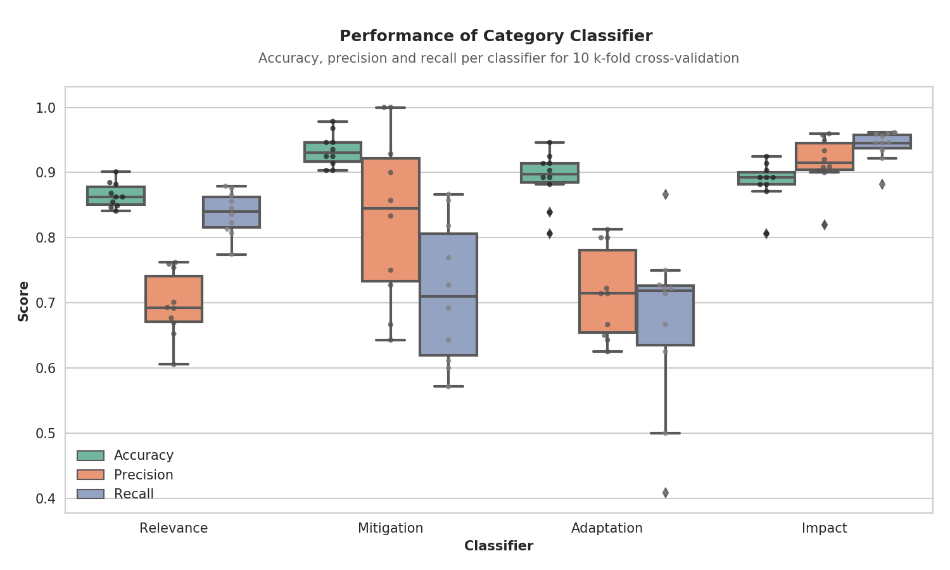
Figure 2: Performance of the different classifiers used. The relevance classifier determines the inclusion in the final dataset, and these documents were then classified into the three categories. For each classifier, three scores are given. Accuracy is simply the share of documents the classifier got correct ([True Positives + True Negatives]/Total). For datasets where there are many more negatives than positives, this however can give a distorted image. Precision (TP/[TP + FP]) and recall (TP/[TP+FN]) are better metrics here. See Box 2 for explanations.
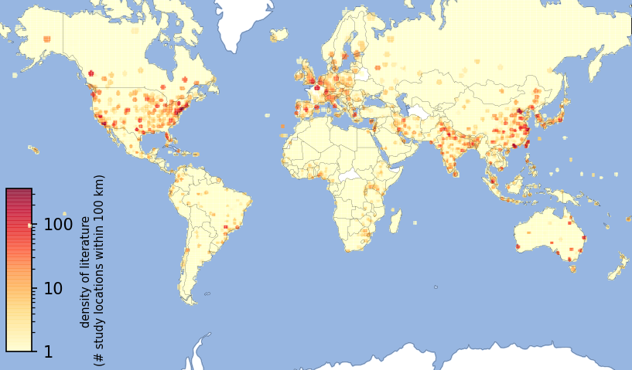Figure 3: Global map of all studies in Part A database and interactive platform. Grid cells are coloured more darkly according to the number of places mentioned within 100km of the cell. Where country names are used in documents, the number of documents is divided over all cells in the country.

Key climate and health topics in the literature
The topic model generated an initial list of 70 topics (Table 3). These were allocated to one or more categories, aligned with the categories in Figure 1: 7 categories of climate hazard, 10 categories of health risks and impacts, 3 categories of mediating pathways, and 4 categories of options and responses. Several topics in the model primarily centred around methodological keywords, which were categorised separately. Note that the topics reported here do not necessarily reflect the most important pathways for climate-health impact or adaptation, but the dominant themes emerging from our review of the scientific literature.
Key emergent topics that were common in the scientific literature include a focus on the health impacts of emissions and particulate matter and a focus on general climate impacts, seasonality and meteorological variability. Topics related to generalised mortality and hospitalisations associated with weather were common. There were a number of topics focused on the impacts of extreme events, heat in particular. Health topics were dominated by climate-sensitive infectious diseases. Reference to public health and health systems was common across studies, but generally reflected the use of the terms ‘health’, ‘public health’, ‘cases’, and ‘hospitalisations’ within a wide range of studies, and were not exclusively related to research on public health or health systems. In other words, studies using health system demand as a proxy for health impacts generally appear to be relatively common; studies that focus on improving the health system as a response use similar language and are therefore included under the same topic, but appear to be less common.
There were relatively few topics related to options and responses. Among these, the co-benefits of mitigation for health was dominant, with lesser research on adaptation topics. Adaptation topics emerging from the literature included a focus on three key areas: adaptation policy and governance, disaster risk reduction, and developing community resilience.
A larger literature focused instead on understanding drivers of exposure and vulnerability (reflecting mediating pathways), including consideration of highly vulnerable demographic (e.g. children, elderly, women, minority ethnicities) and geographic (e.g. urban, rural) groups. We identified a geographic topic focused exclusively on China — the only nation to emerge as a key topic in the literature. Topics related to social vulnerability and building design provide potential entry points for understanding vulnerability entry-points for intervention. There was a large literature dominated by focus on methodological approaches to assessing meteorological impacts on health, reflecting the ongoing challenge of modelling potential climate impacts over space and time.
The 70 topics from Table 3 are mapped in Figure 4, providing a visualisation of how topics cluster in terms of similarity, and categorised by adaptation, mitigation, and impacts. The climate and health scientific literature is dominated by studies exploring the potential impacts of CCVW on health or the associations between CCVW and health; analyses are largely based on meteorological variability rather than climate change. Many studies use the proximal determinants of health rather than health outcomes.
There is relatively limited literature investigating adaptation options and responses. Literature on adaptation is under-represented more generally, with few adaptation-related topics emerging. Despite the prevalence of literature on the meteorological sensitivity of infectious diseases, there is relatively limited integration of these topics with adaptation research (Figure 4). The adaptation literature that has been undertaken is primarily related to preparedness for —or responses to— extreme events, and developing community resilience in the agriculture and water sectors. The mitigation literature forms a relatively distinct area of research that is mainly linked to health through air pollution, with various topics focused on different pollutants.

Table 3: List of topics from the topic model, and associated categorisations based on expert team review (as per Fig. 1), as well as keywords dominant within each topic. Topic prevalence is a ratio reflecting how often each topic occurs relative to the average topic (>1 more prevalent than average; <1 less prevalent).

Aggregated meta-topic | Aggregated topic | Topic name | Top 3 stemmed keywords | Topic prevalence
Climate hazards | Drought | Wildfires | fire, wildfir, smoke | 0.96
Climate hazards | Drought | Dust storms | dust, storm, desert | 0.85
Climate hazards | Drought | Drought | drought, impact, veget | 0.81
Climate hazards | Extreme precipitation & flooding | Extreme weather events | extrem, event, weather | 1.71
Climate hazards | Extreme precipitation & flooding | Floods | flood, damag, river | 1.43
Climate hazards | Extreme precipitation & flooding | Hurricanes | hurrican, evacu, sandi | 1.21
Climate hazards | General climate change | General climate change | climat, chang, impact | 2.86
Climate hazards | General seasonality & weather | Meteorological variables | meteorolog, humid, correl | 2.16
Climate hazards | General seasonality & weather | Seasonality | season, winter, summer | 2.09
Climate hazards | Heat | Ambient temperature | temperatur, effect, ambient | 2.33
Climate hazards | Heat | Increasing temperatures | degre, increas, temperatur | 1.35
Climate hazards | Heat | Heatwaves | heatwav, definit, dure | 1.22
Climate hazards | Heat | Cold & extreme temperatures | cold, spell, hot | 1.07
Climate hazards | Heat | Diurnal temperature range | dtr, diurnal, effect | 0.40
Climate hazards | Precipitation variability | Monthly rainfall | month, rainfal, period | 1.80
Climate hazards | Emissions | Particulate matter | particulatematt, particul, matter | 2.14
Climate hazards | Emissions | Particulate concentration (air) | concentr, particl, site | 1.99
Climate hazards | Emissions | Emissions (Nox & vehicles) | emiss, nox, vehicl | 1.90
Climate hazards | Emissions | Emissions (ozone) | ozon, concentr, ppb | 0.92
Climate hazards | Emissions | PAH | pah, sourc, combust | 0.78
Health risks & impacts | All-cause mortality | Death | death, caus, excess | 1.45
Health risks & impacts | All-cause mortality | Mortality | mortal, cardiovascular, allcaus | 2.05
Health risks & impacts | Chronic | Heat stress | heat, stress, heatrel | 1.65
Health risks & impacts | Chronic | Thermal stress & comfort | thermal, stress, comfort | 1.09
Health risks & impacts | Chronic | Stroke | stroke, ischem, hemorrhag | 0.62
Health risks & impacts | Food & nutrition | Farmers & agriculture | farmer, crop, agricultur | 1.13
Health risks & impacts | Food & nutrition | Food insecurity | food, insecur, secur | 0.93
Health risks & impacts | Patients & health systems | Public health | health, public, review | 2.79
Health risks & impacts | Patients & health systems | Hospital admissions | hospit, admiss, respiratori | 1.40
Health risks & impacts | Patients & health systems | Patients | patient, acut, medic | 1.34
Health risks & impacts | Patients & health systems | Visits to health care facilities | visit, emerg, outpati | 1.02
Health risks & impacts | Infectious | Infectious diseases general | diseas, infecti, respiratori | 1.98
Health risks & impacts | Infectious | Viral diseases | transmiss, outbreak, virus | 1.54
Health risks & impacts | Infectious | Mosquito vector dynamics | mosquito, vector, abund | 1.45
Health risks & impacts | Infectious | Malaria | malaria, transmiss, falciparum | 1.44
Health risks & impacts | Infectious | Dengue | dengu, fever, outbreak | 1.43
Health risks & impacts | Infectious | Influenza | influenza, epidem, week | 0.76
Health risks & impacts | Infectious | HFMD | hfmd, foot, mouth | 0.58
Health risks & impacts | Infectious | Leptospirosis | leptospirosi, leptospira, human | 0.52
Health risks & impacts | Infectious | Cholera | cholera, outbreak, epidem | 0.51
Health risks & impacts | Maternal & child health | Child health | children, child, age | 1.27
Health risks & impacts | Maternal & child health | Birth & pregnancy | birth, preterm, pregnanc | 0.91
Health risks & impacts | Mental health | Mental health & PTSD | mental, ptsd, disord | 1.07
Health risks & impacts | Mental health | Suicide | suicid, associ, rate | 0.51
Health risks & impacts | Occupational health & injury | Occupational injury | injuri, worker, occup | 1.00
Health risks & impacts | Respiratory | Air pollution | pollut, air, qualiti | 2.42
Health risks & impacts | Respiratory | Respiratory viruses | infect, rsv, respiratori | 1.20
Health risks & impacts | Respiratory | Pollen & allergies | pollen, allergen, airborn | 0.82
Health risks & impacts | Respiratory | Asthma | asthma, childhood, exacerb | 0.75
Health risks & impacts | Respiratory | Fungal spores | spore, fungal, airborn | 0.54
Health risks & impacts | WASH | Drinking water quality | water, drink, sourc | 1.32
Options & responses | Developing community resilience | Community resilience | communiti, resili, social | 1.63
Options & responses | Disaster risk reduction | Disaster risk reduction | disast, natur, prepared | 1.53
Options & responses | Mitigation co-benefits | Energy policy & co-benefits | energi, cost, polici | 1.82
Options & responses | Mitigation co-benefits | Greenhouse pathways | scenario, project, rcp | 1.46
Options & responses | Policy & practice | Adaptation | adapt, strategi, plan | 1.55
Mediating pathways | Demographic vulnerability | Age & Sex | age, preval, group | 2.17
Mediating pathways | Geographic exposure | Urban areas | urban, citi, uhi | 1.86
Mediating pathways | Geographic exposure | China | china, provinc, haze | 1.35
Mediating pathways | Geographic exposure | Rural households | household, stove, rural | 1.33
Mediating pathways | Geographic exposure | Building design | indoor, outdoor, home | 0.99
Mediating pathways | Social vulnerability | Vulnerability | vulner, social, hazard | 1.57
Other | Methods & mixed | Spatial analyses | spatial, area, region | 2.40
Other | Methods & mixed | Modeling & forecasting | model, predict, forecast | 2.37
Other | Methods & mixed | Risk assessment & risk perception | risk, factor, percept | 2.20
Other | Methods & mixed | Exposure | exposur, associ, estim | 1.94
Other | Methods & mixed | Case data | case, report, number | 1.89
Other | Methods & mixed | Temporal analyses | day, lag, associ | 1.87
Other | Methods & mixed | Disease incidence | incid, rate, provinc | 1.65
Other | Methods & mixed | Symptoms | symptom, depress, associ | 0.92

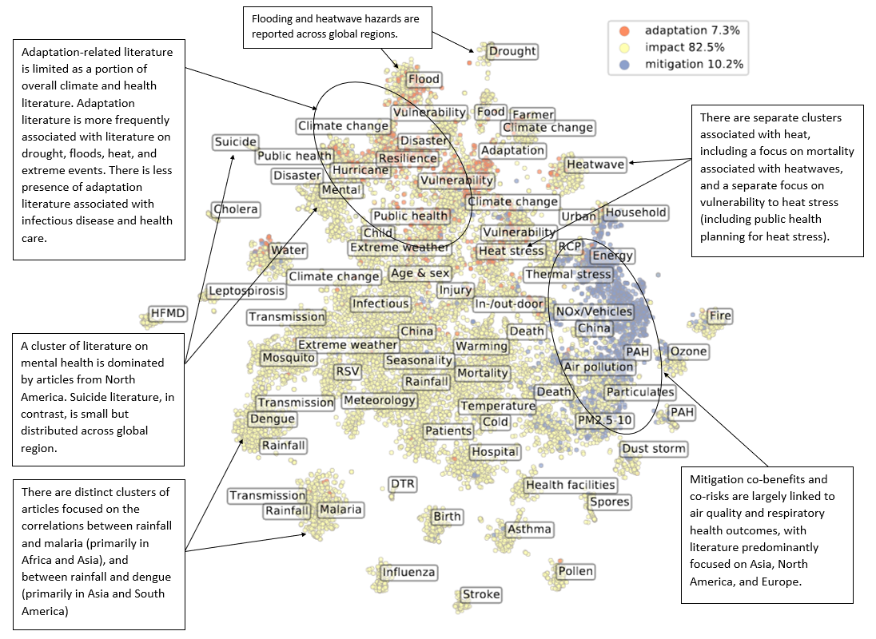
Figure 4: Visualisation of topics in the dataset. Each dot represents a document, coloured by categories of impact, adaptation, or mitigation. Referred to as a ‘topic map’, this visualisation reflects a conceptual space where similar documents are placed closer together, and dissimilar documents are farther apart. Clusters of dots therefore represent areas of literature that have similar topic scores, meaning that they use similar words and therefore are presumed to be about related subjects. The labels indicate the dominant topic in a cluster, and some annotations with extra information from the platform are provided for key areas. The topic map shows a large number of clusters of impact- or association-oriented related topics, including several focused on specific health outcomes (e.g. malaria, influenza, suicide, stroke), which are highly clustered and separate from other topics in the literature. This indicates that literature on these topics is relatively homogeneous and has relatively little overlap with other documents. CCVW-related topics, such as seasonality, meteorology, and temperature, show less distinctive clustering, potentially indicating stronger integration across these topics. Of the health topics, heat stress and air quality appear to be the most strongly integrated with CCVW-related topics, indicating that these areas of research have more strongly engaged with climate research. Mitigation topics are fewer and clustered together, with substantial overlap between mitigation and air pollution topics. Adaptation clusters are relatively uncommon and underrepresented, with fewer topics emerging. There is a notable absence of any substantive overlap of adaptation topics with mitigation topics, indicating negligible attention to co-benefits and co-risks across these two dominant response options. The health areas most strongly clustered with adaptation topics include food and mental health, with many health topics showing negligible proximity to adaptation clusters. Some topics occur twice or more within this graphic, reflecting their association with different and separate areas of literature. The topic 'vulnerability' for example occurs in three areas of distinct literature: once in proximity to heat stress and RCP (Representative Concentration Pathways — denoting different climate change scenarios), once close to climate change, adaptation and resilience, and once close to floods and disasters.

Evidence heat maps
Evidence heat maps indicate the relative volume of literature for each heath impact category by climate hazard (Fig. 5a) and options and responses (Fig. 5b). Results are consistent with Table 3, indicating an emphasis in the literature on meteorological determinants of infectious diseases (particularly precipitation) and respiratory health (particularly co-risks of emissions). Overall, it is notable that the more general topics that are relatively easy to quantify (e.g. temperature, use of health services) tend to both have a high total number of documents and co-occur with a broad range of other topics. This may indicate that studies do not actually assess these topics in depth, but rather that research gets framed around those general topics. The most and least frequently reported climate-health pathways are summarised in Table 4.
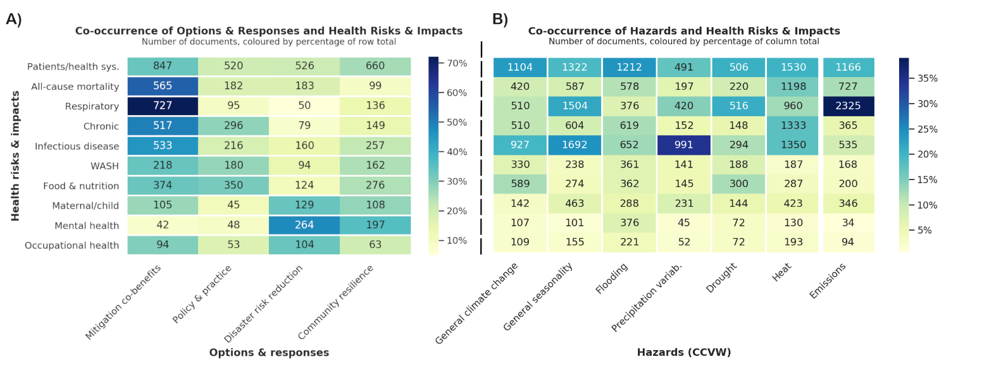Figure 5: Heat maps of the co-occurrence of health risks and impacts with options and responses (A) and hazards (B). Heat maps give the number of documents where both a health topic (on the y-axis) and either options and responses or hazards (on the x-axis) are identified by the topic model in the same document. A document is counted when the topic score is above 0.015. Colour scale set by the percentage of the total number of documents per row for A and by the column total for B.

Figure 5b highlights the number of documents reporting on mitigation options and responses, especially the potential health co-benefits of emissions reductions for respiratory health and other health impacts. In contrast, adaptation options and responses have been much less studied. Emphasis on disaster risk reduction is greatest for health system responses, but also in considering the mental health impacts of extreme events. These health topics are associated with very specific intervention options, such as the emphasis on emissions reductions for respiratory health or disaster risk reduction and community resilience for mental health. Other health topics, such as food and nutrition and health systems, are associated with interventions across the spectrum of topics, including emissions mitigation, disaster preparedness, policy development, and community resilience.
Additional heat maps and results are provided in Appendix 4. The most frequently reported climate-health pathways are summarised in Table 4.

Table 4: Most frequent and least frequently identified climate-health pathways
Most frequently identified  health topics/pathways in the literature | Least frequently identified  health topics/pathways in the literature
Emissions impacts on respiratory health | Occupational health & injury
Respiratory & infectious diseases | Mental health
Public health and health systems | Maternal & child health
Health impacts of heat | Food & nutrition
The importance of extremes events | WASH

A focus on low and lower-middle income countries and priority regions

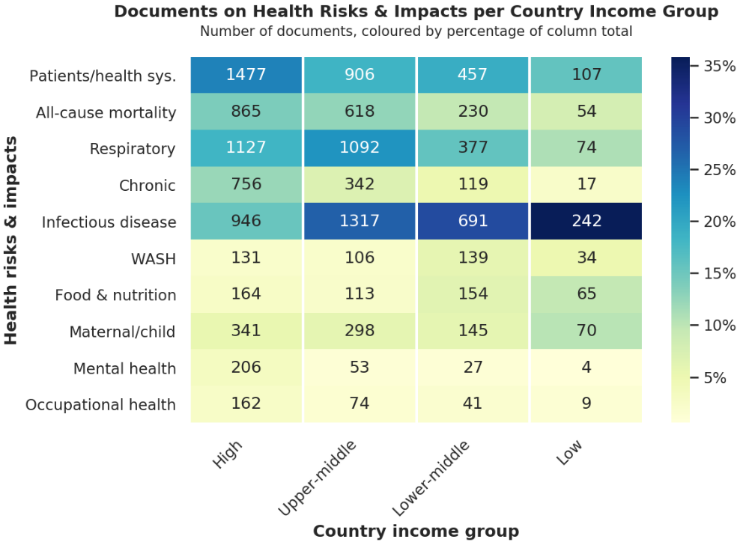
Figure 6: Heatmap of topics and country income classification. A document is counted when the topic score is above 0.015. Colour scale set by the percentage of the total number of studies per column.

Topics within the health literature differ by country economic status (Figure 6). There is an overall dominance of research focused on high income nations, with the volume of literature decreasing with national income status. Low income nations are thus represented by fewer studies overall. In total, 81% of all studies focus on high or upper-middle income nations. The literature in high-income, and to some extent also middle income, countries is largely dominated by public health, all-cause mortality, respiratory, chronic, and infection diseases; by contrast, low income country literature is almost exclusively focused on infectious diseases. There has been limited research on topics prevalent in other regions (e.g. chronic disease, respiratory health), but also on health topics closely linked to the broader determinants of health and the SDGs (e.g. food and nutrition, WASH, maternal and child health, mental health). Notably, even health pathways typically associated with lower income regions, such as WASH and food/nutrition, were underrepresented in the literature for LMICs; we found 2-4 times more articles on these topics in high-income versus low-income countries.

A detailed breakdown of focus topics for priority regions and countries is shown in Figure 7, where we show the most common topics of each type in each region. In the Figure, priority regions are outlined in bold, with common topics highlighted. The axes represent the ratio between the share of each topic in the region with the share of the topic in the whole dataset — i.e. 2 on the x-axis means that a topic is twice as likely to occur in that area compared to the global average; ½ means it is only half as likely to occur. This figure shows for example that research on malaria in priority countries in West Africa is almost 8 times more common than on average across the world. Other commonly studied health impacts in West Africa include food and agriculture (farming), cholera, water, and influenza, while common exposure topics include rainfall, climate change in general, and dust storms. The topic distribution is broadly similar in Middle, Eastern and Northern Africa, although in this region there is a greater focus on child health and viral diseases.
In Western Asia, topics on spores, asthma, and pollen are more common than average, and there is a large literature on cholera, mostly concerning an outbreak in Yemen. Climate driver topics are also notable, with a large literature on particulates and dust storms. The region is under-represented in literature on adaptation compared to other global regions, highlighting a gap in the adaptation literature in Western Asia.
In Central and Southern Asia, vector-borne diseases including dengue and malaria are commonly discussed, along with cholera and impacts on farming. Rainfall and seasonality are common exposure topics, along with PAH (Polycyclic aromatic hydrocarbons — typically present in fossil fuel emissions; they have various health effects) as well as other pollutants.
Finally, in South-eastern Asia, dengue and malaria are the most commonly studied health impacts, with research on food and food insecurity also more common than average. Fire is almost 10 times more commonly studied in South-eastern Asia, with many studies investigating the effects of fires in the region on air quality.

Figure 7: Geographical map of studies in LMICs. Priority regions are outlined in bold, with common topics highlighted, excluding methods topics. Axes represent the ratio between the share of each topic in the region with the share of the topic in the whole dataset — i.e. 2 on the x-axis means that a topic is twice as likely to occur in that area compared to the global average; ½ means it is only half as likely to occur. Grid cells are coloured more darkly according to the number of places mentioned within 100km of the cell; where a country name is mentioned, the score is divided over all the cells in the country.

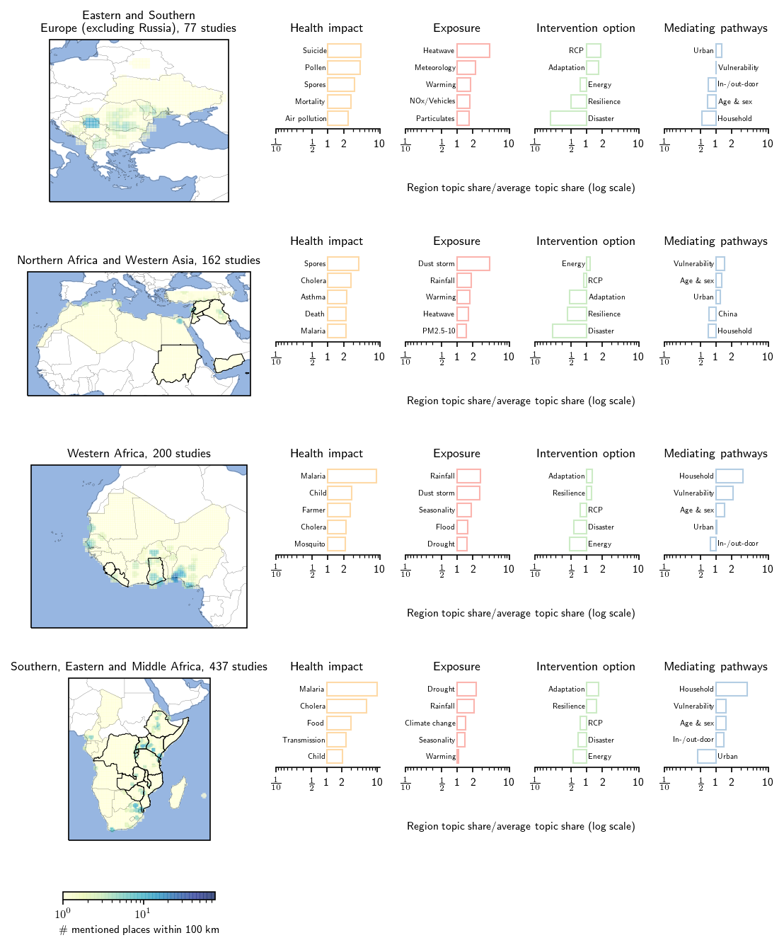

continued next page
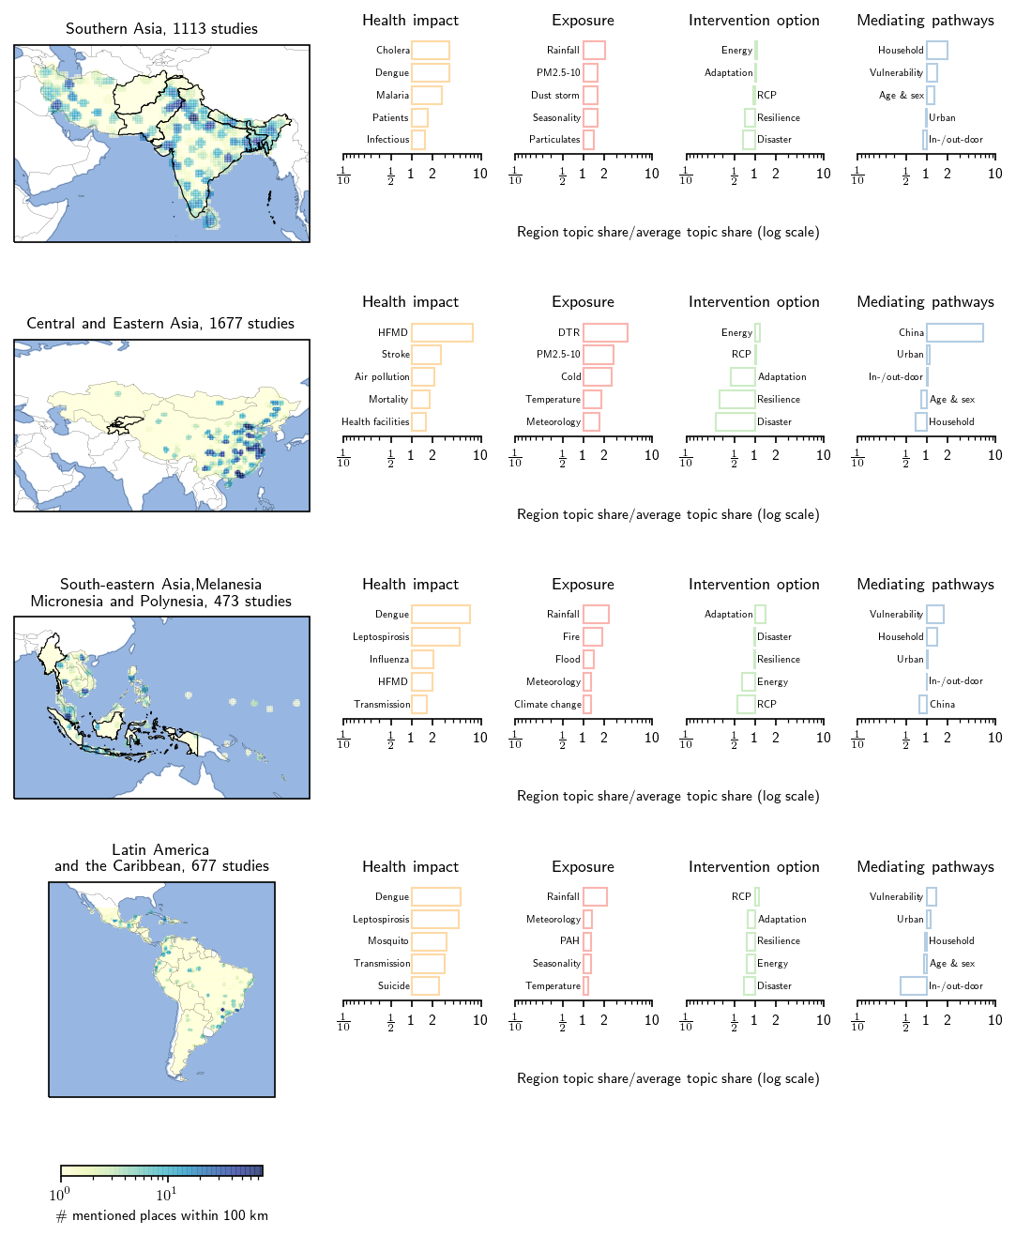

Part A Strengths and limitations
Given that the use of machine learning is — at least currently — fairly unconventional, we provide some guidance as to what our work can and cannot be used for. This is slightly different for the report and the platform, which will therefore be discussed separately.

Report
In the report, the focus has been on capturing the breath of literature. Inevitably, this has meant that some of the literature that is included in the dataset is not relevant to climate change and health (false positives). As mentioned before, there is a considerable grey area too, that is inevitable when mapping relations between such broad concepts. The strength of Part A in this report then by design is its inclusivity; while there is noise in the data, the sheer volume of it allows us to discern important trends.
Results in Part A should be interpreted in a relative sense. When reading the heat maps for example, it would be too strong a statement that there are X papers on a given combination of health impacts and hazards. The heatmaps can, however, be used to state that there is substantially more research into a given combination than into another. Especially when comparing subsets of the literature from a certain geographical area, the confidence in these kinds of statements increases with the size of the subset -- e.g. for Central and Southern Asia (n=870), the locally dominant topics are less likely to be skewed by a single outlier than for Western Asia (n=39).
This review brings together the available global literature on CCVW and health, an evidence base that has been shaped by the availability of funding for research and the ease with which research on this topic can be conducted. While it is not possible to provide an exact estimate of the scale of this bias in the evidence base, it should be noted that there are likely to be certain CCVW and health topics that are disproportionately over and under-reported. Overall, this review should therefore be seen as providing an overview of main themes and trends currently reported in the scientific literature on CCVW and health.
We provide a detailed discussion of the strengths and limitations of machine learning for evidence synthesis in Appendix 2.

Platform
The platform is based on the same dataset and as such, similar caveats apply. However, the interactivity allows for more in-depth analysis. It can be used both to further explore the dataset in general, but also as a first step to answering more advanced questions.
To expand upon the latter, a key strength of machine learning methods is that they do not need to rely on finding exact keywords. Finding studies in any given country or area does not require the user to input all place names within that area, as these have already been identified by the geoparser. Similarly, filtering by topic can provide a pre-selection of papers, without having to create a comprehensive string of keywords. Again however, the user should keep in mind that especially for queries resulting in a small number of papers, it is likely worthwhile to check whether all results actually meet the search requirements.
One functionality that can help reduce uncertainties is the corresponding slider on the platform, which acts as a specificity control. This allows users to set a higher threshold than the inclusive one used in this threshold (0.35). A higher value limits the number of results and therefore is less likely to be comprehensive, but it should make it easier to find literature that is highly relevant to climate.
Lastly, the focus in Part A has been primarily on topical content. One could imagine scenarios when factors such as study design are of importance as well. Here however it is important to keep in mind that Part A did not analyse full texts. Abstracts are designed to cover the most important information and as such, should describe the main topical focus of the work well; whether factors like study design are included however can differ substantially between journals and the data may therefore not be representative. As such, while there are methodological topics in our topic model, these factors have largely been excluded in our analysis; we suggest that users on the platform should be careful not to over-interpret results relating to topics in the ‘other’ category.

Part A Summary
Limited literature on adaptation options and responses: Overall, there is a relatively small literature focused on adaptation options and responses to the health effects of CCVW. The existing literature base remains dominated by studies of correlation and association between meteorological variability and health. Few studies focus on climate change, with the majority of the literature inferring relevance to climate change impacts from meteorological associations (i.e. weather). There is negligible literature establishing causal relationships between weather and health, though these are in some cases well-established biologically. Causal attribution of changing health outcomes to CCVW is negligible and methodologically difficult. Given that weather is not a proxy for climate, the extent to which local weather determinants of health outcomes will translate into climate change risk to health over time remains unclear.
The importance of mitigation co-benefits for health: There is substantial evidence that a key response option for climate risks to health is mitigation of fossil fuel emissions. A large volume of climate-health literature highlights different kinds of particulate matter and exhaust gasses as an important co-risk and determinant of health outcomes, particularly respiratory health but also a range of health pathways. Similarly, there is large literature indicating that mitigation of emissions can provide substantial co-benefits for health. It is notable that focus on mitigation rather than adaptation dominates the literature on options and responses across many of the health pathways studied in this review. This is likely caused by mitigation responses using relatively distinct language from the rest of the dataset, making it easier for the algorithm to identify topics; it is also likely however that the mitigation literature on responses is more developed.
Public health as a response and an impact: Public health systems are not well captured within topic modelling as a distinctive topic. Public health systems can be impacted by climate hazards, through for example increasing health system demand, damage to critical infrastructure, and increased pressure on health burden via mediating pathways. Yet public health systems are also important mechanisms for adaptation response, playing a key role in disaster preparedness, adaptation policy and governance, and developing community resilience. At the same time, public health interfaces with mitigation through contributions to energy demand and emissions arising from health infrastructure (hospitals, health centres, health-related transportation). Public health thus cuts across many of the topics emerging from the literature, and is at the nexus of potential adaptation/mitigation responses, co-benefits, and co-risks. There is a robust and growing literature (including empirical research) on climate change and public health policy and governance that is not explored in detail in this report, and that may merit further targeted review.
Substantial gaps in climate-health research in low income countries: Low income countries are highly underrepresented in the climate-health literature, with publication intensity decreasing with income status. While there is a more diverse profile of research on multiple health pathways in higher income nations, lower income nations are largely focused on infectious diseases. There is limited research in low income countries on a number of topics where climate may have substantial impacts on health, including mental health, occupational health and injury, maternal and child health, chronic disease, and WASH.
Regional variability in climate-health research: Climate-health priorities differ across priority regions, including a stronger focus on respiratory health and air quality in Western Asia compared to other regions, and a notable emphasis on wildfires in SE Asia. African regions are dominated by focus on infectious disease and meteorological variability, particularly rainfall and drought. Household and social vulnerability are key mediating pathways across regions, with emphasis on demographic vulnerability (age and sex) in Western Asia. Response options most frequently studied across regions include development of community resilience and adaptation policy and governance. Emphasis on mitigation of emissions through energy transformation is a key focus in Central and South Asia, and disaster response is a key topic in SE Asia. There is a notable underrepresentation of adaptation literature in Asian regions, and in particular in Western Asia.
A summary of key research gaps is provided in Table 5.

Table 5: Summary of key research gaps related to climate change/variability and health globally, with a focus on priority countries.
Key research gaps
- Climate-health research in low income nations across, particularly in Western Asia and Western Africa.
- Consideration of health pathways other than infectious diseases and health systems, including: mental health; maternal & child health; chronic disease; WASH.
- Emphasis on adaptation options and responses that go beyond impacts to translate vulnerability research into adaptation assessment.
- Co-benefits and co-risks of mitigation for health, particularly in the context of public health systems.
- Assessment of adaptation and intervention options in Asia, particularly Western Asia.

Online interactive evidence platform
The online interactive platform includes many of the figures and visualisations (e.g. evidence heat maps) included in this report, as well as interactive access to the full evidence database from Part A. Example platform functions are shown in Figures 8-10.

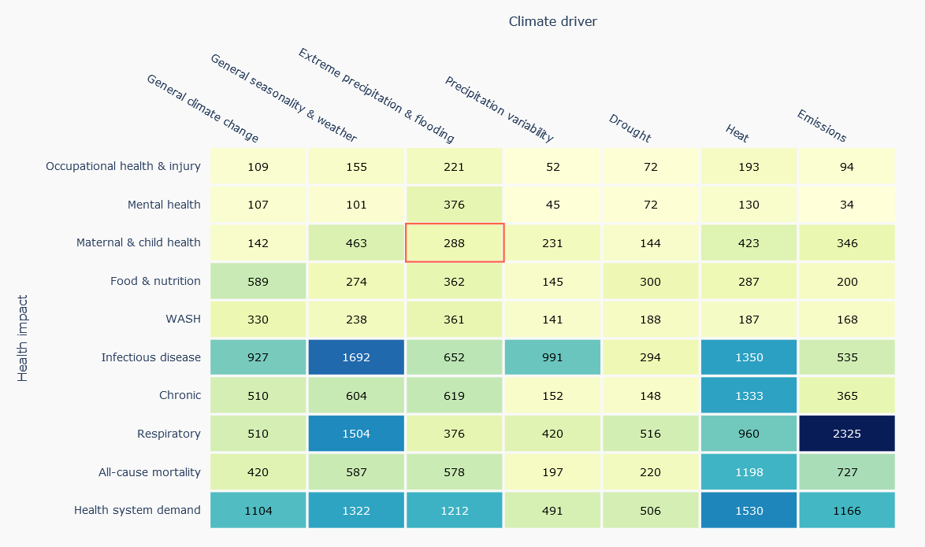
Figure 8: Example interactive heat map of climate hazards and health impacts. Users can scroll over and select grid cells to access a list of relevant publications and links.

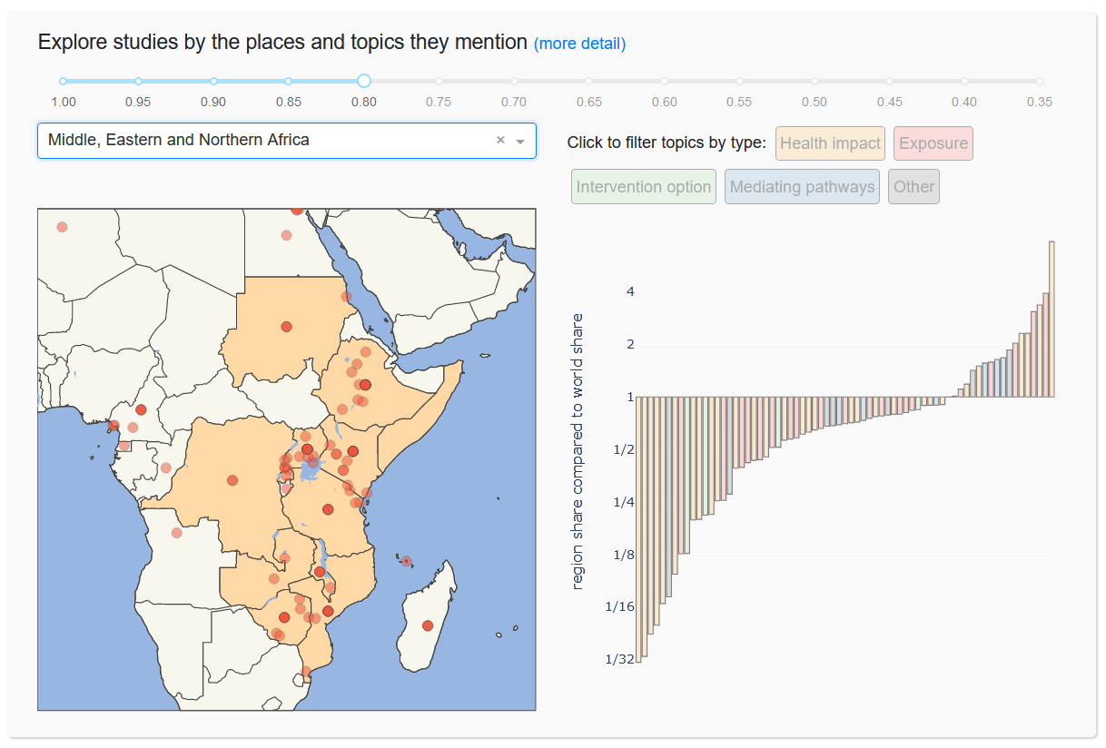
Figure 9: Example interactive evidence map for one priority region and a list of key topics relevant to the region. Users can scroll over and select topic bars to access a list of relevant publications and links as well as select the confidence level with the slider at the top.
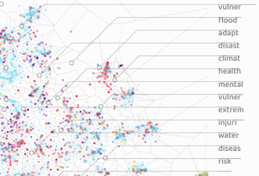
Figure 10: Example interactive screens to explore related topics in the literature (left) and filter by title keywords (right). The filter example retrieves all documents with ‘Uganda’ in their title. Functions can be extended to filter abstracts and keywords as well.

Part B: A focus on assessing the effects on health of adaptation options and responses

Methods
We summarised the available published evidence on the effect on health of CCVW adaptation options and responses in LMICs. We used an existing database, initially constructed for the GAMI project (led by Prof. Lea Berrang Ford), that mapped and reviewed the published literature on CCVW adaptation-related options and responses in human systems. This database was developed through systematic literature searches in Scopus and Web of Science for the years 2013-2019 and retrieved ~60,000 publications. Approximately 1,600 papers were broadly related to CCVW adaptation responses and for the current project these papers were screened for studies that specifically reported the effects on human health of CCVW adaptation options and responses.

Approach
We framed our review using a SPIDER approach: the sample (S) was all LMICs; the phenomena of interest (PI) was the effect on health of CCVW adaptation options and responses (this includes planned adaptations as well as unplanned rapid responses such as disaster response activities); we included all empirical study designs (D) as well as empirically-driven modelling studies and reviews; our aim was to evaluate (E) the effect on health of CCVW adaptation options and responses; and as per the GAMI protocol, we included both qualitative and quantitative research (R). Our time period was 2013-2019 to include studies published since the release of the IPCC AR5 report.

Assessment
Studies were included for this review if they met all of the following four criteria: 1) the study was performed in a LMIC; 2) the study evaluated the impact of a CCVW options and responses; 3) the study clearly stated the climate hazard(s) addressed by the adaptation; and 4) the study clearly reported (quantitatively or qualitatively) health outcomes or data on health indicators (such as WASH or food security).
All included studies were assessed in duplicate for an assessment quality score based on the following criteria:
- Category 1: studies that report formal ex ante planned and designed evaluations of adaptation options and responses (with and without a counterfactual), and feature a baseline and follow-up measurement (or comparison between two areas) of specified health outcomes.
- Category 2: studies that do not report formal ex ante evaluations but assess the impact of adaptation options and responses on specified health outcomes using a “comparison” area (typically that did not adapt) or by using previously collected baseline data (“before and after” design).
- Category 3: studies that report specified health outcomes with no counterfactual.
- Category 4: studies that typically made comments or assertions on the effects of climate change adaptation options and responses on health with little supporting evidence.

Data extraction and synthesis
Relevant data extracted from included papers included: geographic region (continent, urban vs rural, coastal vs inland); population under investigation (general population, farmers, children); type of adaptation option or response (infrastructural, technical, behavioural, health system); and health effect (quantitative and/or qualitative). The extracted data were collated into a database, and categorised by climate hazard, adaptation option/response, and health outcome. Given the heterogeneity of the available data, no formal quantitative analysis was possible. We report the geographic distribution of studies, a heat map of adaptation options and health outcomes, and a narrative synthesis of the evidence under four themes: geographic location; vulnerable target population; climate hazard and type of adaptation response; and health outcome. A searchable spreadsheet of included papers is submitted with this report, and studies are listed in Appendix 5. A briefly annotated list of 10 exemplar studies can be found in Appendix 6.

Results

Evidence Base
We included 99 studies that were conducted in 66 different LMICs and reported 174 measurements of human health outcomes or health indicators from adaptation options and responses (Figure 11 and Table 6). Studies typically reported multiple combinations of climate hazards, health outcomes, and adaptation options and responses, and a total of 1117 measurements were extracted. Seven studies were global studies, and 1 study assessed health outcomes in 57 Small Island States.

The most commonly reported health outcomes were related to infectious diseases (17 studies), with only a few studies reporting the effects of adaptation options and responses on other health outcomes (all-cause mortality [9 studies], mental health [5 studies] and non-communicable disease [2 studies]). No study reported on maternal and child health outcomes. The evidence base was largest for studies evaluating the effect of adaptation options and responses on intermediate health outcomes, especially indicators of vulnerability/livelihood (61 studies); food security (46 studies) and water, sanitation and hygiene (WASH; 16 studies)(Table 6).

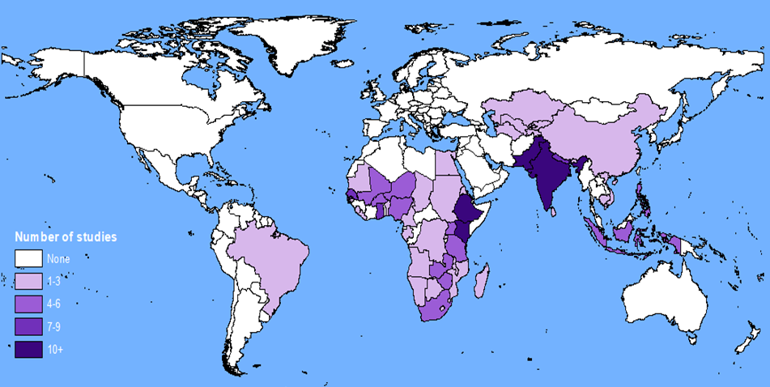
Figure 11: Global distribution of included studies and their relative abundance.
Table 6: Heat map of the various climate drivers and health outcomes - by adaptation category. Adaptation categories include: Improving community resilience; policy, governance and finance; and disaster risk reduction. Several studies assessed the impact of multiple climate hazards, adaptation categories and/or health outcomes, hence numbers are not mutually exclusive.
Climate Hazard | Adaptation or Response | All-cause Mortality | Infectious Disease | Chronic Disease | Maternal & Child Health | Health Systems | WaSH | Food security & malnutrition | Mental Health | Other
 |  | N=9 | N=17 | N=2 | N=0 | N=5 | N=16 | N=46 | N=5 | N=13
Extreme precipitation and inland flooding | Improving community resilience | 6 | 12 | 1 | 0 | 0 | 8 | 16 | 1 | 4
Extreme precipitation and inland flooding | Policy, governance and finance | 3 | 6 | 0 | 0 | 0 | 3 | 6 | 1 | 2
Extreme precipitation and inland flooding | Disaster risk reduction | 5 | 8 | 0 | 0 | 0 | 8 | 13 | 2 | 3
Increased frequency and intensity of heat | Improving community resilience | 4 | 7 | 2 | 0 | 0 | 4 | 7 | 2 | 6
Increased frequency and intensity of heat | Policy, governance and finance | 1 | 5 | 1 | 0 | 0 | 2 | 3 | 0 | 2
Increased frequency and intensity of heat | Disaster risk reduction | 2 | 7 | 1 | 0 | 1 | 4 | 9 | 1 | 3
Precipitation variability | Improving community resilience | 0 | 3 | 1 | 0 | 0 | 3 | 13 | 0 | 3
Precipitation variability | Policy, governance and finance | 0 | 2 | 1 | 0 | 0 | 2 | 5 | 0 | 2
Precipitation variability | Disaster risk reduction | 0 | 3 | 1 | 0 | 0 | 4 | 15 | 0 | 3
Drought | Improving community resilience | 1 | 6 | 1 | 0 | 1 | 5 | 19 | 1 | 5
Drought | Policy, governance and finance | 0 | 2 | 1 | 0 | 0 | 1 | 5 | 0 | 1
Drought | Disaster risk reduction | 1 | 5 | 1 | 0 | 1 | 6 | 22 | 2 | 3
Rising ocean temperature and ocean acidification | Improving community resilience | 0 | 2 | 0 | 0 | 0 | 1 | 2 | 0 | 1
Rising ocean temperature and ocean acidification | Policy, governance and finance | 0 | 1 | 0 | 0 | 0 | 1 | 1 | 0 | 1
Rising ocean temperature and ocean acidification | Disaster risk reduction | 0 | 2 | 0 | 0 | 0 | 1 | 2 | 0 | 1
Sea level rise & coastal flooding | Improving community resilience | 5 | 5 | 1 | 0 | 0 | 4 | 4 | 0 | 4
Sea level rise & coastal flooding | Policy, governance and finance | 2 | 2 | 0 | 0 | 0 | 2 | 4 | 2 | 2
Sea level rise & coastal flooding | Disaster risk reduction | 3 | 5 | 0 | 0 | 0 | 6 | 4 | 1 | 2
Other/general climate impacts | Improving community resilience | 5 | 6 | 1 | 0 | 2 | 4 | 12 | 1 | 5
Other/general climate impacts | Policy, governance and finance | 3 | 4 | 1 | 0 | 2 | 3 | 3 | 0 | 2
Other/general climate impacts | Disaster risk reduction | 5 | 8 | 1 | 0 | 4 | 5 | 17 | 2 | 5

Summary findings by A. Health outcome, B. Climate change hazard, C. Adaptation option and response, and D. Vulnerable group

Health Outcome
Infectious disease
17 studies reported on adaptation options and responses and infectious diseases. Studies reported on Asia (6), Africa (67), Australasia (1) and Global (4). Specific geographies of studies were mixed as some were in coastal areas (8), inland (6), urban (8), and rural (5). 5 studies reported on specific populations; children (1), environmental health practitioners (1), low-income groups (1) and farmers (2). Commonly reported adaptation options and responses were practice or behaviour change (11), information or awareness promotion (7) and physical infrastructure improvements (9) including: migration, safe water storage, domestication of animals as alternative food source and securing livestock, enhanced infectious disease control programmes, breeding site inspection and vector awareness campaigns. The most commonly reported climate exposure was extreme precipitation and inland flooding (10), droughts (9), precipitation variability (6) and coastal flooding (5). The majority of studies were cross-sectional studies (8), 3 studies were qualitative, 1 study was longitudinal and 5 were (systematic) reviews.
Several pathways were reported through which adaptation options and responses affected infectious disease. Primarily, household and community level adaptations reducing the impacts of flood impacts led to a reduction in vector borne disease (dengue and malaria) prevalence. Water conservation was reported to affect water-borne and water-washed diseases including diarrhoea and cholera. One study on a fogging intervention in Delhi suggested that government-level adaptation strategies had limited impact on dengue incidence. 12 studies evaluated the effect of climate response activities on infectious disease; 8 reported a positive response, 2 reported a negative response and 3 reported mixed responses.
On average a 13% [95% CI: -3.1 to -23.0] reduction in incidence of infectious disease was reported resulting from the adaptation activities across all sub-groups. The largest health gains were reported to result from physical infrastructure change, whilst behaviour change and awareness activities commonly found no significant health improvement.
Assessment Quality Score | 1 | 2 | 3 | 4 | (1=high; 4=low)
Number of studies | 0 | 1 | 12 | 4

Water, Sanitation and Hygiene (WASH) indicators
16 studies reported on adaptation options and responses and WASH indicators. Studies reported on Asia (8), Africa (3), Australasia (2), Central and South America (1) and on a global context (3). 8 studies were conducted in coastal settings, 5 of which focussed on urban areas, 2 on rural areas, and 1 study focussed on both urban and rural settings. In non-coastal settings (8/16 studies), there was 1 urban study, 4 rural studies, and 3 studies that did not report on urbanicity. 12 studies assessed the effect of adaptation options and responses on health of the general population, 2 studies reported on farmers, 1 on environmental health practitioners, and 1 on low-income households or communities. Most included studies used a cross-sectional design (9) or were reviews (6): there was 1 expert elicitation.
The pathways through which adaptation options and responses affected WASH indicators were: specific behaviour change approaches (5), physical infrastructure improvements (5), and mixed approaches including institutional, technological and ecosystem responses (8). Common adaptation options and responses included: small dams and flood barriers to reduce inundations in the home and rainwater storage infrastructure. All but three studies evaluated floods and droughts.
The construction of better water storage facilities in both community-led projects and government/NGO-led projects was reported to improve WASH indicators including access to (drinking) water in arid regions. Several studies evaluated the impact of stored water for irrigation on food security. Reduced home flooding was found to be associated with lower gastro-intestinal disease risk, skin infections and injuries. 13 studies reported on the effectiveness of climate response activities; 8 reported a positive response, and 5 reported mixed responses.
On average a 23% [95% CI: 11.9 to 34.0] increase in access to WASH facilities was reported resulting from the adaptation activities across all sub-groups. The largest health gains were reported to result from physical infrastructure change (as a single approach), whilst a combination of technical, ecological and behavioural activities resulted in the largest increase in access to WASH overall.
Assessment Quality Score | 1 | 2 | 3 | 4 | (1=high; 4=low)
Number of studies | 0 | 1 | 11 | 4

Food Security & Malnutrition
46 studies reported on adaptation options and responses and food security and undernutrition. Studies reported on Africa (27), Asia (16), Australasia (3) and on the global context (2). 12 studies were conducted in coastal settings, of which 5 focussed on rural areas, and 7 studies focussed on both urban and rural settings. 24 rural studies, and 2 urban-rural combination studies reported on non-coastal settings; 2 studies did not report on urbanicity. 20 studies assessed the effect in the general population and 20 reported on farmers, 1 study looked into male versus female led households. The majority of studies (35) used a cross-sectional study design, 5 studies were reviews, 4 studies were longitudinal and 2 studies were empirical modelling studies.
Reported adaptation options and responses fell into three categories: expanding agricultural produce to different/additional products (including tree planting); the cultivation of climate resilient crop varieties or the application of climate resilient agricultural management strategies; and enhanced storage or preservation techniques of foodstuffs for consumption at times of reduced food supply. The majority of studies reported responses to extreme events (droughts, extreme heat and extreme precipitation - 35 studies) and a small body of evidence focussed on more general and gradual climate change impacts. 37 studies reported the effectiveness of adaptation options and responses; 23 reported a positive response; 2 a negative response and 12 reported mixed responses.
The studies reported a large variety of food security outcomes, often evaluating multiple combinations of climate exposures, and therefore the results could not be pooled. The largest food security improvements were reported from projects that evaluated the impact of climate resilient crop varieties (often under the heading of climate smart agriculture), and advancements in agricultural management.
Assessment Quality Score | 1 | 2 | 3 | 4 | (1=high; 4=low)
Number of studies | 1 | 12 | 19 | 14

Other health outcomes
A small number of studies reported on adaptation options and responses and all-cause mortality and mental health. 9 studies (of which 6 were from Asia) reported on all-cause mortality and evaluated a range of climate change response activities, including those aiming to reduce the impacts of heat, flood, air pollution and other climate disasters on population mortality. All studies reported that (various) adaptation options and responses reduced all-cause mortality, though three studies found negative health effects for some subgroup analyses. 5 studies reported on adaptation options and responses and mental health, and two reported on non-communicable disease, with all studies reporting positive health effects resulting from the evaluated adaptation activities.

Climate Change Driver
Extreme precipitation and inland flooding
46 papers assessed adaptation options and responses to extreme precipitation and inland flooding. Studies reported on Asia (17), Africa (22), multi-continent (4), Australasia (2) and Central/South America (1). 18 studies were in coastal areas, 12 were inland; 26 were in rural areas, 9 were urban, 5 were both rural and urban and 6 were unknown. Studies reported on general populations (33), farming communities (9), low-income groups (1), children (1), environmental health practitioners (1) and one study analysed gender differences. Study designs were mixed; 35 were cross-sectional, 6 were reviews, 1 was longitudinal, 1 was an expert elicitation and 3 were qualitative studies.
Adaptation options and responses were typically mixed and reported elements of: practice or behaviour change (29), physical infrastructure improvements (21) and technological enhancements (24) and included: house modifications (11), climate-smart agriculture (20), water management (7) and food preservation (2). The most commonly reported outcomes were: food security and undernutrition (18), infectious disease (12), WASH (9), and all-cause mortality (10), whilst a number of studies (22) also reported on income and/or livelihood changes. Some papers reported maladaptive responses (17) including: psychological impacts from migration, long-term implications of financial loans and reduced crop productivity due to new crop varieties. 9 papers reported co-benefits from the climate response activity including access to clean drinking water, reduced greenhouse gas emissions, community building and dietary diversity.
The effectiveness of adaptation options and responses was reported in 40 studies: 23 reported positive responses; 3 reported negative responses and 14 reported mixed responses.
Assessment Quality Score | 1 | 2 | 3 | 4 | (1=high; 4=low)
Number of studies | 0 | 9 | 26 | 11

Precipitation Variability
43 studies assessed adaptation options and responses to precipitation variability. Studies reported on Africa (25), Asia (16), global (2) and Australasia (1). 25 studies were in inland areas; 7 in coastal areas. The majority of studies (32) focussed on rural areas, 3 reported on both urban and rural areas, and the remaining studies were unspecified (8). Study populations were either general (18) or farming communities (25) including 1 study on pastoralists. Study designs were mixed: 30 were cross-sectional, 6 were longitudinal, 4 were reviews, 1 was expert elicitation and 1 was a qualitative study.
Commonly reported adaptation options and responses were: practice or behaviour change (27), physical infrastructure modifications (16), financial incentives (5) and technological improvements (11) or a combination of these, and included: water conservation and treatment techniques, farming practice changes, climate-smart agriculture initiatives, infectious disease control systems, household flood modifications, public education and community engagement, food or monetary transfer schemes and relocation/migration. The most commonly reported outcomes were: food security and undernutrition (25), WASH indicators (11) and infectious disease outcomes (6). A number of studies (26) also reported on socio-economic outcomes, such as income, livelihood assets and vulnerability. Some papers reported maladaptive responses (13) including: cost and psychological impacts of relocation, changes in farming practice leading to decreased yields and increased burden on women. 11 studies reported co-benefits from the adaptation options and responses including increased income and resilience, access to clean drinking water and creation of a crop insurance effect (due to increased crop diversity).
The effectiveness of adaptation options and responses was reported in 39 studies: 21 reported positive responses, 1 reported a negative response and 16 reported mixed responses.
Assessment Quality Score | 1 | 2 | 3 | 4 | (1=high; 4=low)
Number of studies | 1 | 12 | 23 | 7

Drought
59 studies assessed adaptation options and responses to drought. Studies reported on Africa (39), Asia (15), Oceania (2), and Central and South America (1) and two reported on the global context. 26 studies were inland and 10 conducted in coastal areas; 33 studies were among rural populations. Study populations were either general (29) or among farming communities (28) including 2 studies focussing on pastoralists. 1 study reported gender differences and 1 study on environmental health practitioners. Study designs were mixed: 46 were cross sectional, 6 were longitudinal, 5 were reviews, 1 was a qualitative study and 1 an expert elicitation.
Studies based in areas vulnerable to drought often also reported risk of inland flooding (15), extreme heat (12) and precipitation variability (22). Commonly reported adaptation options and responses were: practice and behaviour change (31), technological improvements (12) and physical and green infrastructure implementation (18) including water resource management and implementation, drought-tolerant crop varieties, food preservation and climate smart agriculture. The most commonly reported outcomes included: food security and undernutrition (30), socio-economic indicators, such as income, livelihood assets and vulnerability (16), and infectious diseases (11) or a combination thereof.
The effectiveness of adaptation options and responses was reported in 54 studies: 34 reported positive responses, 1 reported negative responses and 19 reported mixed responses. 16 papers reported maladaptive responses.
Assessment Quality Score | 1 | 2 | 3 | 4 | (1=high; 4=low)
Number of studies | 2 | 12 | 32 | 13

Increased Intensity and Frequency of Heat
32 studies assessed adaptation options and responses to increased intensity and/or frequency of heat. Studies reported on Asia (13), Africa (17), Oceania (1) and Central and South America (1). One study focussed on the global context. 5 studies focussed on coastal settings, whilst 18 studies were in non-coastal settings, 25 in rural areas, 7 in urban areas amongst which 3 studies focussed both on urban and rural areas. The remaining studies did not report on urbanicity. 13 studies reported on the general population, 16 studies reported on farming communities, 1 study on environmental health practitioners, 1 on low-income households and 1 study reported on children. 23 studies were cross-sectional, whilst 5 were reviews, 2 were longitudinal, 1 was qualitative and 1 was an empirical modelling study.
Studies reported a large variety of adaptation options and responses that included: cultivation of heat resistant crop varieties and climate smart agricultural approaches, and specific heat reduction activities in cities. Commonly reported outcomes included: infectious diseases (12) and food security and undernutrition (11). A number of studies (18) also reported on socio-economic outcomes such as income and livelihood assets. 28 studies reported the effectiveness of adaptation options and responses: 19 studies reported positive responses; 1 study reported negative responses and 8 studies reported mixed responses.
Assessment Quality Score | 1 | 2 | 3 | 4 | (1=high; 4=low)
Number of studies | 0 | 8 | 18 | 6

- Climate Change Response Type
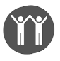Improving Community Resilience
- Practice of Behaviour Change
60 studies reported adaptation options and responses related to practice or behaviour changes. Studies reported on Asia (27), Africa (23), Oceania (3), Central and South America (1) and multi-continent studies (6). 22 studies were in coastal zones, 31 were inland, 42 were in rural settings. 37 studies reported on the general population, 18 reported on farming communities, 1 focussed on children, 2 on gender differences, 1 studied environmental health practitioners and 1 explored low-income groups. Study designs were mixed: 42 were cross-sectional studies, 6 were longitudinal studies; 8 were reviews and 4 were qualitative studies.
Common adaptation options and responses related to extreme precipitation and inland flooding (26), precipitation variability (21) and drought (29) and included: soil and water conservation, relocation/migration, storage of food, agricultural inputs, farming practice and crop diversity. Commonly reported health outcomes included: infectious diseases (10), WASH indicators (10) and food security and undernutrition (25). More than half of the studies (32) also reported on socio-economic determinants, such as income and livelihood assets. Several studies reported maladaptive responses (21) including water conservation strategies that limited crop yields and production. Some co-benefits were identified including: improved social networks, increasing school attendance and enrolment, preservation of traditional practices and improved access to clean water. 50 studies reported the effectiveness of the adaptation options and responses: 24 reported positive responses, 3 reported negative responses and 23 reported mixed responses.
Assessment Quality Score | 1 | 2 | 3 | 4 | (1=high; 4=low)
Number of studies | 1 | 12 | 31 | 16

- Capacity Building
8 studies reported adaptation options and responses related to capacity building. Studies reported on Africa (1), Asia (5) and multi-continent studies (2). 3 studies were in coastal areas, 4 were inland and 1 did not specify location; 3 were in rural areas, 3 in urban settings and 2 were in mixed settings. 4 studies reported on the general population, 3 reported on farming communities, and 1 study focussed on low-income households. 4 studies were cross-sectional, 1 was longitudinal and 3 were reviews.
Reported adaptation options and responses included: training practitioners, emergency management response, community empowerment, resilience strategies and knowledge mobilisation. Reported health outcomes included: food security and undernutrition (3), and infectious disease (2). Almost all studies (7) also reported on socio-economic indicators including income and livelihood assets. All studies reported on the effectiveness of adaptation options and responses: 4 reported positive responses, 2 reported negative responses and 2 reported mixed responses.
Assessment Quality Score | 1 | 2 | 3 | 4 | (1=high; 4=low)
Number of studies | 0 | 3 | 5 | 0
Disaster Risk Reduction
- Physical Infrastructure
38 studies reported adaptation options and responses related to physical infrastructure. Studies reported on Asia (16), Africa (11), multi-continent studies (9), Australasia (1), and Central and South America (1). 19 studies were in coastal areas, 10 were inland and 9 were unspecified. 14 studies were rural, 11 were in urban settings and 5 were mixed. 27 studies reported on the general population, 8 reported on farming communities, 1 in low income groups, 1 in environmental health practitioners and 1 disaggregated by gender. 20 studies were cross-sectional, 2 were longitudinal, 13 were reviews, 1 expert elicitation and 2 were qualitative studies.
Commonly reported adaptation options and responses included: drainage and water systems (15), elevation and strengthening of households (15), farm structural improvements (5), extreme event shelters (2), improvement of road systems (2) and building cooling techniques (4). Reported health outcomes included: socioeconomic pathways (19), WASH indicators (18), food security and undernutrition (10) and infectious disease (7). 11 studies reported maladaptive responses, 10 studies identified co-benefits. 31 papers reported on the effectiveness of adaptation options and responses: 17 reported positive responses, 1 reported a negative response and 13 reported mixed responses.
Assessment Quality Score | 1 | 2 | 3 | 4 | (1=high; 4=low)
Number of studies | 0 | 6 | 23 | 9

- Technology
70 studies reported adaptation options and responses related to technological improvements - including “green” technology on farms. Studies reported on Africa (36), Asia (24), multi-continent (8), Central and South America (1) and Oceania (1). 38 studies were inland, 12 were coastal and the remainder were unspecified. 53 were in rural areas, 4 in urban settings, 5 were mixed and 8 were unspecified. 26 studies reported on adaptation options and responses in the general population, 42 in farming and pastoralist communities, 1 among environmental health practitioners and 1 disaggregated by gender. 51 studies were cross-sectional, 4 were longitudinal, 3 were empirical modelling studies, and 12 were reviews.
Commonly reported adaptation options and responses included: drought-resistant crop varieties, climate smart agricultural practices, rain-water harvesting technology, saline-resistant crops and vehicle improvements. Reported health outcomes included: food security and undernutrition (53), socio-economic indicators (34) and infectious disease outcomes (13). 15 papers reported maladaptive responses, 27 reported co-benefits. 64 studies reported the effectiveness of adaptation options and responses: 40 reported positive responses, 1 reported negative responses and 23 reported mixed responses.
Assessment Quality Score | 1 | 2 | 3 | 4 | (1=high; 4=low)
Number of studies | 1 | 16 | 36 | 17

- Warning Systems
10 studies reported adaptation options and responses related to early warning systems. Studies reported on Asia (4), Africa (3) and multi-continent (3). 3 studies were in coastal areas, 3 were inland and 4 were unspecified. 4 studies were in urban areas, 1 in a rural area, and 1 was mixed. 7 studies reported on climate response activities in the general population, 1 study observed environmental health practitioners, 1 studied looked at gender differences, and 1 study was among low income households. 4 studies were cross-sectional studies, 1 was longitudinal, 1 was qualitative and 4 were reviews.
Warning systems were primarily focussed on infectious disease and climate surveillance including weather-based forecasting systems for the general public. Reported health outcomes were: infectious diseases (5), all-cause mortality (2) and food security (2). 7 studies reported on the effectiveness of adaptation options and responses: 4 reported positive responses and 3 reported mixed responses.
Assessment Quality Score | 1 | 2 | 3 | 4 | (1=high; 4=low)
Number of studies | 0 | 2 | 4 | 4

Policy, Governance & Finance
- Policy
15 studies reported adaptation options and responses related to policy implementation. Studies reported on Asia (6), Africa (1) and multi-continent (8). 3 studies were located inland, 4 were coastal and 8 were unspecified. 4 were in rural areas, 3 were in urban areas, 1 was mixed and 7 were unspecified. 14 reported on adaptation options and responses in the general population, with 1 study reporting on farmers. 6 studies were cross-sectional, 8 were reviews and 1 study was qualitative.
Climate policies included: building and land planning regulations, emission restriction policies, adaptation plans, pastoral sedentarisation policy and general climate policy. Common health outcomes included: infectious disease (4), WASH indicators (3), all-cause mortality (2), food security and undernutrition (2) and health system demand (2). 12 studies reported the effectiveness of adaptation options and responses: 7 reported positive responses, 1 a negative response and 4 reported mixed responses.
Assessment Quality Score | 1 | 2 | 3 | 4 | (1=high; 4=low)
Number of studies | 0 | 2 | 10 | 3

- Financing/Incentives
20 studies reported adaptation options and responses related to financial and incentivisation schemes. Studies reported on Asia (14), Africa (3), Oceania (1) and multi-continent (2). 9 studies were in coastal areas, 5 inland, 2 were in both coastal and inland areas and 4 were unspecified. 13 studies were in rural areas and 3 were in urban areas. Studies reported on adaptation options and responses in the general population (16), among farming communities (3) and in low-income households (1). 12 studies were cross-sectional, 3 were longitudinal, 4 were reviews and 1 was a qualitative study.
Reported financial and incentive schemes included: nutrition schemes (2), rationing and food transfers (2), money transfers and financial support (10), investment schemes (3), loans (2) and insurance (2). Reported health outcomes included: infectious disease (2), mental health (2) and food security and undernutrition (8). 10 studies also reported on socio-economic determinants, including income and livelihood assets. 15 studies reported the effectiveness of adaptation options and responses: 8 reported positive responses, and 7 reported mixed responses.
Assessment Quality Score | 1 | 2 | 3 | 4 | (1=high; 4=low)
Number of studies | 0 | 6 | 6 | 8

Vulnerability and vulnerable groups
Farmers
38 studies reported adaptation options and responses among farming households. Studies reported on Asia (16), Africa (21) or multiple continents (1). 32 studies were cross-sectional, 2 were longitudinal, 2 were reviews and 2 were empirical modelling studies. Commonly reported adaptation options and responses included: changes in irrigation, fertiliser use, crop diversity, water conservation, drought-resistant crop varieties (climate smart agriculture) and mulching. Some studies reported changes to physical and green infrastructure including tree planting, improved storage of crops and building of fences and wells. Reported health outcomes included: food security or farm productivity (23) and socio-economic indicators such as income from production (24). 37 studies reported the effectiveness of adaptation options and responses: 27 reported positive responses, 1 reported negative responses, and 9 were mixed. Several studies reported co-benefits from the climate response activities including stabilised farmer incomes, strengthened social networks and reduced greenhouse gas emissions.
Assessment Quality Score | 1 | 2 | 3 | 4 | (1=high; 4=low)
Number of studies | 2 | 12 | 9 | 5

A description of results by continent can be found in Appendix 7.

Part B Strengths and limitations

This is the first time the published evidence on the effects on health of CCVW adaptation options and responses has been brought together and synthesised in a systematic manner, and the collated evidence provides important insights into the available published literature. However, there are several important limitations that need to be considered when interpreting the findings.
First, the evidence base is relatively restricted both in scale and in quality. The limited scale of the evidence base, resulting in reduced ability to synthesise findings across multiple studies, means that it is not possible to generalise the overall findings. The limited quality of the evidence base, with very few studies being graded as assessment quality score category 1 (i.e. ex ante formal evaluations of a defined adaptation options or responses), means that confidence in the reliability and strength of the findings is reduced. Second, there are limitations in the way in which the studies were identified. The original GAMI project was not designed specifically to answer the question on the effects on human health of CCVW adaptation options and responses. While screening of the GAMI database of 60,000+ papers for relevant studies was systematic, it is possible that some relevant papers were not included in the original GAMI database. Other biases, including those relating to reporting, publication and language, are common concerns in reviews of this nature and should be considered. For example, it is notable that of the 85 studies that reported quantitative findings, 51 reported positive outcomes, 31 reported mixed outcomes and only 3 reported negative outcomes. This may, however, reflect positive reporting bias in the literature. Finally, the review focuses on the currently available (and limited) literature and does not provide much information on newly emergent areas of research. Recent areas of particular research activity include for example a focus on antimicrobial resistance and climate change, as well as a rapidly emerging literature on post-Covid-19 climate governance. An update to this review in 3-5 years would certainly reveal several new priority areas.

Part B Summary

This review identified 99 studies, drawn from a systematically generated database of research published from 2013-2019. The studies report evidence from 66 LMICs, with strongest representation from Africa (particularly Ethiopia) and Asia (particularly India and Bangladesh). The primary climate change hazards reported were flooding, rainfall, drought and extreme heat. The primary CCVW adaptation options and responses were behaviour change, and infrastructural and technological improvements. A few studies reported on climate change policy implementation and financing schemes.
Many studies were conducted among farming communities (typically small-holder and subsistence farmers) and adaptation options and responses in the agricultural sector were a major feature in the database. The evidence base included, for example, several studies assessing the effect of climate smart agriculture (e.g. drought tolerant crops) on food production and food security. The most commonly reported health outcomes were related to infectious diseases and specifically to vector-borne diseases including malaria and dengue. Other primary health outcomes such as all-cause mortality were rarely reported. Several studies reported on intermediate health outcomes including indicators of WASH and food security.
In contrast to Part A that identified a relatively small evidence base on the impact of CCVW on WASH and food security indicators, these intermediate indicators were frequently reported in studies on adaptation options and responses. The reason for this inconsistency is unclear but may relate to the different communities of researchers and practitioners delivering and evaluating interventions, as well as the frequency of topics in LMICs vs. global research. For example, while WASH and food/nutrition were under-represented in the global literature, their relative prevalence in LMICs was higher compared to other health outcomes. Global trends, which are dominated by a larger literature base from high-income countries, are thus skewed towards topics of greater salience to high income regions, including chronic disease, respiratory health, and all-cause mortality. Among low- and lower-middle income countries, both WASH and food/nutrition were more frequently reported in the literature than chronic disease (Part A, Figure 5). The number of evaluation studies within the WASH and agriculture literature is also notably higher than for other health impacts, possibly relating to a tradition of lower reliance on health data for evaluation (e.g. access to improved drinking water, crop productivity).
The overall quality of reported evidence is weak, with very few ex ante formal evaluations (category 1) of the effects on health of CCVW adaptation options and responses. The reported evidence is highly heterogeneous (multiple diverse adaptation options and responses among different population groups, with a range of reported health outcomes) and while no formal conclusions can be drawn on the effectiveness of any specific climate response activity on health, there were broadly positive outcomes reported for adaptation options and responses in agriculture and for outcomes related to WASH and food security. A summary of key research needs is provided in Table 7.

Table 7: Summary of key research needs related to the effects on health of climate response activities.
Key research needs
- Significantly greater consideration of the health outcomes in evaluations of CCVW adaptation options and responses, including pre-specified and well-designed formal evaluations.
- Specification of standardised approaches and reporting requirements of evaluations of effects on health of adaptation options and responses.
- Understanding of the effect on all-cause mortality as well as cause-specific health outcomes, especially related to vulnerable groups including women and children of adaptation options and responses.
- Greater specifications of potential effects on health (positive, negative, and neutral) of CCVW adaptation options and responses, including improved mapping of pathways.
- Economic evaluations of adaptation options and responses that include health outcomes.

Quality Assurance
This review was led by Profs. Lea Berrang Ford and Alan Dangour in partnership with a team of academics from four leading universities with significant expertise in climate change and health, machine learning, and systematic review methods. A review protocol was revised following consultation with FCDO colleagues from Research and Evidence and Policy Divisions.
An independent review panel was constituted to provide expert external oversight. The panel provided detailed advice and feedback that was integrated into the review protocol and the final report. The independent panel comprised:
- Professor Kristie Ebi, Centre for Health and the Global Environment, University of Washington, USA;
- Professor Howard Frumkin, School of Public Health, University of Washington, USA;
- Dr. Shuaib Lwasa, Global Centre on Adaptation, Netherlands (formerly Makerere University, Kampala, Uganda)
- Dr. Chandni Singh, School of Environment and Sustainability, Indian Institute for Human Settlements, Bangalore, India.

Appendices
- Protocol for systematic mapping: using machine learning to map evidence on climate and health
- Expanded Box 2 - Machine learning for evidence mapping: lessons, limits, and potential
- Technical description of classifier and model performance
- Additional figures from Part A
- References of included studies from Part B
- Annotated key studies - climate change response evidence base
- Results Part B - by geographical location (continent)

Appendix 1

Protocol for Systematic Mapping: Using Machine Learning to Map Evidence on Climate and health

Introduction
There are a range of causal pathways linking climate change to environmental and social determinants of health. Climate change is already affecting local and regional weather patterns, with implications for the frequency and intensity of extreme events such as heatwaves, flooding, drought, and wildfires. Increased temperatures have been observed in nearly all geographic regions and populations have experienced some extremely hot summers in recent years. More complex pathways of impact include effects on food systems: changing temperature and rainfall already affect crop yields. Overall, climate change is likely to disproportionately affect the poorest countries.
This review for which this is the protocol therefore focuses on mapping and synthesising literature linking climate change and health in low and lower-middle income countries (LMICs), reflecting a breadth of LMICs, a range of health outcomes, diverse potential interventions, multiple climate-health causal pathways, and multiple study types. In short, we seek to synthesise the breadth of climate-health literature, and will systematically map the evidence of the relationships between, and the present and changing exposures and health effects of, climate change and health globally, and with a particular focus on low and lower-middle income countries.
However, the scientific literature base on climate and health is vast and growing. Scopus alone retrieves over 50,000 documents using the keywords “climat*” and “health*”, roughly two thirds of which have been published in the past 10 years (search conducted: April 2020 on title, abstract and keyword). This large volume of research makes systematically assessing the breadth of evidence difficult using conventional, largely manual methods.
For our review, we therefore opt to use a variety of machine learning methods. While such approaches lack the sensitivity and specificity of traditional systematic review screening methods (i.e. a small portion of relevant literature will be missed, and some irrelevant literature will be captured), the benefits is in the ability to review a much wider breadth of literature and get a sense of the landscape of publishing trends and topics.
In this protocol, we outline the key conceptual and methodological decisions and definitions that underpin our proposed review framework. This framework builds on extensive team expertise, both topical (climate and health research) and methodological (systematic evidence review and synthesis), but is also informed by extensive scoping and testing of search strings and search strategies. The protocol is structured along the ROSES reporting standards for systematic evidence synthesis, with some additions to accommodate the machine learning approach.
Lastly, the proposed protocol has gone through two formal phases of expert review. Following iterative development of methods by the core project team, in consultation with our internal advisory team, the protocol was reviewed and assessed in full by our Internal Advisory Team. Following revisions from this first phase, the revised protocol was assessed by our External Review Team. In both phases, all comments were discussed and responded to, with appropriate revisions made to the document.

Objectives
We frame our review using standards for formulating research questions and searches in systematic reviews, using a PICoST approach: population/problem (P), interest (I), context (Co), and time and scope (T/S) (Table 1). The review population (P) includes all nations globally, with analyses and results stratified to allow focused analysis on LMICs. The focus of interest (I) is the relationship between climate change and health, specifically, the evidence base for the different components of this relationship, as well as present and changing risks within that intersection. The context (Co) is the link between climate change and health, and the time period (T) is 2013 to 2020. This time period will reflect recent understanding of climate and health relationships and risks, and also aligns with literature not already synthesised within the IPCC’s 5th Assessment Report. The objective of our review is also given in Table 1 below.
Recognising that both health and climate change are extremely broad areas of research, we will first further define key concepts and the scope of our review further. Methods will be discussed subsequently.
Table 1: Review objectives.
Review objective(s) | - To systematically map evidence of the relationship between, and the present and changing exposures and health effects of, climate change and health globally;  - To identify evidence within low and lower-middle income countries within this map
Population/ problem (P) | Globally; Low and middle income country (LMICs) subset
Interest (I) | Empirical evidence on the relationship between climate change and human health
Context (Co) | Any component of the nexus between climate change and human health, including climate change impacts on health, and responses (e.g. adaptation, mitigation) to reduce health impacts from climate change, but without prejudice to any climate-health pathways
Time & Scope (T/S) | Scientific articles and reviews published between 2013 and 2020; title, abstract and keywords only (no full text)

Key concepts

An overview of key concepts in this review is given in Table 2 below. For additional details on the definitions of health, climate, adaptation, intervention, and LMICs used in this review, we refer to Annex I.

Table 2: Scoping of key concepts, and categorisations to be used in evidence mapping.
Key concepts | Scope | Categorisations
Health | All health outcomes empirically or conceptually linked to current or future climate change, including health systems and services. General livelihoods, and intermediate pathways linking climate change and health (e.g. air quality, biodiversity, sanitation, loss of ecosystems) are included if articulated as linked to human health outcomes. | 1. All-cause mortality  2. All cause morbidity  3. Infectious disease  4. Chronic disease  5. Maternal & child health,  6. Health systems, socio-economic pathways  7. WASH  8. Food security & malnutrition
Climate | Climate change or variability, as well as the meteorological (e.g. temperature, precipitation, flooding) variables affected by climate change | 1. Extreme precipitation and inland flooding  2. Increased frequency and intensity of heat  3. Precipitation variability  4. Drought  5. Rising ocean temperature and ocean acidification  6. Sea level rise & coastal flooding  7. Other/general climate impacts
Adaptation-related responses | Any response in human systems to reduce the risk of climate impacts on human health due to current or perceived future climate change. This includes intentional interventions as well as unplanned and autonomous adaptation by individuals, households, and communities. | 1. Technological  2. Behavioural  3. Environmental  4. Institutional
Impacts vs. adaptation vs. mitigation | We consider 3 key components of the climate-health nexus. Impacts reflect the effects of climate change on health outcomes. Adaptation and mitigation are both types of responses. Mitigation includes effects to minimise climate change and therefore reduce its likely impacts (e.g. by reducing emissions). Adaptation reflects efforts to prepare for, cope with, or avert burden due to real or expected impacts. | - Impacts  - Mitigation  - Adaptation
Low and middle income countries | Categorised as per the 2020 World Bank income classification rankings to define Low, Lower-middle, Upper-middle, and High-income nations. A subset of priorities countries within these nations is also identified. | -

Scope
Our overall objective is to systematically map impacts of climate change on health. To do so, first, it is important to recognise that there are multiple pathways through which climate change can impact health. There are direct pathways where climate change affects the meteorological determinants of health, such as temperature or precipitation. These meteorological changes impact health outcomes (e.g. floods or heatwaves impacting morbidity and mortality); climate-health impacts however are also frequently mediated through impacts on the social determinants of health (e.g. climate impacts on weather patterns, which in turn affect crop yields and agricultural productivity, further impacting agricultural livelihoods and poverty, as well as access to nutritious food, with implications for malnutrition and mental health).
With this in mind, we consider two key factors: 1) very little of the climate health literature focuses on directly linking climate change and human health outcomes. The bulk of the literature instead captures only a part of the full climate change → health causal pathway(s); 2) Literature relevant to understanding climate impacts on health may be dispersed across a vast range of possible topics, including climate impacts on environmental processes (e.g. flooding), environmental impacts on the social determinants of health (e.g. poverty implications of flooding), and the social determinants of health outcomes (e.g. socio-economic gradients in health). Both factors make systematic mapping more difficult.
Assessment of all literature purely focusing on climate change impacts on environmental and meteorological variables is clearly too far removed from a focus on health to be reasonably included. Similarly, we cannot reasonably include a review of all possible social and environmental determinants of health, many of which will have limited or poorly articulated and highly complex links to climate. At the same time, exclusion of literature exploring the impacts of meteorological and environmental variability -- such as flooding or heatwaves -- on health would miss much of the literature pertinent to this review.
We thus include all pathways linking climate change to human health, but focus our search strings on retrieving literature linking climate change and climate variability to human health outcomes, and literature linking meteorological processes to human health outcomes. This does not exclude any causal pathways from the searches, but rather increases the specificity of searches to exclude irrelevant literature that does not consider climate/meteorological change and variability, or is not relevant to health.
Furthermore, we are taking a broad view of climate change. Our review includes literature on impacts, adaptation, and mitigation. Impacts include the effects that climate has on human health outcomes or pathways. Humans can respond to these impacts in two primary ways: firstly by adapting to the current or future impacts by trying to prepare for, avert, cope with, or minimise risk (referred to as adaptation); and secondly by attempting to slow climate change by reducing greenhouse gas (GHG) concentrations (referred to as mitigation).
Both strategies are important in the context of health. Adapting to climate change may have direct health benefits or diminish potential negative health effects of climate change. An example here would be improving irrigation to combat drought, which could also improve nutrition and thus health. The effects of mitigation may appear to be more spread out, as mitigation action decreases the rate of climate change overall; however, there may also be direct health implications of specific mitigation actions, such a decrease in air pollution and therefore of many respiratory problems as a consequence of switching from fossil fuels to renewable energy sources.
Table 3: Scope of review components.
Scope of key review components
Health outcomes | Inclusion: All health outcomes included as per Table 2  Coding: No coding for health categories, though insights into health pathways may emerge in analyses (topic modelling)
Climate drivers | Inclusion: All climate and meteorological drivers included  Coding: No coding for climate driver categories, though insights into key drivers may emerge in analyses (topic modelling)
Impacts vs. adaptation vs. mitigation | Inclusion: All  Analysis: Formal categorisation of impacts vs. adaptation vs. mitigation will be undertaken during screening.
Adaptation-related responses | As above
Interventions (mitigation and adaptation options and responses) | Included as above, but no additional tagging or differentiation of interventions.
Geographical scope | Inclusion: All countries (global)  Analysis: Formal categorisation by categories as per World Bank Development status

Methods

Methods overview
As stated before, the review draws on machine learning approaches to synthesise a large literature. We use these approaches first to select relevant documents from those retrieved by a broad literature search. Manual screening of a sample of documents is used to ‘train’ the algorithm to select relevant literature. A validation set of the screened documents is used to assess the performance of the machine learning. During screening, we also assign labels to classify documents as relevant to impacts, adaptation and mitigation. Various bibliometric- and machine learning methods are then used to analyse the resulting dataset. Overall, it is comparable to coding or data extraction in traditional systematic literature approaches. Most importantly, we use topic modelling, which is an automated process to extract key clusters of words that are used in similar contexts. These clusters of words then describe the ‘topics’ from the literature.
The overall process can be divided into 4 phases, as described in table 4 below.
Table 4: overview of phases and key activities.
Phases of review | Key activities
1. Database search | Develop search string: scoping of relevant search terms; iterative revision of search strings to ensure comprehensiveness. Retrieve title, abstract & meta-data from Scopus, Web of Science, PubMed.
2. Supervised machine learning | Hand-coding to train computer algorithm for screening and an additional algorithm for adaptation/mitigation/impacts; validation of prediction quality.
3. Text mining analysis of included studies | Analysis of meta-data and common topics using computational text analysis; extraction of geographic locations.
4. Presentation of results | Synthesis of main findings from mapping and text analysis; integration into data platform.

Search strategy

Eligibility criteria
For all searches, the publishing year was limited to 2013-2020, in line with the time and scope for the project as a whole. We further limit our review to articles and reviews only. For each document, the title, abstract, authors and other meta-information is retrieved. Given the number of documents retrieved, analysis of the full papers is not seen as feasible.

Information sources
The search was carried out on three different databases: Web of Science Core Collection, Scopus, and PubMed (Table 5). The former two are general scientific databases whereas the latter is aimed primarily at biomedical and life sciences, including public health. PubMed also includes the Medline database. For all databases except Web of Science Core Collections, the search was carried out on title, abstract and keywords. Searches using keywords in Web of Science automatically generate additional default searches (referred to as “keywords plus”), which act to introduce a huge volume of irrelevant literature and expand the specificity -- and reduce the transparency -- of our search string. We thus limited searches in Web of Science to title and abstract only.
Table 5: Overview of database search parameters and number of documents retrieved per database.
Database | Search on | N. of documents retrieved | Limiting parameters
Web of Science Core Collection | Title or abstract | 186,256 | Document type (article or review only -- excluding book chapters, proceedings, comments, and editorials), publishing year, some excluded journals.
Scopus | Title, abstract or keywords | 297,736
PubMed | Title, abstract or keywords | 66,568
Many relevant search terms (e.g. temperature -- see below) resulted in a high rate of irrelevant documents. To increase relevance of our search without removing relevant terms that could not be reasonably further specified, we excluded search results by journals with a high rate of retrieval of irrelevant publications. This journal exclusion list was restricted to highly-focused titles in material sciences, physics, and chemistry (Table 6).
Table 6: Journals excluded from searches.
ACS Applied Materials And Interfaces  ACS Nano Analytical Chemistry  Biomacromolecules  Bioresource Technology  BMC Genomics  Carbohydrate Polymers  Ceramics International  Colloids And Surfaces B  Biointerfaces  Extremophiles  Industrial Engineering Chemistry Research  International Journal Of Biological Macromolecules  International Journal of Heat and Mass Transfer  International Journal Of Molecular Sciences  International Journal Of Systematic And Evolutionary Microbiology  Journal Of Alloys And Compounds  Journal Of Applied Polymer Science  Journal Of Chromatography B | Journal Of Controlled Release  Journal Of Hazardous MaterialsJournal Of Materials Chemistry B  Journal Of Molecular Liquids  Journal of Nanoscience And Nanotechnology  Journal Of Pharmaceutical And Biomedical Analysis  Journal Of Physical Chemistry B  Journal Of Physical Chemistry C  Journal Of Thermal Analysis And Calorimetry's source details  Journal of Thermal Biology  Langmuir  Materials Science And Engineering C  Methods In Molecular Biology  Nanoscale  Palaeogeography Palaeoclimatology Palaeoecology  Physical Review B  Resuscitation  RSC advances  Sensors And Actuators B Chemical

Search string
Our search string combines two key concepts: climate change and health. We first developed a set of initial search terms from existing keystone articles and reviews, assessment of IPCC reports, and internal team expertise. This step ensures that our search strings do not miss common terms used in the literature. We subsequently tested alternate combinations of search terms iteratively to compare results from different databases and identify further missing areas, as well as terms that reduced precision (e.g. high rate of irrelevant hits). Strings were designed to minimise inclusion bias induced by the search: the focus on inclusivity allows the search strings to comprehensively identify lesser known or understudied pathways that may have received less attention in previous reviews and reports.
Consistent with the scope of our review, our climate-related search string included terms reflecting climatic and meteorological processes, as well as vocabulary reflecting impacts, adaptation, and mitigation, but excluding intermediate pathway terms (Table 6). Selection of terms was based on key vocabulary articulated in the Intergovernmental Panel on Climate Change’s 5th Assessment Report and Special Report on Global Warming of 1.5℃.
Development of the search string for health was similarly aligned with the stated scope, and focused on health outcomes. While we explicitly include literature relevant to health policy and systems, our scoping phase identified no additional search terms needed for this literature, which is captured under our use of general search terms (e.g. ‘health*’). As for climate search strings, health search strings exclude vocabulary specific to intermediate pathways linking climate and health (e.g. air pollution) unless combined within a document with articulation of relevant health outcomes.
We also assessed the potential of including a number of intermediate pathway terms, including air pollution, sanitation, biodiversity, loss of ecosystems and poverty. These terms resulted in a dramatic increase in the number of documents retrieved (i.e. millions of hits), and retrieved a very high rate of literature irrelevant to health. We similarly sought to avoid preferencing well-recognised climate→pathways at the expense of lesser-known pathways by including a selected list of terms reflecting intermediate pathways. The actual list of intermediate pathways linking climate change and health would be extensive and encompass a vast number of socio-economic-environmental causal mechanisms. In practice, creating such a list and ensuring that it is comprehensive is not feasible; using a partial list would introduce selection bias. We therefore did not include pathway-specific keywords. Note however that literature on intermediate pathways is not excluded from our searches or analysis; much of the relevant literature will still be captured as it references health or our health outcome terms.
Search strings were reviewed by our team of internal advisors during iterative development, and revised following extensive team review and discussion. Suggestions were tested and incorporated where they improved the precision and comprehensiveness of the search string. The resulting search string for both the climate and the health component of our search can be found in table 3 below.

Table 3: Summary of search strings. Each of the strings is connected by a boolean ‘OR’. The Scopus search string is given here; for Web of Science, MedLine and PubMed, the syntax is different, and some other minor changes had to be made, most notably, removing left-truncated keywords. Hits are given here for the Scopus database by subtracting the number of hits without the string of the concept from the total number of hits (n=297,736). Search conducted on 9 April 2020.
Note the following data search functions: * = any subsequent letters; W/# = maximum number of words allowed between the term directly to the left and that directly to the right of the W/#; and ? = any letter or space to replace the “?”.
Theme | Key concepts | String (Scopus) | Hits (scopus)
Climate change  (contains at least one of the following climate terms, from any category) | General climate change terms | (climat* OR "global warming" OR "greenhouse effect*") | 35,052
 | Greenhouse gasses, including short-lived greenhouse gasses, when linked to emission or mitigation. Some astronomy results are filtered out. | (("carbon dioxide" OR co2 OR methane OR ch4 OR "nitrous oxide" OR n2o OR "nitric oxide" OR "nitrogen dioxide" OR nox OR *chlorofluorocarbon* OR *cfc* OR refrigerant OR hydrofluorocarbon* OR hfc* OR *chlorocarbon* OR "carbon tetrachloride" OR ccl4 OR halogen* OR ozone OR o3 OR ammonia OR nh3 OR "carbon monoxide" OR co OR "volatile organic compounds" OR nmvoc OR "hydroxyl radical" OR "oh" OR "pm2.5" OR aerosol OR "black carbon" OR "organic carbon" OR "sulphur dioxide" OR "oxidized sulphur" OR "so2" OR "sox" OR "sulphuric acid" OR so4* ) W/2 (emit* OR emission OR releas* OR mitigat*) AND NOT(star OR "solar system")) | 7,871
 | Climate variability indicators/climate indices | (temperature* OR precipitat* OR rainfall OR "heat ind*" OR "extreme-heat event*" OR "heat-wave" OR "extreme-cold*" OR "cold ind*" OR humidity OR drought* OR hydroclim* OR monsoon OR "el ni$o" OR enso OR SOI OR "sea surface temperature*" OR sst) | 199,558
 | Complex climate indices, including extreme weather events, floods, wildfire, and coastal changes. Some paleo-climatic events are excluded. | (snowmelt* OR flood* OR storm* OR cyclone* OR hurricane* OR typhoon* OR "sea-level" OR wildfire* OR "wild-fire*" OR "forest-fire*" OR ( ( extreme W/1 event* ) AND NOT paleo* ) OR "coast* erosion" OR "coastal change*" OR ( disaster* W/1 ( risk OR manag* OR natural))) | 22,031
AND  Health  (contains at least one of the following health terms, from any category) | General health terms | (health* OR well?being OR ill OR illness OR disease* OR syndrome* OR infect* OR medical*) | 49,773
 | General health outcomes | (mortality OR daly OR morbidity OR injur* OR death* OR hospital* OR {a&e} OR emergency OR emergencies OR doctor OR gp) | 33,571
 | Nutrition, including obesity and undernutrition | (obes* OR over?weight OR under?weight OR hunger OR stunting OR wasting OR undernourish* OR undernutrition OR anthropometr* OR malnutrition OR malnour* OR anemia OR anaemia OR "micronutrient*" OR "micro?nutrient*" OR diabet*) | 2,239
 | Cardio-vascular terms. Some studies on Chemical Vapour Deposition (CVD) are excluded. | (hypertension OR "blood pressure" OR stroke OR *vascular OR (cvd AND NOT(vapour or vapor)) OR "heart disease" OR isch?emic OR cardio?vascular OR "heart attack*" OR coronary OR chd) | 6,047
 | Renal health terms | (ckd OR renal OR cancer OR kidney OR lithogenes*) | 4,934
 | Effects of temperature extremes | ((heat W/2 (stress OR fatigue OR burn* OR stroke OR exhaustion OR cramp* ) ) OR skin OR fever* OR renal* OR rash* OR eczema* OR "thermal stress" OR hypertherm* OR hypotherm*) | 23,846
 | Maternal health outcomes | (pre?term OR stillbirth OR birth?weight OR lbw OR maternal OR pregnan* OR gestation* OR *eclampsia OR sepsis OR oligohydramnios OR placenta* OR haemorrhage OR hemorrhage) | 2,041
 | Vector-borne diseases | (malaria OR dengue* OR mosquito* OR chikungunya OR leishmaniasis OR encephalit* OR vector-borne OR pathogen OR zoonos* OR zika OR "west nile" OR onchocerciasis OR filiariasis OR lyme OR tick?borne) | 2,257
 | Bacterial, parasitic and viral infections, including waterborne and foodborne diseases | (waterborne OR “water borne” OR diarrhoea* OR diarrhe*l OR gastro* OR enteric OR *bacteria* OR viral OR *virus* OR parasit* OR vibrio* OR cholera OR protozoa* OR salmonella OR giardia OR shigella OR campylobacter OR food?borne OR aflatoxin OR poison* OR ciguatera OR((snake* OR adder*) W/2 bite*)) | 46,064
 | Respiratory outcomes | (respiratory OR allerg* OR lung* OR asthma* OR bronchi* OR pulmonary* OR copd OR rhinitis OR wheez*) | 3,432
 | Mental health outcomes | (mental OR depress* OR *stress* OR anxi* OR ptsd OR psycho* OR *trauma* OR suicide* OR solastalgi*) | 12,616
 | Health systems | [no additional terms needed]

Estimating the comprehensiveness of the search
There are two main types of factors which limit the comprehensiveness of our search: the first are factors related to the method chosen; the second are those that result from an incomplete search string. Factors of the former kind are well-understood, but the latter must be estimated. It is not possible to guarantee the completeness of the search string, but the expertise of the team leads us to be reasonably confident that the search string is representative. A priori, we ensured that all topics in the existing literature on climate and health, consistent with our definitional scoping, were included. In addition, later we will conduct an assessment of and estimation of completeness by developing a list of key papers identified by team members, advisors, and external reviewers, which will be cross-checked to see whether any key literature has been excluded. This list is currently being developed, and will be used to estimate the comprehensiveness of our search. If a large number of key papers are missing, additional keywords will likely need to be added.

Data extraction
The title and abstract for all papers found by the above search strategy will be retrieved.
In addition to abstracts and titles, for each paper we will have the meta-data that is typically given in the databases included in our search:
- Author information, including the name and institution of the author(s);
- Year of publication;
- Journal in which the paper was published;
- The associated field (Web of Science) or subject area (Scopus).
This meta-data will by itself already allow us to conduct basic analysis, such as the overall volume of relevant literature over time and the distribution of different scientific disciplines over time.
Documents where the abstract is missing will be removed from the dataset as these abstracts are crucial for the inclusion/exclusion classifier. If any of the other data fields are missing, the document will still be included in the dataset. We expect this number to be relatively small. As described under Supervised Machine Learning below, we will use so-called geoparsers to find place names for each document based on both the author’s listed institution and the text in the abstract. When author information is missing, the geoparser cannot determine the location of the author, but it should be able to provide an estimate for nearly every case where author information is given. Similarly, a substantial number of abstracts will not contain any geographic place names as many studies either are place-independent or do not mention the specific case they are investigating in the abstract; while this means they cannot be tagged, they can otherwise be included in the dataset and used in our analysis.

Supervised machine learning
Given the size of the database and the timeline of this work, not all documents can be screened by hand. At the same time however, the broad query constructed above results in a large number of irrelevant studies. To filter these out, we leverage computer-assisted screening. More specifically, we make use of a binary classifier that is trained by manually screening a subset of the data. This trained classifier is then used to select relevant documents from the larger database.

Performance goals
There are three main ways of determining the sample size used to train the classifier, of which the first two are easiest to understand: 1) set a number of documents a priori and accept the resulting level of accuracy. 2) set a desired level of accuracy a priori, meaning one will keep adding manually screened documents until that level is reached. The latter is obviously preferred from a data quality point of view, but the resources required are harder to predict and can be considerable.
This connects to the third way to determine a sample size: determining when increasing the dataset no longer significantly improves performance. In essence, this entails training a number of classifiers separately on increasingly large subsets of all screened documents and mapping out the performance on a ‘learning curve’. The added value per additional screened document can thus be estimated; in practice, the performance gain often falls off sharply beyond a certain point.
Here, we set a goal of at least 90% accuracy, with precision and recall above 80%. However, keeping the above in mind, we will also stop screening if the learning curve has flattened or if our resources run out.

Manual screening strategy
Screening will focus in the first instance on manual identification of relevant documents. Since no full documents will be retrieved in this project, screeners will be able to see titles, abstracts and keywords of the documents and will have to make an inclusion/exclusion decision based on explicit criteria. After a first trial screening of 100 documents, these criteria will be fine-tuned to account for common but unexpected cases, if there are any. Further criteria are also given here for the tagging of documents, which will later be used in supervised learning to automatically tag documents. The criteria will then be re-distributed to all reviewers.
There are three strategies in place to ensure coding consistency: 1) a portion of the review will take place with multiple reviewers working at the same time, enabling real-time feedback and improving consistency; 2) there will be a degree of overlap between coding samples, with inconsistencies in how this overlap is coded discussed to decrease the differences between individual reviewers; and 3) any inconsistencies in the coding will be fed forward into the classifying algorithm -- i.e. by running a preliminary classifier and checking the false positives and false negatives, inconsistencies in the coding may be identified.
To assess the accuracy of the classifier, it is common practice to divide the manually classified set into a training set and a smaller validation set. The results of the classifier on the validation set includes both false positives (i.e. the algorithm included it, but the reviewer did not) and false negatives (i.e. the inverse). If a certain kind of document occurs often in either one of these error categories, this could point to inconsistencies in the manual coding and re-assessing the documents in these error categories can help improve the accuracy of the classifier as well as uncover ambiguities in the screening protocol. In practice, this means that after a round of screening, the false positives and false negatives from the validation set are re-assigned for screening to see if the initial human label is correct.

Screening criteria
Screening will focus on identification of documents that meet PICoST search criteria. This means that documents must:
- Population/problem -- Provide a clear link to actual, projected, or perceived impacts of climate change, responses to reduce the impacts of climate change (adaptation), or the mitigation of greenhouse gas emissions. Evidence of detection and attribution is not required.
- Population/problem -- Include substantial focus on a perceived, experienced, or observed eligible health-related outcome or health system.
- Interest and context -- Present empirically-driven research or a review of such research. To a degree, this is contained in the search string by limiting the search to articles and reviews, but some articles do not present empirical data -- e.g. conceptual papers, papers presenting a framework. It is therefore necessary to still screen for them.
- Time -- Be published between 2013 and 2020. In principle this is contained in the search string.
- Scope -- Be indexed in English. Since full texts will not be analysed in this project, it is irrelevant if the full paper is available in English, but for screening purposes, the indexing should be. This too is largely contained in the search string, as only English search terms are used.
Studies need to meet all criteria to be included. In practice, it is not always clear. Therefore, in addition to inclusion and exclusion, a third category ‘Maybe’ category is included as well. For the purposes of the machine learning classifier, rather than providing a positive example (Inclusion) or a negative example (Exclusion), ‘Maybe’ means that the study will not be used to train the classifier.
In addition to screening for inclusion or exclusion, the manual screening phase will also include ‘tagging’ documents for three categories: adaptation, mitigation, and climate impacts (Table 9). This is akin to undertaking some level of data extraction during the screening phase for included literature. These ‘tags’ can then be used to automatically tag documents during computer-assisted classification, similar to how the inclusion/exclusion classifier is trained. All documents should fall in at least one of the three categories to be considered relevant; it is also possible for documents to be in multiple categories. The screening criteria are summarised in Table 6 below.
Table 6: Tagging criteria for supervised machine learning. For a document to be included, it should meet all inclusion criteria for at least one of the tags; tags are not mutually exclusive.
Inclusion | Exclusion | Tag
Includes substantial focus and empirical data (qualitative or quantitative) or secondary analysis of data on a climate-related driver of impacts,  AND  Includes substantial focus and empirical data (qualitative or quantitative) or secondary analysis of data on a perceived, experienced, or observed eligible health-related outcome or health system | Does not include an eligible climate-related driver of impacts, or a health-related outcome or health system.  OR  Does not include empirical data for both of the above.  OR  Consideration of climate drivers and/or health outcomes is a minor or tangential component of the document | Impacts
OR
Includes empirical data (qualitative or quantitative) or secondary analysis of a driver of climate change, OR secondary analysis of a mitigation or energy production/efficiency measure  AND  Includes substantial focus or consideration of a perceived, experienced, or observed impact on an eligible health-related outcome or health system | Reference to a driver of climate change, mitigation, energy production or efficiency is not accompanied by relevant empirical data and/or analysis.  OR  There is no reference to impacts on eligible health-related outcomes or health systems  OR  The document focuses on emissions within the healthcare sector with no consideration of impacts on health. | Mitigation
OR
Includes substantial focus (documenting and/or empirically assesses) a human response (adaptation) to perceived, experienced, or observed impacts on eligible health-related outcome or health system | Document focuses on potential or planned responses to the health impacts of climate change.  OR  Responses (adaptations) are not relevant to human health (e.g. conservation measures)  OR  Responses (adaptations) that are not clearly linked to eligible health-related outcomes or health systems (e.g. general resilience activities) | Adaptation

Focus on LMICs: Geoparsers
When outlining the scope of this review, we stated that we focus on LMICs. This however is not reflected in the screening criteria above. This is intentional to allow maximum flexibility in the utility of review results. Results from LMICs can, for example, be compared to translatable insights in high-income nations, and different subsets of regions can be iteratively extracted and assessed. Moreover, the global distribution of literature may be of interest to practitioners from LMICs.
Rather than include or exclude documents, therefore, we instead classify documents based on their geographic focus. This will be done through geoparsing. Geoparsers refer to algorithms that can extract geographic place names from text, based on dictionary methods or pre-trained models. We will employ a geoparsers to determine the country of origin for the first author of the paper, as well as to identify which countries or places within countries are mentioned in abstracts for all documents that are predicted to be relevant by the classifier.

Data collection: text mining analysis of included studies
The papers that are predicted to be relevant by the trained classifier, as per the above, will form our initial dataset. To reiterate, we will not retrieve the full papers in this stage, but only the titles, abstracts, and meta-data. This meta-data in itself can be used to gain some basic insights into the dataset. The more complex methods we will use are based on both supervised and unsupervised machine learning. Geoparsers have already been mentioned above; in addition, we will predict the thematic area (impact, mitigation or adaptation) and use topic modelling to identify common topics in the dataset, as well as performing a clustering analysis of these topics to explore linkages between concepts. Each of these will be discussed in more detail below.
Geoparsers will be used to identify both the location of the first author and any location-related feature in the abstract. The latter is the more complex task here, as abstracts can mention locations in many different ways. This requires the geoparser to have some context-awareness, which is why a pre-trained probabilistic geoparser will be used. Author location information by contrast is given in a relatively structured way, but without any normal context -- that is, it is not contained in a sentence. Therefore, a dictionary method will be used here.
Thematic areas -- adaptation, mitigation or impact -- will be predicted using supervised learning. The training data for this will be generated by the tags in the manual screening. Multiple supervised methods included in the Scikit Learn package will be used, and the one with the highest mean accuracy on a validation set will be selected for processing of the full dataset.
Topic modelling of the abstracts will be used to get a better understanding of the content in the database. Topic modelling is a form of unsupervised machine learning, meaning that the resulting topics are not based on any labelling or tagging, but rather that the algorithm finds structures in the data itself. In practice, this means that words which are frequently used in the same abstracts will form a topic, and that each abstract will be assigned a ‘topic score’. This score represents which words associated with a certain topic are used in that abstract. Topic modelling requires the user to a priori set the number of topics, as well as some hyper-parameters. To find the most relevant and interpretable topic model, we will run several topic models using both Latent Dirichlet Allocation (LDA) and Non-negative Matrix Factorization (NMF) with different parameter settings.

Data synthesis
Data synthesis will be conducted by a research assistant and reviewed by team members. Synthesis will focus on providing trends and high-level analysis of the data. We will describe key themes (health topics, climate drivers, climate-health pathways, and intervention types) found in the topic model(s), as well as the development over time of these topics, and differences in geographic distribution. The latter will include a specific focus on the topics that were found to be most relevant to LMICs and priority countries. We may be able to find indications for climate-health pathways that are not covered by the IPCC reports to date, but this will depend on the outcome.
Topic maps will be generated, based on the outcome of the topic model. More specifically, we will use the t-SNE dimensionality reduction algorithm to plot the topic scores for each document, labelling clusters of documents based on locally dominant topics, and overlaying the map with meta-data information. In simpler terms, we make use of the fact that every document has its own topic score, and that each document can contain multiple topics to identify clusters of documents with similar topics by plotting similar documents closely together. The resulting clusters are indications of conceptual linkages between topics and can give further insights into the significance of the identified topics.
Evidence heat maps indicate where two topics frequently occur together. We take the topic distribution of the papers and see where topics frequently co-occur. “Co-occurrence” here is defined as both topics constituting at least 0.35 of the topic distribution of the document.
Geographic analysis results in maps where the locations of studies are indicated. We can then see what topics are more common than the global average for collections of countries, using the UN-statistical geographical regions, and limiting the analysis to LMICs.

Data platform
The main purpose of the data platform is to allow for further exploration of the data. Each document in the dataset at this point will have meta-data from the database, as well as the identified country of the first author, the location being studied -- if any -- and which attributes or themes (e.g. adaptation, specific health pathway) from the topic model it belongs to. By selecting parameters of interest, users will be able to filter for a specific kind of study, while being reasonably certain that the results provide empirical evidence on climate change and health.

Assessment of risk of publication bias
We anticipate substantial publication bias, particularly based on language (dominance of English-language publications via publicly accessible platforms) and region (lower publishing rate in lower income regions). In this context, it is typically difficult to distinguish whether absence of reporting reflects lack of substantive importance and activity, or lack of reporting.
Further bias is introduced by limiting the search to articles and reviews in bibliographic databases. Including grey literature would likely better represent policy proposals for example, but at the expense of the quality of the evidence base. This bias is roughly in the same direction as the language-based bias.
In principle, it should be possible to extend the search to non-English language and even to grey literature sources in the future, but this would require considerable resources. The search string would need to be translated and representative databases found. Bespoke training of computer learning would be required for grey literature, which often lacks abstracts and may have high variation in format.

Appendix 2

Expanded Box 2 - Machine learning for evidence mapping: lessons, limits, and potential
Machine learning provides an array of opportunities to address persistent challenges in evidence synthesis: curating increasing volumes of potentially relevant literature; allowing more up-to-date evidence synthesis that is not delayed by several years; the potential to develop consistent and ‘living’ evidence syntheses; automated generation of outputs. But what are the pitfalls in terms of methodological rigor and usability? We explore this question, drawing on key lessons from machine learning approaches used in this climate-health evidence mapping project.
What is machine learning?
Machine learning means training a computer to conduct some components of your work automatically. In the case of evidence synthesis, we can use machine learning to reduce human resources needed to search, screen, or classify thousands or tens of thousands of scientific articles. Many projects have responded to vast and fast-growing volumes of literature with increasingly narrowly-focused reviews. Additionally, many reviews are already outdated by the time they are published. There are two major types of machine learning, both of which can help with this. Unsupervised machine learning, such as topic modelling, finds structures in large datasets and can be used to categorise documents. Supervised machine learning is based on the concept that a computer algorithm can be trained to predict the decisions that would be made by a human screener or coder. To do so, humans manually screen or code a sample of data. For evidence mapping the supervised ML algorithm is trained with human-screened articles, and can use these to predict both 1) whether an article is relevant, and 2) how the document should be categorised, based on the presence and frequency of key words used in the title and abstract. The algorithm provides a score (e.g. 0-1), predicting the likelihood that the article is relevant and/or belongs to a labelled category.
How does machine learning compare to traditional approaches?
All types of evidence synthesis are limited by the quality of the data they use, and perfect (100%) reliability is not feasible: no approach will identify all relevant literature or screen and code fully consistently. For scientific literature, there exist consistent and systematically curated databases that are available for relatively comprehensive searching either by human or machine approaches. Grey literature is more dispersed and, therefore, more difficult to systematically identify and retrieve for both human and machine approaches. Complementary literature retrieval tools such as reference tracking (searching references of and to, already screened and included articles) are common in traditional literature retrieval approaches, but have been poorly developed in machine learning to-date. Furthermore, in the case of supervised machine learning, algorithms base their decisions on labelled examples provided by humans. If a group of researchers struggles to agree on the relevance of some articles, their labelling will likely be inconsistent; a computer algorithm will consequently struggle to accurately retrieve relevant articles. The reliability of these methods is thus a function of the quality of the training sample, which is in turn affected by how consistently the research team is able to identify relevant documents. Unsupervised learning -- including topic modelling -- in contrast, finds patterns in the data directly, without human training; humans then interpret the resulting topics that emerge.
How reliable is machine learning in identifying relevant documents?
The reliability of machine learning approaches for evidence synthesis varies widely, and validation is therefore an integral part of the workflow. How reliable predictions can be depends mainly on the complexity of the topic and the proportion of relevant documents in the literature corpus. Unsupervised machine learning does not use labels and therefore has no ‘gold standard’ to compare to, making expert validation and interpretation crucial for these methods. Supervised machine learning uses three key concepts to assess reliability:
- Accuracy simply describes how many of the documents are classified correctly as a percentage of the total number of documents.
- Precision reflects the ’purity’ of the sample, so how many of the selected documents are actually relevant as a percentage of all selected documents.
- Recall describes how many relevant documents are also found, so a high recall means that much of the relevant literature is captured (similar to the concept of sensitivity).
Ideally, a machine-supported systematic evidence synthesis would aim for >90% accuracy, but this metric can be deceiving on its own, especially if the sample is "unbalanced". As a simple example, if only 1 in 10 documents is relevant, 90% accuracy can be achieved by simply predicting that all documents are irrelevant. Precision and recall should therefore also be considered, whereby a balance needs to be struck between finding all the relevant literature (high recall) while still having a selection that does not contain too many irrelevant documents (high precision)."
Lessons from the climate change and health literature
We achieved 87% accuracy when predicting whether a document was relevant to climate change and health. This level of accuracy is consistent with intercoder reliability. The small shortfall likely reflects a conceptual ‘ceiling’ on the ability of the algorithm as increasing the size of the training sample has little effect. Notably, this 87% recall is not random, but likely represents the most relevant 87% of documents. That is to say that the 13% of documents mis-classified by the computer algorithm (either relevant documents erroneously omitted or irrelevant documents erroneously included) were likely the least relevant and mostly ‘borderline’ documents, reflecting difficulties in determining what ‘counts’ as adaptation and/or health. Put simply, when labelling the data, it was easy to filter out the completely irrelevant literature, but human coders struggled to distinguish between ‘highly relevant’ and ‘not quite relevant enough’. This is exactly where the algorithm falters too.
Our machine learning approach was much less reliable in predicting which documents could be classified as ‘adaptation’ versus ‘impacts’ versus ‘mitigation’. In our poorest score, we had a recall of only 67% of adaptation documents, compared to 72% of mitigation documents, and 94% of impacts documents. This reflected the challenge of differentiating a climate impact from a climate adaptation (e.g. migration can be considered both an impact and an adaptation response), and in differentiating articles reporting on mitigation versus adaptation (articles frequently mention both). In parallel, the public health literature frequently uses the term ‘mitigation’ to refer to activities that address health burden, conflicting with the distinction between ‘mitigation’ and ‘adaptation’ in climate vocabulary. In this case, therefore, our lower recall rates are a function of conceptual complexity within the scope of the research. Human manual coding would be more reliable in adjudicating the nuances of these distinctions, as the classifiers do not incorporate syntax. In other words, using similar words for different topics is difficult for the classifier. Manual methods would still struggle with conceptual clarity and result in misclassification. Overall, additional screening might increase performance still, but given the low prevalence of adaptation and mitigation literature relative to the impact literature, a large sample will be necessary to find enough positive examples for these categories, which would require additional resources.
The reliability of machine learning approaches for the climate and health literature is lower than ideal, largely due to the conceptual complexity of the topic. These reliability concerns would be present in the case of traditional human manual coding, though less so. This relatively modest reduction in recall with machine learning-supported approaches is the trade-off made in order to avoid restricting the scope of the review. Human manual approaches would be unfeasible for this volume and scope of literature.
The limits and potential of machine learning
Some types of evidence will be more conducive to traditional manual coding by humans, with less added value to be gained from machine learning. These include reviews where there is conceptual complexity and diverse information sources, combined with a manageable volume of literature and sufficient resources. Examples include:
- Reviews with a small but diverse and conceptually complex literature base that is widely dispersed across sources (e.g. grey literature, scientific literature, policy documents).
- Reviews for which a substantial portion of the relevant evidence base is not captured on curated and consistently indexed digital databases.
- Reviews for which key trends are not expected to change substantially over time, and will thus not benefit significantly from automated and regular updating.
Machine learning approaches may provide substantial added-value where the costs of investing in human manual screening and coding of evidence necessitates steep trade-offs in scope and timeliness. These include:
- Reviews with a broad scope (e.g. global, multi-sectoral), a large literature base, and/or a large number of relevant articles (e.g. hundreds, thousands, tens of thousands), where manual human coding approaches would require narrowing or re-framing the research question to be feasible.
- Reviews for which a substantial proportion of the relevant evidence base is captured in curated and consistently indexed web-based platforms.
- Reviews requiring rapid assessment and updating over time. E.g. where key trends are expected to shift rapidly and require rapid response time to inform policy and learning.
Many international development questions are conceptually complex, widely dispersed across literature sources, have a large literature base from which to retrieve relevant documents, and require rapid updating and assessment. Such topics will require trade-offs with either approach. A key constraint is the extent to which algorithms can integrate grey literature. Machine learning approaches have the potential to engage more effectively with grey literature in the future, though these approaches remain underdeveloped. Ideal approaches would integrate machine learning and human training in a customized approach for a particular topic and evidence base.
What does machine learning mean for users of the climate and health evidence platform?
1. The data cover a much broader and wider literature base than would normally be feasible. Instead of a narrow focus on a particular region, health topic, sector, or question, the dataset is global in scope, captures a wide range of health topics, and considers impacts, adaptation, and mitigation co-benefits and co-risks.
2. Users can navigate and interact with the data virtually. Articles can be sorted and organised in many different ways by users.
3. The dataset and platform have the potential to be converted into a ‘living’ platform that updates automatically, providing real-time access to the evolving evidence base.
4. There will be some irrelevant documents in the dataset, and some relevant documents that are not in the database. Missing documents are either those not indexed in the databases used, were not captured in the search string, or do not use common or similar language to most relevant documents. Irrelevant documents reflect articles that ‘look’ relevant according to the computer algorithm, and thus likely contain words similar to relevant articles. The documents in the database are those that are ‘most likely to be relevant’. The presence of these errors is a trade-off incurred in order to maintain such a wide scope (point 1, above).
5. Users can adjust the scope of the database to view only highly relevant articles (using a narrow definition of climate and health) or to view the broader peripheral literature (broadly defining relevance to climate and health).

Appendix 3

Technical description of classifier and model performance
The keyword-based search in the three databases resulted in a total of 286,917 documents after deduplication. During screening, a total of 6,042 labels were assigned by 6 reviewers to 3,730 unique documents -- to reiterate: several documents were screened by multiple people and/or screened multiple times. 992 documents in the sample were labeled as relevant. Out of these, 160 were labelled as mitigation, 198 as adaptation and 762 as impact. This indicates substantial overlap between these three categories.
Using these labels to train on four different classifiers, we got the highest mean accuracy of 87.4% on our test set (using 10 k-fold cross validation) using SVM, with acceptable precision and recall as well. This equates to 0.85 ∓0.02 Receiver Operating Characteristic-Area Under Curve (ROC-AUC). The SVM classifier was used to make predictions on the full dataset.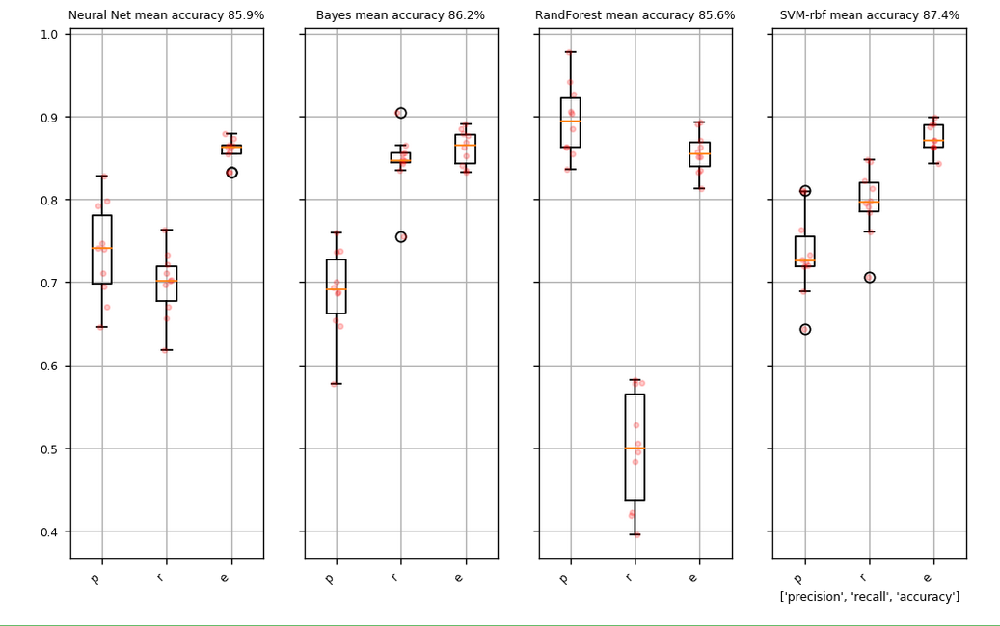
To test whether additional labelling was likely to have a positive impact on the performance of the classifier, a set of test classifiers was trained on random subsets of the labelled data of increasing size. We then plot the performance, measured here by the f1-score, which combines precision and recall for each test set. The resulting figure shows that performance likely does not significantly improve beyond 1500-2000 documents, leading us to believe that the training set was of sufficient size.

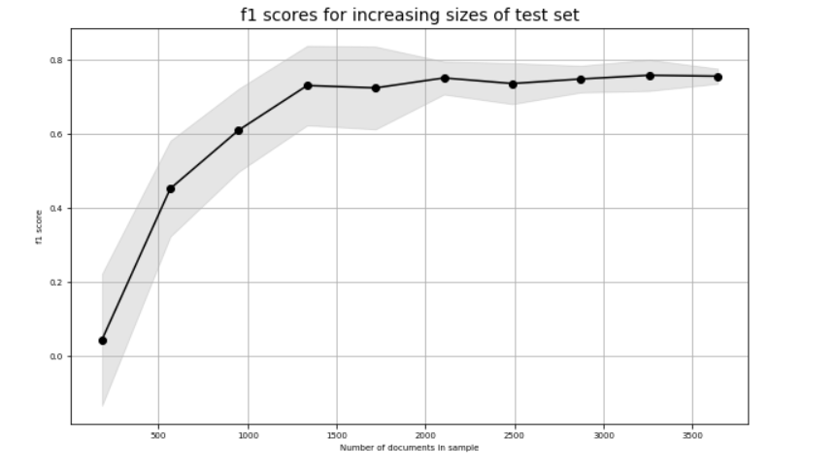
When predicting probabilities rather than using binary prediction, it was observed that the SVM was fairly good at assigning very low relevance scores to the completely irrelevant topics, but at times struggled to filter out topics that were almost relevant but not quite. This is perhaps unsurprising, given that the human labellers also indicated that they found it easy to exclude many, but felt that some studies fell into a grey area.
To err on the side of inclusivity, it was therefore decided to slightly lower the inclusion threshold to 0.35, which resulted in a precision of 70% and a recall of 84% -- i.e. 70% of the documents that were predicted to be relevant were also labelled as relevant, and out of the total number of documents that were labelled as relevant, 84% were included in the predicted relevant group. Applying the trained SVM on the full dataset with this threshold resulted in a total number of 16,078 documents predicted to be relevant.
Predicting if a document was about adaptation, mitigation, or climate impacts proved to be more difficult. A key problem here was the relatively low number of adaptation and mitigation documents. This led to an overall mean accuracy of 76.7%, but with substantial variation between runs. Moreover, mean accuracy for adaptation was only 65%, with 30% of documents being labelled as adaptation only being classified as impact instead. The same numbers for mitigation are 72% and 17%. Accuracy for impact only meanwhile is extremely high at 94%.

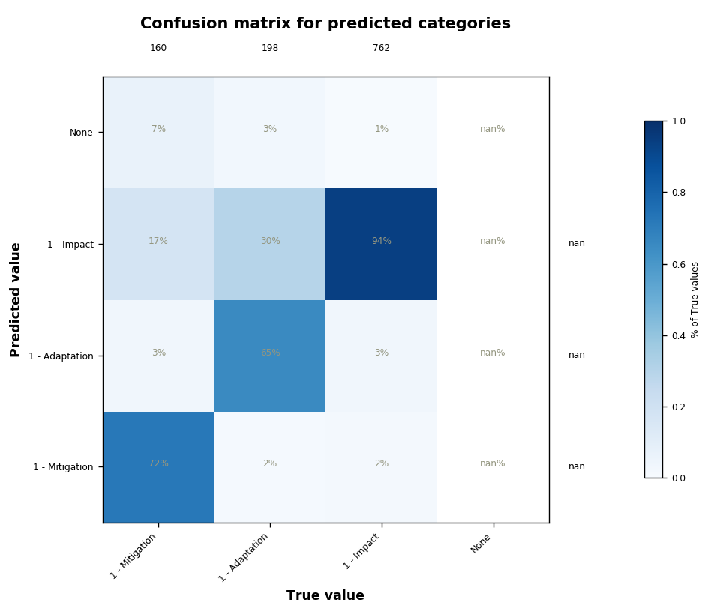
The evaluation of the topic model is not as clearly quantifiable: there is some degree of human judgement in deciding which topic is the most interpretable or useful for the purposes of a specific analysis. There is no ‘ground truth’ to compare the results to, which is typical for unsupervised methods.
The number of topics is of greatest influence for the model outcome. Here, we calculated an initial run of topic models using 40-80 topics at 10-topic intervals on the documents that were predicted to be relevant, followed by a more detailed comparison of 60, 65, 70, 75 and 80-topic models with alpha parameters at 0.01 and 0.1. From these, the best topic model for our purposes was found to contain 70 topics, with alpha set at 0.1. Upper and lower thresholds were kept constant at 95% and 10 documents respectively. Topics were labelled by consensus by 3 team members.
The effect of lowering the threshold could also be investigated using this topic model by calculating for which topics lowering the threshold had the largest effect. By extension, this can be seen as a proxy for the insecurity of the model for different topics. Results suggest little insecurity around topics referring to specific health outcomes whereas topics around food security, vulnerability and disaster responses have a relatively high share of topics with a predicted relevance between 0.35 and 0.5.
Results here are somewhat inconclusive though. Tentatively, once could say that especially specific terminology leads to higher certainty. It is however hard to disentangle to which degree this reflects topics that the classifier struggles with, and to what degree it is more a reflection of how the topic model has found clusters of more generally used words.

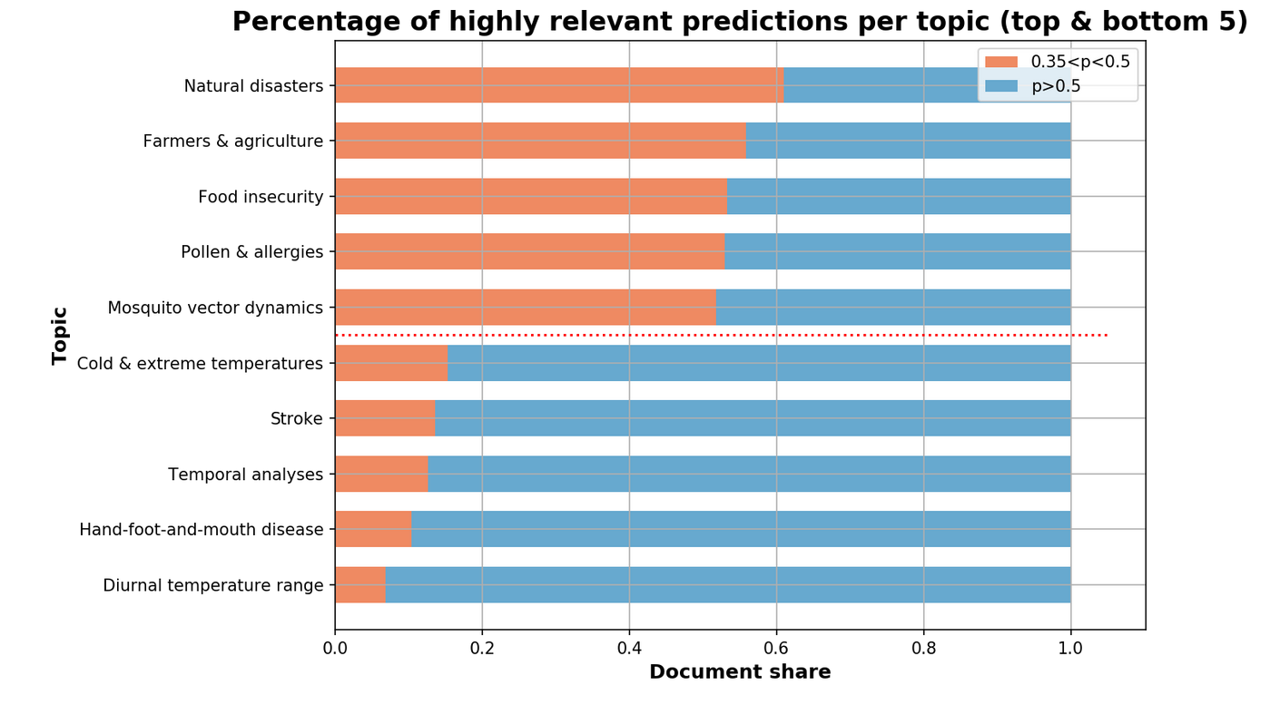

Appendix 4: Additional figures from Part A

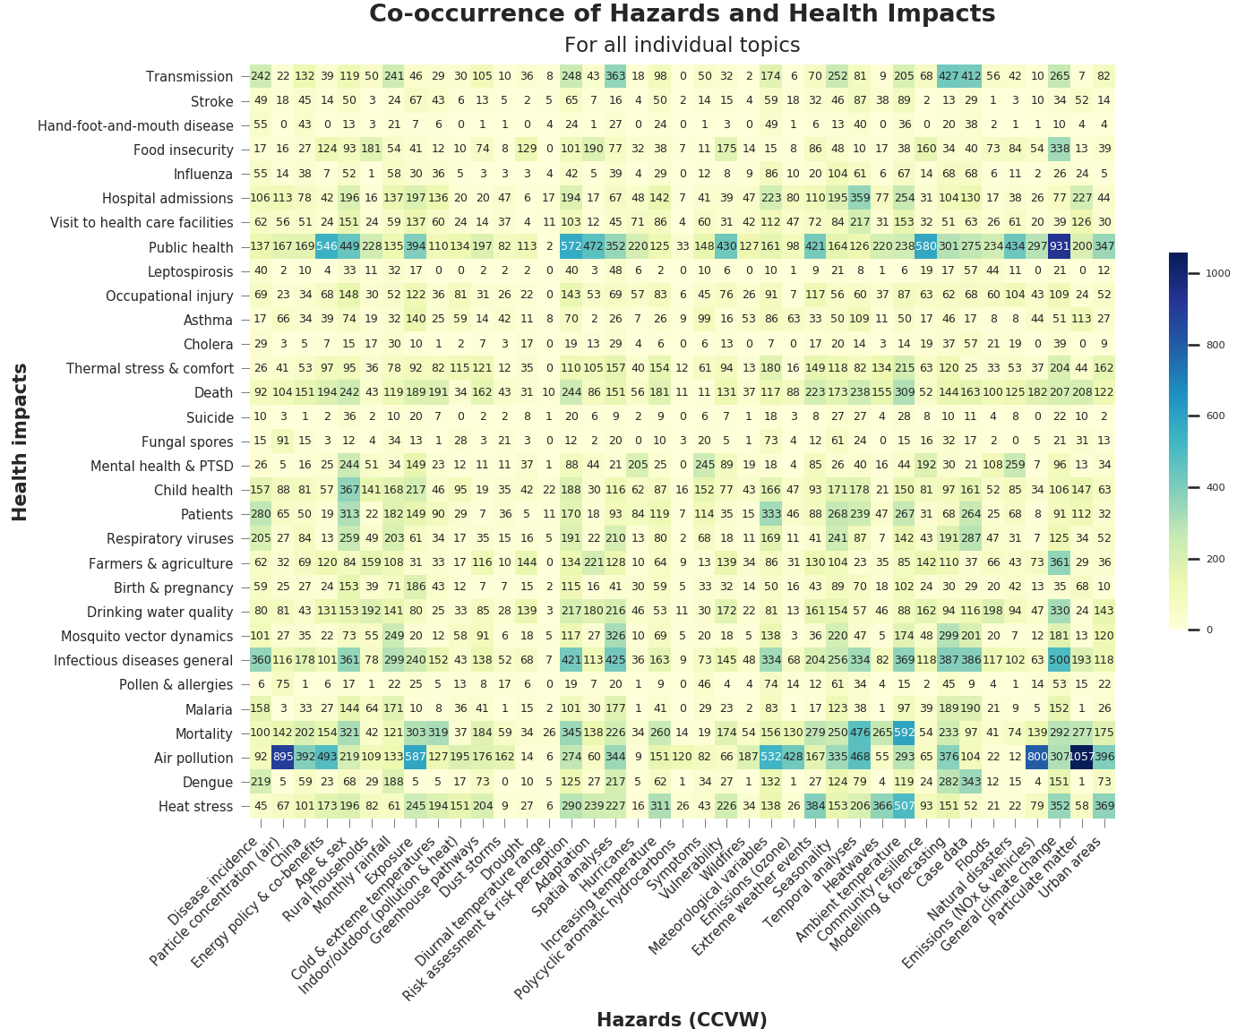
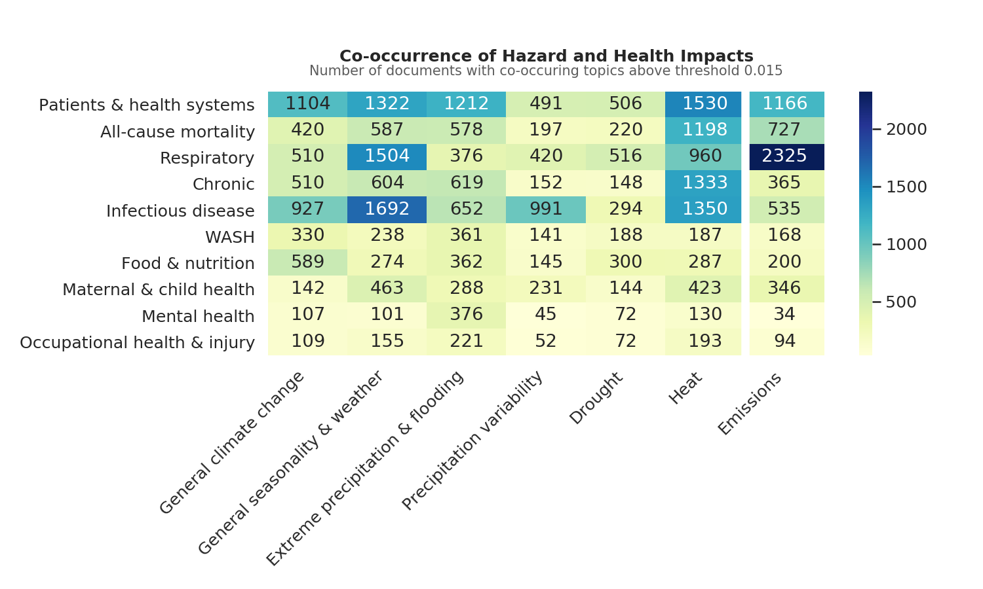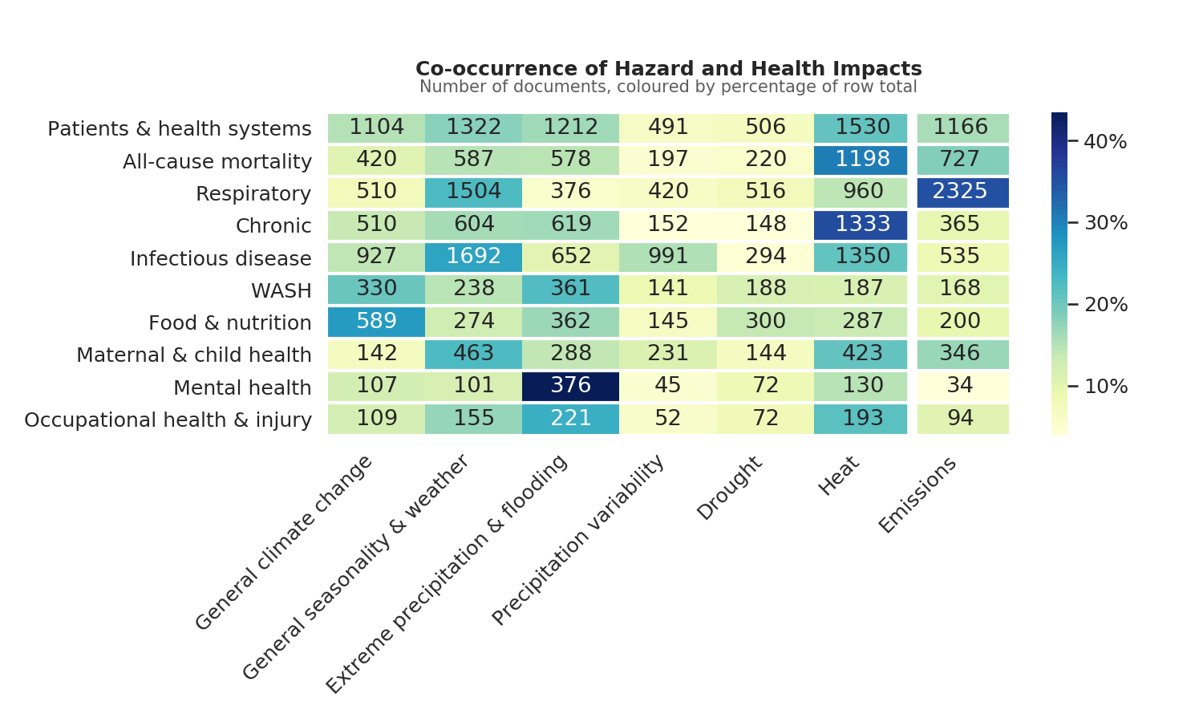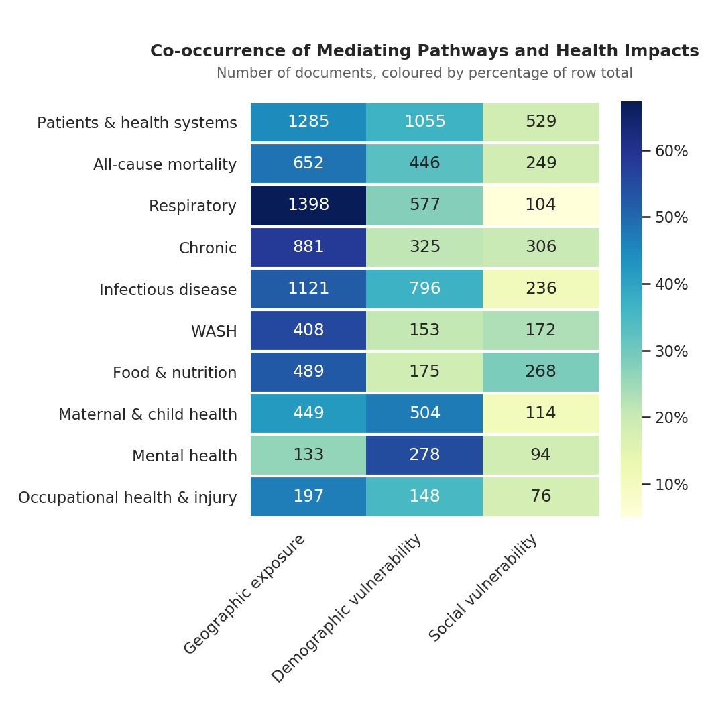
Appendix 5
Studies included in Part B
Abbreviations for climate hazards: X Precipitation = Extreme precipitation & inland flooding; Heat = Increased frequency and intensity of heat; V Precipitation = Precipitation variability; Acidification = Rising ocean temperature & ocean acidification; SLR = Sea level rise & coastal flooding
Abbreviations for adaptation option: Behaviour = Practice of Behaviour Change; Capacity = Capacity Building; Information = Information & Raising Awareness; Physical = Improvement of Physical Infrastructure; Technology = Technology Advancements; Warning = Warning Systems; Policy = Policy Action; Financing = Financing & (Monetary) Incentives
Abbreviations for health outcomes: ACM = All-cause mortality; WASH = Water, sanitation & Hygiene; ID = Infectious disease; NCD = Non-communicable Disease; MH = Mental Health; FS = Food Security; HS = Health Systems; SES = Socio-economic vulnerabilities
N. | Title | First author | Year | Country | Climate hazard | Adaptation option | Health outcome | Health impacts of adaptation | Evaluation quality
1 | The evaluation of famers' climate change adaptation strategies in high-frigid ecological vulnerable region: a case of Gannan Plateau | Wang, Y | 2017 | China | Other | Behaviour, Physical | SES | Positive | 3
2 | Determinants of adaptation strategies to climate and its impact on rice farmers‚ net farm income in South-West Nigeria; published title: Determinants of climate change adaptation strategies and its impact on the net farm income of rice farmers in south-west Nigeria | Ojo, TO | 2014 | Nigeria | Heat, Precipitation, Drought | Behaviour, Technology | SES | Positive | 2
3 | Migrating to tackle climate variability and change? Insights from coastal fishing communities in Bangladesh | Islam, MM | 2014 | Bangladesh | SLR, Other | Behaviour | ACM, WASH, FS, SES | Positive | 2
4 | Flood protection for the City of Beira: An exemplary climate adaptation project in Mozambique | Spekker, H | 2017 | Mozambique | X Precipitation, SLR | Behaviour, Physical, Green | SES | Positive | 2
5 | Health coping strategies of the people vulnerable to climate change in a resource-poor rural setting in Bangladesh | Haque, MA | 2013 | Bangladesh | Heat, Drought, SLR, Other | Behaviour | Other |  | 4
6 | Adaptive governance in the developing world: disaster risk reduction in the State of Odisha, India | Walch, C | 2019 | India | X Precipitation, SLR, Other | Capacity, Policy, Physical, Warning | ACM | Positive | 2
7 | Rainfall variability, food security and human mobility in the Janjgir-Champa district of Chhattisgarh state, India | Murali, J | 2013 | India | V Precipitation, Drought | Behaviour, Financing | FS, SES |  | 4
8 | Adapting to climate change in small island developing states | Betzold, C | 2015 | Multiple | X Precipitation, Acidification, SLR, Other | Behaviour, Information, Physical | ID, FS |  | 4
9 | Local and indigenous knowledge on climate-related hazards of coastal and small island communities in Southeast Asia | Hiwasaki, L | 2014 | Indonesia; Timor-Leste; Philippines | X Precipitation, Drought | Behaviour, Physical, Green | FS | Positive | 3
10 | Climate change from the lens of Malolos children: perception, impact and adaptation | Berse, K | 2017 | Philippinnes | X Precipitation, Heat, SLR | Behaviour | ACM, ID, NCD, SES, Other | Positive | 3
11 | Advocacy for urban resilience: UNISDR's Making Cities Resilient Campaign | Johnson, C | 2014 | Multiple | Other | Policy, Physical, Warning, Financing | HS |  | 4
12 | Individual, communal and institutional responses to climate change by low-income households in Khulna, Bangladesh | Haque, AN | 2014 | Bangladesh | X Precipitation, Heat | Capacity, Behaviour, Physical, Warning, Financing | ID, WASH, SES | Positive | 3
13 | Sustainable survival under climatic extremes: linking flood risk mitigation and coping with flood damages in rural Pakistan | Abbas, A | 2018 | Pakistan | X Precipitation | Behaviour, Policy, Information | ID, FS, SES | Positive | 3
14 | Condemned to live with one's feet in water? A case study of community based strategies and urban maladaptation in flood prone Pikine/Dakar, Senegal | Schaer, C | 2015 | Senegal | X Precipitation | Capacity, Behaviour, Physical | SES | Negative | 3
15 | Sustainable adaptation for resolving climate displacement issues of south eastern islands in Bangladesh | Barua, P | 2017 | Bangladesh | X Precipitation, SLR, Other | Behaviour, Policy, Physical, Financing | ACM, SES | Both | 2
16 | How do households respond to coastal hazards? A framework for accommodating strategies using the example of Semarang Bay, Indonesia | Bott, LM | 2019 | Indonesia | X Precipitation, SLR | Physical, Green, Financing | MH, SES | Positive | 3
17 | Comparing perceived effects of climate-related environmental change and adaptation strategies for the Pacific small island states of Tuvalu, Samoa, and Tonga | Beyerl, K | 2018 | Tonga, Somoa, Tuvalu | X Precipitation, Drought, SLR | Behaviour, Information, Physical, Green, Financing | ID, WASH, FS, SES |  | 4
18 | Climate adaptation in the public health sector in Africa: Evidence from United Nations Framework Convention on Climate Change National Communications | Nhamo, G | 2019 | Botswana, Egypt, Eritrea, Gambia, Ghana, Guinea-Bissau, Kenya, Lesotho, Malawi, Mauritius, Namibia, Nigeria, Rwanda, Sierra Leone, South Africa, Sudan, Swaziland, Seychelles, Uganda, Zambia and Zimbabwe | Heat, V Precipitation, Drought, Other | Policy, Information, Physical, Warning, Technology | ID, NCD | Positive | 3
19 | Post-disaster Housing Reconstruction: The Impact of Resourcing in Post-cyclones Sidr and Aila in Bangladesh | Islam, MZ | 2018 | Bangladesh | X Precipitation, SLR | Physical, Financing | SES | Positive | 2
20 | Climate Change Adaptation Measures in the Coastal City of Semarang, Indonesia: Current Practices and Performance | Wijaya, N | 2014 | Indonesia | Drought, SLR | Physical | WASH, SES | Both | 4
21 | How Can Urban Policies Improve Air Quality and Help Mitigate Global Climate Change: a Systematic Mapping Review | Slovic, AD | 2015 | Multiple | Other | Policy, Physical, Technology | ACM, Other | Positive | 3
22 | Climate-smart agricultural practices and welfare of rural smallholders in Ethiopia: Does planting method matter? | Fentie, A | 2019 | Ethiopia | V Precipitation, Drought, Other | Technology | FS, SES | Positive | 2
23 | Transformation of rural communities: lessons from a local self-initiative for building resilience in the Solomon Islands | Ha'apio, MO | 2018 | Solomon Islands | Heat, V Precipitation, Other | Behaviour | FS, SES |  | 4
24 | How are we adapting to climate change? A global assessment | Lesnikowski, A.C. | 2015 | Multiple | X Precipitation, Heat, Other | Policy, Information, Physical, Warning, Financing, Technology | ACM, ID, FS, SES |  | 4
25 | Vanishing Springs in Nepalese Mountains Assessment of Water Sources, Farmers' Perceptions, and Climate Change Adaptation | Poudel, DD | 2016 | Nepal | X Precipitation, V Precipitation, Drought | Behaviour, Physical, Green | WASH, SES | Positive | 3
26 | Review of key initiatives and approaches to adaptation planning at the national level in semi-arid areas | Bizikova, L | 2015 | Multiple | Other | Policy, Physical, Technology | HS, WASH, FS, SES |  | 4
27 | Resilience of Infrastructure Systems to Sea-Level Rise in Coastal Areas: Impacts, Adaptation Measures, and Implementation Challenges | de Almeida, BA | 2016 | Multiple | SLR, Other | Policy, Physical, Green | ID, WASH, SES | Positive | 3
28 | Adaptation strategies for minimizing heat wave induced morbidity and its determinants | Bakhsh, K | 2018 | Pakistan | Heat | Behaviour | ACM, MH, Other | Positive | 2
29 | Urban adaptation to climate sensitive health effect: Evaluation of coping strategies for dengue in Delhi, India | Sahay, S | 2018 | India | Other | Behaviour, Information, Warning | ID | Both | 2
30 | Urban climate adaptation and the reshaping of state-society relations: The politics of community knowledge and mobilisation in Indore, India | Chu, EK | 2017 | India | X Precipitation, Heat, Acidification, Other | Policy, Information, Physical | ID, WASH | Positive | 3
31 | Adaptation to mountain cryosphere change: issues and challenges | Rasul, G. | 2020 | Multiple | V Precipitation | Behaviour, Policy, Physical, Technology | WASH, SES | Positive | 3
32 | Climate change and DIY urbanism in Luanda and Maputo: new urban strategies? | Udelsmann Rodrigues, C. | 2019 | Angola, Mozambique | X Precipitation, SLR | Behaviour, Physical | ID, SES |  | 4
33 | "I eat two meals per day" impact of climate variability on eating habits among households in rufiji district, tanzania: A qualitative study | Saronga, N.J. | 2016 | Tanzania | X Precipitation, Drought | Behaviour | ID, FS, SES | Negative | 3
34 | Limits to Resilience from Livelihood Diversification and Social Capital in Lake Social-Ecological Systems | Goulden, MC | 2013 | Uganda | X Precipitation, V Precipitation, Drought | Behaviour | ID, FS, SES | Both | 3
35 | Climate Change Vulnerability and Adaptation in Metro Manila Challenging Governance and Human Security of Urban Poor Communities | Porio, E | 2014 | Manila, Philippines | X Precipitation, SLR | Behaviour, Physical | ACM, WASH, SES | Both | 3
36 | Environmental health practitioners potentially play a key role in helping communities adapt to climate change | Shezi, B | 2019 | South Africa | X precipitation, Heat, Drought, SLR | Behaviour, Physical, Green, Warning | ID, WASH | Positive | 3
37 | Transforming local natural resource conflicts to cooperation in a changing climate: Bangladesh and Nepal lessons | Sultana, P. | 2019 | Bangladesh, Nepal | V Precipitation, Other | Behaviour, Information, Financing | SES | Positive | 2
38 | Farmer portfolios, strategic diversity management and climate-change adaptation - implications for policy in Vietnam and Kenya | Hoang, MH | 2014 | Vietnam, Kenya | X Precipitation, Heat, V Precipitation | Capacity, Behaviour, Policy, Technology | ID, FS, SES, Other | Negative | 3
39 | Climate change adaptation and the Least Developed Countries Fund (LDCF): Qualitative insights from policy implementation in the Asia-Pacific | Sovacool, BK | 2017 | Bangladesh, Bhutan, Cambodia, the Maldives, Vanuatu | Other | Capacity, Behaviour, Policy, Physical, Green | SES | Both | 3
40 | Coping with extreme weather: communities in Fiji and Vanuatu share their experiences and knowledge | McNamara, KE | 2014 | Fiji, Vanuatu | X Precipitation, Drought | Behaviour | WASH, FS | Positive | 3
41 | Migration as an adaptive strategy to climate variability: a study of the Tonga-speaking people of Southern Zambia | Simatele, D | 2015 | Zambia | V Precipitation, Drought, Other | Behaviour | FS, SES |  | 4
42 | Gender Differences in Climate Change Adaptation Strategies and Participation in Group-based Approaches: An Intra-household Analysis From Rural Kenya | Ngigi, MW | 2017 | Kenya | X Precipitation, Drought, Other | Behaviour, Information, Warning, Technology | FS |  | 4
43 | Informing notions of climate change adaptation: a case study of everyday gendered realities of climate change adaptation in an informal settlement in Dar es Salaam | Schofield, D | 2019 | Tanzania | SLR | Behaviour, Physical | Other |  | 4
44 | Moving beyond short-term coping and adaptation | Wamsler, C | 2014 | Brazil, El Salvador | X Precipitation, Heat, Drought, Other | Behaviour, Physical, Green | ACM, WASH, MH | Both | 3
45 | Microhydro electrification and climate change adaptation in Nepal: socioeconomic lessons from the Rural Energy Development Program (REDP) | Gippner, O | 2012 | Nepal | Heat, Other | Technology | HS, SES | Positive | 2
46 | Adaptation to climate change and its impacts on food productivity and crop income: Perspectives of farmers in rural Pakistan | Abid, M | 2016 | Pakistan | X Precipitation, Drought | Behaviour | FS, SES | Positive | 2
47 | Expert assessment of the resilience of drinking water and sanitation systems to climate-related hazards | Luh, J | 2017 | Multiple | X Precipitation, V Precipitation, Drought, SLR | Physical | WASH | Both | 3
48 | Evaluation of adaptation practices in the agriculture sector of Bangladesh: An ecosystem based assessment | Arfanuzzaman, M. | 2016 | Bangladesh | V Preciptation, Drought, SLR, Other | Behaviour, Technology | SES | Both | 2
49 | Using a social learning configuration to increase Vietnamese smallholder farmers' adaptive capacity to respond to climate change | Phuong, LTH | 2018 | Vietnam | V Precipitation, Drought, Other | Behaviour | SES | Positive | 1
50 | Agroecological practices for climate change adaptation in semiarid and subhumid Africa | Debray, V | 2018 | Multiple | Other | Behaviour, Green, Technology | WASH, FS |  | 4
51 | Migration as an Adaptation Strategy and its Gendered Implications A Case Study From the Upper Indus Basin | Gioli, G | 2014 | Pakistan | Other | Behaviour | HS, SES | Both | 3
52 | Weather Shocks, Coping Strategies, and Consumption Dynamics in Rural Ethiopia | Gao, JF | 2018 | Ethiopia | Heat, V Precipitation | Behaviour, Financing | SES | Both | 3
53 | The effects of trainings in soil and water conservation on farming practices, livelihoods, and land-use intensity in the Ethiopian highlands | Chesterman, NS | 2019 | Ethiopia | Other | Behaviour, Green, Technology | FS, SES | Both | 3
54 | Lessons Learned on Health Adaptation to Climate Variability and Change: Experiences Across Low- and Middle-Income Countries | Ebi, KL | 2017 | Multiple | Drought, Other | Behaviour, Information, Warning | ID, HS | Both | 3
55 | Developing climate-smart agriculture to face climate variability in West Africa: Challenges and lessons learnt | Partey, ST | 2018 | Ghana, Mali, Niger, Senegal, Burkina Faso | X Precipitation, V Precipitation, Drought | Behaviour, Technology | FS | Positive | 2
56 | Do Development Interventions Confer Adaptive Capacity? Insights from Rural India | Patnaik, U | 2017 | India | V Precipitation, Drought | Capacity, Physical, Financing | FS, SES | Positive | 2
57 | Measuring the impacts of adaptation strategies to drought stress: The case of drought tolerant maize varieties | Wossen, T | 2017 | Nigeria | Drought | Technology | FS, SES | Positive | 1
58 | Achieving water security in rural Indian Himalayas: A participatory account of challenges and potential solutions | Xenarios, S | 2019 | India | V Precipitation | Behaviour, Policy, Information, Physical, Green, Warning, Technology | WASH | Both | 3
59 | Exploring Long-Term Livelihood and Landscape Change in Two Semi-Arid Sites in Southern Africa: Drivers and Consequences for Social-Ecological Vulnerability | Masunungure, C | 2018 | South Africa, Zimbabwe | V Precipitation, Drought | Behaviour, Technology | FS, SES | Positive | 2
60 | Pro-poor adaptation for the urban extreme poor in the context of climate change: A study on Dhaka City, Bangladesh | Hossain, MZ | 2017 | Bangladesh | X Precipitation, V Precipitation, Acidification | Behaviour, Policy, Information, Physical, Financing | SES | Both | 3
61 | Small-island communities in the Philippines prefer local measures to relocation in response to sea-level rise | Jamero, ML | 2017 | Philippinnes | X Precipitation, SLR | Behaviour | SES | Both | 3
62 | Climate change, hydro-meteorological hazards and adaptation for sustainable livelihood in Chitral Pakistan | Nizami, A. | 2019 | Pakistan | X Precipitation, Heat, V Precipitation | Financing | SES |  | 4
63 | Adaptation of agriculture to climate change in semi-arid Borena, Ethiopia | Ng'ang'a, SK | 2016 | Ethiopia | X Precipitation, V Precipitation, Drought | Behaviour, Physical, Green, Technology | SES | Both | 3
64 | Adoption and impact of rain water harvesting technology on rural livelihoods: The case of Makwanpur district, Nepal | Adhikari, SP | 2018 | Nepal | V Precipitation, Drought | Technology | SES | Both | 2
65 | Crop diversification and livelihoods of smallholder farmers in Zimbabwe: adaptive management for environmental change | Makate, C | 2016 | Zimbabwe | X Precipitation, Heat, V Precipitation, Drought | Technology | FS, SES | Positive | 2
66 | Effect of climate-smart agricultural practices on household food security in smallholder production systems: Micro-level evidence from Kenya | Wekesa, B.M. | 2018 | Kenya | X Precipitation, Heat, V Precipitation, Drought | Technology | FS | Positive | 2
67 | How Can African Agriculture Adapt to Climate Change? A Counterfactual Analysis from Ethiopia | Di Falco, S | 2013 | Ethiopia | X Precipitation, Heat, V Precipitation, Drought | Behaviour, Technology | SES | Positive | 3
68 | Impact of sedentarization program on the livelihood and food security of Ethiopian pastoralists | Haji, J | 2017 | Ethiopia | V Precipitation, Drought | Behaviour | FS, SES | Both | 3
69 | Linking agricultural adaptation strategies, food security and vulnerability: evidence from West Africa | Douxchamps, S | 2015 | Burkina Faso, Ghana, Senegal | Heat, V Precipitation, Drough | Behaviour, Technology | FS | Both | 3
70 | Perceived effects of drought on household food security in South-western Uganda: Coping responses and determinants | Twongyirwe, R | 2019 | Uganda | Heat, V Precipitation, Drough | Behaviour, Physical | FS | Both | 3
71 | The effects of adaptation to climate change on income of households in rural Ethiopia | Berhe, M |  | Ethiopia | Heat, V Precipitation, Drought, Other | Physical, Green, Technology | ID, SES | Positive | 3
72 | Buffer capacity: capturing a dimension of resilience to climate change in African smallholder agriculture | Speranza, CI |  | Kenya | Other | Practice, Physical, Green, Technology | SES, Other | Positive | 3
73 | Coping with droughts and floods: A Case study of Kanyemba, Mbire District, Zimbabwe | Bola, G |  | Zimbabwe | X Precipitation, Drought | Practice, Green, Financing, Technology | FS | Both | 4
74 | Enhancing resilience to climate shocks through farmer innovation: evidence from northern Ghana | Tambo, JA |  | Ghana | X Precipitation, Drought | Practice, Green, Technology | FS, Other | Positive | 3
75 | Impacts of climate smart jute farming on resource use efficiency, productivity and economic benefits in rural Eastern India | Singh, AK |  | India | Heat, V Precipitation | Green, Technology | SES | Positive | 2
76 | The potential of agroforestry as an adaptation strategy to mitigate the impacts of climate change: A case study of Kiine Community, Kenya | Nyaruai, MA |  | Kenya | Other | Green | FS | Positive | 3
77 | The Role of Microfinance in Household Livelihood Adaptation in Satkhira District, Southwest Bangladesh | Fenton, A |  | Bangladesh | SLR | Financing | FS, SES | Both | 3
78 | Assessing farmer use of climate change adaptation practices and impacts on food security and poverty in Pakistan | Ali, A |  | Pakistan | Other | Green | FS, SES | Positive | 3
79 | Assessing the roles of community forestry in climate change mitigation and adaptation: A case study from Nepal | Pandey, SS |  | Nepal | Other | Green | SES | Positive | 3
80 | Autonomous adaptations to climate change and rice productivity: a case study of the Tanahun district, Nepal | Khanal, U |  | Nepal | Other | Practice, Green | FS | Positive | 4
81 | Camel management as an adaptive strategy to climate change by pastoralists in southern Ethiopia | Wako, G. |  | Ethiopia | Drought | Technology | FS | Positive | 3
82 | Climate change adaptation strategies and food productivity in Nepal: a counterfactual analysis | Khanal, U |  | Nepal | Other | Practice, Green | FS | Positive | 4
83 | Climate Change Adaptation Strategy for Sustainability and Food Security of Cassava Farming Households in Lampung, Indonesia | Murniati, K |  | Indonesia | Other | Green | FS | Positive | 2
84 | Climate change responses among the Maasai Community in Kenya | Leal, W |  | Kenya | V Precipitation, Drought | Green | FS, SES | Positive | 4
85 | Climate Resilient Villages for Sustainable Food Security in Tropical India: Concept, Process, Technologies, Institutions, and Impacts | Rao, CS |  | India | X Precipitation, Heat, V Precipitation, Drought, Acidification, SLR, Other | Capacity, Practice, Information, Physical, Green, Financing, Technology | FS, SES, Other | Both | 2
86 | Climate Smart Agriculture? Assessing the Adaptation Implications in Zambia | Arslan, A |  | Zambia | Heat, V Precipitation, Drought | Green, Technology | FS | Both | 3
87 | Development interventions, adaptation decisions and farmersâ€™ well-being: evidence from drought-prone households in rural India | Patnaik, U. |  | India | Drought | Capacity, Practice | SES, Other | Positive | 3
88 | Effect of climate change adaptation options on monthly food shortages among smallholder farmers in West Africa | Oyekale, A.S. |  | Burkina Faso, Ghana, Mali, Niger,Senegal | V Precipitation | Physical, Green, Financing | FS | Both | 3
89 | Farmer-Managed Natural Regeneration Enhances Rural Livelihoods in Dryland West Africa | Weston, P |  | Ghana | Drought, Other | Green | FS, MH, SES | Positive | 2
90 | Forest Dependent Indigenous Communities' Perception and Adaptation to Climate Change through Local Knowledge in the Protected Area-A Bangladesh Case Study | Rahman, MH |  | Bangladesh | Heat, V Precipitation, Drought, Other | Practice, Information, Physical, Green, Technology | SES, Other | Both | 4
91 | Household food security in the face of climate change in the Hindu-Kush Himalayan region | Hussain, A |  | India, Pakistan, Buthan, China, Nepal | X Precipitation, Heat, V Precipitation, Drought, Other | Practice, Green, Warning, Technology | FS | Both | 4
92 | Household-level effects of providing forecast-based cash in anticipation of extreme weather events: Quasi-experimental evidence from humanitarian interventions in the 2017 floods in Bangladesh | Gros, C. |  | Bangladesh | SLR | Financing | FS, MH, SES | Positive | 2
93 | How Do Capital Asset Interactions Affect Livelihood Sensitivity to Climatic Stresses? Insights From the Northeastern Floodplains of Bangladesh | Rahman, HMT |  | Bangladesh | SLR | Financing | Other | Both | 4
94 | Impact of Climate Smart Agriculture (CSA) Practices on Cotton Production and Livelihood of Farmers in Punjab, Pakistan | Imran, MA |  | Pakistan | Other | Green | SES | Positive | 3
95 | Impact of climate-change risk-coping strategies on livestock productivity and household welfare: empirical evidence from Pakistan | Rahut, DB |  | Pakistan | Other | Green, Financing | SES | Positive | 4
96 | Impact of climate-smart agriculture adoption on the food security of coastal farmers in Bangladesh | Hasan, MK |  | Bangladesh | V Precipitation, Drought, SLR, Other | Green, Technology | FS | Positive | 3
97 | Impact of drought tolerant maize adoption on maize productivity, sales and consumption in rural Zimbabwe | Makate, C |  | Zimbabwe | Drought | Green | FS, SES | Positive | 3
98 | Implications of climate-smart strategy adoption by farm households for food security in Tanzania | Brussow, K |  | Tanzania | Other | Green | FS | Both | 3
99 | Managing risk, changing aspirations and household dynamics: Implications for wellbeing and adaptation in semi-arid Africa and India | Rao, N. |  | Ghana, Mali, Ethiopia, Kenya, Namibia, India | Other | Practice, Green | Other | Both | 4

Appendix 6

Annotated key studies (Part B)
The below 10 studies were classified as most relevant and highest quality studies on assessing the impact of climate change response on human health.
- Phuong, L.T.H., Wals, A., Sen, L.T.H., Hoa, N.Q., Van Lu, P. and Biesbroek, R., 2018. Using a social learning configuration to increase Vietnamese smallholder farmers’ adaptive capacity to respond to climate change. Local environment, 23(8), pp.879-897.
Phuong and colleagues report their finding of a study on “social learning” (the intervention) on adaptive capacity of a coastal community in Vietnam that is experiencing adverse impacts of climate change. The authors aimed to map out the specific conditions that enhance social learning and include the coastal community in Vietnam as a case study.
Applying four different intervention methods (interviews, farmer-to-farmer learning, participatory observations and focus group discussions) the authors evaluate the social learning configuration. They conclude that the used social learning configuration led to an increased problem ownership, an enhanced knowledge-base with regard to climate change impacts and production adaptation options, improved ability to see connections and interdependencies and finally, strengthened relationships and social cohesion.
The results suggest that increased social learning in the community leads to an increase in adaptive capacity of smallholder farmers and improves both their economic and environmental sustainability.
The benefits of applying a social learning design are multiple and include: increased farmers’ participation, the adoption of appropriate technologies, expanded knowledge in relation to climate change and better understanding of climate change adaptation strategies.
- Wossen, T., Abdoulaye, T., Alene, A., Feleke, S., Menkir, A. and Manyong, V., 2017. Measuring the impacts of adaptation strategies to drought stress: the case of drought tolerant maize varieties. Journal of Environmental Management, 203, pp.106-113.
Wossen and colleagues report on the impacts of drought-tolerant maize varieties on food security, as an adaptation strategy to tackle the adverse effects of prolonged droughts in rural Nigeria. Using a nationally representative sample of maize farmers, the authors used household survey data to evaluate the impact of drought-tolerant maize varieties on poverty and food security in Nigeria.
The study measured two main outcomes: first, Wossen and colleagues assessed how adoption affected productivity and drought risk by explicitly estimating its effect on the variance and skewness of maize yields; and secondly, they assessed the effects of adoption on household food security and poverty.
The results showed that adoption of drought-tolerant maize varieties increased maize yields by 13.3% and reduced the level of variance by 53% and downside risk exposure by 81% among adopters. This suggests that adoption had a “win-win” outcome by increasing maize yields and reducing exposure to drought risk. The gains in productivity and risk reduction due to adoption led to a reduction of 12.9% in the incidence of poverty and of 83.8% in the probability of food scarcity among adopters.
The authors concluded that adoption of drought-tolerant maize varieties was not just a simple coping strategy against drought but also a productivity enhancing and welfare improving strategy.
- Walch, C., 2019. Adaptive governance in the developing world: disaster risk reduction in the State of Odisha, India. Climate and Development, 11(3), pp.238-252.
Walsh reports on “adaptive governance” as a climate change response mechanism to reduce the impact on human health of several climate change drivers. He specifically assessed whether adaptive governance can work for countries where the state has limited resources and reach, as the concept has been mainly developed and applied in industrialized countries.
Using Odisha, India, as a (highly successful) case study, the study examines the Odisha success story and provides on-the-ground evidence of adaptive governance. Second, it tries to explain this success of governance through two main factors: traumatic shock and committed political leadership. The main source of empirical evidence from this paper is derived from semi-structured interviews with representatives of government, local communities, NGOs and International Organizations, and disaster victims in the State of Odisha in October and November 2014.
The paper argues that two main factors are crucial for governments to turn to adaptive governance. First, a traumatic shock is likely to stimulate a reconsideration of the manner in which governance is thought and applied. The shock by involving considerable economic and human cost creates a momentum for governance rethinking. Second, a committed political leadership is essential to make use of that momentum to reform previous governance practices to create a more resilient system.
The case of Odisha has shown that adaptive governance is context specific, and that the type of adaptive governance varies across cases and culture. In order to provide guidance and follow-up action, adaptive governance needs to be grounded in its own context.
- Sultana, P., Thompson, P.M., Paudel, N.S., Pariyar, M. and Rahman, M., 2019. Transforming local natural resource conflicts to cooperation in a changing climate: Bangladesh and Nepal lessons. Climate Policy, 19(sup1), pp.S94-S106.
Sultana and colleagues report in their study on the role of climate change adaptation strategies and cooperation in large scale violent conflicts. Using evidence from participatory action research, the authors describe 79 cases of local collective action over natural resources that experience conflicts in Bangladesh and Nepal.
Nine factors that enable greater cooperation and transformation of conflict were identified, the top 3 being: 1) Participatory dialogue and negotiation processes changed understanding, attitudes and positions of actors ; 2) Learning networks among community organizations encouraged collective action by sharing successes and creating peer pressure. 3) Incentives for cooperation were important. For example, when community organizations formally permitted excluded traditional resource users to access resources, those actors complied with rules and paid towards management costs.
Policy frameworks recognizing collective action and supporting flexible innovation in governance and adaptation would enable wider transformation of natural resource conflicts into cooperation. Many local natural resource conflicts can be resolved but this requires an enabling environment for participatory dialogue, external facilitation, flexible responses to context, and recognition of disadvantaged stakeholder interests.
Transforming conflict to greater cooperation mostly involves social and institutional changes, so adaptation policies should focus less on physical works and more on enabling factors such as negotiation, local institutions, knowledge, and incentives.
- Sahay, S., 2018. Urban adaptation to climate sensitive health effect: Evaluation of coping strategies for dengue in Delhi, India. Sustainable cities and society, 37, pp.178-188.
Sahay reports on the effectiveness for human health of adaptive measures against dengue in Delhi, India. Whilst state-level adaptation strategies included early case reporting and management, vector management (including anti-larval and anti-adult measures), and capacity building, guidelines were also formulated for possible adaptation action and intervention for local governments and households.
For local governments, recommended interventions included thermal fogging in affected areas, social and printed media to increase the awareness about dengue and cleaning of drains and garbage to control of mosquito breeding places. The dengue control measures adopted by households mainly included bite prevention strategies including the use of repellents; both during day and night, using mosquito (medicated) net; wearing full body covering clothes; and screens on windows and doors. Breeding prevention strategies included prevention of water accumulations around houses in empty containers; coconut shells, tyres and flower pots. The coping strategies adopted by households were evaluated using survey data of 559 households. An economic evaluation of coping strategies to serve as an important decision tool in developing adaptive capacity was carried out using household health production function approach.
The results reveal that the dengue risk is mainly addressed by coping strategies at the household level and intervention measures are ineffective due to inappropriate timing and selective approach. The annual economic benefit of adopting coping strategies is estimated as US$ 65 per household. The benefits of coping strategies in reducing dengue risk contribute to the planning of adaptation strategies at city level.
- Spekker, H. and Heskamp, J., 2017. Flood protection for the City of Beira: An exemplary climate adaptation project in Mozambique. Bautechnik, 94(12), pp.872-874.
Spekker and Heskamp report on the new tidal outlet which protects the port city on Mozambique’s Indian Ocean coast. Due to high variability of the Indian ocean, risk of coastal flooding is high thus coastal protection is essential. The Chiveve tidal river regularly overflows due to poor drainage flooding surrounding informal settlements. Additionally, as the river can no longer drain effectively, the stand-still water promotes cholera and malaria.
To address this problem, Inros Lackner designed a new tidal outlet and flood barrier to protect Beira's city centre. The project also included a comprehensive plan for the reestablishment of the original river course and renaturation measures along its embankments. This included excavation of the river, dredging of sludge within the fishing port downstream, resettlement measures, and planting of young mangroves along the riverbanks.
The results of this project reveal improvement in the fishing port’s performance capacity which thus improved the occupational health of workers and had an overall impact on decreasing poverty. This system also improved the flow of the river which has increased drainage reducing the risk of infectious disease. Furthermore, this scheme had a positive co-beneficial impact on ecosystem restoration. Flooding occurrence was reduced post implementation of the new flood outlet.
- Wekesa, B.M., Ayuya, O.I. and Lagat, J.K., 2018. Effect of climate-smart agricultural practices on household food security in smallholder production systems: micro-level evidence from Kenya. Agriculture & Food Security, 7(1), p.80.
Wekesa and colleagues report on climate adaptation practices in Sub-Saharan Africa related to the negative impacts on agricultural production which has led to food insecurity. Climate-smart agricultural (CSA) practices have the potential to reverse this trend because of its triple potential benefits of improved productivity and high income, reduction or removal of greenhouse gases and improved household food security. Hence, they empirically found the effect of CSAs on household food security among smallholder farmers in Kenya.
Primary data were collected in Teso North Sub-county, Busia County of Kenya, among smallholder farmers. CSA practices adopted by farmers were grouped into 4 components: crop management, field management, farm risk reduction and soil management practices.
The results reported that the greatest effect of CSA adoption by smallholder farmers on food security is when they use a larger package that contains all the four categories of practices. Adopters of this package were 56.83% more food secure in terms of HFCS and 25.44% in terms of HDDS. This package mitigates upon the impacts of climate change as well as enhancing nutrient availability in the soils for higher productivity. Further, adoption of this package was positively influenced by gender of the household head, farm size and value of productive farm assets.
This paper argues that CSAs have the potential to alleviate food insecurity among smallholder farmers if used in combinations and to a larger extent. To enhance adoption, land fragmentation should be discouraged through civic education and provision of alternative income-generating activities for farmers to benefit when practiced on relatively bigger land. Farmers should be sensitized on the need to invest in farm productive assets in order to absorb the risks of climate change while enhancing adoption of CSA practices.
- Bakhsh, K., Rauf, S. and Zulfiqar, F., 2018. Adaptation strategies for minimizing heat wave induced morbidity and its determinants. Sustainable cities and society, 41, pp.95-103.
Bakhsh and colleagues explored different adaptation measures in response to heat waves which pose serious health threats to human mortality and morbidity in many countries, including Pakistan. There are various factors that contribute towards heat wave induced morbidity and several adaptation measures are at disposal to avoid adverse effects on human health.
Adaptation responses were determined from 251 respondents in urban and peri-urban areas of Faisalabad, being one of the big cities in Pakistan, using a pre-tested questionnaire. The most common adaptation strategies were identified and an index of adaptation strategies was generated.
The research findings revealed approximately the same adaptation scores of both urban and peri-urban respondents indicating no differences in adaptation level of both groups. The most commonly used adaptation strategies during heat waves included using plenty of water, and juices, increasing the number of baths, using an umbrella, cloth/cap, wearing sunglasses, and using green sheets/chicks in the house. The most important and statistically significant determinants of heat wave induced morbidity were the adaptation to heat waves (captured by adaptation score), urban/peri-urban background, family size, the number of males, and high income. Thus, it was concluded that the adaptation practices have strong health implications in the face of health challenges posed by heat waves.
Based on this paper's findings, it is suggested that the health policies aimed at reducing the health impacts of heat waves may focus on awareness campaigns on available adaptation strategies through different media sources, widening access to health facilities, and extending swimming facilities particularly in urban areas. These strategies are important policy interventions to reduce vulnerability of population to heat waves.
- Barua, P., Rahman, S.H. and Molla, M.H., 2017. Sustainable adaptation for resolving climate displacement issues of south eastern islands in Bangladesh. International Journal of Climate Change Strategies and Management
Barua and colleagues assessed the sustainable adaptation measures for resolving the displacement problem induced by climate change considering the socioeconomic differences between the past and the present location of living places for rural island dwellers of the south-eastern coast of Bangladesh.
Both qualitative and quantitative approaches were adopted for conducting the study. The main tool of the household survey was a questionnaire survey. In addition to the estimate of displacement, the authors have used hazard impact analysis, weightage analysis and sustainable adaptation analysis with various rankings.
Climate change-induced different natural disasters, such as cyclone, tidal surge, tidal flood and coastal erosion, were frequent in the study areas and responsible for mass displacement. After displacement, people lost not only their identity but also social and cultural harmony and faced different economic and environmental crises. However, nearly 20 types of adaptation options were identified for protection from the displacement of coastal people - categorised as: practice or behaviour changes, policy implementation, physical infrastructure improvements, green infrastructure introduction and technological enhancements.
The study prescribed 11 specific criteria and 4 principles of sustainable adaptation options for resolving the climate displacement problem. Moreover, seven adaptation practices showed high sustainability, ten showed medium sustainability and five showed low sustainability in terms of effectiveness, efficiency and implementation ability. The study would help to establish sustainable adaptation measures through the combination of environment, economic and social harmony with regard to the Sustainable Development Goals.

- Partey, ST., Zougmore, RB., Ouedraogo, M and Campbell, BM., 2018. Developing climate-smart agriculture to face climate variability in West Africa: Challenges and lessons learnt. Journal of Cleaner Production, 187, pp. 285-295
Partey and colleagues reviewed the prospects for climate-smart agriculture (CSA) development and promotion in West Africa as well as lessons learnt and challenges with a focus on climate change and variability. It was evident from the literature that West Africa is vulnerable to climate change and variability, on account of its socio-economic and physical characteristics. As climate change and variability persists, the region's quest to use agriculture as the mainstream opportunity to deliver on set targets of the sustainable development goals will be strongly challenged without appropriate interventions.
Adopting CSA seems to be a suitable strategy to achieve food security while also mitigating and adapting to climate-related risks. Among numerous CSA technologies, the review found (1) agroforestry (farmer-managed natural regenerations), soil and water conservation technologies (zai, half-moon, tie/contour ridges, conservation agriculture) and (3) climate information services as highly valued promising options for climate change adaptation and risk management in West Africa. In addition, institutional settings at the community, national and regional levels such as the establishment of multi-stakeholder innovation platforms, national science policy dialogue platforms on CSA in parts of West Africa and the formulation of the West Africa CSA Alliance were found to be crucial in promoting capacity development and awareness of CSA technologies and innovations in the region.
The review found that CSA still faces a number of challenges, including: lack of clear conceptual understanding, limited enabling policy and financing. The prospects of CSA in West Africa hinge on the capacities of farming households and the region's national institutions to understand the environmental, economic and social challenges in the context of climate change, and consequently self-mobilize to develop and implement responsive policies at appropriate scales

Appendix 7

Results Part B by continent
Africa
37 studies reported analysis conducted in Africa: Ethiopia (11), Kenya (10), Ghana (8), Senegal (7), Zimbabwe (6), Burkina Faso (5), Mali (5), Niger (5), Tanzania (5), Uganda (5), Nigeria (4), South Africa (4), Zambia (4), Malawi (3), Mozambique (3), Namibia (3), Angola (2), Botswana (2), Cameroon (2), Chad (2), DRC (2), Eritrea (2), Lesotho (2), Madagascar (2), Mauritania (2), Rwanda (2), Sierra Leone (2), Sudan (2), Swaziland (2), Benin (1), Cape Verde (1), Egypt (1), Gabon (1), Gambia (1), Guinea-Bissau (1), Liberia (1) and South Sudan (1) - non-mutually exclusive. Studies typically reported on adaptations in the general population (13) and among farming communities (21). The majority of studies were cross-sectional in design (29/25); 3 studies had a longitudinal design, whilst 2 were empirical models.
Most studies assessed a combination of climate hazards. The most commonly reported hazards were droughts (39), precipitation variability (24), extreme precipitation and inland flooding (22), and increased intensity of heat (16). The most frequently reported adaptation strategies (often evaluated in combinations) were: changes in practice or behaviour (23) and technological improvements (20). Specific adaptations included relocation/migration, agricultural practice change, food storage, change in meal frequency, and pastoral sedentarisation. Other adaptation strategies reported included, green (16) physical infrastructure changes (11), and financial or incentivisation schemes (3).
The most commonly reported health outcomes were food security and malnutrition outcomes (25) such as dietary diversity, nutrition scores, and meal frequency; infectious disease (6) including vector-, water- and food-borne diseases; 21 studies reported on socioeconomic determinants of health including household income, occupation change, education expenditure and attendance. Some studies discussed maladaptation (8), equally, 7 studies discussed co-benefits of climate adaptive responses that were adopted in communities. 32 studies reported on the association of the presence of climate adaptation strategies and health outcomes: 19 studies reported positive associations; 11 reported both positive and negative associations and 2 studies reported negative associations.
Assessment Quality Score | 1 | 2 | 3 | 4 | (1=high; 4=low)
Number of studies | 1 | 8 | 21 | 7

Asia
47 papers reported analysis conducted in Asia: Bangladesh (15), India (12), Pakistan (10), Nepal (8), Philippines (4), Indonesia (4), Bhutan (2), China (2), Timor-Leste (2) Vietnam (2), Cambodia (1), Kazakhstan (1), Kyrgyzstan (1), Sri Lanka (1), Tajikistan (1), Turkmenistan (1) and Uzbekistan(1) - non-mutually exclusive. The studies varied in geographical typology; 25 studies were inland, 21 in coastal areas and the remainder were in other or unknown locations; 32 were reporting on rural areas and 16 on urban settings. Studies typically reported on adaptations in the general population (28) and among farming communities (16). Almost all studies were cross-sectional in design (36); 6 were longitudinal, 3 were reviews and 2 were qualitative studies.
Studies evaluated a range of climate hazard combinations: the most commonly reported ones included: extreme precipitation and inland flooding (17), coastal flooding (16), precipitation variability (15) and drought (15). The most frequently reported adaptation strategies (often studied in combinations) were: changes in practice and behaviour change (27), “green” and technological enhancements (22) and physical infrastructure improvements (16) including: relocation/migration, agricultural practice change, water management, food storage, and household modifications. Additional climate adaptation response types to note were information and awareness systems (8) and financing and monetary incentive strategies (14).
The most commonly reported outcomes in the included studies were socio-economic pathways (32), and food security and malnutrition (14). Common outcomes under these themes included: farm and household income, improved nutrition and food availability, yields and food production, access to safe water supply, education access. Some studies discussed maladaptation (32), equally, 23 studies discussed co-benefits of climate adaptive responses that were adopted in Asian communities. 43 studies reported on the association of the presence of climate adaptation strategies and health outcomes: 29 studies reported positive associations and 14 reported both positive and negative associations.
Assessment Quality Score | 1 | 2 | 3 | 4 | (1=high; 4=low)
Number of studies | 1 | 16 | 19 | 11

Emissions do not represent an exposure (climate hazard) to the effects of climate change strictly speaking, but were included on the exposure axis anyway since they represent a change in the biophysical environment.
Taking the 50 most recent articles as a heuristic for the journal relevance: if none of these articles was relevant and the remit of the journal did not explicitly refer to either climate or human health, the journal was excluded.

