Sprinkler Head Types
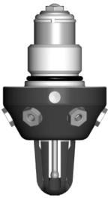 | HI-FOG 1000 | No action required
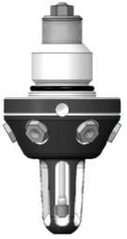  Single groove | HI-FOG 1900 | Action required
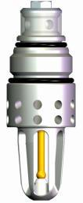 | HI-FOG 2000 | No action required  This type should not be used in A1000 Assembly Body
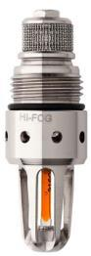 | HI-FOG 3000 | No action required  This type should not be used in A1000 Assembly Body

Assembly Body Types
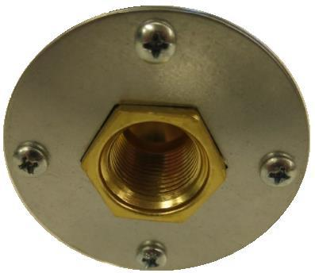 | A1000 | Action required  Cover Plate over Assembly Body surface, held by the sprinkler - HI-FOG 1000 \ 1900 only
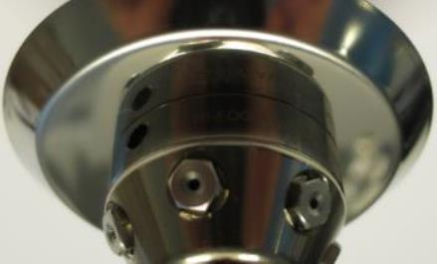 | A1000 | Action required  Cover Plate over Assembly Body surface, held by the sprinkler - HI-FOG 1000 \ 1900 only
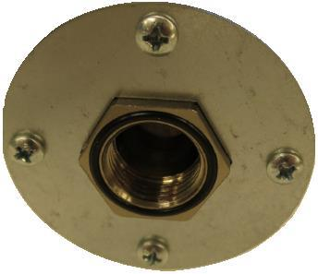 | A2000 | No action required  Cover Plate over Assembly Body surface, held by the sprinkler – HI-FOG 2000 only
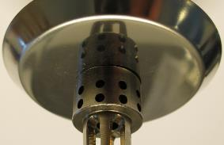 | A2000 | No action required  Cover Plate over Assembly Body surface, held by the sprinkler – HI-FOG 2000 only
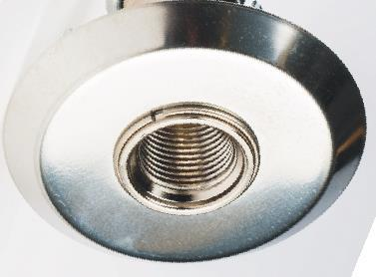  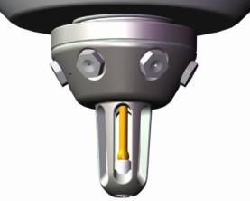  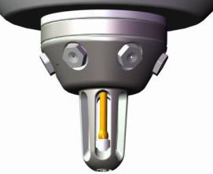 | AB | No action required  Clip Ring holds cover plate to the Assembly Body  Optional Adaptor Ring to close gap between sprinkler and cover plate - multiple sprinkler types
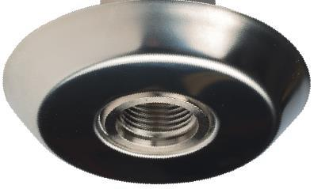  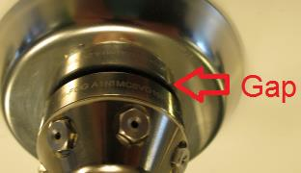 | C | No action required  Narrow gap between cover plate and Assembly Body, plate snapped to the Assembly Body - multiple sprinkler types

