Maritime and Coastguard Agency

Counter Pollution Stockpiles
Table of Contents
Current stockpile arrangements 4
Map of UK Marine Counter Pollution Resources 5
Aircraft 6
Emergency Towing Vessel 7
Counter Pollution Equipment 8
Aerial Capability 12
Beechcraft King Air 200 13
Piper Navajo ‘Panthers’ 14
Boeing 737 15
Emergency Towing Vessel 16
Emergency Towing Vessel (ETV) 17
Offshore Equipment 18
Current Buster Systems 19
Current Buster Pumping System 21
Heavy Oil Skimmer 22
Tar Ball Skimmer (Scan Trawl) 23
Terminator Skimmer / Combination Skimmer System 25
Weir Skimmer 26
Heavy Duty Offshore Boom 28
25 Tonne Flexible Floating Storage Tank 30
Shoreline Equipment 32
Shallow Draft Combination Skimmers 33
Mini Vacuum Unit 35
Manta Ray Skimmer Head 36
Rock Scrubber & Brush Skimmer 37
Trailer Mounted Rope Mop Skimmer 39
Temporary Storage Tanks 40
Fast Tank Rapides 41
All Terrain Vehicle (ARGO Cat Avenger) 42
Air Tent 43
Fence Boom 44
Shore Sealing Boom 45
Inshore Inflatable Skirt Boom 47
Rapid Deployment Solid Floatation Boom (Boombag) 48
Disc Skimmer 49
Sorbent Boom 51
Dispersant 52
Dispersant 53
Boat Spray Set 55
Boom Vane Spray 56
Ancillaries 57
Inert Gas generator 58
Multi-Purpose Hydraulic Power Pack(s) 60
Diesel Driven Hydraulic Power Packs 61
Heavy Oil Pump 63
Spate Pump 64
Cargo Transfer Pumps 65
Gas Freeing Fans 67
General Purpose Air Compressors 68
Safe Zone Compressor 69
Inflatable Fenders 70
Self-Contained Lighting Rigs and Portable Lighting Systems 71
Contact information 72

Current stockpile arrangements
The Maritime and Coastguard Agency’s (MCA) counter pollution equipment and dispersant are distributed across several strategic locations around the UK.
There are three equipment stockpiles, situated in Bristol, Barnsley and Dundee. The location of these sites enables the MCA’s contracted pollution responders to reach any part of the coast on the UK mainland and ferry terminals to Northern Ireland within 12 hours. The equipment stockpiles contain oil spill response equipment for use offshore, near to shore and on the shoreline. The equipment is intended primarily for the deflection, containment, recovery and temporary storage of oil. A number of specialist items of ancillary equipment are also kept in the stockpile, including all-terrain vehicles and a portable inert gas generator.
The UK’s 1400 tonnes of Type 3 dispersant are currently stored at eight stockpiles across the UK. Two large stockpiles are situated near Nottingham and Glasgow, in close proximity to East Midlands and Prestwick airports respectively, where the dispersant can be loaded on to the MCA’s aircraft for aerial spraying campaigns. A small quantity of dispersant is kept at each of these airports to enable rapid mobilisation for a test spray. The remaining four smaller satellite stockpiles in Milford Haven, Belfast, Stornoway and Shetland enable mobilisation to response vessels for ship mounted spray campaigns in those areas. This catalogue gives an overview of the MCA’s stockpiles.
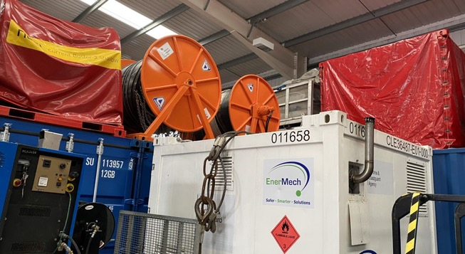

Map of UK Marine Counter Pollution Resources
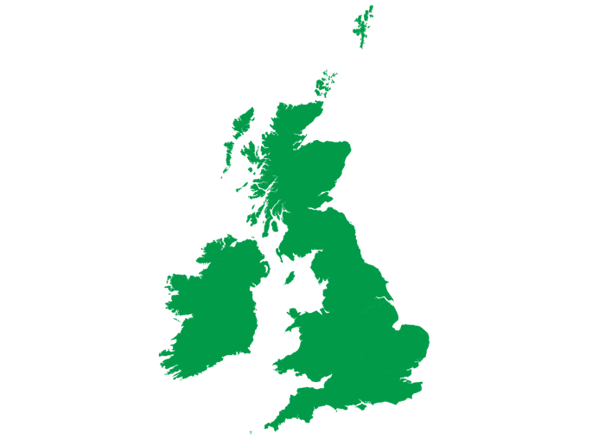
Key:
Stockpile Locations
Dispersant Locations
Aircraft Home Base
Emergency Towing Vessel

Aircraft
System | Role | Location
Boeing 737 | Large scale dispersant application | East Midlands Airport – can be forward deployed to Prestwick Airport or another suitable airfield in the event of a mobilisation
Beechcraft King Air 200 | Aerial verification | Doncaster Airport

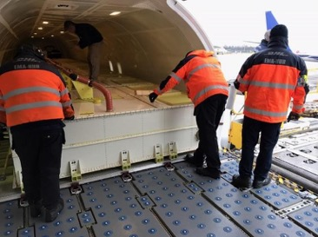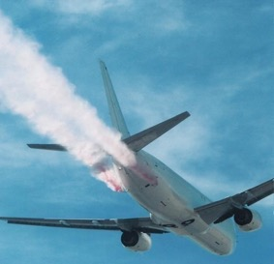
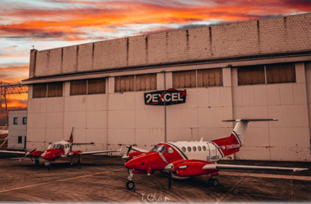

Emergency Towing Vessel
Vessel name | Type | Role | Location
Ievoli Black | Anchor Handling Tug Supply Vessel | Emergency towing | Patrol area from the Western Isles to the Shetland Islands

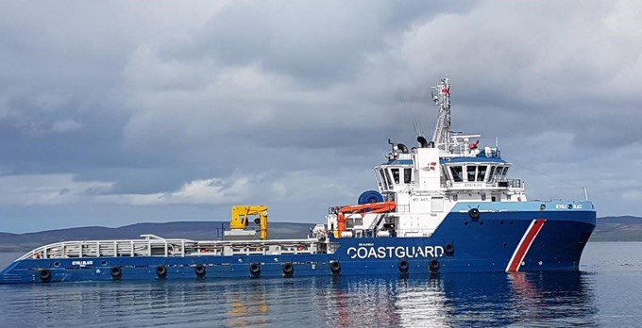

Counter Pollution Equipment
Off-shore Equipment:
System | Overall quantity | Barnsley | Bristol | Dundee
Current Buster 6 | 3 | 1 | 1 | 1
Current Buster 4 | 2 | 2
Current Buster 2 | 2 | 2
Current Buster Pumping System | 1 | 1
Heavy Oil Skimmer | 3 | 1 | 1 | 1
Tar Ball Skimmer (Small) | 2 | 2
Tar Ball Skimmer (Large) | 2 |  | 1 | 1
Combination Skimmer System | 3 | 1 | 1 | 1
Weir Skimmer | 5 | 2 | 1 | 2
Heavy Duty Offshore Boom | 2400m | 1400m | 400m | 600m
25 Tonne Flexible Floating Storage Tank | 24 | 12 | 6 | 6

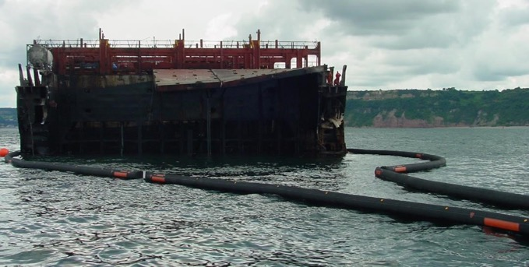
Shoreline/inshore Equipment:
System | Overall quantity | Barnsley | Bristol | Dundee
Shallow Draft Combination Skimmers | 5 | 2 | 1 | 2
Mini-vacuum Skimmers | 6 | 6
Manta Ray Head | 11 | 7 |  | 4
Brush skimmer | 3 | 1 | 1 | 1
Rock Scrubber | 2 | 1 |  | 1
Rope Mop | 2 |  | 1 | 1
10,000L Temporary Storage | 62
1,500L Fastank Rapides (for decontamination) | 23 | 15 | 4 | 4
All-Terrain Vehicles (ARGO Cat) | 7 | 5 | 1 | 2
Inflatable Tents | 6 | 4 | 1 | 1
Spate Pumps | 9 | 4 | 2 | 3
Rope Mop | 2 |  | 1 | 1
Fence Boom | 1400m | 600m | 400m | 400m
Shore Sealing Boom | 4310m | 2825m | 455m | 1030m
Inflatable Skirt Boom | 5910m | 3060m | 460m | 2390m
Rapid Deployment Solid Floatation Boom | 600m | 600m
Disk Skimmers | 5 | 3 | 1 | 1
Sorbent boom | Large quantities at each stockpile

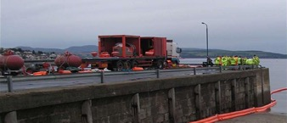

Ancillary Equipment:
System | Overall quantity | Barnsley | Bristol | Dundee
Inert Gas Generator | 1 | 1
Intrinsically Hydraulic Safe Power Packs | 9 | 5 | 2 | 2
Back Up Unit for Intrinsically Safe Hydraulic Power Packs | 4 | 2 | 1 | 1
General Purpose Hydraulic Power Packs (not already assigned to specific systems) | 13x Vikoma GP10  Mark 2-e, 2x  Desmi 50kW | 9 | 3 | 3
Heavy Oil Pump | 1 | 1
Cargo Transfer Pump TK80 Oil/Water | 4 | 2 | 1 | 1
Cargo Transfer Pump TK80 Chemical | 2 | 2
Cargo Transfer Pump TK5 (s/s hoses) | 2 | 2
Cargo Transfer Pump TK5 | 2 | 1 |  | 1
Cargo Transfer Pump TK150 | 4 | 2 | 1 | 1
Cargo Transfer Pump TK6 | 6 | 4 | 1 | 3
Gas Freeing Fans | 4 | 4
Safe zone Air Compressor | 1 | 1
General Purpose Air Compressor | 2 | 2
Trailer Mounted Pressure Washers | 3 | 1 | 1 | 1
Inflatable Tents | 10 | 6 | 2 | 2
Inflatable Fenders | 4x 4m, 2x 12m | 6
Portable Lighting Systems (intrinsically safe) | 20 | 20
Self-Contained Breathing Apparatus Sets | 8 | 8
Personal Air Quality Monitors | 12 | 12
Area Gas Monitors | 4 | 4
Radios | For all team members

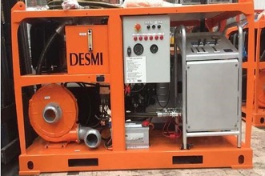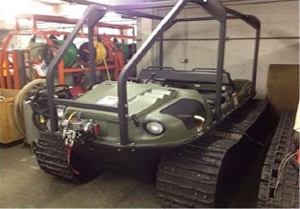

Aerial Capability

Beechcraft King Air 200
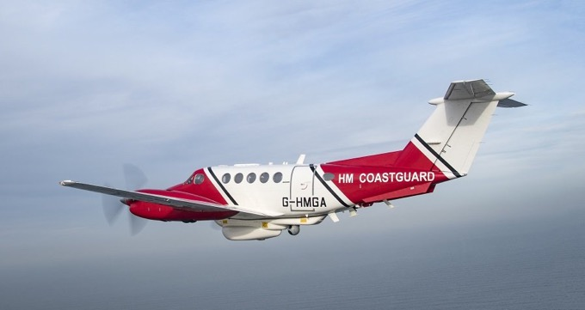

Application
The current MCA contract includes two King Air surveillance aircraft operated by 2Excel Aviation.

Remote-Sensing Equipment
The remote sensing system can detect and evaluate pollution and conduct surveillance on the sea both day and night, in all weathers. The main components:
• Osprey 30 – Surveillance Radar
• Optimare LWIR/UV Line Scanner – pollution detector and quantification
• MX15 HD – Electro Optical, IR Sensor
• Rhotheta SAR DF – Direction Finding of VHF/UHF/EPRB transmissions

Locations
Doncaster Airport

Piper Navajo ‘Panthers’

Application
These aircraft will provide a temporary additional line of tasking during busy periods and at other times will provide a layer of resilience in the service.

Remote-Sensing Equipment
Wescam MX-15 HD Electro Optical (EO) sensor with both wide and narrow fields of view (for day and low light conditions) and Infra-red:
• Geo pointing
• Auto tracking
• Haze penetration
• Image enhancement

Boeing 737
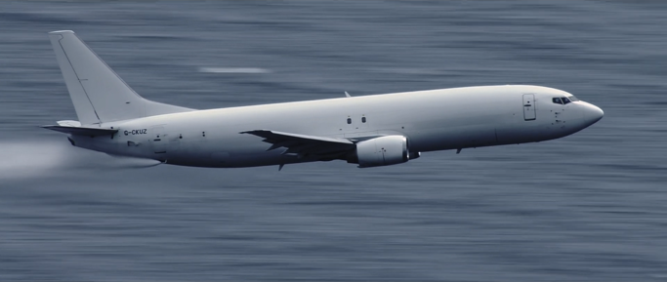

Application
The Boeing 737 has an installed dispersant spray system. This system can be used for a bulk spray of dispersant as part of a to larger-scale dispersant spraying operation.
This aircraft has a maximum spraying capability of 900 metric tonnes over 48 hours (seasonal – depending on hours of light within a day). The plane would spray from between 150 – 200 ft and can perform a round trip of circa 400 nautical miles with 25 minutes on-scene over a circa 3-hour operation with loading and reloading.

Dispersant Spraying System
The dispersant spraying system consists of 7 tanks individually palletised. There is a self-contained palletised diesel pump capable of pumping 400 – 800 US gallons per minute through two spray nozzles. The aircraft can carry up to 18m3 of dispersant at any one time and spraying is controlled from the cockpit.
Note – The Boeing 737 is currently not operational but will be within the next few months.

Locations
East Midlands Airport, with occasional forward deployment to Prestwick Airport.

Emergency Towing Vessel

Emergency Towing Vessel (ETV)
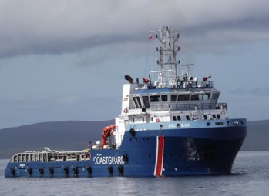

Application
The primary purpose of the ETV is to protect the UK coastline from the potential threat of pollution from any vessel.
Built |  | 2010
Call Sign
Bollard Pull |  | 120 tonnes
Registered |  | Italy
Gross Tonnage |  | 2283 tonnes
Deadweight |  | 2064 tonnes
Dimensions | LOA | 70m x 15.5m
Draft |  | 5.1m
Crew |  | 13

Mobilisation within half an hour of being called.
Propulsion and Positioning. Built to RINA class it has fifi1 and DP2 capabilities. Propulsion follows a conventional two engine, twin controllable-pitch propeller configuration, powered by two Wärtsilä 12V M26 main engines developing 7,440kW at 900rpm turning 3,400mm propellers in nozzles. Maneuvering is enhanced with two bow and one stern tunnel thrusters.
Deck Equipment. Deck equipment provision is extensive, dominated by a Fukushima anchor-handling/towing winch with brake capacity 3,922kN, each drum having capacity for 1,500m of 72mm wire.
Fire Fighting. FFS supply the fire-fighting installation, two centrifugal pumps supplying two 1,200m³/hr dualflow monitors on the wheelhouse roof

Offshore Equipment

Current Buster Systems
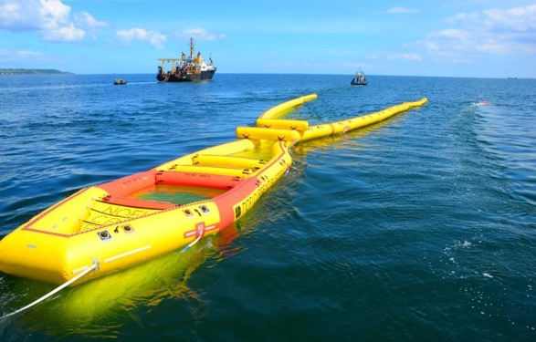

Application
The Current Buster system is a containerised inflatable towed skimmer assembly designed to collect, contain and separate spilled oil at speeds ranging from 0.5 to 5 knots in reasonable weather conditions. The systems can be towed between two vessels, or a single vessel utilising a ‘Boom Vane’. The skimmer system is deployed from a hydraulically driven reel, mounted within a 10ft by 8ft frame, fitted with a hydraulic power pack.
• The Current Buster 6 has a 34m opening, is 62.9m in length and can collect in its separator section up to 70m³ of oily water mix (two parts oil to one-part water), wherein a pump or skimmer heads can be placed for the recovery of oil to a temporary storage system. It can be deployed in approximately 25 minutes using 6 experienced operators.
• The Current Buster 4 has a 23-metre opening, is 35.2m in length and its separator section has a capacity of 35m³. It can be deployed in 20 minutes using 5 experienced operators.
• The Current Buster 2 has a 15m opening, is 27m in length and its separator section is 15m³. The current buster 2 as the smallest of the 3 Current Busters is deployable in circa 10 minutes.

Locations
Barnsley: 2x CB6, 2x CB4, 2x CB2, Dundee: 1x CB6

Specifications
 | Current Buster 2 | Current Buster 4 | Current Buster 6
Freeboard | 600mm | 800mm | 1000mm
Towing Speed | 3 knots | 4 knots | 5 knots
Total Length | 27m | 35.2m | 62.9m
Front Opening | 15m | 22m | 34m
Separator | 15m³ | 35m³ | 70m³
Deployment Time | 10 mins | 10-20 mins | 25 mins
Boom Reel Size | 3m³ | 5m³ | 10m³
Container Size | 8ft | 10ft | 10ft
Total Weight plus Container | 2500kg | 3200kg | 4400kg

Current Buster Pumping System
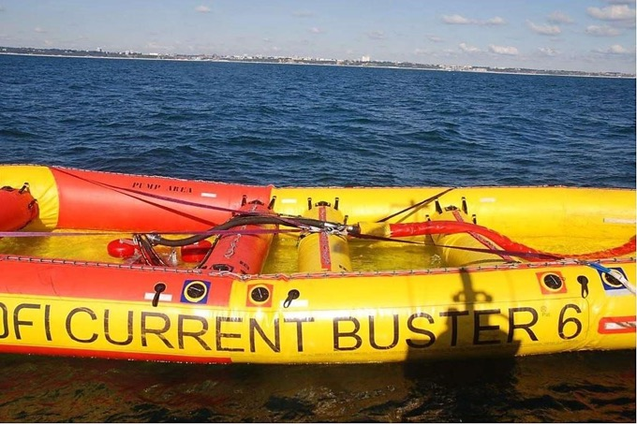

Application
A weir skimmer specifically designed to be integrated with either the Current Buster 4 or 6. The skimmer head is deployed and secured in the collection area of the Current Buster, from which an umbilical hose, secured to either the port or starboard side sweeping arm, leads back to a pump and power pack on the deploying vessel.

Recovery rate
70m³ per hour

Location
1 system stored at Barnsley

Heavy Oil Skimmer
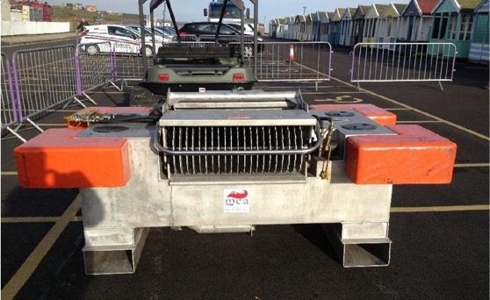

Application
A mechanical skimmer for use offshore on viscous oils (including weathered heavy fuel oil and mousses

Specification
The skimmer has two banks of 21 toothed discs driven independently by hydraulic motors which recover oil into a positive displacement pump rated at 100m3/h. The system has a draught of 610mm.

Ancillaries
There is a separate control console. The unit is powered by a diesel driven hydraulic power pack.

Weight
480 kg Skimmer (without hoses)
104 kg Control Console
Total weight 728 kg

Locations
1 x Barnsley, 1 x Bristol, 1 x Dundee

Tar Ball Skimmer (Scan Trawl)
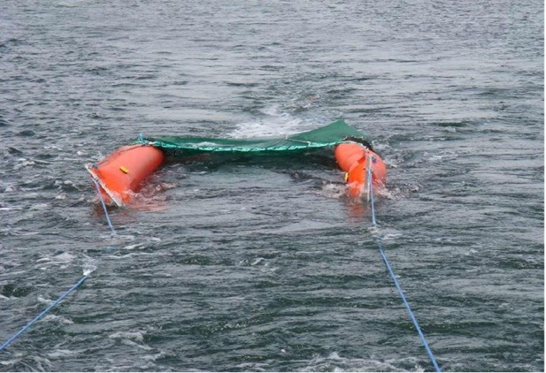

Application
Scan trawl systems are for the recovery of floating tar balls, fuel oils, oil contaminated debris and asphalt/bitumen residues from oil or emulsion spills. The skimmer is able to filter the water, trapping the heavy oils in a trawl net when equipped with a heavy-duty cover tube. The entrance net has sweeping wings, which guides oil into the trawl bag. Up to three trawl bags can be positioned behind the entrance net. The system can be rapidly deployed from small workboats and a simple air blower for the inflation of the sweeping wings is required.

Dimensions
Small – 2440mm x 1220mm x 1330mm
Large – 1800mm x 1210mm x 2500mm

Weight
Small: 162kg
Large: 500 kg

Location
2 x Small at Barnsley, 1 x Large at Bristol, 1 x Large at Dundee

Specification
Description | Small System | Large System
Sweeping Wings in PVC/Polyester | 2 x 5 metres long | 2 x 20 metres long
Net Skirt Draft | 0.500 meters | 0.77 metres
Volume | 2 m³ | 10m³
Number of Trawl Bags | 1 | 3
Mesh Size | 3 – 5 mm | 3 – 5 mm

Terminator Skimmer / Combination Skimmer System
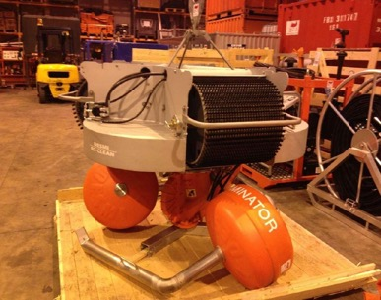

Application
The combination skimmer system is designed to recover a range of spilled oils using interchangeable modules. Using the brush module pictured, the system can recover Heavy Oils. By changing the brush module for the disc module, the skimmer can be used for recovery of lighter oils. Also available is a rope-mop and belt module to further increase the versatility of the system. By removing the head assembly altogether, the DOP pump can be used as a standard salvage pump. The unit is driven by a hydraulic power pack, which includes a remote operation station to allow operators a more flexible system layout.

Specification
Dependent upon the grade of oil, recovery rate is up to 100 tonnes per hour.

Dimensions
3048 x 2438mm x 2590mm

Weight
2200 kg

Locations
1 x Barnsley, 1 x Bristol, 1 x Dundee

Weir Skimmer
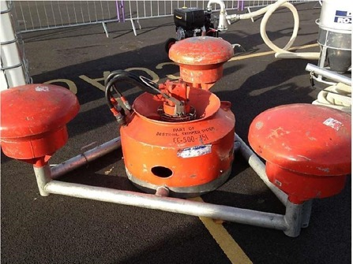

Application
A weir skimmer for use on light to medium oils. The pump unit is easily detachable and can be used as an emergency offloading pump. For best results, the skimmer requires a calm sea and wind conditions.

Specification
Optimum recovery is 70m3/hr. The pump unit has a cutting edge for dealing with soft debris that may be mixed in with the oil or water. The skimmer system has a dedicated power pack.
Engine: Lister HR3 34KW at 2200 RPM, hydraulic start.
Maximum hydraulic pressure is 210 bar, maximum flow 140 LPM. An air compressor for altering weir height is fitted – 10 bar, 240 LPM, accumulator capacity 50L.

Ancillaries
Dedicated hydraulic power pack, extension hose reel, spares box.

Dimensions
Skimmer Head 1870mm x 1020mm x 1100mm
Power Pack 2000mm x 1230mm x 1400mm

Weight
Skimmer Head 372 kg
Power Pack 1400 kg

Location
2 x Barnsley, 1 x Bristol, 2 x Dundee

Heavy Duty Offshore Boom
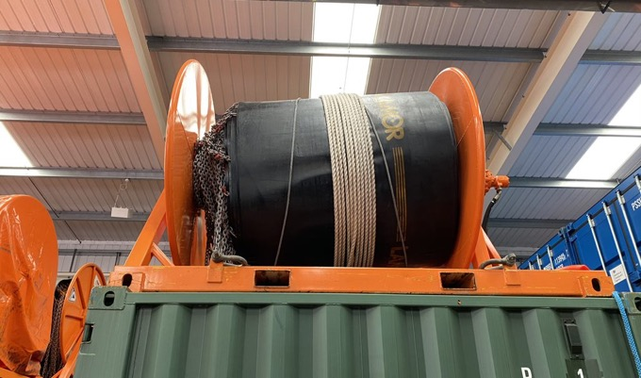

Application
Designed to be deployed over the stern of a vessel and attached to towing vessel in open waters.

Specification
HD boom is manufactured from heavy duty neoprene rubber with a Hypalon external skin. The construction is seamless and has high abrasion existence and high tensile strength. Flotation is obtained by inflating sections of boom with an air blower. A power pack is required to deploy and recover boom, ensuring that the boom reel is secured to the vessel. The boom has galvanised ballast/tension chain to keep the boom upright when deployed.

Dimensions
Overall: 1.30 metres
Freeboard: 0.50 metres
Draft: 0.80 metres
Ballast: Galvanised chain
Section: 50 metre (4 per reel)

Connectors
ASTM

Weight
4030 kg per 50m section

Locations
9 x 200m Barnsley 1 x 200m Bristol 2 x 200m Dundee

Deployment Requirement
2 x vessels or 1 vessel with utilisation of Boom Vane, with vessel crew and 6 -person deployment team.

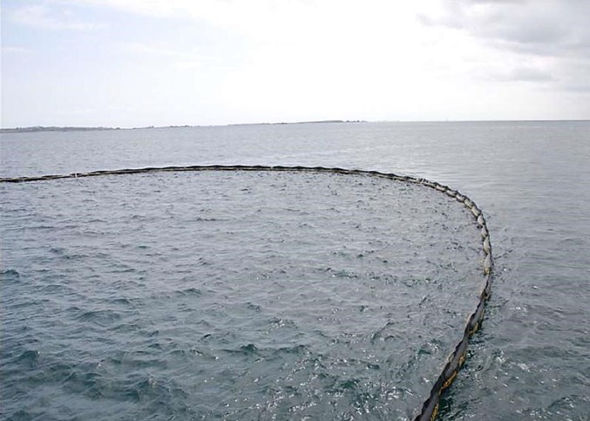

25 Tonne Flexible Floating Storage Tank
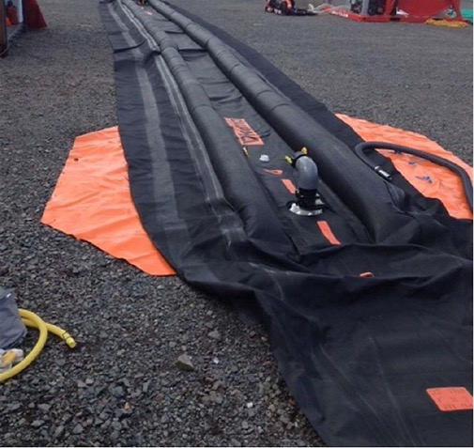

Application
The flexible floating storage tanks are primarily for use as temporary storage of oil recovered at sea and would be used in conjunction with other oil spill recovery equipment, including containment devises and skimmers/pumps. The tank is manufactured from reinforced double-faced neoprene and can store and approximately 25 tonnes of recovered oil. Full, the bag can be towed up to a maximum speed of 6 knots. Inflatable chambers in the top surface maintain buoyancy above the surface of the water, where filling and discharge connections enable decanting to larger storage facilities if necessary. Tank ends can also be opened for cleaning, this allows for use and reuse for exercises. Included with this product are fluid transfer pumps and air blowers for inflation of the buoyancy chambers, allowing for quick and proper application.

Dimensions
Flat width 2570mm, Flat length 17750mm

Weight
Dry 138 kgs

Locations
18x at Barnsley, 3x at Dundee, 3x at Bristol

Shoreline Equipment

Shallow Draft Combination Skimmers
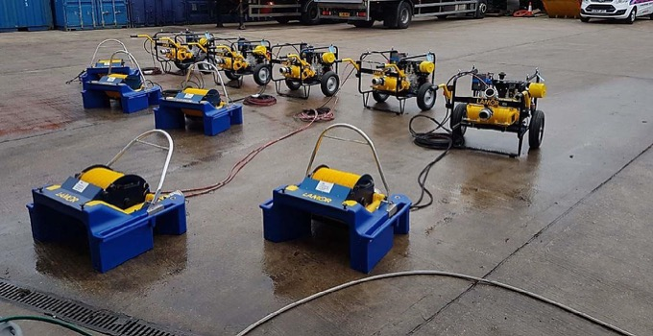

Application
A shallow draft combination skimmer system for use in shallow waters close to the shoreline. This is a modular system with interchangeable ‘wheels’ with either brush, oleophilic disk or drums, allowing for the recovery of most oil viscosities. The system is light and portable and can be carried manually by two responders.

Locations
3x at Barnsley, 1x Bristol, 1x Dundee

Technical Specifications
Length | 852 mm
Width | 853 mm
Height | 464 mm
Weight | 22.5 kg
Draft | 128 mm
Capacity w/ Brush Wheel | 26.8 m³/h*
Capacity w/ Disk Wheel | 15 m³/h
Hydraulic Flow | 1-3 l/min
Hydraulic Pressure | 60-100 bar
Power Requirement | <0.5 kW
Free Water Collected w/ Brush | <2%

Mini Vacuum Unit
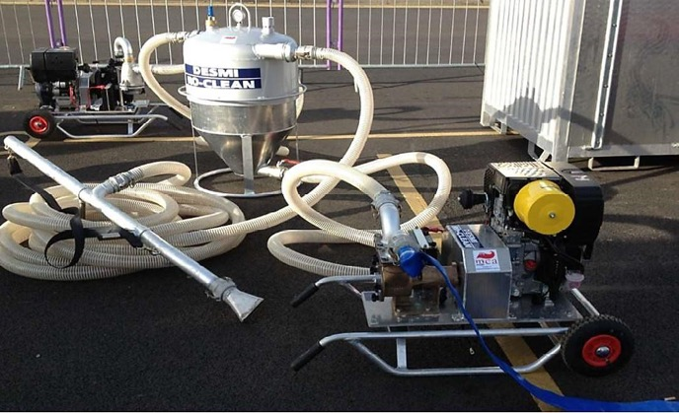

Application
The Mini Vac System is a lightweight and mobile vaccum skimming system consisting of vaccum pump, transfer pump, hopper and lance.
The system has a vacuum pump with a capacity of 1980 lpm and a vacuum of - 0.89 at 1500 rpm. The diesel engine has electric and recoil start.

Dimensions
1100mm length x 700mm x 600mm high

Weight
88 kg

Location
6x at Barnsley

Manta Ray Skimmer Head
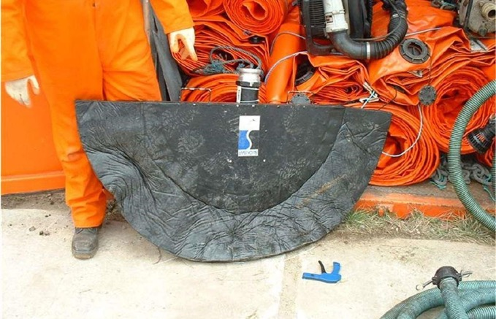

Application
This is a semi-submerged suction head used for the recovery of oil from the water surface. This product must be used in conjunction with a vacuum skimmer or a spate pump.

Dimensions
600 m length x 1200 mm wide x 60 mm high

Weight
12 kg

Locations
7 x Barnsley, 4 x Dundee

Rock Scrubber & Brush Skimmer
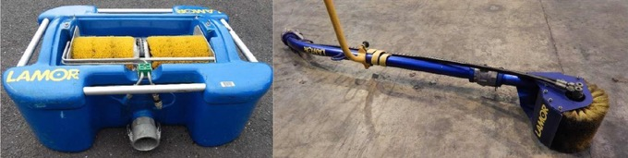

Application
The floating skimmer head has two brush wheels which rotate to recover heavy oil. The heavier oils stick to the brushes and then get scrapped off by blades into a sump. The sump is connected to a small suction pump or power pack which delivers the oil to collection tanks. The rock scrubber unit works on the same principle but is portable and is configured to allow the rotating brush to reach rock faces and quaysides.

Rock Scrubber

Recovery rate:
2-6m³/per hour

Dimensions
1500 mm x 400 mm

Weight
15 kg

Locations
Brush Skimmer – 1 x Barnsley, 1 x Dundee, 1 x Bristol
Rock Scrubber – 1 x Barnsley, 1 x Dundee, 1 x Bristol

Brush Skimmer

Recovery rate:
12m³/per hour

Dimensions
840 mm x 660 mm x 320 mm

Weight
26 kg

Trailer Mounted Rope Mop Skimmer
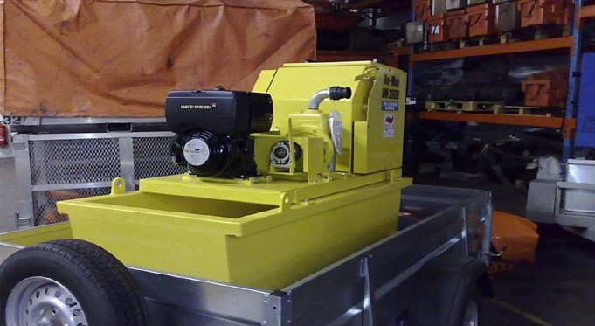

Application
A rope mop skimmer employs long continuous loops of oleophilic polypropylene material that floats on water. The rope is guided over the water surface by one or more pulley secured at convenient locations. The rope loop is pulled through a wringer that removes the oil.

Specification
A trailer mounted diesel driven OM2600 Ro-mop with floating pulleys. Oil is recovered into a tank under the Romop unit and has a recovery rate of 12m³/hr which can then be pumped to a storage tank and/or be removed as waste.

Dimensions
1760 mm x 820 mm x 1220 mm

Weight
460 kg

Locations
1 x Bristol, 1 x Dundee

Temporary Storage Tanks
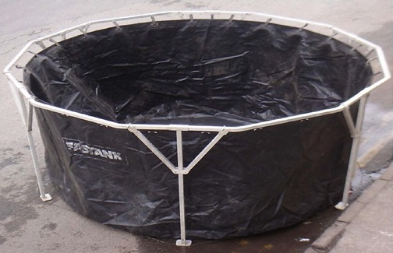

Application
A portable, temporary storage system, for the containment of recovered oil on the shoreline. It can also be used as reservoir or pool for cleaning of oiled materials or wildlife.

Specification
There are 65x 10,000L fast tanks and 10x 7,500L fast tanks. The fabric is made of PVC coated polyester, which is U.V. resistant. The frame is aluminium. A ground sheet, pipe saddle and decanting valve are provided.

Ancillaries
Polythene lines, hand-pumps, pipe-saddles.

Dimensions
1640mm x 420mm x 460mm

Weight
64 kg

Locations
Barnsley, Bristol and Dundee

Fast Tank Rapides
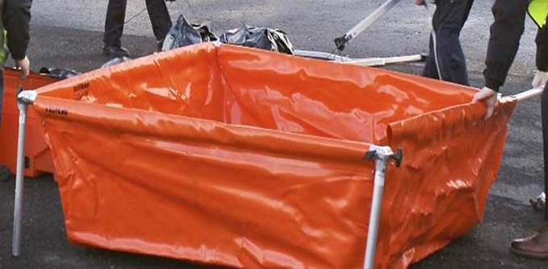

Application
The Fastank Rapide acts as an oil spill clean-up/decontamination pool, used for the cleaning of personnel and equipment during an incident. It also works as a pool for splash protection, containment of leaks, animal cleaning or storage of soiled sorbent. It is light and can be handled and assembled by one person.

Specification
1500L capacity

Ancillaries
Polythene lines, hand-pumps, pipe-saddles.

Locations
Barnsley, Bristol and Dundee

Dimensions
1.72m x 1.67 x 0.6m (68" x 66" x 24")

Weight
15Kg

All Terrain Vehicle (ARGO Cat Avenger)
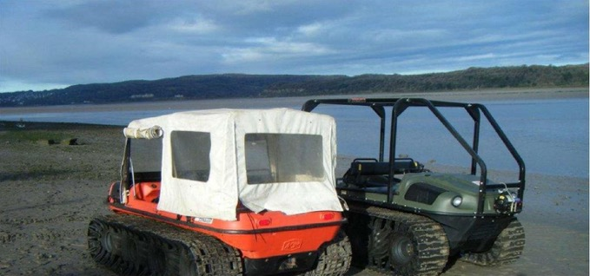

Application
These all-terrain vehicles, which are also semi-amphibious, can be used to access areas inaccessible to road vehicles, such as mud flats. The vehicles feature eight 25” (635mm) diameter low-pressure tyres and tracks to provide a light foot print on sensitive terrain, resulting in low environmental impact. They can travel up to 30mph. Each vehicle features a towable trailer for transporting equipment.

Specification
The vehicle has a 31hp Daihatsu petrol engine. Vacuum formed lower hull and skid plate are formed from high density polyethylene (HDPE). The frame is powder coated, 3” tubular steel of welded construction.
Maximum speed: 30 mph.

Air Tent
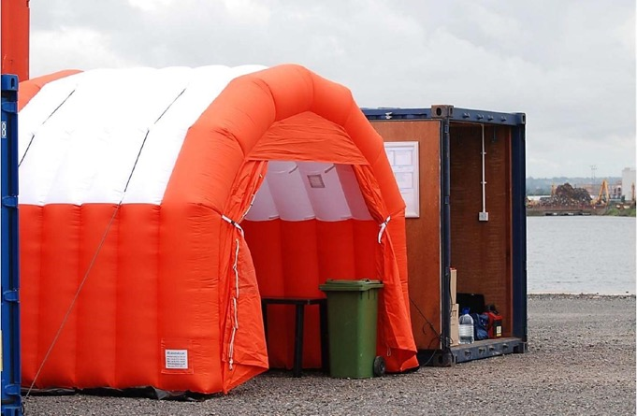

Application
An inflatable tent designed to be quickly erected to provide shelter on site for exercises and deployments

Specification
Each tent has its own constant feed/loss air blower and provides space for approximately 20 people.

Locations
6x Barnsley, 2x Bristol, 2x Dundee

Fence Boom
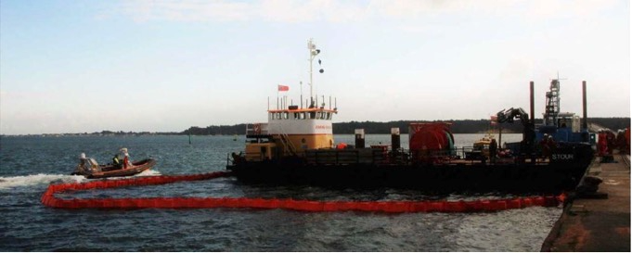

Application
Designed to provide rapid oil spill containment, for use as either containment or spur boom in harbours, marinas, or enclosed coastal waters. The boom will fail in increased an increased sea state or current.

Specification
Solid buoyancy boom manufactured from PVC/Nitrile rubber impregnated onto polyester woven fabric. Encapsulated closed cell foam buoyancy blocks have been individually welded to the outer panels, which means they cannot get waterlogged if the boom becomes damaged. These are additionally stiffened with vertical fibre reinforced battens that add support. The foam blocks have a special memory property so when compressed onto a reel it retains the original shape and size as on deployment. The galvanised ballast chain has overall breaking strain in excess of 15 tonnes. The MCA stockpile has 200 metres of Fence boom stored on a reel, which is driven by a power pack for deployment and recovery purposes.

Dimensions
3040mm x 1975mm x 2000mm

Weight
1740 kg

Locations
600m Barnsley, 400m Dundee, 400m Bristol

Shore Sealing Boom
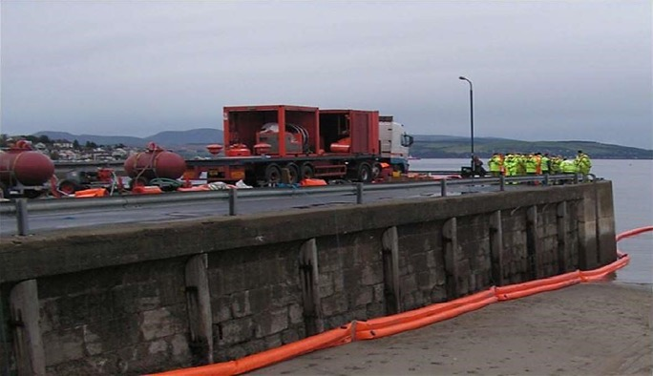

Application
A specialised boom designed for forming land surface seals, e.g. on inter tidal zones, river banks, mud flats. etc.

Specification
The boom is made of polyurethane coated nylon fabric, with aluminium Unicon connectors in 10 and 20 metre lengths. It consists of three tubes. The top tube is inflated for buoyancy and the bottom two tubes are filled with water for ballast and sealing purposes. Both air and water insertion take place through Monson valves for which Monson adaptors are required the air blowers and water pumps. Pressure relief valves are fitted to the water tube to avoid over pressurizing.

Ancillaries
Transport box, ancillary cage, Bruce or Seaclaw anchors, tripping buoys, chain, mooring stakes, sledgehammers.

Dimensions
280mm freeboard
280mm draft
560mm high

Weight
20 metre length 70 kg

Locations
Stored in all three bases – Barnsley, Dundee and Bristol

Inshore Inflatable Skirt Boom
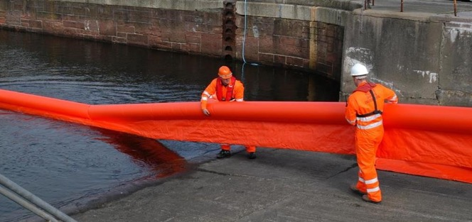

Application
Containment / spur boom for shoreline, estuarine, harbour and river use.

Specification
Made from polyurethane-coated nylon fabric with aluminium Unicon connectors. Steel wire hawser provides tension and ballast. Monson valves each end for air inflation.

Ancillaries
Transport box, ancillary cage, Bruce or Seaclaw anchors, tripping buoys, chain, mooring stakes, Tirfor winches, sledgehammers.

Dimensions
330mm freeboard
405mm draught
735mm high

Weight
65 kg per 20 metre length

Location
Stored in all three bases – Barnsley, Dundee and Bristol

Rapid Deployment Solid Floatation Boom (Boombag)
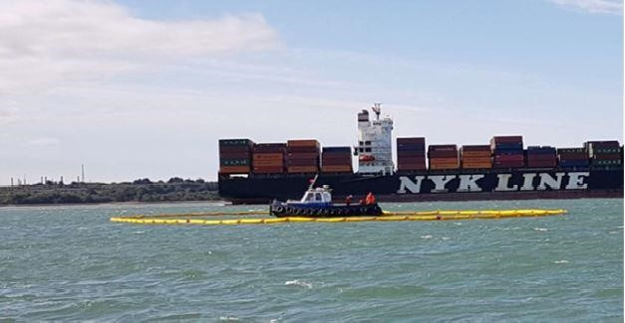

Application
A rapid deployment containment system for use in sheltered waters such as harbours, inlets, lochs, estuaries and sounds. The system is comprised of 200m of solid floatation boom stored in a zig zag formation inside the 20m Boombag. The bag can be towed at speeds of up to 15 knots to the scene of an incident. Once the sea anchor is released the boom can be deployed in less than 60 seconds around a casualty to contain a spill or in a defensive formation to deflect oil from an object or area. The bag is deployed from s 20ft skid positioned on a quayside or slipway. It can be towed into the water from a height.

Quantity
3 x 200m Barnsley

Dimensions
On Pod – 18ft x 8ft, 3 meters

Weight
1350kg

Disc Skimmer
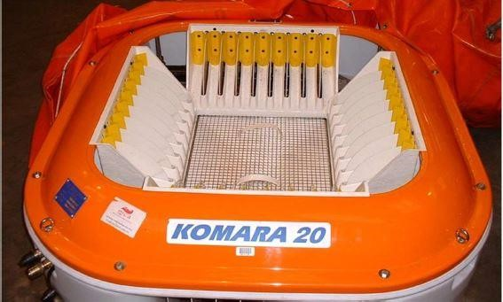

Application
A portable oleophilic disc skimmer for use on light to medium oils. The discs will be ineffective against dispersed or moussed/emulsified oil. The system is ideal as a portable skimmer in shallow water situations such as harbours, marinas or beaches.

Specification
The skimmer has 32 plastic discs driven by 2 hydraulic motors from a remote diesel hydraulic power pack. It weighs 60kg and has an operating draught of 24cm. Recovered oil in the sump is discharged through a 3” line to a Spate diaphragm pump fitted to the power pack. This skimmer is rated at 12 tonnes/hour with crude oil and 2 tonnes/hour in gas/diesel oil. Oil to water ratio maybe as high as 90%.

Ancillaries
Power pack, pump and spares box.

Dimensions
Skimmer Head 1280mm x 1280mm x 830mm
Power Pack 990mm x 940mm x 860mm

Weight
Skimmer Head 60kg
Power Pack 210kg

Sorbent Boom
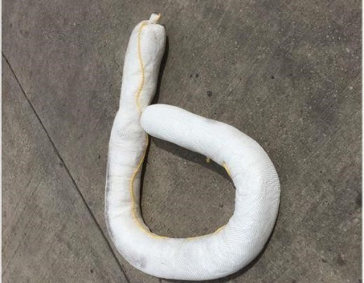

Application
Sorbent booms are used to absorb thin layers of spilled oil. They are particularly useful in removing sheens of spilled light oils, e.g. marine diesel fuel.
Sorbent boom consists of a fibre filling that absorbs the spilled oil while allowing water to pass through. The fibre filling is a special polypropylene crimped fibre opened and blown into the fabric. The fabric is specially treated to make it hydrophobic (repels water). The material is already oleophilic, (has an affinity for hydrocarbons). The fabric cover is produced from polypropylene yarn, which is woven with sufficient picks to allow total enclosure of the fibre whilst allowing an ingress of oil.

Dimensions
Nominal 8” wide and 10’ long

Location
Small quantities of sorbent boom are stored in each of our sites, Barnsley, Bristol and Dundee.

Dispersant

Dispersant
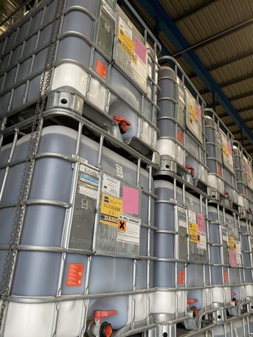

Application
Oil dispersant is a chemical formulated to break up oil and disperse oil into smaller particles, facilitating bioremediation. The dispersant can be either sprayed aerially using dedicated aerial spraying platforms or from a vessel using the Boat Spray Sets or the Boom Vane Spray set. The MCA, on behalf of the UK, holds a stock of over 1170 tonnes of Type 3 dispersant. The brands of dispersant held are Corexit, Dasic Slickgone NS,Dasic Slickgone EW, Dasic Slickgone LSTW, Agma, Super Dispersant 25, Finasol and Enesperse.

Dimensions
1m³ IBC

Weight
1000 kg

Locations and quantities
Type | Milford Haven | Glasgow | East Midlands | Shetland | Stornoway | Belfast | Prestwick Airport | Totals for Stockpile
 | Quantity | Quantity | Quantity | Quantity | Quantity | Quantity | Quantity | Quantity
Dasic Slickgone NS | 17 | 79 | 86 | 0 | 0 | 29 | 0 | 211
Dasic Slickgone LSTW | 3 | 21 | 17 | 39 | 0 | 0 | 0 | 80
Dasic Slickgone EW | 0 | 10 | 9 | 0 | 0 | 0 | 0 | 19
Superdispersant 25 | 6 | 242 | 225 | 0 | 0 | 0 | 49 | 522
AGMA Superconcentrate DR 379 | 0 | 119 | 83 | 0 | 31 | 0 | 0 | 233
Finasol OSR 51 | 0 | 48 | 22 | 0 | 0 | 0 | 0 | 70
Enersperse 1583 | 0 | 0 | 21 | 3 | 0 | 0 | 0 | 24
Corexit 9500A | 0 | 0 | 11 | 0 | 0 | 0 | 0 | 11
Totals per site | 26 | 519 | 474 | 42 | 31 | 29 | 49 | 1170

Boat Spray Set
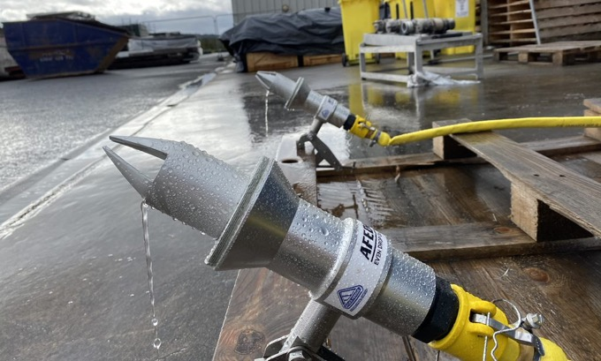

Application
The boat-spray 100TS is a portable diesel powered dispersant spray system for the application of concentrated or diluted dispersant from a specially designed even droplet nozzle with a port and starboard feature which have been introduced as an alternative to spray arms.

Dimensions
1250mm long x 1250mm x 1000mm high

Weight
301kg

Location
2 x Bristol, 2 x Dundee, 1 Belfast, 1 Stornoway

Boom Vane Spray
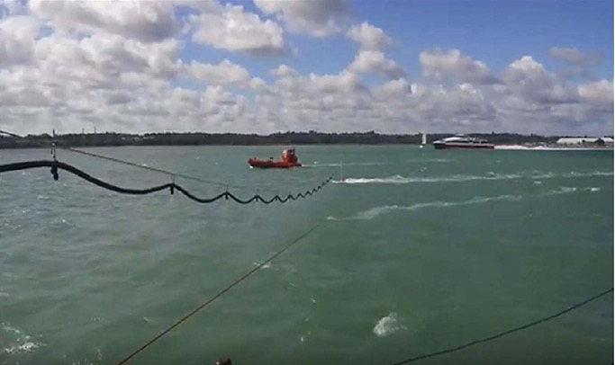

Application
A dispersant spraying system that utilises a Boom Vane with an attached mast support a 25-metre line and hose nozzle/hose assembly out to the starboard side of the deploying vessel which applies neat dispersant at a rate of up to 107 litres per minute.

Quantity
1x system at Barnsley

Dimensions
10ft Container in storage, 25meters when deployed.

Ancillaries

Inert Gas generator
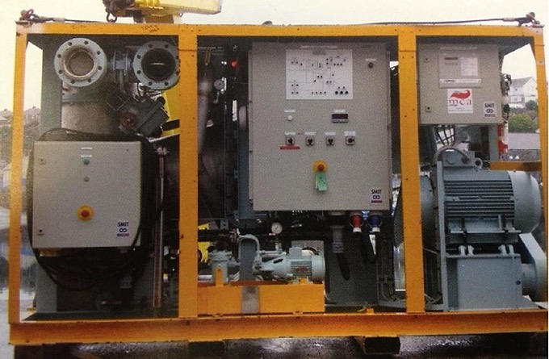

Application
This unit is used to generate large quantities (2000m3/hr) of inert gas that will not support or sustain ignition of what would be flammable vapours given off by hydrocarbons. Precisely controlled combustion of fuel oil at the burner produces flue-gas typically composed of 1.0 to 1.5% Oxygen, 14% Carbon Dioxide, 100ppm Carbon Monoxide, and the remains of Nitrogen.
The unit is one of only a few portable inert gas generators in Europe and is operated in conjunction with a self-contained, electrical generator, and an accessories container.

Dimensions
Inert Gas Generator: 3150mm x 1500mm x 2400mm
Electrical Generator: 3150mm x 1350mm x 2200mm
Accessories Container: 2000mm x 1550mm x 1700mm

Weight
Inert Gas Generator: 3000kg
Electrical Generator: 2000kg
Accessories Container: 1000kg

Location
Barnsley

Multi-Purpose Hydraulic Power Pack(s)
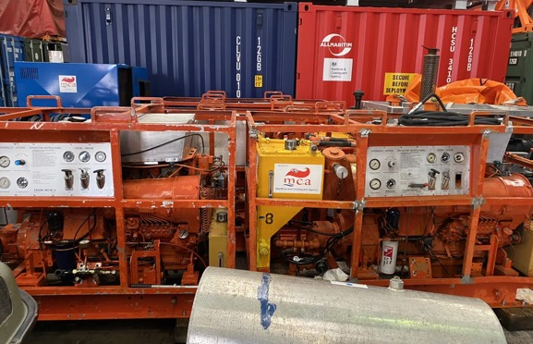

Application
Small portable diesel engine driven hydraulic power packs which can be used to power a number of systems including skimmers, pumps and boom reels.

Specification
The unit has three hydraulic systems of different size and flows and can be configured to operate in 3 modes; High Flow/Low Torque, Low Flow/Low Torque or Low Flow/High Torque. It can power both a pump and a skimmer simultaneously or a boom reel on its own. It is mounted within a crash frame which includes lifting points and forklift pockets.

Dimensions
1210mm x 780mm x 940mm

Weight
191kg

Location
7 x Barnsley, 3 x Dundee, 2 x Bristol

Diesel Driven Hydraulic Power Packs
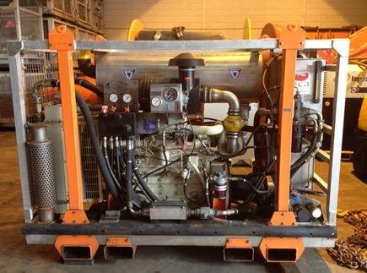

Application
There are three different types of hydraulically or mechanically started diesel engines which drive hydraulic pumps, all are self-contained with hydraulic oil and fuel oil tanks, mounted on a skid for transportation. These units have no electrical components and insulated exhausts and are therefore are safe to use in hazardous environments. Their primary function is to be used in conjunction with a back-up unit, and cargo transfer pumps, but can be used to power other large hydraulically driven equipment such as large skimmers.

Locations
Power Pack / Back up unit | Location | Total
Framo Power Pack | Barnsley x4, Bristol x1, Dundee 1 | 6
Vikoma Mark I | Bristol x1, Dundee x1 | 2
Vikoma Mark II | Barnsley x2 | 2
Back Up Unit | Barnsley x2, Bristol x1, Dundee x1 | 4

Power Pack | Weight (Kg) | Length (mm) | Width (mm) | Height (mm)
Framo On Skid | 2350 | 2400 | 2000 | 2000
Framo | 1250 | 2000 | 900 | 750
Vikoma IS | 1300 | 2100 | 930 | 1750
Back Up 1300 | 2400 | 2000 | 2000 | 2000

Power Pack | Weight (kg) | Length (mm) | Width (mm) | Height (mm)
Framo on Skid | 2350 | 2400 | 2000 | 2000
Framo | 1250 | 2000 | 900 | 750
Vikoma IS | 1300 | 2100 | 930 | 1750
Back Up Unit | 1300 | 2400 | 2000 | 2000

Heavy Oil Pump
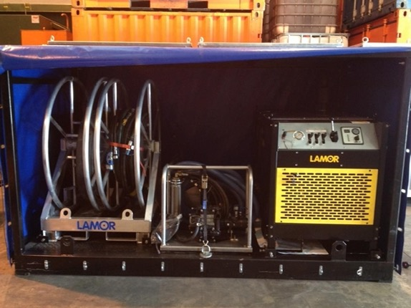

Application
A hydraulically driven pump set designed primarily to pump highly viscous fluids such as heavy fuel oil, bitumen, crude or sludge

Specification
The unit comprises a skid mounted diesel driven power pack, pump set and reels with hoses.
The pump is a submersible positive displacement pump with a capacity of up to 140m3/hr, and includes water/steam injection and a debris cutting knife in the inlet

Dimensions
2810mm x 1460mm x 1680mm

Location
1 x Barnsley

Spate Pump
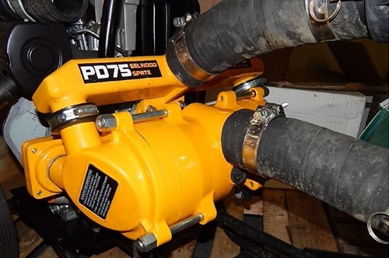

Application
Principally used as a transfer pump for oil or water. Can be used for fluid transfer between temporary storage facilities.

Specification
The unit is a self-priming, induced flow, diaphragm pump. When used on water a suction lift of up to 9 metres is attainable, a delivery head of 30 metres is possible and the maximum rated capacity is approximately 30 tonnes per hour. The performance of the pump diminishes the higher the viscosity of the liquid being pumped, meaning the more viscous the oil the lower the capacity that can be pumped.

Weight
180 kg

Dimensions
1160 x 820 x 1000 mm

Location
Barnsley, Bristol and Dundee

Cargo Transfer Pumps
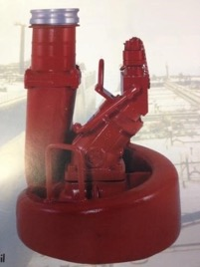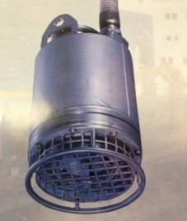

Application
Cargo pumps can be used during salvage operations to transfer oil or chemicals between tanks or to remove oil or chemicals to another ship. The TK series of pump heads are centrifugal pumps. The pump head is submerged in the fluid to be pumped. Two pump heads can be powered by a single hydraulic power pack that is driven by a diesel engine.

Specification
The flow rate of the pumps varies with fluid viscosity and the 'head' (vertical distance) to be pumped.
Nominal maximum flow rates are:
Pump Head | Nominal Max. Pump Rate  (m³ / per hour) | Static Head  (Metre water column)
TK80 | 80 | 70mwc
TK5 | 190 | 50mwc
TK150 | 300 | 60mwc
TK6 | 500 | 40mwc

Weights and dimensions
Pump Head | Weight(kg) | Diameter (mm) | Height(mm) | Notes
TK 80 | 25 | 250* | 625 | Chemical/water
TK 5 | 60 | 298* | 653 | Chemical/water
TK150 | 78 | 300* | 609 | Chemical/water
TK6 | 85 | 520 | 700 | Heavy oil or water

*Pump will fit through Butterworth Hatch

Locations
Pump heads | Type | Location | Total
TK80 | Oil/ Water | Barnsley x 2, Bristol x1, Dundee | 4
TK80 | Chemical | Barnsley x 2 | 2
TK5 (s/s Hoses) | Chemical/Water | Barnsley x 2 | 2
TK5 | Chemical/Water | Barnsley x1, Dundee x1 | 2
TK150 | Chemical/Water | Barnsley x 2, Dundee x1, Bristol x1 | 4
TK6 | Oil / Water | Barnsley x 4, Dundee x3, Bristol x1 | 8

Gas Freeing Fans
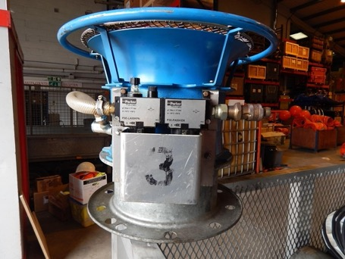

Application
These fans fit standard deck openings (12.5”) and can supply air or extract air vapour from a cargo tank. They are air-driven and intrinsically safe meaning they can be used around flammable gases if needed.

Specification
Victor Pyrate Type 850A
Moves 8000 m³/hour with a compressed air supply at 7.5 bar
Each fan has 10 metre sections of flexible ducting or 2 metre exhaust stack.

Dimensions:
463mm x 590mm diameter

Weight:
25 kg

Location:
4 x Barnsley

General Purpose Air Compressors
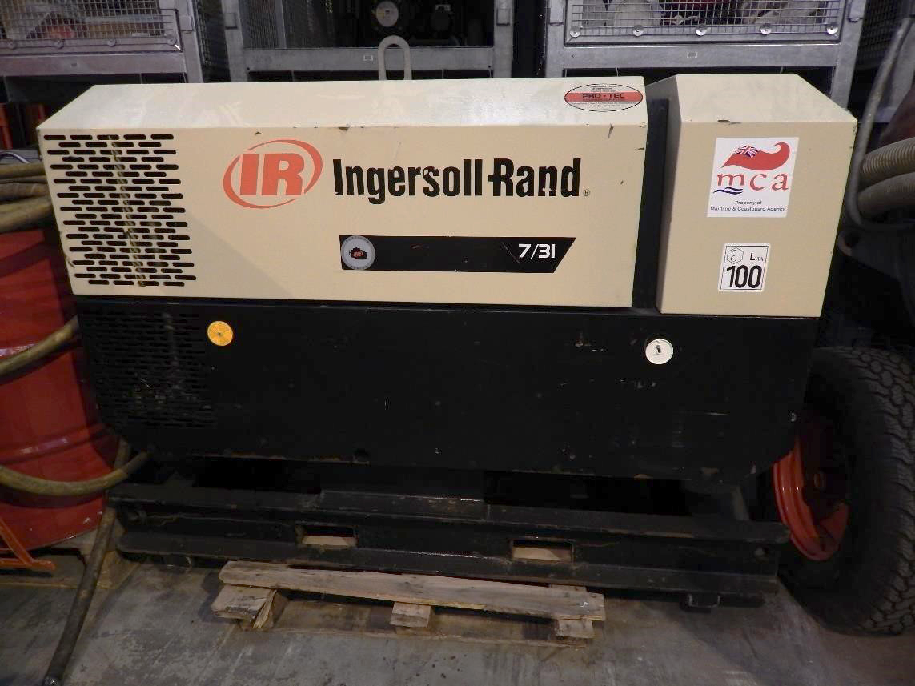

Application
Several standard duty compressors are held for normal operating conditions to drive pumps, fans, lighting or tools.

Location
2 x Barnsley

Safe Zone Compressor
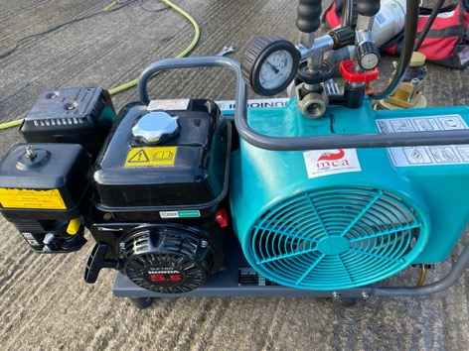

Application
This compressor is designated as a ‘Safe zone’ Compressor. This means it is built with additional safety features for operation in ‘safe zones’ on offshore platforms. These safety features include an intake shutdown device that, in the event that flammable gases enter the engine, will shut the unit down. No electrical components are used, effectively eliminating the chance of sparks.
The unit is housed in a DNV 2:7-1 Offshore spec crash frame and lifting rig.
It is used to supply compressed air at 200cfm primarily to drive intrinsically safe air powered lighting, or to drive air driven gas-freeing fans.

Dimensions
2140mm x 2200mm x 1860mm high

Weight
2400 kg

Location
1 x Barnsley

Inflatable Fenders
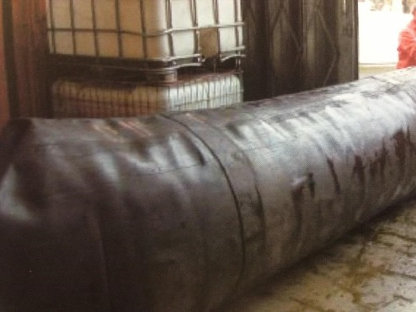

Application
The Dunlop low-pressure fenders are rapidly transportable and can be easily inflated to provide damage protection during ship-to-ship transfer operations.
There are two sizes that are currently stored as part of the stockpile: a 4 x 1 metre in diameter x 4-metre-long and a 2 x 2 metre diameter x 12 metres long. (Sizes are when fully inflated)

Dimensions
The fenders are transported in cages that are:
2500mm long x 1700mm wide x 1350mm high

Weight
Small fender: 50kg
Large fender: 200kg

Locations
2 x Barnsley (large), 2 x Bristol (small), 2 x Dundee (small).

Self-Contained Lighting Rigs and Portable Lighting Systems
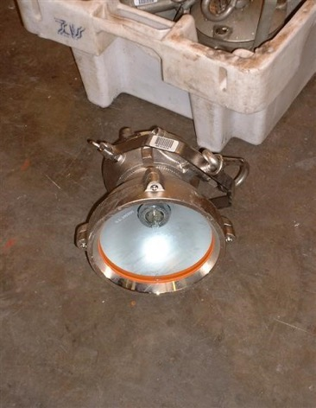

Application
Self-contained diesel driven 8 metre lighting towers consisting of 2 x 1000-watt halogen lamps. 2 x Ampco Intrinsically Safe Light System (1 x generator, 4 x floodlights per system)
12 x Wolf air driven turbo lamps. 6 Units can be driven on a standard air compressor.

Location
20x Barnsley

Contact information
For non-urgent enquiries:
Counter Pollution and Salvage Branch, Resources and Claims Lead –
Jerry Connors: jerry.connors@mcga.gov.uk
Counter Pollution: counterpollution@mcga.gov.uk
For all marine or shoreline pollution incidents the first point of contact is the Coastguard, who can be reached by dialling 999 and asking for the Coastguard.
This catalogue is produced by:
The Maritime and Coastguard Agency
105 Commercial Road,
Spring Place,
SO15 1EG

