Official Statistics
22 July 2021

Introduction
This statistical release provides summary information on appeals, which represent the highest volume (in terms of number of cases) of the work of the Planning Inspectorate.

These statistics are produced each month and the focus is on timeliness, as that is an area in which stakeholders have an interest. Information on the decisions that we have made is also included; and on the number of Inspectors available to make those decisions.

We are seeking feedback! If you have any thoughts on how we can develop these statistics – including on the additional quarterly and annual figures - please let us know at statistics@planninginspectorate.gov.uk

These statistics have been published to ensure everyone has equal access to the information and to support the Planning Inspectorate’s commitment to release information where possible.

This statistical bulletin provides:
- Appeals decisions and events held from July 2020 to June 2021
- The time taken to reach those decisions
- Number of open cases
- Number of Inspectors
- Number of virtual events
The data in this release is only applicable to England.

The Planning Inspectorate
The Planning Inspectorate makes decision and provides recommendations and advice on a range of land use planning-related issues across England and Wales. We do this in a fair, open and timely way.

The Planning Inspectorate deals with planning appeals, national infrastructure planning applications, examinations of local plans and other planning-related and specialist casework in England and Wales. The Planning Inspectorate is an executive agency, sponsored by the Ministry of Housing, Communities & Local Government and the Welsh Government.
Summary
Impact of Covid-19 pandemic
This statistical release reflects that, as with everyone else, the Inspectorate has now been operating for over 12 months with the impact of the Covid-19 pandemic. Previous statistical releases have outlined the impact of the pandemic on the Inspectorate in three ways; events were suspended during the first national lockdown in Spring 2020, timeliness measures increased, and the number of open cases also increased.

Performance
The mean average time to make a decision, across all cases in the last 12 months (Jul 20 to Jun 21), was 27 weeks. The median time is 23 weeks.
The median timeliness for June 21 was 22 weeks – this was a marginal decrease of 0.1 weeks (1 day) from May 21.
Median timeliness by procedure type is shown in the summary table below.

Procedure type | Last 12 months | June 21
Written Representations | 22 weeks | 21 weeks
Hearings | 48 weeks | 61 weeks
Inquiries | 58 weeks | 64 weeks

The median timeliness increased between June 20 and Nov 20, peaking at almost 27 weeks. Between December 20 and March 21 there was a reduction in the median time to decision, down to a low in March 21 of 18.9 weeks. The median for the last three months has been around 22 weeks. Enforcement decisions made in the last 12 months had a median decision time of 34 weeks. Looking at the annual totals, the median and mean time to decision for specialist decisions have been broadly the same as for enforcement decisions, and longer than the median for planning decisions. Since February 21 there has been a change in this trend, with Specialist cases being quicker than Enforcement

The median time for inquiries under the Rosewell Process over the 12 months to June 21 is 36 weeks.

Decisions
The Planning Inspectorate has made 18,254 appeal decisions in the last 12 months, an average of just over 1,500 per month. The monthly breakdown shows fewer decisions for the months of July and August 20, and April 21, than would have been expected. This is thought to be due to the impact of national lockdowns, and in respect of April 21, also staff taking more annual leave in 2021 than in 2020.

Written representations decisions had recovered to pre-pandemic levels between September and December 20 (pre-pandemic being between approximately 1,600 and 2,000 decisions per month). Written representation decisions during 2021 have ranged between a low of 994 (April 21) and a high of 1,529 (March 21).

The number of hearings decided in June 21 (82) was the highest in the last 12 months. Decisions for hearings since December 20 have ranged between approximately 40 and 80 per month. The number of inquiries decided in June 21 (57) was the highest in the last 12 months.

Open Cases
At the end of June 21, the Planning Inspectorate had over eleven thousand seven hundred cases open (11,777). This is slightly higher than the previous month.

Planning Inspectors
There were 349 Planning Inspectors employed by the Inspectorate in June 21 – with a full-time equivalent of 310.8.

Virtual Events
The Inspectorate are continuing to carry out events ‘virtually’. There were 86 cases involving Virtual Events during June 21. There continue to be concerns about the quality of the data on virtual events: there appears to be under-recording despite the introduction of system changes aimed at improving the quality of data.

Decisions, Events & Open Cases
The number of decisions issued in June 21 was 1,539. This was marginally higher than the previous month and broadly in line with previous months of 2021 (except April 21).
The number of events held in June 21 was the highest since October 20. For the months of December 20 to May 21 events average at around 1,450 per month. In the last 12 months the highest number of events held was September 20, when almost 2,100 events were held.
The median time to decide a case very marginally decreased by 0.1 weeks (1 day) between May and June 21, with the median in April 21 being exactly 22 weeks. Performance for the last three months has been around 22 weeks. Performance had been improving between November 20 and March 21.
Figure 1: Number of events held, decisions issued and median time between valid date & decision date; Jul 20 to Jun 21
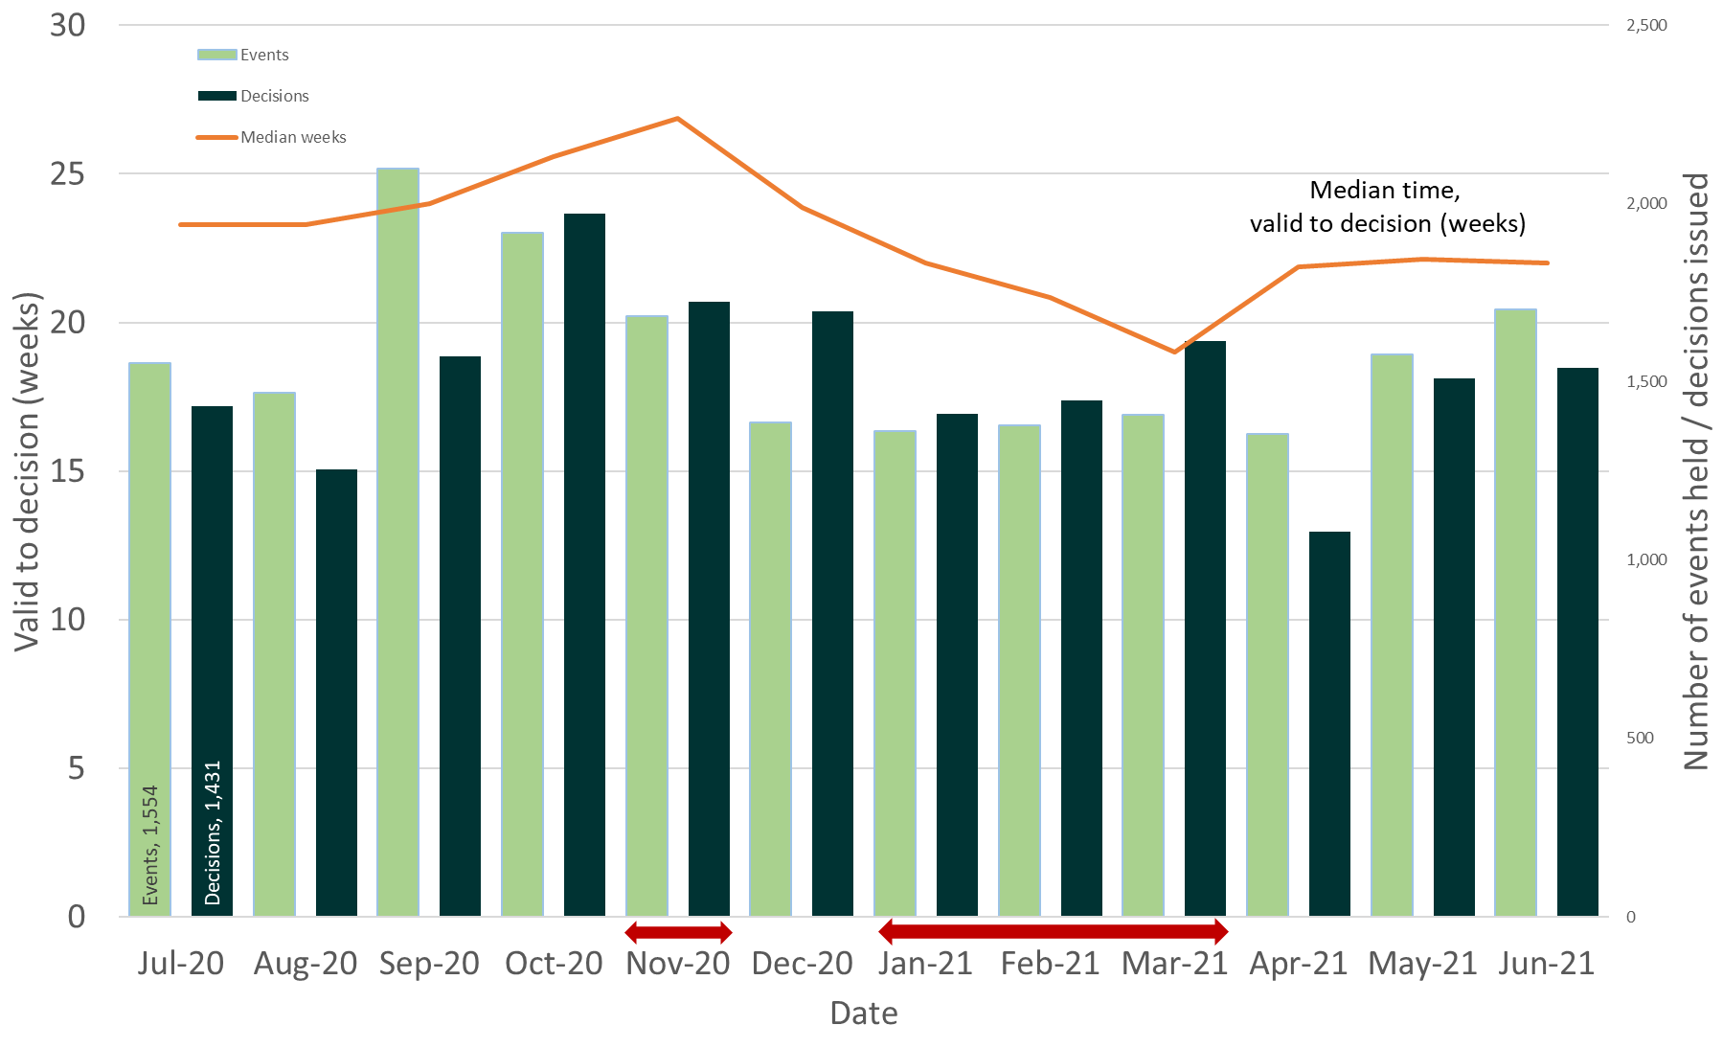
Source: Horizon, Picaso, Inspector Scheduling System
Note – Red arrows indicate periods when national lockdowns were in effect
Table 1: Number of events held, decisions issued and median time between valid date & decision date; Jul 20 to Jun 21
Month | Jul 20 | Aug 20 | Sep 20 | Oct 20 | Nov 20 | Dec 20 | Jan 21 | Feb 21 | Mar 21 | Apr 21 | May 21 | Jun 21 |  | Total
Events Held | 1,554 | 1,469 | 2,097 | 1,918 | 1,685 | 1,386 | 1,362 | 1,377r | 1,407 | 1,355r | 1,576r | 1,702 |  | 18,888
Decisions | 1,431 | 1,254 | 1,571 | 1,971 | 1,725 | 1,698 | 1,411 | 1,448 | 1,615 | 1,081 | 1,510 | 1,539 |  | 18,254
Median | 23.3 | 23.3 | 24.0 | 25.6 | 26.9 | 23.9 | 22.0 | 20.9 | 19.0 | 21.9 | 22.1 | 22.0 |  | 22.9
Source: Horizon, Picaso, Inspector Scheduling System. r denotes revision – a change of more than 5 cases since last month (see Background Quality Report for more information)

The number of open cases has been between 11,700 and 11,800 in the last three months, the highet level of the last 12 months. The increases in the number of open cases reflect the impact of the third national lockdown, and increased levels of staff leave. This contrasts with the period September to December 20, where once schools re-opened and full Inspectorate capacity had returned, the number of cases being closed noticeably exceeded the number received.

The numbers of receipts and cases closed both average at around 1,700 per month, over the last 12 months.

Note – The number of cases closed is higher than the number of decisions, as it includes cases where an appeal is withdrawn, notice is withdrawn, or the appeal is turned away.

Figure 2: Number of cases received, closed and open; Jul 20 to Jun 21
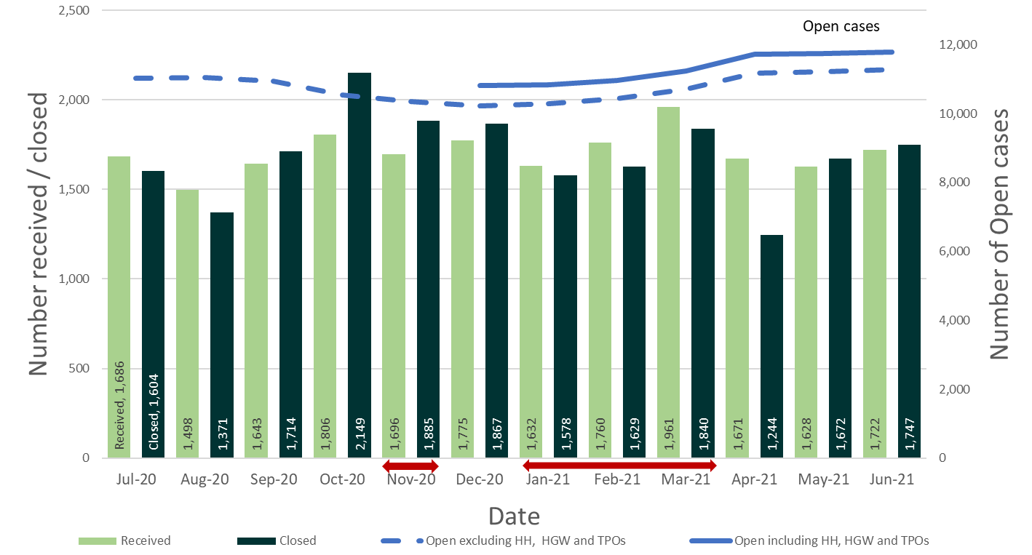
Source: Horizon and Picaso
Note – Red arrows indicate periods when national lockdowns were in effect
Data note 1 - the count of open cases from December 2020 onwards has been revised to include some specialist casework types that were previously excluded: High Hedge (HH), Hedgerow (HGW) and Tree Preservation Order (TPO).
Data note 2 – there is a known anomaly that means that the number of open cases does not exactly follow the volumes of cases closed or received (for example the number of open cases can increase between months even though the number closed exceeded the number received). Investigations into this anomaly have found a potential problem because the data for open cases is captured from a snapshot process, whereas closed and received data comes from an aggregated process. Please see the Background Quality Report for more details.
Table 2: Number of cases received, closed and open; Jul 20 to Jun 21
Month | Jul 20 | Aug 20 | Sep 20 | Oct 20 | Nov 20 | Dec 20 | Jan 21 | Feb 21 | Mar 21 | Apr 21 | May 21 | Jun 21 | Total
Received | 1,686 | 1,498 | 1,643 | 1,806 | 1,696 | 1,775 | 1,632 | 1,760 | 1,961r | 1,671r | 1,628 | 1,722 | 20,478
Closed | 1,604 | 1,371 | 1,714 | 2,149 | 1,885 | 1,867 | 1,578 | 1,629 | 1,840 | 1,244 | 1,672 | 1,747 | 20,300
Open (excl. HH, HGW, TPO) | 11,022 | 11,049 | 10,950 | 10,540 | 10,349 | 10,216 | 10,297 | 10,438 | 10,711 | 11,176 | 11,216 | 11,271 | N/A
Open(All) | 11,023 | 11,050 | 10,951 | 10,541 | 10,350 | 10,825 | 10,830 | 10,954 | 11,247 | 11,730 | 11,738r | 11,777 | N/A
Source: Horizon and Picaso. r denotes revision – a change of more than 5 cases since last month (see Background Quality Report for more information)

Number of Decisions
The Planning Inspectorate has made 18,254 appeal decisions in the last 12 months, an average of over 1,500 per month. Table 3 below shows the monthly breakdown with fewer decisions for the months of July and August 20, and April 21, than would have been expected. This is thought to be due to the impact of national lockdowns, and in respect of April 21, also staff taking more annual leave in 2021 than in 2020.
Table 3: Appeal Decisions; Jul 20 to Jun 21
Month | Jul 20 | Aug 20 | Sep 20 | Oct 20 | Nov 20 | Dec 20 | Jan 21 | Feb 21 | Mar 21 | Apr 21 | May 21 | Jun 21 | Total
Decisions | 1,431 | 1,254 | 1,571 | 1,971 | 1,725 | 1,698 | 1,411 | 1,448 | 1,615 | 1,081 | 1,510 | 1,539 | 18,254
Source: Horizon and Picaso.
Figure 3 – Appeal Decisions; Jul 20 to Jun 21
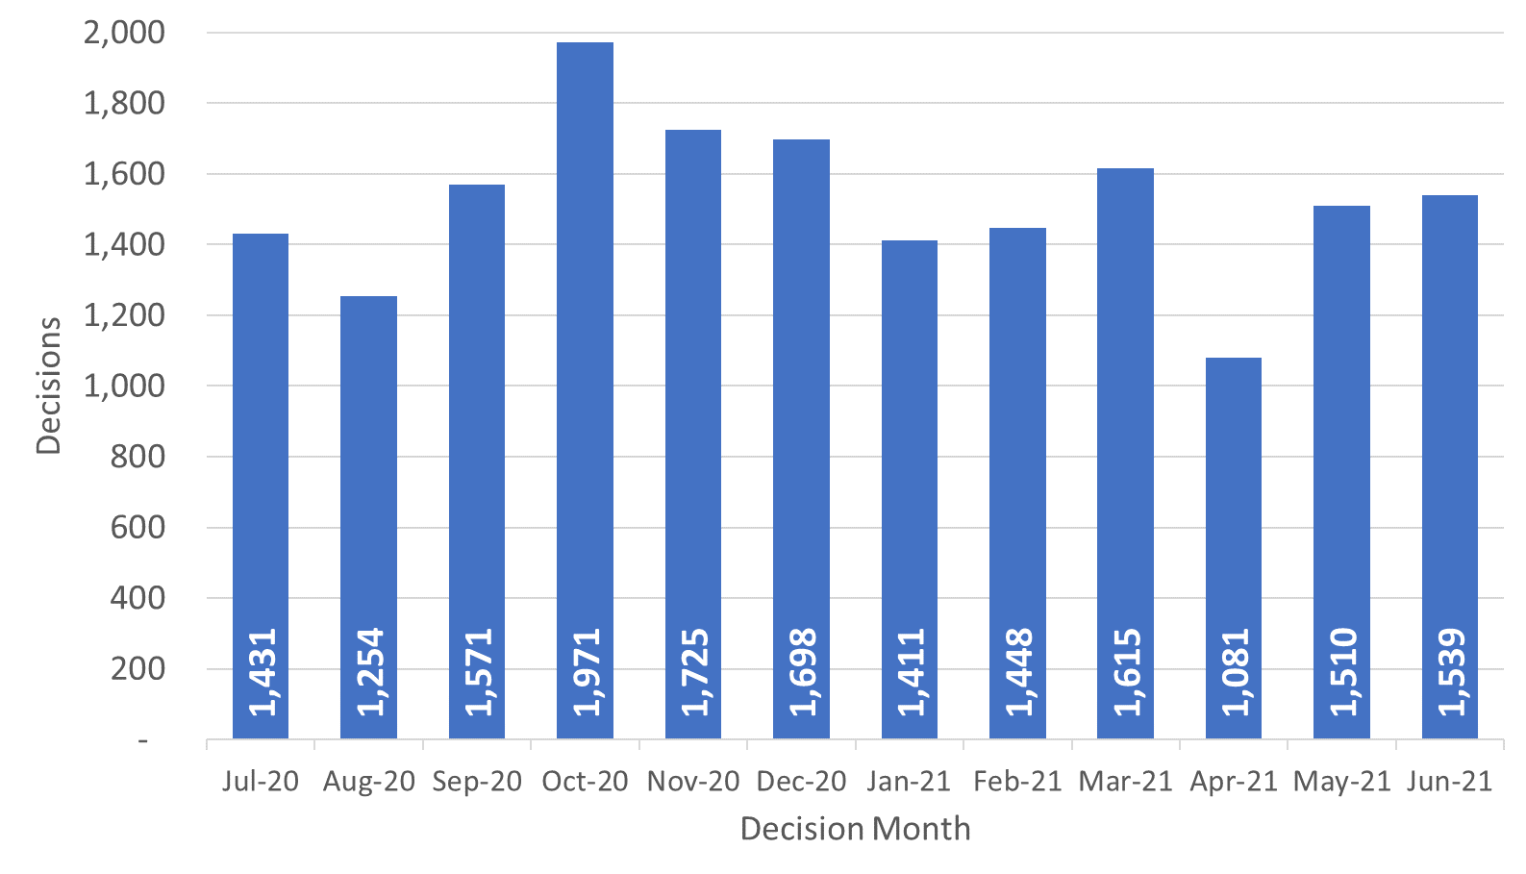
Source: Horizon and Picaso

Decisions by procedure and case type

Planning Inspectors work on a broader range of work than the appeals featured in this Release. For example, they also work on examining Nationally Significant Infrastructure Project applications, Local Plans, Compulsory Purchase Order applications and many other specialist licencing/application types.

Table 4 below gives the numbers of appeal decisions made broken down by whether the case was dealt with by written representations, hearings, or inquiries.
The large majority of decisions (17,413) were made on written representations. This is about ninety five percent of all appeal decisions made. Table 4 shows that written representations decisions had recovered to pre-pandemic levels between October and December 20 (pre-pandemic being between approximately 1,600 and 2,000 decisions per month). Decisions have ranged between a low of 994 (April 21) and a high of 1,529 (March 21) in 2021.

There were 538 decisions made on hearings. The number of hearings decided in June 21 (82) was the highest in the last 12 months. Decisions for hearings since December 20 have ranged between approximately 40 and 80 per month. Pre-panedmic levels for hearing decisions were between 50 and 100 decisions per month.

There were 303 decisions made on inquiries. The number of inquiries decided in June 21 (57) was the highest in the last 12 months. Pre-panedmic levels for inquiry decisions were between 15 and 90 decisions per month.

Table 4: Appeal Decisions by procedure and casework category; Jul 20 to Jun 21
Month | Jul 20 | Aug 20 | Sep 20 | Oct 20 | Nov 20 | Dec 20 | Jan 21 | Feb 21 | Mar 21 | Apr 21 | May 21 | Jun 21 | Total
Written Representations | 1,410 | 1,230 | 1,543 | 1,918 | 1,672 | 1,612 | 1,327 | 1,385 | 1,529 | 994 | 1,393 | 1,400 | 17,413
Hearings | 16 | 14 | 21 | 40 | 33 | 60 | 58 | 44 | 53 | 52 | 65 | 82 | 538
Inquiries | 5 | 10 | 7 | 13 | 20 | 26 | 26 | 19 | 33 | 35 | 52 | 57 | 303
Total | 1,431 | 1,254 | 1,571 | 1,971 | 1,725 | 1,698 | 1,411 | 1,448 | 1,615 | 1,081 | 1,510 | 1,539 | 18,254
Month | Jul 20 | Aug 20 | Sep 20 | Oct 20 | Nov 20 | Dec 20 | Jan 21 | Feb 21 | Mar 21 | Apr 21 | May 21 | Jun 21 | Total
Planning | 1,149 | 991 | 1,323 | 1,638 | 1,484 | 1,463 | 1,185 | 1,244 | 1,416 | 938 | 1,290 | 1,275 | 15,396
Enforcement | 239 | 227 | 215 | 281 | 195 | 186 | 165 | 112 | 150 | 100 | 161 | 203 | 2,234
Specialist | 43 | 36 | 33 | 52 | 46 | 49 | 61 | 92 | 49 | 43 | 59 | 61 | 624
Total | 1,431 | 1,254 | 1,571 | 1,971 | 1,725 | 1,698 | 1,411 | 1,448 | 1,615 | 1,081 | 1,510 | 1,539 | 18,254
Source: Horizon and Picaso

The large majority of cases were planning (15,396). This is about eighty four per cent of all appeal decisions made. There were 2,234 enforcement decisions and 624 specialist decisions. These totals are also shown in Table 4 and Figure 4 below.

Trends for planning decisions show similar patterns to written representations. The number of enforcement decisions had been decreasing month on month between October 20 and February 21 and has been variable for the latest four months. Decisions in June 21 were double those issued in April 21. Specialist casework figures continue to vary each month, from a low of 33 (September 20) to a high of 92 (February 21).

Figure 4 – Appeal Decisions by Procedure and Casework Category; Jul 20 to Jun 21
Appeal Decisions by Procedure | Appeals Decisions by Casework Category
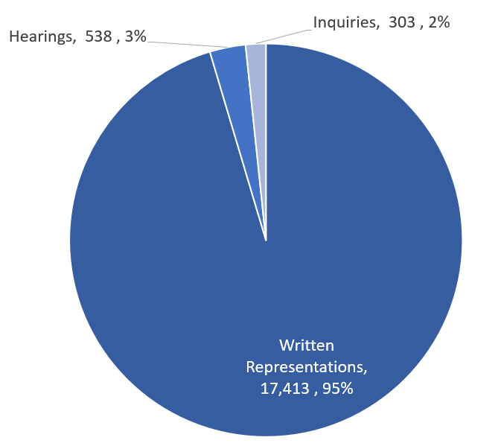 | 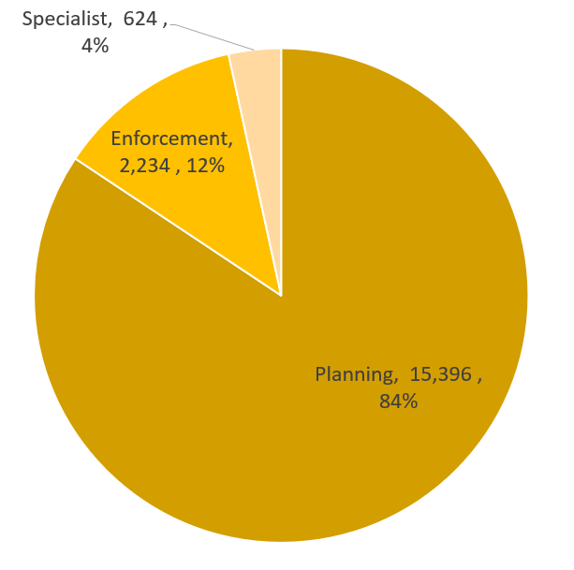
Source: Horizon and Picaso

Decision timeliness

It is important for people to know how long an appeal is going to take, so that they can make plans and decisions based on this information. This section covers the timeliness of decisions (i.e. how long it takes to make a decision) across our appeal casework. In addition to an overall measure, timeliness is analysed by procedure type and casework category, as timeliness varies a great deal depending on these characteristics.

Table 5 below shows that the mean average time to make a decision, across all cases in the last 12 months (July 20 to June 21), was 27 weeks. Figure 5 shows the mean has been above 25 weeks, with the exception of March 21, for the last 12 months.

Table 5 also shows the median time is 23 weeks. Each month the median is less than the mean; this is due to the larger impact on the mean of very long cases.

The median timeliness increased between June 20 to Nov 20, peaking at almost 27 weeks. Between December 20 to March 21 there was a reduction in the median time to decision, down to a low in March 21 of 18.9 weeks. The median for the last three months has been around 22 weeks.

Also included in the table is the standard deviation of decision timeliness. A lower standard deviation would demonstrate greater consistency in the Planning Inspectorate’s decision timeliness. The data shows that the variability was getting less towards the end of 2020 – the standard deviation values are 15.6 or lower for July to December. Data for the months in 2021 show greater variability, with a low of 16 weeks and a high of 19.7 weeks for June 21.

What are mean, median, and standard deviation?
Measure | Definition
Mean | The total time taken divided by the number of cases. Also referred to as the ‘average’. A measure of how long each case would take, if the total time taken was spread evenly across all cases.
Median | This is the time taken by the ‘middle’ case if all cases were sorted from quickest to longest
Standard deviation | This is a measure of variability or spread. It is calculated by examining how much each value differs from the mean. A higher standard deviation means the individual decision times vary more widely around the mean.

Table 5: Mean, Median and Standard Deviation of Time to Decision; Jul 20 to Jun 21
Month | Jul 20 | Aug 20 | Sep 20 | Oct 20 | Nov 20 | Dec 20 | Jan 21 | Feb 21 | Mar 21 | Apr 21 | May 21 | Jun 21 | Total
Valid to Decision (mean weeks) | 26.0 | 25.9 | 26.1 | 28.4 | 28.5 | 27.8 | 27.7 | 26.7 | 24.0 | 27.3 | 26.2 | 28.3 | 26.9
Valid to Decision (median weeks) | 23.3 | 23.3 | 24.0 | 25.6 | 26.9 | 23.9 | 22.0 | 20.9 | 19.0 | 21.9 | 22.1 | 22.0 | 22.9
Standard Deviation (weeks) | 14.4 | 14.1 | 12.5 | 14.9 | 12.9 | 15.6 | 18.1 | 16.9 | 16.0 | 18.7 | 16.7 | 19.7 | 15.8
Source: Horizon and Picaso

Figure 5: Mean and Median time to decision; Jul 20 to Jun 21
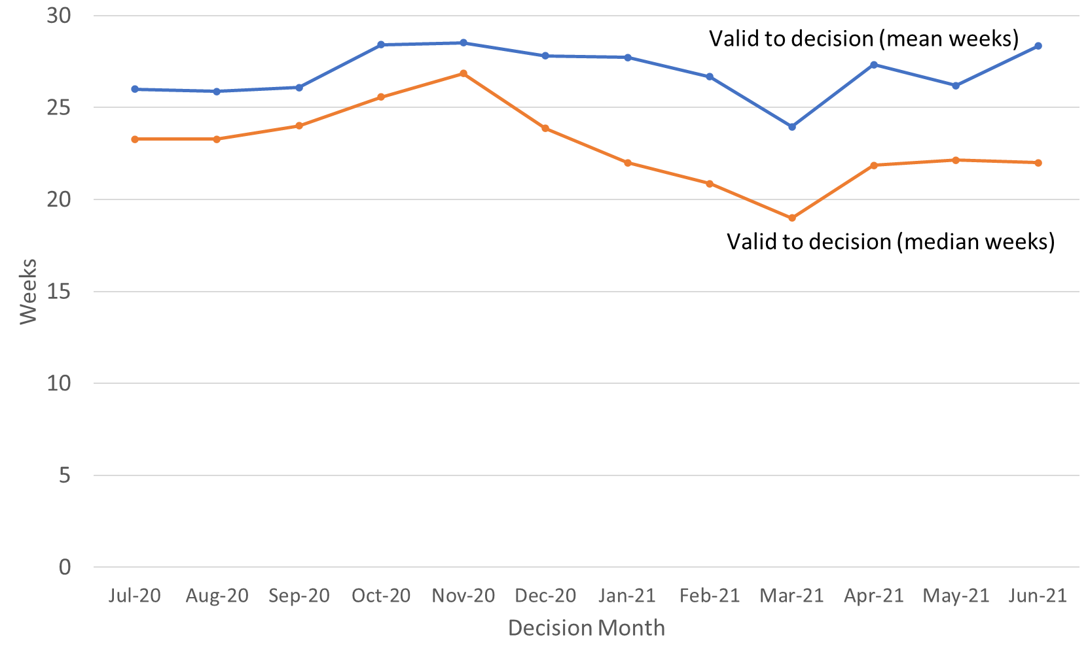
Source: Horizon and Picaso

Procedure Type
Table 6 below shows decision timeliness broken down by the procedure type. Hearings and inquires take longer than written representations – with inquiries taking more than twice as long as written representations. Because 19 of every 20 cases are by written representation, the timeliness measures for written representations is similar to the measure across all cases.

Where a small number of cases has been decided, the average timeliness (whether mean or median) is less meaningful as a measure than where there are many cases. Those areas shaded in the table below should be treated with caution as there are fewer than 20 cases decided.

The median time for written representations over the 12 months to June 21 is 22 weeks. The median time for inquiries over the 12 months to June 21 is over a year - 58 weeks. The median time for hearings is slightly less at 48 weeks. For each of these procedure types, the mean is higher as it is more affected by the longest cases.

Table 6: Mean and Median Time to Decision, with standard deviation, by procedure; Jul 20 to Jun 21
Measure | Procedure | Jul 20 | Aug 20 | Sep 20 | Oct 20 | Nov 20 | Dec 20 | Jan 21 | Feb 21 | Mar 21 | Apr 21 | May 21 | Jun 21 | Total
Valid to Decision (mean weeks) | Written Representations | 25.6 | 25.4 | 25.6 | 27.9 | 28.0 | 26.6 | 25.8 | 25.3 | 22.1 | 24.1 | 24.1 | 24.9 | 25.6
Valid to Decision (mean weeks) | Hearings | 56.0 | 44.5 | 50.5 | 49.8 | 37.3 | 49.6 | 59.8 | 47.5 | 56.7 | 63.8 | 42.8 | 57.2 | 52.6
Valid to Decision (mean weeks) | Inquiries | 42.3 | 55.1 | 63.2 | 43.8 | 58.5 | 52.8 | 53.9r | 76.3 | 57.6 | 64.4 | 61.7 | 70.1 | 61.5
 | All Cases | 26.0 | 25.9 | 26.1 | 28.4 | 28.5 | 27.8 | 27.7 | 26.7 | 24.0 | 27.3 | 26.2 | 28.3 | 26.9
Valid to Decision (median weeks) | Written Representations | 23.1 | 23.0 | 23.9 | 25.1 | 26.6 | 23.1 | 21.3 | 20.4 | 18.6 | 20.9 | 21.1 | 20.7 | 22.4
Valid to Decision (median weeks) | Hearings | 39.6 | 47.6 | 40.3 | 40.1 | 37.3 | 43.9 | 51.5 | 49.0 | 52.4 | 62.0 | 39.6 | 61.3 | 47.9
Valid to Decision (median weeks) | Inquiries | 24.0 | 44.4 | 65.0 | 37.3 | 55.0 | 40.1 | 47.3r | 68.1 | 41.3 | 62.4 | 66.0 | 64.1 | 58.0
Valid to Decision (median weeks) | All Cases | 23.3 | 23.3 | 24.0 | 25.6 | 26.9 | 23.9 | 22.0 | 20.9 | 19.0 | 21.9 | 22.1 | 22.0 | 22.9
Standard Deviation (weeks) | Written Representations | 13.7 | 13.4 | 11.7 | 14.2 | 12.3 | 14.0 | 15.2 | 14.8 | 12.6 | 13.6 | 14.0 | 13.9 | 13.6
Standard Deviation (weeks) | Hearings | 31.8 | 11.4 | 20.4 | 25.5 | 14.7 | 20.0 | 29.1 | 20.9 | 26.3 | 26.9 | 18.3 | 22.0 | 24.5
Standard Deviation (weeks) | Inquiries | 24.0 | 34.0 | 18.5 | 17.4 | 14.0 | 31.0 | 30.5r | 36.9 | 31.3 | 27.8 | 26.1 | 42.9 | 32.0
Standard Deviation (weeks) | All Cases | 14.4 | 14.1 | 12.5 | 14.9 | 12.9 | 15.6 | 18.1 | 16.9 | 16.0 | 18.7 | 16.7 | 19.7 | 15.8
Source: Horizon and Picaso. Cells shaded grey had fewer than 20 decisions. r denotes revision – a change of more than 0.5 weeks since last month

The standard deviation information indicates that for all three procedures, there is considerable variation, meaning times are widely spread about the mean. For each type, the amount of variation does not appear to be either increasing or decreasing through the year.

Casework Category
The nature of the cases the Planning Inspectorate deal with varies widely and several factors play a part in determining how long it takes to make a decision. One such factor is the casework type. Table 7 below shows the time taken to decide, in planning cases, in enforcement cases, and in specialist cases, as does Figure 6.

The median time to decision for planning cases (there are many more of these decisions than in the other categories) is lower than for other casework categories, apart from in March 21 and May 21. Table 7 and Figure 6 shows the median time for planning cases was, apart from February and March 21, above 20 weeks for the last 12 months. Across the whole year, the median time to decision is 22 weeks.

Annex B gives information on mean and median time to decision, with standard deviation, for these procedure types, split by planning, enforcement and specialist casework categories.

Table 7: Decisions, Mean, Median and Standard Deviation of Time to Decision – Planning, Enforcement, Specialist Cases; Jul 20 to Jun 21
Casework Category | Measure | Jul 20 | Aug 20 | Sep 20 | Oct 20 | Nov 20 | Dec 20 | Jan 21 | Feb 21 | Mar 21 | Apr 21 | May 21 | Jun 21 | Total
Planning Cases | Valid to Decision (mean wks) | 22.9 | 23.0 | 23.7 | 25.6 | 27.0 | 25.4 | 24.6 | 23.2 | 21.9 | 24.7 | 24.5 | 25.2 | 24.3
 | Valid to Decision (median wks) | 22.1 | 21.9 | 22.6 | 24.1 | 25.6 | 22.7 | 20.9 | 19.8 | 18.3 | 20.9 | 21.6 | 20.7 | 21.7
 | St. dev. of decision (weeks) | 9.6 | 11.4 | 9.8 | 11.3 | 11.3 | 12.3 | 12.3 | 11.6 | 12.3 | 14.6 | 13.1 | 15.1 | 12.1
Enforcement Cases | Valid to Decision (mean wks) | 38.0 | 36.8 | 37.5 | 42.8 | 37.7 | 42.1 | 43.7 | 42.7 | 41.6 | 47.6 | 40.6 | 45.7 | 40.7
 | Valid to Decision (median wks) | 33.0 | 33.3 | 33.6 | 38.4 | 34.6 | 36.9 | 37.6 | 34.9 | 30.5 | 35.2 | 28.3 | 38.9 | 33.9
 | St. dev. of decision (weeks) | 22.6 | 17.3 | 15.5 | 20.5 | 16.8 | 23.1 | 28.9 | 26.7 | 26.2 | 29.4 | 28.9 | 29.8 | 23.6
Specialist Cases | Valid to Decision (mean wks) | 42.8 | 37.4 | 47.0 | 38.8 | 39.4 | 45.3r | 46.1 | 53.7 | 29.1 | 36.7 | 24.6 | 36.6 | 40.4
 | Valid to Decision (median wks) | 41.1 | 37.3 | 48.7 | 35.5 | 41.1 | 45.6r | 52.9 | 53.6 | 15.0 | 22.0 | 15.6 | 28.0 | 37.1
 | St. dev. of decision (weeks) | 17.1 | 17.9 | 24.3 | 26.4 | 18.3 | 24.6r | 33.7 | 24.7 | 28.3r | 30.4 | 21.9 | 27.7 | 26.6
Source: Horizon and Picaso. r denotes revision – a change of more than 0.5 weeks since last month.
Figure 6 – Median time to decision by casework area; Jul 20 to Jun 21
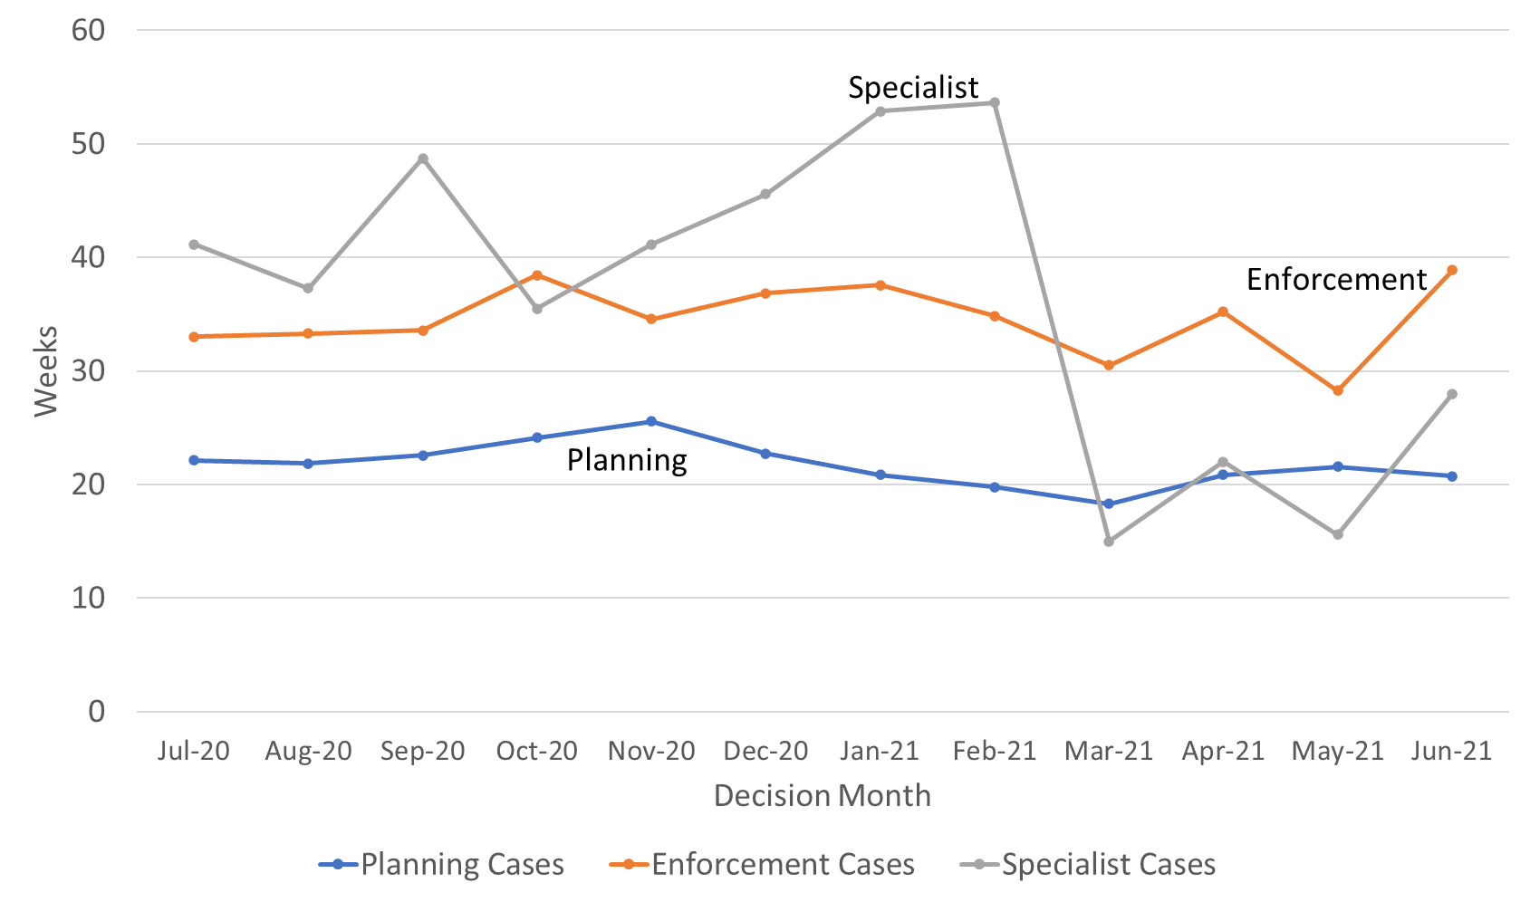
Source: Horizon and Picaso
Enforcement decisions made in the last 12 months had a median decision time of 34 weeks. For the last 12 months the mean is 41 weeks. The median time for enforcement decisions is longer than the median decision time for planning cases.
There are considerably fewer specialist cases which means results are more liable to be distorted by extreme values. Looking at the annual totals, the median and mean time to decision for specialist decisions have been broadly the same as for enforcement decisions, and longer than the median for planning decisions. Since February 21 there has been a change in this trend, with Specialist cases being quicker than Enforcement. The mix of casework being decided under the Specialist group has changed, and there was a concentrated effort to decide a high number of older Tree Preservation Order (TPO) cases that has influenced performance figures.
Note that the Inspectorate publishes each month, information on the mean and median times from valid to decision, for selected appeal types. The information published also breaks down the time for each stage of the process. See Annex C for further details.

Planning Inquiry Decisions
For planning appeals decided by the inquiry process, The Planning Inspectorate has been implementing recommendations from the Rosewell review.

The median time for inquiries over the 12 months to June 21 is 36 weeks, with the mean being marginally higher at 40 weeks. With the exception of February 21, decision volumes have been above ten per month since Dec 20, reaching their highest level in June 21 (31 decisions).

Table 8: Decisions, Mean and Median Time to Decision, Planning Inquiry cases under Rosewell process; Jul 20 to Jun 21
Measure | Jul 20 | Aug 20 | Sep 20 | Oct 20 | Nov 20 | Dec 20 | Jan 21 | Feb 21 | Mar 21 | Apr 21 | May 21 | Jun 21 | Total
Decisions | 3 | 5 | 2 | 7 | 7 | 18 | 13 | 8 | 15 | 17 | 16 | 31 | 142
Mean (weeks) | 22.7 | 42.5 | 41.1 | 45.7 | 45.7 | 35.3 | 36.5 | 40.7 | 36.7 | 53.5 | 34.3r | 40.1 | 40.1
Median (weeks) | 23.4 | 45.6 | 41.1 | 32.6 | 50.9 | 39.4 | 40.3 | 40.7 | 33.7 | 51.9 | 30.1 | 32.6 | 36.1
St. Dev. (weeks) | 1.4 | 16.0 | 1.1 | 22.1 | 9.1 | 10.2 | 12.2 | 7.9 | 12.0 | 31.1 | 9.9 | 21.9 | 18.8
Source: Horizon. r denotes revision – a change of more than 0.5 weeks since last month.
Most inquiry decisions now being issued are under the revised ‘Rosewell’ process but some inquiries, for example those that are linked together with associated enforcement cases, do not follow the Rosewell process.

Table 9: Decisions, Planning Inquiry cases under non-Rosewell process; Jul 20 to Jun 21
Month | Jul 20 | Aug 20 | Sep 20 | Oct 20 | Nov 20 | Dec 20 | Jan 21 | Feb 21 | Mar 21 | Apr 21 | May 21 | Jun 21 | Total
Decisions | 0 | 1 | 0 | 1 | 5 | 0 | 1 | 1 | 1 | 1 | 4 | 7 | 22
Source: Horizon
Figure 7 below shows the mean and median time to decision for planning inquiry cases under the Rosewell process.

Figure 7: Mean, Median Time to Decision, Rosewell Inquiry Process; Jul 20 to Jun 21
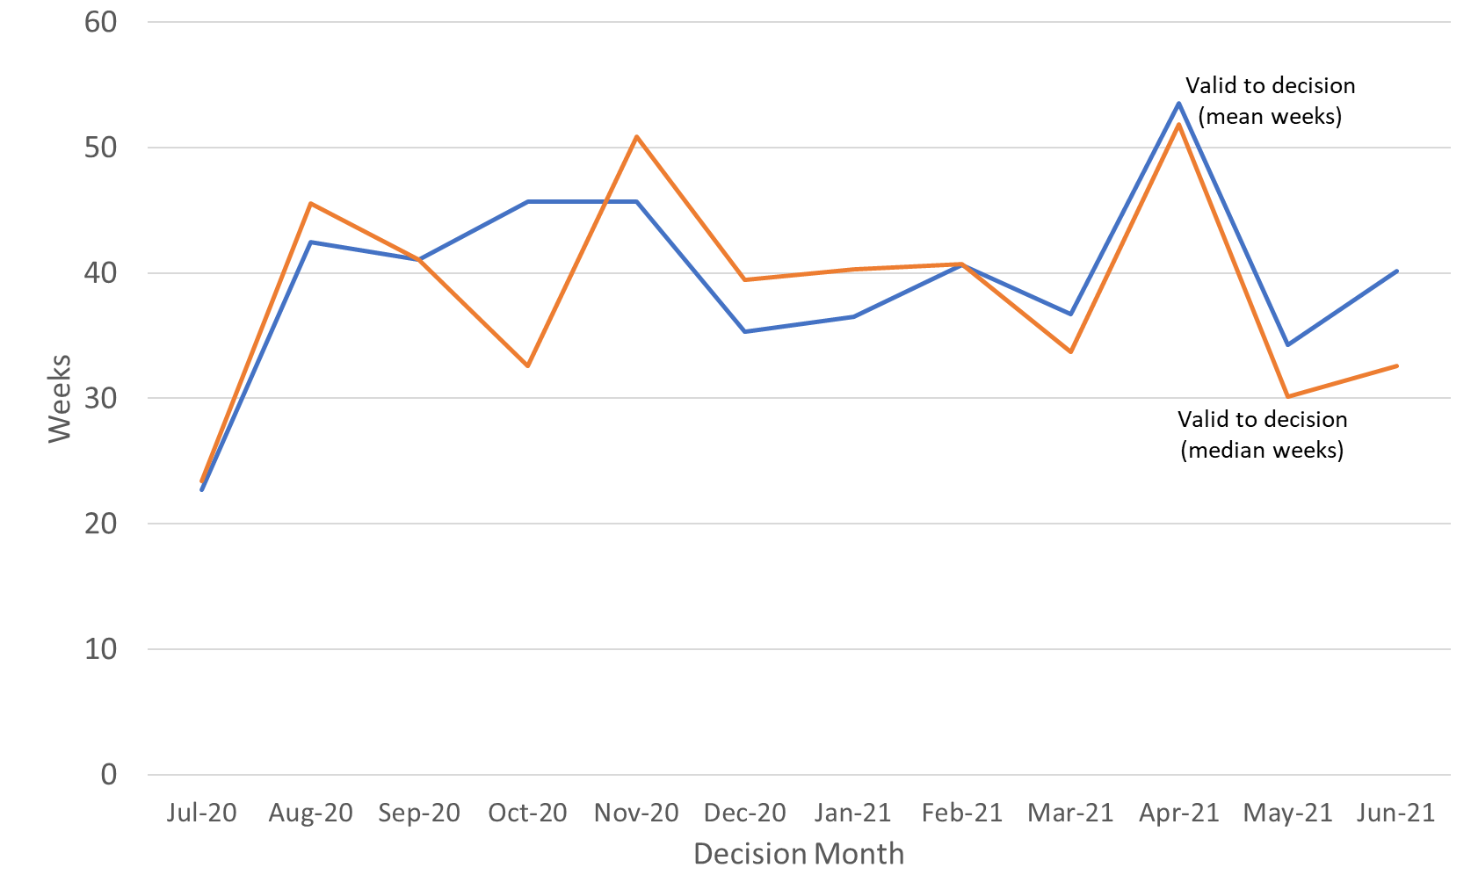
Source: Horizon

Open Cases

At the end of June 21, the Planning Inspectorate had over eleven thousand seven hundred cases open (11,777). This is slightly higher than the previous month. The open cases comprised over 9,900 cases being handled through written representations; just over 1,000 through hearings; and over 700 through inquiries. This is not the number of ‘live’ hearings and inquiries since it includes cases where the event (hearing or inquiry) has yet to start, as well as those where the event has finished but the decision has yet to be issued.

For each procedure type, there are more cases with an event scheduled but not yet started, than at any other stage in the process. Event refers to either a site visit, hearing or inquiry.

Table 10: Open cases by procedure and stage, as of end of June 2021
Procedure | Case received but yet to be deemed valid | Case deemed valid, event date yet to be set / in the future | Event complete but decision not yet issued |  | Total
Written Representations | 568 | 7,750 | 1,605 |  | 9,923
Hearings | 42 | 844 | 136 |  | 1,022
Inquiries | - | 597 | 121 |  | 718
Total | 610 | 9,292 | 1,875 |  | 11,777
Source: Horizon
Note there are 114 cases that have no procedure type recorded (see Background Quality Report for more detail) These are included in the total row but excluded from the breakdown by procedure.

Data note 1 - the count of open cases from December 2020 onwards has been revised to include some specialist casework types that were previously excluded: High Hedge (HH), Hedgerow (HGW) and Tree Preservation Order (TPO).
Data note 2 – there is a known anomaly that means that the number of open cases does not exactly follow the volumes of cases closed or received (for example the number of open cases can increase between months even though the number closed exceeded the number received). Investigations into this anomaly have found a potential problem because the data for open cases is captured from a snapshot process, whereas closed and received data comes from an aggregated process. Please see the Background Quality Report for more details.
Inspectors

Table 11 below shows the number of inspectors in the Planning Inspectorate in each month from July 20 to June 21. This includes headcount (i.e. the number of different individuals) and full-time equivalents (FTE) where those working part time are counted in proportion with their contracted hours. There were 349 Planning Inspectors employed by the Inspectorate in June 21 – with a full-time equivalent of 310.8.

By both measures (headcount and FTE) the maximum Inspector resource in the last 12 months was in July 20; and by both, the number at the end of January 21 was the lowest.

Table 11: Planning Inspectors – Headcount and FTE; Jul 20 to Jun 21 (at end of month)
Month | Jul 20 | Aug 20 | Sep 20 | Oct 20 | Nov 20 | Dec 20 | Jan 21 | Feb 21 | Mar 21 | Apr 21 | May 21 | Jun 21
Headcount | 355 | 352 | 352 | 347 | 345 | 345 | 343 | 345 | 352 | 355 | 353 | 349
FTE | 318.2 | 316.4 | 316.4 | 310.0 | 308.1 | 308.1 | 305.4 | 308.1 | 314.4 | 317.0 | 314.4 | 310.8
Source: SAP HR

As above, Planning Inspectors work on a broader range of work than the appeals featured in this Release. They also work on applications and examinations. Please note that data on Planning Inspectors is only applicable to salaried employees (it does not include fixed term contract Inspectors or non-salaried Inspectors).

Virtual Events

The Planning Inspectorate has continued moving casework forward during the pandemic by adapting the ways of working so that examinations, hearings and inquiries (which would previously have been held face-to-face) could take place virtually.

The Inspectorate are continuing to increase the number of events carried out ‘virtually’. There appears to be under-recording despite the introduction of system changes aimed at improving the quality of data.

The table and graph below give the number of virtual events that have occurred each month. There were 86 cases involving Virtual Events during June 21.

Data quality and corrections
There are concerns about the quality and accuracy of the data collection methods for virtual events data. Changes to recording systems aimed at reducing under-recording have been implemented but do not appear yet to be providing fully reliable information.
See the Background Quality Report for further information.

Table 12: Virtual Events, Jul 20 to Jun 21P
Case Type | Jul 20 | Aug 20 | Sep 20 | Oct 20 | Nov 20 | Dec 20 | Jan 21 | Feb 21 | Mar 21 | Apr 21 | May 21 | Jun 21
s78 Hearings | 11 | 18 | 36 | 41 | 43 | 35 | 35 | 23 | 33 | 29 | 26 | 33
s78 Inquiries | 6 | 4 | 11 | 11 | 17 | 17 | 14 | 15 | 21 | 15 | 24 | 18
Enforcement | 1 | 3 | 9 | 15 | 18 | 26 | 35 | 36 | 30 | 31 | 19 | 18
Local Plans | 2 | 3 | 7 | 14 | 12 | 12 | 5 | 7 | 9 | 5 | 6 | 11
National Infrastructure | 1 (3) | 1 (2) | 2 (3) | 10 (30) | 3 (9) | 6 (18) | 3 (7) | 4 (8) | 2 (2) | 3 (1) | 1 (1) | 2 (2)
Other | 1 | 0 | 0 | 4 | 16 | 7 | 14 | 8 | 11 | 9 | 9 | 4
Total | 22  (24) | 29  (30) | 65  (66) | 95 (115) | 109 (115) | 103 (115) | 106 (110) | 93  (97) | 106 (106) | 92  (90) | 85  (85) | 86  (86)
Source: Virtual Events ‘Triage’ data and SharePoint list, data as at 14/07/21

Numbers in brackets show count of events but note concerns below over counting sessions on same day. Local Plans are counted as cases where at least one sitting day occurred in a month.
‘Other’ case type includes specialist casework like Environmental appeals, Transport examinations and Rights of Way cases
Some virtual events have occurred but the source data does not record the casework type. These have not been included in the above table.
P – These numbers should be treated as provisional due to concerns about quality and accuracy.

Note – some cases can have multiple ‘events’ – for example an inquiry may sit over four to eight days but would only be counted as one ‘event’. On the other hand, casework like National Infrastructure may have multiple events for the same project. For Local Plans, cases are counted as having held a virtual event, if at least one sitting day occurred that month.

Figure 8: Virtual Events; Jul 20 to Jun 21P
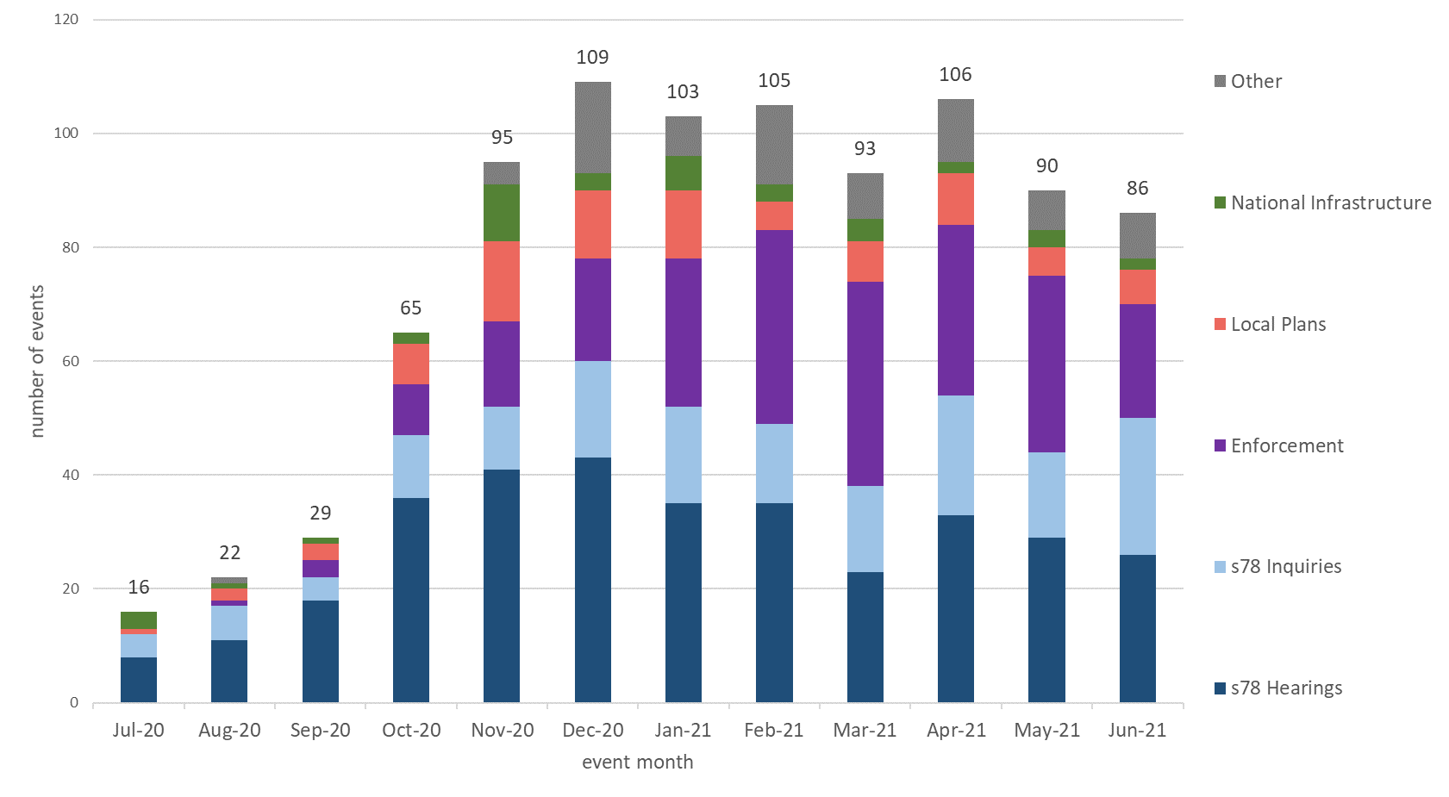
Source: Virtual Events ‘Triage’ data and SharePoint list, data as at 14/07/21
P – These numbers should be treated as provisional.

For National Infrastructure, the number given in the table is the number of projects that have held virtual events. The number in brackets is the number of individual events but this is potentially misleading as multiple sessions on the same day (e.g. morning and afternoon sessions) have been counted as separate events.

Quarterly Volume Statistics

The Inspectorate has also published today a series of tables of quarterly data. The quarterly volume statistics differ from the monthly statistical release. Some of the data published is on casework types that The Planning Inspectorate deals with, that are larger in scale but smaller in volume. The best examples of this are Nationally Significant Infrastructure Projects and Local Plans, where volumes never go into the hundreds, and can the time between submission to report issue can be over a year. Other data breaks appeals down into more detail than in the monthly totals. This data has been published on a quarterly basis for many years as management information.

All tables can be found at https://www.gov.uk/government/publications/planning-inspectorate-statistics

Section 78 Planning appeals

Appeals received compared decisions
In the last five complete financial years (April 2016 to March 2021) the highest level of quarterly receipts occurred in October to December 2017 and the highest number of decisions was in July to September 2019.

The impact of the pandemic can be clearly seen in a significant reduction in decisions during 2020/21 compared to the previous year, and particularly the drop in decisions issued in April to June 2020, when the first national lockdown was in effect. Receipts levels, although 7% lower during 2020/21 than the previous year, did not fall to the same extent as decisions, 32% lower, although it should be noted that 2019/20 was the highest number of decisions in the past eleven years.

Figure 9: s78 Planning appeals received and decided, 2015/16 to 2021/22, by quarter
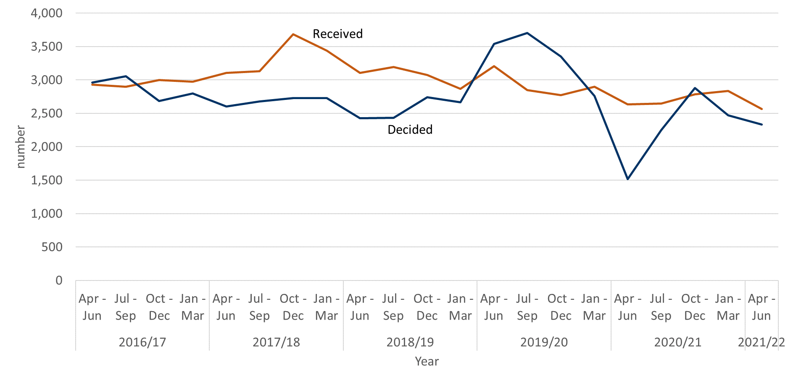
Source: Horizon & Picaso. Full published data in Tables 2.1 and Table 2.4.
See Annex D, table a, for full data table.

Appeals Allowed
The percentage of planning appeals that were allowed in the latest quarter was 31% - this is the highest percentage of appeals allowed since July to September quarter in 2018/19.

The overall percentage allowed is heavily influenced by the number of written representations appeals allowed, as this procedure type contributes by far the greatest number of decisions each year. There has been slightly more variation in the percentage allowed for hearings and inquiries. See Figure 11 below for further details.

Figure 10: s78 planning appeals, percentage allowed, 2015/16 to 2021/22, by quarter
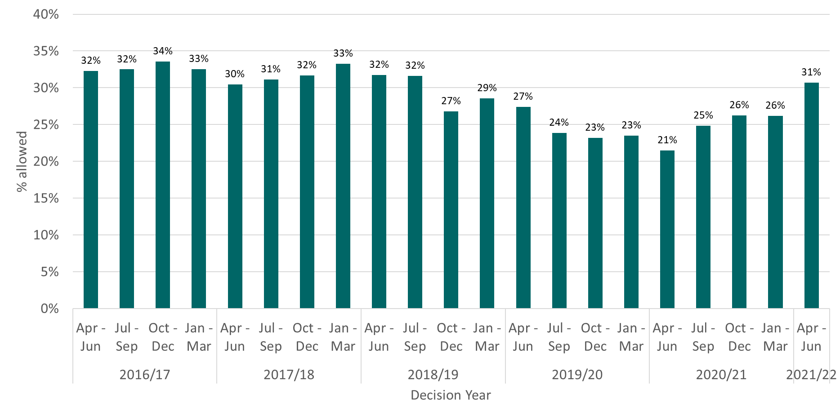
Source: Horizon & Picaso. Full published data in Table 2.4 s78 planning appeals decided.
See Annex D, table b, for full data table

Figure 11: s78 planning appeals, percentage allowed by procedure type, 2015/16 to 2021/22, by quarter
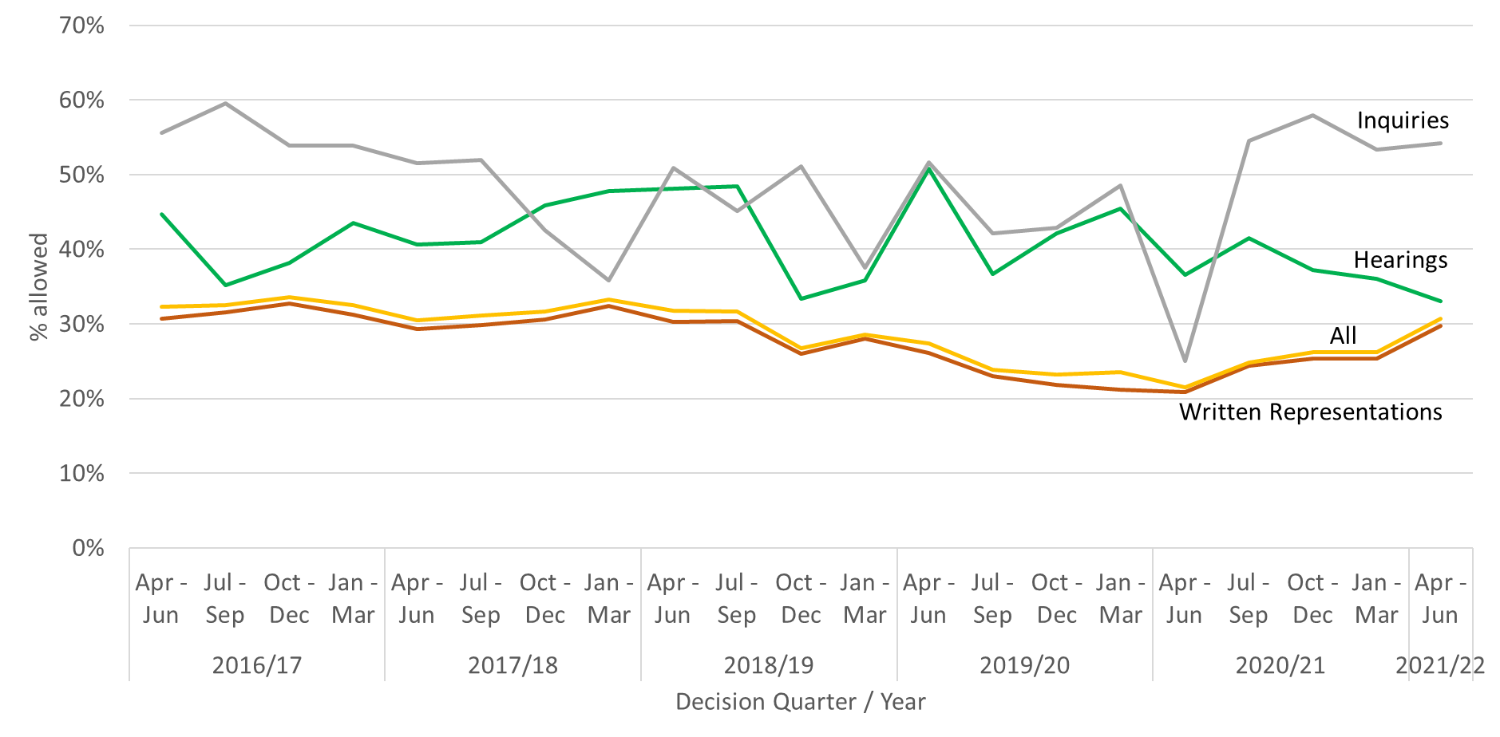

Source: Horizon & Picaso. Full published data in Table 2.4 s78 planning appeals decided.
See Annex D, table b, for full data table

Figure 12: s78 planning appeals, number of appeals allowed, 2015/16 to 2021/22, by quarter
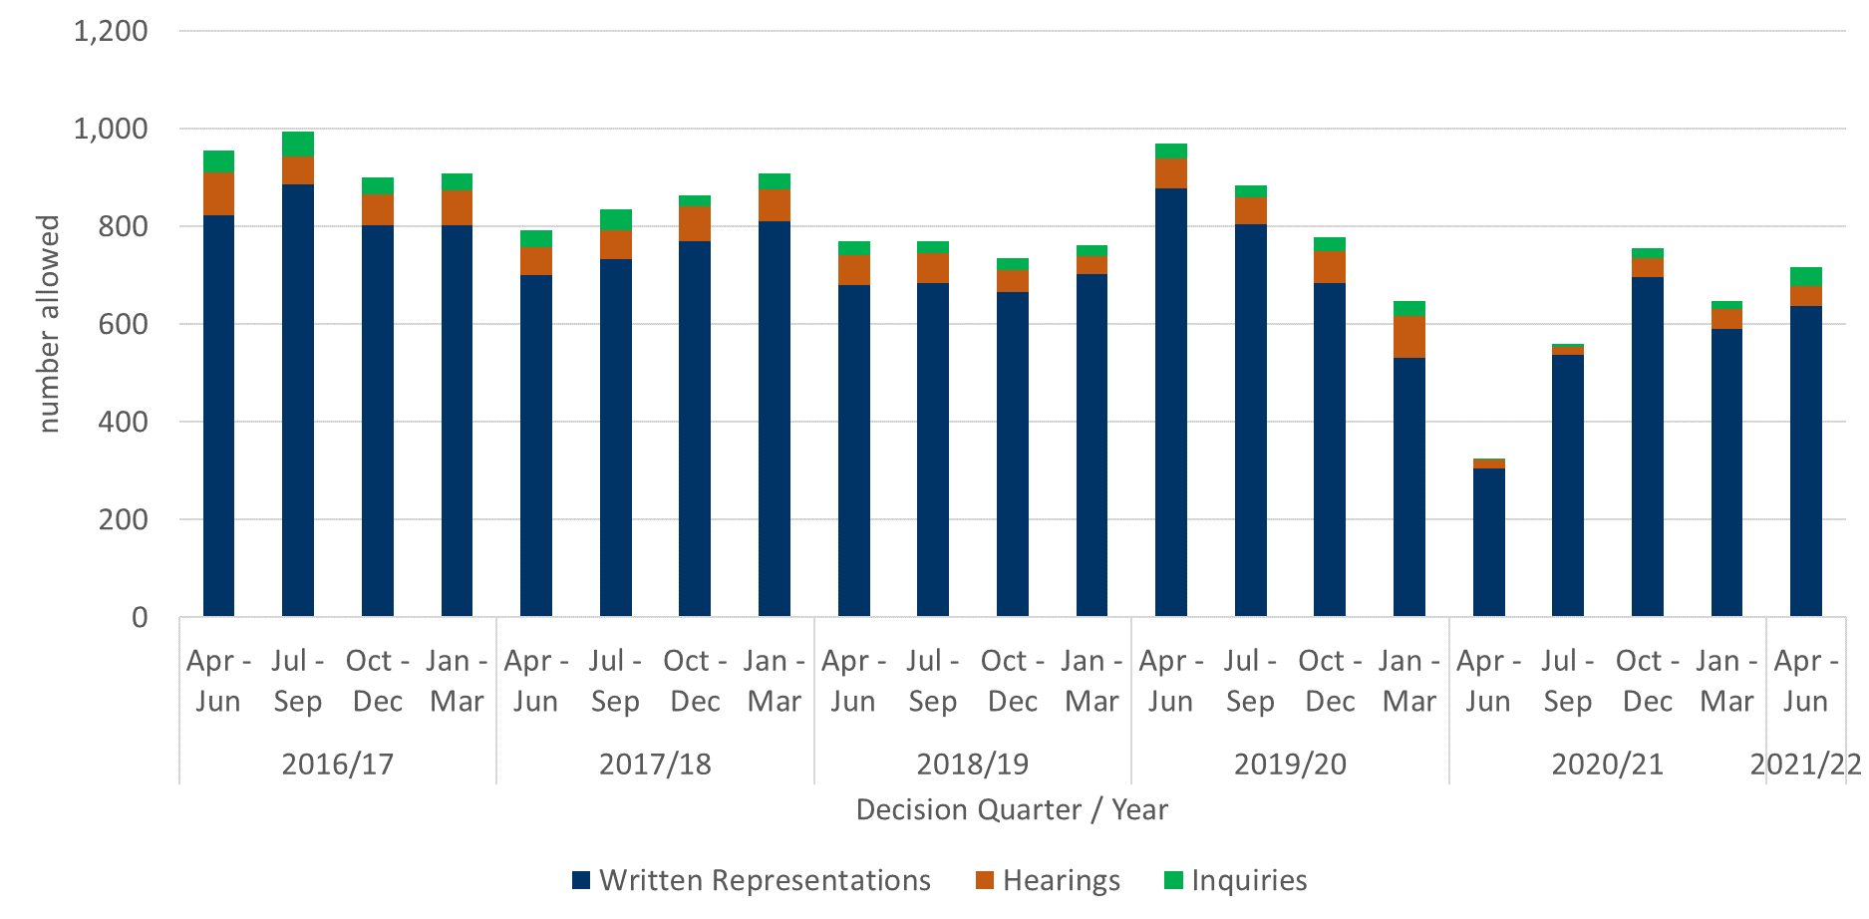

Source: Horizon & Picaso. Full published data in Table 2.4 s78 planning appeals decided.
See Annex D, table c, for full data table

Annex A – Content of ad-hoc Statistical Releases, 2020

Note: The Table below covers ad-hoc statistical releases. From November 2020 onwards, the content is fixed, so is the same as this publication.

Date | March 2020 | April 2020 | July 2020 | September 2020 | October 2020
Content | Appeals receipts and decisions in the last 12 and 24 months (1st March 2018 – 29th February 2020)  Number of section 78 Planning Appeals received / decided / within target that used the written representation method in the last 12 months (1st March 2019 – 29th February 2020)  Number of dwellings decided and number of dwellings allowed by appeal decisions between 1st January 2017 and 31st December 2019.  Number of Planning Inspectors employed by the Planning Inspectorate at the end of each quarter between 31st March 2017 and 31st December 2019. | Appeals receipts and decisions between 17th March 2020 and 22nd April 2020  Live appeals in the system as at 23rd April 2020  Number of appeals involving housing within the system as at 23rd April 2020  Virtual site visits | Appeals decisions between 17th March 2020 and 22nd June 2020  Number of open cases  Number of virtual events  Number of appeals  involving housing within the system as at 12th June 2020 | Appeals decisions between 17th March 2020 and 21st September 2020  Number of open cases  Number of virtual events | Appeals decisions from October 2019 to September 2020  Number of open cases  Number of virtual events
Scope | England only  Planning cases, Enforcement cases and Rights of Way orders | England only  Planning cases, Enforcement cases and Rights of Way orders | England only  Planning cases, Enforcement cases and Rights of Way orders | England only  Planning cases, Enforcement cases and Rights of Way orders | England only  Planning cases, Enforcement cases, Specialist cases: Common Land, Rights of Way orders, Tree Preservation Orders, High Hedges appeals and Hedgerow appeals

Annex B – Mean and median time to decision, with standard deviation, for planning, enforcement and specialist casework
Planning
Measure | Procedure | Jul 20 | Aug 20 | Sep 20 | Oct 20 | Nov 20 | Dec 20 | Jan 21 | Feb 21 | Mar 21 | Apr 21 | May 21 | Jun 21 | Total
Valid to decision (mean weeks) | Written Representations | 22.6 | 22.5 | 23.3 | 25.2 | 26.6 | 24.6 | 23.7 | 22.5 | 21.0 | 22.9 | 23.5 | 23.5 | 23.6
Valid to decision (mean weeks) | Hearings | 46.7 | 42.2 | 51.3 | 39.7 | 35.0 | 45.9 | 46.2 | 41.2 | 48.0 | 56.1 | 40.6 | 48.8 | 45.2
Valid to decision (mean weeks) | Inquiries | 22.7 | 60.0 | 41.1 | 44.6 | 54.9 | 35.3 | 40.4 | 50.6 | 35.8 | 54.9 | 44.8 | 52.7 | 46.8
Valid to decision (mean weeks) | All Cases | 22.9 | 23.0 | 23.7 | 25.6 | 27.0 | 25.4 | 24.6 | 23.2 | 21.9 | 24.7 | 24.5 | 25.2 | 24.3
Valid to decision (median weeks) | Written Representations | 22.0 | 21.7 | 22.3 | 23.9 | 25.4 | 22.0 | 20.4 | 19.4 | 18.0 | 20.1 | 21.0 | 20.0 | 21.3
Valid to decision (median weeks) | Hearings | 34.4 | 45.1 | 43.1 | 34.0 | 36.1 | 43.0 | 46.6 | 46.4 | 44.8 | 56.9 | 37.3 | 44.4 | 41.9
 | Inquiries | 23.4 | 49.2 | 41.1 | 34.8 | 53.9 | 39.4 | 40.7 | 42.9 | 33.6 | 52.4 | 32.9r | 36.9 | 39.9
 | All Cases | 22.1 | 21.9 | 22.6 | 24.1 | 25.6 | 22.7 | 20.9 | 19.8 | 18.3 | 20.9 | 21.6 | 20.7 | 21.7
Standard Deviation (weeks) | Written Representations | 8.8 | 10.4 | 8.8 | 10.7 | 10.9 | 11.4 | 10.8 | 10.5 | 10.9 | 11.2 | 11.8 | 11.9 | 10.7
Standard Deviation (weeks) | Hearings | 27.9 | 9.7 | 20.5 | 18.5 | 13.3 | 17.4 | 23.0 | 16.7 | 24.6 | 23.6 | 18.7 | 20.7 | 20.9
 | Inquiries | 1.4 | 41.8 | 1.1 | 20.8 | 13.1 | 10.2 | 18.4 | 29.0 | 12.1 | 30.7 | 23.5r | 37.1 | 27.4
 | All Cases | 9.6 | 11.4 | 9.8 | 11.3 | 11.3 | 12.3 | 12.3 | 11.6 | 12.3 | 14.6 | 13.1 | 15.1 | 12.1

Enforcement
Measure | Procedure | Jul 20 | Aug 20 | Sep 20 | Oct 20 | Nov 20 | Dec 20 | Jan 21 | Feb 21 | Mar 21 | Apr 21 | May 21 | Jun 21 | Total
Valid to decision (mean weeks) | Written Representations | 37.2 | 36.8 | 37.1 | 41.4 | 36.7 | 38.3 | 36.8 | 35.4 | 32.3 | 34.4 | 31.5 | 32.9 | 36.5
Valid to decision (mean weeks) | Hearings | 96.5 | 34.4 | 34.3 | 84.4 | 54.4 | 64.3 | 82.7 | 66.3 | 78.5 | 77.9 | 50.9 | 63.4 | 70.3
Valid to decision (mean weeks) | Inquiries | - | - | 84.6 | 43.9 | 62.5 | 102.9 | 75.4r | 108.7 | 81.8 | 73.8 | 71.3 | 104.9 | 82.0
Valid to decision (mean weeks) | All Cases | 38.0 | 36.8 | 37.5 | 42.8 | 37.7 | 42.1 | 43.7 | 42.7 | 41.6 | 47.6 | 40.6 | 45.7 | 40.7
Valid to decision (median weeks) | Written Representations | 32.6 | 33.3 | 33.6 | 36.9 | 33.9 | 35.2 | 31.1 | 28.1 | 27.6 | 29.6 | 24.9 | 28.9 | 32.0
Valid to decision (median weeks) | Hearings | 100.1 | 34.4 | 34.3 | 89.0 | 56.0 | 68.5 | 78.8 | 68.8 | 84.4 | 71.3 | 45.2 | 61.6 | 66.6
 | Inquiries | - | - | 84.6 | 42.6 | 56.1 | 99.0 | 86.1r | 125.3 | 86.7 | 62.4 | 66.0 | 108.0 | 80.4
 | All Cases | 33.0 | 33.3 | 33.6 | 38.4 | 34.6 | 36.9 | 37.6 | 34.9 | 30.5 | 35.2 | 28.3 | 38.9 | 33.9
Standard Deviation (weeks) | Written Representations | 21.8 | 17.3 | 14.9 | 19.3 | 16.3 | 18.9 | 23.2 | 17.8 | 16.9 | 20.9 | 25.6 | 17.8 | 19.3
Standard Deviation (weeks) | Hearings | 5.2 | 0.0 | 0.0 | 12.8 | 12.3 | 22.6 | 23.2 | 22.2 | 15.6 | 28.0 | 13.6 | 19.0 | 23.3
 | Inquiries | - | - | 0.0 | 10.1 | 10.1 | 19.2 | 38.1r | 23.2 | 26.8 | 20.3 | 21.4 | 30.7 | 29.0
 | All Cases | 22.6 | 17.3 | 15.5 | 20.5 | 16.8 | 23.1 | 28.9 | 26.7 | 26.2 | 29.4 | 28.9 | 29.8 | 23.6

Specialist
Measure | Procedure | Jul 20 | Aug 20 | Sep 20 | Oct 20 | Nov 20 | Dec 20 | Jan 21 | Feb 21 | Mar 21 | Apr 21 | May 21 | Jun 21 | Total
Valid to decision (mean weeks) | Written Representations | 41.4 | 34.3 | 45.2 | 38.9 | 37.5 | 44.7r | 42.7 | 52.8 | 27.1r | 33.3 | 22.6 | 34.5 | 38.6
Valid to decision (mean weeks) | Hearings | 0.0 | 62.1 | - | - | - | - | 89.8 | 65.0 | 80.0 | 82.1 | 60.0 | 100.8 | 80.3
Valid to decision (mean weeks) | Inquiries | 71.6 | 47.9 | 63.7 | 37.3 | 66.7 | 59.9 | 58.4 | 77.6 | 18.0 | 85.1 | 100.0 | - | 62.1
Valid to decision (mean weeks) | All Cases | 42.8 | 37.4 | 47.0 | 38.8 | 39.4 | 45.3r | 46.1 | 53.7 | 29.1 | 36.7 | 24.6 | 36.6 | 40.4
Valid to decision (median weeks) | Written Representations | 40.6 | 35.9 | 48.1 | 33.7 | 39.1 | 44.0r | 43.6 | 53.1 | 14.9 | 21.9 | 15.3 | 26.9 | 35.0
Valid to decision (median weeks) | Hearings | - | 62.1 | - | - | - | - | 102.1 | 65.0 | 80.0 | 82.1 | 60.0 | 100.8 | 69.1
 | Inquiries | 71.6 | 43.1 | 65.0 | 37.3 | 60.4 | 59.9 | 64.0 | 81.9 | 18.0 | 85.1 | 100.0 | - | 65.0
 | All Cases | 41.1 | 37.3 | 48.7 | 35.5 | 41.1 | 45.6r | 52.9 | 53.6 | 15.0 | 22.0 | 15.6 | 28.0 | 37.1
Standard Deviation (weeks) | Written Representations | 16.2 | 17.1 | 24.5 | 26.6 | 16.7 | 24.8r | 33.3 | 24.5 | 26.9r | 28.4 | 19.3 | 25.4 | 25.9
Standard Deviation (weeks) | Hearings | - | 0.0 | - | - | - | - | 18.1 | 0.0 | 16.3 | 12.9 | 0.0 | 7.1 | 18.3
 | Inquiries | 0.6 | 13.4 | 12.7 | 0.0 | 17.3 | 13.1 | 19.5 | 19.9 | 0.0 | 0.0 | 0.0 | - | 20.1
 | All Cases | 17.1 | 17.9 | 24.3 | 26.4 | 18.3 | 24.6r | 33.7 | 24.7 | 28.3r | 30.4 | 21.9 | 27.7 | 26.6
r denotes revision – a change of more than 0.5 weeks since last month.

Annex C – Detailed Information on timeliness (June)

The information below is published today on the number and length of decisions made in June 2021:
Casework Type | Procedure Type | Mean (weeks) | Median (weeks) | Decisions
s78 planning appeals | Written Representations | 25.2 | 21.9 | 808
s78 planning appeals | Hearings | 48.2 | 43.4 | 39
s78 planning appeals | Inquiries | 49.3 | 36.4 | 36
Householder appeals | Written Representations | 19.1 | 16.6 | 323
Enforcement appeals | Written Representations | 31.5 | 28.9 | 144
Enforcement appeals | Hearings | 50.9 | 61.6 | 40
Enforcement appeals | Inquiries | 71.3 | 108.0 | 19

The smaller the number of decisions, the less helpful the mean and median are as measures for summarising performance. Particular care should be taken when there are fewer than twenty decisions. These are shaded grey in the table but have been provided for completeness and transparency.

The information published below shows the time taken for different stages of the appeals process:
 | s78 planning appeals |  |  | Householder appeals
 | Written Representations | Hearings | Inquiries | Householder appeals
Weeks between valid date & start date
Mean (average) | 8.1 | 24.7 | 4.7 | 7.8
Median (average) | 6.4 | 19.7 | 2.6 | 8.1
Cases that started in June 21 | 552 | 17 | 20 | 377
Weeks between start date & event date
Mean (average) | 13.7 | 17.7 | 18.0 | 9.9
Median (average) | 9.9 | 13.0 | 14.7 | 8.1
Cases where an event occurred during June 21 | 854 | 43 | 19 | 357
Weeks between event date & decision date
Mean (average) | 4.3 | 6.6 | 9.6 | 3.6
Median (average) | 3.1 | 5.0 | 8.9 | 2.4
Cases that have been decided in June 21 | 796 | 49 | 18 | 343

- Valid date – the date a case is deemed to have been validly received
- Start date – date when a case has started its documentation phase (requesting statements and additional information) and an Inspector resource has usually been identified to carry out the case
- Event date – the date of either a site visit, hearing or inquiry
- Decision date – the date the decision was issued by The Planning Inspectorate

Annex D – Data tables

Table a) s78 planning appeals received and decided

Year or Quarter |  | received | decided
2015/16 | Apr - Jun | 2,944 | 1,963
 | Jul - Sep | 2,972 | 2,539
 | Oct - Dec | 2,927 | 2,447
 | Jan - Mar | 2,955 | 3,332
2016/17 | Apr - Jun | 2,929 | 2,958
 | Jul - Sep | 2,895 | 3,056
 | Oct - Dec | 2,997 | 2,683
 | Jan - Mar | 2,972 | 2,796
2017/18 | Apr - Jun | 3,108 | 2,600
 | Jul - Sep | 3,132 | 2,680
 | Oct - Dec | 3,685 | 2,728
 | Jan - Mar | 3,437 | 2,733
2018/19 | Apr - Jun | 3,104 | 2,428
 | Jul - Sep | 3,193 | 2,431
 | Oct - Dec | 3,075 | 2,741
 | Jan - Mar | 2,867 | 2,666
2019/20 | Apr - Jun | 3,203 | 3,540
 | Jul - Sep | 2,849 | 3,705
 | Oct - Dec | 2,772 | 3,350
 | Jan - Mar | 2,900 | 2,759
2020/21 | Apr – Jun | 2,631 | 1,514
 | Jul – Sep | 2,647 | 2,253
 | Oct – Dec | 2,783 | 2,880
 | Jan - Mar | 2,825 | 2,474
2021/22 | Apr – Jun | 2,568 | 2,332

Table b) s78 planning appeals, percentage allowed by procedure type

Year or Quarter |  | Written Representations | Hearings | Inquiries | All
2016/17 | Apr - Jun | 31% | 45% | 56% | 32%
 | Jul - Sep | 32% | 35% | 60% | 32%
 | Oct - Dec | 33% | 38% | 54% | 34%
 | Jan - Mar | 31% | 44% | 54% | 33%
2017/18 | Apr - Jun | 29% | 41% | 51% | 30%
 | Jul - Sep | 30% | 41% | 52% | 31%
 | Oct - Dec | 31% | 46% | 43% | 32%
 | Jan - Mar | 32% | 48% | 36% | 33%
2018/19 | Apr - Jun | 30% | 48% | 51% | 32%
 | Jul - Sep | 30% | 48% | 45% | 32%
 | Oct - Dec | 26% | 33% | 51% | 27%
 | Jan - Mar | 28% | 36% | 38% | 29%
2019/20 | Apr - Jun | 26% | 51% | 52% | 27%
 | Jul - Sep | 23% | 37% | 42% | 24%
 | Oct - Dec | 22% | 42% | 43% | 23%
 | Jan - Mar | 21% | 45% | 48% | 23%
2020/21 | Apr - Jun | 21% | 37% | 25% | 21%
 | Jul - Sep | 24% | 41% | 55% | 25%
 | Oct - Dec | 25% | 37% | 58% | 26%
 | Jan - Mar | 25% | 36% | 53% | 26%
2021/22 | Apr - Jun | 30% | 33% | 54% | 31%

Table c) s78 planning appeals, percentage allowed by procedure type

Year or Quarter |  | Written Representations | Hearings | Inquiries | All
2016/17 | Apr - Jun | 822 | 88 | 45 | 955
 | Jul - Sep | 885 | 58 | 50 | 993
 | Oct - Dec | 802 | 63 | 35 | 900
 | Jan - Mar | 803 | 71 | 35 | 909
2017/18 | Apr - Jun | 701 | 56 | 35 | 792
 | Jul - Sep | 732 | 61 | 41 | 834
 | Oct - Dec | 769 | 72 | 23 | 864
 | Jan - Mar | 811 | 65 | 33 | 909
2018/19 | Apr - Jun | 679 | 62 | 29 | 770
 | Jul - Sep | 683 | 63 | 23 | 769
 | Oct - Dec | 666 | 44 | 24 | 734
 | Jan - Mar | 702 | 38 | 21 | 761
2019/20 | Apr - Jun | 877 | 62 | 31 | 970
 | Jul - Sep | 805 | 55 | 24 | 884
 | Oct - Dec | 683 | 67 | 27 | 777
 | Jan - Mar | 532 | 84 | 32 | 648
2020/21 | Apr - Jun | 304 | 19 | 2 | 325
 | Jul - Sep | 537 | 17 | 6 | 560
 | Oct - Dec | 696 | 38 | 22 | 756
 | Jan - Mar | 591 | 40 | 16 | 647
2021/22 | Apr - Jun | 637 | 40 | 39 | 716

Annex E – Casework types included in this release

Planning covers s78 planning appeals, Householder appeals, Commercial appeals, s20 Listed Building appeals, Advertisement appeals, s106 Planning Obligation appeals and Called In Planning Applications.

Enforcement covers s174 Enforcement appeals, s39 Enforcement Listed Building appeals and Lawful Development Certificate appeals.

Specialist casework includes Common Land, Rights of Way orders, Purchase orders, Tree Preservation Orders, High Hedges appeals and Hedgerow appeals.
(Note that the data on Open Cases in previous publications excluded Tree Preservation Orders and High Hedges and Hedgerow appeals.)

Background notes

Data sources
Horizon / Picaso – The main casework management systems used for processing appeals casework (note that Picaso is no longer a live system).
SAP HR – The Human Resources system database used to store all information regarding members of staff.

Measure | Definition
Mean | The total time taken divided by the number of cases. Also referred to as the ‘average’. A measure of how long each case would take, if the total time taken was spread evenly across all cases.
Median | This is the time taken by the ‘middle’ case if all cases were sorted from quickest to longest
Standard deviation | This is a measure of variability or spread. It is calculated by examining how much each value differs from the mean. A higher standard deviation means the individual decision times vary more widely around the mean.

Compliance with the Code of Practice for Statistics
These statistics have been published in accordance with the Code of Practice for Statistics, which cover trustworthiness, quality and value. They have been pre-announced, and publication is overseen by the Head of Profession.

Technical Notes
A Background Quality Report is published alongside this Statistical Release. It provides more detail on the quality of statistics in this publication.

Data quality | Data on cases is taken from a live casework system, and details of cases can change for a number of reasons even after a decision has been made. We are seeking to get a better understanding of the nature and volume of these changes and will provide further information as it is available.  We carry out regular checks on the quality of our data and may undertake ad hoc data cleansing exercises. Therefore, all the data for the last 12 rolling months is published in provisional form.  We have indicated in this publication any data where a number of cases has changed by more than five cases in a month; or where a measure (mean, median or standard deviation) has changed by more than 0.5 weeks.
Virtual Events | Data is currently being sourced from an operational MS Excel workbook. It is therefore being constantly updated and refined and may result in data may changing between monthly publications.  There are concerns about the quality and accuracy of the data collection methods. Definitions of what constitutes an event are being refined, as this differs according to the type of casework. Whilst this work is in progress these numbers should be treated as provisional.  Data for Local Plans is now being sourced from information recorded by Inspectors on their timesheets.
Measuring weeks | Data are measured in days and then converted to weeks.  Note that not all decimal values are possible where converting days to weeks. 1 day is 1/7 of a week, or 0.14 weeks (to two decimal places). 2 days = 0.29; 3 days = 0.43; 4 days = 0.57; 5 days = 0.71; 6 days = 0.86.  When these are used to calculate averages, or displayed to one decimal place, the result will not equate to a full day which can be misleading: it may appear that we are measuring part days (e.g. 19.8 weeks) but we only measure in whole days.

Glossary
Term | Explanation
Appeals | The right to appeal a planning decision made by a local authority is a key feature of the planning system, as is appealing when an authority is taking too long.
Appeals decided | Number of appeals by the date the appeal was decided by The Planning Inspectorate.
Appeals received | Number of appeals by the date the appeal was received by The Planning Inspectorate.
Applications | Planning Inspectorate manage the application process for proposed Nationally Significant Infrastructure Projects (NSIPs) within England and Wales in line with the 2008 Planning Act.
Closed | The total number of appeals decided, withdrawn or turned away.
Decision | The outcome of the case e.g. appeal allowed or rejected. The date of the decision is taken as the date a decision letter is sent to the appellant.
Event | A site visit, hearing or inquiry (may be virtual)
Event Type | The different options of how an Inspector visits a site for a written representations appeal.
Examinations | The process of examining local plans is dealt with by the Planning Inspectorate. Every Local Planning Authority is required to have a local plan. This includes a vision for the future and plan to address housing needs in the area.  When a Local Planning Authority has finished preparing and consulting on a local plan it must be submitted to the Secretary of State who appoints an Inspector to carry out an independent examination.
FTE | Full Time Equivalent – a count of employees where those working part time are counted in proportion with their contracted hours.
Headcount | Total number of staff employed regardless of how many hours they work (i.e. the number of different individuals).
Hearings | A hearing involves the submission of written evidence by the main parties and a hearing once all the written submissions have been received.  This takes the form of a round-the-table discussion (in person or virtually) that will be led by the planning inspector. It allows for all parties to respond to any questions that the inspector might have, and to let everyone make their case known.  Source: Planning Portal
Inquiries | An inquiry is usually used for complex cases where legal issues may need to be considered. The main parties will usually have legal representatives to present their case and to cross-examine any witnesses. Prior to the inquiry date, the Planning Inspectorate will expect to have received various documents from all parties that will be taking part in the appeal. These may include statements of case and proofs of evidence from expert witnesses. Third parties may also take part. The inquiry will be led by the inspector and will follow a formal procedure.  At some point during or on conclusion of the inquiry the inspector and the main parties will undertake a site visit.  Source: Planning Portal
Live appeals | Number of live appeals in that have an appeal valid date but no end date (either decision date or a closed date, e.g. for appeals that have been withdrawn).
Open Cases | Number of cases that have been received but on which a decision has not yet been made/ issued. Will differ from Live Appeals as it includes those received but not yet verified.
Procedure Type | The method by which The Planning Inspectorate processes and decides appeals.
Written Representations | Most planning appeals are decided by the written representations’ procedure. With this procedure the Inspector considers written evidence from the appellant, the LPA and anyone else who has an interest in the appeal. The site is also likely to be visited.

Contact Us

The Planning Inspectorate welcome feedback on our statistical products. If you have any comments or questions about this publication or about our statistics in general, you can contact us as follows:
Media enquiries 0303 444 5004
email press.office@planninginspectorate.gov.uk

Public enquiries email statistics@planninginspectorate.gov.uk

Please note we are currently reviewing our statistics with a view to making them as clear and helpful as possible for users. We would be delighted if you could contact us via the address below with any views on this approach; particularly on what content would be most useful and why.

email statistics@planninginspectorate.gov.uk

If you require information which is not available within this or other available publications, you may wish to submit a Request for Information under the Freedom of Information Act 2000 to the Planning Inspectorate. For more information, see: https://www.gov.uk/make-a-freedom-of-information-request/the-freedom-of-information-act

See Annex A for breakdown of what has been included in recent releases.
The appeal types include planning & related appeals, Enforcement and Specialist casework (covering a range of casework types). Please note that some previous releases covered only Rights of Way orders within Specialist casework. Annex A details the scope of previous releases, Annex D the scope of this release and Background Notes has further information.
Open cases are any that have been received but on which a decision has not yet been made/ issued. Cases included comprise Planning, Enforcement, and the following Specialist cases: Common Land, Environment, Purchase Notice and Rights of Way, Tree Preservation Orders, Hedgerows and High Hedges cases. Note that previous publications excluded Tree Preservation Order, Hedgerow and High Hedge cases from open cases totals. See Background Quality report for more information.
See the section on Decision timeliness for more, including definitions of the average measures used in this release.
A site visit, hearing or inquiry. From April 2020 onwards all hearings and inquiries have been held virtually.
The appeal types include planning & related appeals, Enforcement and Specialist casework (covering a range of casework types). Please note that some previous releases covered only Rights of Way orders within Specialist casework. Annex A details the scope of previous releases, Annex D the scope of this release and Background Notes has further information.
Data on volumes for Nationally Significant Infrastructure projects and Local Plans can be seen here; https://www.gov.uk/government/publications/planning-inspectorate-statistics (Tables 1.1 and 1.2)
The time to make a decision is measured from the time we judge we have enough information for the case to proceed (i.e. it is deemed ’valid’) to the time a decision letter is issued. We estimate that most cases are ‘validated’ (the difference between receipt date and the validation process being completed) in a week or less.
The decisions made in a given month will include those that started many months before, and thus do not give an accurate indication of how decisions submitted, or deemed ‘valid’ in that month, will take.
Specialist cases comprise Common Land, Rights of Way, Tree Preservation Orders, High Hedges appeals and Hedgerow appeals
Data also published on gov.uk at https://www.gov.uk/guidance/appeals-average-timescales-for-arranging-inquiries-and-hearings
The ‘Rosewell’ process introduced changes to how the inquiry event date was agreed and a firm timetable for submission of documentation. Further information on what the Rosewell Review concluded is at https://www.gov.uk/government/publications/independent-review-of-planning-appeal-inquiries-report
Open cases are any that have been received but on which a decision has not yet been made/ issued. Cases included comprise Planning, Enforcement, and the following Specialist cases: Common Land, Environment, Purchase Notice and Rights of Way, Tree Preservation Orders, Hedgerows and High Hedges cases. Note that previous publications excluded Tree Preservation Order, Hedgerow and High Hedge cases from open cases totals. See Background Quality report for more information.
Data as at the last day of the month.
Virtual Events data includes casework types not covered elsewhere in this release, including Local Plans and Nationally Significant Infrastructure Projects.
s78 planning appeals are the highest volume of appeals the Inspectorate receives. These are appeals against refusal of planning application, conditions attached to a planning application approval on non-decision within the specified time period of a planning application by a local planning authority
See the May Statistical release for more information - https://www.gov.uk/government/statistics/planning-inspectorate-statistical-release-20-may-2021
Also published on gov.uk here https://www.gov.uk/guidance/appeals-average-timescales-for-arranging-inquiries-and-hearings

