Application Decision
by Richard Holland
Appointed by the Secretary of State for Environment, Food and Rural Affairs
Decision date: 13 July 2021

Application Ref: COM/3266986
The Severn Ham, Tewkesbury, Gloucestershire
Register Unit No: CL 21
Commons Registration Authority: Gloucestershire County Council
- The application, dated 14 January 2021, is made under Section 38 of the Commons Act 2006 (the 2006 Act) for consent to carry out restricted works on common land.
- The application is made by Dalcour Maclaren Ltd for Severn Trent Water Ltd.
- The works of approximately 6 months duration comprise i) replacement of an existing underground water main with 900mm twin mains within a temporarily 40m wide x 1302m long working area; ii) a short length of polythene pipe; iii) temporary enclosure with 1.2m high post and wire fence of a total area of 54705m² during the works period; and iv) temporary Heras fencing of no more than 100m in length at any one time to surround open excavations as necessary.

Decision
  - Consent is granted for the works in accordance with the application dated 14 January 2021 and submitted plans subject to the following conditions:
        - the works shall begin no later than 3 years from the date of this decision; and
        - all fencing shall be removed and the land shall be fully reinstated within six months from the completion of the works.
  - For the purposes of identification only, the location of the proposed works is shown in red on the attached plans.

Preliminary Matters
  - I have had regard to Defra’s Common Land Consents Policy in determining this application under section 38, which has been published for the guidance of both the Planning Inspectorate and applicants. However, every application will be considered on its merits and a determination will depart from the policy if it appears appropriate to do so. In such cases, the decision will explain why it has departed from the policy.

  - This application has been determined solely on the basis of written evidence. I have taken account of the representations made by Gloucestershire County Council Heritage Team (GCCHT) and the Open Spaces Society (OSS).

  - I am required by section 39 of the 2006 Act to have regard to the following in determining this application:-
- the interests of persons having rights in relation to, or occupying, the land (and in particular persons exercising rights of common over it);
- the interests of the neighbourhood;
- the public interest; and
- any other matter considered to be relevant.

Reasons

The interests of those occupying or having rights over the land
  - The land is owned by Tewkesbury Town Council (the Council) and managed by the Severn Ham Committee (SHC), which the applicant advises includes a number of Council representatives. Neither has commented on the proposals. However, the applicant confirms that both were extensively consulted and that they are supportive of the urgent need to replace the existing water mains that run through the Severn Ham. There is no evidence before me to suggest that this is not the case.
  - The commons register records the Trustees of Tewkesbury Commons (TTC) as the only holders of rights of common. The right relates to grazing over the whole of the common at certain times of the year. TTC lets the right to graze livestock between 12 August until 13 February (only sheep after 20 November). The applicant advises that the right is let to a single grazier, although thirteen individual commoners are said by the applicant to have been consulted about the proposals; none of the thirteen have commented about the proposals. TTC has not commented on the proposals and there is no evidence before me to suggest that the proposals will harm their interests.
  - I am satisfied that the interests of persons having rights in relation to, or occupying, the land (and in particular persons exercising rights of common over it) are unlikely to be harmed by the proposals.

The interests of the neighbourhood and protection of public rights of access
  - The applicant advises that the existing water mains have significantly deteriorated with age. They are prone to failure and serious bursts can leave thousands of people being left without mains water. The land is a floodplain that floods frequently in the winter months and is also within a Site of Special Scientific Interest (SSSI); this makes carrying out repairs difficult. The application works have become urgent and the applicant advises that there is no viable alternative to replacing the existing main due to the closeness of the town and the boundaries imposed by the River Severn and River Avon.
  - The interests of the neighbourhood test relates to whether the works will unacceptably interfere with the way the common land is used by local people and is closely linked with the interests of public access. The common is subject to rights of access under section 193 of the Law of Property Act 1925, which includes a right to access on horseback. The applicant advises that, to their knowledge, no horse riding takes place on the Severn Ham as it is an island of land between the Severn and Avon rivers with limited access via footbridges. I consider it likely that the characteristics of the land make it unattractive to horse riders but that there is public access on foot when conditions allow.
  - Two parallel lines of post and rail fencing, 40m apart, will extend for 1302m from the common’s northern boundary to a point on the eastern boundary where it follows the line of the River Avon. The fencing will separate the common into two areas whilst the works are taking place. Five crossing points will be provided through the fence lines so that both areas remain accessible to the public. The 6 months duration of works includes a post-works restoration period during which the post and rail fencing will remain in place.
  - The fencing is required to protect members of the public and livestock from the working area, where there will be machinery and site vehicle movements and open excavations. I consider the post and rail fencing proposals to be a proportionate measure to maintain public access over the common during the works period. The proposed Heras fencing will not impact on public access as it will be within the post and rail fenced areas.
  - The applicant says the post and rail fencing may have to stay in place into 2022 in the event that further reinstatement works are required or because of unavoidable circumstances such as flooding. I accept that this may be necessary and the consent given allows for the fencing to remain in place for up to six months following completion of the works.

Nature conservation and Landscape interests
  - The application land lies within the Severn Ham Tewkesbury SSSI and the applicant advises that the above interests have been taken into account through an Environmental Impact Assessment screening process. The works will be supported by an application to Natural England (NE) for SSSI Assent and an application to the Environment Agency (EA) for the relevant environmental permits.
  - A comprehensive reinstatement strategy has been designed in consultation with NE and EA and also with SHC, Severn Trent’s Water Ecology Team and Dalcour Maclaren. The strategy will be employed during the latter stages of the works and be focussed on enhancing the Severn Ham both in terms of its ecological value as an SSSI and to ensure that the features of the common are enhanced and maximised.
  - The fencing is temporary and the water main works will introduce no permanent above ground features. I am satisfied that suitable measures will be put in place via the necessary agreements with the above stakeholders to ensure that nature conservation and landscape interests are not harmed by the proposed works.

Archaeological remains and features of historic interest
  - GCCHT advises that a desk-based assessment has established that although the works will be located in an area of potential archaeological interest, it is likely that the proposed water mains will be accommodated within post-medieval alluvial silts. The works will be supported by an archaeological watching brief, which will follow the written scheme of investigation agreed and signed off by GCCHT in relation to undesignated archaeology. GCCHT confirms that is has no objections to the proposed works and that the public interest in the protection of archaeological remains and features of historic interest will be safeguarded.
  - I am satisfied that the above interests will not be harmed by the proposed works.

Other matters
  - Defra’s common land consents policy guidance advises that that works may be proposed which do not benefit the common but confer some wider benefit on the local community, such as minor works undertaken by a statutory undertaker where the works are of temporary duration (such as a worksite), where the works will be installed underground (such as a pipeline or pumping station) and where the proposals ensure the full restoration of the land affected and confer a public benefit. I am satisfied that the proposed works accord with this policy objective.

Conclusion
  - I conclude that the proposed works will not unacceptably harm the interests of the neighbourhood and public rights of access, or harm the other interests set out at paragraph 5 above, and will confer a public benefit by ensuring the continued integrity of water supply to the local community. Consent is therefore granted for the works subject to the conditions set out in paragraph 1.

Richard Holland

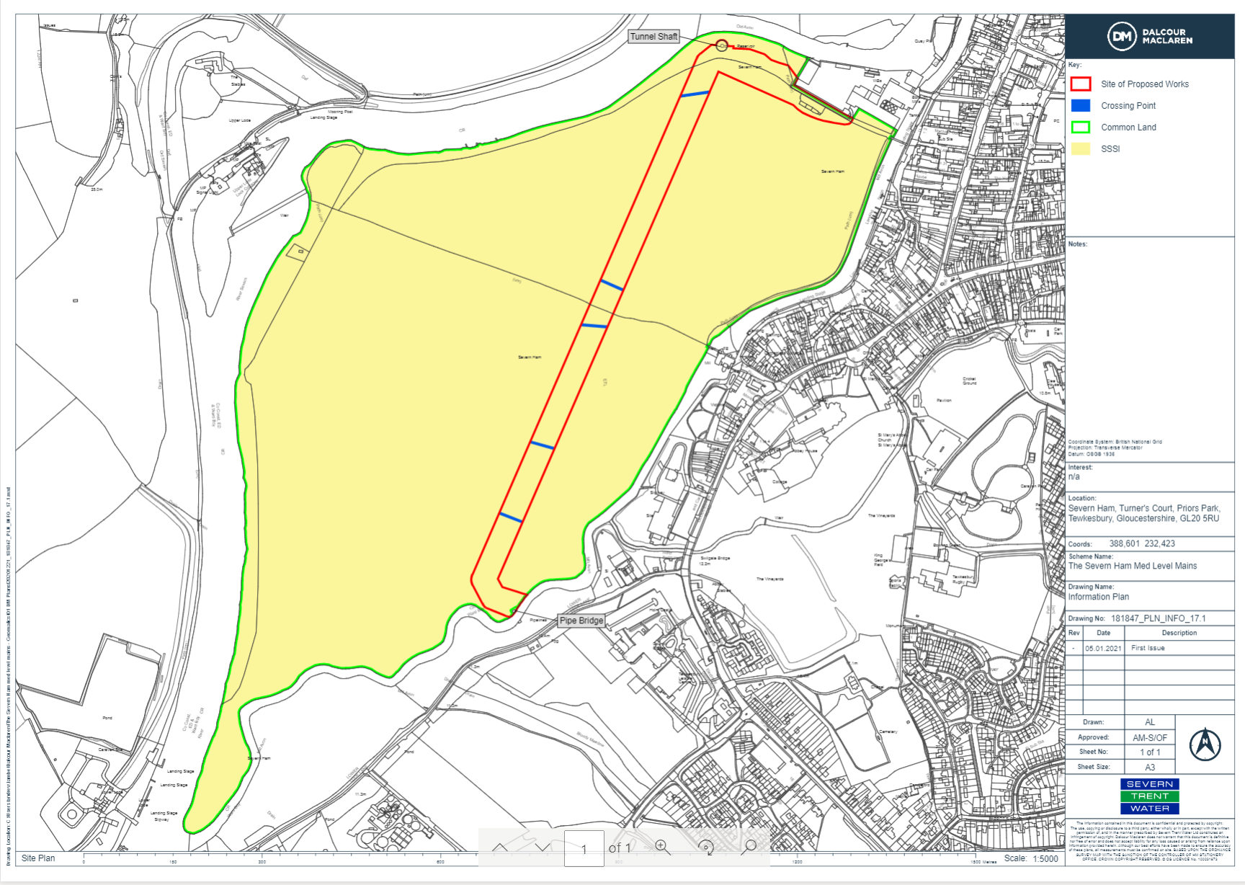

Common Land Consents Policy (Defra November 2015)
Section 39(2) of the 2006 Act provides that the public interest includes the public interest in; nature conservation; the conservation of the landscape; the protection of public rights of access to any area of land; and the protection of archaeological remains and features of historic interest.

