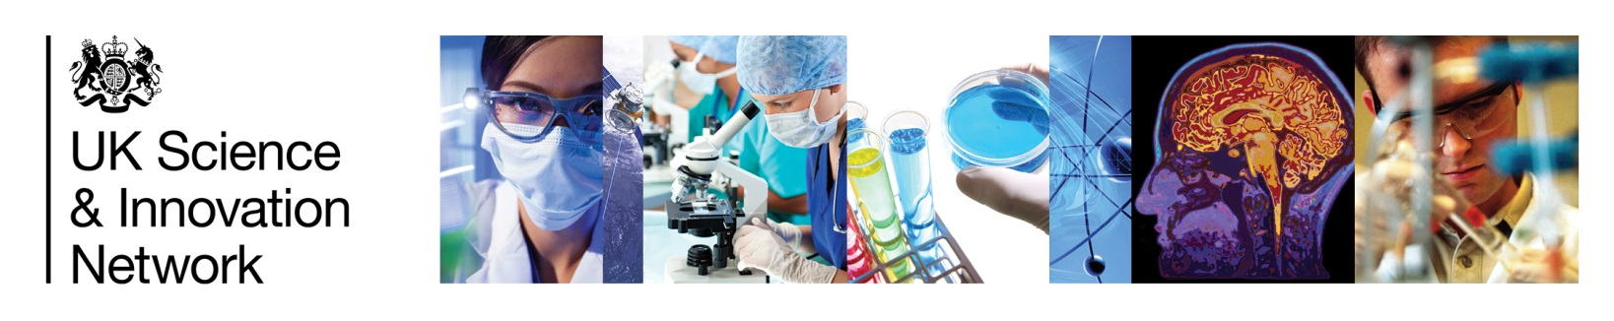
[Type a quote from the document or the summary of an interesting point. You can position the text box anywhere in the document. Use the Drawing Tools tab to change the formatting of the pull quote text box.]

UK Science & Innovation Network Country Snapshot:
Finland
Science and Innovation Landscape
Finland position in Global Innovation Index 2020:
7th
UK position in Global Innovation Index 2020:
4th

Finland has consistently ranked high in international comparisons of education, research, technology and innovation. Finland’s strengths have largely been based on its high quality educational system and good integration between industry, research institutes, universities and the public sector.

Finland has a highly sophisticated and integrated innovation system. At the Ministerial level, the Prime Minister chaired Research and Innovation Council helps set overall direction of the Finnish S&I landscape. Nearly 80 per cent of governmental R&D funding is channelled through two ministries, the Ministry of Education and Culture and the Ministry of Economic Affairs and Employment. These ministries are the foremost organisations responsible for science and technology policies.

The Ministry of Education and Culture sponsors the Academy of Finland, which is the Finnish Funding Agency for Basic Research as well as universities. The Ministry of Employment and the Economy sponsors Business Finland, the Finnish Funding Agency for Technology and Innovation (Innovate UK equivalent). Business Finland gathers all services related to innovation funding and to the promotion of exports, investments and travel under one roof.
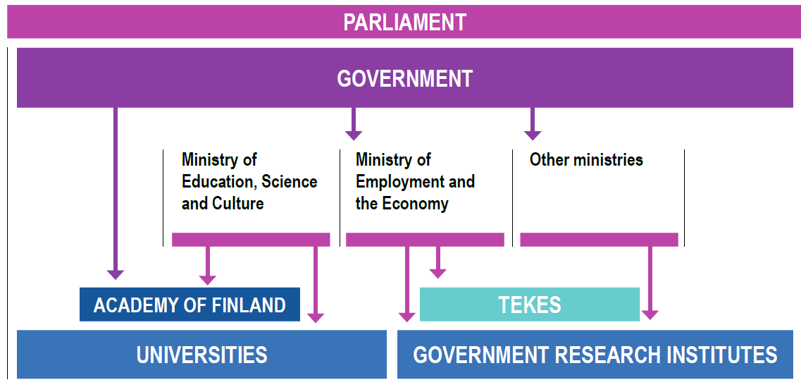

BUSINESS FINLAND
Source: Academy of Finland

Finland spends 2.7% of GDP on R&D with an objective of 4% by 2030. Finland leads the way in digital technologies and take-up, for example around AI and 5G/6G research, and hosts companies with global reach such as Nokia. Cooperation between the Alan Turing Institute in the UK and Finnish Centre for Artificial Intelligence provide a platform for close cooperation. Finland is also world-leading in terms of human capital for research and innovation and has strengths in the bio- and circular economy. Finland hosts the prestigious Millennium Innovation Prize and Europe’s leading start-up and technology event, Slush.
Higher Education and research landscape

Higher Education and research institute networks cover the populated parts of the country. Finland has 13 universities, 22 polytechnics and 14 government research institutes. 9 Finnish universities are featured in the QS World University Ranking 2021, led by the University of Helsinki at 104th in the world. The government programme includes many commitments to strengthen Finnish S&I and Education, including €40 million annual increase to university funding, a significant increase in student intake in HE, and a target to increase Research and Development investment to 4% by 2030.

UK Science and Innovation in Finland

The UK has a strong S&I footprint in Finland, fuelled by student and researcher mobility. In recent years, the UK has been first choice for Finns studying abroad, with a record 2197 students in 2018-19. Finnish and UK scientists published 9887 co-authored scientific articles between 2015 and 2018, making the UK Finland’s 2nd most popular partner after US. Under Horizon 2020, the UK is the second most important collaboration partner (in terms of funding) to Finland.

The engagement with Finland on science and innovation is wide-ranging and involves mutual priority areas like clean energy, artificial intelligence, Arctic research and climate change mitigation. Forums like Arctic Spirit (organised by the Arctic Centre at the University of Lapland), start-up event Slush, World Circular Economy Forum (initiated by Finnish Innovation Fund Sitra), and UK-Finland Natural Resources Initiative (co-led by British Embassy Helsinki and Geological Survey Finland) provide platforms for new and strengthened partnerships between UK and Finnish S&I communities.

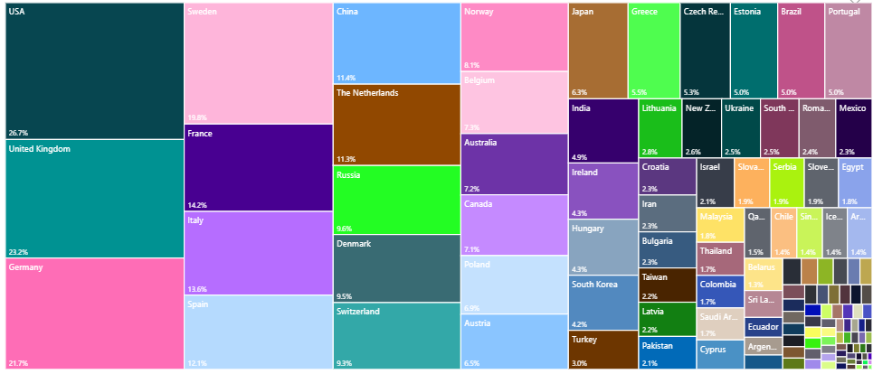
Finland’s partner countries in international co-authored publications between 2015-2018 (source: research.fi).

SIN Finland Contact
Rosa Degerman, Science and Innovation Officer
rosa.degerman@fcdo.gov.uk

