Order Decision
Site visit made on 27 April 2021
by Mark Yates BA(Hons) MIPROW
an Inspector appointed by the Secretary of State for Environment, Food and Rural Affairs
Decision date: 24 May 2021

Order Ref: ROW/3256055
- This Order is made under Section 53(2)(b) of the Wildlife and Countryside Act 1981 (“the 1981 Act”) and is known as The Hampshire (New Forest District No.67) (Parish of New Milton) Definitive Map Modification Order 2019.
- The Order was made by Hampshire County Council (“the Council”) on 20 August 2019 and proposes to add footpath (“the claimed route”) to the definitive map and statement, as detailed in the Order Map and Schedule.
- There were two objections and one representation outstanding when the Council submitted the Order for confirmation to the Secretary of State for Environment, Food and Rural Affairs.
Summary of Decision: The Order is confirmed subject to modifications set out below in the Formal Decision.

Preliminary Matters
- The claimed route is located between Chestnut Avenue and Farm Lane North in the parish of New Milton. Evidence was submitted to the Council in 1978 in support of the route being a public right of way. It is apparent that this matter was not determined at the time and a formal application was made by Mr Sherrad and others in 2018 to record the route as a byway open to all traffic (“BOAT”).
- Mr Sherrad objects to the Council’s decision to record the claimed route as a public footpath. The objection from the owners of the land crossed by the route (Mr and Mrs Blakey) relates to the width specified in the Order for the path. A number of points have been raised in the written representations, such as health and safety concerns, which have no relevance to the main issues I need to consider when reaching my decision (see below) and therefore I have not addressed these additional matters further.

Main Issues
- The Order relies on the occurrence of an event specified in Section 53(3)(c)(i) of the 1981 Act. Therefore, if I am to confirm the Order, I must be satisfied that the evidence discovered shows that a right of way which is not shown in the definitive map and statement subsists. The burden of proof to be applied is the balance of probabilities.
- The relevant statutory provision, in relation to the dedication of a public right of way, is found in Section 31 of the Highways Act 1980. This requires consideration of whether there has been use of a way by the public, as of right and without interruption, for a period of twenty years prior to its status being brought into question and, if so, whether there is evidence that any landowner demonstrated a lack of intention during this period to dedicate a public right of way.
- If statutory dedication is not applicable, I shall consider whether an implication of dedication can be shown at common law.
- In respect of the assertion that the route should be recorded as a BOAT, I need to have regard to the Natural Environment and Rural Communities Act 2006 (“the 2006 Act”). Subject to certain exemptions found in Section 67 (2) and (3) of this Act, unrecorded public rights for mechanically propelled vehicles over a way which, immediately prior to the commencement date, was not shown in a definitive map and statement are extinguished. Section 66 of the 2006 Act prevents the creation of public rights for mechanically propelled vehicles after the commencement date subject to two provisions, which are not applicable in this case.

Reasons

The implications of the 2006 Act
- The Council asserts that none of the relevant exemptions in the 2006 Act are applicable and nothing has been provided to suggest that this view is incorrect. In terms of the user evidence, it cannot be determined that the main lawful use by the public during the period of 5 years prior to the commencement date was by mechanically propelled vehicles or that the route was created by virtue of use by vehicles during a period ending before 1 December 1930. In reaching this view, I have had regard to the one evidence form which refers to use dating back to around 1930. There is nothing to suggest that any of the other exemptions in Section 67(2) of the Act are applicable. Additionally, no application has been made to add a BOAT to the definitive map and statement which satisfies any of the exemptions found in Section 67(3).
- In light of the above, the claimed route cannot be recorded as a BOAT. Further, evidence of use by mechanically propelled vehicles will not give rise to a lower public right of way.

Map evidence
- The earliest map to show the claimed route is the Ordnance Survey (“OS”) map of circa 1932. Given that the route is not shown on the 1908 OS map, it is presumed that it came into existence at some point between 1908 and 1932. It is stated to be shown on sale plans for plots in Barton on Sea from the early twentieth century. The same is applicable to a map with a guide to the area from circa 1958.
- The above maps only point to the existence of the claimed route as a physical feature. They do not purport to identify the status of the ways shown. It is also evident that the claimed route was not identified as being maintainable at public expense on a map of 1946. It follows that this Order needs to be determined in relation to the user evidence provided.

Statutory dedication

When the status of the claimed route was brought into question
- The Council’s assertion that the status of the claimed route was first brought into question by notices erected in around 1975, which stated “Private No Right of Way”, is not disputed. Additional action was later taken to restrict access for vehicular traffic, and this triggered a request for the route to be recorded as a public right of way. I accept on balance that the original notices served to bring the status of the route into question. This means the relevant twenty-year period to be considered for the purpose of statutory dedication is 1955-1975 (“the relevant period”).

Evidence of use by the public
- Two batches of user evidence forms have been provided in support of use of the claimed route. These comprise of sixteen submitted in 1978 and twenty-six completed in 2018. The majority of the people who completed the later forms did not use the route during the relevant period. Reference is made by the Council to some forms that refer to the person exercising a private right of way and I have treated the few potentially relevant forms with caution. As outlined in paragraph 8 above, the use by mechanically propelled vehicles cannot be taken into account and should therefore be discounted.
- Nonetheless, there remains evidence of regular use throughout the relevant period on foot. In contrast, the evidence of use by cyclists and horse riders is very limited for this period. Additionally, I note that a letter from the New Milton Neighbourhood Council, dated 25 August 1978, refers to the route having been used as a footpath for over thirty years.
- Having regard to the above, I find that the user evidence is sufficient to raise a presumption of the dedication of a public footpath. Therefore, the first part of the statutory test is satisfied.

Whether any landowner demonstrated a lack of intention to dedicate a public footpath
- There is nothing to suggest that action was taken during the relevant period to demonstrate to the public that there was a lack of intention to dedicate a footpath.

Conclusions
- I have concluded that the evidence is sufficient to raise a presumption that the claimed route has been dedicated as a public footpath. In addition, there is no evidence that any landowner demonstrated to the public a lack of intention to dedicate a footpath during the relevant period. Therefore, I conclude on the balance of probabilities that a public footpath subsists. In light of this conclusion, there is no need for me to address the evidence in the context of common law dedication.

The width of the route
- The Council’s position is that the variable width of the track between the longstanding boundaries should be recorded in the definitive statement for the claimed route on the basis that the whole track was available to the public during the relevant period. This width is clearly stated in the Order and represented on the Order Map.
- It is apparent that the whole width between these boundaries was available for people to use during the relevant period and there is nothing to indicate that their use was confined to a particular portion of the track. It is also apparent from the correspondence in 1978 that a width of approximately 15 feet was available and this generally corresponds to the variable width surveyed by the Council more recently. Only the later batch of evidence forms ask a question regarding the width of the route and the responses point to it comprising of the full width of the track, including those people who used the route during the relevant period.
- It is not appropriate for me to have regard to the issues put forward by Mr and Mrs Blakey regarding the impact the proposed width would have on their use of the land or what would constitute a desirable width for the claimed route. Overall, no evidence has been provided to justify a lesser width being recorded in the Order and I consider on balance that the user is likely to have extended over the full width of the track.
- Reference is also made to the route no longer being enclosed for the whole of its length and this was apparent from my visit to the site. I therefore consider that the Order Schedule should be modified to make it clear that the route mainly follows an enclosed track.

Other Matters
- Whilst reference has been made in correspondence to the position of a gas main, this has no bearing on the status of the claimed route. Nor does the Order impact upon any private rights of access that exist.

Overall Conclusion
- Having regard to these and all other matters raised in the written representations I conclude that the Order should be confirmed with modifications.

Formal Decision
- I confirm the Order subject to the following modifications:
- Insert “a mainly” before “enclosed” in the third line of the description contained in Part I of the Order Schedule.
- Insert “a mainly” before “enclosed” in the third line of the description contained in Part II of the Order Schedule.

Mark Yates

Inspector

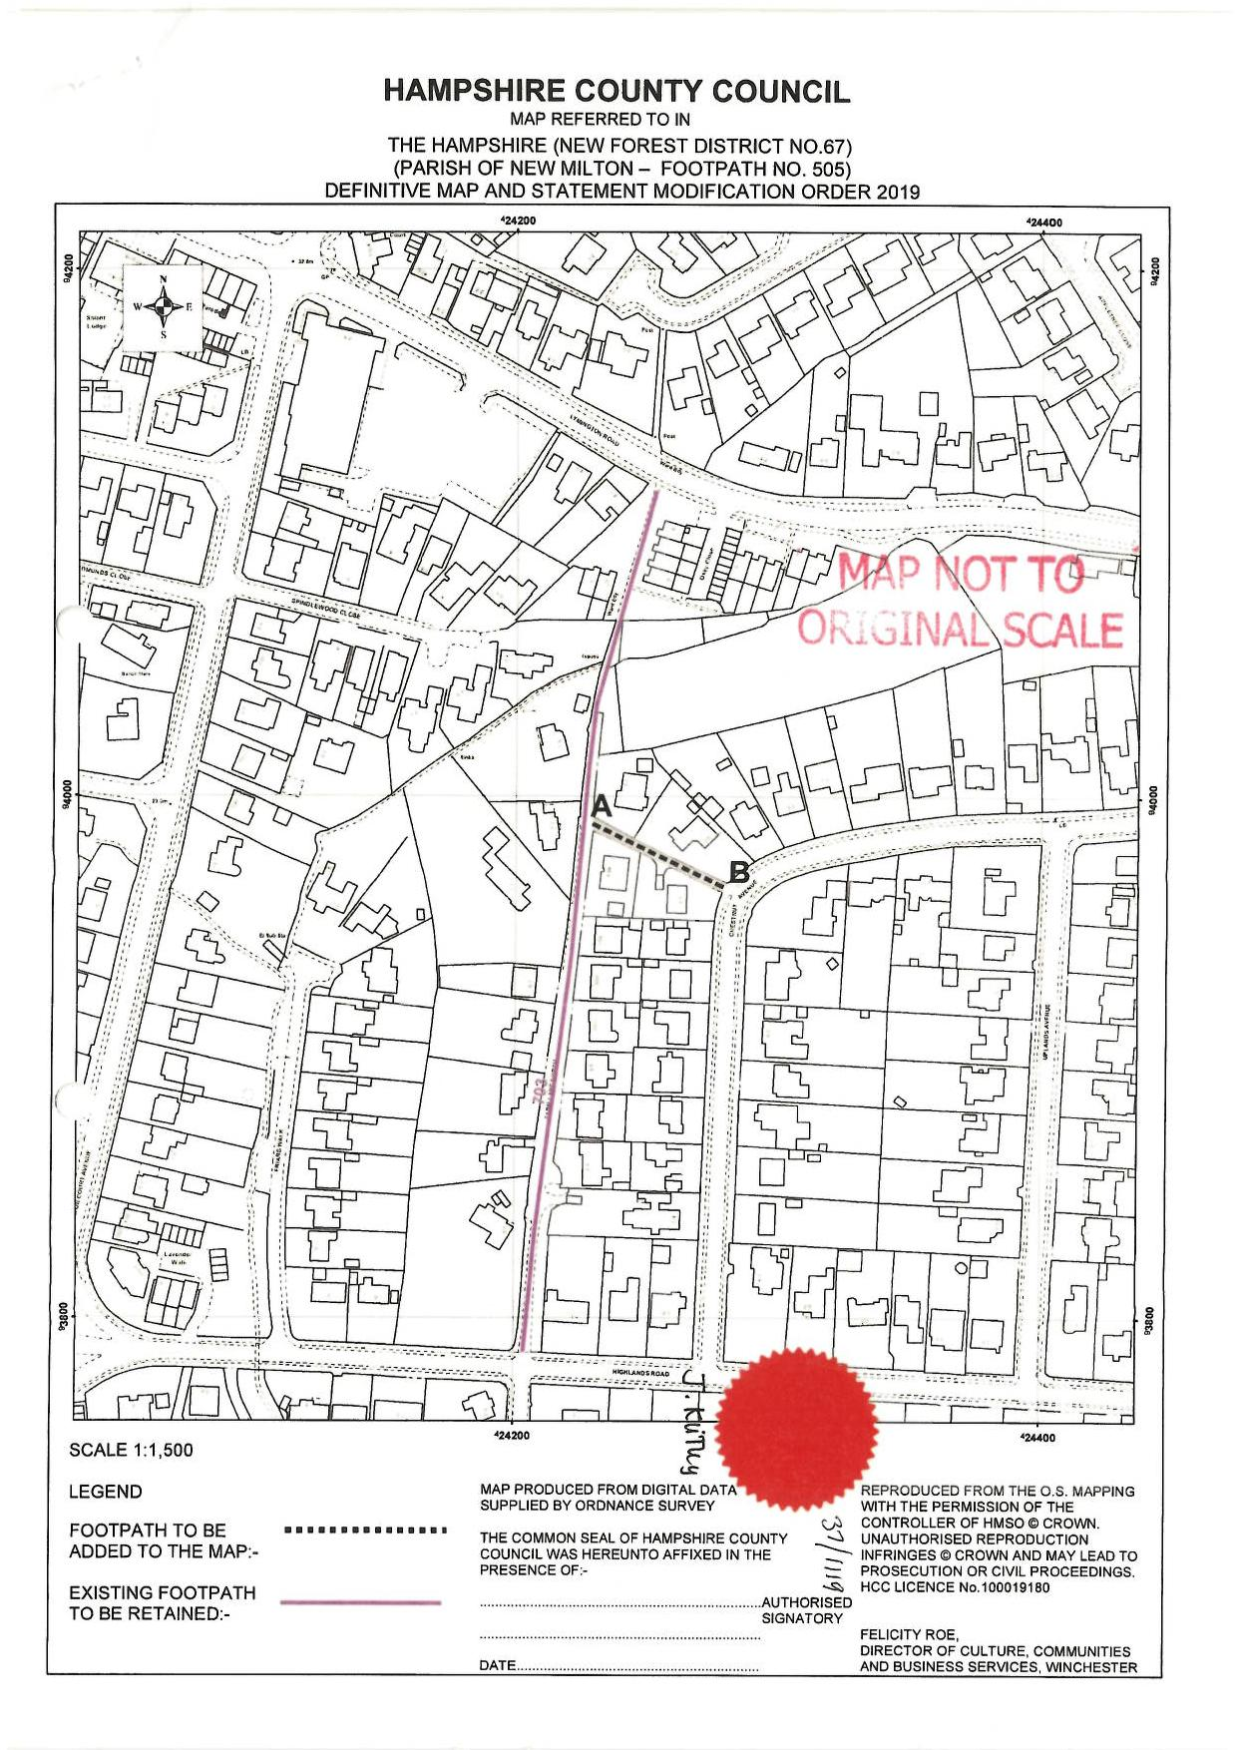

Without force, secrecy or permission
2 May 2006
As set out in sections 55 and 56 of the report to the Council’s Regulatory Committee of 24 July 2019
See the exemption in Section 67(2)(a) of the 2006 Act
See the exemption in Section 67(2)(e) of the 2006 Act

