Order Decision
Hearing Held on 22 April 2021
Site visit made on 13 April 2021
by Alan Beckett BA MSc MIPROW
An Inspector appointed by the Secretary of State for Environment, Food and Rural Affairs
Decision date: 20 May 2021

Order Ref: ROW/3249807
- This Order is made under Section 119 of the Highways Act 1980 (‘the 1980 Act’) and is known as the Kent County Council (Public Footpath ZR408 (Part), Selling) Public Path Diversion and Definitive Map and Statement Modification Order 2019.
- The Order is dated 30 May 2019 and proposes to divert the public right of way shown on the Order plan and described in the Order Schedule.
- There were 2 objections outstanding at the commencement of the hearing.
Summary of Decision: The Order is confirmed subject to the modifications set out in the Formal Decision.

Procedural Matters
- One of the statutory objectors exercised his right to be heard by the Secretary of State and the Order was considered to be suitable for consideration by way of a hearing. The introduction of restrictions as a result of the Covid-19 pandemic meant that a public meeting of this nature could not be held in person and consequently it was agreed that the Order would be determined by means of a hearing held virtually.
- The hearing had originally been scheduled for 19 January 2021 but restrictions on travel and the unavailability of overnight accommodation which would be required in order that I could undertake a pre-hearing site inspection meant that the hearing had to be postponed with a new date of 22 April 2021 being set.
- In advance of the hearing, I made an unaccompanied inspection of footpath ZR408 and the proposed alternative route on the morning of 13 April 2021. With the permission of Mr & Mrs Falcon, the applicants for the Order, I viewed the footpath from the garden area of their house on the morning of the following day. In order to limit the need for travel in accordance with Government guidelines, I did not consider that a second, post-hearing site inspection was required.
- I therefore held the hearing on 22 April 2021 with the aid of Microsoft Teams technology. The statutory objector who had exercised his right to be heard did not attend the hearing. Notwithstanding this, I am extremely grateful to all concerned for their engagement with this alternative arrangement during difficult times.
- The Order contains one minor typographic error. In the Schedule, Part II, the terminal point of the new path is described as Point B when it should be Point C. Although of a minor nature and unlikely to have prejudiced the interests of any party, as I propose to modify Parts II and IV of the Schedule with regard to other matters, I will take the opportunity to correct this error.

The Main Issues
- Section 119(6) of the 1980 Act requires that I must be satisfied that three separate tests are met before the Order can be confirmed. These are:
TEST 1: whether the diversion is expedient in the interests of the owner, lessee or occupier of land crossed by the path or of the public. This is subject to any altered point of termination of the path being substantially as convenient to the public.
TEST 2: whether the proposed diversion would not be substantially less convenient to the public.
TEST 3: whether it is expedient to confirm the Order having regard to the effect which— (a) the diversion would have on public enjoyment of the path as a whole, (b) the coming into operation of the Order would have as respects other land served by the existing public right of way, and (c) any new public right of way created by the order would have as respects the land over which the right is so created and any land held with it.
- In deciding expediency at the Test 3 stage, (a)-(c) are mandatory factors. Other factors are not excluded from consideration and could, for instance, include those pointing in favour of confirmation. On (b) and (c) of Test 3, the statutory provisions for compensation for diminution in value or disturbance to enjoyment of the land affected by the new path must be taken into account where applicable.
- In reaching my decision I am also required to have regard to any material provision contained in a rights of way improvement plan (ROWIP) for the area. Furthermore, I need to consider what impact (if any) the proposed diversion would have upon the needs of agriculture and forestry or the biodiversity and natural beauty of the area. I must also consider whether the Public Sector Equality Duty (PSED) would be discharged by this proposal.
- The Order has been made in the interests of the owner of the land crossed by that part of footpath ZR408 at issue.

Reasons

Whether it is expedient, in the interests of the owner of the land crossed by the footpath, that the footpath in question should be diverted
- Footpath ZR408 Selling provides a link between Shepherds Hill Road and the public rights of way network within the Lees Court Estate and passes through Shepherds Hill Farm, the home of the applicants, as the path leaves the Grove Road / Shepherds Hill Road junction. That part of footpath ZR408 at issue runs within a parcel of woodland adjacent to the garden amenity space of the applicant’s property.
- The definitive map shows that line of the footpath being tight against the boundary between the woodland and garden, whereas the walked route on the ground meanders along that boundary depending on the tree and shrub cover present but is generally within a few metres of the boundary. The boundary between the garden of the house and the woodland is marked by a post and wire fence and by trees and other vegetation; the tree and vegetation cover is discontinuous along the length of the garden boundary and it is possible to view the garden from a number of points along the footpath.
- The applicants contend that the number of walkers using the footpath has increased during the years in which they have been resident; whilst the majority of walkers pass by the property without incident, there are a number who take the opportunity to stand and stare into the garden. The applicants submit that the part of the garden which faces the footpath is that part where the family socialises and entertains, and that users of the footpath can also view the entrance to the long-established swimming pool located within the garden. The applicants consider that the actions of some walkers are intrusive and an invasion of privacy.
- The applicants also noted the increase of night walkers using torches and other aids to negotiate the path in the hours of darkness. The applicants propose that the path is moved approximately 40 metres to the northern side of the wood where path users would be unable to see into their garden.
- I saw from my site visit that when approaching Shepherds Hill Farm from the south it was possible to see directly into the garden from the vicinity of the pedestrian gate which leads into the wood. Further along the path there were a number of locations where the trees and shrubs thinned out or were absent from the boundary and it was possible to see the applicant’s outdoor seating area, garden table, trampoline, and the entrance to the swimming pool.
- I also had the opportunity to view the footpath from the garden. Those who used the footpath during my site inspection were readily visible as they headed in the direction of Lees Court. Standing within the garden, it was not difficult to appreciate the concerns the applicants have over privacy given the proximity of the footpath to the garden.
- The proposed path would run close to the northern boundary of the wood. I saw that even in early spring when the trees were almost bare of leaves that the view towards the garden was obscured by the trees.
- The objectors submit that they had been unaware of the existence of the garden when using the path due to the thickness of the vegetation within the wood. Whilst I accept that during the summer months the garden may be less visible from the path, there will remain areas along the boundary where the vegetation is sparse or not present and where path users will be able to see into the applicants’ garden. I am satisfied that the proposed diversion of part of footpath ZR408 would enhance the amenity of the applicants’ property.
- Overall, I am satisfied that the proposed diversion would be in the interests of the owners of the land crossed by footpath ZR408.

Whether the terminal point of the proposed footpath would be substantially as convenient to the public as the terminal point of the existing footpath
- The proposed diversion would result in the point where footpath ZR408 joins Shepherds Hill Road being moved north along that road for approximately 46 metres. Those users travelling along footpath ZR408 from the west intending to walk towards Hogben’s Hill via footpath ZR648 would find the amount of road walking along Shepherds Hill Road reduced accordingly. For those path users, the proposed terminal point at C would be substantially as convenient as the current terminal point at B.
- Mr Jull considered that the opposite would apply to those users intending to walk from ZR408 along Grove Road to reach towards the rights of way network in the vicinity of Perry Wood or vice versa. In Mr Jull’s view, the introduction of a dogleg in an otherwise straight route would be inconvenient for those walkers approaching the path along Grove Road.
- Although users travelling east-west would be required to walk 46 metres along Shepherd’s Hill Road to connect with Grove Road, the introduction of this slight dogleg and the additional road walking is unlikely to inconvenience such users. The dogleg at issue would be minor and would not prevent the user from completing an east-west journey between Perry Wood and Lees Court. Furthermore, a journey along Grove Road currently involves approximately 500 metres of road walking to reach footpath ZR415; an additional 46 metres along a quiet, lightly trafficked road is unlikely to present a substantial inconvenience to most users.
- I am not persuaded that anyone undertaking a journey to or from Perry Wood incorporating footpath ZR408 would be inconvenienced by the additional road walking introduced by the diversion. For those wishing to undertake an east-west journey, the proposed terminal point at C will be substantially as convenient as the existing terminal point at B.

Whether the new footpath will not be substantially less convenient to the public
- The proposed diversion would have little impact on users in terms of length as the diverted section of the path would be 1 metre shorter than the existing path; path users would not be inconvenienced in this respect.
- That part of footpath ZR408 at issue requires users to negotiate a pedestrian gate at point A and a pedestrian gate on the boundary between the pasture field and the wood. There is a gap between the wood and Shepherds Hill Road at point B. The pedestrian gate at point A would be unaffected by the diversion with the pedestrian gate on the boundary between the pasture and wood being relocated approximately 40 metres to the north. A gap would be created to serve as the exit onto Shepherds Hill Road at point C.
- There would therefore be no change to the path furniture which users would have to negotiate. The path furniture is also currently the least restrictive to public passage given the need to prevent livestock access to the wood and onwards onto Shepherds Hill Road. Users would not be inconvenienced in this respect.
- From point A both the current and proposed footpaths cross the same pasture field which at the time of my visit was grazed by sheep. Both the current and proposed paths cross the same parcel of woodland. There is no discernible difference between the gradient and path surface on the current path and that which would be available on the proposed alternative. Path users are unlikely to be inconvenienced in these respects.
- As noted above, for those undertaking a short circular walk in the area from Hogben Hill via the Lees Court Estate and footpath ZR408, the diversion would reduce the quantity of roadside walking along Shepherds Hill Road to reach footpath ZR468. An increase in roadside walking to reach Perry Wood from footpath ZR408 is unlikely to inconvenience path users as they are currently required to walk at least 500 metres along Grove Road to reach the rights of way network in the vicinity of Perry Wood.
- Overall, I consider that the proposed footpath would not be substantially less convenient to the public.

Whether it is expedient to confirm the Order having regard to

(a) the effect the diversion would have on public enjoyment of the path as a whole
- The enjoyment derived from the use of a public right of way is, to a large extent, a personal and therefore subjective assessment. For example, enjoyment can be influenced as much by the weather during a walk as by individual personal preferences. However, I have attempted to assess this matter objectively, comparing such matters as the characteristics of both routes and the views afforded by both routes.
- Land use on the proposed route is the same as that crossed by the current path; that is, part sheep pasture and part woodland. The experiences to be gained from walking through pasture and woodland would not be diminished as a result of the diversion. The proposed footpath would run in a natural ‘avenue’ between maturing trees and would provide a more direct and less circuitous route through the wood compared to what is currently available.
- The views of the surrounding countryside are extensive from that part of the path which crosses the sheep pasture. The views to the west would be enhanced by the proposed diversion as the path would emerge from the woodland into open pasture; on the current path views to the west and to the south are limited by a field boundary hedge. The extensive views available from the remainder of the current path towards Lees Court when heading west, or towards Shepherds Hill when heading east, would be unaffected by the proposed diversion. The proposed diversion is therefore unlikely to adversely affect the enjoyment of a walk along footpath ZR408 in this respect.
- Mr Jull contended that as footpath ZR408 was broken down into a number of ‘links’ in the online version of Kent’s definitive map, the question of the impact of the diversion on ‘the path as a whole’ would be much greater if ‘whole’ referred to that link affected by the diversion.
- For the Council, Mr Barfoot said that footpath ZR408 was a single continuous path from its junction with Shepherds Hill Road to its junction with ZR404 at its western end. The identification of ‘links’ within that continuous path on the online map was an administrative exercise undertaken for maintenance and management purposes.
- The definitive map shows footpath ZR408 as a single continuous route as described above; for the purposes of this part of the statutory test I am satisfied that ‘the path as a whole’ refers to the path as shown in the definitive map. On balance, I feel the enjoyment of those who seek pleasure from informal recreation on footpaths such as ZR408 would not be diminished as a result of this Order.

(b) The effect the coming into operation of the Order would have with respect to the land served by the existing path
- The proposed diversion would enhance the amenity of the garden at Shepherds Hill Farm; this is likely to have a positive impact upon the land held as part of that property. I conclude that it is unlikely that the diversion would have any adverse impact upon the land served by the existing path.

(c) The effect any new right of way created by the Order would have as respects land over which the new right is created together with any land held with it, account being taken of the provisions as to compensation
- The land crossed by the current and proposed routes is in the ownership of the applicants. No evidence has been submitted which suggests that the proposed diversion would have any negative impact upon the land over which the alternative path would run. Compensation under the provisions of section 28 of the 1980 Act is not relevant in this case.

Consideration given to the provisions of a ROWIP
- The Council has prepared a ROWIP; I understand that there are no provisions within that plan of particular relevance to this case.
- Consideration given to the needs of agriculture and forestry and the conservation of biodiversity and natural beauty

Agriculture and forestry
- The applicants submit that the proposed diversion would guide path users away from the hedge on the southern boundary of the pasture, thereby reducing disturbance to the sheep grazing the field as the hedge was used by sheep for shelter from the elements. Whilst the wood through which the footpath passes is managed by the applicants, it is not a forestry plantation. Consequently, I consider it unlikely that there would be any negative impact upon agricultural or forestry operations arising from the proposed diversion.

Biodiversity
- The land crossed by the proposed route is not classified as a Site of Special Scientific Interest and is not covered by any other local designations aimed at conserving habitat types or species diversity. Consequently, there is no evidence before me that the proposed diversion would have any adverse impact upon biological diversity.

Natural beauty
- Footpath ZR408 is located within the Kent Downs Area of Outstanding Natural Beauty. The proposed diversion is of a minor nature and the minor works required to bring the proposed footpath into a fit condition for public use are unlikely to have any adverse impact upon the conservation of the natural beaty of the area.

Conclusions on whether it is expedient to confirm the Order
- For the reasons given above, I do not find that there would be any detrimental impact upon the enjoyment to be derived from a walk along the footpath at issue, and that there would be no adverse impact upon the land currently served by the footpath or the land which the diverted path would cross. Consequently, there is no conflict between the outcomes of Test 3 and Tests 1 and 2. It follows that I conclude that it would be expedient to confirm the Order.

PSED
- As noted above, there would be no change in the nature of the path furniture which users will have negotiate as a result of the diversion. Pedestrian gates are the least restrictive boundary structures given the need for livestock management. I conclude that there should be no disproportionality (over and above that likely to be experienced by the rest of the population) introduced by the proposed diversion.

Width
- Parts II and IV of the Schedule sets out that the proposed path will have a width of two metres. I saw at my site visit that within the ‘avenue’ of trees where the proposed path would run there is a 2-metre width available for the majority of the proposed path. However, that width was constrained at points where existing trees were growing within that 2-metre corridor and consequently constrained the width which would be available.
- I am unaware of any authority that demonstrates that it would not be possible for the proposed route to become a public right of way subject to pre-existing trees being present on the line of the proposed path as temporary constraints upon the available width. Formal acknowledgement of the existence of these trees as temporary constraints on the width of the path would also prevent them from being considered obstructions within the right of way.
- I propose to modify Parts II and IV of the schedule to record that the path has a width of 2 metres, incorporating various trees temporarily constraining the available width to 1 metre in places.

Overall Conclusion
- Having regard to these and all other matters raised in the written representations, I conclude that the Order should be confirmed with modifications.

Formal Decision
- I confirm the Order subject to the following modifications:

in the Schedule Part II, line 1 between ‘metres’ and ‘which’ insert ‘(incorporating within the woodland section various trees temporarily constraining the available width (in 2021) to 1 metre in places)’;

in the Schedule Part II, line 4, amend ‘( Point B)’ to (Point C);

in the Schedule Part IV, line 3 after ‘path’ insert ‘(incorporating within the woodland section various trees temporarily constraining the available width (in 2021) to 1 metre in places)’.

Alan Beckett

Inspector

Attendance at the hearing:

Mr Barfoot Definitive Map Officer, Kent county Council

Mr Falcon Applicant

Mrs Falcon Applicant

Mr Jull Local Resident

Mr Elam Local representative of The Ramblers

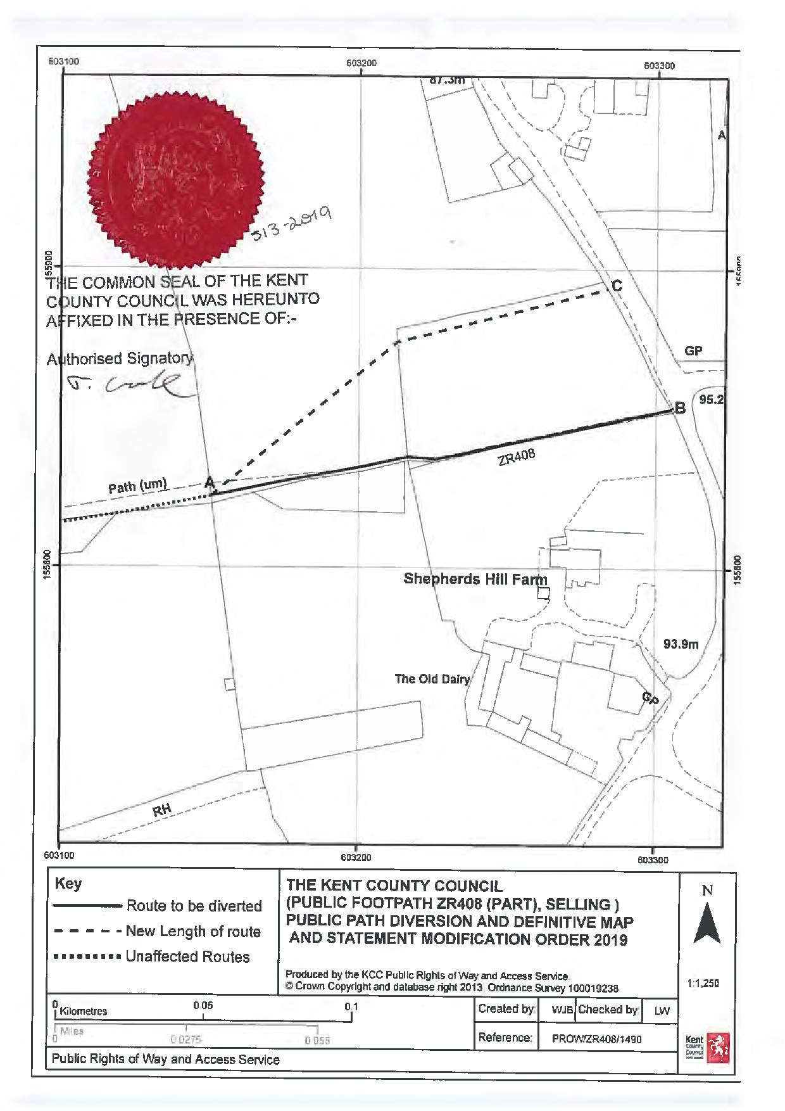

Section 121 (3) of the 1980 Act
Section 40 of the Natural Environment and Rural Communities Act 2006 - duty to have regard to the purpose of conserving biodiversity.
Section 11 of the Countryside Act 1968 duty to have regard to the desirability of conserving natural beauty and amenity of the countryside.
This structure would be authorised by the Council under the provisions of section 137 of the 1980 Act

