Order Decision
Site visit made on 12 May 2021
by Mark Yates BA(Hons) MIPROW
an Inspector appointed by the Secretary of State for Environment, Food and Rural Affairs
Decision date: 08 July 2021

Order Ref: ROW/3245809
- This Order is made under Section 53(2)(b) of the Wildlife and Countryside Act 1981 (“the 1981 Act”) and is known as The Nottinghamshire County Council (Staythorpe Footpath No. 4) Modification Order 2017.
- The Order was made by Nottinghamshire County Council (“the Council”) on 13 October 2017 and proposes to add a footpath (“the claimed route”) to the definitive map and statement.
- There was one objection outstanding when the Council submitted the Order for confirmation to the Secretary of State for Environment, Food and Rural Affairs.
Summary of Decision: The Order is confirmed subject to a modification set out below in the Formal Decision.

Procedural Matters
- The total length specified for the claimed route in Part II of the Order Schedule does not correspond with the combined distances for the different sections of the route which are stated elsewhere in the Order. If confirmed, the Order should be modified accordingly.
- The sole objection only relates to the width included in the Order for the route. Nonetheless, in reaching my decision, I shall have regard to the information previously supplied by the objector in relation to the claimed route.

Main Issues
- The Order relies on the occurrence of an event specified in Section 53(3)(b) of the 1981 Act. Therefore, for me to confirm the Order, I must be satisfied the evidence shows the expiration of any period such that the enjoyment by the public of the way during that period raises a presumption that it has been dedicated as a public path. The issue to be determined when evaluating the evidence is whether it can be concluded on the balance of probabilities that a public footpath has been dedicated over the claimed route.
- The Council asserts that a footpath has been dedicated in accordance with Section 31 of the Highways Act 1980. This requires consideration of whether there has been use of a way by the public, as of right and without interruption, for a period of twenty years prior to its status being brought into question and, if so, whether there is evidence that any landowner demonstrated a lack of intention during this period to dedicate a public right of way.
- If statutory dedication is not applicable, I shall consider whether the evidence is supportive of the dedication of a footpath under common law.

Reasons

Statutory dedication

When the status of the claimed route was brought into question
- Mr Ellison erected signage in October 2015 which stated: “MANOR FARM, PRIVATE ROAD, NO ACCESS WITHOUT PERMISSION, PUBLIC FOOTPATH IS VIA PINGLEY CLOSE”. This signage would have been a clear challenge to members of the public using the route. It is also apparent that this action triggered the application to add the route to the definitive map on 3 November 2015.
- I accept that the status of the claimed route was brought into question by the signage in 2015. This means the starting point for the consideration of statutory dedication is that the relevant twenty-year period (“the relevant period”) should be taken to be 1995-2015. However, it may be necessary to consider an alternative period if there is evidence of any earlier action that was sufficient to bring the status of the route into question.

Evidence of use by the public
- Forty-one people have submitted a user evidence form (“UEF”) in support of use of the claimed route. The Council conducted follow up research and interviews with a number of the users to clarify information contained in the UEFs. This evidence was submitted by residents of Staythorpe and other villages in the locality as well as visitors to the area. Statements were also submitted by Mr Ellison and the previous owner of Manor Farm (Mrs Mitchell) and a neighbouring farmer.
- The user evidence is supportive of there being regular public use of the claimed route throughout the relevant period. Whilst there is evidence of use of the route dating back to the late 1960s and correspondence from 1993 which indicates that local people were using the claimed route, this evidence sits outside of the period presently under consideration. The same applies to the reference made to earlier discussions involving the parish council. I note that several of the users are members of the same family. However, given the quantity and quality of the user evidence as a whole, I do not consider that this issue impacts on the weight of the evidence.
- Both the past and present landowners assert that the route was not used in the past to the extent claimed. There was a lack of observed use until Mr Ellison became aware of use by dog walkers about two years after he moved into the property. Nonetheless, a lack of observed use does not mean that people did not use the claimed route. Reference has been made to the large conifer trees previously in place which, along with the trees that remain, may have served to limit the extent that people using the route could be seen from the property. Additionally, the applicant for the Order refers to the former layout of Manor Farm and he suggests that this was the reason why walkers were not previously seen. It is also evident that there is conflicting evidence regarding whether some of the users saw or spoke to residents of Manor Farm on occasions. The assertions by the landowners need to be weighed against the substantial body of evidence in support of use of the route.
- The evidence as a whole is not supportive of permission specifically being granted for people to walk along the route during the relevant period. For instance, one of the users states that he had permission to drive along it. There is nothing to show that the use was by force or undertaken in secret.
- The evidence is supportive of works being undertaken in October 2012 over the course of several days to remove the conifer trees. It is also evident that access was deterred or hindered during this period. Given the limited timeframe involved and the purpose of the works, I do not find that any interruption to the public’s use would have been sufficient to prevent the dedication of a footpath under statute.
- Overall, from my evaluation of the evidence, I find on balance that it is sufficient to raise a presumption of the dedication of a public footpath over the claimed route.

Whether any landowner demonstrated a lack of intention to dedicate a public footpath
- Mr Ellison purchased Manor Farm from Mr and Mrs Mitchell in January 2012. The owner of the remainder of the land crossed by the route raises no objection to the Order.
- The landowners may not have specifically encouraged access but the issue to be determined is whether they took any overt action during the relevant period which was sufficient to demonstrate to the public that there was a lack of intention to dedicate a footpath. Whilst some general references are made to the issuing of challenges, there is a lack detail regarding the frequency of such challenges and the period involved. There is the potential for the challenges to have occurred outside of the relevant period. Given that Mr Ellison was not aware of any use until at least 2014, it is also possible that the alleged challenges occurred during 2015.
- Mrs Mitchell has referred to one occasion when she challenged a group of people who had stated that they were on a treasure hunt. Although it is uncertain when this occurred, a treasure hunt could potentially be viewed as a different activity to walking along an alleged right of way. One of the users states that they were challenged by Mr Ellison and the follow up research undertaken by the Council could indicate that this occurred prior to 2015. However, I do not find that a single challenge by itself would be sufficient to inform the public of a lack of intention to dedicate a footpath. It is also noteworthy that the application to add the claimed route to the definitive map was submitted shortly after the erection of the signage. This suggests that any earlier widespread challenges would have attracted a similar response.
- There is conflicting evidence on whether challenges were issued to people on the claimed route. However, the lack of details regarding the alleged challenges when weighed against the clear statements of the users on this matter means I do not find on balance that action was taken during the relevant period which was sufficient to demonstrate a lack of intention to dedicate a footpath. Even if it could be demonstrated that Mr Ellison challenged people on the claimed route at some point in 2014 or the early part of 2015, there is still a significant amount of evidence of use for the preceding twenty-year periods.

Conclusions
- I have concluded on balance that the evidence is sufficient to raise a presumption that the claimed route has been dedicated as a public footpath. In addition, I am not satisfied that there is sufficient evidence to find that any landowner demonstrated to the public a lack of intention to dedicate a footpath during the relevant period. Therefore, I conclude on the balance of probabilities that a public footpath has been dedicated under statute. In light of this conclusion, there is no need for me to address the evidence in the context of common law dedication.

The width of the claimed route
- The width included in the Order aims to correspond with the extent of the track present on site. It is apparent that the whole of the track was available for people to use during the relevant period. The additional responses from the users are generally supportive of use not being confined to any particular part of the track.
- It is not appropriate for me to have regard to the safety concerns raised by Mr Ellison in relation to the footpath encompassing the full width of the track. Overall, no evidence has been provided to justify a lesser width being recorded in the Order and I consider on balance that the user is likely to have extended over the whole of the track.

Other Matters
- The issue of whether there is a need for another footpath in this locality is not relevant to my decision.
- In respect of the current gates, this is a matter for the Council to address. No limitations are recorded in the Order and there is nothing to suggest that any gates were in place during the relevant period.

Overall Conclusion
- Having regard to these and all other matters raised in the written representations I conclude that the Order should be confirmed with a modification.

Formal Decision
- I confirm the Order subject to the following modification:
- Delete “220 metres” from the column in Part II of the Order Schedule after the heading “Approx. Length” and insert “205 metres”.

Mark Yates

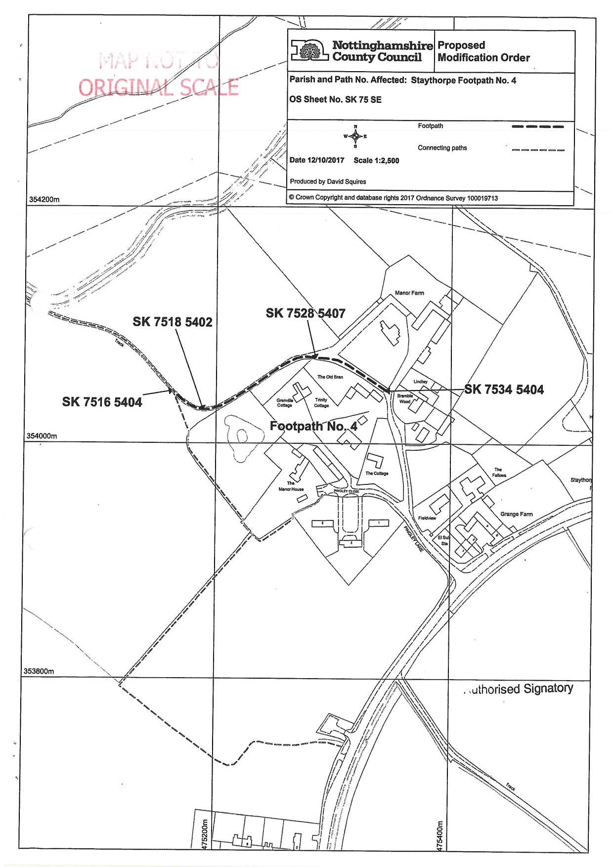

Submitted by Mr Ellison
Without force, secrecy or permission
This would have been from around 2014

