Order Decision
Site visit made on 7 April 2021
by Alan Beckett BA MSc MIPROW
An Inspector appointed by the Secretary of State for Environment, Food and Rural Affairs
Decision date: 20 May 2021

Order Ref: ROW/3239899
- This Order is made under Section 53 (2) (b) of the Wildlife and Countryside Act 1981 (‘the 1981 Act’) and is known as the Northamptonshire County Council Public Footpath RZ14 – in the Parish of Stoke Bruerne) Definitive Map Modification Order 2017.
- The Order is dated 16 March 2017 and proposes to modify the Definitive Map and Statement for the area by adding a public footpath as shown in the Order plan and described in the Order Schedule.
- There were 13 objections outstanding when Northamptonshire County Council (‘the Council’) submitted the Order to the Secretary of State for Environment, Food and Rural Affairs for confirmation.
Summary of Decision: The order is confirmed.

Procedural Matters
- This Order was provisionally scheduled to be determined by means of a public inquiry although no firm date had been set on which the inquiry would open. Unfortunately, the continued restrictions on public meetings of this nature in response to the Covid-19 pandemic meant that a public inquiry could not be held as planned. In order to progress this matter without delay, all interested parties were invited to consider whether a change of procedure would be acceptable in these circumstances. As a result, it was agreed that the Order would be determined by means of written representations together with an accompanied visit to the site.
- I am grateful to all concerned for their assistance in making this alternative arrangement during difficult times. I carried out my inspection of the route at issue on the morning of Wednesday 7 April at 10:00. The meeting point had been arranged as being just to the south-east of the point where the Order route makes a junction with public footpaths RZ8 and RW8. Mr Smart, Mr Doughty and Mr Welch (three of the objectors) were in attendance, however neither the representative of the Council nor the applicant for the Order appeared.
- Although the commencement of the site inspection was delayed in order to allow additional time for these parties to arrive, by 10:15 they had still not arrived and in the absence of parties supporting the Order, I determined that I should conduct my site inspection unaccompanied. During the progress of my site inspection, I received notice from my case officer, Ms McEntee, that the representative of the Council had been waiting at the junction of the Order route with Shutlanger Road. I continued my site inspection unaccompanied.

The Main Issues
- The Order has been made under Section 53(2)(b) of the 1981 Act in consequence of the occurrence of an event specified in Section 53(3)(c)(i).
- Therefore, the main issue is whether the Council have discovered evidence which, when considered with all other evidence available, is sufficient to show that a right of way which is not shown in the definitive map and statement subsists over land in the area to which the map relates such that the definitive map and statement require modification.

Legal Framework
- Whilst it suffices under section 53(3)(c)(i) for a public right of way to be reasonably alleged to subsist for an Order to be made, the standard of proof is higher for the Order to be confirmed. At this stage, evidence is required which demonstrates, on a balance of probabilities, that a right of way subsists.
- Dedication of a public right of way through a long period of use can be deemed to have occurred under Section 31 of the Highways Act 1980 (‘the 1980 Act’). Section 31 provides that where a way has been actually enjoyed by the public as of right and without interruption for a full period of 20 years, that way is deemed to have been dedicated as a highway unless there is sufficient evidence that during that period the landowner had no intention to dedicate it. Use ‘as of right’ is use which has been without force, secrecy, or permission.
- The period of 20 years is to be calculated retrospectively from the date when the right of the public to use the way was brought into question, either by a notice or otherwise.
- Should the tests for deemed dedication under section 31 not be met, then it may be appropriate to consider the dedication of the way at common law. This requires consideration of three issues: (i) whether any current or previous owners of the land had capacity to dedicate a highway (ii) whether there was express or implied dedication by the landowners and (iii) whether there is acceptance of the highway by the public. There is no fixed period of use at common law and depending on the facts of the case it may range from a few months to several decades. There is no particular date from which use must be calculated.

Reasons

Background
- The Order route follows the course of the roadway that provides vehicular access to a number of residential properties in the vicinity of Stoke Park Pavilions. The Order route commences at the junction with Shutlanger Road and runs in a generally southerly then south-south-easterly direction for approximately 1200 metres where it makes a junction with public footpath RZ8. The roadway has a tarmac surface throughout its length with grass verges either side. Ownership of the route between points A and B is unknown, whereas the land crossed by the Order route between points B and C is owned by the principal objector, Mr Smart.

Documentary evidence
- I have had the opportunity to study the copies of maps and plans which the Council have considered as part of its investigation of the application. The earliest of these documents being the plan attached to the 1842 tithe apportionment for Stoke Bruerne. Other documents considered include the Stoke and Shutlanger Inclosure Award of 1844, Ordnance Survey 6 inch to 1-mile maps, the valuation books and plans for Stoke Bruerne prepared under the Finance Act 1910 and a number of land conveyances.
- The Tithe map shows the Order route between points A and B in the same manner as other roads in the parish; that is, unnumbered and coloured yellow. Whilst the route is shown to be open at the Stoke – Shutlanger road end, a solid line at the Stoke Park boundary indicates a barrier of some type. The colour used on the roadway may be indicative of the surface treatment of the road as opposed to signifying its status.
- The Inclosure documents show that A – B on the Order plan was awarded as ‘Private Road No. 4’, leading from the Stoke and Shutlanger road over ‘Church Field’ to the gate at Stoke Park Wood; the road was set out at a width of 30 feet. The continuation of the Order route between points B and C was not subject to the inclosure as Stoke Park comprised ‘old inclosures not given up to be allotted’.
- Ordnance Survey mapping shows the Order route as being open at the Shutlanger – Stoke road end and being crossed by a solid line where the route enters and emerges from Stoke Park Wood; these marks may represent a gate in its closed position over the road.
- No reductions in incremental land value duty were recorded for Stoke Park under the provisions of the Finance Act 1910. Conveyances of land at Stoke Park dated 3 May 1935 and 10 September 1946 both grant a private right of access over the Order route A – B.
- The limited documentary evidence considered demonstrates that the Order route has physically existed since at least 1842 and its current condition reflects that depicted in the historical mapping. That part of the route A – B was set out as a private road for vehicles to access Stoke Park under the Inclosure Award and was not considered to have any public status at the time. Whilst none of the documentary sources provide conclusive evidence as to the status of the Order route, they demonstrate the existence for at least 170 years of a route which would have been capable of supporting vehicular and other forms of traffic.

User evidence – section 31 of the 1980 Act

The date on which the right of the public to use the footpath was brought into question
- In order for the right of the public to use the Order route to have been brought into question for the purposes of section 31 (2) of the 1980 Act, some action must have been taken or an event occurred which brings home to at least some of those using the path that their right to do so is being challenged. The means by which such a challenge can occur are not exhaustive, but whatever means are employed must be sufficiently overt to bring that challenge to the attention of the public using the route.
- Where there is no evidence of a physical obstruction to the route at issue or no evidence of any other event which brings use of the route into question, section 31 (7A) and (7B) of the 1980 Act provides that an application made to the surveying authority to add a route to the definitive map can serve as a challenge to use for the purposes of section 31 (2) of the 1980 Act. An application to record the Order route as a public footpath was made to the Council in September 2010. This provision does not appear to be applicable in this case.
- In this case there is no evidence that the Order route has been obstructed by gates or fences and given that it provides a means of vehicular access to a number of properties located towards is south-eastern end this is entirely understandable. There are a number of speed humps located along the access road which are designed to reduce the speed at which vehicles travel along it, but these do not pose any restriction on the ability of pedestrians to travel along the road.
- The main point of contention between the parties is the wording of signage located at or near point B on the Order plan. The sign present on site is comprised of three elements which the landowner has confirmed have been erected at different points in time. The first element consists of a sign with white lettering on a blue background which is attached to a metal framework which has at some point been concreted in to the ground, although at the time of my site visit, the legs of this sign were out of the ground and the sign was propped upright with a substantial baulk of timber.
- The sign reads ‘Private no through road’ with the text being separated out over two lines; the word ‘Private’ appearing on the top line. It is common ground that this sign was erected in 2000. Underneath this sign is a second sign containing text in red and black on a white background which states ‘Warning speed ramps’ together with a 20mph speed limit sign. The text is spread over two lines with ‘Warning’ being prominent. This sign was affixed at a later date and is mounted at the bottom of the original sign and the legs which carry it.
- In the top right-hand corner of the blue and white sign is a third sign with black lettering on a white background which reads ‘Private no public right of way’; the text is again on two lines with ‘Private’ appearing on the top line. This sign was erected in 2009.
- It is the Council’s case that the erection of this third sign is the matter which brought public use of the route on foot into question and that the relevant period of use for the purposes of section 31 (1) of the 1980 Act is 1989 to 2009. The Council submits that the earlier signs did not have the effect of bringing pedestrian use of the route into question as the user evidence submitted in support of the application demonstrated that those who had used the path felt that the blue and white notice erected in 2000 was only relevant to those using the road with vehicles.
- The objector contends that this is an incorrect conclusion to draw and submits that the sign erected in 2000 was intended to be read as two separate statements with ‘Private’ being aimed at pedestrians as well as other road users. The objector readily acknowledges that the ‘warning speed ramps’ sign was added some years after the original blue and white sign had been erected and whilst the later sign was applicable to motorists, the original blue and white sign was a clear instruction to all road users, whether on foot or otherwise. The objector also submits that the ‘Private no public right of way’ sign was erected in a response to ongoing trespass by local residents.
- Both parties refer to the case of Burrows v Secretary of State for Environment, Food and Rural Affairs [2004] EWHC 132 as authority on how signs such as these are to be considered and how the message being conveyed is to be understood. It is common ground that the test applied by the Court in Burrows is how the notice is likely to be understood by members of the public who see the notice in the context in which it is set.
- At issue in the Burrows case was a sign erected on an existing public footpath which read ‘Private Road – Access Only’. In that case it was held that those reading the sign would have understood it to relate to vehicular use of the way and was not a prohibition on use by the public on horseback. The objectors submit that the current case can be distinguished from the facts in Burrows by the words ‘Private’ and ‘Road’ not being juxtaposed and that ‘Private’ appearing in isolation and separate from ‘no through road’ should be interpreted as applying to all users of the route in question, including pedestrians.
- I can readily accept that the small sign erected in 2009 would have brought use of the Order route into question. It may have been the erection of that sign, and challenges to use reported by those supporting the application as having occurred at or about that date, which prompted the making of the application in 2010. The question which arises is what effect the sign erected in 2000 would have had; Burrows provides guidance that the message being conveyed by the sign is to be considered from the standpoint of those who would have seen the original notice in its context.
- The sign is set on the eastern side of the access road facing north towards Shutlanger Road. As noted above, the road provides vehicular and other access to a number of properties in the vicinity of Stoke Park Pavilions and has a tarmac surface with grass verges and runs between hedges or other boundary features. The context in which the sign is displayed is therefore of a vehicular access which can also carry other forms of traffic.
- The objectors contend that the layout of the 2000 signs is such that it conveyed two messages: ‘Private’ and ‘No through road’. The objectors submit that the term ‘Private’ has a clear meaning which should have been well understood by any person, pedestrian or otherwise, who read the sign. It is the objector’s case that the erection of an additional sign in 2009 did not indicate that the original sign was not directed at pedestrians but was an attempt to make his intent clearer to those who wilfully ignored the 2000 sign.
- Having had the opportunity to view the sign for myself, I consider that although the word ‘Private’ appears on a separate line to the words ‘no through road’, this appears to be a result of the appropriate spacing of the words within the constraint of the available space on the sign, as opposed to an attempt being made to convey two separate messages. I consider that anyone approaching the sign on foot is likely to have read it as being a single composite message. The message ‘Private no through road’, even when displayed over two lines of text, in the context of the setting of the sign is therefore likely to have been understood by pedestrians reading it as there being no public right of passage for vehicles and no outlet for any vehicle passing beyond the sign.
- Furthermore, any pedestrian resident within the local area approaching the sign from the north is likely to have been aware that footpaths RZ8 and RW8 could be accessed from the Order route. The use of the Order route as part of a recreational walk taking in those footpaths is adequately demonstrated by the evidence of use submitted. For such users, the Order route is therefore not a cul-de-sac (as suggested by the notice) as an onward journey on foot could be made towards Shutlanger in one direction or towards Stoke Bruerne in the other. Set in this context, it is unlikely that pedestrians would have understood that by erecting the sign in 2000, the landowner was seeking to challenge their use of the Order route.
- To my mind, the addition of the ‘warning speed ramps 20 mph’ sign to the sign erected in 2000, serves to reinforce the message being conveyed by the earlier sign that it related to vehicular use and not pedestrian use. Pedestrian users are unlikely to have been concerned about the existence of speed ramps as they would not have prevented access on foot.
- The objectors submit that the addition of the 2009 sign sought to clarify the intention of the landowner to the public. If the landowner’s intention required such clarification, it suggests that the initial message being conveyed to the public was unclear or ambiguous.
- It follows that I conclude, in relation to the various signs which have been present at point B, that it was the erection in 2009 of the ‘Private no public right of way’ sign which conveyed to the reader an unequivocal message that the landowner was challenging the public’s right to walk along the Order route. Consequently, I also conclude that the relevant 20-year period for the purposes of section 31 (1) of the 1980 Act is 1989 to 2009.

Whether the claimed footpath was used by the public for a period of not less than 20 years ending on the date the public’s right to do so was brought into question
- The Council had received user evidence forms (UEFs) from 39 individuals as to their use of the claimed footpath. Of those individuals, 10 respondents have also provided the Council with proofs of evidence as to their use of the Order route, the Council having conducted interviews with those respondents as part of its investigation of the application.
- The UEFs were completed during July 2010 with the proofs of evidence being produced during the spring of 2015. Where the respondents state in their UEFs that their use extends to ‘the present day’ or ‘to date’, they are providing evidence of use up to July 2010. None of the UEFs are accompanied by a map or plan showing the route to which the user evidence relates. However the written descriptions of the route used (for example) - ‘RZ5, RW5, RW6, RW8 & Stoke Park Road’; ‘from Bridge Road to Stoke Park and to access numerous footpaths off road’; and ‘from road entrance down as far as public footpath’ are sufficient for me to be able to be satisfied that, despite the lack of a graphic representation, the UEF evidence relates to the Order route. The proofs of evidence were accompanied by a signed and dated map showing the route to which the proof related.
- Those who provided evidence of use claimed to have used the Order route on foot for recreational walking with or without a dog, with some respondents having used the Order route whilst riding a bicycle. Although there is some evidence of use with a bicycle, it is insufficient to suggest that any higher public rights were being exercised. The evidence of one respondent has to be discounted as he states that his use was ‘to get to and from my land at all times of day and night’; this suggests that the respondent had some private right of access over the Order route from which access to adjacent land was taken. Two other respondents ceased their use prior to the commencement of the relevant 20-year period.
- The earliest claimed use of the Order route dates from the 1940s with other respondents describing use that commenced in succeeding decades. Of the respondents, 28 had used the Order route throughout the relevant 20-year period. The frequency of use ranged from daily through to monthly or less frequently.
- The pedestrian use described in the UEFs was primarily for recreational purposes as part of a circular walk in the area and as a place to walk the family dog. The picture painted by the evidence of use submitted in support of the application is one of frequent and consistent use of the Order route over a prolonged period of time. Until the erection of the ‘Private no public right of way’ sign in 2009, none of those using the Order route had been challenged in their use. In the witness proofs of evidence submitted, two respondents described being challenged by Mr Smart during 2009 but did not recall any earlier challenges to their use.

Whether use was as of right and without interruption
- The evidence before me is that the entrance and exit points of the Order route have at all material times been open and unobstructed. Users have not had to break down or climb over fences or gates in order to make their way between Shutlanger Road and footpath RZ8 or the rights of way network in the vicinity of Stoke Park. Whilst there are boundary hedges and fences to the east and west of the Order route and there are speed humps to the south of point B, the route was not gated at the date of my site visit and there is no evidence that travel along the Order route has ever been restricted by such structures.
- Use appears to have been conducted in full view of anyone who cared to look, and no evidence has been presented that the claimed use was with the permission of the owner or that permission had been sought or granted.

Conclusions regarding the evidence of use
- There is a substantial body of evidence which demonstrates uninterrupted public use on foot of the Order route as of right throughout the 20-year period under consideration. I conclude that the evidence adduced is sufficient to raise a presumption that the Order route has been dedicated as a public footpath.

Whether there is sufficient evidence that there was during the 20-year period under consideration no intention to dedicate the claimed right of way
- For a lack of intention to dedicate to be demonstrated a landowner is required to have taken action to make the public aware that he, she, or they had no intention of dedicating a public right of way. ‘Intention’ in this context is an objective test of what a reasonable user of the path would have understood the landowner’s intention to be; that is, whether a reasonable user would have understood that the owner intended to disabuse the user of the notion that the way was a public highway.
- The most common way in which the landowner’s intentions could have been brought to public attention would have been by the erection on the path of a notice or notices denying the existence of a right of way, or to place a suitably worded notice in the local newspaper. This is clearly what Mr Smart did in 2009 which he states happened following a conversation with a member of the Council’s Rights of Way team as a response to ongoing trespass.
- As noted above, the erection of the ‘Private no public right of way’ sign in 2009 was an attempt by the landowner to clarify his intention as the 2000 sign had not dissuaded the public from making their way along the Order route on foot. The conclusion I reached with regard to the 2000 sign not having brought use into question is equally applicable to the question of whether the 2000 sign demonstrated a lack of intention to dedicate a public footpath. The equivocal nature of the 2000 sign as regards pedestrian access along the Order route does not demonstrate that the intention of the landowner was made clear to the public during the relevant period. The retrospective assertion as to what was intended to be conveyed by it is insufficient as evidence of a lack of intention to dedicate.
- The objectors also submit that challenges to public use of the Order route have also been made over a long period of time by or on behalf of the owner of the access road. There is reference to such challenges having been made within the proofs of evidence submitted in support of the application. However, the personal challenges that were made to the respondents occurred in or after 2009 following the erection of the ‘Private no public right of way’ sign.
- The claim that personal challenges were made prior to 2009 is also a retrospective assertion made by the objectors. Whilst it is entirely possible that such challenges were made, they do not appear to have been made with such frequency or consistency to become notorious in the same way that challenges made in 2009 appear to have become. Although the claimed challenges may have been made, there is little contemporaneous evidence of such events having occurred during the relevant 20-year period. I consider that there is insufficient evidence of such events for the landowner to be able to take advantage of the proviso found in section 31 (1) of the 1980 Act.
- There is no evidence before me that prohibitory notices of the kind erected in 2009 were erected during the relevant 20-year period. There is insufficient evidence that the owner of the access road during that period took any overt action to disabuse the public of the belief that the way had been dedicated to public use.
- It follows that I conclude that there is insufficient evidence of actions having been taken by the landowner to rebut the presumption of dedication raised by the user evidence.

Conclusions on statutory dedication
- I conclude that the evidence of use of the Order route on foot by the public as of right and without interruption throughout the period between 1989 and 2009 is sufficient to raise a presumption of dedication of the route as a public footpath.
- There is no evidence to suggest that prohibitive notices had been erected on the Order route at any time during the relevant period. There is insufficient evidence of challenges to use having been made, and insufficient evidence that the landowner brought to the attention of the public using the Order route that there was no intention to dedicate.
- For these reasons I consider that as the landowner did not demonstrate a lack of intention to dedicate a public right of way, the presumption raised by the user evidence has not been rebutted.
- It follows that I am satisfied that the evidence before me is sufficient to show that, on a balance of probabilities, a public footpath subsists over the Order route.
- Given my finding that dedication of a public footpath can be deemed to have taken place under section 31 of the 1980 Act, it is unnecessary for me to consider whether dedication at common law could be inferred.

Overall Conclusion
- Having regard to these and all other matters raised in the written representations I conclude that the Order should be confirmed.

Formal Decision
- I confirm the Order.

Alan Beckett

Inspector

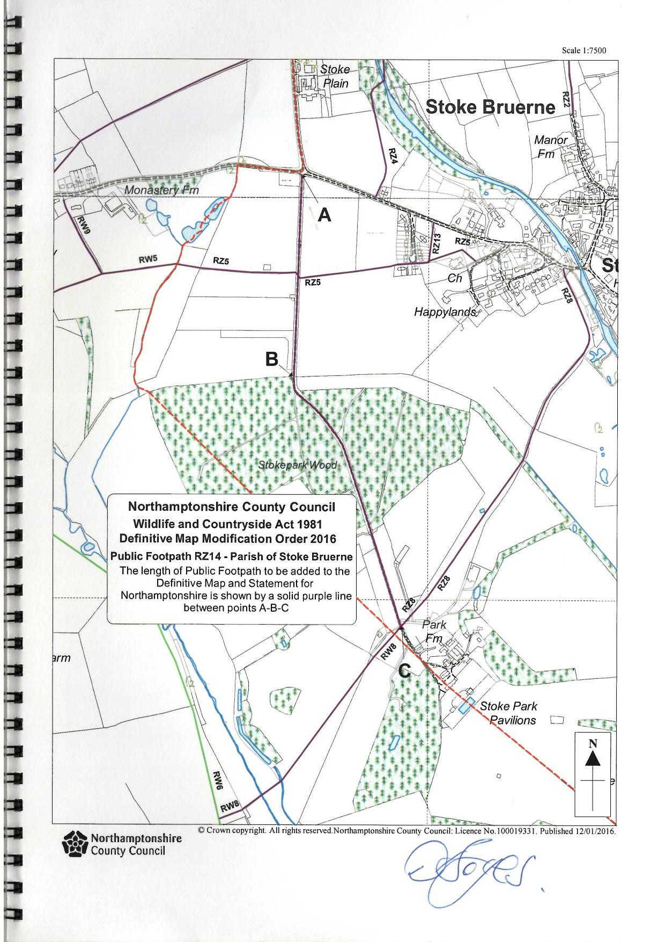

Northamptonshire County Council ceased to exist on 1 April 2021 and its functions are now performed by two new Unitary Authorities. For the purposes of my decision references to ‘the Council’ are references to the former Authority which made the Order.
Via e-mail and regular mail 12 March 2021
This application was deemed to be non-compliant with the requirements of Schedule 14 to the 1981 Act and a compliant application was subsequently submitted in October 2014.

