Order Decision
Site visits made on 2 November 2020 and 8 June 2021
by D M Young JP BSc (Hons) MA MRTPI MIHE
an Inspector appointed by the Secretary of State for Environment, Food and Rural Affairs
Decision date: 23 June 2021

Order Ref: ROW/3237390
- This Order is made under Section 257 of the Town and Country Planning Act 1990 (the Act) and is known as the Oldham Borough Council (Part of Footpath 119 Saddleworth) Public Path Diversion and Definitive Map and Statement Modification Order 2017.
- The Order is dated 4 October 2017 and proposes to divert the public right of way shown on the Order plan and described in the Order Schedule. If confirmed, the Order will also modify the definitive map and statement for the area, in accordance with Section 53(3)(a)(i) of the Wildlife and Countryside Act 1981, once the provisions relating to the diversion come into force.
- There were three objections outstanding when Oldham Borough Council submitted the Order to the Secretary of State for Environment, Food and Rural Affairs for confirmation.
Summary of Decision: The Order is not confirmed.

Procedural Matters
- I was originally scheduled to undertake an accompanied site visit on 9 November 2020. However, on 31 October it was announced that England would be entering a four-week lockdown commencing on 6 November. I therefore decided to undertake an unaccompanied site visit at short notice on November 2. However, following a complaint from one of the objectors, an accompanied site visit was re-arranged for June 2021. Representatives from the Council in addition to Mr Davenport, were present at that visit.

The Main Issues
- The Order was made because it appeared to the Council that it was necessary to divert the footpath to enable development to be carried out in accordance with planning permission PA/340311/17 (the planning permission). This permission which, involves the change of use of a strip of land to the rear of 1-3 Treetops Close to residential curtilage, expired on the 26 January 2021.
- Section 257 of the Act requires that, prior to confirming the Order, I must be satisfied that it is necessary to divert the footpath to allow the development to be carried out in accordance with a valid planning permission which has not expired by the passage of time or invalid on some other ground.
- Although the merits of the development are not at issue, it should not be assumed that because planning permission has been granted necessitating a path closure that confirmation of an extinguishment order will automatically follow. I have a degree of discretion to consider the merits and disadvantages of the proposed closure in relation to the facts that pertain and, in reaching a decision, I am entitled to take into account the effect the Order would have on those whose rights would be extinguished by it.
- As mentioned above, the planning permission has expired. As a consequence, there is not currently a valid planning permission and the Order cannot be confirmed. Nonetheless, in light of the time it has taken to arrange an accompanied site visit, it is right that I consider the substantive merits of the Order, so that the Council can make an informed decision whether to resubmit the Order at some future date.

Reasons

Whether it is necessary to divert the footpath to enable the development to be carried out
- The Order concerns a small section of Footpath 119 which runs adjacent to the rear boundary of 1-3 Treetops Close in the village of Dobcross. The plan approved pursuant to the now expired planning permission shows the application site extending to the surfaced school route at the bottom of the slope. I am thus satisfied the development would encompass the existing line of Footpath 119.
- In some situations, it is possible for a public footpath to pass through a private garden without conflict and it should not be assumed that the two must inevitably be mutually exclusive. However, in the circumstances that apply here, I accept it would be unrealistic, impractical and undesirable for the approved development to co-exist with the continued presence of the public right of way given the rather obvious privacy/security implications to the occupiers of Nos 1-3. I therefore agree that extinguishment of the Order route is reasonably necessary to enable the development to be carried out
- On the basis of the land registry plans submitted with the Council’s statement, I am satisfied that the proposed alignment shown the Order plan would be over land registered with the Council. I have noted Mr Davenport’s comments to the contrary but, it is not my role to determine land ownership matters or to decide whether he is in adverse possession of the land in question, or to consider the merits of his doing so. At the site visit the Council again re-iterated the point that the diversion would not encroach onto Mr Davenport’s land.

Whether the development is substantially complete
- When I visited the area there was no evidence to suggest that any works in connection with the planning permission have commenced. On that basis, I am satisfied that the development is not substantially complete.

The effect the Order would have on those whose rights would be extinguished by it
- In reaching a conclusion on this Order, I am required to weigh the advantages to be conferred by it against any disadvantages or loss likely to arise, either to members of the public generally or to persons whose properties adjoin or are near the existing path.
- The first point to make is that the diversion of the footpath would be fairly modest in its extent and there would be no significant inconvenience arising from the additional seven metres. When I conducted my first site visit, I noted the existing route was narrow, tightly enclosed and very muddy. By contrast, the proposed route would be along a wider, surfaced path which would result in significant betterment especially in the winter months. I acknowledge the gradient between points B and C may well prove challenging for the less mobile. However, it has to be recognised that many footpaths in the area traverse steep gradients such is the local topography.
- Moreover, and with the benefit of having walked both the existing and proposed route, I do not consider there will be any material effect on the public’s enjoyment of the route nor the privacy or security of neighbouring occupiers.

Other Matters
- Those opposing the Order have raised various concerns many of which relate to planning or private land ownership matters none of which are relevant to my consideration of this Order under Section 257 of the Act.
- Mr Hampar on behalf of the Peak and Northern Footpaths Society, has pointed out that the proposed route would not terminate on an adopted highway. The Council accepts this and has suggested the issue could be remedied by extending the proposed route from Point C to A. As this modification would simply extend the proposed route along an existing Council owned path, I am satisfied that the Order could be modified without prejudice to any party.

Conclusions
- Having regard to these and all other matters raised in the written representations, I conclude that it would have been expedient to confirm the Order had it remained valid. However, for the reasons given in paragraph 5 of this Decision, I am unable to confirm the Order.

Formal Decision
- The Order is not confirmed.

D. M. Young
Inspector

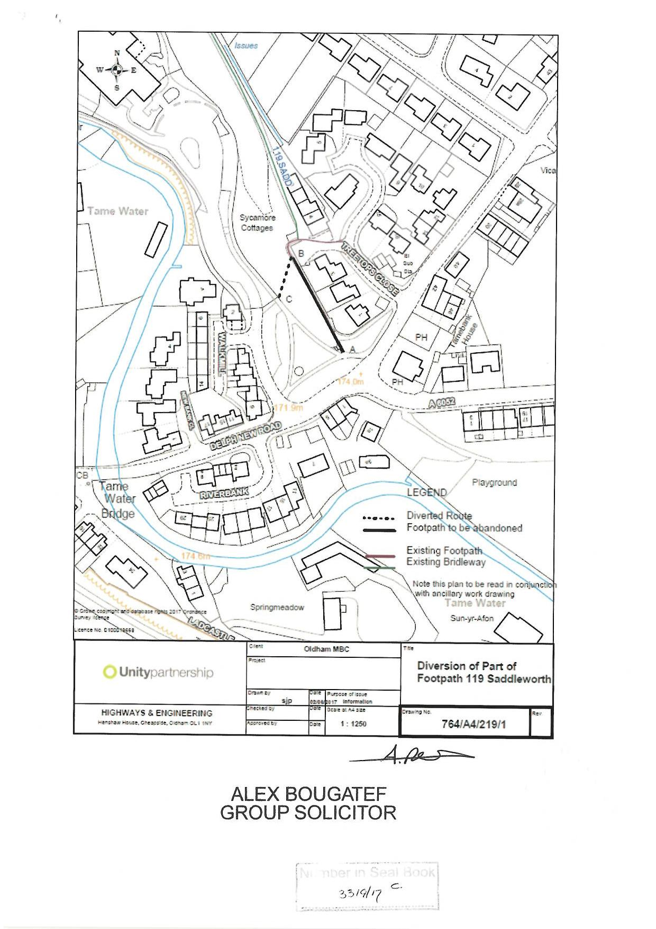

Mr Davenport
Title No. GM380350

