Logo

|  |
| --- |
| **Appeal Decision** |
| **by Barney Grimshaw BA DPA MRTPI (Rtd)** |
| **an Inspector appointed by the Secretary of State for Environment, Food and Rural Affairs** |
| **Decision date: 15 June 2021** |

|  |
| --- |
| **Appeal Ref: FPS/W2275/14A/23** |
| * This Appeal is made under Section 53(5) and Paragraph 4(1) of Schedule 14 of the Wildlife and Countryside Act 1981 against the decision of Kent Council not to make an Order under section 53(2) of that Act. |
| * The Application dated 1 August 2016 was refused by Kent County Council on 3 September 2020. |
| * The appellant claims that a route running between Winkland Oaks Lane and Dover Hill on Forge Lane, Sutton next Ripple, should be upgraded from footpath to bridleway. |
| **Summary of Decision: The appeal is allowed.** |
|  |

Preliminary Matters

1. I have been directed by the Secretary of State for Environment, Food and Rural Affairs to determine this appeal under Section 53(5) and Paragraph 4(1) of Schedule 14 of the Wildlife and Countryside Act 1981 (the 1981 Act).
2. I have not visited the site, but I am satisfied I can make my decision without the need to do so.
3. I attach a copy of a map submitted with the application showing the claimed route for reference purposes.

Main issues

1. Section 53(3)(c)(ii) of the 1981 Act states that an order should be made on the discovery by the authority of evidence which, when considered with all other relevant evidence available, shows that a highway shown in the map and statement as a highway of a particular description ought to be there shown as a highway of a different description.

Reasons

1. The evidence in this case consists entirely of historic documents, a substantial number of which have been referred to by the applicant and Kent County Council, the Order Making Authority (OMA).

*Early Maps*

1. A map surveyed by the Ordnance Survey (OS) in the 1790s but published by Faden in 1801 shows the claimed route between Points C and D as a minor drive. The remainder of the route is not shown. The first official OS map (1831) shows the same information and was probably based on the same survey.
2. Greenwood’s map (1819/20) also shows the route C-D and a short section south-east of E but no connection between the two.

*Tithe Maps*

1. On the Ripple Tithe Map, the route C-D is shown as an enclosed road and the section from C to Winkland Oaks Farm is described in the apportionment as *“Public Roads and Waste Land”*. The section running from the farmyard to the parish boundary at D is shown on the map in a similar manner but does not appear to have been allocated a separate parcel number and is not referred to in the apportionment. The route is also shown continuing in a similar manner for a short distance north of Point D.
2. On the copy of the Sutton Tithe Map in the National Archive the route D-E is shown by a pecked line adjacent to a field boundary suggesting a track unenclosed on one side. There is no specific reference to it in the apportionment.
3. Tithe maps were prepared to indicate productive land and not rights of way. Nevertheless, the description of part of the claimed route as a public road is evidence of its perceived status at the time. Also, it is arguable that, if the route from C to the farmyard was a public road, it would have been unlikely to have terminated as a cul de sac at the farmyard or at the parish boundary.

*OS Maps*

1. The OS 1:2500 scale map of 1872 shows the whole of the claimed route as a continuous unenclosed track. It is coloured sienna indicating that it had a metalled surface. Between Points D and E, it is numbered as parcels 41 and 46 which are described in the accompanying book of reference as *“Road”*. The 1896 map shows the route in a similar manner, but I have not seen a book of reference for this map.
2. OS maps such as these provide good evidence of features that were present on the ground, but they do not indicate the status of routes shown. Nevertheless, the description of the route as *‘Road’* and the metalling of it is consistent with it being a public route of bridleway or higher status.

*Finance Act 1910*

1. This Act imposed a tax on the incremental value of land which was payable each time it changed hands. In order to levy the tax a comprehensive survey of all land in the UK was undertaken between 1910 and 1920. This survey was carried out by the Board of Inland Revenue under statutory powers and it was a criminal offence for any false statement to be made for the purpose of reducing liability. The existence of public rights of way over land had the effect of reducing the value of the land and hence liability for the tax; they were therefore recorded in the survey.
2. In this case, the whole of the claimed route is recorded as being within hereditament 407, Winkland Oaks Farm, and no deduction is shown for rights of way within this hereditament. The appellant suggests that this may reflect the fact that the landowner chose not to claim a deduction, as some landowners did, rather than that there was no public right of way. Nevertheless, the Finance Act records add nothing to the case in favour of upgrading the route.

*Eastry Rural District Council (RDC) Records*

1. A report of the surveyor to the RDC in 1911 refers to the bad state of *“…the road leading from Dover Hill Sutton past Winkland Oaks Farm to the road leading from Ripple school to Martin”*. This would appear to be a reference to the claimed routeand the surveyor reported pointing out that *“…the road was only a bridle rd”*. A subsequent report in 1913 also refers to the same route and describes it as a bridle road, albeit one on which no repairs had ever been done. Then, in 1924, the route between Points D and E was again referred to as a bridle road.

*The Definitive Map process*

1. In the parish surveys carried out in 1952-53 as part of the process of preparing the first definitive map, Sutton parish showed a footpath running in a direct line between Point D and the bottom of Dover Hill. This was later amended and added to the map as a footpath on the current line (EE427, Points D-E). All of the 25 rights of way identified in the survey were described as footpaths and none of any higher status.
2. In the Ripple parish survey, the section C-D was not identified at all, but it was subsequently included in the draft map as a cart road footpath (CRF). It was then shown on the definitive map as a Road Used as a Public Path (RUPP). It was subsequently downgraded to footpath status as part of a Special Review in 1970 and continued to be shown as such even though the review was abandoned. After the route had been downgraded to footpath status it was decided in a Court of Appeal judgement[1] that, in the absence of new evidence to the contrary, designation of a way as a RUPP conferred a presumption of the existence of bridleway rights. Nevertheless, the appeal route has continued to be recorded as a footpath.
3. Overall, the appellant suggests that there is some doubt as to whether the route is recorded correctly, even though no objection appears to have been raised when the definitive map was published.

*Electricity Supply Acts*

1. In 1923, a notice placed in the London Gazette related to an application for an order under the Electricity Supply Acts to authorise undertakers to break up certain ‘streets’ which were not repairable by local authorities. One of the ‘streets’ listed was the appeal route. The term ‘street’ in this context includes any route in the area to which the undertakers were authorised to supply electricity. It could relate to public highways or wholly private routes. However, the Acts did not empower undertakers to break up a ‘street’ not repairable by a local authority without the consent of the body responsible for repairs.
2. It is argued by the appellant that, if a route was wholly private, the responsibility for its repair would lie with the owner. It is therefore suggested that inclusion of the appeal route in the notice implies that it was regarded as being a public highway. The appellant further argues that most of the ‘streets listed in the notice are now recognised as public bridleways or higher status routes and that others are subject to, or likely to be subject to, applications for them to be recorded as such.
3. On the other hand, the OMA states that, although the notice indicates that the route was a public highway not maintainable at public expense, this is consistent with the route being a public footpath.

*Other Evidence*

1. Sales particulars relating to the auction of Winkland Oaks Farm in 1936 describe the appeal route between Points D and E as ‘Road’.
2. In the National Farm Survey, 1941-43, the appeal route is shown coloured blue whereas the rest of the holding is coloured pink. The appellant suggests that this indicates that the route was regarded as unproductive land not under the control of the farmer, probably a public bridleway as a public footpath would have been unlikely to have been shown in this manner.
3. A route to the east of Point C (Footpath EE451, Hangman’s Lane) was part of the original application and has recently been upgraded from footpath status to bridleway. The appellant has argued that the current appeal route should be considered as part of a single entity with this route. However, the OMA regards the appeal route as a separate one with a different history and background. The evidence I have seen does not in my view necessarily indicate that the appeal route should be regarded as part of single route along with Hangman’s Lane. I have therefore considered it as a separate entity.

Conclusion

1. Much of the available evidence in this case is consistent with the appeal route being either a public footpath or bridleway. Since 1970 the definitive map has recorded it as a footpath, although before then part of the route was recorded as a CRF suggesting a possible higher status.
2. Some of the evidence also suggests that the route might have a higher status. In particular, the references in the Eastry RDC surveyor’s reports specifically describe it as a bridle road. Also, references in the tithe records, the Electricity Supply Acts notice, the National Farm Survey and the OS map of 1872 and book of reference are suggestive of a higher status.
3. Accordingly, even though it is generally appropriate to presume that the definitive map is correct, it is now my view, on the balance of probabilities, that it is more likely that the appeal route is a public bridleway then a public footpath. I therefore conclude that the appeal should be allowed.

Formal Decision

1. The appeal is allowed and in accordance with paragraph 4(2) of Schedule 14 to the 1981 Act Kent County Council is directed to make an order under section 53(2) and Schedule 15 of the Act to modify the definitive map and statement to upgrade public footpath EE427 to bridleway status, as proposed in the application dated 1 August 2016. This order to be made within 3 months of the date of this direction. This decision is made without prejudice to any decision that may be given by the Secretary of State in accordance with his powers under Schedule 15 of the 1981 Act.

Barney Grimshaw

Inspector

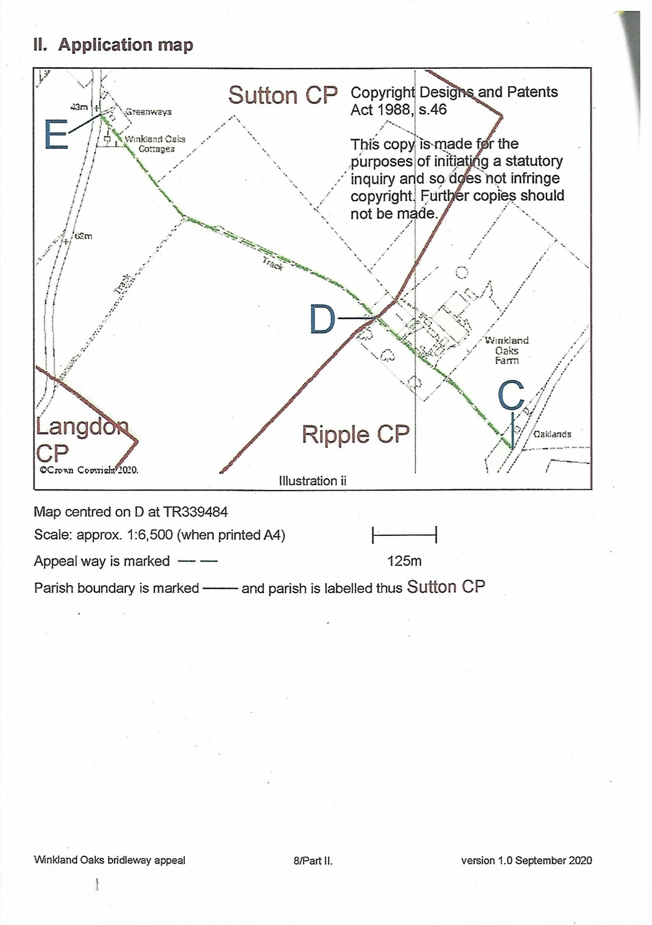

1. R v Secretary of State for the Environment ex parte Hood [1975]