PINS Logo

|  |
| --- |
| **Appeal Decisions** |
|  |
| **by Barney Grimshaw BA DPA MRTPI (Rtd)** |
| **an Inspector appointed by the Secretary of State for Environment, Food and Rural Affairs** |
| **Decision date: 22 June 2021** |

|  |
| --- |
| **Appeal Ref: FPS/G1440/14A/13** referred to as **Application A** |
| * This Appeal is made under Section 53(5) and Paragraph 4(1) of Schedule 14 of the Wildlife and Countryside Act 1981 against the decision of East Sussex County Council not to make an Order under section 53(2) of that Act. |
| * The Application dated 9 March 2017 was refused by East Sussex County Council on 3 November 2020. |
| * The appellant claims that the following routes should be added to the definitive map:   - a bridleway running from Folkington Road at grid ref 555982 103918 (Point H) to grid ref 556125 104005 (Point I);  - a footpath running from grid ref 556125 104005 (Point I) to Folkington Road at grid ref 556580 104048 (Point D), or |
| **Summary of Decision: The appeal is allowed.** |
|  |
| Appeal Ref: FPS/G1440/14A/14 referred to as Application B |
| * This Appeal is made under Section 53(5) and Paragraph 4(1) of Schedule 14 of the Wildlife and Countryside Act 1981 against the decision of East Sussex County Council not to make an Order under section 53(2) of that Act. |
| * The Application dated 9 March 2017 was refused by East Sussex County Council on 3 November 2020. |
| * The appellant claims that a footpath from Folkington Road at grid ref 5556080 103889 (Point B) to Folkington Road at grid ref 556580 104048 (Point D) should be added to the definitive map. |
| Summary of Decision: The appeal is dismissed. |

Preliminary Matters

1. I have been directed by the Secretary of State for Environment, Food and Rural Affairs to determine these appeals under Section 53(5) and Paragraph 4(1) of Schedule 14 of the Wildlife and Countryside Act 1981 (the 1981 Act).
2. I have not visited the site, but I am satisfied I can make my decisions without the need to do so.
3. I attach copies of maps submitted with the applications showing the claimed routes for reference purposes.

Main issues

1. Section 53(3)(c)(i) of the 1981 Act states that an order should be made on the discovery by the authority of evidence which, when considered with all other relevant evidence available, shows that a right of way which is not shown on the map and statement subsists or is reasonably alleged to subsist over land to which the map relates.

Reasons

1. The two applications are effectively alternatives, the appellant argues that either the Application A route was diverted on to the Application B route or that it remains in existence.
2. All of the evidence adduced in this case consists of historic documents which I consider briefly below.

*Early maps*

1. A number of early maps that were considered either do not show the application routes at all or show a route or routes in the general area but not apparently on the lines of the application routes.

*Tithe records*

1. The Folkington Tithe Map (1839) shows the Application A route in a similar manner to other tracks and roads in the area. Tithe documents were produced for the purpose of identifying productive land subject to liability for payment of tithe and not for the purpose of identifying public rights of way. Accordingly, although these records provide evidence of the existence of the route, they do not indicate its status.

*Quarter Sessions records*

1. In 1844, at the court of Quarter Sessions it was decided that certain routes should be stopped up and a new route created instead. The routes to be stopped up were a public footpath (Points C-D), a public highway (Points C-I) and a public bridleway (Points I-H), namely the Application A route. The new route to be provided was a route corresponding to the Application B route (B-D) which was to be part bridleway and part footpath.
2. There is no record of the Justices ever having subsequently inspected the works and certified that they were satisfactory. If the new route was not laid out and certified the diversion would not have taken effect and the existing routes would have remained in existence. It is argued by the appellant that it was not unusual for there to be no record of justices inspecting work, suggesting that this does not mean that it did not take place.
3. The Ordnance Survey (OS) 25" to the mile map surveyed in 1873 does not show the proposed new route B-D but does show the old route (D-C-I-H). In fact, there appears to be no evidence that the Application B route has ever existed on the ground. This possibly indicates that the diversion proposed in the 1844 decision did not in fact take place.
4. In 1877, another Quarter Sessions decision concerned, amongst other matters, the diversion of the highway from the Lewes to Polegate road to Folkington village. The route to be diverted included section C-I of the Application A route. This order was subsequently signed off by the Justices. The fact that it was thought appropriate to divert section C-I would appear to confirm that it had not already been diverted as a result of the 1844 order. The appellant argues that although this order closed this section of the road as a highway for all traffic, pedestrian rights over it may have remained.
5. The evidence of the Quarter Sessions records is somewhat confusing. The 1844 order appears to confirm that the Application A route was then a public highway of various types. The order proposed to close this route and create the Application B route. However, the available evidence suggests that this never actually happened. The 1877 order then closed the section C-I but did not affect the remainder of the Application A route. This might suggest that two parts of this route are still public rights of way albeit cul de sacs or, if the appellants argument is accepted, that they are linked by a public footpath.

*Other evidence*

1. No more recent evidence of the existence of either application route has been discovered.

*Conclusions regarding the Documentary Evidence*

1. On balance, it is my view that it is most likely that the Application B route never came into existence despite the 1844 Quarter Sessions order. The appeal in respect of Application B should therefore be dismissed. On the other hand, the Application A route does appear to have existed both before and after the 1844 order which itself confirmed that it was then a public right of way. A section of the route was closed as a highway open to all traffic by the 1877 order, but there is no evidence of the remainder of the route having been stopped up. It is therefore reasonable to allege that most, if not all, of the Application A route is still a public right of way. The appeal in respect of Application A should therefore be allowed

Formal Decision

1. The appeal in respect of Application A is allowed and in accordance with paragraph 4(2) of Schedule 14 to the 1981 Act East Sussex County Council is directed to make an order under section 53(2) and Schedule 15 of the Act to modify the definitive map and statement to add a public footpath, as proposed in the application dated 9 March 2017. This decision is made without prejudice to any decision that may be given by the Secretary of State in accordance with his powers under Schedule 15 of the 1981 Act.

Barney Grimshaw

Inspector

**APPLICATION A**

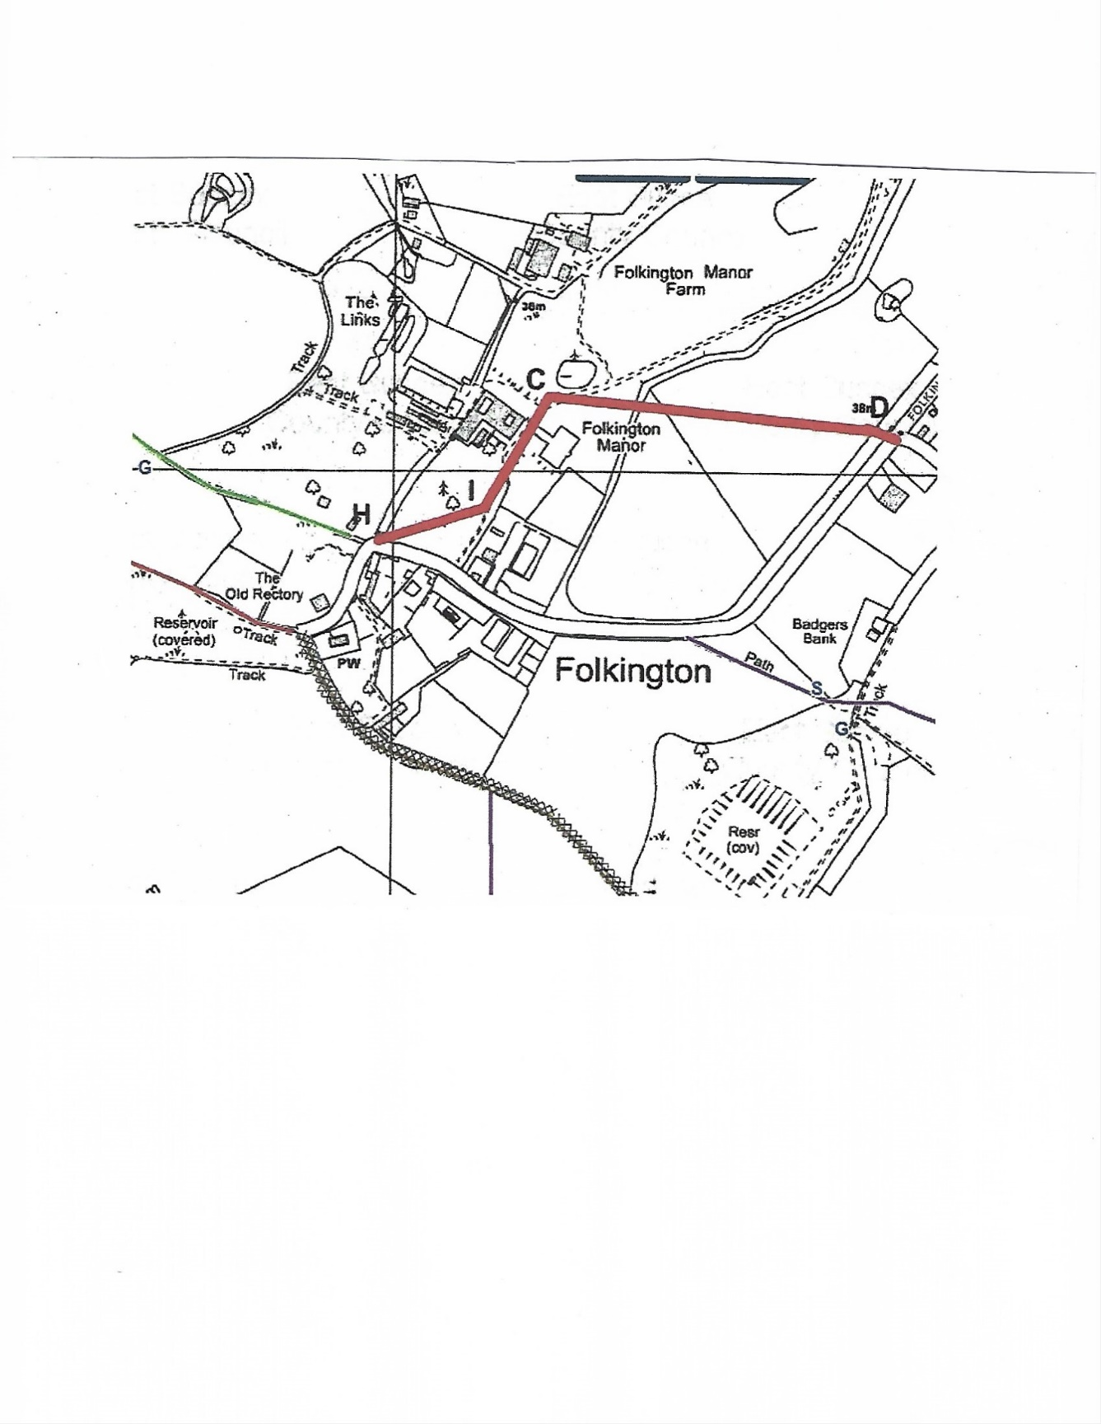

**APPLICATION B**

