Application Decision
Site visit made on 22 June 2021
by Helen O'Connor LLB MA MRTPI
an Inspector appointed by the Secretary of State for Environment, Food and Rural Affairs
Decision date: 5 July 2021

Application Ref: COM/3265102
Leigh Common, Leigh Road, Wimborne Minster, Dorset
Register Unit: CL1
Registration Authority: Dorset Council

- The application is made under Section 16 of the Commons Act 2006 (“the 2006 Act”) to deregister and exchange land registered as common land.
- The application was made on behalf of Sir William Hanham of Hanham Estate (owner of the release land) and Dorset Council (owner of the replacement land).
- The release land comprises of approximately 5,259m² of land. There are three constituent parts, a linear strip of 4260m² on the south side of Leigh Road and two linear strips on the north side of Leigh Road of 171m² (north west) and 828m² (north east).
- The replacement land comprises 5,990m² of land adjoining the east of Leigh Common and is part of Bytheway Field.

Decision
- The application is granted.

Main Issues
- Section 16(1) of the 2006 Act provides that the owner of any land registered as common land may apply for the land (‘the release land’) to cease to be so registered. If the area of the release land is greater than 200m² a proposal must be made to replace it with other land to be registered as common land (‘the replacement land’).
- I am required by Section 16(6) of the 2006 Act to have regard to the following in determining this application:

(a) the interests of persons having rights in relation to, or occupying, the release land (and in particular persons exercising rights of common over it);

(b) the interests of the neighbourhood;

(c) the public interest;

(d) any other matter considered to be relevant.

The Application
- The deregistration of three linear strips of land on the north and south sides of Leigh Road is sought. Dorset Council wishes to use the release land primarily to facilitate the construction of a cycleway and footway on both sides of Leigh Road. It is intended that highway improvements to the Leigh Road corridor will form one element of a wider programme of works funded from the Transforming Cities Fund to improve sustainable transport corridors throughout urban south east Dorset.

The Release Land
- In total the release land amounts to approximately 5,259m². The majority (4260m²) is situated next to the southern side of Leigh Road where it is regularly interspersed by private accesses and consists in part of an existing footway. These elements are generally asphalt surfaced. In addition, consents exist on part of the land to provide two signalised junctions. Two further strips on the northern side of Leigh Road also form part of the release land. The shorter section lies to the west of the junction with Northleigh Lane and amounts to approximately 171m². The longer strip of 828m² to the east of Northleigh Lane comprises primarily of a stretch of asphalt-surfaced footway.
- For the purposes of identification, a copy of the application plan is attached to this decision at Appendix A. The release land is edged in red.

The Replacement Land
- The replacement land amounts to approximately 5,990m² of grassed land bisected by a gravel path and is part of the wider Bytheway Field. Bytheway Field is open space, dedicated as Suitable Alternative Natural Greenspace (SANG) and owned by Dorset Council. The replacement land parcel adjoins Leigh Common on three sides. A fence marks the boundary which is adjacent to a ditch. There are two pedestrian gates and an existing culvert and gate in the fence which provide direct access between Leigh Common and the replacement land.
- The release land is hatched in green on the application plan (Appendix A).

Representations and Objections
- Three representations were made in response to the Council’s notice of the application. Of these representations, Natural England was generally supportive of the application. One local resident sought clarification more closely related to the impact arising from the intended highway improvements to the Leigh Road Corridor. Finally, the Open Spaces Society (OSS) raised an objection.
- The OSS considers that the replacement land would not provide a beneficial exchange as the land is part of a SANG. As such, it is open to the public and used for recreation. Further protection against development is provided by the covenant with the National Trust over the replacement land. In addition, it states that the moderating effect of the wide verges of Leigh Road that are intended to facilitate the provision of the footpath and cycleway would harm the setting of the common. Moreover, these works are primarily intended to improve communication in the vicinity of Wimborne rather than access to the common.

Assessment
- In determining the application, I have had regard to the Department for Environment, Food and Rural Affairs Common Land consents policy, November 2015 (the 2015 Guidance) published for the guidance of both the Planning Inspectorate and applicants. Paragraph 3.2 sets out overall policy objectives to protect commons which includes the outcome that the stock of common land and greens is not diminished so that any deregistration of registered land is balanced by the registration of other land of at least equal benefit.

The interests of those occupying or having rights over the land
- The release land is owned by Sir William Hanham of the Hanham Estate who is party to the application with Dorset Council. Rights to graze specified numbers of cows over the whole of the common land are registered to two named parties. It is stated that these rights are not exercised, and that light grazing that has occurred in the past was part of biodiversity management overseen by the Council. There is nothing to indicate that anyone occupying or having rights over the release land would be adversely affected by the exchange.

The interests of the neighbourhood
- The 2015 guidance indicates that the issues to be considered in this context include whether the exchange would prevent local people from using the common in the way they are used to, and whether or not there would be an interference with the future use and enjoyment of the land as a whole. It also provides for positive benefits to be taken into account.
- The strip of land to the south of Leigh Road includes some sections of footway adjacent to the carriageway and multiple private access points to dwellings. The release land to the north of Leigh Road includes sections of footway and grassed area that appear as roadside verge. As such, the release land has a peripheral character that contrasts with the woodland in the main body of the common where there are recreational paths through the Local Nature Reserve. Local people are therefore likely to have primarily used the release land for travel purposes and/or access to Leigh Road rather than consciously using it as common land. This is reinforced by the representation received from a local resident concerned about maintaining the ability to safely access and egress Leigh Road from his property in a vehicle.
- Moreover, the exchange would facilitate the provision of a footway/cycle path along both sides of Leigh Road. Whilst the detailed highway design is not before me, some schematic drawings have been provided. The project would be required to consider safety measures and is intended to promote sustainable means of travel. As such, the release land would remain as part of the highway as a cycleway and footway. Therefore, local people would not only be able to continue to use the land for travel in the way they are used to, but this would be enhanced by a continuous footway and improved safety conditions for cyclists. There is nothing to suggest the proposal would interfere with existing access to private properties.
- As such, there is nothing before me to indicate that there will be any significant adverse effect on the interests of the neighbourhood nor from which I could conclude that the proposed exchange would interfere with the future use and enjoyment of the common by local people. Moreover, local people would be likely to generally benefit from improvements to access that would be delivered by Dorset Council’s proposals for cycle and footway provision near to Leigh Common, as a component of the wider sustainable transport corridors improvement programme.

The public interest

The protection of public rights of access
- The application form confirms that the release land is subject to access rights under section 193 of the Law of Property Act 1925. It will also be subject to right of access on foot in accordance with Part 1 of the Countryside and Rights of Way Act 2000 (2000 Act). The replacement land would be subject to these access provisions, although this would not come into effect until a review of the maps prepared under Part 1 of the 2000 Act has taken place. However, there is nothing to indicate that access to the replacement land will be restricted, especially given that it is already freely accessible to the public as part of Bytheway Field.
- Some parts of the release land are surfaced as a footway but otherwise it generally appears as highway verge adjacent to a busy road. The presence of Leigh Road hinders access between the southern and northern parts of the common. Furthermore, there are multiple access points serving private property on the southern parcel of release land. These factors impede the recreational use of the release land and public access tends to be for the purpose of traversing the space along the footway. In this sense the larger, more open space provided by the replacement land would be an improvement as it would provide more flexible space for general recreation and play and would not be separated from the main body of Leigh Common by Leigh Road. Existing pedestrian gates and a vehicular access gate would provide direct access between the replacement land and the existing common.
- However, paragraph 4.5 of the 2015 guidance states in relation to replacement land “the Secretary of State would not normally grant consent where the replacement land is already subject to some form of public access, whether that access was available by right or informally, as this would diminish the total stock of access land available to the public”.
- In this case, the replacement land is already subject to public access as part of a SANG. The SANG is a recreational site, intended to attract residents of new development away from designated sites of importance for biodiversity in the Dorset Heathlands where the ecology is sensitive to recreational activity. As such, public access is integral to its purpose. This is reinforced by the existence of pedestrian access gates to Leigh common as well as an existing pathway route within the SANG lying across the replacement land.
- The Council considers that the proposed exchange would confer a greater degree of long-term access protection upon the replacement land than currently exists. However, little substantive evidence to support this assertion has been provided. There is nothing before me to suggest that in the absence of common land status, the SANG would have public access withdrawn or restricted, which is acknowledged by the Council. Furthermore, it is not suggested that the proposed exchange would confer any enhancements over the present level of public access to the replacement land. Consequently, the present situation as experienced by the public visiting the SANG would not be notably altered. Therefore, the net result would be a diminution in the total stock of access land available to the public contrary to the 2015 guidance.
- Reference is made to changes to junctions that would result in 397m² of common land being returned from asphalt carriageway to natural verge on the northern side of Leigh Road near to the junction with Northleigh Lane. Be that as it may, this would not affect the overall stock of access land.
- My attention is drawn to an application where a deregistration and exchange order was made despite the replacement land being subject to public access. Unlike this case, the access was under licence, with notices on the land to that effect and therefore there are differences between it and the application before me. Nevertheless, the case illustrates an example where the Inspectorate has departed from the 2015 guidance where appropriate to do so. In general terms it carries limited weight in favour of the merits of this proposal.
- Nevertheless, taking all these factors together, I consider that the proposal would result in a reduction in the stock of land to which the public have access, and this weighs against the approval of the application. This will be factored into the overall balance of the merits of the application later in my determination.

Nature conservation and biodiversity
- Leigh Common is a Local Nature Reserve (LNR). The Council says that the release land would for the most part lie adjacent to, but outside of the boundary of the LNR and is not subject to any statutory designations for nature conservation. The release land on the northern side of Leigh Road is described by Natural England as herb rich grassland with a narrow-tarmacked path. The release land on the southern side is likely to be of lower ecological value as it constitutes roadside grass verge with some ornamental trees and accommodates asphalt footway and entrances into dwellings. I also observed the presence of street lighting, signage and cabinets. Furthermore, recent road construction works have degraded parts of the land. Overall, given its present condition, amount of hardstanding, street furniture and proximity to the road, the release land is likely to have limited potential for biodiversity.
- The replacement land within Bytheway Field is a larger area of predominantly open grassland and rush which is seasonally damp.
- Natural England state that they are satisfied that biodiversity would not be negatively impacted subject to the applicant providing greenspace improvements along the cycling corridor. However, this comment appears to relate to the merits of the wider transport proposal rather than a direct comparison of the replacement and release land.
- The current use and biodiversity of the replacement land would be unaffected by the exchange.
- Overall, I consider it to be unlikely that the proposed exchange would have any adverse impact upon biodiversity or nature conservation.

Conservation of the landscape
- My observations of the release land were that due to its condition, separation from the main body of the common (by the main road in the case of the southern section and ditch in the case of the northern sections), degree of hardstanding and proximity to Leigh Road, it is predominantly comprised of land that has a commonplace roadside verge character.
- The proposed exchange would facilitate the provision of foot and cycleways alongside Leigh Road. Utilising the limited additional width that would be provided by the release land would be unlikely to significantly change the character of the arterial road overall, nor its impact in the wider landscape. On that basis, it would not have an adverse effect on the enjoyment of the remaining part of the common or its setting.
- Although the OSS contend that the impact of Leigh Road on the common is moderated by wide verges, my findings in this regard are not dissimilar to those made in relation to two previous s38 applications at Leigh Common. Furthermore, the grass verge along the northern side of the road between the surfaced footway and carriageway does not form part of Leigh Common.
- No physical alterations are proposed for the replacement land which forms part of the Bytheway Field SANG. The Council are content for the scheme of management under the Commons Act 1899 that applies to Leigh Common to be carried forward to the replacement land. Based on the evidence before me, this would not result in a significant alteration to the landscape.
- Overall, the impact on the landscape character of the area would be neutral.

Archaeological remains and features of historic interest
- There are no listed buildings, scheduled ancient monuments or non-designated nationally important archaeological sites on the release land. It follows that there is no evidence before me that the exchange would have any adverse effect in this regard.

Other relevant matters
- The impetus for the application is Dorset Council’s intention to improve the Leigh Road transport corridor in order to provide foot and cycle ways on both sides of the road. The Council states that space for the proposed improvements cannot be found entirely within the existing carriageway. This is a project within a wider programme of works planned by the Council to improve sustainable transport corridors. Evidence has been provided to show that a programme, funding and authority is broadly in place to support the delivery of the works over the next 3-4 years. Furthermore, construction has commenced on the wider corridor that does not affect common land, which I observed nearby at my site visit. As such, there is a high degree of probability that, in the event of the exchange being permitted, the transport corridor improvements would be secured.
- I observed the section of Leigh Road near to Leigh Common to be a busy road and cyclists are presently required to share the main carriageway. The limited width, alignment of the road and frequent presence of other traffic would present limited opportunities for motor vehicles to overtake cyclists safely. Consequently, the noise and close presence of motorised traffic could deter less than confident cyclists and would not present conditions conducive to recreational cycling. This situation is at odds with the inclusion of this section of Leigh Road within the National Cycle Network, which seeks to encourage more cycling.
- Moreover, whilst there is a continuous footway along the northern side of Leigh Road, this is not the case for the southern side, where the nearest residences are situated.
- By improving the environment and safety for cyclists and pedestrians, encouragement would be given to non-car modes of transport. This would provide wider public benefits that would be likely to include an increase in active travel and associated health benefits, the potential to reduce carbon emissions from fossil fuel dependant car use, as well as improving access locally and as part of the national cycle network.
- Given the proximity of Leigh Common to the transport corridor proposed to be improved, it may well encourage more members of the public to travel to the common by foot or bicycle. These wider benefits are relevant to my determination and weigh considerably in favour of permitting the application.

Overall balance and conclusion
- The 2015 guidance is explicit in the matter of the protection of public rights of access. However, paragraph 1.3 of the 2015 guidance indicates that the Inspectorate may depart from the guidance where appropriate to do so. It must nevertheless provide an explanation for doing so. Having regard to the matters addressed above, the main factors that should be put into the balance are the impact of the exchange on public access and the benefits arising from it.
- It is significant that, despite the replacement land being greater in quantity than the release land, as it forms part of the SANG, it is already subject to public access. However, paragraph 4.5 of the 2015 guidance referred to above also states that it is assumed that the release land will cease to be available for recreation and access, unless a legally binding provision is intended to be made to assure continued use. The circumstances presented in this case intend the release land to provide for the provision of improved foot and cycle ways. Based on the information provided regarding the background and wider programme, I am confident that the Council can be relied upon to carry out the improvement works which would allow the public to continue to pass over the land.
- Whilst I accept that this would not necessarily afford equal rights of access and exercise as common land designation, it would mean that public access would not be removed from the release land and it would continue to perform a valuable public service. The measures would also be likely to improve public access and recreational use for pedestrians and cyclists enhancing and making more effective use of the land that has already been used as footway in places and appears as roadside verge in others. Consequently, this significantly tempers the harm arising from the reduction in the stock of land to which the public have access.
- Accordingly, there is a compelling case for an exchange in this case due to the proposed transport improvements which would bring benefits to the neighbourhood as well as serve the wider public interest. In my view, the justification for the exchange outweighs the disadvantages and that in these circumstances, the replacement land would be adequate when assessed against the statutory criteria.
- Therefore, on balance and having regard to all matters raised in the application and written representations, I find that consent for an exchange of common land should be granted and an Order of Exchange given in respect of the application.

Helen O’Connor

Inspector

Order

On behalf of the Secretary of State for Environment, Food and Rural Affairs and pursuant to section 17(1) and (2) of the Commons Act 2006, I HEREBY ORDER Dorset Council, as commons registration authority for the area in which the release land and the replacement land are situated:
- to remove the release land from its register of common land, by amending register unit CL1 to exclude the release land;
- to register the replacement land as common land, by amending register unit CL1 to include the replacement land; and
- to register as exercisable over the replacement land (in addition to remaining exercisable over the remainder of the land comprised in register unit CL1) any rights of common which, immediately before the date on which the release land is removed from the register, are registered as exercisable over the release land and the remainder of the land comprised in register unit CL1.

First Schedule – the release land

Colour On Plan | Description | Extent
Edged red | Land forming part of register unit CL1, comprising three constituent parts, a linear strip of 4260m² on the south side of Leigh Road and two linear strips on the north side of Leigh Road of 171m² (north west) and 828m² (north east). | 5,259m²

Second Schedule – the replacement land

Colour On Plan | Description | Extent
Hatched green | Land east of Leigh Common adjoining register unit CL1, comprising part of Bytheway Field. | 5,990m²

Helen O’Connor

Inspector

Appendix A – Copy of application plan (not to scale)

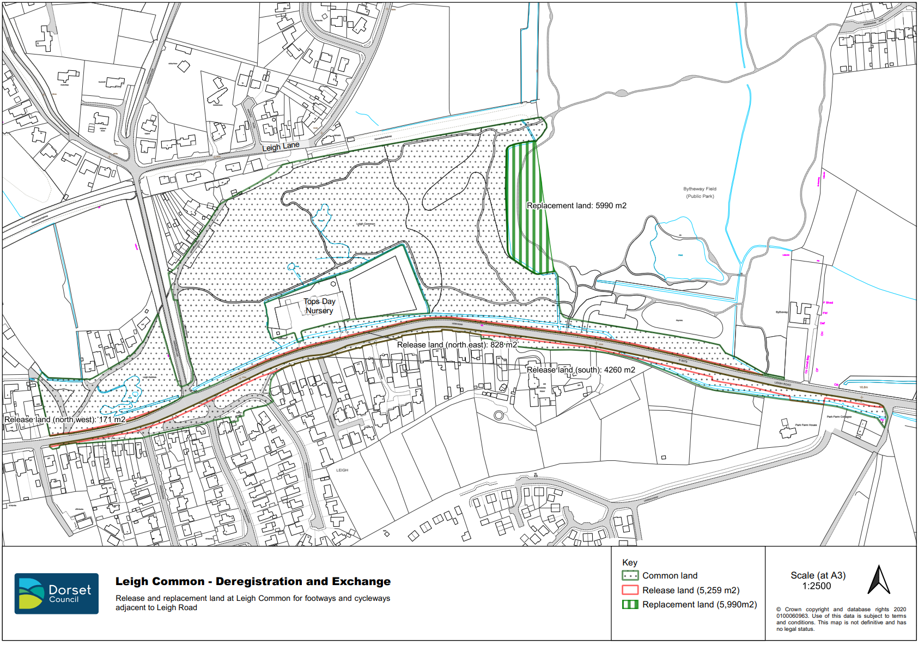

Section 16(8) of the 2006 Act provides that the public interest includes the public interest in: nature conservation; the conservation of the landscape; the protection of public rights of access to any area of land; and the protection of archaeological remains and features of historic interest.
Under section 38 of the 2006 Act, referenced COM/3169414 and COM/3190392
Response to representations (First Statement)
Notice dated 10 December 2020
Reference COM/3222749 Land at Lammas Grounds, Eton College
Letter dated 11 January 2021
Referenced COM/3169414 & COM/3190392

