Application Decision
by Richard Holland
Appointed by the Secretary of State for Environment, Food and Rural Affairs
Decision date: 07 July 2021

Application Ref: COM/3270292
Kings Stanley Free Meadows, Gloucestershire
Register Unit No: CL 99
Commons Registration Authority: Gloucestershire County Council
- The application, dated 3 March 2021, is made under Section 38 of the Commons Act 2006 (the 2006 Act) for consent to carry out restricted works on common land.
- The application is made by Severn Trent Water Limited.
- The works comprise:
- Section 1 to the south of the A419 includes installing 750 mm (88 m) and 3 x 900 mm (92m) sewer pipes underground within a temporary working area of approx. 8,240 m² leaving approx. 3.2 m² of permanent apparatus for two manhole covers.
- Section 2 to the north west of the A419 includes installing 750 mm (7 m) and 375 mm (53 m) sewer pipes underground within a temporary working area of approx. 950 m² leaving approx. 2 m² of permanent apparatus for a manhole cover.
- Section 3 to the north east of the A419 includes installing 1500 mm (183 m) and 900mm (27 m) sewer pipes underground within a temporary working area of approx. 8650 m² leaving approx. 9.76 m² of permanent apparatus for access to the sewers and five manhole lids.
- Bore holes and the excavation of trial holes of two to three days duration.
- Temporary fencing will be used during the construction phase only to include a mixture of stock proof fencing, heras fencing and barriers around construction areas.

Decision
  - Consent is granted for the works in accordance with the application (as amended) dated 3 March 2021 and accompanying plan, subject to the following conditions:
  - the works shall begin no later than three years from the date of this decision; and
  - all fencing shall be removed and the common restored within one month from the completion of the works;
  - the fencing along the haul road shall include a pair of heras fence style pedestrian access gates.
  - For the purposes of identification only the location of the works are hatched in purple, orange and blue within the common land boundary outlined in green on the attached plan.
Preliminary Matters
  - I have had regard to Defra’s Common Land Consents Policy in determining this application under section 38, which has been published for the guidance of both the Planning Inspectorate and applicants. However, every application will be considered on its merits and a determination will depart from the policy if it appears appropriate to do so. In such cases, the decision will explain why it has departed from the policy.

- This application has been determined solely on the basis of written evidence.

- I have taken account of the representations made by the Gloucestershire Wildlife Trust (GWT), the Open Spaces Society (OSS) and the Archaeologist at Gloucestershire County Council.
- I am required by section 39 of the 2006 Act to have regard to the following in determining this application:-
- the interests of persons having rights in relation to, or occupying, the land (and in particular persons exercising rights of common over it);
- the interests of the neighbourhood;
- the public interest; and
- any other matter considered to be relevant.

Reasons

The interests of those occupying or having rights over the land
- The applicant confirms that rights of grazing are exercised between 1 August and 14 November. The works include stock proof fencing to prevent livestock entering the working areas. The active commoners and the landowners, Health and Leisure Properties Limited and Stroud Water Redevelopment Partnership Limited, have been consulted about the application and have not objected to the works. I am satisfied that the works will not impact adversely on the interests of those occupying or having rights over the common.

The interests of the neighbourhood and the protection of public rights of access
- The interests of the neighbourhood test relates to whether the works will unacceptably interfere with the way the common is used by local people. The applicant explains that the works form part of a vital upgrade to the sewer system in Stroud requiring the installation of a new trunk sewer which will follow a similar route to the existing sewer that runs through the common. The upgrade is required to reduce the risk of sewer flooding, pollution, improve water quality of the River Frome and ensure the sewer system is fit for purpose in the future. The works will directly benefit communities within Stroud. Due to engineering, geographical and customer complaints there is no alternative to undertaking the works on the common. The works are expected to begin at the end of 2021 and be completed in 2023.
- Temporary fencing is required during the construction phase to ensure the safety and security of construction personnel, equipment, the public and prevent livestock straying into working areas. Access to the rest of the common will be maintained as far as possible by incorporating crossing points across the working areas and diversions agreed with the local authority to ensure the health and safety of the public. In response to concerns raised by the OSS about public access across the haul road in Section 3, the applicant has agreed to use a heras fence style pedestrian access gate either side of the road instead of a pair of stiles as originally proposed.
- In conclusion, I accept that the temporary fencing is needed for health and safety purposes and there is no viable alternative to undertaking the works on the common. The temporary fencing will be removed upon completion of the work, the manhole covers will be flush to the surrounding surface and all other permanent works will be underground. I am satisfied that there will be no significant or lasting impact on the interests of the neighbourhood or public rights of access.

Nature conservation
- GWT advised that the area is adjacent Ebley Tip Local Wildlife Site, designated for botanical interest. The excavations should not impact on the Local Wildlife Site, however, any application of herbicides to the bunds should be carried out to a method that avoids any drift onto surrounding land and the reinstatement should seek to provide enhancement of the site by biodiversity net gain, through use of an appropriate local seed mix to enhance the biodiversity value of the sward. In response the applicant has advised that measures will be undertaken to prevent migration of the herbicide and will review options/consult GWT on biodiversity enhancement. The applicant explains that the works will also provide environmental benefits to the biodiversity of the River Frome. In view of the applicant’s assurances, I am satisfied that the works will not harm nature conservation interests.

Conservation of the landscape
- The common is located within the Cotswold Area of Outstanding Natural Beauty (AONB). The applicant explains that the works will follow a similar route to the existing sewer and is limited to approximately 450 m of pipework. The main storage site, headwall and above ground structures will be located outside the common. The construction works will be screened to some extent by existing trees, hedgerows and sealed topsoil bunds.
- The construction will be open cut excavation with a small part installed using a tunnelling machine. The temporary fencing will be removed and the common will be fully reinstated upon completion of the works. I am satisfied that the works will not have a lasting visual impact on the common and will conserve the natural beauty of the AONB long term.

Archaeological remains and features of historic interest
- Gloucestershire County Council commented that the works are in an area of archaeological interest, particularly for its industrial heritage, and recommends a full assessment of the potential heritage impact and mitigation. In response the applicant explained that a desk-based assessment was prepared for the wider route. The applicant further adds that an archaeological evaluation of the combined water overflow site has been completed and submitted to Gloucestershire County Council; I note that no further comments from the Council have been made in response. I am satisfied that there is no evidence before me to indicate that the works will harm archaeological remains and features of historic interest.

Other matters
- The application has been decided on its merits; I have given little weight to OSS’ representations about the Acquisition of Land Act 1981 and compensation for commoners for the loss of grazing during the works.

Conclusion
- Defra’s policy advises that “…works may be proposed in relation to common land which do not benefit the common, but confer some wider benefit on the local community, such as minor works undertaken by a statutory undertaker (e.g. a water utility) to provide or improve the public service to local residents and businesses,………..consent under section 38 may be appropriate where the works are of temporary duration (such as a worksite), where the works will be installed underground (such as a pipeline or pumping station), or where their physical presence would be so slight as to cause negligible impact on the land in question (such as a control booth or manhole), and the proposals ensure the full restoration of the land affected and confer a public benefit.”
- I consider that the works will have no significant or lasting impact on the interests set out in paragraph 6 above. Furthermore, the works accord with Defra’s policy and will confer a public benefit by upgrading local sewer facilities. Consent is therefore granted for the works subject to the conditions set out in paragraph 1.

Richard Holland

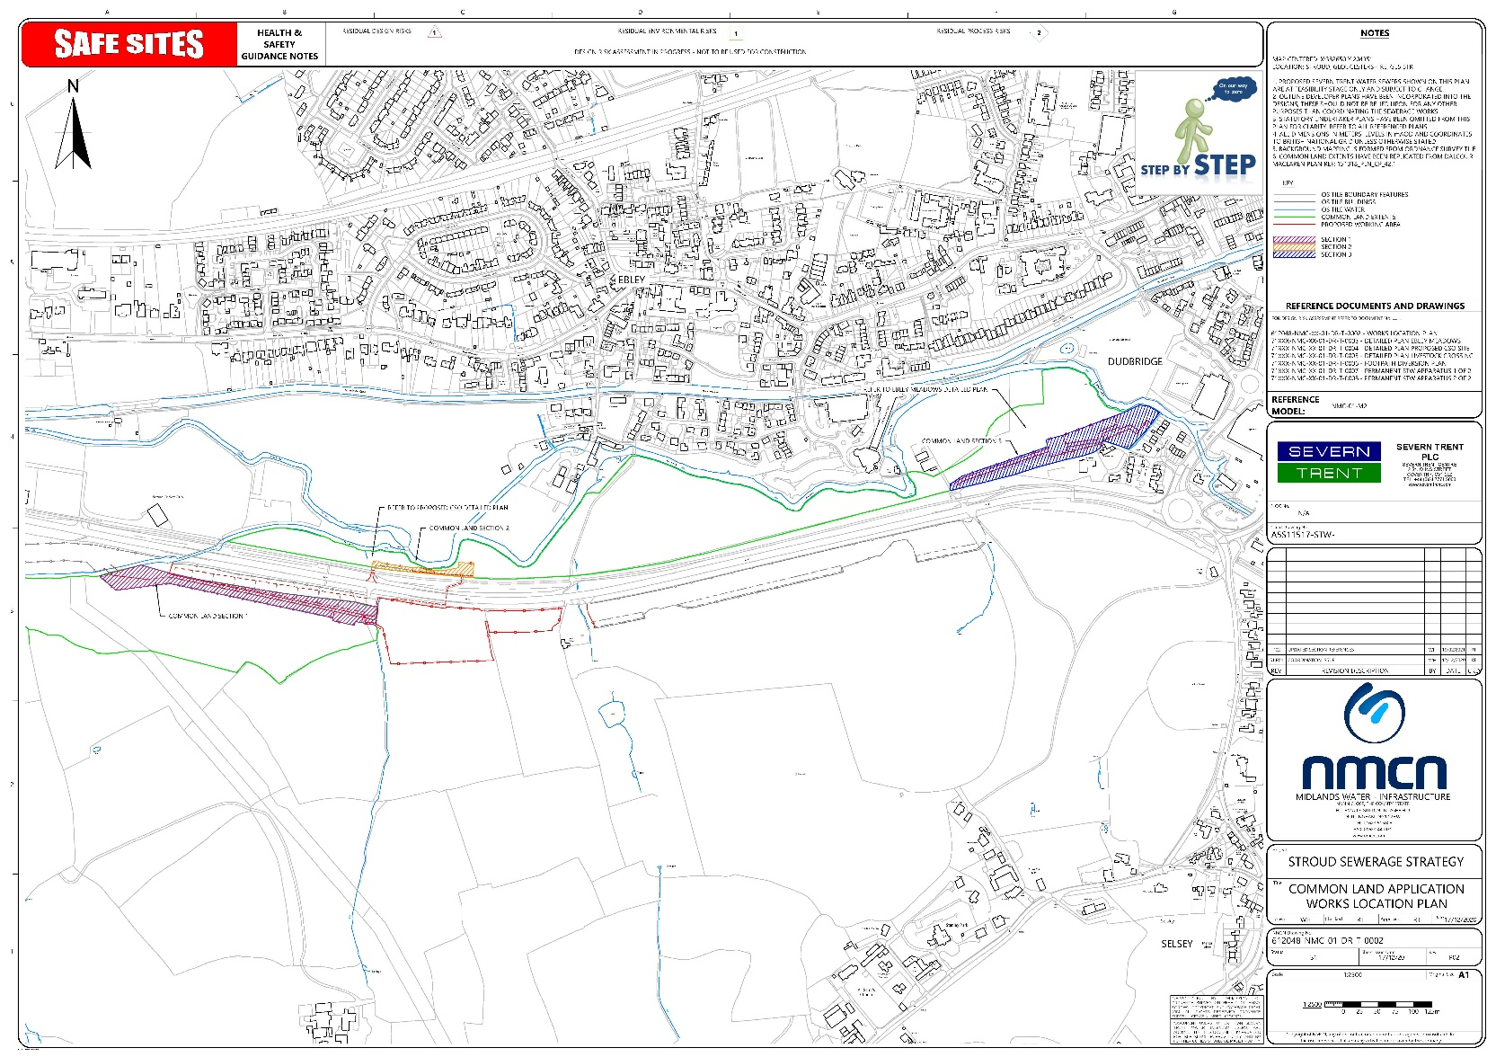

Common Land Consents Policy (Defra November 2015)
Section 39(2) of the 2006 Act provides that the public interest includes the public interest in; nature conservation; the conservation of the landscape; the protection of public rights of access to any area of land; and the protection of archaeological remains and features of historic interest.

