Tuberculosis (TB) in Cattle: Pre-movement and Post-movement Testing in Great Britain, 2006 to September 2020

This notice contains statistics on statutory pre- and post- movement TB testing that is carried out to reduce the risk of spreading TB through movements of infected cattle. Unlike the majority of TB tests, the pre- and post-movement tests reported on in this notice were arranged and paid for by herd owners.

Key points in this quarterly release July to September 2020:

- Pre-movement tests in England led to the identification of 171 reactors, including 4 inconclusive reactors (IRs) that became reactors at retest, out of 126,563 tests completed.
- Pre-movement testing in Wales led to the identification of 20 reactors, out of 37,479 tests completed.
- Post-movement testing in the Low Risk Area (LRA) of England led to identification of 3 reactors, out of 11,927 tests completed.
- There were 405 post-movement tests in Scotland of animals that had arrived from annual and six-monthly testing areas in England and Wales. These tests identified no reactors.
- There were 3,355 post-movement tests in the low TB area of Wales. These tests identified no reactors.

The different TB movement testing regimes in England, Scotland and Wales reflect regional variations in disease incidence, including the Officially TB Free status of Scotland.

Correction Notice
Our quality-assurance procedures have identified that in previous editions of this release, the reported number of 6 Day Standstill herds in the Wales Post Movement dataset were incorrect by a factor of 3. The source of this error has been corrected, and this and future releases will include the correct values for this figure.

Contents of this official statistics release:

England Pre-movement TB Testing 2
Wales Pre-movement TB Testing 3
Scotland Post-movement TB Testing 5
Post-movement TB Testing in the Low Risk Area of England 5
Post-movement TB Testing in Low TB Area of Wales 7
About these statistics 8

The movement of cattle with undetected TB infection is believed to be the most common way in which this disease spreads to new areas. In particular, movements of cattle from high bovine TB incidence areas of GB pose a substantial risk of introducing the infection to the lower incidence areas of England and Wales and to Scotland, which has been officially free of TB since September 2009. Such movements account for more than a third of all new TB herd breakdowns with lesion- or culture-positive animals identified in the LRA each year and about one fifth of such breakdowns in the Edge Area. Source: Bovine tuberculosis in England in 2019: Epidemiological analysis of the 2018 data and historical trends. Figure 3.2.10 Summary of the weighted source of infection attributed for all incidents that started in 2018, in the LRA.

England Pre-movement TB Testing

Compulsory pre-movement testing of cattle was introduced in England in March 2006, initially for animals over 15 months of age. The minimum qualifying age was lowered to 42 days the following year. Legislative changes implemented since 2012 have progressively led to the abolition of the majority of pre-movement testing exemptions that were permitted under the original TB legislation. Nowadays, all cattle aged 42 days and over moving out of annually (or more frequently) tested herds must have a skin test with negative results within 60 days before movement, with few exceptions such as cattle moving directly to slaughter, to an approved finishing unit (AFU) or to a slaughter market.

Figure 1 Reactors slaughtered by quarter in England following disclosure by pre-movement tests, since the rollout of the policy in March 2006
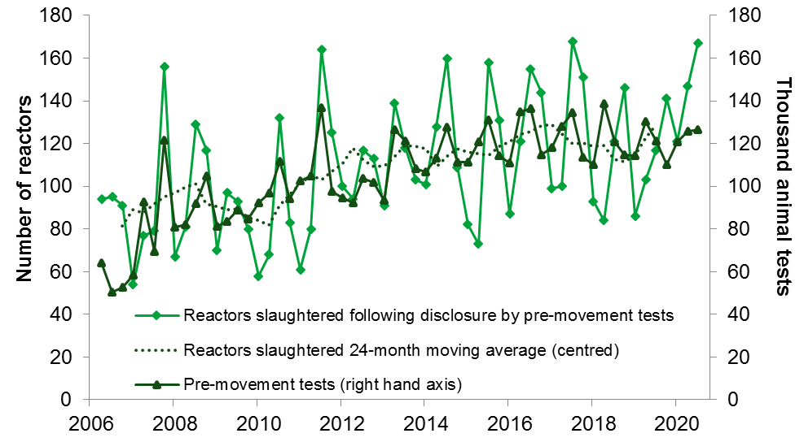

Note: “reactors slaughtered” timeline excludes inconclusive reactors (IR) that became reactors (R) at retest – known as IR to R.

Table 1 England pre-movement TB tests quarterly
Measure | Oct-Dec 2019 | Jan-Mar 2020 | Apr-Jun 2020 | Jul-Sep 2020
All movements | 1,200,029 | 1,131,042 | 1,161,792 | 1,157,820
Pre-movement animal tests | 110,233 | 120,624 | 125,757 | 126,563
Pre-movement test reactors | 141 | 121 | 147 | 167
Total reactors: PRMT and IR to R | 151 | 124 | 154 | 171
Herds with reactors | 53 | 64 | 67 | 92

Table 2 England pre-movement TB tests annually, 2016 to 2019
Measure | 2016 | 2017 | 2018 | 2019
All movements | 4,635,166 | 4,738,884 | 4,704,690 | 4,643,159
Pre-movement animal tests | 496,698 | 494,268 | 484,427 | 475,734
Pre-movement test reactors | 507 | 518 | 444 | 447
Total reactors: PRMT and IR to R | 554 | 565 | 489 | 480
Herds with reactors | 271 | 280 | 232 | 215

Annual numbers of pre-movement tests (PRMT) in England increased by 27% between 2012 and 2016. There was an expansion of the areas under annual routine testing and the division of England on 1 January 2013 into a Low Risk Area (on background four-yearly herd testing) and High Risk and Edge Areas (where cattle herds were placed on annual or six-monthly surveillance testing). Annual numbers of pre-movement tests in England have declined 4% since 2016.

Since 2013 the number of herds in England that have had reactors disclosed by pre-movement testing has remained fairly constant as an annual total. Figure 1 shows the seasonal fluctuation in reactors slaughtered with peaks generally in the July to September quarter. This is most likely due the PRMT undertaken prior to the October moves and sales, when animals have been grazing outdoors during spring and summer.
The underlying statistical dataset from 2006 (Table A: England Pre-movement tests) is available to download.

Wales Pre-movement TB Testing
The policy was introduced to Wales in May 2006, with some changes to exemptions since 2010. All cattle aged 42 days and over moving out of an annually or more frequently tested herd must have tested negative to a TB test within 60 days before movement - unless the herd or type of movement is exempt.

Figure 2 Reactors slaughtered by quarter in Wales following disclosure by pre-movement tests, since the rollout of the policy in March 2006
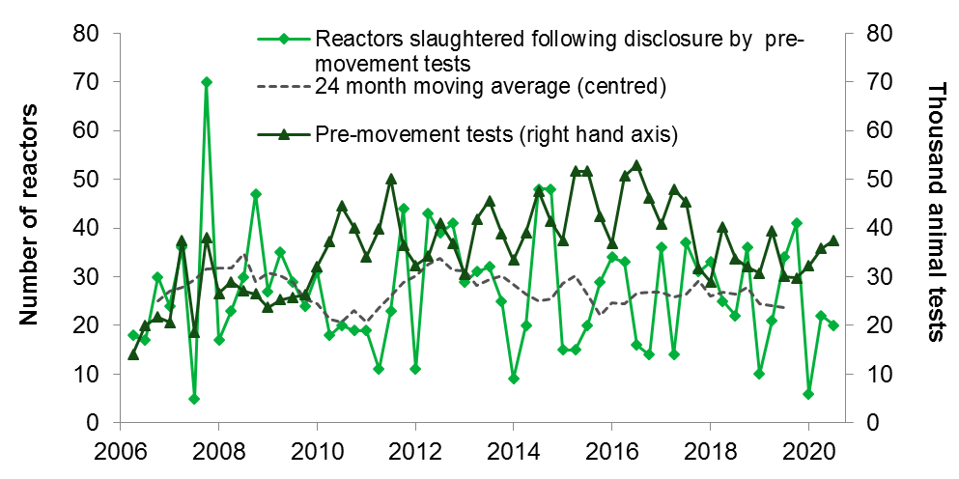

Note: “reactors slaughtered” timeline excludes inconclusive reactors (IR) that became reactors (R) at retest – known as IR to R.
Table 3 Wales pre-movement TB tests quarterly
Measure | Oct-Dec 2019 | Jan-Mar 2020 | Apr-Jun 2020 | Jul-Sep 2020
All movements | 242,633 | 201,526 | 219,505 | 225,618
Pre-movement animal tests | 29,779 | 32,273 | 35,758 | 37,479
Pre-movement test reactors | 41 | 6 | 22 | 20
Total reactors: PRMT and IR to R | 50 | 7 | 22 | 20
Herds with reactors | 17 | 4 | 9 | 14

Table 4 Wales pre-movement TB tests annually, 2016 to 2019
Measure | 2016 | 2017 | 2018 | 2019
All movements | 872,081 | 894,532 | 917,358 | 880,329
Pre-movement animal tests | 186,538 | 165,786 | 134,983 | 129,855
Pre-movement test reactors | 97 | 118 | 116 | 106
Total reactors: PRMT and IR to R | 117 | 134 | 136 | 128
Herds with reactors | 52 | 57 | 55 | 54

From 1 October 2017 farmers in the Low TB Area of Wales are not required to pre-movement test (PRMT) cattle (some exceptions apply). In the 12 months before the policy change farmers in the Low TB area paid for 50,304 PRMT, around 45,000 of these tests in Wales would now not be required. This represents 25% of all PRMT in Wales during the 12 month period before the policy change. The underlying statistical dataset from 2006 (Table B: Wales Pre-movement tests) is available to download.

Scotland Post-movement TB Testing
Introduced in 2005, all cattle 42 days old and over in a yearly testing area must be pre-movement tested before they enter any Scottish herd. Having entered a Scottish herd these animals must be post-movement tested within 60-120 days although exemptions apply such as if a routine herd test is scheduled.

The figures shown here relate solely to Scotland's post-movement testing rules. A small number of compliance tests are carried out in Scotland on animals with movements not compliant with England and Wales testing rules before they were moved to Scotland. These tests are not included in the data.

Table 5 Scotland post-movement tests quarterly
Measure | Oct-Dec 2019 | Jan-Mar 2020 | Apr-Jun 2020 | Jul-Sep 2020
Post-movement tests (POMT) | 722 | 265 | 442 | 405
Post-movement test reactors | 0 | 0 | 8 | 0
Total reactors: POMT and IR to R | 0 | 0 | 8 | 0
Herds with reactors | 0 | 0 | 1 | 0

Table 6 Scotland post-movement tests annually, 2016 to 2019
Measure | 2016 | 2017 | 2018 | 2019
Post-movement tests | 1,414 | 1,218 | 1,223 | 1,859
Post-movement test reactors | 0 | 0 | 1 | 0
Total reactors: POMT and IR to R | 0 | 0 | 1 | 0
Herds with reactors | 0 | 0 | 1 | 0

The number of reactors disclosed by these tests is consistently very low. The 8 reactors identified in Quarter 2 of 2020 were all animals from one batch of cattle that moved from a single herd in Wales.
The number of post-movement tests carried out each quarter in Scotland is usually in the 200 to 400 range. Q4 2019 was exceptionally high at 722.

In September 2015 there was a change to the way that tests on animals arriving from Northern Ireland were recorded so that they are now captured on a separate code. Data from earlier years is not directly comparable. The underlying statistical dataset from 2006 (Table C: Scotland post-movement tests) is available to download.

Post-movement TB Testing in the Low Risk Area of England
Introduced on 6 April 2016, post-movement testing is required between 60 and 120 days after animals arrive to the LRA from other parts of England or from Wales. Therefore, the movements may have been undertaken in the previous period e.g. reactors found in Q1 could correspond to testing of animals moved during Q4.

Figure 3 Reactors slaughtered by quarter in England following disclosure by post-movement tests, since the rollout of the policy in April 2016
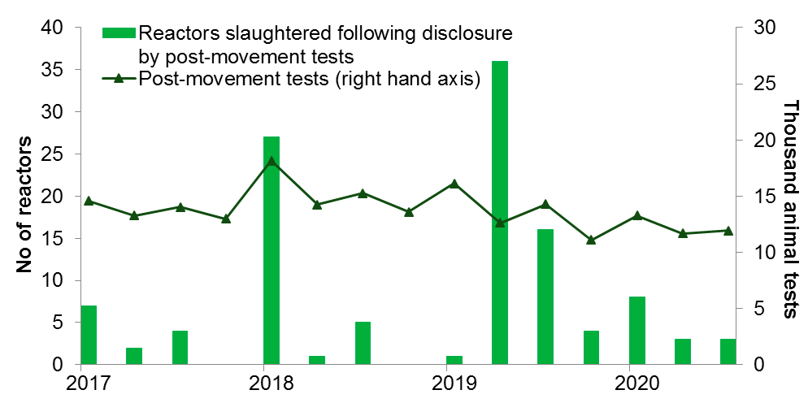

Note: “reactors slaughtered” timeline excludes inconclusive reactors (IR) that became reactors (R) at retest – known as IR to R.

Table 7 Post-movement testing in Low Risk Area of England, quarterly
Measure | Oct-Dec 2019 | Jan-Mar 2020 | Apr-Jun 2020 | Jul-Sep 2020
Cattle movements on to the LRA from Wales and higher risk areas of England | 27,139 | 25,897 | 28,900 | 28,869
Post-movement tests (POMT) | 11,107 | 13,290 | 11,685 | 11,927
POMT reactors | 4 | 8 | 3 | 3
Total reactors: POMT and IR to R | 5 | 9 | 3 | 3
Herds with reactors | 1 | 6 | 3 | 3
Table 8 Post-movement testing in Low Risk Area of England, annually
Measure | Apr-Dec 2016 | 2017 | 2018 | 2019
Cattle movements on to the LRA from Wales and higher risk areas of England | 77,212 | 117,875 | 115,431 | 104,521
Post-movement tests (POMT) | 10,020 | 54,861 | 61,254 | 54,143
POMT reactors | 1 | 13 | 33 | 57
Total reactors: POMT and IR to R | 1 | 15 | 34 | 63
Herds with reactors | 1 | 10 | 8 | 6

The latest quarter identified 3 reactors. The quarterly testing effort has remained relatively consistent since 2017, with the number of reactors disclosed ranging from 0 to 40. The underlying statistical dataset (Table D: England post-movement tests) is available to download.

Post-movement TB Testing in Low TB Area of Wales
From 1 October 2017 farmers in the Low TB Area of Wales need to Post-Movement Test cattle which move from a herd in an Intermediate or High TB area in Wales; or the Edge or High Risk Area of England. In common with the England LRA testing policy, a post movement test is not needed if the animal is tested as part of an annual surveillance test within the 60 to 120 day Post-Movement Test window. Therefore the movements may have been undertaken in the previous period e.g. reactors found in Q1 could correspond to testing of animals moved during Q4 the previous year (or earlier if tested when non-compliance was found).

Table 9 Post-movement testing in Low TB Area of Wales, quarterly
Measure | Oct-Dec 2019 | Jan-Mar 2020 | Apr-Jun 2020 | Jul-Sep 2020
Cattle movements on to the Low TB Area from higher risk areas of England and Wales | 4,041 | 3,898 | 4,975 | 4,981
Post-movement tests (POMT) | 2,438 | 2,182 | 2,481 | 3,355
POMT reactors | 0 | 0 | 0 | 0
Total reactors: POMT and IR to R | 0 | 0 | 0 | 0
Herds with reactors | 0 | 0 | 0 | 0

Table 10 Post-movement testing in Low TB Area of Wales, annually
Measure | Oct-Dec 2017 | 2018 | 2019
Cattle movements on to the Low TB Area from higher risk areas of England and Wales | 5,078 | 14,335 | 16,091
Post-movement tests (POMT) | 63 | 8,751 | 10,786
POMT reactors | 0 | 0 | 0
Total reactors: POMT and IR to R | 0 | 0 | 0
Herds with reactors | 0 | 0 | 0

To date no reactors have been detected in herds in Low TB Area of Wales under the post movement testing policy. The underlying statistical dataset (Table E: Wales post-movement tests) is available to download.

About these statistics

Data source and future revisions

These statistics are obtained from the two sources:
- Animal and Plant Health Agency (APHA) work management IT support system (Sam), used for the administration of TB testing in GB,
- The Cattle Tracing System (CTS).
Data can be subject to review back to 2018.

Feedback on these statistics
We encourage our users to engage with us so we can improve our National and Official Statistics and identify gaps in the statistics that we produce.
This document has been designed to meet the accessibility requirements outlined in WCAG 2.1. Should you have any comments on this statistical release and how to improve it to meet your needs please contact us by email to tbstatistics@defra.gov.uk

Phone (UK only): 03459 33 55 77
Phone (outside UK): +44 20 8225 7318
Media Enquiries (Press Office): 020 8225 7318

This is an Official Statistics publication. These statistics have been produced to the high professional standards set out in the Code of Practice for Official Statistics.

Glossary of terms

Term | Definition
AFU | Approved Finishing Units.  AFUs provide a route for rearing, fattening or finishing cattle from TB restricted and un-restricted farms. AFUs must be approved and licensed by APHA. There are two types: AFUs with grazing (only in certain areas of the High Risk Area of England only) and AFUs without grazing.
APHA | Animal and Plant Health Agency.
CTS | Cattle Tracing System.
EFU | Exempt Finishing Units. EFUs provide a route for beef producers to finish cattle without the need for a pre-movement test. EFUs must be approved and licensed by APHA. These units must meet strict conditions to reduce the potential risk of disease spread from the premises. There are two types: EFUs with grazing and EFUs without grazing.  From 1 July 2017 no new units can be approved in Wales. From 1 January 2018 no EFUs exist in Wales.
IR | Inconclusive reactor. An animal showing a positive reaction to tuberculin that was not strong enough for it to be deemed a reactor. These animals may be tested again after 60 days or can be slaughtered voluntarily.
LFU | A licensed finishing unit (LFU) is a type of TB unit approved by APHA in the LRA and Low TB Area of Wales. Cattle finished in LFUs will remain under movement restrictions at all times and can only be moved from those units directly to slaughter.
LRA | Low risk area of England.
POMT | General term for all types of post movement tests.
POSTLRAOV | LRA Post-Movement TB Test Code
POSTMOVOV | Wales Low TB Area Post-Movement Test Code
POSTMTS | Post-movement test (Scotland) This is a post-movement test, paid for by the keeper, to be carried out 60-120 days after arrival to Scotland from England or Wales (exceptions apply). The code was amended in September 2015 to exclude animals arriving from Northern Ireland.
PRMT | Pre-movement test (England, Wales) a pre-movement test carried out 60 days or less prior to movement of an animal(s) from an annually or more frequently tested herd.
PRMTS | A test paid for by the keeper to be carried out on cattle that have arrived into Scotland that should have had a pre-movement test before departure. Data is not included in these statistics.
R | Reactor. An animal which was compulsorily slaughtered because it responded to the tuberculin skin test in a way that was consistent with it being infected with Mycobacterium bovis.

© Crown copyright 2021. You may re-use this information free of charge under the terms of the Open Government Licence v.3. The licence is available to view online.

