

Statistical Digest of Rural England
Expenditure
This document is part of the larger compendium publication the Statistical Digest of Rural England, a collection of rural statistics on a wide range of social and economic government policy areas.
The Statistical Digest of Rural England is an official statistics publication meaning these statistics have been produced to the high professional standards set out in the Code of Practice for Official Statistics.
More information on the Official Statistics Code of Practice can be found on the Code of Practice web pages.

These statistics allow comparisons between the different rural and urban area classifications. The Rural-Urban Classification is used to distinguish rural and urban areas. The Classification defines areas as rural if they fall outside of settlements with more than 10,000 resident population.
More information on the Rural-Urban Classification can be found on the Rural-Urban Classification web pages.

Any enquiries regarding this publication should be sent to us at:
rural.statistics@defra.gsi.gov.uk

Last updated: 24th June 2021

Expenditure
- Levels of household expenditure are unsurprisingly closely related to disposable income.
- However, there are differences in absolute and proportional spending patterns, appearing to reflect where households live.
- These differences may illustrate where changes in price or spending patterns would have the greatest impacts.
- As of March 2020, households in Rural Villages had both the highest disposable incomes, and the highest levels of expenditure. Households in Rural Town & Fringe areas had the lowest levels of disposable income, while households in Urban areas had the lowest levels of expenditure.
- The measure of average weekly household expenditure excludes mortgage payments. Please see the notes at the end of the section for further detail on this.

Nominal expenditure and disposable income
Average weekly household expenditure (excluding mortgage payments) and disposable income, by rural-urban classification, England, year ending March 2020
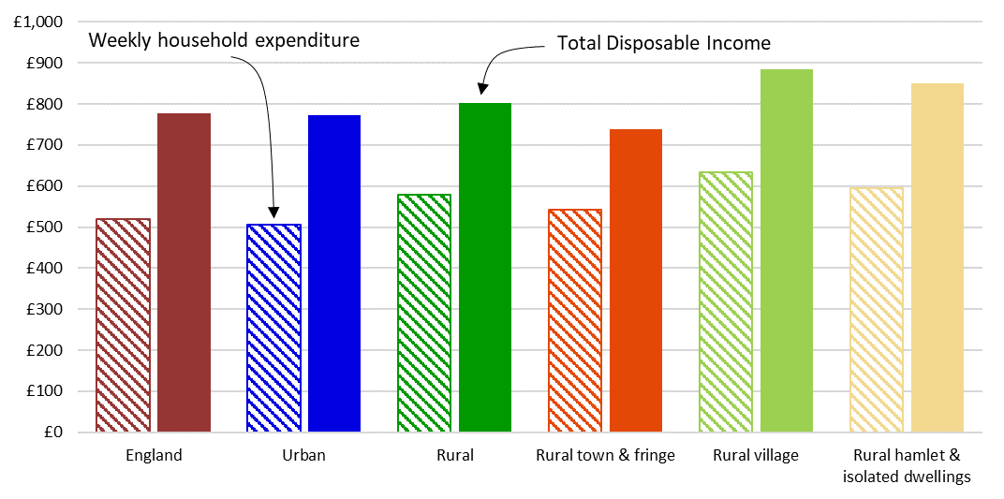
- Households in Rural Villages have the highest disposable incomes at £885 on average, which is around £113 more than the Urban average. However, they also have the highest weekly household expenditure at £634 on average, £128 higher than Urban households (household expenditure excludes mortgage payments).
- In the year ending March 2020, average household expenditure as a proportion of disposable income ranges from the lowest at 66 per cent in Urban areas to the highest at 73 per cent in Rural Town and Fringe (household expenditure excludes mortgage payments).

Average weekly expenditure (excluding mortgage payments) as a percentage of average weekly disposable income, rural-urban classification, England, for years ending December 2011 to March 2020
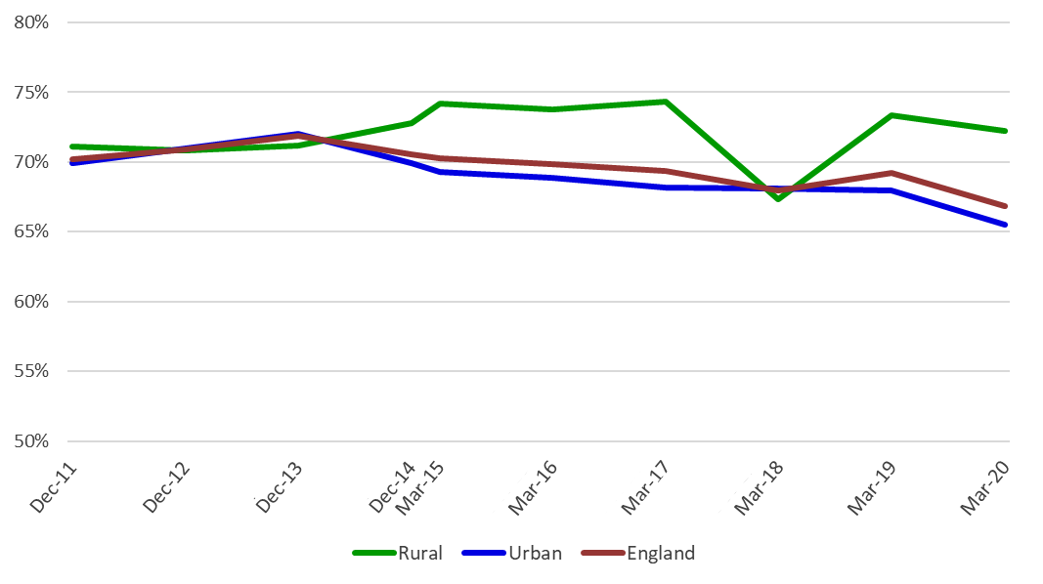
Note: The reporting period for weekly expenditure and income changed at the end of 2014 and moved from calendar year (ending December) to financial year (end March). All other variables stayed the same.
- In December 2011, average weekly expenditure (excluding mortgage payments) as a percentage of average weekly disposable income was highest in Rural Villages and Rural Hamlet and Isolated Dwellings at 71 per cent. It was lowest in Urban areas at 70 per cent.
- Since December 2011 there has been some fluctuation in the relationship between average income and average expenditure in both rural and urban areas. However, in March 2020 average weekly expenditure (excl. mortgage payments) as a percentage of average weekly disposable income was highest in Rural Town and Fringe areas and lowest in Urban areas.
- Historically, from the year-ending December 2014, the average weekly expenditure (excluding mortgage payments) as a percentage of average weekly disposable income has been consistently higher in rural areas than urban areas, except for the year-ending March 2018.
- For the year-ending March 2020 compared to the year-ending March 2018, there was a large increase in expenditure as a percentage of disposable income for rural areas. The largest changes of weekly expenditure on a commodity or service were a £12 increase for ‘Transport costs’, and an £11 increase for ‘Recreation’.
Average weekly expenditure (excluding mortgage payments) as a percentage of average weekly disposable income, rural-urban classification, England, for years ending December 2011 to March 2020
 | Dec -2011 | Dec -2012 | Dec -2013 | Dec -2014 | Mar- 2015 | Mar-2016 | Mar-2017 | Mar-2018 | Mar-2019 | Mar-2020
Rural | 71.1 | 70.8 | 71.2 | 72.8 | 74.2 | 73.8 | 74.3 | 67.3 | 73.3 | 72.2
Rural town & fringe | 70.3 | 68.7 | 68.7 | 73.4 | 73.7 | 73.8 | 74.8 | 68.1 | 68.1 | 73.4
Rural villages | 71.0 | 73.0 | 68.3 | 72.3 | 75.4 | 74.0 | 73.8 | 66.6 | 80.4 | 71.6
Rural hamlet & isolated dwellings | 71.0 | 68.4 | 74.7 | 72.3 | 71.7 | 72.8 | 73.8 | 67.2 | 71.1 | 70.0
Urban | 69.9 | 71.0 | 72.0 | 69.9 | 69.3 | 68.9 | 68.2 | 68.1 | 67.9 | 65.5
England | 70.2 | 70.9 | 71.9 | 70.5 | 70.3 | 69.9 | 69.3 | 67.9 | 69.2 | 66.9

Expenditure on commodity or service groups
Breakdown of average weekly household expenditure (excluding mortgage payments), by commodity or service, by rural-urban classification, England, year ending March 2020
Average weekly household expenditure (excluding mortgage repayments) in Rural areas:
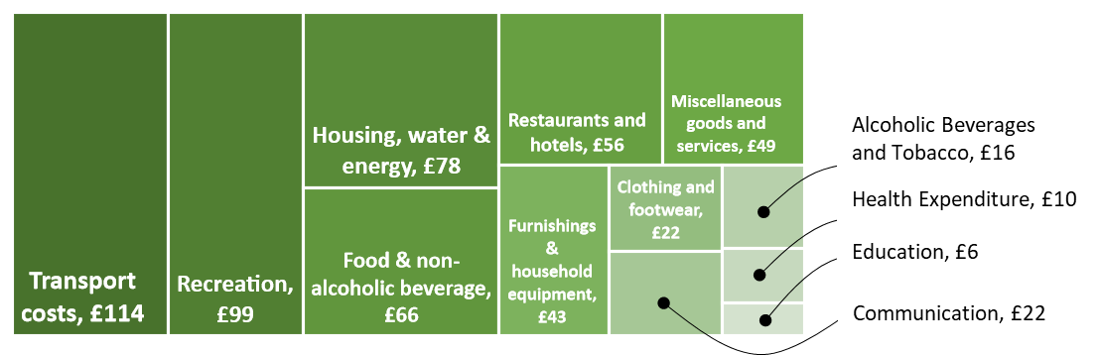
Average weekly household expenditure (excluding mortgage repayments) in Urban areas:
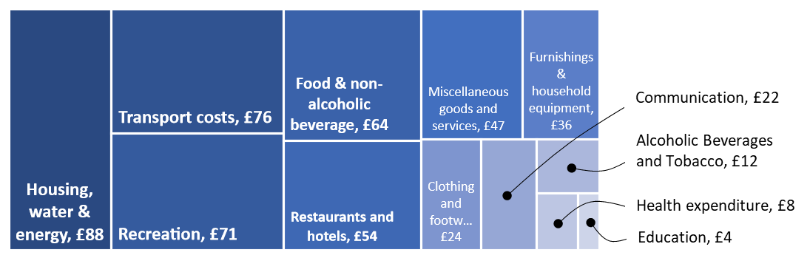
- Rural households spend a higher proportion of their disposable income on ‘transport’ and ‘recreation’ than they do on ‘housing, water and energy’, compared with urban areas where households on average spend the highest proportion of their income on ‘housing, water and energy’.
- Rural household’s average weekly ‘Transport costs’ were £38 greater than those of urban households. Similarly, the average weekly ‘Recreation’ expenditure was £27 greater for those from rural households compared with those of urban households.
- In the year ending March 2020, average weekly ‘Transport costs’ was greatest for those in Rural Villages at around £131, which accounted for 14.8 per cent of their weekly disposable income and was £55 higher than households in Urban areas.
- The amount spent on most commodities and services, such as ‘Food’, ‘Alcohol’, ‘Recreation’, and ‘Hotels’, was greatest for households in Rural Villages and Rural Hamlets and Isolated Dwellings. However, both these settlement types also have the highest average weekly disposable incomes at £885 and £851, respectively.
- Tables showing the average weekly household expenditure and a percentage breakdown for the year-ending March 2020, broken down by rural-urban classification are available in the rural living supplementary data tables.
Average weekly Housing, water & energy expenditure (excluding mortgage payments) as a percentage of average weekly disposable income, rural-urban classification, England, for years ending December 2013 to March 2020
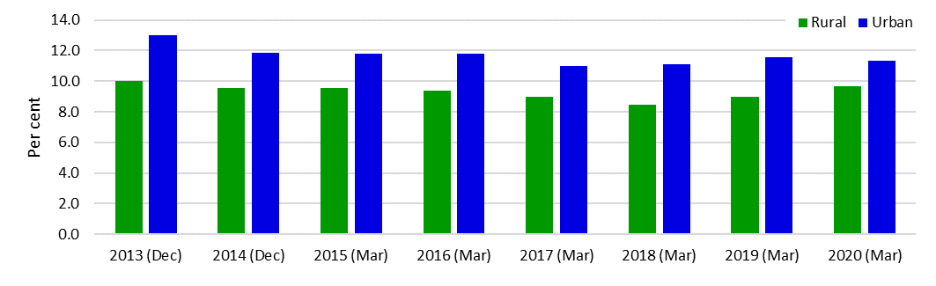
Average weekly expenditure on Transport costs as a percentage of average weekly disposable income, rural-urban classification, England, for years ending December 2013 to March 2020
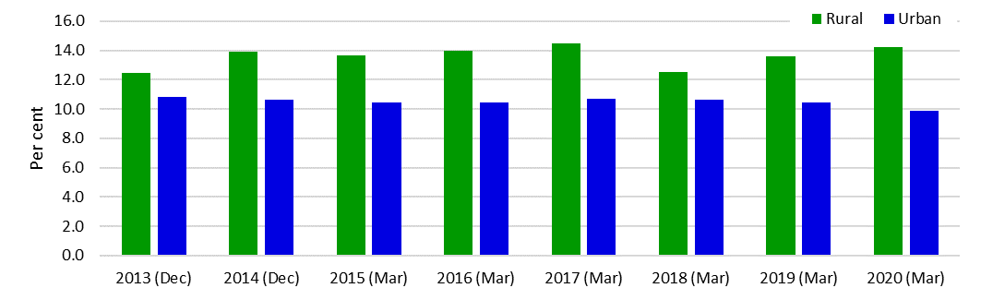
- Average weekly expenditure on ‘housing (excluding mortgage payments), water and energy’, and ‘transport costs’ represent the two biggest expenditure items for Urban and Rural areas respectively.
- Average weekly expenditure on ‘housing (excluding mortgage payments), water and energy’ (as a percentage of average weekly disposable income) declined year-on-year in Rural areas between 2013 and 2018 but has since risen to 10 per cent of disposable income.
- Average weekly expenditure on ‘transport costs’ has increased to 14 per cent of disposable income in Rural areas, while in Urban areas it has fallen to 10 per cent of disposable income.

Notes:
- Average weekly expenditure does not include mortgage payments. Data come from the ONS Living Costs and Food Survey which uses the Classification Of Individual Consumption by Purpose (COICOP) system to classify expenditure items. COICOP is an internationally agreed system of classification for reporting consumption expenditure within National Accounts and is used by other household budget surveys across the European Union. COICOP classified housing costs do not include, what is considered to be, non-consumption expenditure, for example: mortgage interest payments, mortgage capital repayments, mortgage protection premiums, council tax and domestic rates.
- The measure of income used here does not include withdrawal of savings, loans and money received in payment of loans, receipts from maturing insurance policies and proceeds from the sale of assets.
- Transport costs include the purchase and operation of personal vehicles and fares paid on public vehicles. All journeys are recorded within the transport section. Recreation costs include for example sports equipment, admission charges, audio-visual equipment, the purchase of CDs, computer equipment and games, pets and horticultural equipment.

Source: Office for National Statistics, Living Costs and Food Survey: www.ons.gov.uk/peoplepopulationandcommunity/personalandhouseholdfinances/incomeandwealth/methodologies/livingcostsandfoodsurvey)

