
National Security Framework Ref: NSF 15.3

VETTING FUNCTION
SECURITY VETTING – ADDITIONAL RISK CRITERIA FOR EX-OFFENDERS WORKING IN PRISON AND COMMUNITY SETTINGS
This Instruction applies to : |  |  | Reference :
HMPPS Headquarters  Prisons  Providers of Probation Services |  |  | AI 20/2014  PSI 27/2014  PI 23/2014
Issue Date | Effective Date  Implementation Date |  | Expiry Date
Revised  26 June 2021 | 26 June 2021 |  | n/a
Issued on the authority of | HMPPS Operational Policy Sub-Board
For action by | All staff responsible for the development and publication of policy and instructions  HMPPS HQ  Probation Service  Public Sector Prisons  Contracted Prisons*  Governors  Heads of Groups  HMPPS Rehabilitation Contract Services Team  Other Providers of Probation Services  * If this box is marked, then in this document the term Governor also applies to Directors of Contracted Prisons
Instruction type | Service Improvement
For information | All HQ, Prison staff, Probation Service staff, Probation Service Providers and voluntary workers.
Provide a summary of the policy aim and the reason for its development | This PSI/PI provides an explanation of the policy and procedures that must be followed for the security vetting of all ex-supervised individuals requiring Standard Plus vetting.  26 June 2021 This policy has been revised to reflect the termination of CRC contracts from June 2021 and provide up-dated references to structures and roles.
Contact | SOCT.Procedures@justice.gov.uk
Associated documents | Extant Target Operating Model  PSI 40/2014 – PI 26/2014 Offenders as mentors  PSI 07/2014 - AI 05/2014 - PI 03/2014 Security Vetting  PSI 38/2013 Reconsideration of central vetting decisions  Information Sharing Policy Framework  PSI 42/2014 Exclusions of personnel on grounds of misconduct  PSI 03/2018 The Data Protection Act 2018 and General Data Protection Regulation  The Freedom of Information Act 2000  Environmental Information Regulations 2004
Replaces the following documents which are hereby cancelled: PSI 31/2012 - Security Vetting: Additional Risk Assessment Criteria Following Disclosed Criminal Convictions (Ex Offenders)

Audit/monitoring: The Director of the Probation Service in England, and Director of HMPPS in Wales and HMPPS Director of Rehabilitation Services for Probation service providers will monitor compliance with the mandatory requirements in this instruction.

HMPPS contract management will hold providers to account for delivery of mandated instructions as required in the contract.

HMPPS Prison Group Directors and Controllers, will monitor compliance with the mandatory actions set out in this Instruction.
Notes: All Mandatory Actions throughout this instruction are in italics and must be strictly adhered to.

Contents

Hold down “Ctrl” and click on section titles below to follow the link.

Section | Subject | Reference by
1 | Executive Summary | All staff and workers
2 | Introduction | All staff and workers
3 | Objectives scope and limitations of the policy | All staff and workers
4 | Overview of Procedure | All staff and workers
5 | Risk Management | All staff and workers
6 | Review Process | All staff and workers
7 | Equal Opportunities | All staff and workers
8 | Data Protection | All staff and workers
Annex A | Sample Local Risk Assessment -Prisons | All staff and workers
Annex B | Standard Plus Prison – Request For Information | All staff and workers
Annex C | Standard Plus Prison – Confirmation Letter | All staff and workers
Annex D | Standard Plus Prison – Request For Renewal | All staff and workers
Annex E | Sample Local Risk Assessment - Community | All staff and workers
Annex F | Guidance On The Suitability For Standard Plus Prison And Community | All staff and workers
Annex G | Standard Plus Community – Request For Prison Visit | All staff and workers
Annex H | Standard Plus Community – Confirmation Letter | All staff and workers
Annex I | Standard Plus Community – Request For Renewal | All staff and workers
Annex J | Roles And Responsibilities | All staff and workers
Annex K | Glossary of Terms | All staff and workers

EXECUTIVE SUMMARY

Background
  - This instruction contains guidance and mandatory direction to be followed by both Governors/Directors and Senior Managers in the Probation Service and Probation Service Providers when security vetting ex-supervised individuals who have failed the normal vetting process. The policy recognises that an ex-supervised individual’s previous offending history may prevent them from being successfully vetted through the normal centralised framework. This policy makes provision for them to be considered through a time limited vetting level called either ‘Standard Plus - Prison’ or ‘Standard Plus - Community’ dependent upon the primary location of the activity they will be undertaking. This can be run concurrently with normal vetting procedures. Governors and Directors of prisons retain the discretion to refuse access to a prison where security concerns about an individual are identified even where Standard Plus – Community clearance has been approved.
  - Ex-offenders are defined as individuals whose community/suspended sentence order; licence or post sentence supervision has been completed and there is no longer a right to recall. A separate policy covering Offenders as Mentors has been issued within PSI 40/2014/ PI 26/2014.
  - Ex-offenders, who have served sentences for particular specified offences where the underlying risk posed to safety and security in a prison or community environment is judged to remain significant, will only be considered for Standard Plus in exceptional circumstances. Guidance on the suitability for Standard Plus is given at Annex F.

    - This Instruction should be read in conjunction with PSI 07/2014 - AI 05/2014 - PI 03/2014 Security Vetting

Desired Outcomes
- Greater flexibility for those organisations engaged with reducing re-offending and rehabilitative activities to use ex-offenders within a prison or in the community to work with current supervised individuals.

- Provide a policy framework which ensures that Probation service providers comply with relevant legislation and all non directly employed workers and volunteers undergo consistent and appropriate security vetting checks.

- Provide assurance to HMPPS that security vetting checks have been undertaken on all individuals engaged on rehabilitation activities in both prison and probation community settings.

- Ensure all Standard Plus vetting clearances in prisons and the community are logged centrally at Shared Services.

- Ensure that accountability for the suitability of ex-supervised individuals is approved by Governor/Director, Head of Group, or a Senior Manager within the Probation Service.

Changes to the Policy

  - Standard Plus vetting is now split between those rehabilitation roles in a prison and those relating to the provision of probation services almost entirely in the community.
  - Prison based roles will be called Standard Plus – Prison
  - Community based roles, Standard Plus – Community.
  - the Probation Service are accountable for decisions on the suitability of ex-supervised individuals for Standard Plus – Community.
  - Governors are responsible for decisions on the suitability of ex-offenders put forward for Standard Plus – Prison and entry to a prison for those working mainly in the community under Standard Plus - Community.

Mandatory Actions

  - All mandatory actions in this instruction are indicated in italics, unless specified otherwise. Prison Group Directors, Probation Service Regional Probation Directors, of the Probation Service, Governors/Directors and Senior Managers within the Probation Service and Probation service providers must ensure that all relevant staff are aware of the mandatory actions required and that the policy is implemented and adhered to. It is the responsibility of the suppliers to ensure that the vetting of ex-offenders remains up to date. An audit trail must be retained for all vetting cases.

  - Mandatory actions are referenced in the following sections 2.3, 2.6, 2.9, 2.10, 2.12, 2.14, 2.15, 2.16, 3.4, 4.5, 4.7, 4.8, 4.10, 4.11,5.2, 5.3, 5.4, 6.3, Annex A, E, F, H, I, J.

Resource Implications

  - Prisons will need to ensure that sufficient resources are available for carrying out the risk assessment and the supervision of ex-offenders granted Standard Plus. Probation Service and Probation service providers senior managers will need to have arrangements in place to manage the ex-offenders workers and volunteers working on rehabilitation activities in the community.

(Approved for publication)

Kevin Reilly and Peter Greenhill, Joint-Chairs OPS

2. INTRODUCTION

  - This policy revises the guidance within PSI 31/2012 for each prison establishment and probation region to have in place a process for considering ex-supervised individuals for a ‘Standard Plus’ security vetting clearance. The policy scope is extended to include those ex-offenders working for the Probation Service, and Probation service providers providing rehabilitative services.

  - It is at the discretion of the Governor/Director to evaluate and decide the suitability of applications for Standard Plus for entry to a prison. Where the work is mainly focused in a community setting, access to a prison on an infrequent basis will also be at the discretion of the Governor.

  - For community based activities outside prisons in relation to supervised individuals supervised by the Probation Service or Probation service providers, senior management must ensure that any ex-offenders engaged directly through the providers are vetted in accordance with PSI 07/2014 - AI 05/2014 - PI 03/2014 Security Vetting and in line with the contract for service providers. Decision making on the suitability of an ex-supervised individual to provide probation services or mentoring in the community under the Standard Plus – Community, will be signed off and approved by a senior manager in the Probation Service. A full audit trail must be retained by the Probation Service and where relevant the Probation service provider.

  - It is the responsibility of senior managers to ensure the policies outlined within this instruction are monitored and adhered to.

  - Standard Plus vetting is now split between those rehabilitation roles in a prison and those working for the Probation Service almost entirely in the community. Prison based roles will be called Standard Plus – Prison and community based roles, Standard Plus – Community. Annex J sets out the roles and responsibilities for both processes.

  - Standard Plus is for ex-offenders who will be engaged in delivering rehabilitative activities who would not usually be successful through the usual security vetting procedures because of their previous convictions. For those working in prisons on a frequent basis, the Standard Plus – Prisons clearance is limited to one specific prison location and must be reviewed annually to ensure that any underlying risks are identified and managed accordingly. For community-based roles the Standard Plus – Community clearance will be national unless there are compelling reasons to restrict its scope in particular cases.

  - For Standard Plus – Community security vetting will comply with the mandated HMPPS requirements. MoJ commercial will undertake audit assurance checks for compliance purposes. Probation Service All vetting must always meet the requirements stated in the contract.

  - This model of delivery avoids the need to undertake a large scale change to vetting procedures in Shared Services Connected Limited (SSCL) at a disproportionate cost, in relation to the number of prospective applicant’s able to use this route.

  - The Probation Service, and Probation service providers should not assume that because they have successfully nominated an individual for Standard Plus – Prison at one location he/she will automatically be accepted into others. Where a service provider covers more than one location and wishes to have an individual work across a range of sites, they must make a separate application to each one. This is on the basis that each prison needs to take account of the specific risks relating to their operation.

  - All Standard Plus vetting clearances in a community based setting must be logged by the Probation Service and the record retained for audit purposes.
Standard Plus – Prison

  - Standard Plus - Prison is only for ex-offenders who will work regularly in a prison delivering work focused on the rehabilitation of supervised individuals. Governors will maintain ultimate authority in relation to decisions made concerning individual ex-offenders suitability to work in their establishment. This includes access to any ICT systems. Further information on the consideration of suitability is available in Annex F.

Standard Plus – Community

  - Standard Plus has been extended to include ex-offenders in the community working with the Probation Service, . These roles will be community based with limited prison activity. A decision on the suitability of an ex-supervised individual to work on rehabilitation activities in the community (including access to any ICT systems) will be subject to the same considerations as all other vetting cases. Each case must be signed off for approval by a senior manager within the Probation Service. In this way direct accountability is ensured.

  - The Probation service providers must undertake appropriate vetting themselves. This will be to the level specified in the current contract and will require them to take full responsibility and be fully accountable for the security vetting of all staff and workers within their organisation. Where services are subcontracted the primary contractor retains responsibility for those working for them directly or non-directly. They must also adhere fully with the vetting requirements specified within this policy and the Security Vetting policy PSI 07/2014/PI 03/2014. However, when ex-offenders seek to work in a prison on a regular basis, they will be subject to HMPPS prison security vetting checks. Governors retain ultimate authority to approve or refuse applicants where they are deemed to pose a risk to the safety and security of the prison establishment in all circumstances.

The Probation Service will use the HMPPS central vetting process for ex-offenders who may fail the normal security and vetting process. Advice on an ex-supervised individual’s suitability for Standard Plus will be advised by the Approvals and Compliance Team. Probation Service Regional Probation Directors of the Probation Service will maintain ultimate authority in relation to decisions made concerning individual ex-supervised individual’s suitability to work in their divisions and Wales. An audit trail must be maintained for accountability purposes.

Expiry of Standard Plus

  - All Standard Plus clearances and any individually issued security passes and ICT logins will expire after one year. Ex-Offenders cannot continue to work in the organisation without a renewed vetting clearance. SSCL will close the vetting record unless the prison or Probation service provider confirms that the clearance is still required after review/renewal. This can be confirmed by email in the format outlined at Annex D for prison based programmes and Annex I for community based programmes. Prisons, business units or Probation Service and probation service providers must notify any changes in circumstances, for example where an individual leaves or resigns from the programme or activity, the contract or service being provided is completed or terminated, or, they as individuals have been excluded due to non compliance with local security arrangements. The Standard Plus vetting level will be closed in each case.

  - If an individual is identified as working beyond the expiry date of their Standard Plus clearance they must be removed immediately from their activities until a new clearance has been approved. Governors/Directors, and in the community Senior Probation Service managers, will be accountable for failures to adhere fully to the policy.

OBJECTIVES, SCOPE AND LIMITATIONS OF THE POLICY

3.1 The main objective of the policy remains to improve and provide opportunities for workers/volunteers with previous criminal convictions to work with prisoners and supervised individuals within both prison and community environments without compromising safety and security.

The policy applies to paid and unpaid workers/volunteers with previously openly declared criminal convictions that are going to be engaged on activities relating to reducing re-offending in both the public and private prison sectors or working with the Probation Service or probation service providers delivering rehabilitation activities.

  - This is not a policy that can be applied generically to all applicants who have previous criminal convictions. It is limited to ex-offenders delivering rehabilitative activities for the prison or for a provider working within a prison or working for the Probation Service in the community. Other applicants providing other services and goods must be managed through the normal security vetting procedure as outlined within PSI 07/2014 - AI 05/2014 - PI 03/2014 Security Vetting.

The High Security and Young People’s estates

  - It will not always be possible to facilitate Standard Plus – Prison within the High Security Estate (HSE) where additional security measures may need to be in place or, equally, in the Young People’s estate where there will be additional limitations and welfare measures to meet the specific vetting requirements for working with children and young people.

- OVERVIEW OF PROCEDURE

  - Each applicant will complete the appropriate security vetting procedure dependent on the mandatory vetting levels specified in the Security Vetting policy. These will vary between prison and community settings. The vetting application will be processed, and the criminal conviction checks carried out as part of the vetting process.

  - Where it is identified that the applicant is likely to fail the normal vetting procedure due to their offending history, the prison, or the Probation Service can mark the application for Standard Plus – Prison or Community consideration at the outset. For those cases managed through central vetting procedures, this will mean that consideration for Standard Plus – Prison or Community can run concurrently with the normal procedure once the criminal record check is complete. This will reduce processing time and help inform any decision on suitability more quickly.

  - All security vetting checks for prison and Probation Service community-based job roles will be subject to the HMPPS vetting policy requirements. All applications under this policy will require complete declarations of current spent and unspent convictions prior to consideration for Standard Plus.

  - Ex-supervised individuals will usually be unsuccessful through HMPPS vetting checks because of their recorded convictions. Recourse to a Standard Plus clearance is therefore the only option available to them if they wish to be engaged on rehabilitation programmes through providers of probation services. Their eligibility and suitability for Standard Plus should be flagged alongside their normal vetting application and run concurrently, so streamlining the procedure.

  - Completing a security vetting application is the easiest and most consistent mechanism for ensuring that each case is logged centrally (through the Shared Services function) and the possibility of Standard Plus is considered. For prison-based roles this application will need to be logged with the Governor/Director of the individual prison concerned.

  - For community based roles, the Probation Service will have the application logged centrally and the outcome notified. Probation service providers undertaking their own vetting on ex-supervised individuals approved for Standard Plus - Community for those based outside of HMPPS premises, must report each case on at least a monthly basis to the Approvals and Compliance Team. This is to ensure that a central record is captured for all Standard Plus cases across HMPPS organisation.

  - For prison based roles, if the Governor/Director agrees to consider the Standard Plus – Prison application, the prison will request additional information from the ACT using the form at Annex B. The ACT will provide information to the prison on the result of full criminal convictions (including spent convictions) and any evidence that the applicant has previously been excluded from any prisons, as well as other information that may assist the risk assessment evaluation.

  - On the basis of this information and knowledge of the job role applied for, Governors must identify a responsible head of function who will complete a risk assessment (Annex A) forwarding it to their Governor/Director for consideration and decision. Annex A includes examples of the main issues and factors that the Governor/Director should consider but other considerations may be taken into account. This risk assessment must be carried out and reviewed annually.

  - For prison based roles, it is the responsibility of the Governor/Director to approve or decline the Standard Plus vetting level. If approved, the decision will be advised on the Standard Plus Prison Confirmation Form (Annex C), which must be e-mailed to Shared Services via the ACT team and will state any limitations relating to the applicant (i.e. escorted or supervised at all times, suitability to handle keys or have unaccompanied access to prisoners, access to ICT systems). They will log and pass the confirmation to Shared Services to update the individual’s Oracle vetting record. The Shared Services vetting team will then issue a confirmation to the prison that Standard Plus has been approved.

  - For community-based roles, the Probation Service will decide if they wish to accept or decline the application for the Standard Plus vetting level. For the Probation Service, all applications must be processed through SSCL for consistency and to ensure all cases are logged centrally. A decision on suitability will be advised on the Standard Plus Community Confirmation Form (Annex H) from the Approvals and Compliance Team. Each case will be logged and updated on the individual’s SOP vetting record. The SSCL vetting team will then issue a confirmation to the Probation Service that Standard Plus has been approved.
  - Any Probation service providers must have procedures in place to manage ex-offenders in accordance with their contractual obligations and compliance with HMPPS policies. This applies to all those who will be based on their premises. They must undertake all of the appropriate vetting checks themselves, in line with that specified in the contract. Annex F provides guidance for Probation service providers as they undertake their own internal vetting process Annex G. Annex E provides a service provider risk assessment form.

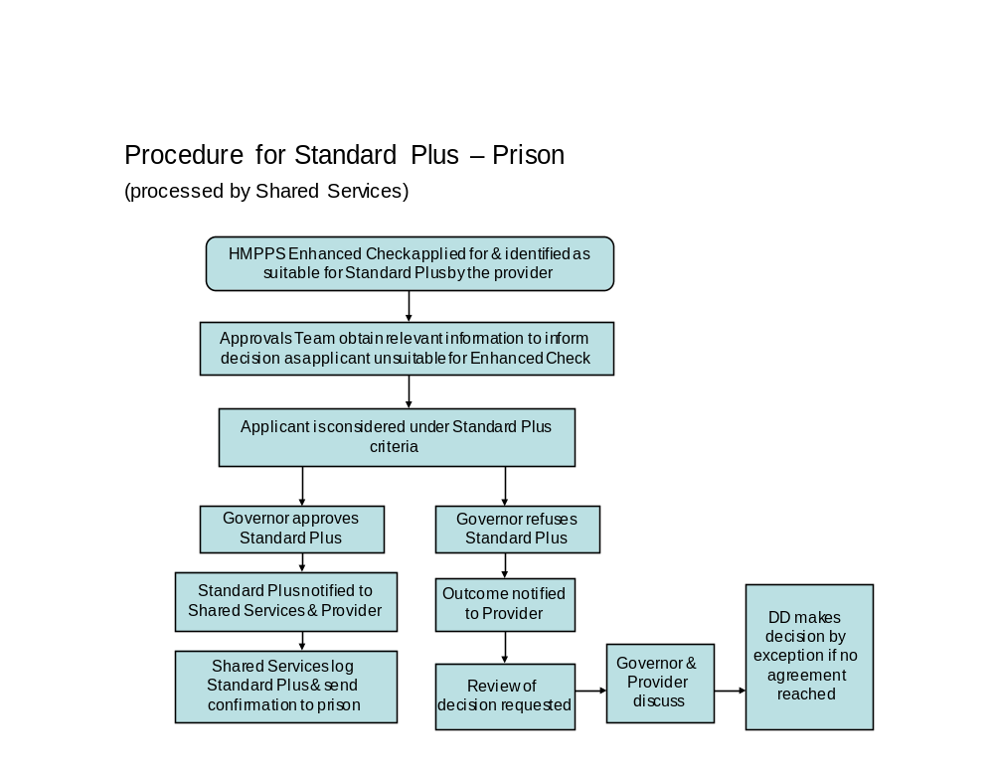

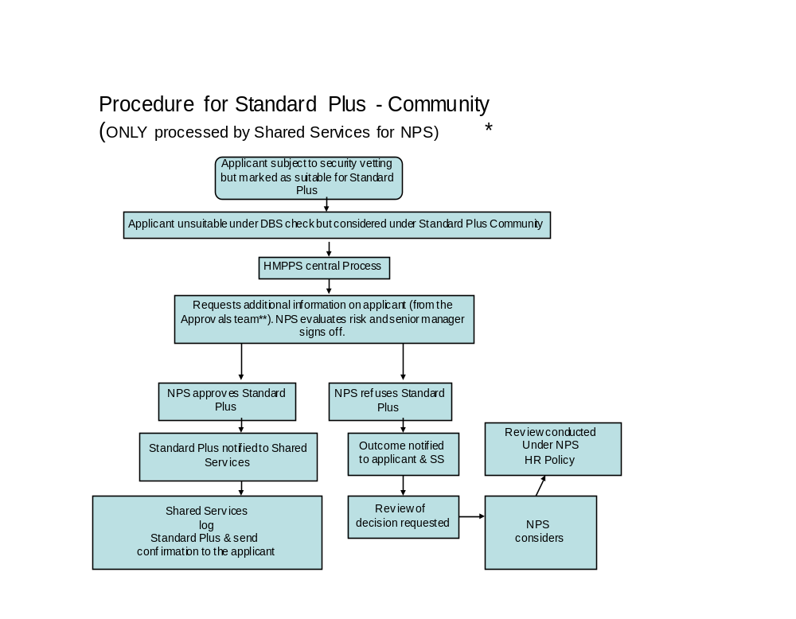
* Standard Plus - Community applications processed through SSCL will follow the same process as outlined for Standard Plus - Prison including the appeal process.
** Approvals and Compliance team are the operational team located at Newport evaluating suitability for appointment.
*** Probation Service will use the SSCL route as part of HMPPS HQ.

- RISK MANAGEMENT

Risk Ownership and Decision Making - Prisons

  - For prison based programmes the risk evaluation is the responsibility of the Governor/Director. In some instances, ex-offenders will be refused Standard Plus clearance on the basis that the underlying risk is deemed too high or resource intensive to manage. Where the applicant has been refused under Standard Plus the reason for refusal must be notified to the sponsoring organisation.

Risk Ownership and Decision Making – Probation Service, and Probation service providers

  - For community-based activities there are distinct differences in risk ownership and responsibilities for the Probation Service, and Probation service providers who engage with ex-offenders. Whilst prison-based activities provide challenging and more obvious security risks, community-based options require careful risk management to ensure contractual obligations are adhered to. This includes ensuring that all staff are security vetted to the appropriate level and information about them is appropriately managed and stored. There are also public protection and safeguarding issues (children and vulnerable adults) that must be considered in relation to community probation activities. The reason for the refusal needs to be explained to ensure an open dialogue is maintained and all parties are clear on the reasons why someone has been refused. Suitability for providing probation and similar services in the community will remain the responsibility of a nominated senior manager in the Probation Service and Probation service providers- and the Approvals and Compliance Team notified of all cases by email - recruitment-decisions@justice.gov.uk.
  - As each case must be signed off, accountability for decisions on suitability will remain with the Probation Service or Probation service providers. Annex E provides an example of localised risk assessment for Probation service providers use.

Risk Evaluation Considerations – Prisons

  - Consideration must be given to the balance of the benefits that ex-offenders can offer, against the potential additional risks posed. A risk assessment needs to consider the possibility of, for example, longer term attempts at infiltration by criminal networks or by the media as well as the potential susceptibility to conditioning by prisoners whilst working within a prison (which is also true for any directly employed member of staff). The job of Governor/Director is to consider if the individual presents significant additional risks to the prison.
  - Examples of factors for the risk assessment are shown in Annex A.

Risk Evaluation Considerations – Community

  - Senior managers within the Probation service providers and Probation Service must ensure that for community based programmes all ex-supervised individuals are properly vetted to ensure that they are suitable to deliver probation activities and do not pose an ongoing risk of causing harm to the public. As with prison-based programmes the risks of infiltration and conditioning need to be considered and managed accordingly. All providers must conduct risk based assessments for all ex-offenders.

- Examples of factors for the risk assessment are shown in Annex E.

REVIEW PROCESS

  - For those Probation Service applicants who have been declined for Standard Plus where their application has been processed through the Shared Service route, can request a review through the Probation Service. For Standard Plus – Prison the Probation Service can write to the Governor/Director. For Standard Plus – Community the Probation Service can write directly to the Approvals and Compliance Team located at Shared Services (if they are processing the vetting application for Standard Plus) asking for clarification of the decision. Reviews that cannot be resolved will be considered independently by the relevant Deputy Director who is responsible for the particular region or functional area and for ensuring a degree of consistency in decision making. This will be the exception not the norm.

  - The appeal process for Standard Plus - Prison and those Standard Plus - Community applications processed through Shared Services will follow the procedures set out within PSI 38/2012 Reconsideration of Central Vetting Decisions by Exception. The decision of the Prison Group Director having considered all of the information presented will be final.

- EQUAL OPPORTUNITIES
  - All applicants subject to security vetting are subject to a risk assessment and the same evaluation of suitability. Any consideration of Standard Plus will be based on an assessment of benefit against risk for the rehabilitation activities involved.

- DATA PROTECTION

  - The policy adheres to provisions of the Data Protection Act. All personal information will be held securely and in line with the PSI 03/2018 The Data Protection Act 2018 and General Data Protection Regulation, The Freedom of Information Act 2000, Environmental Information Regulations 2004 and the Information Sharing Policy Framework.

Annex A Sample Local Risk Assessment – Standard Plus Prison

Establishment

Risk assessment carried out by
(Name and role)
Information on applicant
Applicant’s name

Is the applicant an ex-supervised individual?
Date of last known convictions, warnings, reprimands, or sentence expiry date
Is there any evidence of re-offending since being released from prison?
Has the current period of community/suspended sentence order; licence or post sentence supervision been completed?
Nature of applicant’s work
What work will the applicant will be undertaking?
Examples of previous experience and/or competence of reducing re-offending, rehabilitative work or community based voluntary work (in date order), which demonstrate commitment to a law abiding way of life
Does the applicant have references supporting the application from the organisation(s) they have worked for? – if so summarise here
Working environment
Applicant’s working hours and times

What is the current security risk assessment for the area as per the NSF/ LSS? | Low/ Medium/HIGH
Ways to reduce the risk(s)

Contact with prisoners and staff
What frequency and type of contact will the applicant have with prisoners – supervised or un-supervised?
What frequency and type of contact will the applicant have with staff?
Overall risk rating for prisoner/staff contact | Low/ Medium/ High
Ways to manage risk

Security controls
Is access to keys required for the job role?

Will the applicant have access to personal information held on ICT systems?
Any other security measures to be carried out?
Decision
Overall risk rating | Refused / Approved with conditions/ Approved
Ways to manage risk

Conclusion

Sign off
Sign off by Governor/Director

Name in Block Capitals
Date of submission

This risk assessment must be carried out and re-assessed annually.

Annex B Request for Information to Consider Standard Plus - Prison



REQUEST FOR CONSIDERATION AT STANDARD PLUS – PRISON VETTING LEVEL

This applicant is likely to be refused vetting under the Enhanced Check procedure due to their previous offending history. We wish to consider if Standard Plus vetting will be appropriate as their prospective job role relates to rehabilitation activities.
Can you please review any relevant information that you hold in order that I can evaluate the evidence against the associated risks of agreeing Standard Plus in this case.
1. Sent to Shared Services Approvals and Compliance team, electronically via e-mail to the team’s mailbox at: Recruitment-Decisions marked PROTECT – Security Standard Plus

Personal Details of Applicant Excluded Non Directly Employed Worker (this section must be completed in all cases)
Surname (enter in box
Forename (enter in box)
Title (enter in box)
National Insurance Number (AANNNNNNA) e.g. ZZ123456D
Date of Birth (Enter DD MON YYYY) e.g. 23 Jun 1984
Name of Provider Organisation, or voluntary organisation (where appropriate)
Job Role (enter in box)
Which rehabilitative activities is this linked to?
Full Name Governor/Assigned Manager (enter in box)
Job Role
Location of Business Unit/Establishment
Risk Assessment Completed? Y/N
FOR COMPLETION BY APPROVALS AND COMPLIANCE TEAM ONLY
Date Received
Has additional information been sent
Examined by Approvals and Compliance team
Name in BLOCK CAPITALS

Date

When you have completed please send a copy via e-mail to the Approvals and Compliance mailbox:

recruitment-decisions@justice.gov.uk
For correspondence, their address is:

Approvals and Compliance Team
HMPS Shared Service Centre
PO Box 3037 Newport Gwent
NP20 9BB

When you have completed, retain a copy locally.

Annex C Standard Plus Confirmation Form - Prison

STANDARD PLUS – PRISON CONFIRMATION

This form must be completed in every case where a Governor in charge or their delegated manager, confirms they are willing to accept an ex - supervised individual working on rehabilitative activities within the prison establishment. Once completed and in order for this to processed and logged, this report must be:
1. Sent to Shared Services Approvals and Compliance team, electronically via e-mail to the team’s mailbox at:
Recruitment-Decisions OFFICIAL SENSITIVE - Security - Standard Plus – Prison Confirmation
2. A hard or soft copy of the report form must be retained locally for audit purposes.

Personal Details of Applicant Excluded Non Directly Employed Worker (this section must be completed in all cases)
Surname (enter in box)
Forename (enter in box)
Title (enter in box)
National Insurance Number (AANNNNNNA) e.g. ZZ123456D
Date of Birth (Enter DD MON YYYY) e.g. 23 Jun 1984
Name of Provider Organisation, or, voluntary organisation (where appropriate)
Job Role (enter in box)
Which Reducing Re-offending Pathway or rehabilitation activity is this linked to?
Full Name Governor/Assigned Manager (enter in box)
Job Role
Location of Business Unit/Establishment
Risk Assessment Completed? Y/N
FOR COMPLETION BY APPROVALS AND COMPLIANCE TEAM ONLY
Date Received
Standard Plus – Prison Confirmed Y/N
Examined by Approvals and Compliance team
Name in BLOCK CAPITALS

Date

Oracle Updated (please insert date)

When you have completed please send a copy via e-mail to the Approvals and Compliance mailbox:

recruitment-decisions@justice.gov.uk
For correspondence, their address is:

Approvals and Compliance Team
HMPS Shared Service Centre
PO Box 3037 Newport Gwent
NP20 9BB

When you have completed, retain a copy locally.

Annex D Request for Renewal of Standard Plus - Prison

REQUEST FOR RENEWAL OF STANDARD PLUS - PRISON

The following non directly employed worker has been subject to Standard Plus under the rehabilitative activities. After local review, we wish to renew the Standard Plus – Prison for another year.
1. Confirmation must be sent to Shared Services Approvals and Compliance team, electronically via e-mail to the team’s mailbox at: Recruitment-Decisions marked OFFICIAL SENSITIVE – Security - Standard Plus - Prison

Personal Details of Applicant Excluded Non Directly Employed Worker (this section must be completed in all cases)
Surname (enter in box
Forename (enter in box)
Title (enter in box)
National Insurance Number (AANNNNNNA) e.g. ZZ123456D
Date of Birth (Enter DD MON YYYY) e.g. 23 Jun 1984
Name of Provider Organisation, or voluntary organisation (where appropriate)
Job Role (enter in box)
Which Reducing Re-offending Pathway or rehabilitation activity is this linked to?
Full Name Governor/Assigned Manager (enter in box)
Job Role
Location of Business Unit/Establishment
Risk Assessment Completed? Y/N
Date Received
Examined by Approvals and Compliance Team
Name in BLOCK CAPITALS

Date

The vetting record will be updated on the vetting database by Shared Services.

For correspondence, their address is:

Approvals and Compliance Team
HMPS Shared Service Centre
PO Box 3037 Newport Gwent
NP20 9BB

When you have completed, retain a copy locally.

Annex E Sample Local Risk Assessment – Standard Plus Community

Community Probation location (address)

Risk assessment carried out by
(Name and role)
Information on applicant
Applicant’s name

Is the applicant an ex-supervised individual?
Date of last known convictions, warnings, reprimands, or sentence expiry date
Is there any evidence of re-offending since being released from prison and/or expiration of the community/suspended sentence order?
Has the current period of community/suspended sentence order; licence or post sentence supervision been completed?
Do any of the above suggest any concerns in relation to contact with supervised individuals, children or vulnerable adults?
Is the individual on either of the barred lists for children or adults?
Nature of applicant’s work
What work will the applicant will be undertaking?
Business Case (the importance and urgency for bringing in the applicant to carry out this work within a community setting)
Examples of previous experience and/or competence of reducing re-offending, rehabilitative work or community based voluntary work (in date order), which demonstrate commitment to a law abiding way of life and relevant expertise of value in a community setting?
Does the applicant have credible references supporting the application from the organisation(s) they have worked for? – if so summarise here
Working environment
Applicant’s working hours and times

What is the current security risk assessment for the community location | Low/ Medium/ HIGH
Ways to reduce the risk(s)

Will the applicant need to visit prisons?
Will the applicant be required to visit supervised individuals at home?
Contact with community supervised individuals, and prisoners
What frequency and type of contact will the applicant have with supervised individuals, prisoners – supervised or un-supervised?
What frequency and type of contact will the applicant have with Probation Service staff?
What frequency and type of contact will the applicant have with children or vulnerable adults?
Overall risk rating for supervised individual/prisoner/staff/safeguarding contact | Low/ Medium/ HIGH
Ways to manage risk

Security controls
Will the applicant have access to keys/entry to the building?

Will the applicant be subject to staff supervision?
Will the applicant have access to personal information held on ICT systems?
Will the applicant have access to money/travel warrants?
Any other security measures to be carried out or required?
Decision
Overall risk rating | Refused / Approved with conditions/ Approved
Ways to manage risk

Conclusion

Sign off
Sign off by Senior Probation service provider manager

Name in Block Capitals

Date of approval

This risk assessment must be carried out and re-assessed annually.

Annex F – Guidance on suitability for Standard Plus Prison and Community

The Approvals and Compliance Team (ACT) is made up of operational managers who are based at HMPPS Shared Services in Newport. Their role is to consider those vetting applications where normal criminal record checks have identified either undeclared previous convictions, or, declared previous convictions which appear on the specified offences list. They will consider this information and provide information relating to the suitability of an individual for prisoner/supervised individual facing roles.

The ACT will consider all applications for Standard Plus – Prisons. They will also consider those individual’s requiring Standard Plus – Community, from the Probation Service or where an individual with Standard Plus - Community clearance wishes to have infrequent/limited access to a prison.

In these circumstances Probation Service must complete the form at Annex G and submit it to the Approvals and Compliance Team. The ACT will run background checks on the ex-supervised individual. When these checks are complete the ACT will notify the Governor of their findings in order that the Governor has all the information they require to make an informed decision on whether to allow access, or where relevant, to the senior manager within the Probation Service.

A national record will be maintained of all applications.

For Probation service providerswho undertake their own vetting through a process that complies with the HMPPS Vetting Policy, the following considerations should be taken into account when assessing the suitability of an individual to engage with prisoners or supervised individuals on a rehabilitation activities or pathways.

- Any gaps in available information / proof i.e. insufficient documentation presented to prove address, employment and missing or delayed references.
- Any negative references
- Criminal record histories (see also specified offences below)
- Series of discrepancies in information provided/obtained
- Outcome of Baseline Personnel Security Standard (BPSS) and Disclosure and Barring Service (DBS) checks

On the basis of vetting information available the Probation service providers must:

- Make balanced judgements based on an evaluation of the evidence collated to judge its credibility
- Ensure compliance with Vetting Policy as laid out in PSI 07/2014 - AI 05/2014 - PI 03/2014 Security Vetting
- Make decisions based on Security Vetting Guidance
- Confirm applicants have the Right to Work within the UK
- Ensure consistency in Vetting Decisions
- Ensure Security Vetting Levels are assigned appropriately and consistently to the role
- Decide suitability to work
- Request/contact candidate for further information / to discuss where appropriate
- Report all approved applications under Standard Plus – Community to Recruitment-Decisions providing full name, date of birth, NI number, Contract Package Area.
- Refer to a Senior Probation service provider managers for a final decision and sign off

Specified Offences - Serious offences requiring risk management

For information on specified offences, click on the link below.

https://www.gov.uk/government/publications/dbs-list-of-offences-that-will-never-be-filtered-from-a-criminal-record-check

When assessing ex-offenders for Standard Plus – Community, the Probation Service should carefully consider the risks of engaging an individual where they have been convicted of one of the more serious specified offences. Although not definitive these specifically include:

- Offences relating to terrorism /offences under the Anti Terrorism and Crime Act 2003 / Prevention of Terrorism Act 1989 / Terrorism Act 2000 & 2006
- Offences relating to children /offences under the Children and Young Persons Act 1933 / Child Abduction Act 1984
- False Imprisonment – Common Law
- Kidnapping – Common Law
- Murder - Common Law
- Racially / religiously aggravated offences / offences under the Crime and Disorder act 1998
- Supply controlled drug / offences under the Misuse of Drugs Act 1971 in prison settings.
- Violent and/or serious offences / Offences against the Person act 1861/ offences under the Public Order Act 1986
- Sex offences / any offence under the Sexual Offences Act 1956
- Stalking involving fear of violence or serious alarm or distress

In these circumstances where these and similar offences are identified there will be a presumption of refusal, although there may be exceptions where a clear and compelling argument is made to merit their appointment.

Where necessary, the Probation service providers may also consider putting in place safeguards to mitigate any risks.

Annex G

STANDARD PLUS – COMMUNITY REQUEST FOR A PRISON VISIT FROM A PROBATION SERVICE PROVIDERSOR Probation Service

This applicant has been granted Standard Plus - Community and/or the Provider Organisation/Probation Service is applying for them to undertake occasional prison visits.
Can you please provide any relevant information that you hold in order that I can evaluate the evidence against the associated risks of agreeing Standard Plus in this case.
1. Sent to Approvals and Compliance Team, electronically via email to the team’s mailbox at: Recruitment-Decisions marked OFFICIAL – Security Standard Plus

Personal Details of Applicant (this section must be completed in all cases)
Surname (enter in box
Forename (enter in box)
Title (enter in box)
National Insurance Number (AANNNNNNA) e.g. ZZ123456D
Date of Birth (Enter DD MON YYYY) e.g. 23 Jun 1984
Name of Provider Organisation, or voluntary organisation (where appropriate)
Job Role (enter in box)
How is the role linked to delivering probation rehabilitative services in the community?
Location of Prison(s) visits
Full Name of Provider Organisation/Probation Service Senior Manager(enter in box)
Job Role
Provider Organisation/Probation Service Registered address
Risk Assessment Completed? Y/N
FOR COMPLETION BY APPROVALS AND COMPLIANCE TEAM ONLY
Date Received
Has additional information been sent
Examined by Approvals and Compliance team
Name in BLOCK CAPITALS

Date

When you have completed please send a copy via e-mail to the Approvals and Compliance mailbox:

recruitment-decisions@justice.gov.uk
For correspondence, their address is:

Approvals and Compliance Team
HMPS Shared Service Centre
PO Box 3037 Newport Gwent
NP20 9BB

When you have completed, retain a copy locally.

Annex H

STANDARD PLUS – COMMUNITY CONFIRMATION LETTER

This form must be completed in every case where a Governor in charge or their delegated manager, confirms they are willing to accept an ex-supervised individual delivering Probation Services in the community, but requiring to undertake preliminary visits to supervised individuals in prison prior to their release from custody. Once completed and in order for this to processed and logged, this report must be:
1. Sent to Shared Services Approvals and Compliance team, electronically via e-mail to the team’s mailbox at: Recruitment-Decisions marked OFFICIAL – Security - Standard Plus Confirmation
2. Sponsoring Provider Organisation/Probation Service. A hard or soft copy of the report form must be retained locally for audit purposes.

Personal Details of Applicant (this section must be completed in all cases)
Surname (enter in box
Forename (enter in box)
Title (enter in box)
National Insurance Number (AANNNNNNA) e.g. ZZ123456D
Date of Birth (Enter DD MON YYYY) e.g. 23 Jun 1984
Name of voluntary organisation (where appropriate)
Job Role (enter in box)
Full Name Governor/Director Manager (enter in box)
Job Role
Prison
Risk Assessment Completed? Y/N
FOR COMPLETION BY APPROVALS AND COMPLIANCE TEAM ONLY
Date Received
Standard Plus Confirmed Y/N
Examined by Approvals and Compliance Team
Name in BLOCK CAPITALS

Date

Oracle Updated (please insert date)

When you have completed please send a copy via e-mail to the Approvals and Compliance mailbox:

recruitment-decisions@justice.gov.uk
For correspondence, their address is:

Approvals and Compliance Team
HMPS Shared Service Centre
PO Box 3037 Newport Gwent
NP20 9BB

When you have completed, retain a copy locally.

Annex I

STANDARD PLUS – COMMUNITY REQUEST FOR RENEWAL

The following non directly employed worker has been subject to Standard Plus Community. After local review, we wish to renew the Standard Plus for another year.
1. Confirmation must be sent to Shared Services Approvals and Compliance team, electronically via e-mail to the team’s mailbox at: Recruitment-Decisions marked OFFICIAL.

Personal Details of Applicant (this section must be completed in all cases)
Surname (enter in box
Forename (enter in box)
Title (enter in box)
National Insurance Number (AANNNNNNA) e.g. ZZ123456D
Date of Birth (Enter DD MON YYYY) e.g. 23 Jun 1984
Name of voluntary organisation
Job Role (enter in box)
Which Rehabilitation activity is this linked to?
Full Name of Probation Service Senior Manager (enter in box)
Job Role
Probation Service Community programme address
Risk Assessment Completed? Y/N
Date Received
Examined by Approvals and Compliance team
Name in BLOCK CAPITALS

Date

The vetting record will be updated on the vetting database by Shared Services.

For correspondence, their address is:

Approvals and Compliance Team
HMPS Shared Service Centre
PO Box 3037 Newport Gwent
NP20 9BB

When you have completed, retain a copy locally.

Annex J Roles and Responsibilities

Approvals and Compliance Team (ACT)
This comprises a team of experienced operational managers who evaluate and decide the suitability of applicants subject to pre appointment security vetting procedures. They will also provide background information to a Governor/Director (or Senior Probation service providers or Probation Service Manager, where appropriate) when considering the suitability of vetting at Standard Plus level for ex-offenders in order that an informed decision can be made.
Probation Service
The Probation Service carry out the critical roles of providing advice to court, assessing the risk a supervised individual poses to the public and directly managing those who pose the highest risk to the public, who have committed the most serious crimes. The Service is operated by a Director of Probation and a Director HMPPS Wales (whose remit will include and extend beyond the Probation Service in Wales). It will deliver services under a service level agreement.

Probation Service Providers
These organisations will deliver pre-agreed probation services in the community. They will mainly be responsible for the management of supervised individuals assessed to present a low/medium risk of serious harm to the public. They will provide rehabilitation activities under contract, which may involve the use of mentoring or support using ex-offenders. All personnel within the Probation service providers will undergo the necessary vetting levels as stated within the contract.

VCSE
These organisations will work with the Probation Service and Probation service providers in the delivery of rehabilitation activities. Where relevant, any concerns expressed by workers relating to their refusal under the Standard Plus vetting level must be managed by the service providers. It is the responsibility of the sponsoring organisation to advise the worker that they have been refused due to security considerations. The organisation can ask for this to be reconsidered through the management line to the Prison Group Director for prison related job roles (if considered through Shared Services centrally), whose decision will be final. Alternatively, a Senior Manager within the Probation service providers for Standard Plus – Community will hold the same responsibility. Governors and Heads of Unit will not engage in direct correspondence with individual workers on acceptance or refusal to grant security vetting.

Prison Group Director (PGD)
The PGD and Deputy Director Contracted Custodial Services will consider any cases under the Standard Plus criteria from the sponsoring organisation or via the Governor where this has been refused.

Governors/Directors
Governors are responsible for managing and assessing the risk in their prison, taking into account how they could grant the Standard Plus vetting level for those with previous criminal convictions. It is at the discretion of the Governor if the vetting level is granted. Governors maintain ultimate authority in relation to decisions made concerning individual supervised individuals and the implementation of any mentoring schemes linked to their prison establishment.

Shared Services Connected Limited (SSCL)
SSCL are responsible for maintaining securely all vetting records across the organisation and processing staff and non-directly employed worker applications. They will issue a confirmation of the Standard Plus vetting level where granted, direct to the Governor, as well as closing the record down after one year unless the prison make a request to renew the Standard Plus for another year. They will issue confirmation to those Probation service providers whose candidates are located within a HMPPS building and therefore use the SSCL vetting route.
Annex K Glossary of Terms

ACT | Approvals and Compliance Team
CTC | Counter Terrorism Check
DBS | Disclosure and Barring Service
PGD | Prison Group Director
HSE | High Security Estate
NDE | Non Directly Employed
HMPPS | Her Majesty’s Prison and Probation Service
PSI | Prison Service Instruction
PI | Probation Instruction
Probation Service Providers | Those external organisations who work in partnership with HMPPS to deliver rehabilitative interventions to the Probation Service.
SSCL | Shared Services Connected Limited
Ex-offender | Person whose community/suspended sentence order; licence or post sentence supervision has been completed
Standard Plus - Prison | Applicable to prison based activities
Standard Plus - Community | Applicable to community based activities
VCP | Vetting Contact Point
VCSE | Voluntary, Community and Social Enterprise

