Application Decision
by Richard Holland
Appointed by the Secretary of State for Environment, Food and Rural Affairs
Decision date: 11 June 2021

Application Ref: COM/3256608
Ealing Common, London Borough of Ealing
Register Unit No: CL115
Commons Registration Authority: Ealing Council.

- The application, dated 2 July 2020, is made under Article 12 of the Ministry of Housing and Local Government Provisional Order Confirmation (Greater London Parks and Open Spaces) Act 1967 for consent to carry out works on common land.
- The application is made by Ealing Council.
- The works comprise:
- 696.36m of new metal knee-rail fencing around an area of 68,512.6m² to match the historic fencing already on site;
- new wildflower grass mounds on the perimeter of the site covering an area of 3,115.78m²;
- 5 new gates and bollards at main entrances; and
- transformation of Warwick Road from highway to grasscrete, grass and wildflowers.

Decision
  - Consent is granted for the works in accordance with the application dated 2 July 2020 and the plans submitted with it, subject to the condition that the works shall begin no later than three years from the date of this decision.
  - For the purposes of identification only the location of the works is shown on the attached plan.

Preliminary Matters
  - The application was made under section 38 of the Commons Act 2006 but it is more properly an application made under Article 12 of the Ministry of Housing and Local Government Provisional Order Confirmation (Greater London Parks and Open Spaces) Act 1967 for consent to construct works on common land. Article 7 of the 1967 Act provides that a local authority may in any open space provide and maintain a variety of facilities for public recreation subject to conditions. Article 12 of the 1967 Act provides that in the exercise of powers under Article 7 the local authority shall not, without the consent of the Minister, erect, or permit to be erected, any building or other structure on any part of a common.
  - I have had regard to Defra’s Common Land consents policy in determining this application, which has been published for the guidance of both the Planning Inspectorate and applicants. However, every application will be considered on its merits and a determination will depart from the policy if it appears appropriate to do so. In such cases, the decision will explain why it has departed from the policy.

  - This application has been determined solely on the basis of written evidence. I have taken account of the representations made by Natural England (NE) and the Open Spaces Society (OSS).

  - I am required by section 39 of the Commons Act 2006 to have regard to the following in determining applications under Article 12 of the 1967 Act:-
- the interests of persons having rights in relation to, or occupying, the land (and in particular persons exercising rights of common over it);
- the interests of the neighbourhood;
- the public interest; and
- any other matter considered to be relevant.

Reasons

The interests of those occupying or having rights over the land
  - The common is owned and managed by the applicant, Ealing Council (the Council). The common land register records no rights of common over the land. I am satisfied that the works will not harm the above interests.

The interests of the neighbourhood and the protection of public rights of access
  - The works are proposed around the perimeters of the area of common south of the A4020 Uxbridge Road and along Warwick Road, which bisects the common. The purpose of the works is to prevent unauthorised vehicular access onto the common from surrounding roads and to return Warwick Road to green space from adopted highway.
  - The interests of the neighbourhood test relates to whether the works will impact on the way the common land is used by local people and is closely linked with interests of public access.
  - Much of the perimeter of the common is lined with trees and there are several short lengths of knee-high rail fencing already in place. The additional fencing, mounds and bollards will, in conjunction with some new ornamental tree planting, complete a barrier to unauthorised vehicular access that will extend all around that part of the common the subject of the application. All current entrances will be maintained using 1.5m wide access gaps which will allow free pedestrian movement through current desire lines into the common. The Council confirms that the application plan is a true representation of the extent of the proposed mounds and the regular gaps between them. The gaps will allow pedestrian access onto the common to continue from many points. The plan shows one very short section where there will be both new fencing and a mound but, as it is located immediately next to one of the entrances, I consider that there will be no detriment to public access.
  - The proposed fencing is low and I consider it likely that some people may be able to step over it in order to gain pedestrian access to the common. It may be that the mounds will also be low enough to walk over, although the fencing and mounds are clearly not meant to be used in this way and they will restrict, if not prevent, public access, especially for wheelchair or pushchair users. However, their purpose is to prevent unauthorised vehicular access, which the council advises has been an unfortunate regular occurrence, causing distress to members of the public and leaving the common damaged and strewn with litter. I conclude that preventing such access is in the interests of those wishing to visit the common for legitimate purposes and that, as there are a good number of formal access points, it outweighs the harm the fencing and mounds will cause to unrestricted pedestrian access.
  - The Council advises that it is a long-desired aspiration to return Warwick Road to a green space, re-uniting the areas of common currently separated by it. The area will be transformed using grasscrete (allowing temporary vehicular access when needed), grass and wildflowers. I conclude that returning the road to grass, whilst retaining the cycle path element, will be of substantial benefit to the neighbourhood and public rights of access.

Nature conservation, conservation of the landscape and archaeological remains and features of historic interest
  - NE raises no concerns about the impact of the works on nature conservation interests. The Council advises that the mounds will be seeded with wildflowers to enhance the visual appearance of the area and to create wildlife opportunities. I consider it likely that the flowers will attract insects and other wildlife and will create an attractive feature for visitors to the common to enjoy. There is no evidence before me which leads me to think that the works will harm any archaeological remains or features of historic interest.

Other matters
  - OSS suggests that the Council may be able to carry out the works under Article 3 of the scheme for Ealing Common confirmed by the Metropolitan Commons Supplemental Act 1877 without the need for Secretary of State Consent. Whilst this may be the case, the applicant applied for such consent and has not subsequently withdrawn the application in the light of the OSS comments. Furthermore, common land legislation does not preclude the granting of consent for the proposed works and there is no sound reason for declining to determine the application, which has been decided on its merits.
  - OSS also sought clarity as to the legislative means by which Warwick Road may be closed to traffic. Whilst the Council has clarified that it will be by means of a stopping up order under sections 247 and 248 of the Town and Country Planning act 1990, this is not a matter relevant to the determination of the application.

Conclusion
  - I conclude that the works will benefit legitimate use of the common by uniting two areas separated by a road and by preventing unauthorised vehicular access. They will not harm the other interests set out in paragraph 6 above, indeed, the wildflowers will be an attractive feature for visitors to enjoy and may bring wildlife benefits. The works are those that a local authority may, under Article 7 of the 1967 Act, provide and maintain for persons resorting to the open space and consent for the works is granted subject to the condition set out at paragraph 1.

Richard Holland

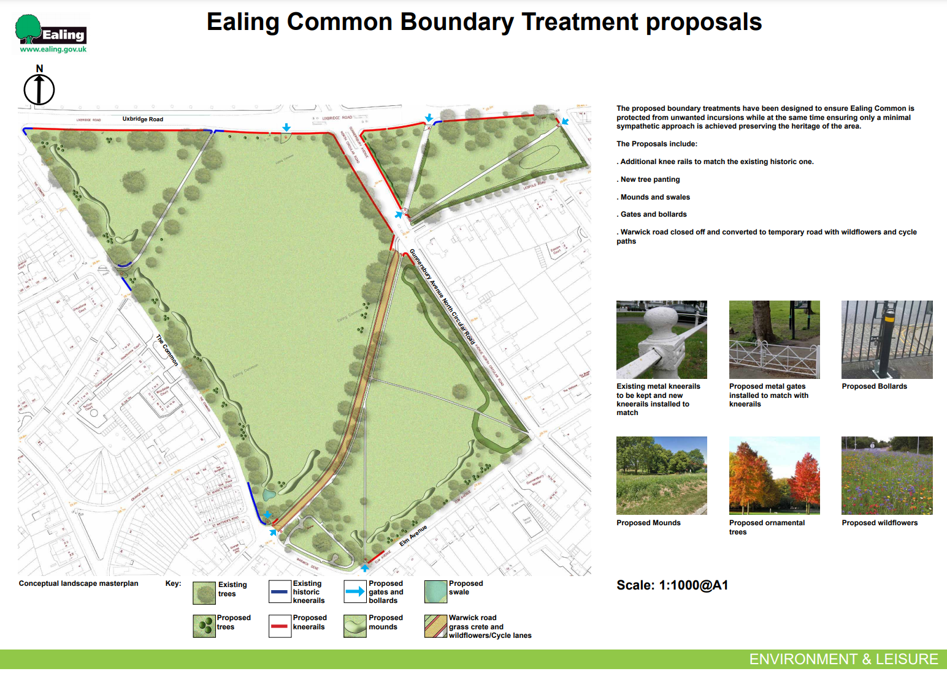

Common Land consents policy (Defra November 2015)
Section 39(2) of the 2006 Act provides that the public interest includes the public interest in; nature conservation; the conservation of the landscape; the protection of public rights of access to any area of land; and the protection of archaeological remains and features of historic interest.

