Application Decision
by Richard Holland
Appointed by the Secretary of State for Environment, Food and Rural Affairs
Decision date: 10 June 2021
Application Ref: COM/3262569
Mardale Common, Cumbria
Register Unit No: CL86
Commons Registration Authority: Cumbria County Council
- The application, dated 10 October 2020, is made under Section 38 of the Commons Act 2006 (the 2006 Act) for consent to carry out restricted works on common land.
- The application is made by RSPB and Mardale Commoners Association.
- The works comprise a single and continuous 1027m long section of 1.2m high sheep net stock fencing with two bridleway gates and one field gate to be in place for 14 years.

Decision
- Consent is granted for the works in accordance with the application, as amended, dated 10 October 2020 and submitted plan subject to the following conditions:
- the works shall begin no later than 3 years from the date of this decision;
- all gates shall comply with British Standard BS5709 and the gates shall be marked with ‘open access land’ signage; and
- all works shall be removed on or before 30 June 2035.
- For the purposes of identification only, the location of the proposed works is shown in red on the attached plan.
Preliminary Matters
- I have had regard to Defra’s Common Land consents policy in determining this application under section 38, which has been published for the guidance of both the Planning Inspectorate and applicants. However, every application will be considered on its merits and a determination will depart from the policy if it appears appropriate to do so. In such cases, the decision will explain why it has departed from the policy.
- This application has been determined solely on the basis of written evidence.
- I have taken account of the representations made by Natural England (NE), Historic England (HE), Lake District National Park Authority (LDNPA), Friends of the Lake District (FLD), Cumbria & Lakes Joint Local Access Forum (CLJLAF), the Open Spaces Society (OSS) and Cumbria Bridleway Society (CBS).
- I am required by section 39 of the 2006 Act to have regard to the following in determining this application:-
- the interests of persons having rights in relation to, or occupying, the land (and in particular persons exercising rights of common over it);
- the interests of the neighbourhood;
- the public interest; and
- any other matter considered to be relevant.

Reasons

The interests of those occupying or having rights over the land
- The land is owned by United Utilities Water Limited (UU), which was consulted by the applicant about the application but has not commented. There is no evidence before me to suggest that UU’s interests will be harmed by the proposals.

- The common land register records three rights to graze sheep, cattle and horses in favour of Naddle Farm, Swindale Farm and Thornthwaite Hall. Rights across all three holdings are exercised but in lower numbers than registered. The applicants advise that RSPB holds the rights associated with Naddle and Swindale Farms and manages Thornthwaite Hall’s fell flock under a separate agreement. Mardale Commoners Association is joint applicant with RSPB and I am satisfied that the application is made in the commoners’ interests. Kentmere Commoners Association, Bampton Commoners Association and the Federation of Cumbrian Commoners were also consulted about the application. None have commented and I am satisfied that any neighbouring commoner interests, should there be any, will not be harmed by the proposals.

The interests of the neighbourhood and public rights of access

- It is proposed to erect and retain the fence for a period of 14 years which ties in with a Higher-Level Stewardship (HLS) Agreement ending in 2034. The fence will run between the common’s northern and southern boundaries at Harter Fell, which is one of its narrowest points. The proposed fence route rises in altitude from north to south, where it will link with existing fencing, following a line appropriate to the terrain. Its purpose is to control grazing on the eastern side to improve the condition of the land and to protect high altitude arctic-alpine plant communities, which are known for their sensitivity to grazing.

- The interests of the neighbourhood test relates to whether the works will impact on the way the common land is used by local people and is closely linked with interests of public access. CLJLAF advises that Harter Fell is popular with walkers seeking a more remote area to walk and has extensive views, especially over Haweswater. I consider that despite its remoteness, the area is likely to be regularly accessed by the public and the fence has the potential to harm such access.

- Two pedestrian gates were originally proposed for public access, one at each end of the fence. The southern gate would link with the Gatesgarth Pass to Nan Bield Pass footpath. The northern gate would link with an informal route/desire line used as a short cut between the Gatesgarth and Small Water paths. However, in response to CBS concerns, and in recognition that Mardale Common is used by both walkers and horse riders, the applicants have agreed to install bridleway gates with a useable width of at least 1.525m, as per the LDNPA Structures Standards Guide 2011, instead of pedestrian sprung gates.

- The application proposes no intermediate gates in the fence but the applicants advise that they are happy to install additional crossings in the form of step-stiles and suggest that three such evenly placed stiles would leave approximately 250m between each crossing point. However, they further advise that long sections of the fence are close to precipitous crag faces and the locations of any intermediate crossing points would need to be agreed with LDNPA. None of the parties to have made representations have requested intermediate crossing points either at specific locations or in principle. This is likely to be because they recognise that, for safety reasons, users of the common will not wish to cross the fence at such points.

- I conclude that the proposed bridleway gates will provide acceptable and appropriate public access and that it is not necessary to require intermediate access points as a condition of the consent.

The public interest

Nature Conservation

- The fence is proposed to control the movement of livestock to protect high altitude arctic-alpine plant communities in association with the wider HLS Agreement. The applicants advise that due to the impact of grazing over a long period of time the plant communities are now wholly restricted to inaccessible ledges and without the ability to control grazing it will not be possible to create the conditions necessary for them to increase and recover.

- It is within the applicant’s control to manage the grazing rights over Mardale Common. However, the area of the common west of the proposed fence is bordered by Kentmere Common and unwanted ingress of grazing animals from there has long been a problem. The fence will prevent such ingress any further eastwards into controlled areas. The applicants advise that since the HLS Agreement started, they have been closely monitoring the habitat response in partnership with NE and have realised that the ingress is impacting on their ability to deliver the restoration objectives of the Agreement. By preventing ingress, the fence will allow the objectives of the agreement to be met.

- Mardale Common supports two Sites of Special Scientific Interest (SSSI). The proposed fence will be less than a kilometre from the Blea Water SSSI at its nearest point, although Blea Water is at the westernmost edge of the common and does not lie within the area from which grazing animals are intended to be excluded. The second SSSI, Naddle Forest, lies much further to the north, well away from the proposed fence.

- A separate area of the common at Harter Fell has been identified by NE as of SSSI quality because it supports almost one quarter of England’s tall herb vegetation, which is a species-rich and rare upland habitat. NE advises that the fence will enable a change to the grazing regime that will allow the tall herb vegetation to expand and improve in condition and will also enable a change of management on part of the Naddle Forest SSSI to consolidate and accelerate its improving condition.

- I am satisfied that the fence will assist in bringing nature conservation benefits to the arctic-alpine plant communities and more widely to Harter Fell and the Naddle Forest SSSI. I am also satisfied that it will help to fulfil the nature conservation objectives of the HLS Agreement and that it is sensible to tie in any consent with the Agreement period.

Conservation of the landscape

- Informal pre-application consultation proposed four fencing options. Option D was then ruled out on landscape grounds. The three remaining options were independently appraised from a landscape perspective and a modified version of Option C forms the proposals the subject of this application. The appraisal concluded that under Option C the fence will be sited to follow the grain of the landscape and rocky features, to tie in with existing boundaries and to have the shortest length across Harter Fell Ridge.

- I consider that there is a general acceptance from the parties to have made representations that the fence’s overall visual harm will not be so great as to outweigh the conservation benefits that will arise from preventing unwanted ingress of livestock. However, OSS and FLD have asked for the top section of fence to be seasonal, as was discussed during the informal consultation, to limit any visual harm. They propose that the section of fence should be removed, including the fence posts, during the winter months when no livestock are on the commons and the fence is unnecessary. The applicants concede that the fence will be visually intrusive at the top of the fell, although this will be tempered by the presence of the existing fence, which it will adjoin.

- However, the applicants are reluctant to install seasonal fencing on grounds of cost and the practicalities of yearly removal and reinstatement at this remote and topographically challenging location. They estimate that 16 separate vehicular return journeys over sensitive habitats would be needed every year in order to remove and reinstate the 200m of fence comprising the top section. The applicants say that all posts would need to be loose fitted, perhaps using some semi-permanent in-ground sleeve system, if they were to be easily and regularly removed and that such fencing would be less robust than standard fencing.

- LDNPA considers that the fence will have a slight impact on the landscape in the short term and only for those visitors who walk along and explore the ridge area of the common. It further considers that there will be important longer-term gains for improving the landscape character and visual amenity of the common. I am satisfied that, by restoring arctic-alpine plant habitat, the fence will help to ensure that the natural beauty of the Lake District National Park is conserved and this outweighs the temporary visual harm identified. The use of seasonal fencing is likely to be insufficiently robust and cause significant ground erosion, counter to conservation objectives. As the fence will not cause serious visual harm and I conclude that it is not necessary to require seasonal fencing as a condition of the consent

Archaeological remains and features of historic interest
- HE advises that there are no scheduled ancient monuments to be affected by the proposals and no reason to suspect that any non-designated nationally important archaeological sites would be impacted.

- The common lies within the Lake District World Heritage Site. HE has considered the potential for the proposed works to impact adversely on the Outstanding Universal Value of the Site and advises that, given the conclusions of the Motmot Consulting appraisal and the specific aim to allow a rare plant community to regenerate, there will be no adverse effect.

- LDNPA is the managing authority for the World Heritage Site and has some concerns about the impact of the fence on some cultural practices, specifically in relation to hefted flocks, and will work with the applicants to monitor the impact. LDNPA fears that traditional practices may diminish further during the fenced period and regards the removal of the fence at the end of the period applied for as essential; this can be secured by attaching a suitable condition to the consent.

- I am satisfied that the fence is unlikely to harm any archaeological remains or features of historic interest or harm the World Heritage Site status.

Conclusion
- I conclude that the proposed works will benefit nature conservation and landscape interests in the long term, whilst allowing public access over established routes to continue, and will not unacceptably harm the other interests set out in paragraph 6 above. Consent is therefore granted for the works subject to the conditions set out in paragraph 1.

Richard Holland

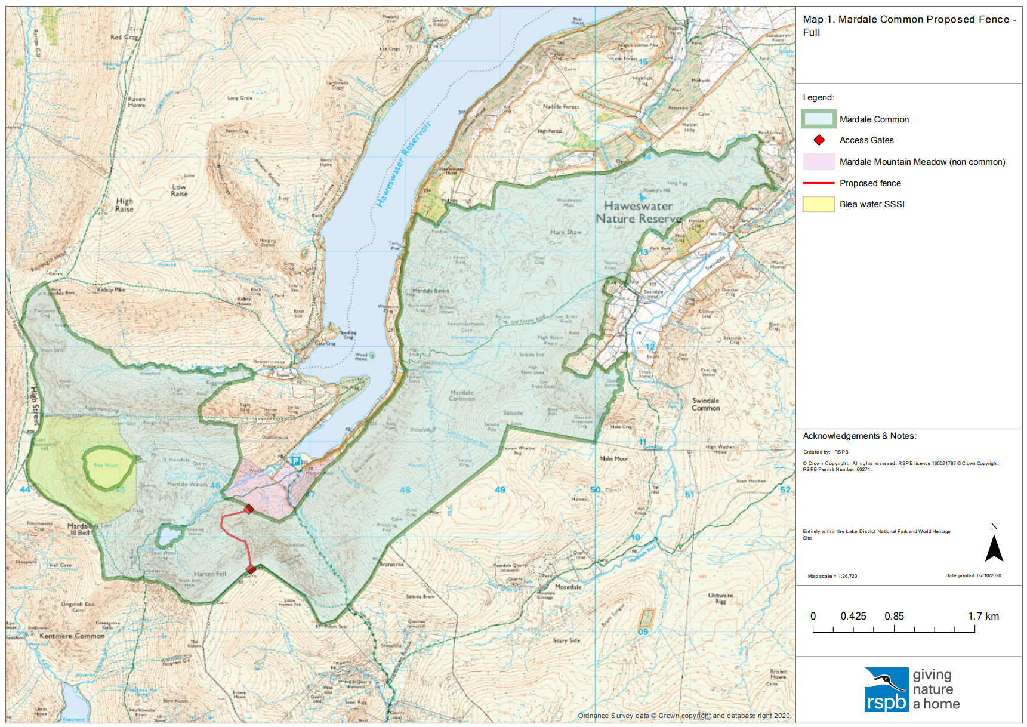

Common Land consents policy (Defra November 2015)
Section 39(2) of the 2006 Act provides that the public interest includes the public interest in; nature conservation; the conservation of the landscape; the protection of public rights of access to any area of land; and the protection of archaeological remains and features of historic interest.
Mardale Common fencing proposal Landscape and Visual Option Appraisal September 2020: Motmot Consulting.

