Application Decision
by Richard Holland
Appointed by the Secretary of State for Environment, Food and Rural Affairs
Decision date: 09 June 2021

Application Ref: COM/3271577
Highridge Green, Bristol
Register Unit No: CL3
Commons Registration Authority: Bristol City Council.
- The application, dated 22 March 2021, is made under Section 38 of Commons Act 2006 (the 2006 Act) for consent to carry out restricted works on common land.
- The application is made by Western Power Distribution.
- The works comprise the installation of a new electricity pole and stay wire to form a flying stay.

Decision
  - Consent is granted for the works in accordance with the application dated 22 March 2021 and accompanying plan, subject to the following conditions:-
  - the works shall begin no later than three years from the date of this decision; and
  - the working area shall be restored within one month from the completion of the works.
  - For the purposes of identification only the location of the works is shown in red on the attached plan.
Preliminary Matters

- I have had regard to Defra’s Common Land Consents Policy in determining this application under section 38, which has been published for the guidance of both the Planning Inspectorate and applicants. However, every application will be considered on its merits and a determination will depart from the policy if it appears appropriate to do so. In such cases, the decision will explain why it has departed from the policy.

- This application has been determined solely on the basis of written evidence.
- I have taken account of the representations made by Historic England (HE) and the Open Spaces Society (OSS).
- I am required by section 39 of the 2006 Act to have regard to the following in determining this application:-
- the interests of persons having rights in relation to, or occupying, the land (and in particular persons exercising rights of common over it);
- the interests of the neighbourhood;
- the public interest; and
- any other matter considered to be relevant.

Reasons

The interests of those occupying or having rights over the land
- The applicant confirms that the owner of the land, Bristol City Council has provided formal consent for the works and has submitted an Owner Wayleave Consent with the application. The applicant says that rights registered over the common are not exercised. There is no evidence before me to suggest that the works will harm the interests of those occupying or having rights over the land.

The interests of the neighbourhood and the protection of public rights of access
- The interests of the neighbourhood test relates to whether the works will unacceptably interfere with the way the common land is used by local people and is closely linked with the interests of public access. The works will form a flying stay which is required to secure an essential existing overhead line and are part of a network providing electricity supplies to the surrounding population. The applicant confirms that there is no alternative to the works and the permanent footprint on the common amounts to less than 0.06 m².
- I am satisfied that the works are needed on the common, are small scale and will not interfere with the way the common is used by local people. I conclude that the works will not impact on the interests of the neighbourhood or public rights of access.

Nature conservation, conservation of the landscape and archaeological remains and features of historic interest
- The applicant explains that existing overhead lines are visible in the surrounding neighbourhood. The works will comprise a wood pole and stay wire located within 1 metre of the kerb edge. The stay wire will be installed at a rake of 5.5 m from the base of the pole exiting the ground in line with the inner edge of the bund bordering the common. The working area will be reinstated upon completion of the works.
- HE advised that the impact upon the character and appearance of the conservation area is not likely to be harmful and did not wish to make any detailed comments on the works. The applicant has submitted ecological and archaeological surveys with the application and confirms that any recommendations made in the reports will be adhered to. The recommendations include archaeological monitoring during the works and ecological mitigation measures to reduce short term disturbance.
- I am satisfied that the measures undertaken by the applicant will ensure the works will not harm nature conservation or archaeological remains and features of historic interest. Given that the works are located near, and connect to, existing overhead electricity lines alongside the highway, I consider the visual impact is minimal and not out of keeping with the surrounding area. I conclude that the works will conserve the landscape.

Other relevant matters
- The works are proposed in the interests of improving infrastructure safety and local electricity supply. Defra’s policy guidance advises that that “works may be proposed in relation to common land which do not benefit the common, but confer some wider benefit on the local community, such as minor works undertaken by a statutory undertaker (e.g. a water utility) to provide or improve the public service to local residents and businesses… consent under section 38 may be appropriate where the works are of temporary duration (such as a worksite), where the works will be installed underground (such as a pipeline or pumping station), or where their physical presence would be so slight as to cause negligible impact on the land in question (such as a control booth or manhole), and the proposals ensure the full restoration of the land affected and confer a public benefit”. I am satisfied that the works accord with this policy objective.

Conclusion
- I conclude that the works will not harm the interests set out in paragraph 6 above and will confer a public benefit by maintaining the local electricity supply. Consent is therefore granted for the works subject to the conditions set out in paragraph 1.

Richard Holland

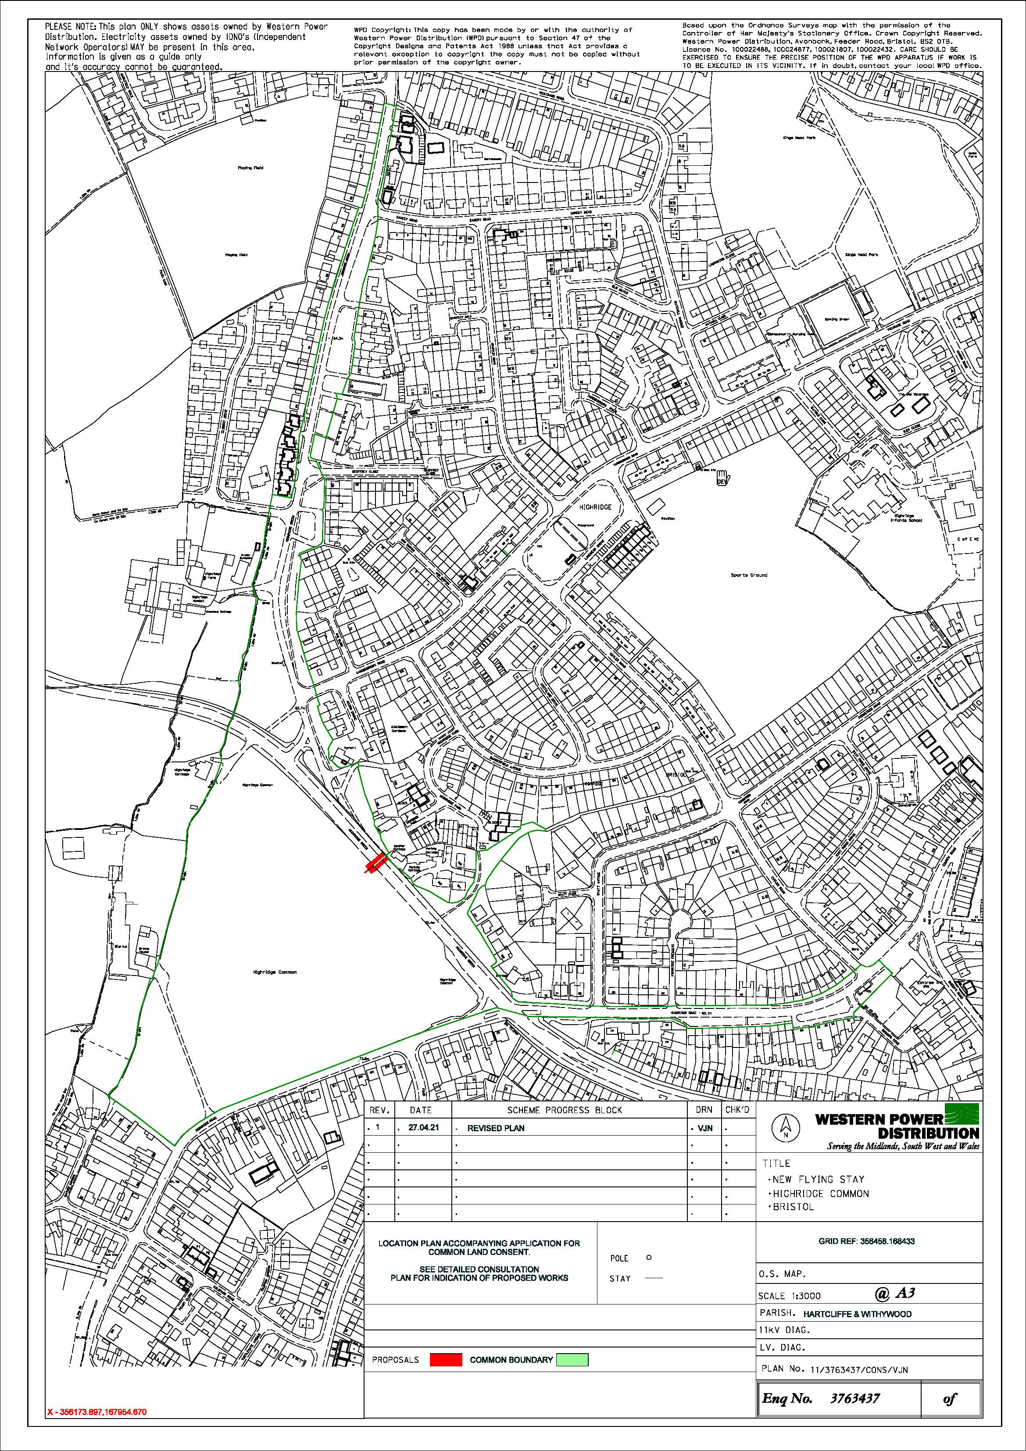

Common Land Consents Policy (Defra November 2015)
Section 39(2) of the 2006 Act provides that the public interest includes the public interest in; nature conservation; the conservation of the landscape; the protection of public rights of access to any area of land; and the protection of archaeological remains and features of historic interest.

