Application Decision
by Alan Beckett
Appointed by the Secretary of State for Environment, Food and Rural Affairs
Decision date: 1 June 2021

Application Ref: COM 3259695
Northam Burrows, Bideford, Devon
Register Unit No: CL9
Commons Registration Authority: Devon County Council.
- The application, dated 7 September 2020, is made under Section 38 of Commons Act 2006 (the 2006 Act) for consent to carry out restricted works on common land.
- The application is made by Torridge District Council.
- The works comprise:
- excavation and remodelling of a man-made bank to create the site for a new café adjacent to the existing Visitor Centre;
- a café comprising a modular building including kitchen, dining area and public toilets. The building will be a timber clad steel frame structure with concrete pads as a foundation. The dimensions of the structure are 16m x 9.1m and 2.9m in height covering 145.6m² of floor space. Outdoor seating will be provided around the building on a millboard terrace totalling 130m²;
- a concrete path around the outside (fenced and gated at both ends) to provide access to the toilets and changing facilities and a small timber bin store;
- resurfacing a 400m (approx.) section of access road with tarmac, infilling low levels and elevating 600mm with hardcore specified by Natural England to prevent flooding;
- in total the works will encroach 0.0876ha onto the common. This includes the remodelled bank, which will be temporarily fenced off to re-establish the turf for a period of no longer than 3 years. Once the fence has been removed the total land lost will be 0.0568ha. 3 parking spaces will be restored to pasture to mitigate any lost grazing; and
- a temporary fence will be erected around the work site enclosing 0.1ha (approx.) for a duration of 4 months.

Decision
  - Consent is granted for the works in accordance with the application dated 7 September 2020 and accompanying plan, subject to the following conditions:-
  - the works shall begin no later than three years from the date of this decision; and
  - all temporary fencing shall be removed and the common shall be restored within one month of the completion of the works.
  - For the purposes of identification only the location of the works is shown red on the attached plan.
Preliminary Matters

- I have had regard to Defra’s Common Land Consents Policy in determining this application under section 38, which has been published for the guidance of both the Planning Inspectorate and applicants. However, every application will be considered on its merits and a determination will depart from the policy if it appears appropriate to do so. In such cases, the decision will explain why it has departed from the policy.

- This application has been determined solely on the basis of written evidence.

- I have taken account of the representations from Northam Town Council (NTC), North Devon Coast Area of Outstanding Natural Beauty (the AONB Board), Natural England (NE), the Open Spaces Society (OSS) and Ms Irene Browning.
- I am required by section 39 of the 2006 Act to have regard to the following in determining this application:-
- the interests of persons having rights in relation to, or occupying, the land (and in particular persons exercising rights of common over it);
- the interests of the neighbourhood;
- the public interest; and
- any other matter considered to be relevant.

Reasons

The interests of those occupying or having rights over the land
- The common is owned by the applicant, Torridge District Council (TDC), and it follows that the proposals are in the landowner’s interest.
- The common land register records the right of the inhabitants of the ancient parish of Northam to graze 1200 sheep and 100 horses over the whole of the land comprised in the register unit. Allocation of the right varies each year and is decided by NTC as Trustee for the inhabitants. The right is exercised annually. TDC proposes to return three areas of gravel car park totalling approximately 0.1ha to dune pasture to mitigate any lost grazing land as a result of the works. NTC advises that it is very happy to accept the offer of this alternative grazing land, which is in excess of the land that may be lost to grazing, and fully supports the proposed works.
- The Royal North Devon Golf Club leases part of the common for an 18-hole golf course and driving range. Whilst the Golf Club has not commented on the application, TDC has submitted a copy of the Golf Club’s letter of 15 January 2019, in which it expresses support for a new café at the Visitor Centre site.
- I am satisfied that the proposed works will not harm the interests of those occupying or having rights in relation to the land and will be of some benefit to the graziers.

The interests of the neighbourhood and the protection of public rights of access
- The proposed works are part of a scheme to improve the services provided by the Visitor Centre. The scheme is supported by the Coastal Communities Fund, which was set up to support seaside communities and stimulate the local economy. TDC advises that the Visitor Centre is well used but, having been built in 1984, is outdated and only offers limited services. The scheme includes its refurbishment, although refurbishment works do not form part of the application before me. The proposed works the subject of the application comprise three general elements; works to build a new café, works to improve the access road to the site and temporary fencing (both short term and longer term).
- The interests of the neighbourhood test relates to how the proposed works will impact on the way the land is used by local people and is closely related to rights of public access. As well as being registered common land under the Commons Registration Act 1965, Northam Burrows is designated as a Country Park under the Countryside Act 1968. TDC advises that the park is popular with visitors throughout the year, who enjoy access to the open countryside and the adjacent beach. It has been used as a site for public recreation since the mid-19th century and is close to the Victorian seaside resort of Westward Ho! TDC employs a Ranger team to manage the park and to deliver an environmental education programme and public events from the Visitor Centre.
- The café is proposed to be located next to the existing Visitor Centre on land comprising part of a man-made bank, which will need to be excavated to accommodate the café. The remaining bank will be to the rear of the café and will be remodelled. TDC advises that the bank is a grass covering to a spoil heap that was left on site when the original Visitor Centre was built. It is not routinely used by the public for access as there is a dedicated access path in existence which leads to the Centre. Due to its location and form I am satisfied that the bank is unlikely to be of great recreational value and I do not consider that a café built on part of it will seriously harm public access.
- The toilet facilities within the café will replace and upgrade those in the Visitor Centre and will include two additional ambulant disabled units with integral baby changing facilities. TDC advises that the intended new cubicle arrangement will be more appropriate in a post-Covid environment. I conclude that the café will benefit the interests of the neighbourhood by providing a useful amenity for visitor centre users and recreational users of the common alike.

- The proposed access road improvement works affect the existing 400m or so of road leading north from Sandymere Road to the Visitor Centre, which is now to be open year-round. The works include timber sleeper edging and are to improve, level and elevate the surface slightly to address flood risk and avoid problems associated with access to the Visitor Centre site during the winter months. The works will not change the use of the land concerned or extend the access road and I am satisfied that the interests of the neighbourhood and public rights of access will not be harmed. Indeed, the existing means of access will be improved for all.
- Three areas of fencing are proposed; one permanent and two temporary. All are intended to exclude public access to a certain extent.
- The permanent fence is proposed to be of timber post and rail and forms part of the café works. It will extend from each side of the café around the path leading to the toilet facilities at the rear and will separate the café from the remaining area of bank, which I will now refer to simply as ‘the bank’. Access to the bank from the rear of the café will be permanently prevented by the fence. However, access to it from other directions will not be affected by the fence and I am satisfied that the fence will have only a small impact on general access to and over the bank. The fence will have no impact on public access to other areas of the common.
- A 100m long fence made of chestnut pailing and timber posts is proposed to adjoin each end of the permanent fence and extend around the bank to enclose it for approximately three years. The purpose of this fencing is to exclude public access to allow turf to fully recover following remodelling. TDC advises that the remodelled area will be used more extensively as a gathering space for visitors to the Centre. I am satisfied that it is necessary to exclude the public from the fenced area to allow full recovery of the bank’s turf following its remodelling and that there will be benefits to public access in the long term as the land will become more usable.
- A ring of Heras safety/security fencing is proposed to surround the café construction site and the temporary chestnut pailing fencing during the works period, which is expected to be around four months. I am satisfied that such fencing is needed for health and safety and site security purposes and that it is in the public interest to temporarily restrict access in this way.
- I conclude that the works, especially the fencing, will cause some short and medium term harm to public access. However, restricting access temporarily will open up greater access in the long term and the café will provide a valuable amenity for local people, users of the Visitor Centre and the public alike.

Nature conservation
- The Visitor Centre and proposed café site is surrounded by the Northam Burrows Site of Special Scientific Interest (SSSI) but is exempt from the designation and none of the café, bank and fencing works fall within the SSSI boundary. The potential impact of the works on nature conservation interests within the exempt area would seem to be in relation to the excavation and remodelling of the bank. Whilst the bank is comprised of man-made spoil from 1984 it may be that it now hosts sensitive species or habitats. However, no-one has suggested that this is the case and there is no evidence that nature conservation interests will be harmed by the works in the exempt area.

- Almost all of the access road runs through the SSSI. NE advised that it had raised objections to the separate planning permission applications in respect of the raising and resurfacing of the access road and the associated installation of a new system to deal with foul water. Whilst the concerns relate directly to the planning applications, NE re-iterated those concerns in commenting on the application now before me. However, NE subsequently confirmed that it had withdrawn the planning application objections following further discussions with the relevant parties and I am satisfied that there are no outstanding NE objections for me to take into consideration in deciding this application.

- In light of NE’s representations, and in the absence of any other concerns raised by other parties, there is no evidence before me to suggest that the proposed access road works will harm the conservation interests of the SSSI.

Conservation of the landscape
- The application land lies within the North Devon Coast Area of Outstanding Natural Beauty (AONB). The AONB Board advises that the area concerned is a significant part of the landscape within the AONB and a site that helps to deliver a wide range of objectives and policies in the North Devon Coast AONB Management Plan. The AONB Board is happy with the proposals, subject to NE’s satisfaction, particularly with regard to the access road works.
- I consider that the proposed access road works will give it a tidier appearance and will not harm landscape interests. NE’s concerns about the access road works were largely nature conservation related. However, a concern was also raised about the raised, re-profiled and timber-edged road being a ‘fixed structure’, which may inhibit the natural roll back of the nearby pebble ridge. In light of NE’s withdrawal of objections, as addressed in paragraph 22 above, I am satisfied that any AONB Board concerns about the access road works have been resolved.
- Ms Browning contends that adding a café will add nothing to an area already popular with people who come for its natural and unspoilt beauty and will instead have a negative impact. I take this to possibly be a comment about the appearance of the café. TDC proposes to clad the café in timber to give it a natural finish similar to the Visitor Centre and advises that the roof height will be below the apex of the Centre and will be hidden behind sand dunes from the west and by the bank on the eastern side. Notwithstanding its hiding from view from certain directions, I am satisfied from schematic drawings submitted with the application that the café will not be an unattractive addition into the landscape and that the remodelling of the bank will be sympathetic to the surroundings.
- Chestnut pailing fencing is proposed as the only viable temporary fencing for the bank because it prevents the movement of sand. Whilst no images of this type of fence have been provided, I consider that to serve this purpose it is likely to be a solid and unattractive new feature in the landscape for a number of years. However, it will not be a permanent feature and will facilitate recovery of the bank’s turf following remodelling, which will be of long-term benefit to the landscape.
- The Heras works fencing will be in place for only four months or so and will have only a short-term impact on the landscape. The land occupied by the fencing will be reinstated to its former state once the fencing is removed, which can be ensured by attaching a suitable condition to the consent.
- I am satisfied that overall, the works will not damage landscape interests and that road improvement and bank re-modelling works will enhance the natural beauty of the AONB.

Archaeological remains and features of historic interest
- TDC advises that there are two World War 2 decoy radar stations on Northam Burrows and two shipwrecks at Westward Ho! Beach. All are Scheduled Ancient Monuments (SAMs) but are not within 750m of the proposed works. Historic England was consulted about the proposed works but has not commented. There is no evidence to suggest that any archaeological remains or features of historic interest will be harmed by the proposed works.

Other matters
- Ms Browning is concerned that trying to make the area into a tourist hotspot will ruin what visitors currently travel to Northam Burrows for and that a café only adds competition for already struggling businesses in the local area. In response TDC submitted the Northam Burrows Country Park Visitor Access Management Plan, which addresses the issues that increased visitor numbers may cause. TDC also advises that the Visitor Centre is 1.5km from the nearest café in Westward Ho! and much further from similar facilities in Northam or Appledore. Whilst Mrs Browning’s concerns are understandable and have been addressed by TDC, I do not consider that they are matters directly related to the merits of the proposed works and I do not give significant weight to them in determining the application.
- OSS contends that the application should have been made under Section 9 of The Countryside Act 1968 and cannot be made under Section 38 of the 2006 Act. Whilst it may be that an application could have been made under the former, the applicant applied under the latter and has given reasons for doing so. Furthermore, common land legislation does not preclude the granting of consent for the proposed works under the provisions of Section 38. There is no sound reason for declining to determine the application, which has been decided on its merits.

Conclusion
- I conclude that the proposed works will benefit the interests of the neighbourhood by providing a useful amenity for Visitor Centre users and recreational users of the common alike and will not unduly harm the other interests set out in paragraph 6 above. Consent is therefore granted for the works subject to the conditions set out in paragraph 1.

Alan Beckett

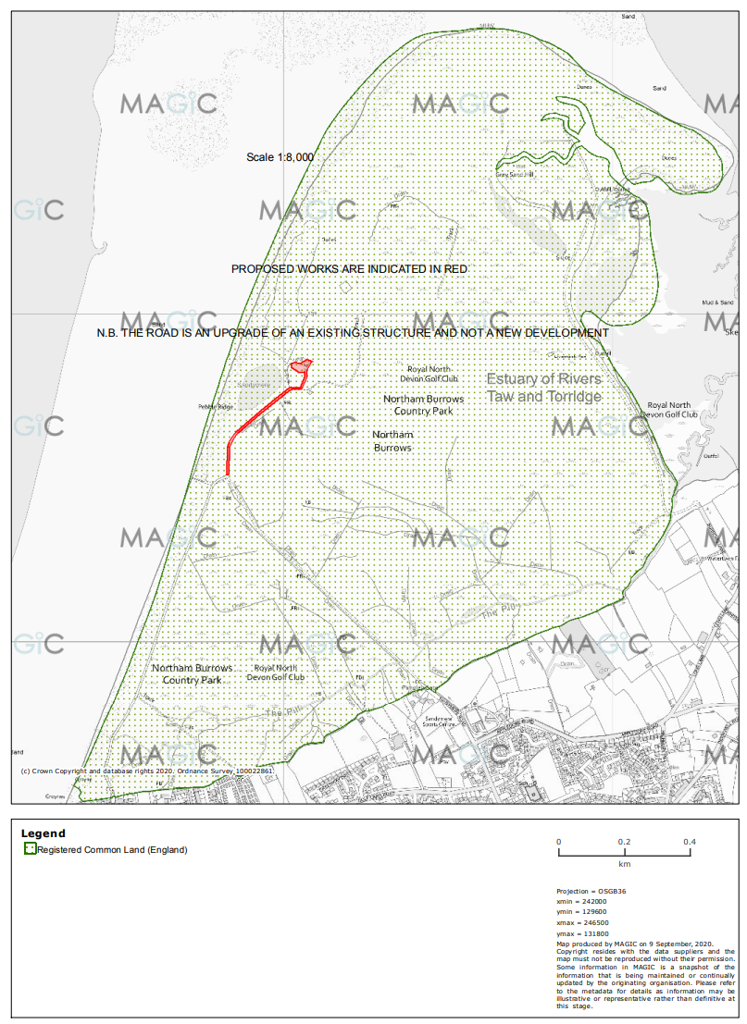

Common Land Consents Policy (Defra November 2015)
Section 39(2) of the 2006 Act provides that the public interest includes the public interest in; nature conservation; the conservation of the landscape; the protection of public rights of access to any area of land; and the protection of archaeological remains and features of historic interest.

