Application Decision
by D M Young JP BSc (Hons) MA MRTPI MIHE
an Inspector appointed by the Secretary of State for Environment, Food and Rural Affairs
Decision date: 26 May 2021

Application Ref: COM/3263703
Danehill Common (area immediately adjoining northern edge of Danehill CE Primary School), School Lane, Danehill, East Sussex RH17 1JB
Register Unit: CL 78
Registration Authority: East Sussex County Council
- The application dated 19 November 2020 is made under Section 38 of the Commons Act 2006 (the 2006 Act) for consent to carry out restricted works on common land.
- The application is made by Richard Allan (Chair of the Governing Body) on behalf of Danehill Church of England Primary school
- The works comprise the installation of a 12.5m x 19m Multi Use Games Area (MUGA), adjoining the north side of the school, with a planted scheme of natural screening plants covering a 15m x 2m area between the MUGA end and School Lane. The MUGA will have 3m high green Dulok fencing, and a green artificial grass surface finish. Total surface area of works = 267.5mts2.

Decision
- Consent is granted for the proposed works in accordance with the application dated 19 November 2020 and the plans submitted with it subject to the condition that the works shall begin no later than 3 years from the date of this decision.

Preliminary Matters
- I have not inspected the site, but I am satisfied I can make my decision without the need to do so.
- For purposes of identification only, the location of the works is shown on the attached plan.
- Following advertisement of the proposal, no objections have been received

The Application
- I am required by Section 39 of the 2006 Act to have regard to the following in determining this application:
(a) the interests of persons having rights in relation to, or occupying, the land (and in particular persons exercising rights of common over it),
(b) the interests of the neighbourhood,
(c) the public interest, and
(d) any other matters considered to be relevant.
- I am also required to have regard to the department for Environment, Food and Rural Affairs (Defra) Common Land Consents Policy, which has been published for the guidance of both the Planning Inspectorate and applicants.

Interests of those occupying or having rights over the land
- Danehill Common is owned by Reverend Patrick Mac Bain and the Church Wardens who have made no objection to the application and are supportive of it.
- Danehill Church of England School is the only occupier and holds the exclusive charges and rights over the land. There are no other rights of common registered over the land and no one other than the owners with a relevant interest in the land.
- Overall, it is my view that the proposed works would have no significant adverse effect on the interests of those occupying or having rights over the land.

Interests of the Neighbourhood
- In general terms works should only be permitted on common land if they maintain or improve the condition of the common or where they confer some wider public benefit and are either temporary in duration or have no significant or lasting impact
- The proposed MUGA would adjoin the northern edge of the school and help to rectify an existing qualitative and quantitative shortfall in outside play space for children. The proposed use is fully in line with the specified educational purpose of the land as laid out in the 1861 deed, and the exclusive rights given over the common land for use in educating children.
- The Church and Wardens, the Diocese, the Parish Council and the Local Planning Authority have all given approval for the installation of the MUGA which is seen as a priority for improving the physical and mental well-being of the school’s children.
- As the school is a community facility, I conclude that the proposal would be in the wider interests of the neighbourhood.

Public Interest
- Section 39(2) of the 2006 Act provides that the public interest includes the public interest in; nature conservation; the conservation of the landscape; the protection of public rights of access to any area of land; and the protection of archaeological remains and features of historic interest

Nature Conservation
- The land affected by the proposed works is not in or near a designated area of either national or local nature conservation importance. Natural England has raised no objection to the proposed works.
- I therefore have no reason to believe that the proposed works would have any significant adverse effect on nature conservation.

Landscape
- The proposed site is currently an unattractive parcel of wasteland adjacent School Lane. It makes very little or no contribution to the visual amenity of the area. The land is not in a National Park, Area of Outstanding Natural Beauty or covered by any formal landscape designation.
- The height of the fencing around the MUGA would be kept to a minimum and landscaping across the site frontage, comprising indigenous species, would help to soften its visual appearance.
- Overall, I am satisfied that the works would not have a significant impact on the conservation of the landscape.

Public access
- Although the public have a right of access to the land under the Countryside and Rights of Way Act 2000, the site is already part of the school site and not used by the public. Accordingly, the proposed works would have no adverse effect on public access.

Archaeological remains and Features of Historic Interest
- There is no evidence to suggest that the proposed works would have an adverse effect on any archaeological remains or features of historic interest.

Conclusions
- The proposed works would not harm the interests of persons having rights in relation to, or occupying the land, the interests of the neighbourhood or the wider public. Accordingly, the application should therefore be granted.

D. M. Young
Inspector

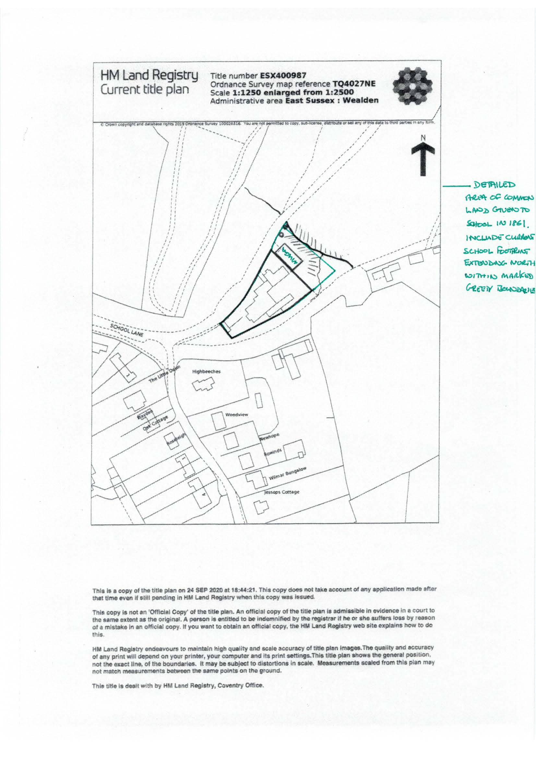

Section 39(2) of the 2006 Act provides that the public interest includes the public interest in; nature conservation; the conservation of the landscape; the protection of public rights of access to any area of land; and the protection of archaeological remains and features of historic interest.
Defra, Common Land Consents Policy, November 2015
Defra, Common Land Consents Policy, para.3.2

