NHS BSP tomosynthesis image reporting template – reflective evidence
Patient identification
Hospital no.
Date of birth
Previous screening information
Manufacturer model (please circle) |  | Hologic Siemens GE Fuji MIS/ Giotto Other
Lesion identified? (please circle) |  | Yes / No
On which slice(s) was the lesion identified? |  |  | …………….
Review of screening mammogram
Side and site of abnormality Right  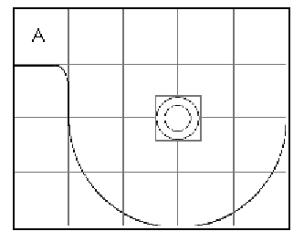 |  |  |  |  | Left  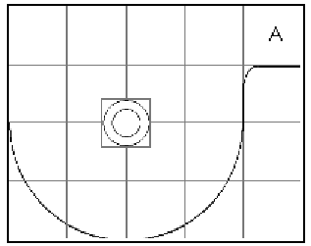
Mammographic features (please circle one or more options)
Well defined | Ill defined |  |  | Spiculate
Casting | Granular |  |  | Punctate |  | Benign Other
Architectural distortion | Asymmetry |  |  | Skin thickening |  | Lymph node
Fatty | Mixed |  |  | Dense
Learning points
Do your outcomes agree with the test set outcomes?
………………………………………………………………………………………………………………………
…………………………………….………………………………………………………………………………..
What are the main learning points identified and how will these inform your future practice?
………………………………………………………………………………………………………………………
………………………………………………………………………………………………………………………
………………………………………………………………………………………………………………………
………………………………………………………………………………………………………………………
………………………………………………………………………………………………………………………
………………………………………………………………………………………………………………………
………………………………………………………………………………………………………………………
………………………………………………………………………………………………………………………

