OFFICIAL

scm Specification Template Example

  - Should Cost Modelling

MAY 2020

Version 1.0

How to use this Template

A model Specification is used to plan the development of a model and forms the blueprint for its production. As the model is developed the model Specification should be updated to reflect any required changes. An up to date model Specification will be required for testing of the model. Once development is complete the model Specification should be an accurate reflection of what the model does. The final model Specification may need to include additional sections once the model is fully developed (e.g. Model Configuration, Version number etc.).

This Specification Template Example (“this Template”) is an example of how a model Specification can be set out and includes section headings and example content.

All Should Cost Models (SCMs) vary in nature and as such there is ‘no one size fits all’ model Specification template. This Template is intended to add structure and provide a head start on the development of a model Specification but should be tailored as required. Consider the need to add, remove or amend sections within this Template when populating it.

This Template includes example sections that may be relevant to the model Specification being developed. ‘[Square Brackets]’ or ‘[TBC]’ are included where either:
- further information should be populated; and/or
- the information in this Template should be checked and confirmed that it is correct for the SCM being developed; and/or
- illustrative examples are included which should be removed when populating the Template.

Prior to completing this Template, it is recommended that the SCM Scoping Template is completed first. Included in the body of this template in ‘{Curly Brackets}’ are references to the sections in the SCM Scoping Template that may help to inform completion of this Template. Further information on preparing a model Specification is available in the SCM Development Guidance.

This Template includes supplementary guidance in red italics. This should be deleted when populating this Template.

This Template has been prepared on the assumption that the SCM will be built in a Spreadsheet-based application (e.g. MS Excel). However, if this is not the case, this Template can still be tailored and used.

It is recommended that this section (‘How to use this template’) is deleted once the Template is populated.

This Template uses GCF branding for illustrative purposes. Please remove GCF branding and update to reflect the branding of your contracting authority prior to populating it.

Consider the need to add a Protective Marking to this Template ahead of populating it.

The use of this Template is not mandated, although it is recommended where there is nothing similar in use within the contracting authority. It should be applied in a manner that is proportional to the risks associated with a specific SCM and its use.

You should consult the Cabinet Office Sourcing Programme for further information or before planning an SCM for complex services, projects or programmes via sourcing.programme@cabinetoffice.gov.uk.
Contents
1. How to use this Template 1
2. Document Control 4
3. Scope 5
4. Key Personnel 7
5. Model Functionality 9
6. Model Structure 12
7. Outputs 14
8. Cost Lines, Calculation Logic and Other Inputs 15

Document Control
Document Name:
Document Version:
Document Author: [Insert Name]
Author Email: [Insert Email Address]

Document Edit History:
Version | Date | Comment | Updated By | Approved by

Scope

Background

[Insert Project Background including estimated project value]

{May be informed by Questions 3.1, 4.1 – 4.6 of Scoping Template}

Document Purpose

The purpose of this document is to [outline the specification and design of the Should Cost Model (“the model”) and confirm the key drivers and assumptions]

Model Objectives

The purpose of the model is to [TBC].

[e.g. What decision is the model required to support and what does it need to do/ show/ compare /analyse?]

{May be informed by Questions 4.3, 4.4, 4.7 – 4.9 of Scoping Template}

Note, this section is of critical importance because a model is designed and built to meet specific objectives. These objectives need to be clear before the model can be specified.

General Model Details

Model Classification: [Official / Official-Sensitive / Secret / Top Secret]

Business Critical Model: [Yes / No]

Interactions/Dependencies on other models/projects: [TBC]

IMA Score: [Low / Medium / High]

Model Limitations

The primary focus of this section is to make explicit what the model is not capable of doing, cannot be used for or does not support. This may include areas that were discussed in model planning and subsequently not taken forward, or areas that could be reasonably assumed to be included in the model. This section may also highlight key modelling simplifications.

Illustrative examples are:
- The number of scenarios the model can run
- The number of staff pay grades included
- Out of scope cost items (e.g. disposal costs not included)
- The model presents incremental costs only and not absolute costs
- The model only includes costs not wider benefits
- Overheads have been modelled as fixed costs (only valid in certain ranges)
- [TBC]
- [TBC]
- [TBC]
- [Add as many Limitations as required]

{May be informed by Section 9 of Scoping Template}

Key Personnel

Stakeholders
Key model stakeholders and decision makers (taking ownership for the assumptions used and responsible for the model) are:
- [Insert Name] – Model SRO
- [Insert Name – Insert Role]
- [Insert Name – Insert Role]
- [Insert Name – Insert Role]
- [Insert as many names and roles as required]
{May be informed by Section 11 and 12 of Scoping Template}

Model Operators
The Model Operator are:
- [Insert Name – Insert Role]
- [Insert as many names and roles as required]
{May be informed by Section 11 of Scoping Template}

Data Management
The Data Providers are:
- [Insert Name – Insert Role]
- [Insert as many names and roles as required]
The Data Owners are:
- [Insert Name – Insert Role]
- [Insert as many names and roles as required]
{May be informed by Section 8 and 12 of Scoping Template}
[Insert a description of how the data will be signed off and changes manged]

Model Functionality

Model Timeline
The model timeline is based on a [financial year from 1 April – 31 March].
[The model shows forecast projections only and does not include the functionality to incorporate actual costs]
or
[The model includes forecast projections and also includes functionality to incorporate actual costs]
The model covers the following periods:
[Insert Periods covered by the model]

{May be informed by Section 10 of Scoping Template}

Periodicity
The model is calculated on a [monthly/quarterly/annual/[TBC]] basis [and includes annual summaries].

{May be informed by Section 10 of Scoping Template}

Scenarios & Sensitivities
The model includes the following scenario functionality:
[Enter details regarding the names / number of scenarios included in the model.
Enter details of sensitivities included in the model.]

{May be informed by Question 7.9 and 8.2 of Scoping Template}

Risk & Uncertainty

The model takes the following approach to Risk & Uncertainty:
[Enter details regarding how the model treats Risk & Uncertainty]

{May be informed by Question 7.13 of Scoping Template}

Optimism Bias

The model takes the following approach to Optimism Bias:
[Enter details regarding how the model accounts for Optimism Bias]
{May be informed by Question 7.14 of Scoping Template}

Model Currencies
[Modelling will be undertaken in GBP and the model does not include any functionality with regards to foreign currencies or foreign exchange]
or
[Modelling will be undertaken in GBP and the model will [enter details regarding foreign currencies or foreign exchange considerations]]

{May be informed by Question 7.12 of Scoping Template}

Inflation

The model takes the following approach to Inflation:
[Enter details regarding how inflation is treated]

{May be informed by Question 7.10 of Scoping Template}

Taxation

The model takes the following approach to Taxation:
[Enter details regarding how the model treats Taxation (including irrecoverable VAT)]

{May be informed by Question 7.11 of Scoping Template}

Model Structure

Software requirements
The model is built in [Microsoft Excel 2016] saved in the [XLSM] file format.
[The model makes use of VBA (Macros) for [TBC] purposes]

{May be informed by Section 14 of Scoping Template}

Sign convention
The model adopts the following signage conventions:
• [Costs are shown as positive values (+)]

Error control
[Enter details of how the model handles and reports errors]

Model Map / Design
The design and structure of the model is shown in the diagram below:
[Insert a Model Map showing the model design and a description of the individual worksheets]
[See below for an illustrative Model Map. This should be replaced with a Model Map that fits the model requirements]
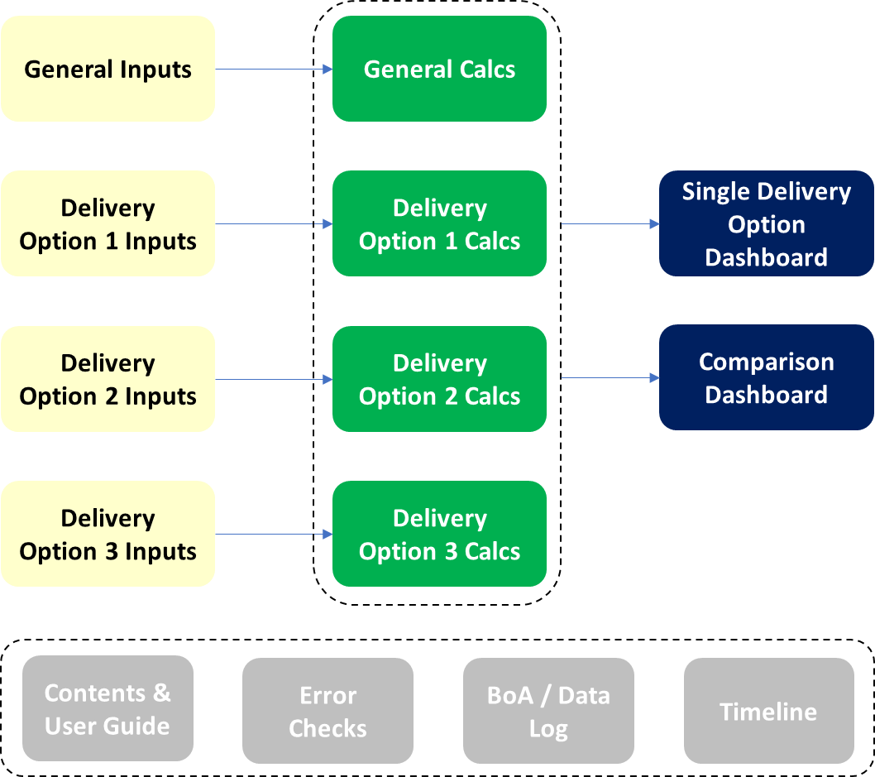

Outputs
The model includes the following Outputs worksheets:

[Output Sheet 1]
The [Output Sheet 1] includes the following:
- [Insert key information]
- [Insert key information]
- [Add as many bullets as required]
An extract of the [Output Sheet 1] sheet can be seen below:
[Insert extract of output sheet]
[Replicate Output Sheet sections for each output sheet in the model, as required]
Initial output templates should be prepared that set out the content, format and layout of model outputs. This will enable discussion and iteration of planned model outputs prior to model development. The final output templates will form the basis of the model to be developed.
[Example Output templates can be found in [Insert Filename]]

{May be informed by Section 6, Question 7.8 of Scoping Template}

Cost Lines, Calculation Logic and Other Inputs
This section should document the cost line items, associated calculation logic and inputs the SCM will use. This section will differ for every SCM and the following structure should be adapted to meet the needs of the model being built.
For example, if there is more than one delivery option, the cost line items for each delivery option will need to be documented. In some models this could be captured by one Cost Line Items table, with differences denoted in a Comments column. For other models, cost line items may vary significantly between delivery options and therefore it may be better to populate different Cost Line Items tables for each delivery option.
The guiding principle that should be followed, is that this document should be sufficiently detailed to enable someone independent to follow the logic and reproduce the model if required.
This section identifies the key components which are modelled and the main drivers of these components.

Cost Line Items
Item | Category | Description | Forecast Calculation | Input Data Fields | Inflation Treatment | Comments
1 | [e.g. Staff Costs] | [e.g. Grade 6 FTE Costs] | [e.g. A x B] | [e.g. A = FTE Numbers]  [e.g. B = FTE Salary] | [e.g. Wage Inflation Rate] | [e.g. Staff Costs are expected to be incurred from period 2]
2 | [e.g. Staff Costs] | [e.g. Grade 5 FTE Costs]
3 | [e.g. Overheads] | [Insert description of cost line item]

{May be informed by Section 7 and Question 8.1 of Scoping Template}

Other Inputs
Item | Category | Description | Comments
1 | [e.g. Inflation] | [e.g. Wage Inflation Rate]
2 | [e.g. Inflation] | [e.g. GDP Deflator]

{May be informed by Section 7 and Question 8.1 of Scoping Template}
Input templates should be prepared that set out the content, format and layout of model inputs (informed by sections 8.1 and 8.2 above). The input templates will form the basis of the model to be developed and will also help to inform the Data Plan.
[Example Input templates can be found in [Insert Filename]]

© Crown copyright 2021
This publication is licensed under the terms of the Open Government
Licence v3.0 except where otherwise stated. To view this licence,
visit nationalarchives.gov.uk/doc/open-government-licence/version/3
Where we have identified any third party copyright information you
will need to obtain permission from the copyright holders concerned.

