Official Statistics
20 May 2021

Introduction
This statistical release provides summary information on appeals, which represent the highest volume (in terms of number of cases) of the work of the Planning Inspectorate.

These statistics are produced each month and the focus is on timeliness, as that is an area in which stakeholders have an interest. Information on the decisions that we have made is also included; and on the number of Inspectors available to make those decisions.

For this release additional statistics on workload volumes have been provided that are published on a quarterly and annual basis.

We are seeking feedback! If you have any thoughts on how we can develop these statistics – including on the additional quarterly and annual figures - please let us know at statistics@planninginspectorate.gov.uk

These statistics have been published to ensure everyone has equal access to the information and to support the Planning Inspectorate’s commitment to release information where possible.

This statistical bulletin provides:
- Appeals decisions and events held from May 2020 to April 2021
- The time taken to reach those decisions
- Number of open cases
- Number of Inspectors
- Number of virtual events
- Quarterly and annual statistics on volumes of cases received, decided and allowed
The data in this release is only applicable to England.

The Planning Inspectorate
The Planning Inspectorate makes decision and provides recommendations and advice on a range of land use planning-related issues across England and Wales. We do this in a fair, open and timely way.

The Planning Inspectorate deals with planning appeals, national infrastructure planning applications, examinations of local plans and other planning-related and specialist casework in England and Wales. The Planning Inspectorate is an executive agency, sponsored by the Ministry of Housing, Communities & Local Government and the Welsh Government.
Summary
This release has been slightly restructured to reflect that, as with everyone else, the Inspectorate has now been operating for over 12 months with the impact of the Covid-19 pandemic.
Performance
The mean average time to make a decision, across all cases in the last 12 months (May 20 to Apr 21), was 27 weeks. The median time is 23 weeks.
The median timeliness for April 21 was 21.9 weeks – this was an increase of 2 weeks from March 21.
Median timeliness by procedure type is shown in the summary table below.

Procedure type | Last 12 months | April 21
Written Representations | 23 weeks | 21 weeks
Hearings | 47 weeks | 61 weeks
Inquiries | 56 weeks | 62 weeks

The median time to decision for planning cases (there are many more of these decisions than in the other categories) is lower than for other casework categories, apart from in May 20. Across the whole year, the median time to decision for planning cases is 22 weeks. Enforcement decisions made in the last 12 months had a median decision time of 34 weeks. The median time to decision for specialist decisions is broadly the same as for enforcement decisions, and longer than the median for planning decisions.

The median time for inquiries under the Rosewell Process over the 12 months to April 21 is 40 weeks.

Decisions
The Planning Inspectorate has made 16,980 appeal decisions in the last 12 months, an average of just over 1,400 per month. The monthly breakdown shows fewer decisions from May to August 20, and for the months of January and March 21, than would have been expected, due to the impact of the national lockdowns.
The number of decisions each month showed an upward trend to October 20 (with a slight dip in August linked to leave for decision makers). However, since October decisions decreased. The 1,083 decisions for April 21 was almost 33% lower than March 21.

Written representations decisions had recovered to pre-pandemic levels between September and December 20 (pre-pandemic being between approximately 1,600 and 2,000 decisions per month). January and March 21 were lower. And April 21 was considerably lower at just under 1,000.

Decisions for hearings for the last six months have ranged between approximately 40 and 60 per month. The 37 inquiry decisions made in April 21 were the most in any of the last 12 months.

Open Cases
At the end of April 21, the Planning Inspectorate had over eleven thousand one hundred cases open (11,184). This is an increase of 470 (4%), from the previous month, and the highest number of open cases in the last 12 months.

Planning Inspectors
There were 355 Planning Inspectors employed by the Inspectorate in April 21 – with a full-time equivalent of 317. A small number (six) of recently recruited Inspectors, as part of planned recruitment, started in April 21.

Virtual Events
The Inspectorate are continuing to carry out events ‘virtually’. There were 82 cases involving Virtual Events during April 2021.

Quarterly & annual volume statistics

Nationally Significant Infrastructure Projects (NSIPs)
- Nine applications were submitted in 2020/21, compared to 14 in 2019/20
- Ten reports were issued to the relevant Secretary of State in 2020/21, compared to 20 in 2019/20

Local Plans
- In 2020/21, 32 plans were submitted for examination, compared to 59 in 2019/20

Section 78 Planning Appeals
- The number of appeals received dropped by 7% in 2020/21 compared to 2019/20
- The number of decisions was 32% lower in 2020/21 compared to 2019/20. The number of decisions in 2019/20 was the highest in the past eleven years, and 2020/21 decisions were heavily impact by the Covid-19 pandemic.
- One in four appeals decided (25%) were allowed in 2020/21, the same proportion as in 2019/20
- The percentage of dwellings allowed, for major dwellings appeals (those with proposals of 10 or more dwellings) was 58% in 2020/21, compared to 45% in 2019/20.

Decisions, Events & Open Cases
The number of decisions issued in April 21 was significantly lower than the previous month, with only May and June 20 being lower, with the impact of the first Covid lockdown. The number of decisions issued in April 21 has been partly influenced by decision makers taking leave over the Easter holiday period.
The number of events between December 20 and Apr 21 have been around 1,400 per month. In the last 12 months the highest number of events held was September 20, when almost 2,100 events were held.
The median time to decide a case increased by two weeks between March and April 21, with the median in April 21 being just under 22 weeks. Performance had been improving from November 20 to March 21.
Figure 1: Number of events held, decisions issued and median time between valid date & decision date; May 20 to Apr 21
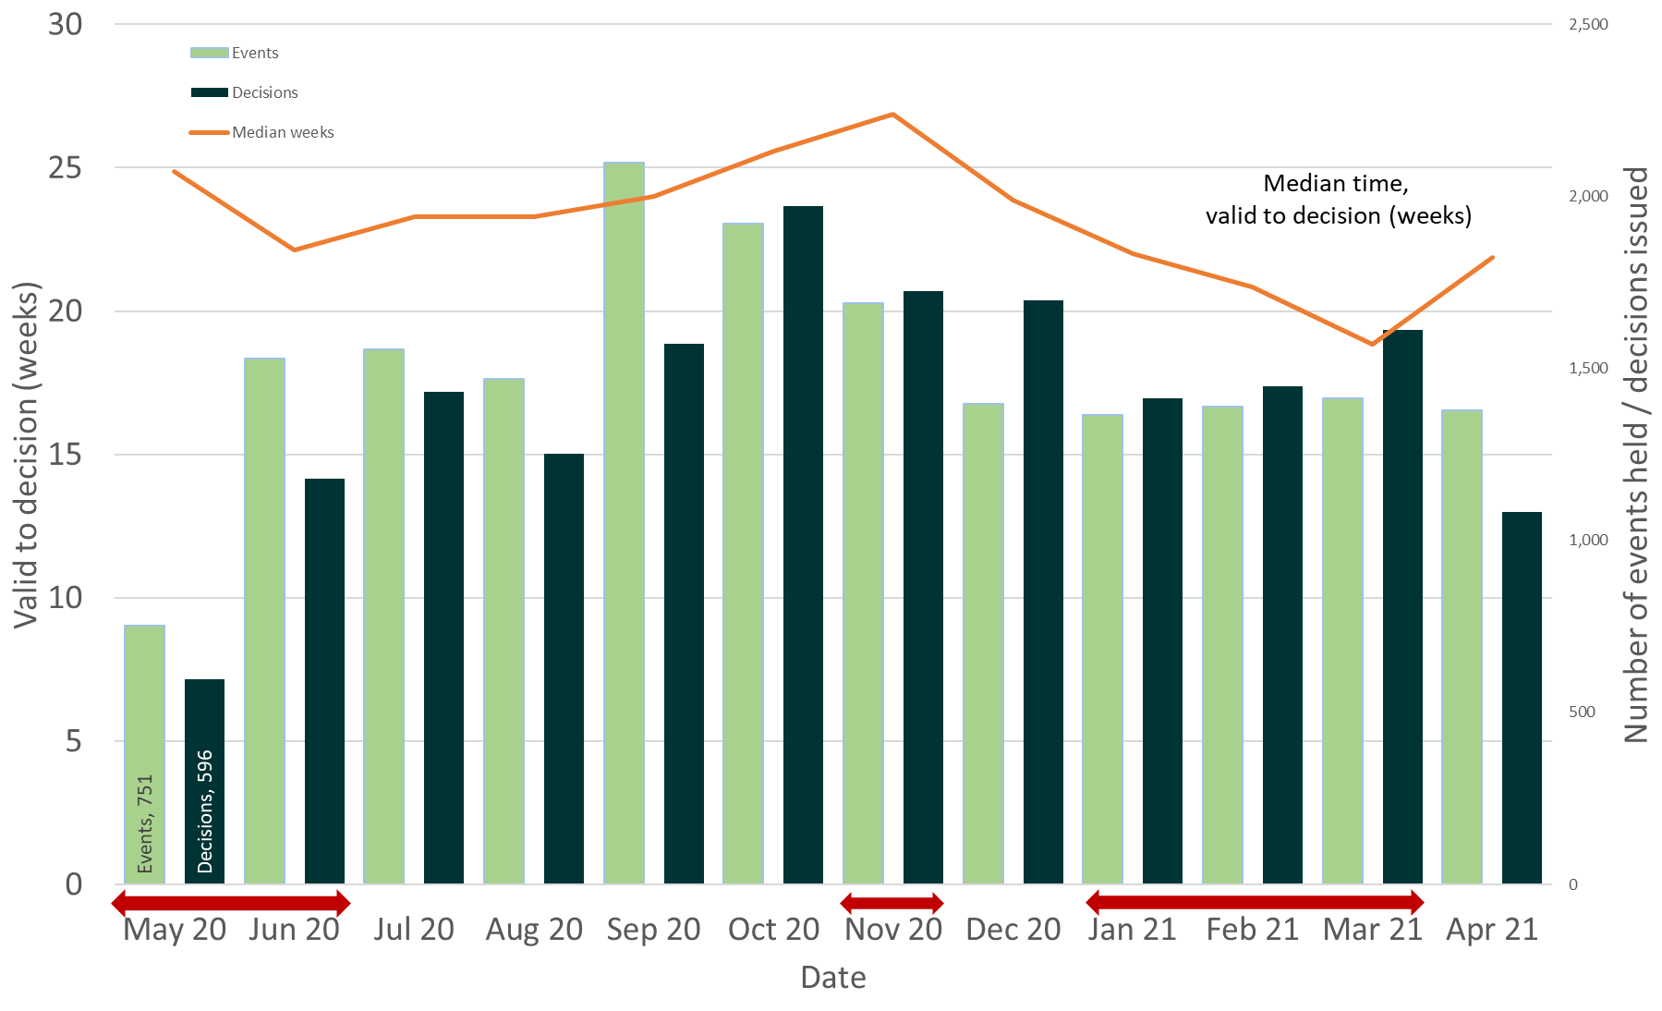
Source: Horizon, Picaso, Inspector Scheduling System
Note – Red arrows indicate periods when national lockdowns were in effect
Table 1: Number of events held, decisions issued and median time between valid date & decision date; May 20 to Mar 21
Month | May 20 | Jun 20 | Jul 20 | Aug 20 | Sep 20 | Oct 20 | Nov 20 | Dec 20 | Jan 21 | Feb 21 | Mar 21 | Apr 21 |  | Total
Events Held | 751 | 1,528 | 1,555 | 1,470 | 2,097r | 1,921r | 1,691r | 1,398r | 1,366r | 1,390r | 1,414r | 1,377 |  | 17,958
Decisions | 596 | 1,180 | 1,432 | 1,253 | 1,571 | 1,971 | 1,725 | 1,699 | 1,412 | 1,447 | 1,611 | 1,083 |  | 16,980
Median | 24.9 | 22.1 | 23.3 | 23.3 | 24.0 | 25.6 | 26.9 | 23.9 | 22.0 | 20.9 | 18.9 | 21.9 |  | 23.0
Source: Horizon, Picaso, Inspector Scheduling System. r denotes revision – a change of more than 5 cases since last month (see Background Quality Report for more information)

The number of open cases has been increasing since December 20 and increased by 4% between the end of March 21 and the end of April 21, to the highest level in the last 12 months. This contrasts with the period September to December 20, where once schools re-opened and full Inspectorate capacity had returned, the number of cases being closed noticeably exceeded the number received.

The number of open cases is influenced both by capacity to carry out casework (resulting in decisions issued / cases closed) and incoming demand (cases received). As mentioned above, decisions for April 21 were low. The number received in April 21 was 16% less than the previous month. March 21 had the highest number of cases received in the last 12 months (1,907). Over the last 12 months around 1,700 cases have been received each month.

Note – The number of cases closed is higher than the number of decisions, as it includes cases where an appeal is withdrawn, notice is withdrawn, or the appeal is turned away.

Figure 2: Number of cases received, closed and open; May 20 to Apr 21
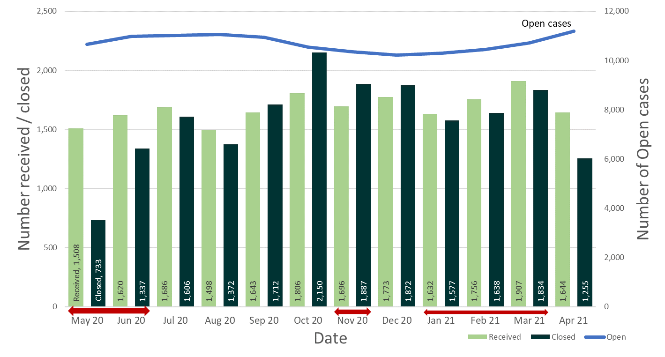
Source: Horizon and Picaso
Note – Red arrows indicate periods when national lockdowns were in effect

Table 2: Number of cases received, closed and open; May 20 to Apr 21
Month | May 20 | Jun 20 | Jul 20 | Aug 20 | Sep 20 | Oct 20 | Nov 20 | Dec 20 | Jan 21 | Feb 21 | Mar 21 | Apr 21 | Total
Received | 1,508 | 1,620 | 1,686 | 1,498 | 1,643 | 1,806 | 1,696 | 1,773 | 1,632 | 1,756 | 1,907r | 1,644 | 20,169
Closed | 733 | 1,337 | 1,606 | 1,372 | 1,712 | 2,150 | 1,887 | 1,872 | 1,577 | 1,638 | 1,834r | 1,255 | 18,973
Open | 10,665 | 10,987 | 11,023 | 11,050 | 10,951 | 10,541 | 10,350 | 10,217 | 10,298 | 10,440 | 10,714 | 11,184 | N/A
Source: Horizon and Picaso. r denotes revision – a change of more than 5 cases since last month (see Background Quality Report for more information)

Number of Decisions
The Planning Inspectorate has made 16,980 appeal decisions in the last 12 months, an average of just over 1,400 per month. Table 3 below shows the monthly breakdown with fewer decisions from May to August 2020, and for the months of January and March 2021, than would have been expected, due to the impact of national lockdowns.
As can be seen from the table, the fewest decisions were made in May 2020 – just under six hundred decisions. Since then the number of decisions each month showed an upward trend to October 20 (with a slight dip in August linked to leave for decision makers). However, since October decisions decreased. The 1,083 decisions for April 21 was almost 33% lower than March 21. The same information is represented in Figure 3.
Table 3: Appeal Decisions; May 20 to Apr 21
Month | May 20 | Jun 20 | Jul 20 | Aug 20 | Sep 20 | Oct 20 | Nov 20 | Dec 20 | Jan 21 | Feb 21 | Mar 21 | Apr 21 | Total
Decisions | 596 | 1,180 | 1,432 | 1,253 | 1,571 | 1,971 | 1,725 | 1,699 | 1,412 | 1,447 | 1,611 | 1,083 | 16,980
Source: Horizon and Picaso.
Figure 3 – Appeal Decisions; May 20 to Apr 21
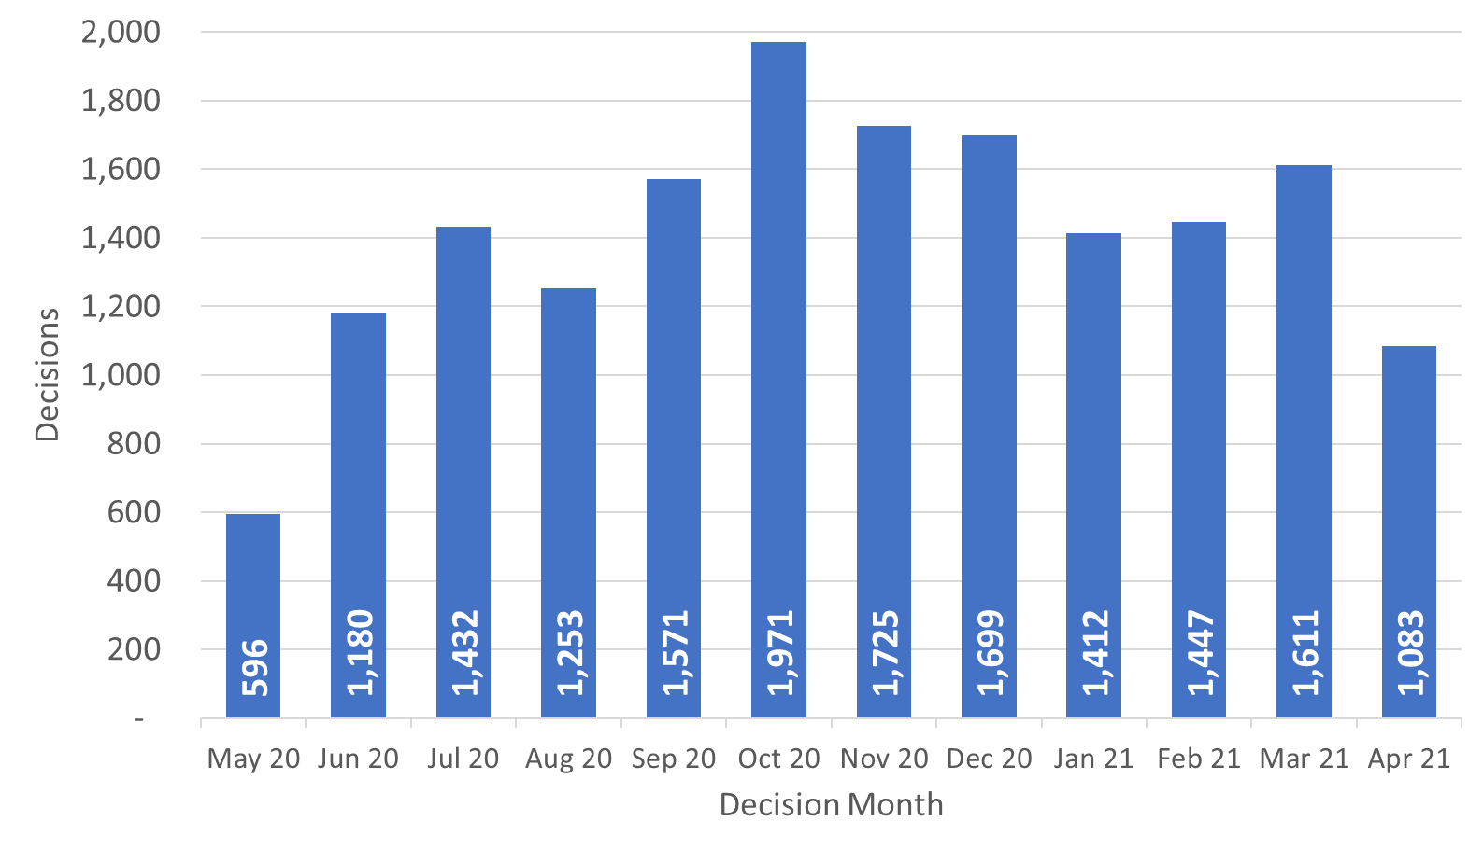
Source: Horizon and Picaso

Decisions by procedure and case type

Planning Inspectors work on a broader range of work than the appeals featured in this Release. For example, they also work on examining Nationally Significant Infrastructure Project applications, Local Plans, Compulsory Purchase Order applications and many other specialist licencing/application types.

Table 4 below gives the numbers of appeal decisions made broken down by whether the case was dealt with by written representations, hearings, or inquiries.

The large majority of decisions (16,353) were made on written representations. This is about ninety six percent of all appeal decisions made. Table 4 shows that written representations decisions had recovered to pre-pandemic levels between September and December 20 (pre-pandemic being between approximately 1,600 and 2,000 decisions per month). January and March 21 were lower. And April 21 was significantly lower at just under 1,000.

There were 419 decisions made on hearings. Decisions for hearings for the last six months have ranged between approximately 40 and 60 per month.

There were 208 decisions made on inquiries. The 37 inquiry decisions in April 21, were the most per month in the last 12 months.

Table 4: Appeal Decisions by procedure and casework category; May 20 to Apr 21
Month | May 20 | Jun 20 | Jul 20 | Aug 20 | Sep 20 | Oct 20 | Nov 20 | Dec 20 | Jan 21 | Feb 21 | Mar 21 | Apr 21 | Total
Written Representations | 575 | 1,157 | 1,411 | 1,230 | 1,543 | 1,918 | 1,672 | 1,613 | 1,330 | 1,384 | 1,525 | 995 | 16,353
Hearings | 17 | 13 | 16 | 13 | 21 | 40 | 33 | 60 | 58 | 44 | 53 | 51 | 419
Inquiries | 4 | 10 | 5 | 10 | 7 | 13 | 20 | 26 | 24 | 19 | 33 | 37 | 208
Total | 596 | 1,180 | 1,432 | 1,253 | 1,571 | 1,971 | 1,725 | 1,699 | 1,412 | 1,447 | 1,611 | 1,083 | 16,980
Month | May 20 | Jun 20 | Jul 20 | Aug 20 | Sep 20 | Oct 20 | Nov 20 | Dec 20 | Jan 21 | Feb 21 | Mar 21 | Apr 21 | Total
Planning | 439 | 970 | 1,149 | 991 | 1,323 | 1,638 | 1,484 | 1,463 | 1,186 | 1,244 | 1,417 | 939 | 14,243
Enforcement | 145 | 178 | 239 | 227 | 215 | 281 | 195 | 187 | 165 | 112 | 150 | 100 | 2,194
Specialist | 12 | 32 | 44 | 35 | 33 | 52 | 46 | 49 | 61 | 91 | 44 | 44 | 543
Total | 596 | 1,180 | 1,432 | 1,253 | 1,571 | 1,971 | 1,725 | 1,699 | 1,412 | 1,447 | 1,611 | 1,083 | 16,980
Source: Horizon and Picaso

The large majority of cases were planning (14,243). This is about eighty four per cent of all appeal decisions made. There were 2,194 enforcement decisions and 543 specialist decisions. These totals are also shown in Table 4 and Figure 4 below.

Trends for planning decisions show similar patterns to written representations. The number of enforcement decisions had been decreasing month on month since October 20, apart from March 21. Specialist casework figures continue to vary each month by a significant amount.

Figure 4 – Appeal Decisions by Procedure and Casework Category; May 20 to Apr 21
Appeal Decisions by Procedure | Appeals Decisions by Casework Category
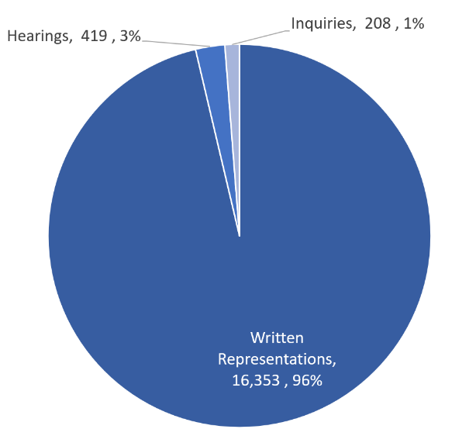 | 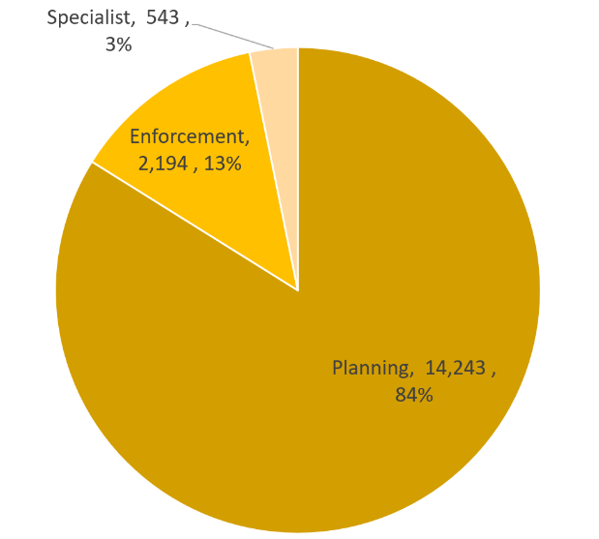
Source: Horizon and Picaso

Decision timeliness

It is important for people to know how long an appeal is going to take, so that they can make plans and decisions based on this information. This section covers the timeliness of decisions (i.e. how long it takes to make a decision) across our appeal casework. In addition to an overall measure, timeliness is analysed by procedure type and casework category, as timeliness varies a great deal depending on these characteristics.

Table 5 below shows that the mean average time to make a decision, across all cases in the last 12 months (May 20 to Apr 21), was 27 weeks. Figure 5 shows the mean has been above 25 weeks, with the exception of March 21, for the last 12 months.

Table 5 also shows the median time is 23 weeks. Each month the median is less than the mean; this is due to the larger impact on the mean of very long cases.

The median timeliness increased between June 20 to Nov 20, peaking at almost 27 weeks. Between December 20 to March 21 there was a reduction in the median time to decision, down to a low in March 21 of 18.9 weeks. April 21 shows an increase to 21.9 weeks.

Also included in the table is the standard deviation of decision timeliness. A lower standard deviation would demonstrate greater consistency in the Planning Inspectorate’s decision timeliness. The data shows that the variability was getting less towards the end of 2020 – the standard deviation values are 15.6 or lower for June to December. Data for the months in 2021 show greater variability, with a low of 15.8 weeks and a high of 18.7 weeks.

What are mean, median, and standard deviation?
Measure | Definition
Mean | The total time taken divided by the number of cases. Also referred to as the ‘average’. A measure of how long each case would take, if the total time taken was spread evenly across all cases.
Median | This is the time taken by the ‘middle’ case if all cases were sorted from quickest to longest
Standard deviation | This is a measure of variability or spread. It is calculated by examining how much each value differs from the mean. A higher standard deviation means the individual decision times vary more widely around the mean.

Table 5: Mean, Median and Standard Deviation of Time to Decision; Apr 20 to Mar 21
Month | May 20 | Jun 20 | Jul 20 | Aug 20 | Sep 20 | Oct 20 | Nov 20 | Dec 20 | Jan 21 | Feb 21 | Mar 21 | Apr 21 | Total
Valid to Decision (mean weeks) | 29.0 | 26.1 | 26.0 | 25.9 | 26.1 | 28.4 | 28.5 | 27.8 | 27.7 | 26.7 | 23.8 | 27.4 | 27.0
Valid to Decision (median weeks) | 24.9 | 22.1 | 23.3 | 23.3 | 24.0 | 25.6 | 26.9 | 23.9 | 22.0 | 20.9 | 18.9 | 21.9 | 23.0
Standard Deviation (weeks) | 15.6 | 13.9 | 14.4 | 14.0 | 12.5 | 14.9 | 12.9 | 15.6 | 18.1 | 16.9 | 15.8 | 18.7 | 15.5
Source: Horizon and Picaso

Figure 5: Mean and Median time to decision; May 20 to Apr 21
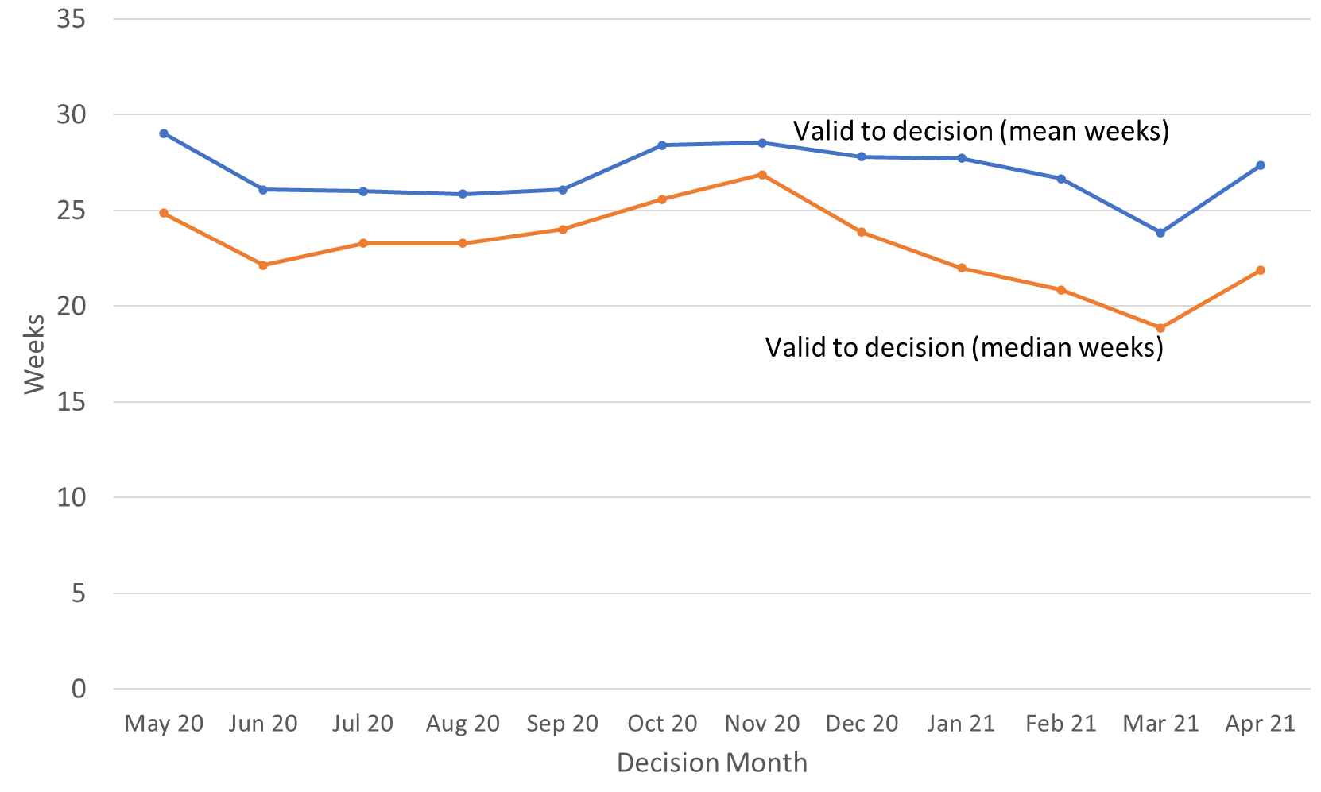
Source: Horizon and Picaso

Procedure Type
Table 6 below shows decision timeliness broken down by the procedure type. Hearings and inquires take longer than written representations – with Inquiries taking more than twice as long as written representations. Because 19 of every 20 cases are by written representation, the timeliness measures for written representations is similar to the measure across all cases.

Where a small number of cases has been decided, the average timeliness (whether mean or median) is less meaningful as a measure than where there are many cases. Those areas shaded in the table below should be treated with caution as there are fewer than 20 cases decided.

The median time for written representations over the 12 months to April 21 is 23 weeks. The median time for inquiries over the 12 months to April 21 is over a year - 56 weeks. The median time for hearings is slightly less at 47 weeks. For each of these procedure types, the mean is higher as it is more affected by the longest cases.

Table 6: Mean and Median Time to Decision, with standard deviation, by procedure; May 20 to Apr 21
Measure | Procedure | May 20 | Jun 20 | Jul 20 | Aug 20 | Sep 20 | Oct 20 | Nov 20 | Dec 20 | Jan 21 | Feb 21 | Mar 21 | Apr 21 | Total
Valid to Decision (mean weeks) | Written Representations | 28.1 | 25.3 | 25.6 | 25.4 | 25.6 | 27.9 | 28.0 | 26.6 | 25.8 | 25.3 | 22.0 | 24.1 | 25.8
 | Hearings | 50.4 | 63.8 | 56.0 | 43.1r | 50.5 | 49.8 | 37.3 | 49.6 | 59.8 | 47.5 | 56.7 | 63.2 | 52.5
 | Inquiries | 73.0r | 71.4 | 42.3 | 55.1 | 63.2 | 43.8 | 58.5 | 52.8 | 57.0 | 76.3 | 57.6 | 65.7 | 61.0
 | All Cases | 29.0 | 26.1 | 26.0 | 25.9 | 26.1 | 28.4 | 28.5 | 27.8 | 27.7 | 26.7 | 23.8 | 27.4 | 27.0
Valid to Decision (median weeks) | Written Representations | 24.1 | 22.0 | 23.1 | 23.0 | 23.9 | 25.1 | 26.6 | 23.1 | 21.3 | 20.4 | 18.4 | 20.9 | 22.7
 | Hearings | 47.1 | 52.6 | 39.6 | 45.1r | 40.3 | 40.1 | 37.3 | 43.9 | 51.5 | 49.0 | 52.4r | 61.1 | 46.7
 | Inquiries | 76.6r | 67.7 | 24.0 | 44.4 | 65.0 | 37.3 | 55.0 | 40.1 | 52.0 | 68.1 | 41.3 | 62.4 | 55.6
 | All Cases | 24.9 | 22.1 | 23.3 | 23.3 | 24.0 | 25.6 | 26.9 | 23.9 | 22.0 | 20.9 | 18.9 | 21.9 | 23.0
Standard Deviation (weeks) | Written Representations | 14.5 | 12.3 | 13.7 | 13.4 | 11.7 | 14.2 | 12.3 | 14.0 | 15.2 | 14.8 | 12.3 | 13.6 | 13.7
 | Hearings | 20.3 | 30.7 | 31.8 | 10.7r | 20.4 | 25.5 | 14.7 | 20.0 | 29.1 | 20.9 | 26.3 | 26.8 | 24.9
 | Inquiries | 18.2 | 13.2 | 24.0 | 34.0 | 18.5 | 17.4 | 14.0 | 31.0 | 29.8 | 36.9 | 31.3 | 27.6 | 29.6
 | All Cases | 15.6 | 13.9 | 14.4 | 14.0 | 12.5 | 14.9 | 12.9 | 15.6 | 18.1 | 16.9 | 15.8 | 18.7 | 15.5
Source: Horizon and Picaso. Cells shaded grey had fewer than 20 decisions. r denotes revision – a change of more than 0.5 weeks since last month

The standard deviation information indicates that for all three procedures, there is considerable variation, meaning times are widely spread about the mean. For each type, the amount of variation does not appear to be either increasing or decreasing through the year.

Casework Category
The nature of the cases the Planning Inspectorate deal with varies widely and several factors play a part in determining how long it takes to make a decision. One such factor is the casework type. Table 7 below shows the time taken to decide, in planning cases, in enforcement cases, and in specialist cases, as does Figure 6.

The median time to decision for planning cases (there are many more of these decisions than in the other categories) is lower than for other casework categories, apart from in May 2020. Table 7 and Figure 6 show the median time for planning cases was, apart from February and March 21, above 20 weeks for the last 12 months. Across the whole year, the median time to decision is 22 weeks.

Annex B gives information on mean and median time to decision, with standard deviation, for these procedure types, split by planning, enforcement and specialist casework categories.

Table 7: Decisions, Mean, Median and Standard Deviation of Time to Decision – Planning, Enforcement, Specialist Cases; May 20 to Apr 21
Casework Category | Measure | May 20 | Jun 20 | Jul 20 | Aug 20 | Sep 20 | Oct 20 | Nov 20 | Dec 20 | Jan 21 | Feb 21 | Mar 21 | Apr 21 | Total
Planning Cases | Valid to Decision (mean wks) | 27.1 | 23.5 | 22.9 | 23.0 | 23.7 | 25.6 | 27.0 | 25.4 | 24.6 | 23.2 | 21.9 | 24.7 | 24.4
 | Valid to Decision (median wks) | 23.7 | 21.3 | 22.1 | 21.9 | 22.6 | 24.1 | 25.6 | 22.7 | 20.8 | 19.8 | 18.3 | 20.9 | 21.9
 | St. dev. of decision (weeks) | 14.4 | 10.0 | 9.6 | 11.4 | 9.8 | 11.3 | 11.3 | 12.3 | 12.3 | 11.6 | 12.3 | 14.6 | 11.9
Enforcement Cases | Valid to Decision (mean wks) | 34.5 | 37.5 | 38.0 | 36.8 | 37.5 | 42.8 | 37.7 | 42.1 | 43.7 | 42.7 | 41.6 | 47.6 | 39.8
 | Valid to Decision (median wks) | 29.1 | 29.0 | 33.0 | 33.3 | 33.6 | 38.4 | 34.6 | 36.9 | 37.6 | 34.9 | 30.5 | 35.2 | 33.7
 | St. dev. of decision (weeks) | 17.6r | 21.3 | 22.6 | 17.3 | 15.5 | 20.5 | 16.8 | 23.0 | 28.9 | 26.7 | 26.2 | 29.4 | 22.0
Specialist Cases | Valid to Decision (mean wks) | 32.3 | 40.6 | 42.3 | 36.9r | 47.0 | 38.8 | 39.4 | 44.3 | 46.1 | 53.7 | 25.5 | 37.8 | 40.9
 | Valid to Decision (median wks) | 19.9 | 37.1 | 40.9 | 36.6r | 48.7 | 35.5 | 41.1 | 44.0 | 52.9 | 53.3 | 14.7 | 23.9 | 37.2
 | St. dev. of decision (weeks) | 18.5 | 23.1 | 17.2 | 17.5 | 24.3 | 26.4 | 18.3 | 25.4 | 33.7 | 24.8 | 25.8 | 30.7 | 25.8
Source: Horizon and Picaso. Cells shaded grey had fewer than 20 decisions. r denotes revision – a change of more than 0.5 weeks since last month. P means the data is provisional.
Figure 6 – Median time to decision by casework area; Apr 20 to Mar 21
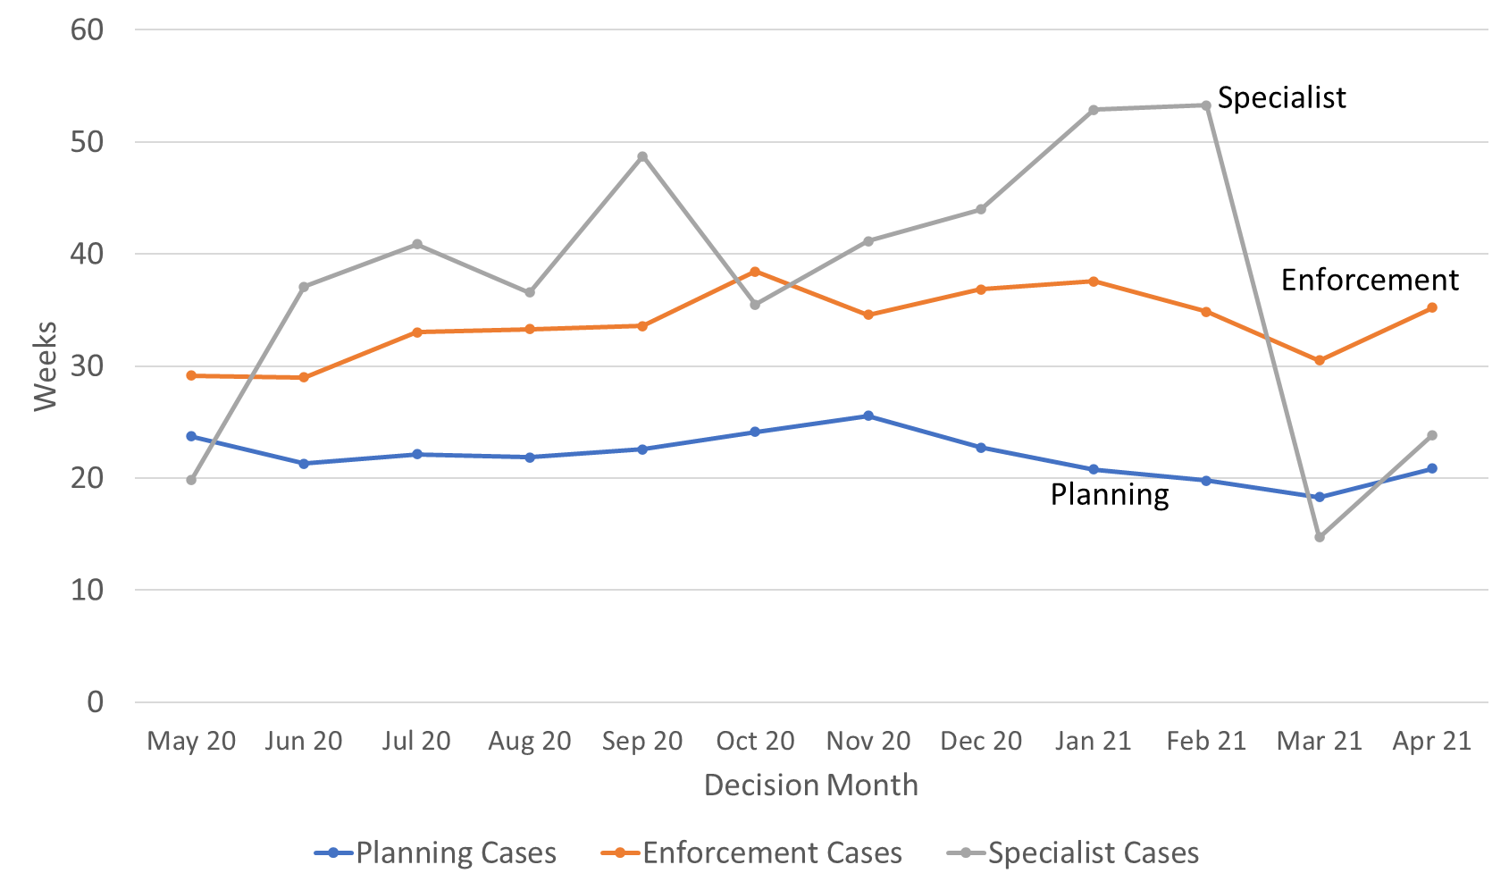
Source: Horizon and Picaso
Enforcement decisions made in the last 12 months had a median decision time of 34 weeks. For the last 12 months the mean is 40 weeks. The median time for enforcement decisions is longer than the median decision time for planning cases.
There are considerably fewer specialist cases which means results are more liable to be distorted by extreme values. Looking at the annual totals, the median and mean time to decision for specialist decisions are broadly the same as for enforcement decisions, and longer than the median for planning decisions. Performance in February 21 was influenced by a high number of older Tree Preservation Order (TPO) cases being decided in the month. Since then a higher proportion of much more recent TPO cases were decided in March and April 21.
Note that the Inspectorate publishes each month, information on the mean and median times from valid to decision, for selected appeal types. The information published also breaks down the time for each stage of the process. See Annex C for further details.

Planning Inquiry Decisions
For planning appeals decided by the inquiry process, The Planning Inspectorate has been implementing recommendations from the Rosewell review.

The median time for inquiries over the 12 months to April 21 is 39 weeks, with the mean being marginally higher at 41 weeks. With the exception of February 21, decision volumes have been above ten per month since Dec 20.

Table 8: Decisions, Mean and Median Time to Decision, Planning Inquiry cases under Rosewell process; May 20 to Apr 21
Measure | May 20 | Jun 20 | Jul 20 | Aug 20 | Sep 20 | Oct 20 | Nov 20 | Dec 20 | Jan 21 | Feb 21 | Mar 21 | Apr 21 | Total
Decisions | 1 | 0 | 3 | 5 | 2 | 7 | 7 | 18 | 13 | 8 | 15 | 17 | 96
Mean (weeks) | 47.0 | - | 22.7 | 42.5 | 41.1 | 45.7 | 45.7 | 35.3 | 36.5 | 40.7 | 36.7 | 53.5 | 40.9
Median (weeks) | 47.0 | - | 23.4 | 45.6 | 41.1 | 32.6 | 50.9 | 39.4 | 40.3 | 40.7 | 33.7 | 51.9 | 39.4
St. Dev. (weeks) | - | - | 1.4 | 16.0 | 1.1 | 22.1 | 9.1 | 10.2 | 12.2 | 7.9 | 12.0 | 31.1 | 18.4
Source: Horizon
Most inquiry decisions now being issued are under the revised ‘Rosewell’ process, but we are still deciding those under the previous process.

Table 9: Decisions, Planning Inquiry cases under non-Rosewell process; May 20 to Apr 21
Month | May 20 | Jun 20 | Jul 20 | Aug 20 | Sep 20 | Oct 20 | Nov 20 | Dec 20 | Jan 21 | Feb 21 | Mar 21 | Apr 21 | Total
Decisions | 1 | 2 | 0 | 1 | 0 | 1 | 5 | 0 | 1 | 1 | 1 | 1 | 14
Source: Horizon
Figure 7 below shows the mean and median time to decision for planning inquiry cases under the Rosewell process.

Figure 7: Mean, Median Time to Decision, Rosewell Inquiry Process; May 20 to Apr 21
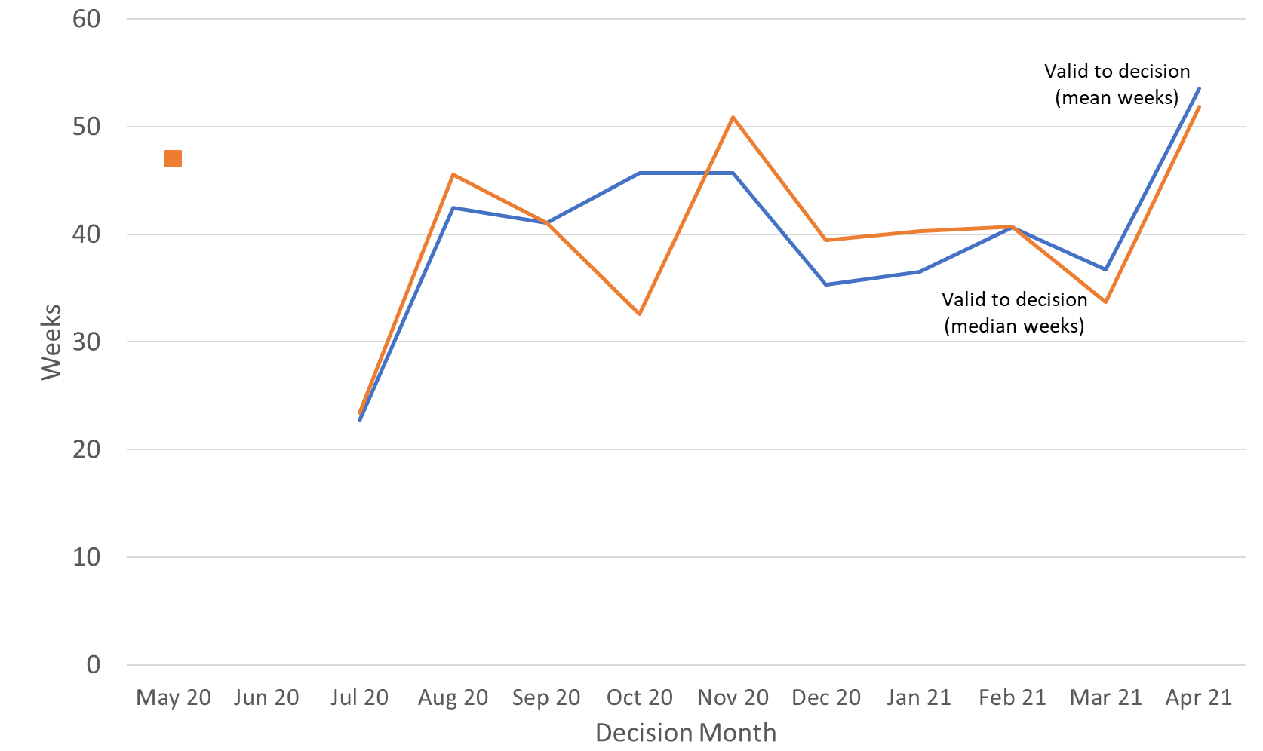

Source: Horizon
Note – 1 decision was made in May 20, with a mean & median timeliness of 47 weeks. No decisions were made during June 2020

Open Cases

At the end of April 21, the Planning Inspectorate had over eleven thousand one hundred cases open (11,184). This is an increase of 470 (4%), from the previous month. The open cases comprised 9,300 cases being handled through written representations; just over a 1,000 through hearings; and 675 through inquiries. This is not the number of ‘live’ hearings and inquiries since it includes cases where the event (hearing or inquiry) has yet to start, as well as those where the event has finished but the decision has yet to be issued.

For each procedure type, there are more cases with an event scheduled but not yet started, than at any other stage in the process. Event refers to either a site visit, hearing or inquiry.

Table 10: Open cases by procedure and stage, as of end of April 2021
Procedure | Case received but yet to be deemed valid | Case deemed valid, event date yet to be set / in the future | Event complete but decision not yet issued |  | Total
Written Representations | 666 | 7322 | 1,408 |  | 9,396
Hearings | 57 | 815 | 142 |  | 1,014
Inquiries | 9 | 525 | 141 |  | 675
Total | 732 | 8,750 | 1,702 |  | 11,184
Source: Horizon and Picaso
Note there are 99 cases that have no procedure type recorded (see Background Quality Report for more detail)

Inspectors

Table 11 below shows the number of inspectors in the Planning Inspectorate in each month from May 20 and April 21. This includes headcount (i.e. the number of different individuals) and full-time equivalents (FTE) where those working part time are counted in proportion with their contracted hours. There were 355 Planning Inspectors employed by the Inspectorate in April 21 – with a full-time equivalent of 317. A small number (six) of recently recruited Inspectors, as part of planned recruitment, started in April 21.

By both measures (headcount and FTE) the maximum Inspector resource in the last 12 months was in May 20; and by both, the number at the end of January 21 was the lowest.

Table 11: Planning Inspectors – Headcount and FTE; May 20 to Apr 21 (at end of month)
Month | May 20 | Jun 20 | Jul 20 | Aug 20 | Sep 20 | Oct 20 | Nov 20 | Dec 20 | Jan 21 | Feb 21 | Mar 21 | Apr 21
Headcount | 356 | 356 | 355 | 352 | 352 | 347 | 345 | 345 | 343 | 345 | 352 | 355
FTE | 319.1 | 319.0 | 318.2 | 316.0 | 316.4 | 310.0 | 308.1 | 308.1 | 305.4 | 308.1 | 314.4 | 317.0
Source: SAP HR

As above, Planning Inspectors work on a broader range of work than the appeals featured in this Release. They also work on applications and examinations. Please note that data on Planning Inspectors is only applicable to salaried employees (it does not include fixed term contract Inspectors or non-salaried Inspectors).

Virtual Events

The Planning Inspectorate has continued moving casework forward during the pandemic by adapting the ways of working so that examinations, hearings and inquiries (which would previously have been held face-to-face) could take place virtually.

The Inspectorate are continuing to increase the number of events carried out ‘virtually’. The table and graph below give the number of virtual events that have occurred each month. There were 82 cases involving Virtual Events during April 21. This is lower than previous and may have been influenced by decision makers taking annual leave around the Easter holiday period.

Data quality and corrections
There are concerns about the quality and accuracy of the data collection methods for virtual events data. We are reviewing the quality and methodology of how we record this data. See the Background Quality Report for further information.

Table 12: Virtual Events, Jun-20 to Apr-21^{P}
Case Type | Jun-20 | Jul-20 | Aug-20 | Sep-20 | Oct-20 | Nov-20 | Dec 20 | Jan 21 | Feb 21 | Mar 21 | Apr 21
s78 Hearings | 8 | 11 | 18 | 36 | 41 | 43 | 35 | 33 | 23 | 29 | 29
s78 Inquiries | 4 | 6 | 4 | 11 | 11 | 17 | 16 | 13 | 13 | 20 | 13
Enforcement | 0 | 1 | 3 | 9 | 15 | 18 | 20 | 29 | 35 | 29 | 27
Local Plans | 1 | 2 | 3 | 7 | 14 | 12 | 12 | 5 | 7 | 9 | 5
National Infrastructure | 3 (3) | 1 (3) | 1 (2) | 2 (3) | 10 (30) | 3 (9) | 6 (18) | 3 (7) | 4 (8) | 2 (2) | 3 (1)
Other | 0 | 1 | 0 | 0 | 4 | 16 | 6 | 11 | 7 | 8 | 5
Total | 16 (16) | 22 (24) | 29 (30) | 65 (66) | 95 (115) | 109 (115) | 95 (107) | 94 (98) | 89 (93) | 97 (97) | 82 (80)
Source: Virtual Events ‘Triage’ data and SharePoint list, data as at 13/05/21
Numbers in brackets show count of events but note concerns above over counting sessions on same day. Local Plans are counted as cases where at least one sitting day occurred in a month.
Other case type includes specialist casework like Environmental appeals, Transport examinations and Rights of Way cases
P – These numbers should be treated as provisional due to concerns about quality and accuracy.

Figure 8: Virtual Events; Jun 19 to Apr 21 ^{P}
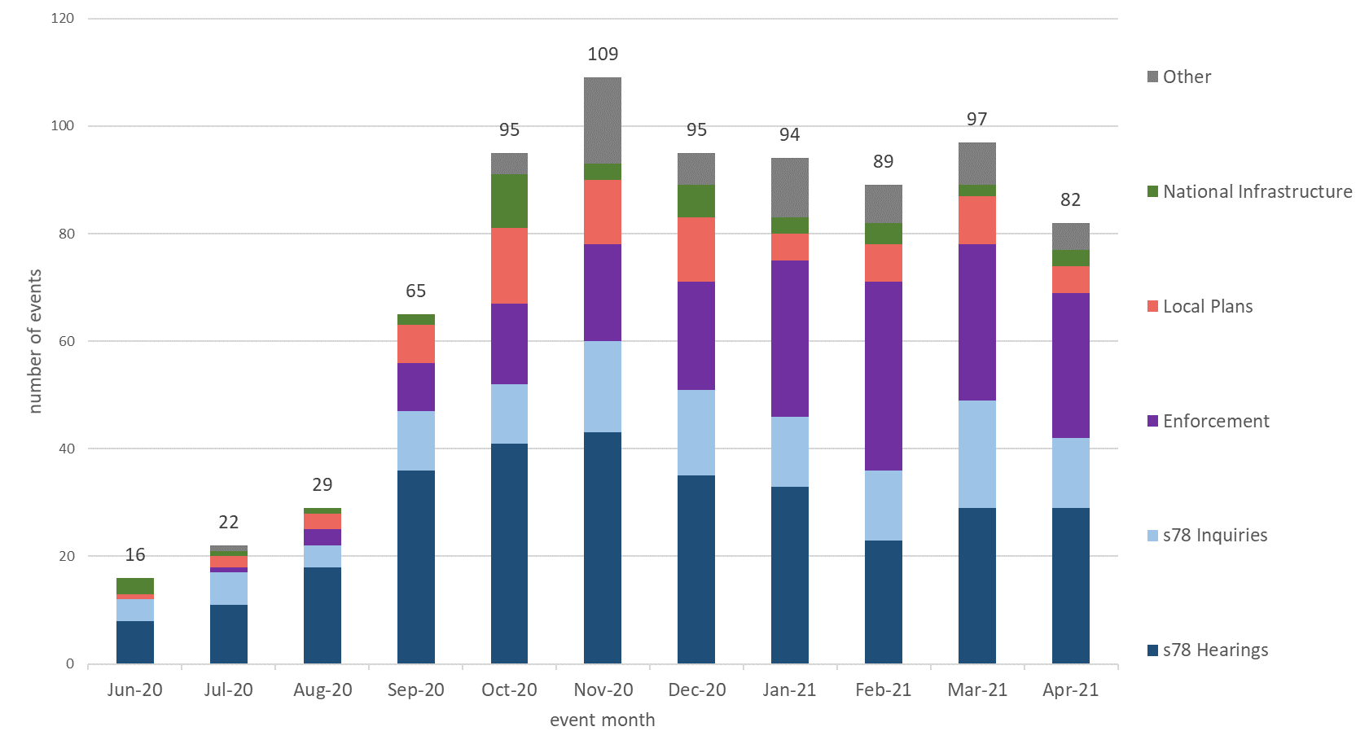
Source: Virtual Events ‘Triage’ data and SharePoint list, data as at 13/05/21
P – These numbers should be treated as provisional.

Note – some cases can have multiple ‘events’ – for example an inquiry may sit over four to eight days but would only be counted as one ‘event’. On the other hand, casework like National Infrastructure may have multiple events for the same project. For Local Plans, cases are counted as having held a virtual event, if at least one sitting day occurred that month.

For National Infrastructure, the number given in the table is the number of projects that have held virtual events. The number in brackets is the number of individual events but this is potentially misleading as multiple sessions on the same day (e.g. morning and afternoon sessions) have been counted as separate events.

Quarterly & Annual Volume Statistics

The Inspectorate has also published today a series of tables showing how many cases have been received, decided, and allowed. This data has been published on a quarterly basis for many years as management information.

The quarterly and annual volume statistics differ from the monthly statistical release. Some of the data published is on casework types that The Planning Inspectorate deals with, that are larger in scale but smaller in volume. The best examples of this are Nationally Significant Infrastructure Projects and Local Plans, where volumes never go into the hundreds, and can the time between submission to report issue can be over a year. Other data breaks appeals down into more detail than in the monthly totals.

All tables can be found at https://www.gov.uk/government/publications/planning-inspectorate-statistics

We are seeking feedback! Do you have any thoughts on whether data in this section should also be shown on a quarterly basis? Are there casework types you would like to be shown? There are also specific questions for readers in this section. If you have any thoughts please let us know at statistics@planninginspectorate.gov.uk

Nationally Significant Infrastructure Projects (NSIPs)

The number of NSIP applications submitted for examination per year varied from as low as three to a high of twenty-three projects. In 2020/21 nine projects were submitted. The process of accepting an application, the necessary consultation, examination and then submitting a recommendation to the relevant Secretary of State takes usually over a year to complete. This explains the reason for an increase in decision submitted for the year 2019/20, following the highest submission of projects the previous financial year. The types of NSIP applications submitted are mainly in the Energy or Transport sectors.

Figure 9: NSIP applications submitted | Figure 10: NSIP application report issued
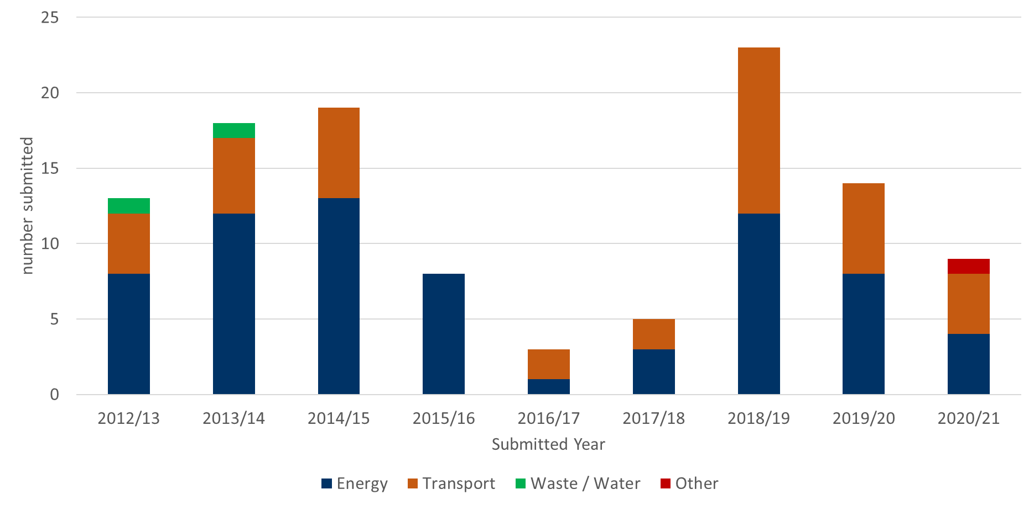 | 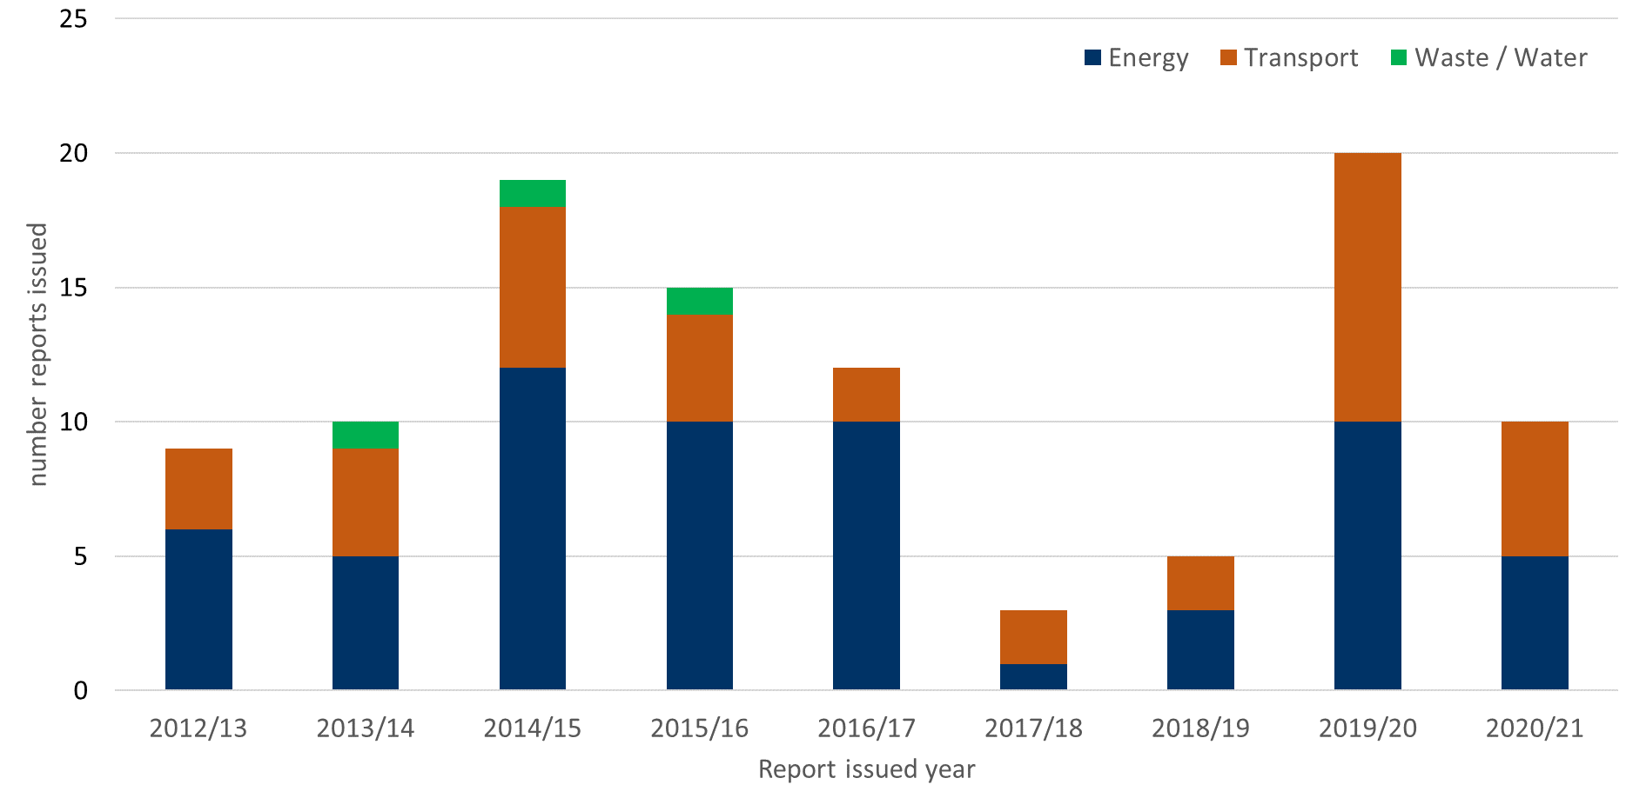
Source: NSIP spreadsheet. Full published data is available at Table 1.1 Infrastructure

Table 13: NSIP applications submitted, 2012/13 to 2020/21
Year | 2012/13 | 2013/14 | 2014/15 | 2015/16 | 2016/17 | 2017/18 | 2018/19 | 2019/20 | 2020/21
Energy | 8 | 12 | 13 | 8 | 1 | 3 | 12 | 8 | 4
Transport | 4 | 5 | 6 | 0 | 2 | 2 | 11 | 6 | 4
Waste / Water | 1 | 1 | 0 | 0 | 0 | 0 | 0 | 0 | 0
Other | 0 | 0 | 0 | 0 | 0 | 0 | 0 | 0 | 1
TOTAL | 13 | 18 | 19 | 8 | 3 | 5 | 23 | 14 | 9

Table 14: NSIP applications reports issued, 2012/13 to 2020/21
Year | 2012/13 | 2013/14 | 2014/15 | 2015/16 | 2016/17 | 2017/18 | 2018/19 | 2019/20 | 2020/21
Energy | 6 | 5 | 12 | 10 | 10 | 1 | 3 | 10 | 5
Transport | 3 | 4 | 6 | 4 | 2 | 2 | 2 | 10 | 5
Waste / Water | 0 | 1 | 1 | 1 | 0 | 0 | 0 | 0 | 0
Other | 0 | 0 | 0 | 0 | 0 | 0 | 0 | 0 | 0
TOTAL | 9 | 10 | 19 | 15 | 12 | 3 | 5 | 20 | 10

Question for readers of this release – Is there any other data that you would like to see about Nationally Significant Infrastructure Projects in future statistical releases?

Local Plans

Plans are submitted to The Planning Inspectorate by Local Planning Authorities for examination, with an Inspector submitting a report at the end of the process. There are different types of ‘plan’ that are counted in the casework group of Local Plans. Figure 11 shows that in many years strategic plans represent the highest category within Local Plans, followed by site allocation and area action plans. The lower number of plan reports submitted in 2020/21 reflects a slowdown in submissions of plans for examination.

Figure 11: Local Plans reports issued, 2010/11 to 2020/21
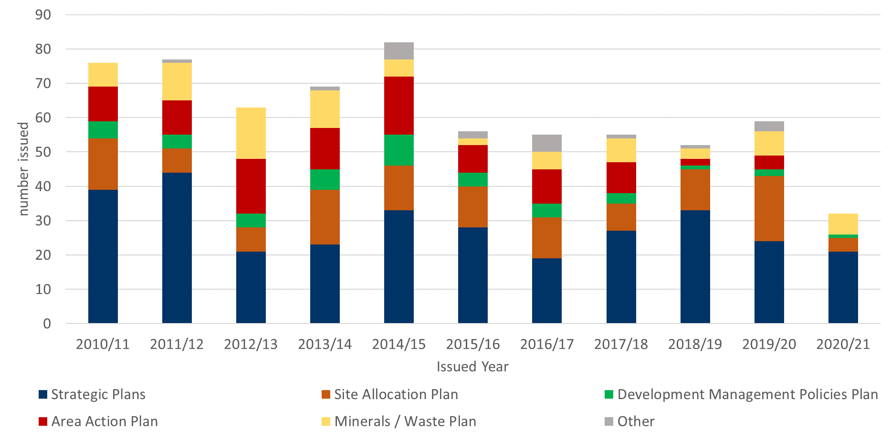
Source – Local Plans Team spreadsheet. Full published data is available in Table 1.2 Local Plans.
Table 15: Local Plan reports issued, 2010/11 to 2020/21
Year | 2010/11 | 2011/12 | 2012/13 | 2013/14 | 2014/15 | 2015/16 | 2016/17 | 2017/18 | 2018/19 | 2019/20 | 2020/21
Strategic Plans | 39 | 44 | 21 | 23 | 33 | 28 | 19 | 27 | 33 | 24 | 21
Site Allocation Plan | 15 | 7 | 7 | 16 | 13 | 12 | 12 | 8 | 12 | 19 | 4
Development Management Policies Plan | 5 | 4 | 4 | 6 | 9 | 4 | 4 | 3 | 1 | 2 | 1
Area Action Plan | 10 | 10 | 16 | 12 | 17 | 8 | 10 | 9 | 2 | 4 | 0
Minerals / Waste Plan | 7 | 11 | 15 | 11 | 5 | 2 | 5 | 7 | 3 | 7 | 6
Other | 0 | 1 | 0 | 1 | 5 | 2 | 5 | 1 | 1 | 3 | 0
TOTAL | 76 | 77 | 63 | 69 | 82 | 56 | 55 | 55 | 52 | 59 | 32

Question for readers of this release – Is there any other data that you would like to see about Local Plans in future statistical releases?

Section 78 Planning appeals

Received
The largest number of appeals that The Planning Inspectorate receives each year is for Section 78 (s78) planning appeals. Figure 12 below shows that total volumes in the last eleven years peaked in 2017/18 at 13,362. In 2020/21 the number received was 10,886, 7% lower than the previous year. Most s78 planning appeals received are dealt with by the written representation process.

Figure 12: s78 planning appeals received by procedure type, 2010/11 to 2020/21
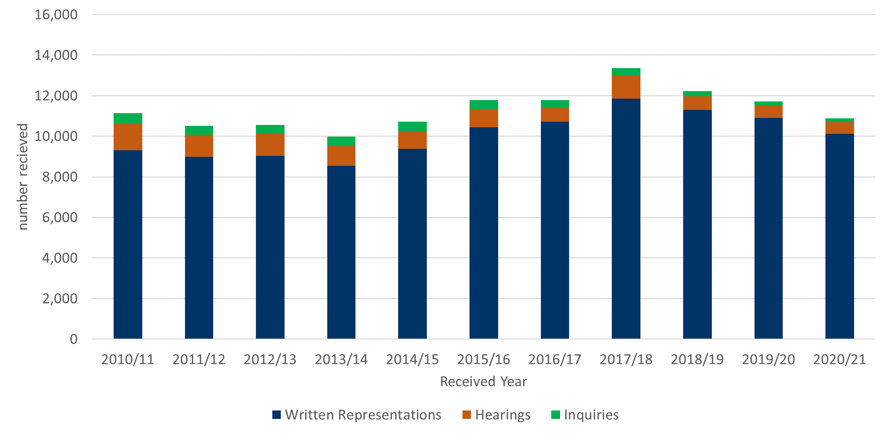
Source: Horizon and Picaso. Full published data in Table 2.1 s78 planning appeals received by procedure type

Table 16: s78 planning appeals received by procedure type, 2010/11 to 2020/21
Year | 2010/11 | 2011/12 | 2012/13 | 2013/14 | 2014/15 | 2015/16 | 2016/17 | 2017/18 | 2018/19 | 2019/20 | 2020/21
Written Representations | 9,320 | 8,984 | 9,043 | 8,543 | 9,388 | 10,445 | 10,722 | 11,846 | 11,300 | 10,917 | 10,131
Hearings | 1,318 | 1,091 | 1,067 | 964 | 865 | 907 | 670 | 1,171 | 669 | 617 | 563
Inquiries | 502 | 439 | 452 | 480 | 471 | 446 | 401 | 345 | 270 | 190 | 192
TOTAL | 11,140 | 10,514 | 10,562 | 9,987 | 10,724 | 11,798 | 11,793 | 13,362 | 12,239 | 11,724 | 10,886

As Figure 12 above shows, most appeals received are dealt with by the written representation process. Figure 13 below shows that most appeals received are for minor development proposals.

Figure 13: s78 planning appeals received by development type group, 2010/11 to 2020/21
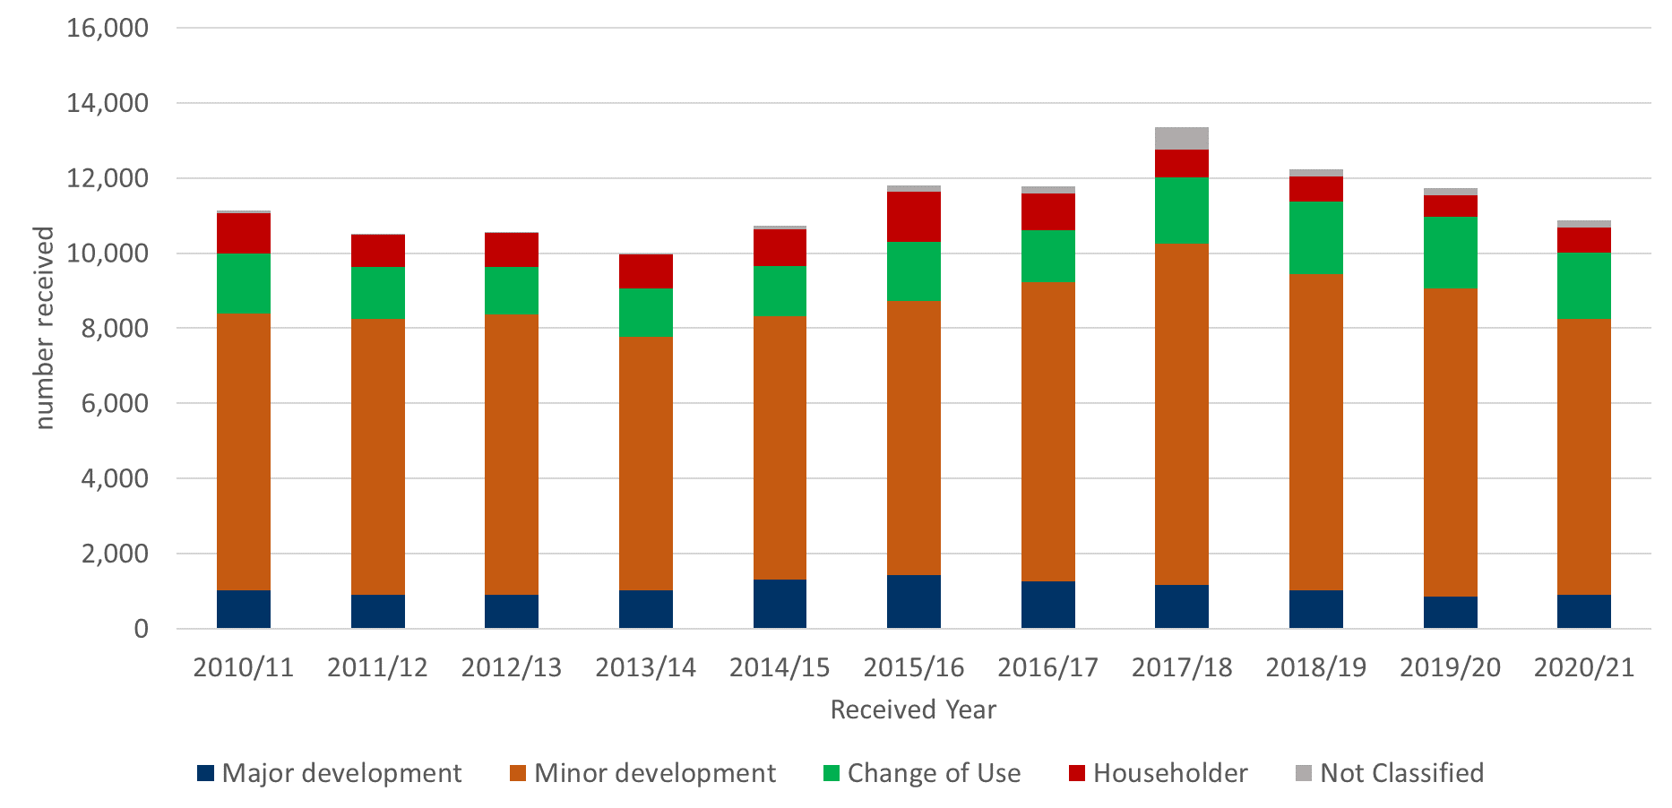
Source: Horizon & Picaso. Full published data in Table 2.2 s78 planning appeals received by development type group. Note – Not classified refers to records with no development type recorded on source systems.

Table 17: s78 planning appeals received by development type group, 2010/11 to 2020/21
Year | 2010/11 | 2011/12 | 2012/13 | 2013/14 | 2014/15 | 2015/16 | 2016/17 | 2017/18 | 2018/19 | 2019/20 | 2020/21
Major development | 1,010 | 891 | 907 | 1,033 | 1,319 | 1,418 | 1,261 | 1,168 | 1,030 | 853 | 908
Minor development | 7,389 | 7,356 | 7,460 | 6,745 | 7,001 | 7,304 | 7,973 | 9,077 | 8,416 | 8,219 | 7,347
Change of Use | 1,604 | 1,375 | 1,260 | 1,287 | 1,340 | 1,577 | 1,368 | 1,763 | 1,920 | 1,888 | 1,761
Householder | 1,073 | 870 | 917 | 908 | 969 | 1,327 | 978 | 749 | 679 | 592 | 674
Not Classified | 64 | 22 | 18 | 14 | 95 | 171 | 212 | 605 | 194 | 172 | 196
TOTAL | 11,140 | 10,514 | 10,562 | 9,987 | 10,724 | 11,797 | 11,792 | 13,362 | 12,239 | 11,724 | 10,886
Note – Not classified refers to records with no development type recorded on source systems.

Decided
The number of s78 planning appeal decisions in 2020/21 was 32% lower (or 4,000 decisions) than the previous year. This was because 2019/20 saw the highest number of decisions in the last eleven years as the Inspectorate caught up with backlogs built up in previous years. The Covid-19 pandemic has had a big impact in 2020/21, with fewer events being arranged and therefore fewer decisions.

Figure 14: s78 appeals decided by procedure type, 2010/11 to 2020/21
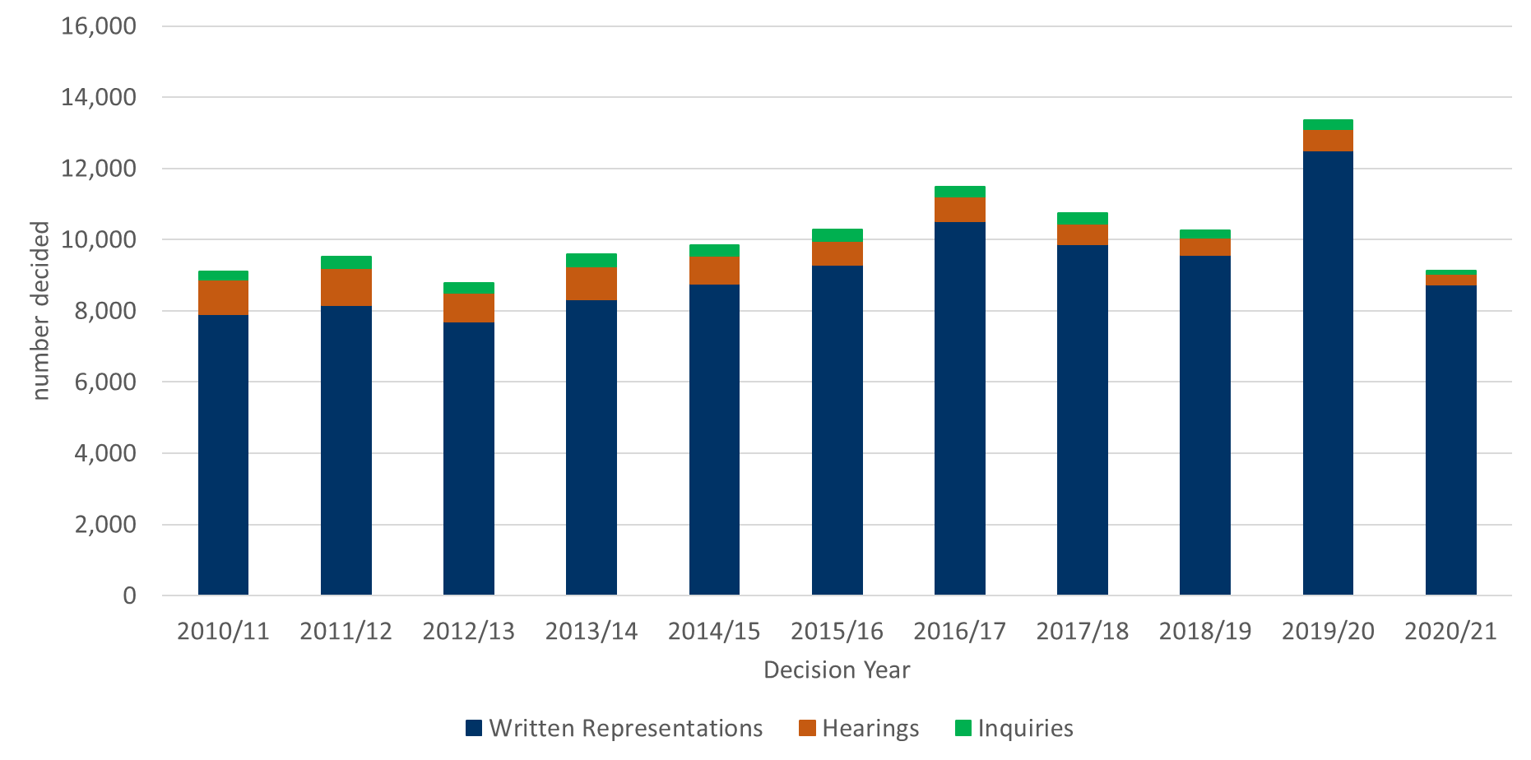

Table 18: s78 appeals decided by procedure type, 2010/11 to 2020/21
Year | 2010/11 | 2011/12 | 2012/13 | 2013/14 | 2014/15 | 2015/16 | 2016/17 | 2017/18 | 2018/19 | 2019/20 | 2020/21
Written Representations | 7,906 | 8,152 | 7,705 | 8,330 | 8,768 | 9,283 | 10,508 | 9,867 | 9,558 | 12,492 | 8,728
Hearings | 975 | 1,045 | 794 | 918 | 769 | 684 | 690 | 581 | 497 | 616 | 306
Inquiries | 219 | 318 | 283 | 344 | 309 | 314 | 295 | 293 | 211 | 246 | 87
TOTAL | 9,100 | 9,515 | 8,782 | 9,592 | 9,846 | 10,281 | 11,493 | 10,741 | 10,266 | 13,354 | 9,121

Appeals Allowed
The percentage of planning appeals that have been allowed in 2020/21 was 25%. This was the same as the year before. Looking over the last eleven years, the percentage allowed has been 30% or more except for the last two financial years.

There were significant reductions in the percentage of planning appeals allowed in Oct 2018 - Mar 2021, compared to Jan 2015 – Sep 2018. In Apr 2020 – Mar 2021, the percentage of planning appeals allowed generally stabilised (i.e. was not significantly different to the previous year). There has, however, been a significant increase in the percentage of written representation planning appeals allowed in Apr 2020 – Mar 2021.

The overall percentage allowed is heavily influenced by the number of written representations appeals allowed, as this procedure type contributes by far the greatest number of decisions each year. There has been slightly more variation in the percentage allowed for hearings and inquiries.

Figure 15: s78 planning appeals, percentage allowed by procedure type, 2010/11 to 2020/21
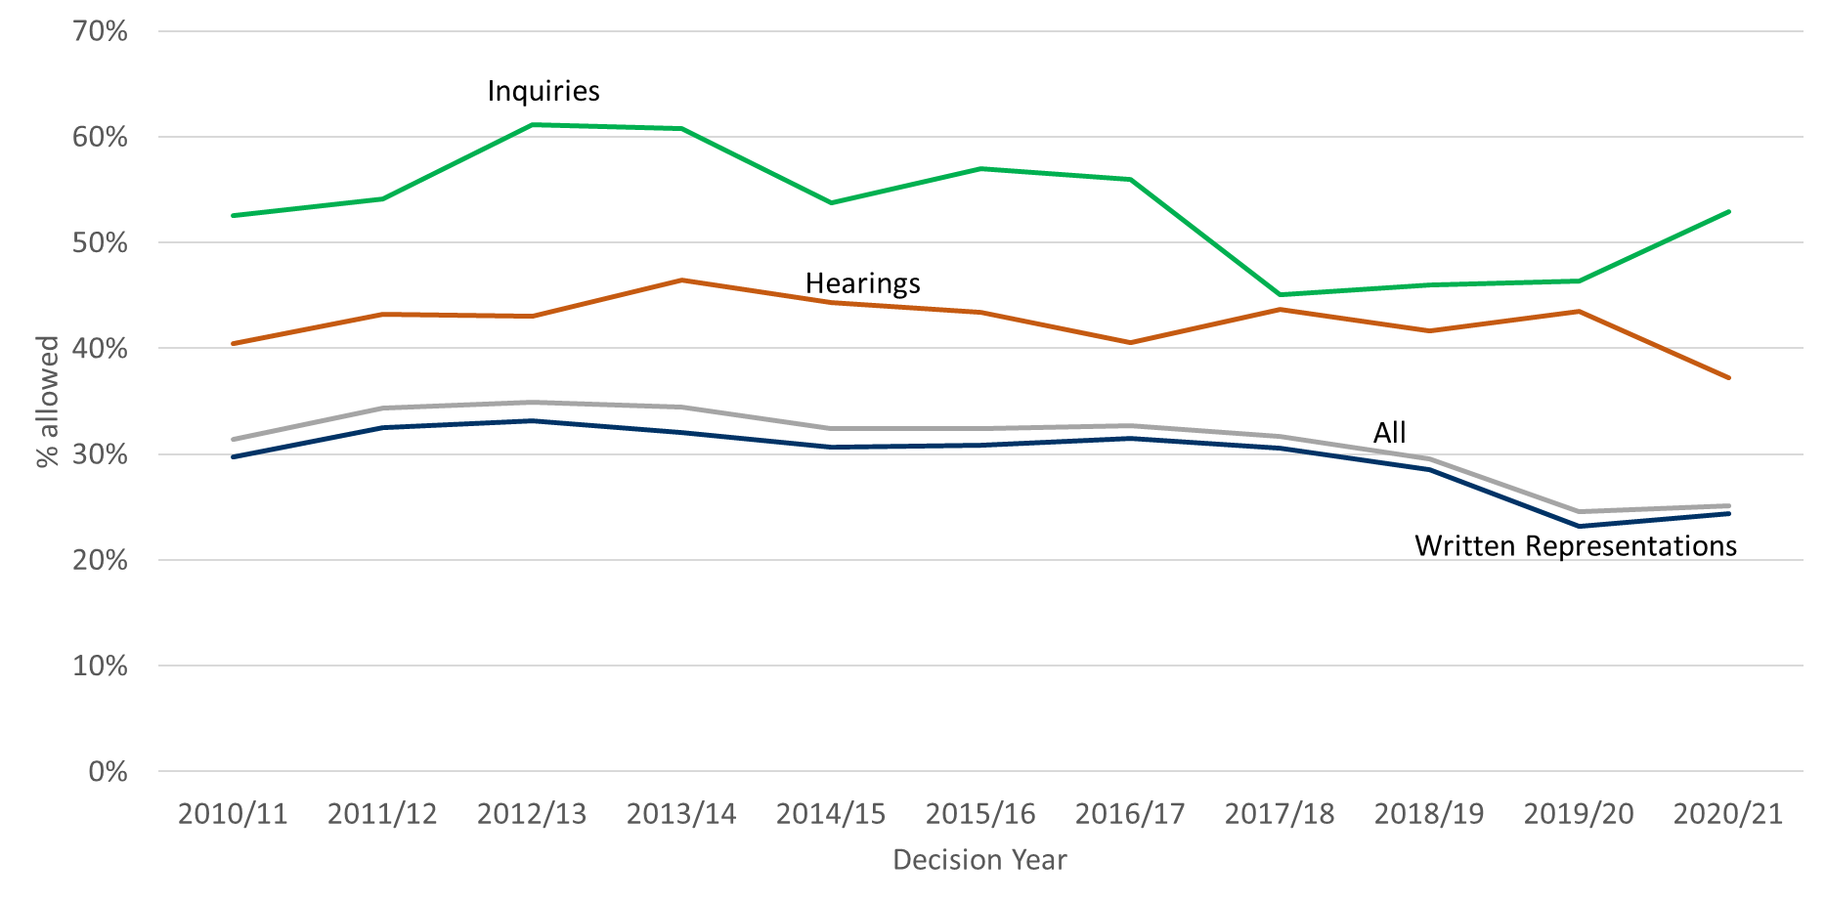
Source: Horizon & Picaso. Full published data in Table 2.4 s78 planning appeals decided.

Table 19: s78 planning appeals, percentage allowed by procedure type, 2010/11 to 2020/21
Year | 2010/11 | 2011/12 | 2012/13 | 2013/14 | 2014/15 | 2015/16 | 2016/17 | 2017/18 | 2018/19 | 2019/20 | 2020/21
Written Representations | 30% | 32% | 33% | 32% | 31% | 31% | 32% | 31% | 29% | 23% | 24%
Hearings | 40% | 43% | 43% | 46% | 44% | 43% | 41% | 44% | 42% | 44% | 37%
Inquiries | 53% | 54% | 61% | 61% | 54% | 57% | 56% | 45% | 46% | 46% | 53%
ALL | 31% | 34% | 35% | 34% | 32% | 32% | 33% | 32% | 30% | 25% | 25%

The number of appeals allowed in 2020/21 was far less than previous years, due to the impact of the Covid-19 pandemic on overall decision outputs.

Figure 16: s78 planning appeals, number of appeals allowed, 2010/11 to 2020/21
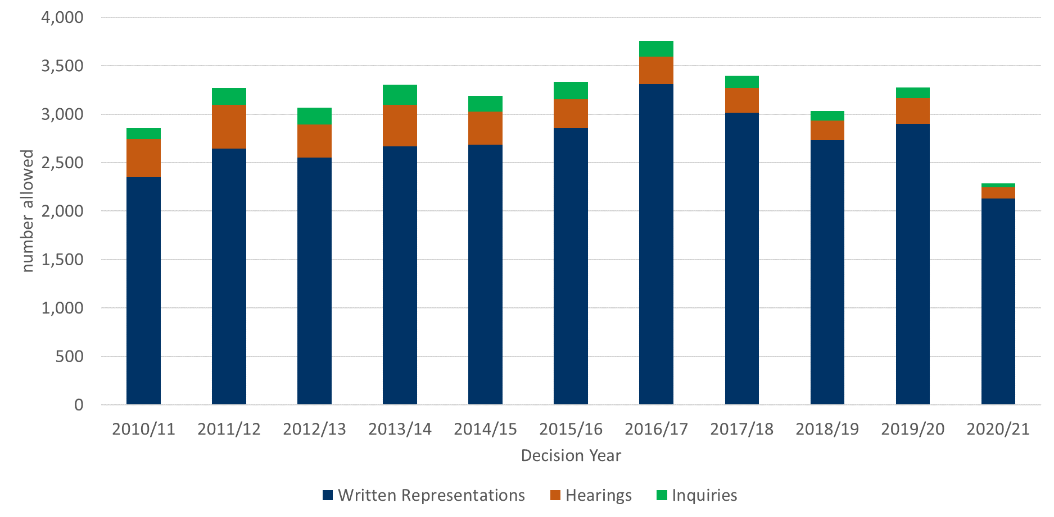
Source: Horizon & Picaso. Full published data in Table 2.4 s78 planning appeals decided.

Table 20: s78 planning appeals, number of appeals allowed, 2010/11 to 2020/21
Year | 2010/11 | 2011/12 | 2012/13 | 2013/14 | 2014/15 | 2015/16 | 2016/17 | 2017/18 | 2018/19 | 2019/20 | 2020/21
Written Representations | 2,348 | 2,646 | 2,553 | 2,668 | 2,684 | 2,859 | 3,312 | 3,014 | 2,730 | 2,897 | 2,129
Hearings | 394 | 452 | 342 | 426 | 341 | 297 | 280 | 254 | 207 | 268 | 114
Inquiries | 115 | 172 | 173 | 209 | 166 | 179 | 165 | 132 | 97 | 114 | 46
ALL | 2,857 | 3,270 | 3,068 | 3,303 | 3,191 | 3,335 | 3,757 | 3,400 | 3,034 | 3,279 | 2,289

Dwellings allowed
Appeals for dwellings (often referred to as houses but in this measure, for example, a development of eight flats counts as eight dwellings) form a significant part of the Inspectorate’s output. Figures 17 and 18 show the percentage of dwellings allowed, and number of dwellings allowed, over the last eleven years.

Note – major dwellings are appeals for 10 or more dwellings.

Figure 17: s78 planning appeals involving dwellings, percentage of dwellings allowed by major or minor dwellings, 2010/11 to 2020/21
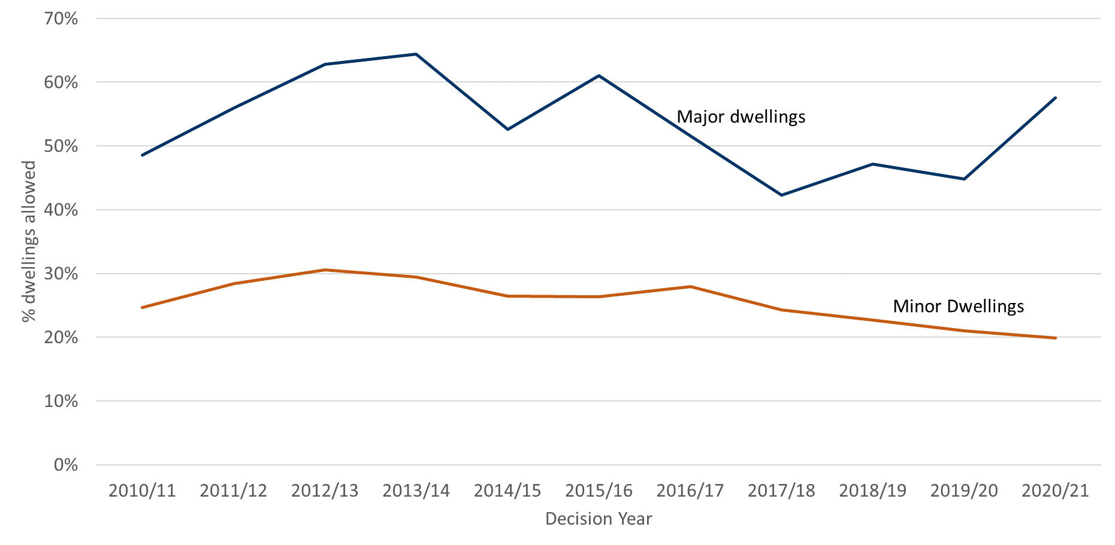
Source: Horizon & Picaso. Full published data in Table 2.5 s78 planning appeals involving dwellings.

Table 21: s78 planning appeals involving dwellings, percentage of dwellings allowed by major or minor dwellings, 2010/11 to 2020/21
Year | 2010/11 | 2011/12 | 2012/13 | 2013/14 | 2014/15 | 2015/16 | 2016/17 | 2017/18 | 2018/19 | 2019/20 | 2020/21
Major dwellings | 49% | 56% | 63% | 64% | 53% | 61% | 52% | 42% | 47% | 45% | 58%
Minor dwellings | 25% | 28% | 31% | 29% | 26% | 26% | 28% | 24% | 23% | 21% | 20%

Figure 18: s78 planning appeals involving dwellings, number of dwellings allowed by major or minor dwellings, 2010/11 to 2020/21
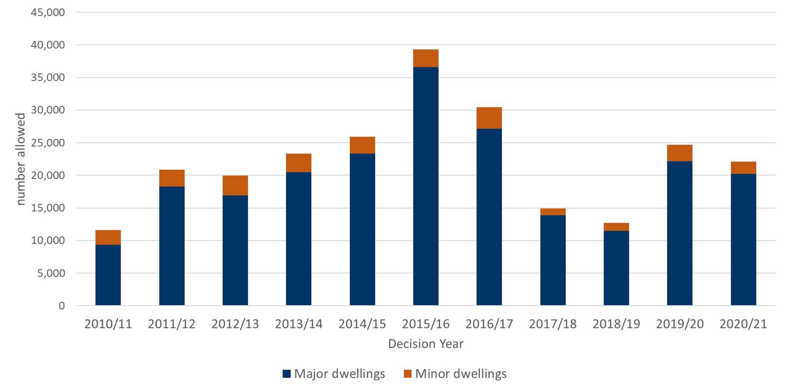
Source: Horizon & Picaso. Full published data in Table 2.5 s78 planning appeals involving dwellings.

Table 22: s78 planning appeals involving dwellings, number of dwellings allowed by major or minor dwellings, 2010/11 to 2020/21
Year | 2010/11 | 2011/12 | 2012/13 | 2013/14 | 2014/15 | 2015/16 | 2016/17 | 2017/18 | 2018/19 | 2019/20 | 2020/21
Major dwellings | 9,350 | 18,240 | 16,879 | 20,455 | 23,322 | 36,573 | 27,144 | 13,866 | 11,447 | 22,122 | 20,192
Minor dwellings | 2,228 | 2,622 | 3,080 | 2,846 | 2,613 | 2,739 | 3,264 | 1,032 | 1,238 | 2,558 | 1,921
TOTAL | 11,578 | 20,862 | 19,959 | 23,301 | 25,935 | 39,312 | 30,408 | 14,898 | 12,685 | 24,680 | 22,113

Appeals received versus decided
To ensure consistency, Figure 21 is provided below, as it has been in previous published releases that have accompanied quarterly and annual volume statistics.

Figure 19: s78 planning appeals received and decided, 2010/11 to 2020/21
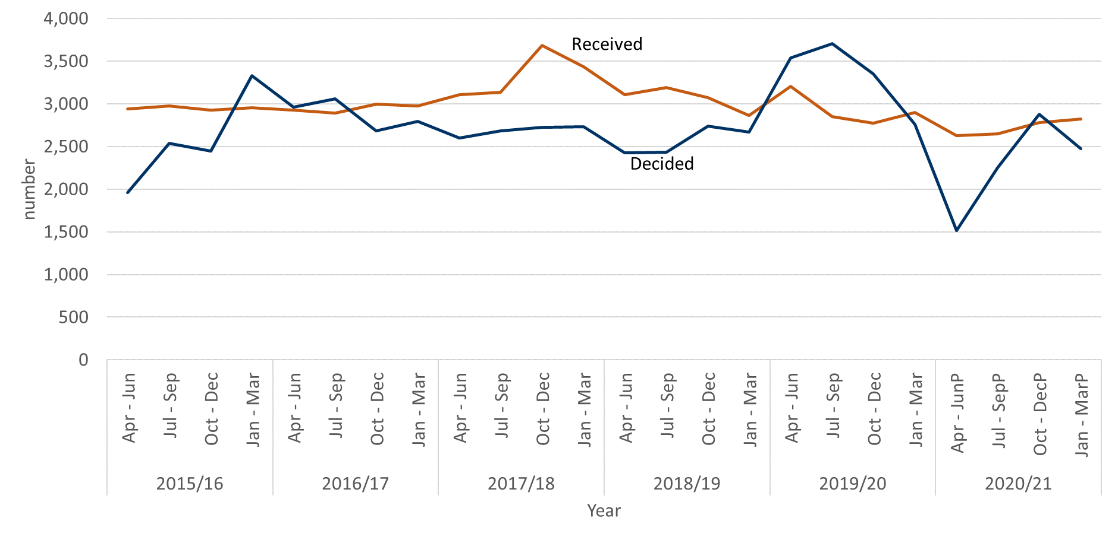
Source: Horizon & Picaso. Full published data in Tables 2.1 and Table 2.4.
See Annex D for full data table.

Householder appeals allowed

After s78 planning appeals, Householder appeals are the highest volume of appeals received each year. Householder appeals are for small scale development. We also receive some larger proposals that are categorised as householder but decided under the s78 planning appeal process. The householder appeals process requires less documentation to be submitted.

In terms of the proportion of householder appeals allowed, over the last eleven years the percentage allowed has varied between 35% and 41%. In 2020/21 36% of householder decisions were allowed.

Figure 20: Householder appeals, percentage allowed, 2010/11 to 2020/21
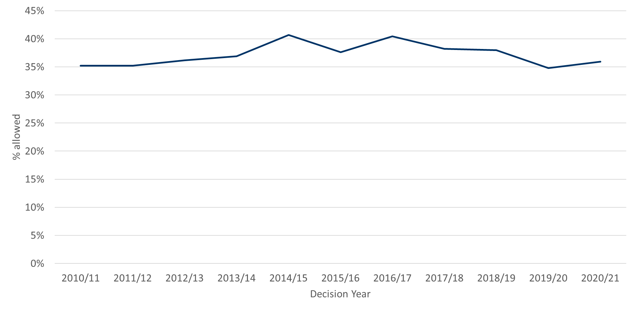
Source: Horizon & Picaso. Full published data in Table 2.6 Householder appeals received, decided and allowed

Table 23: Householder appeals, percentage allowed, 2010/11 to 2020/21
Year | 2010/11 | 2011/12 | 2012/13 | 2013/14 | 2014/15 | 2015/16 | 2016/17 | 2017/18 | 2018/19 | 2019/20 | 2020/21
% allowed | 35% | 35% | 36% | 37% | 41% | 38% | 40% | 38% | 38% | 35% | 36%

Section 174 enforcement appeals, received & decided
The third largest number of appeals received are for s174 enforcement notice appeals. These are appeals against enforcement notices issued by Local Planning Authorities, alleging activity that does not have planning permission. Received volumes reduced by 27% between 2020/21 and 2019/20; this was a direct result of the Covid-19 pandemic and fewer enforcement notices being issued by local authorities.

Figure 21: s174 enforcement notice appeals received and decided, 2010/11 to 2020/21
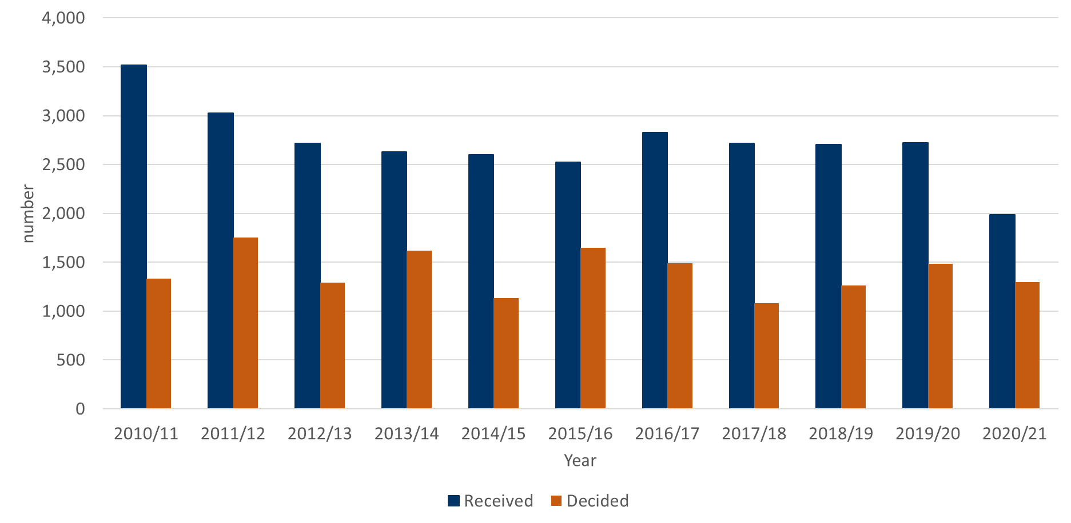
Source: Horizon & Picaso. Full published data in Tables 3.1 & 3.2

Table 24: s174 enforcement notice appeals received and decided, 2010/11 to 2020/21
Year | 2010/11 | 2011/12 | 2012/13 | 2013/14 | 2014/15 | 2015/16 | 2016/17 | 2017/18 | 2018/19 | 2019/20 | 2020/21
received | 3,517 | 3,024 | 2,718 | 2,627 | 2,599 | 2,526 | 2,825 | 2,719 | 2,706 | 2,723 | 1,986
decided | 1,332 | 1,753 | 1,293 | 1,620 | 1,135 | 1,649 | 1,489 | 1,083 | 1,264 | 1,486 | 1,295

Annex A – Content of ad-hoc Statistical Releases, 2020

Note: The Table below covers ad-hoc statistical releases. From November 2020 onwards, the content is fixed, so is the same as this publication.

Date | March 2020 | April 2020 | July 2020 | September 2020 | October 2020
Content | Appeals receipts and decisions in the last 12 and 24 months (1st March 2018 – 29th February 2020)  Number of section 78 Planning Appeals received / decided / within target that used the written representation method in the last 12 months (1st March 2019 – 29th February 2020)  Number of dwellings decided and number of dwellings allowed by appeal decisions between 1st January 2017 and 31st December 2019.  Number of Planning Inspectors employed by the Planning Inspectorate at the end of each quarter between 31st March 2017 and 31st December 2019. | Appeals receipts and decisions between 17th March 2020 and 22nd April 2020  Live appeals in the system as at 23rd April 2020  Number of appeals involving housing within the system as at 23rd April 2020  Virtual site visits | Appeals decisions between 17th March 2020 and 22nd June 2020  Number of open cases  Number of virtual events  Number of appeals  involving housing within the system as at 12th June 2020 | Appeals decisions between 17th March 2020 and 21st September 2020  Number of open cases  Number of virtual events | Appeals decisions from October 2019 to September 2020  Number of open cases  Number of virtual events
Scope | England only  Planning cases, Enforcement cases and Rights of Way orders | England only  Planning cases, Enforcement cases and Rights of Way orders | England only  Planning cases, Enforcement cases and Rights of Way orders | England only  Planning cases, Enforcement cases and Rights of Way orders | England only  Planning cases, Enforcement cases, Specialist cases: Common Land, Rights of Way orders, Tree Preservation Orders, High Hedges appeals and Hedgerow appeals

Annex B – Mean and median time to decision, with standard deviation, for planning, enforcement and specialist casework
Planning
Measure | Procedure | May 20 | Jun 20 | Jul 20 | Aug 20 | Sep 20 | Oct 20 | Nov 20 | Dec 20 | Jan 21 | Feb 21 | Mar 21 | Apr 21 | Total
Valid to decision (mean weeks) | Written Representations | 26.5 | 23.2 | 22.6 | 22.5 | 23.3 | 25.2 | 26.6 | 24.6 | 23.7 | 22.5 | 21.0 | 22.9 | 23.7
 | Hearings | 42.9 | 50.0 | 46.7 | 42.2 | 51.3 | 39.7 | 35.0 | 45.9 | 46.2 | 41.2 | 48.0 | 56.1 | 45.0
 | Inquiries | 69.4 | 62.0 | 22.7 | 60.0 | 41.1 | 44.6 | 54.9 | 35.3 | 40.4 | 50.6 | 35.8 | 54.9 | 46.1
 | All Cases | 27.1 | 23.5 | 22.9 | 23.0 | 23.7 | 25.6 | 27.0 | 25.4 | 24.6 | 23.2 | 21.9 | 24.7 | 24.4
Valid to decision (median weeks) | Written Representations | 23.3 | 21.3 | 22.0 | 21.7 | 22.3 | 23.9 | 25.4 | 22.0 | 20.4 | 19.4 | 18.0 | 20.1 | 21.4
 | Hearings | 42.0 | 42.4 | 34.4 | 45.1 | 43.1 | 34.0 | 36.1 | 43.0 | 46.6 | 46.4 | 44.8 | 56.9 | 41.9
 | Inquiries | 69.4 | 62.0 | 23.4 | 49.2 | 41.1 | 34.8 | 53.9 | 39.4 | 40.7 | 42.9 | 33.6 | 52.4 | 40.3
 | All Cases | 23.7 | 21.3 | 22.1 | 21.9 | 22.6 | 24.1 | 25.6 | 22.7 | 20.8 | 19.8 | 18.3 | 20.9 | 21.9
Standard Deviation (weeks) | Written Representations | 13.7 | 9.2 | 8.8 | 10.4 | 8.8 | 10.7 | 10.9 | 11.4 | 10.8 | 10.5 | 10.9 | 11.1 | 10.8
 | Hearings | 14.7 | 24.9 | 27.9 | 9.7 | 20.5 | 18.5 | 13.3r | 17.4 | 23.0 | 16.7 | 24.6 | 23.6 | 20.6
 | Inquiries | 22.4 | 1.6 | 1.4 | 41.8 | 1.1 | 20.8 | 13.1 | 10.2 | 18.4 | 29.0 | 12.1 | 30.7 | 24.2
 | All Cases | 14.4 | 10.0 | 9.6 | 11.4 | 9.8 | 11.3 | 11.3 | 12.3 | 12.3 | 11.6 | 12.3 | 14.6 | 11.9

Enforcement
Measure | Procedure | May 20 | Jun 20 | Jul 20 | Aug 20 | Sep 20 | Oct 20 | Nov 20 | Dec 20 | Jan 21 | Feb 21 | Mar 21 | Apr 21 | Total
Valid to decision (mean weeks) | Written Representations | 33.0 | 35.0 | 37.2 | 36.8 | 37.1 | 41.4 | 36.7 | 38.4 | 36.5 | 35.4 | 32.3 | 34.4 | 36.6
 | Hearings | 74.8 | 94.8 | 96.5 | 34.4 | 34.3 | 84.4 | 54.4 | 64.3 | 82.7 | 66.3 | 78.5 | 77.9 | 75.2
 | Inquiries | 88.1r | 85.6 | - | - | 84.6 | 43.9 | 62.5 | 102.9 | 94.7 | 108.7 | 81.8 | 73.8 | 83.1
 | All Cases | 34.5 | 37.5 | 38.0 | 36.8 | 37.5 | 42.8 | 37.7 | 42.1 | 43.7 | 42.7 | 41.6 | 47.6 | 39.8
Valid to decision (median weeks) | Written Representations | 28.5 | 28.9 | 32.6 | 33.3 | 33.6 | 36.9 | 33.9 | 35.3 | 31.1 | 28.1 | 27.6 | 29.6 | 32.3
 | Hearings | 76.5 | 93.4 | 100.1 | 34.4 | 34.3 | 89.0 | 56.0 | 68.5 | 78.8 | 68.8 | 84.4 | 71.3 | 77.0
 | Inquiries | 88.1r | 87.0 | - | - | 84.6 | 42.6 | 56.1 | 99.0 | 96.9 | 125.3 | 86.7 | 62.4 | 86.7
 | All Cases | 29.1 | 29.0 | 33.0 | 33.3 | 33.6 | 38.4 | 34.6 | 36.9 | 37.6 | 34.9 | 30.5 | 35.2 | 33.7
Standard Deviation (weeks) | Written Representations | 15.6 | 18.2 | 21.8 | 17.3 | 14.9 | 19.3 | 16.3 | 18.9 | 23.1 | 17.8 | 16.9 | 20.9 | 18.4
 | Hearings | 16.4 | 16.6 | 5.2 | 0.0 | 0.0 | 12.8 | 12.3 | 22.6 | 23.2 | 22.2 | 15.6 | 28.0 | 23.1
 | Inquiries | 0.0r | 7.6 | - | - | 0.0 | 10.1 | 10.1 | 19.2 | 21.0 | 23.2 | 26.8 | 20.3 | 26.0
 | All Cases | 17.6r | 21.3 | 22.6 | 17.3 | 15.5 | 20.5 | 16.8 | 23.0 | 28.9 | 26.7 | 26.2 | 29.4 | 22.0

Specialist
Measure | Procedure | May 20 | Jun 20 | Jul 20 | Aug 20 | Sep 20 | Oct 20 | Nov 20 | Dec 20 | Jan 21 | Feb 21 | Mar 21 | Apr 21 | Total
Valid to decision (mean weeks) | Written Representations | 29.4 | 37.4 | 40.9 | 34.6 | 45.2 | 38.9 | 37.5 | 43.6 | 42.7 | 52.7 | 23.0 | 33.3 | 39.1
 | Hearings | 0.0 | - | - | 62.1 | - | - | - | - | 89.8 | 65.0 | 80.0 | 69.1 | 78.2
 | Inquiries | 65.0 | 62.0 | 71.6 | 47.9 | 63.7 | 37.3 | 66.7 | 59.9 | 58.4 | 77.6 | 18.0 | 87.3 | 63.1
 | All Cases | 32.3 | 40.6 | 42.3 | 36.9r | 47.0 | 38.8 | 39.4 | 44.3 | 46.1 | 53.7 | 25.5 | 37.8 | 40.9
Valid to decision (median weeks) | Written Representations | 18.6 | 34.5 | 39.8 | 35.9 | 48.1 | 33.7 | 39.1 | 42.4 | 43.6 | 53.0 | 13.9 | 21.9 | 35.9
 | Hearings | - | - | - | 62.1 | - | - | - | - | 102.1 | 65.0 | 80.0 | 69.1 | 67.1
 | Inquiries | 65.0 | 63.5 | 71.6 | 43.1 | 65.0 | 37.3 | 60.4 | 59.9 | 64.0 | 81.9 | 18.0 | 88.4 | 65.0
 | All Cases | 19.9 | 37.1 | 40.9 | 36.6r | 48.7 | 35.5 | 41.1 | 44.0 | 52.9 | 53.3 | 14.7 | 23.9 | 37.2
Standard Deviation (weeks) | Written Representations | 16.3 | 22.6 | 16.4 | 17.0 | 24.5 | 26.6 | 16.7 | 25.6 | 33.3 | 24.7 | 23.4 | 28.4 | 25.2
 | Hearings | - | - | - | 0.0 | - | - | - | - | 18.1 | 0.0 | 16.3 | 0.0 | 17.5
 | Inquiries | 0.0 | 6.5 | 0.6 | 13.4 | 12.7 | 0.0 | 17.3 | 13.1 | 19.5 | 19.9 | 0.0 | 1.5 | 21.4
 | All Cases | 18.5 | 23.1 | 17.2 | 17.5 | 24.3 | 26.4 | 18.3 | 25.4 | 33.7 | 24.8 | 25.8 | 30.7 | 25.8
r denotes revision – a change of more than 0.5 weeks since last month.

Annex C – Detailed Information on timeliness (April)

The information below is published today on the number and length of decisions made in April 2021:
Casework Type | Procedure Type | Mean (weeks) | Median (weeks) | Decisions
s78 planning appeals | Written Representations | 26.2 | 23.0 | 526
 | Hearings | 55.8 | 56.9 | 32
 | Inquiries | 53.5 | 51.9 | 17
Householder appeals | Written Representations | 17.6 | 15.4 | 305
Enforcement appeals | Written Representations | 34.4 | 29.6 | 68
 | Hearings | 77.9 | 71.3 | 16
 | Inquiries | 73.8 | 62.4 | 16

The smaller the number of decisions, the less helpful the mean and median are as measures for summarising performance. Particular care should be taken when there are fewer than twenty decisions. These are shaded grey in the table but have been provided for completeness and transparency.

The information published below shows the time taken for different stages of the appeals process:
 | s78 planning appeals |  |  | Householder appeals
 | Written Representations | Hearings | Inquiries
Weeks between valid date & start date
Mean (average) | 8.1 | 17.6 | 3.1 | 7.3
Median (average) | 6.5 | 13.9 | 3.1 | 7.7
Cases that started in Apr 21 | 596 | 20 | 16 | 297
Weeks between start date & event date
Mean (average) | 13.4 | 17.4 | 28.1 | 8.9
Median (average) | 9.6 | 11.6 | 20.6 | 6.6
Cases where an event occurred during Apr 21 | 719 | 47 | 31 | 290
Weeks between event date & decision date
Mean (average) | 5.0 | 10.7 | 8.0 | 3.6
Median (average) | 3.7 | 6.4 | 8.0 | 2.9
Cases that have been decided in Apr 21 | 517 | 32 | 17 | 301

- Valid date – the date a case is deemed to have been validly received
- Start date – date when a case has started its documentation phase (requesting statements and additional information) and an Inspector resource has usually been identified to carry out the case
- Event date – the date of either a site visit, hearing or inquiry
- Decision date – the date the decision was issued by The Planning Inspectorate

Annex D – Data table from s78 planning appeals received & decided by quarter

Year or Quarter |  | received | decided
2015/16 | Apr - Jun | 2,944 | 1,963
 | Jul - Sep | 2,972 | 2,539
 | Oct - Dec | 2,927 | 2,447
 | Jan - Mar | 2,955 | 3,332
2016/17 | Apr - Jun | 2,929 | 2,958
 | Jul - Sep | 2,895 | 3,056
 | Oct - Dec | 2,997 | 2,683
 | Jan - Mar | 2,972 | 2,796
2017/18 | Apr - Jun | 3,108 | 2,600
 | Jul - Sep | 3,132 | 2,680
 | Oct - Dec | 3,685 | 2,728
 | Jan - Mar | 3,437 | 2,733
2018/19 | Apr - Jun | 3,104 | 2,428
 | Jul - Sep | 3,193 | 2,431
 | Oct - Dec | 3,075 | 2,741
 | Jan - Mar | 2,867 | 2,666
2019/20 | Apr - Jun | 3,203 | 3,540
 | Jul - Sep | 2,849 | 3,705
 | Oct - Dec | 2,772 | 3,350
 | Jan - Mar | 2,900 | 2,759
2020/21 | Apr – Jun | 2,631 | 1,514
 | Jul – Sep | 2,647 | 2,253
 | Oct – Dec | 2,783 | 2,880
 | Jan - Mar | 2,825 | 2,474

Annex E – Casework types included in this release

Planning covers s78 planning appeals, Householder appeals, Commercial appeals, s20 Listed Building appeals, Advertisement appeals, s106 Planning Obligation appeals and Called In Planning Applications.

Enforcement covers s174 Enforcement appeals, s39 Enforcement Listed Building appeals and Lawful Development Certificate appeals.

Specialist casework includes Common Land, Rights of Way orders, Purchase orders, Tree Preservation Orders, High Hedges appeals and Hedgerow appeals.
Note that the data on Open Cases excludes Tree Preservation Orders and High Hedges and Hedgerow appeals.

Background notes

Data sources
Horizon / Picaso – The main casework management systems used for processing appeals casework (note that Picaso is no longer a live system).
SAP HR – The Human Resources system database used to store all information regarding members of staff.

Measure | Definition
Mean | The total time taken divided by the number of cases. Also referred to as the ‘average’. A measure of how long each case would take, if the total time taken was spread evenly across all cases.
Median | This is the time taken by the ‘middle’ case if all cases were sorted from quickest to longest
Standard deviation | This is a measure of variability or spread. It is calculated by examining how much each value differs from the mean. A higher standard deviation means the individual decision times vary more widely around the mean.

Compliance with the Code of Practice for Statistics
These statistics have been published in accordance with the Code of Practice for Statistics, which cover trustworthiness, quality and value. They have been pre-announced, and publication is overseen by the Head of Profession.

Technical Notes
A Background Quality Report is published alongside this Statistical Release. It provides more detail on the quality of statistics in this publication.

Data quality | Data on cases is taken from a live casework system, and details of cases can change for a number of reasons even after a decision has been made. We are seeking to get a better understanding of the nature and volume of these changes and will provide further information as it is available.  We carry out regular checks on the quality of our data and may undertake ad hoc data cleansing exercises. Therefore, all the data for the last 12 rolling months is published in provisional form.  We have indicated in this publication any data where a number of cases has changed by more than five cases in a month; or where a measure (mean, median or standard deviation) has changed by more than 0.5 weeks.
Virtual Events | Data is currently being sourced from an operational MS Excel workbook. It is therefore being constantly updated and refined and may result in data may changing between monthly publications.  There are concerns about the quality and accuracy of the data collection methods. Definitions of what constitutes an event are being refined, as this differs according to the type of casework. Whilst this work is in progress these numbers should be treated as provisional.  Data for Local Plans is now being sourced from information recorded by Inspectors on their timesheets.
Measuring weeks | Data are measured in days and then converted to weeks.  Note that not all decimal values are possible where converting days to weeks. 1 day is 1/7 of a week, or 0.14 weeks (to two decimal places). 2 days = 0.29; 3 days = 0.43; 4 days = 0.57; 5 days = 0.71; 6 days = 0.86.  When these are used to calculate averages, or displayed to one decimal place, the result will not equate to a full day which can be misleading: it may appear that we are measuring part days (e.g. 19.8 weeks) but we only measure in whole days.

Glossary
Term | Explanation
Appeals | The right to appeal a planning decision made by a local authority is a key feature of the planning system, as is appealing when an authority is taking too long.
Appeals decided | Number of appeals by the date the appeal was decided by The Planning Inspectorate.
Appeals received | Number of appeals by the date the appeal was received by The Planning Inspectorate.
Applications | Planning Inspectorate manage the application process for proposed Nationally Significant Infrastructure Projects (NSIPs) within England and Wales in line with the 2008 Planning Act.
Closed | The total number of appeals decided, withdrawn or turned away.
Decision | The outcome of the case e.g. appeal allowed or rejected. The date of the decision is taken as the date a decision letter is sent to the appellant.
Event | A site visit, hearing or inquiry (may be virtual)
Event Type | The different options of how an Inspector visits a site for a written representations appeal.
Examinations | The process of examining local plans is dealt with by the Planning Inspectorate. Every Local Planning Authority is required to have a local plan. This includes a vision for the future and plan to address housing needs in the area.  When a Local Planning Authority has finished preparing and consulting on a local plan it must be submitted to the Secretary of State who appoints an Inspector to carry out an independent examination.
FTE | Full Time Equivalent – a count of employees where those working part time are counted in proportion with their contracted hours.
Headcount | Total number of staff employed regardless of how many hours they work (i.e. the number of different individuals).
Hearings | A hearing involves the submission of written evidence by the main parties and a hearing once all the written submissions have been received.  This takes the form of a round-the-table discussion (in person or virtually) that will be led by the planning inspector. It allows for all parties to respond to any questions that the inspector might have, and to let everyone make their case known.  Source: Planning Portal
Inquiries | An inquiry is usually used for complex cases where legal issues may need to be considered. The main parties will usually have legal representatives to present their case and to cross-examine any witnesses. Prior to the inquiry date, the Planning Inspectorate will expect to have received various documents from all parties that will be taking part in the appeal. These may include statements of case and proofs of evidence from expert witnesses. Third parties may also take part. The inquiry will be led by the inspector and will follow a formal procedure.  At some point during or on conclusion of the inquiry the inspector and the main parties will undertake a site visit.  Source: Planning Portal
Live appeals | Number of live appeals in that have an appeal valid date but no end date (either decision date or a closed date, e.g. for appeals that have been withdrawn).
Open Cases | Number of cases that have been received but on which a decision has not yet been made/ issued. Will differ from Live Appeals as it includes those received but not yet verified.
Procedure Type | The method by which The Planning Inspectorate processes and decides appeals.
Written Representations | Most planning appeals are decided by the written representations’ procedure. With this procedure the Inspector considers written evidence from the appellant, the LPA and anyone else who has an interest in the appeal. The site is also likely to be visited.

Contact Us

The Planning Inspectorate welcome feedback on our statistical products. If you have any comments or questions about this publication or about our statistics in general, you can contact us as follows:
Media enquiries 0303 444 5004
email press.office@planninginspectorate.gov.uk

Public enquiries email statistics@planninginspectorate.gov.uk

Please note we are currently reviewing our statistics with a view to making them as clear and helpful as possible for users. We would be delighted if you could contact us via the address below with any views on this approach; particularly on what content would be most useful and why.

email statistics@planninginspectorate.gov.uk

If you require information which is not available within this or other available publications, you may wish to submit a Request for Information under the Freedom of Information Act 2000 to the Planning Inspectorate. For more information, see: https://www.gov.uk/make-a-freedom-of-information-request/the-freedom-of-information-act

See Annex A for breakdown of what has been included in recent releases.
Previous statistical releases have outlined the impact of the pandemic on the Inspectorate in three ways; events were suspended during the first lockdown in Spring 2020, timeliness measures increased, and the number of open cases also increased.
The appeal types include planning & related appeals, Enforcement and Specialist casework (covering a range of casework types). Please note that some previous releases covered only Rights of Way orders within Specialist casework. Annex A details the scope of previous releases, Annex D the scope of this release and Background Notes has further information.
Open cases are any that have been received but on which a decision has not yet been made/ issued. Cases included comprise Planning, Enforcement, and the following Specialist cases: Common Land, Environment, Purchase Notice and Rights of Way. Tree Preservation Orders, Hedgerows and High Hedges cases are excluded.
s78 planning appeals are the highest volume of appeals the Inspectorate receives. These are appeals against refusal of planning application, conditions attached to a planning application approval on non-decision within the specified time period of a planning application by a local planning authority
See the section on Decision timeliness for more, including definitions of the average measures used in this release.
The appeal types include planning & related appeals, Enforcement and Specialist casework (covering a range of casework types). Please note that some previous releases covered only Rights of Way orders within Specialist casework. Annex A details the scope of previous releases, Annex D the scope of this release and Background Notes has further information.
Data on volumes for Nationally Significant Infrastructure projects and Local Plans can be seen here; https://www.gov.uk/government/publications/planning-inspectorate-statistics (Tables 1.1 and 1.2)
The time to make a decision is measured from the time we judge we have enough information for the case to proceed (i.e. it is deemed ’valid’) to the time a decision letter is issued. We estimate that most cases are ‘validated’ (the difference between receipt date and the validation process being completed) in a week or less.
The decisions made in a given month will include those that started many months before, and thus do not give an accurate indication of how decisions submitted, or deemed ‘valid’ in that month, will take.
Specialist cases comprise Common Land, Rights of Way orders, Tree Preservation Orders, High Hedges appeals and Hedgerow appeals
Data also published on gov.uk at https://www.gov.uk/guidance/appeals-average-timescales-for-arranging-inquiries-and-hearings
The ‘Rosewell’ process introduced changes to how the inquiry event date was agreed and a firm timetable for submission of documentation. Further information on what the Rosewell Review concluded is at https://www.gov.uk/government/publications/independent-review-of-planning-appeal-inquiries-report
Open cases are any that have been received but on which a decision has not yet been made/ issued. Cases included comprise Planning, Enforcement, and the following Specialist cases: Common Land, Environment, Purchase Notice and Rights of Way. Tree Preservation Orders, Hedgerows and High Hedges cases are excluded.
Data as at the last day of the month.
Virtual Events data includes casework types not covered elsewhere in this release, including Local Plans and Nationally Significant Infrastructure Projects.
s78 planning appeals are the highest volume of appeals the Inspectorate receives. These are appeals against refusal of planning application, conditions attached to a planning application approval on non-decision within the specified time period of a planning application by a local planning authority
Statistical comparisons made between approval rates in different time periods, using the chi squared test. Significant change identified with a ‘p value’ less than 0.05 - i.e. 95% chance that the difference in approval rate is not due to random variation.
Householder appeals are received for appeals against refusal of a householder development application (or conditions attached to an approval, or non-decision within the specified time period of a planning application by a local planning authority)
s174 enforcement notice appeals are received where a local planning authority has issued an enforcement notice (alleging activity that does not have permission) and a person who has received the notice has appealed to The Planning Inspectorate.
Also published on gov.uk here https://www.gov.uk/guidance/appeals-average-timescales-for-arranging-inquiries-and-hearings

