Application Decision
by Richard Holland
Appointed by the Secretary of State for Environment, Food and Rural Affairs
Decision date: 12 May 2021

Application Ref: COM 3260911
Tickners Heath and Lakers Green, Alfold and Dunsfold, Surrey
Register Unit No: CL187
Commons Registration Authority: Surrey County Council.
- The application, dated 15 September 2020, is made under Section 38 of Commons Act 2006 (the 2006 Act) for consent to carry out restricted works on common land.
- The application is made by Surrey County Council.
- The works to facilitate a new footway at Dunsfold Road comprise:
- construction of 21 x headwalls to discharge surface water run-off from the highway (approximate height 0.4m, approximate total area 21m²);
- construction of 10 x swales to receive and disperse run-off from the highway (approximate depth 0.4m, approximate total area 65m²);
- re-alignment of 89m of existing ditch (approximate depth 0.5m, approximate total area 89m²); and
- minor re-grading of existing ground levels.

Decision
  - Consent is granted for the works in accordance with the application dated 15 September 2020 and accompanying plans, subject to the following conditions:-
  - the works shall begin no later than three years from the date of this decision; and
  - the common shall be restored within one month from the completion of the works.
  - For the purposes of identification only the location of the works is shown in red on the attached plan.
Preliminary Matters

- I have had regard to Defra’s Common Land Consents Policy in determining this application under section 38, which has been published for the guidance of both the Planning Inspectorate and applicants. However, every application will be considered on its merits and a determination will depart from the policy if it appears appropriate to do so. In such cases, the decision will explain why it has departed from the policy.

- This application has been determined solely on the basis of written evidence.

- I have taken account of the representations from Open Spaces Society (OSS), which does not object to the proposed works.

- I am required by section 39 of the 2006 Act to have regard to the following in determining this application:-
- the interests of persons having rights in relation to, or occupying, the land (and in particular persons exercising rights of common over it);
- the interests of the neighbourhood;
- the public interest; and
- any other matter considered to be relevant.

Reasons

The interests of those occupying or having rights over the land
- The common land has no known owner. The Commons Commissioner recorded in his decision of 15 November 1983 (Ref 236/U/194) that he was not satisfied that any person is the owner of the land and it will therefore remain subject to (local authority) protection under section 9 of the Commons Registration Act 1965. The applicant confirms that Surrey County Council, Waverley Borough Council and Dunsfold and Alfold Parish Councils were all consulted about the proposals but no comments have been received by them. The commons register records no rights over the land.
- I am satisfied that the proposed works will not harm the interests of those occupying or having rights in relation to the land.

The interests of the neighbourhood and the protection of public rights of access
- The application land sits beside an unlit section of Dunsfold Road that has no footway. The proposed works will provide water run-off drainage for a new footway to be installed on the south side of the road. The footway itself will run outside the common land boundary but the associated drainage infrastructure will be inside the boundary. Installing a footway and necessary drainage on the north side of the road would avoid encroaching onto common land but there is insufficient highway land available on that side.
- The interests of the neighbourhood test relates to how the works will impact on the way the land is used by local people and is closely related to public rights of access. The applicant advises that there is significant heavy goods vehicle use generated by nearby Dunsfold Park and that a footway will benefit the neighbourhood by providing a safe pedestrian facility between Alfold Crossways and The Compasses mobile home park. The proposed drainage works are intrinsic to completion of the footway.
- The part of the common affected by the proposal has little recreational value other than for general access and the works, once completed, will not materially affect such access or the way in which the common is used.

Nature conservation
- There is no evidence before me to indicate that the proposed works will harm nature conservation interests.

Archaeological remains and features of historic interest

- The applicant advises that there are no known archaeological remains or features of historic interest within the application land and there is no evidence to suggest otherwise. I am satisfied that the above interests are unlikely to be harmed by the works.

Conservation of the landscape
- The applicant confirms that on completion of the works the land will be reinstated, which can be secured by attaching a suitable condition to the consent. All earthworks and ditching will be regraded to tie into existing levels and, where possible, reinstated using grass seed and topsoil set aside for re-use. The applicant advises that the headwalls, which will be the only permanent visible features, will blend into the existing environment over time and I consider that this is likely to be the case.
- The works may cause some harm to the landscape, especially in the short term. However, the common has no special landscape designation and such harm will not be unacceptable.

Conclusion
- I conclude that the works will cause some visual harm and will not otherwise benefit the common or how it is used. However, there is a wider public benefit that the works will help bring about, namely, the new footway. The footway will allow pedestrians to travel more safely along the busy stretch of Dunsfold Road between Alford Crossways and The Compass mobile home park. I consider that this public benefit outweighs any harm and justifies the works. Consent is therefore granted for the works subject to the conditions set out in paragraph 1.

Richard Holland

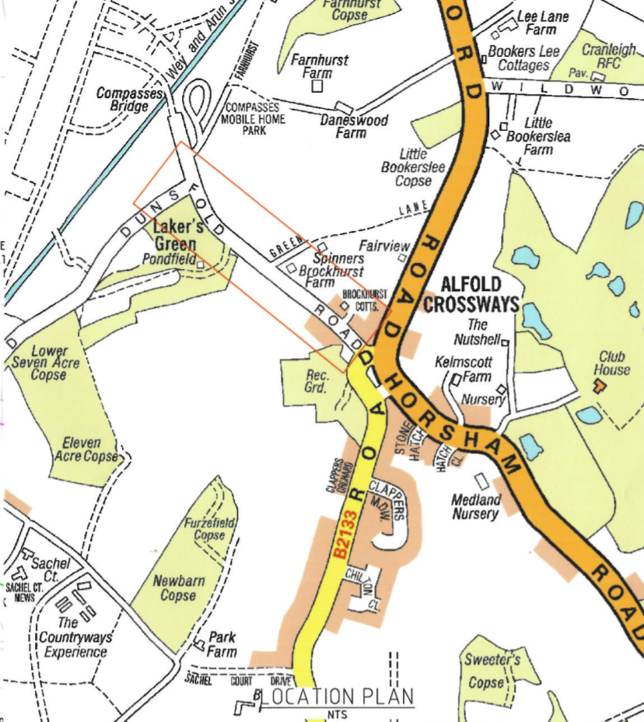

Common Land Consents Policy (Defra November 2015)
Section 39(2) of the 2006 Act provides that the public interest includes the public interest in; nature conservation; the conservation of the landscape; the protection of public rights of access to any area of land; and the protection of archaeological remains and features of historic interest.

