Application Decision
by Richard Holland
Appointed by the Secretary of State for Environment, Food and Rural Affairs
Decision date: 5 May 2021
Application Ref: COM/3260914
Whelpside, Steel End, West Head, Armboth and Bleaberry Fells, Cumbria
Register Unit No: CL413
Commons Registration Authority: Cumbria County Council
- The application, dated 23 September 2020, is made under Section 38 of the Commons Act 2006 (the 2006 Act) for consent to carry out restricted works on common land.
- The application is made by United Utilities Water Limited.
- The works to enclose 2.38 hectares of common land for 10 years comprise:
- creation of a fenced enclosure with approximately 441m of 1.2m high wooden post and woven wire stock fencing; and
- installation of two public access wicket gates with self-closing mechanisms.

Decision
- Consent is granted for the works in accordance with the application, as amended, dated 23 September 2020 and submitted plan subject to the following conditions:
- the works shall begin no later than 3 years from the date of this decision;
- all gates shall comply with British Standard BS5709 and be marked with ‘open access land’ signage; and
- all works shall be removed on or before 31 May 2031.
- For the purposes of identification only, the location of the proposed works is shown in red on the attached plan.
Preliminary Matters
- I have had regard to Defra’s Common Land consents policy in determining this application under section 38, which has been published for the guidance of both the Planning Inspectorate and applicants. However, every application will be considered on its merits and a determination will depart from the policy if it appears appropriate to do so. In such cases, the decision will explain why it has departed from the policy.
- This application has been determined solely on the basis of written evidence.
- I have taken account of the representations made by Natural England (NE), Historic England (HE), Lake District National Park Authority (LDNPA), Friends of the Lake District (FLD), Cumbria & Lakes Joint Local Access Forum (CLJLAF) and the Open Spaces Society (OSS).
- I am required by section 39 of the 2006 Act to have regard to the following in determining this application:-
- the interests of persons having rights in relation to, or occupying, the land (and in particular persons exercising rights of common over it);
- the interests of the neighbourhood;
- the public interest; and
- any other matter considered to be relevant.

Reasons

The interests of those occupying or having rights over the land
- The land is owned by the applicant, United Utilities Water Limited (UU). The common land register records two rights to graze sheep and one right to turn out geese. UU advises that these rights are not exercised but that there are two agricultural tenancies with exercised grazing rights on Armboth Fell and Bleaberry Fell, which are the areas of the common nearest to the proposed fence. The active graziers were consulted about the proposals but have not commented, although UU advises that they are in support and I have no reason to believe otherwise. I am satisfied that the works will not harm the interests of those occupying or having rights over the land.

The interests of the neighbourhood and public rights of access

- It is proposed to erect and retain the fence for a period of 10 years. Its purpose is to enclose an area of severely eroded and degraded peatland at a location known as The Pewits in order to exclude grazing livestock. Livestock exclusion will allow vegetation to recover following peat restoration project works. UU advises that without the fence the land will continue to be grazed and any improvements to the vegetation will be lost.

- The interests of the neighbourhood test relates to whether the works will impact on the way the common land is used by local people and is closely linked with interests of public access. A desire line corresponding to a published walking route from High Seat to High Tove runs north/south through the proposed enclosure just inside its western edge. The two proposed gates will be installed at the north west and south west corners of the enclosure to allow the desire line to be followed and they will also allow public access into the enclosure more generally. The enclosure’s western edge also marks the boundary of the common beyond which lies an area of National Trust (NT) peatland that is, or will be, similarly enclosed to facilitate peat restoration works.

- UU advises that additional access points into the enclosure, as requested by OSS, would be unsuitable due to the nature of the terrain, which is severely degraded blanket bog forming part of the area to be restored. UU further advises that allowing access from multiple points might result in trampling across freshly restored ground, which would endanger the project’s success. I am satisfied that two gates at the proposed locations will provide appropriate and adequate public access through the enclosure and that the absence of additional access points will not prevent anyone from walking over all the land within the enclosure should they wish to.
- At OSS’ request, UU agreed to install wicket type gates with a self-closing mechanism instead of 1.2m wide field gates, as specified in the application form. The request was made because wicket gates are smaller, more user-friendly and more likely to be closed by users, especially in very windy conditions. The parties to have made representations were advised of this change and I am satisfied that no party has been prejudiced by it. I consider the change to be appropriate and in the interests of public access.

The public interest

Nature Conservation
- The common lies within the Armboth Fells Site of Special Scientific Interest (SSSI) and the Lake District High Fells Special Area of Conservation (SAC). NE advises that the SSSI is designated in part for its blanket bog, which is the second largest area in the Lake District, and that a peat restoration project is being carried out within it in partnership with the National Trust (NT) and Cumbria Wildlife Trust (CWT). The works the subject of this application are to be carried out by UU in partnership with Fix the Fells (FTF) and NT’s Riverlands Project (hence the enclosure on the NT side of the common land boundary).

- NE was involved in the development of the fencing proposals and believes they will help to restore important blanket bog habitat and improve its ability to store carbon. NE envisages that the restored peatland will also benefit the flora and fauna associated with it. Once peat is damaged organic matter is washed into streams, reducing the quality of the whole water catchment. NE advises that restoration of the peat will not only improve biodiversity but will have implications for the water catchment, hence the partnership with the Riverlands Project, which aims to deliver water quality improvements many miles downstream to the benefit of freshwater species such as otters, Atlantic salmon and vendace.

- I conclude that the proposed works are in the interests of nature conservation.

Conservation of the landscape

- The common lies within the Lake District National Park and the proposed fencing will have a detrimental impact on the landscape to a certain degree, although the extent to which it will be visible from the surrounding land is uncertain.

- LDNPA considers that the visual impact will be mainly from a short distance as it will be located in a depression and will be hidden within the landscape, whereas NE considers that as it will be situated high up on the Armboth Fell it is likely to be visible from High Seat and High Tove. However, NE further considers that the negative impact of the fencing needs to be balanced with the ongoing damage to the peat, which itself is deleterious to the landscape, and it is their view that the presence of fencing in the short term will have long term benefits for the landscape, resulting in a net gain.

- No party has suggested that the fencing will cause serious damage to the landscape during its 10-year placement and I am satisfied that it will assist in peat restoration to the benefit of the landscape in the long term. I conclude that the proposals will help to ensure the natural beauty of the Lake District National Park is conserved and that this outweighs any temporary visual harm.

Archaeological remains and features of historic interest
- HE advises that there are no scheduled ancient monuments to be affected by the proposals and no reason to suspect that any non-designated nationally important archaeological sites would be impacted.

- The common lies within the Lake District World Heritage Site. HE has considered the potential for the proposed works to impact adversely on the Outstanding Universal Value of the Site and advises that there will be no adverse effect. LDNPA considers that the proposed works do not in principle impact upon the integrity of the Site and that the works are a balanced response to sustaining the Site’s Outstanding Universal Value and addressing the resilience of the landscape to climate change.

- I am satisfied that the works are unlikely to harm any archaeological remains or features of historic interest or impact harmfully on the Lake District World Heritage Site.

Other matters

- The western boundary of the common land runs north/south through The Pewits. Peat restoration works are proposed on each side of the boundary, necessitating a separate fenced enclosure on NT owned land outside the common. FLD is concerned about some fencing already present on the NT side, some of which they suggest may actually be on common land, and they seek a commitment from NT to remove it. OSS has similar concerns and seeks a requirement for both the application fencing and the NT fencing to be removed after any consented 10-year period. However, the application before me is not concerned with any existing fencing nor with any new fencing to be erected outside the common and these are not matters for my consideration in deciding the application.

- All those to have made representations, other than HE, refer to UU’s intention to improve the surface of the desire line. NE refers specifically to a ‘pitched stone path’, FLD to ‘slate slabs’ and OSS to ‘a permanent surface solution’. Such works may need s38 consent in their own right. However, the application before me includes no proposals to improve the desire line surface. It is therefore not a matter for my consideration in deciding the application, nor is the provision of digital maps of the application works to LDNPA.

Conclusion
- I conclude that the proposed works will not unacceptably harm the interests set out in paragraph 6 above. Indeed, they will benefit nature conservation and landscape interests in the long term, whilst allowing public access over the application land to continue. Consent is therefore granted for the works subject to the conditions set out in paragraph 1.

Richard Holland

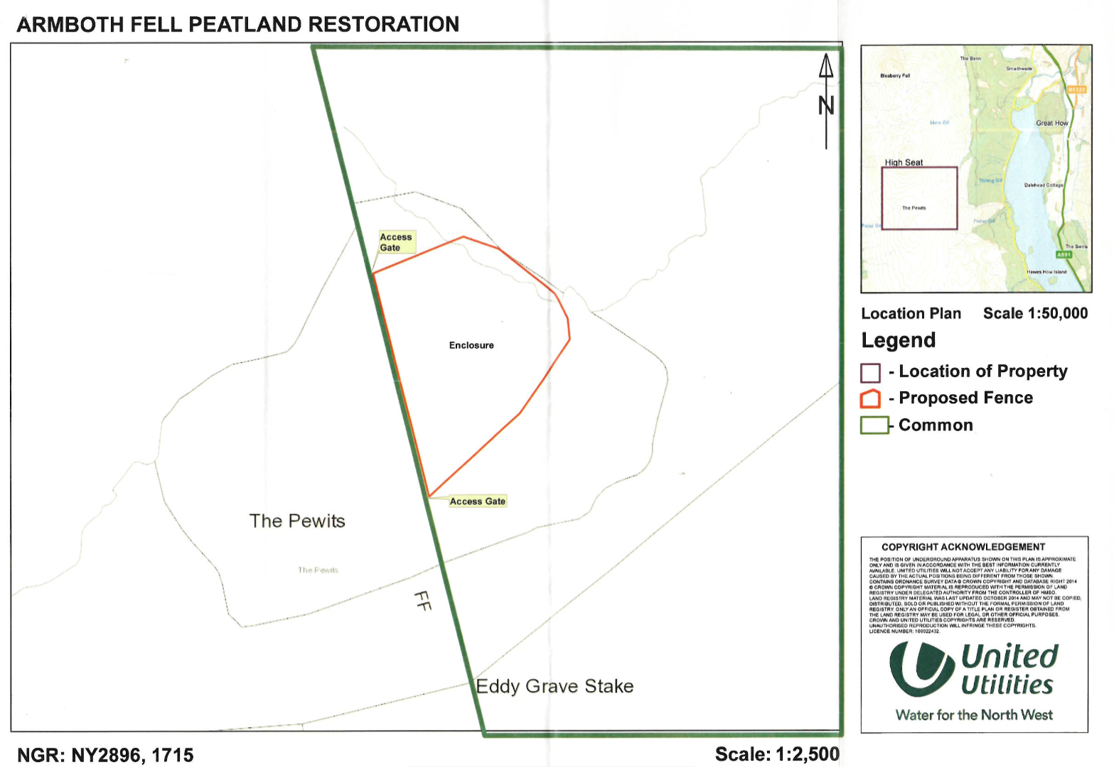

Common Land consents policy (Defra November 2015)
Section 39(2) of the 2006 Act provides that the public interest includes the public interest in; nature conservation; the conservation of the landscape; the protection of public rights of access to any area of land; and the protection of archaeological remains and features of historic interest.

