Application Decision
Site visit made on 19 February 2021
by R J Perrins MA
an Inspector appointed by the Secretary of State for Environment, Food and Rural Affairs
Decision date: 1 March 2021

Application Ref: COM/3265797
Tooting Bec Common, London SW16
- The application, dated 11 December 2020, is made under Article 12 of the Ministry of Housing and Local Government Provisional Order Confirmation (Greater London Parks and Open Spaces) Act 1967 (‘the 1967 Act’) for consent to construct works on common land.
- The application is made by Wandsworth Borough Council.
- The works are described as:
Phase 1: The construction of a new electrical substation adjacent to the Lido pavilion and situated within the existing external boundary of the Lido.
Phase 2: The excavation of trenches for new high and low voltage power cables, the installation of those cables and their connections into the main supply (off site) and new equipment (on site), the backfilling of the trenches once cable installations are completed and the restoration of tarmac and grass surfaces to existing conditions as appropriate. Phase 2 works will run concurrently with Phase 1.
Phase 3: The partial demolition of the lido pump house (south room) including the dismantling, removal and disposal of existing mechanical equipment and reconstruction on the existing footprint including the installation of new plant/equipment. The current built footprint remains unchanged

Decision
- Consent is granted for the works in accordance with the application dated 11 December 2020 and accompanying plans, subject to the following conditions: -

i. The works shall begin no later than three years from the date of this decision.

ii. All fencing shall be removed and the common shall be fully restored within one month from the completion of the works.
- For the purposes of identification only, the location of the works is shown outlined on the attached drawing.

Preliminary Matters
- Following advertisement of the application, representation was received from Natural England and the Open Spaces Society who raise no objections to the proposal. No other representations were received.
- I carried out an unaccompanied site visit on 19 February 2021. The weather on the day was overcast but dry. I walked extensively around the area of Tooting Bec Lido and Common to familiarise myself with the general area and the location.
- This application has been determined on the basis of the written evidence and my own observation of the site and surrounds.

Main Issues
- I am required by section 39 of the Commons Act 2006 to have regard to the following in determining applications under Article 12 of the 1967 Act:-

a. the interests of persons having rights in relation to, or occupying, the land (and in particular persons exercising rights of common over it);

b. the interests of the neighbourhood;

c. the public interest; and

d. any other matter considered to be relevant.
- In determining this application, I have had regard to the latest edition of Defra’s Common Land Consents Policy (‘the 2015 Policy’) which has been published for the guidance of both the Planning Inspectorate and applicants. However, every application will be considered on its merits and a determination will depart from the policy if it appears appropriate to do so. In such cases, the decision will explain why it has departed from the policy.

Reasons

The interests of those occupying or having rights over the land
- There are no rights registered over the area of common impacted by the works. I am also satisfied that the interests of those occupying the land is not at issue.

The interests of the neighbourhood and public rights of access
- The interests of the neighbourhood test relate to whether the works would unacceptably interfere with the way the common is used by local people and is closely linked with public rights of access. The works are needed to replace the Lido Pump House which, as I have observed, has suffered extensive structural damage. At the same time the mechanical equipment within the pump house would be replaced, and a new electrical substation installed to service the increase in power required for the new equipment, including water filtration systems.
- The works have been given planning permission subject to a number of planning conditions to protect the character and appearance of the area, the common itself, local wildlife/biodiversity and trees. The works will restrict access to parts of the common for the duration of the works. Those restrictions would be way of a low-level barrier for cable trench excavation running along the eastern side of the access to the Lido car park and temporary hoarding around substation and pump house. All as indicated on the drawing attached to this decision.
- The fencing would be required to meet health and safety requirements and would be an inconvenience to users of the common be that walking, cycling or other informal recreation. However, the inconvenience would be minimal and only likely to require minor detours around the protected areas. Access would remain to the car park and main footpaths nearby. Furthermore, the works and fencing would be temporary, and I am satisfied they would not have a significant or lasting impact on the common and would not harm the interests of the neighbourhood or public rights of access.

Archaeological remains and features of historic interest
- There is no evidence before me to indicate that the works would harm archaeological remains and features of historic interest.

Nature conservation and conservation of the landscape
- The proposal would see 37 meters of permanent fencing removed. Whilst some of that would be replaced with new façades to the sub-station, an area of 126 square meters would be returned to open access land. The temporary fencing would be painted green and sections of fencing removed as soon as works progress with the common reinstated to its previous condition.
- Natural England confirmed that it would not be commenting on the application. Furthermore, I am satisfied, based on the evidence before me, that there is nothing to indicate that the works would unduly impact on nature conservation interests. The permanent works would either be underground or subject to planning conditions to ensure the character and appearance of the area remains unharmed. Planning conditions would also secure protection of trees and biodiversity.
- For these reasons I find the works would conserve the landscape in the long term and would not have any adverse effect upon nature conservation.

Conclusion
- Defra’s policy guidance advises that “works may be proposed in relation to common land which do not benefit the common, but confer some wider benefit on the local community, such as minor works undertaken by a statutory undertaker (e.g. a water utility) to provide or improve the public service to local residents and businesses … consent under section may be appropriate where the works are of temporary duration (such as a worksite), where the works will be installed underground (such as a pipeline or pumping station), or where their physical presence would be so slight as to cause negligible impact on the land in question (such as a control booth or manhole), and the proposals ensure the full restoration of the land affected and confer a public benefit”.
- The works would secure the future of the Lido pump house and associated equipment, a public benefit. Thus, I am satisfied that the works would accord with this policy objective.
- Having regard to the criteria set out above, I conclude that the works would not have a significant or lasting impact, or harm the interests set out in paragraph 6 above and would confer a public benefit. Consent is therefore granted for the works subject to the conditions set out in paragraph 1 to ensure the works will progress and reinstatement of the common will be timely.

Richard Perrins

Inspector

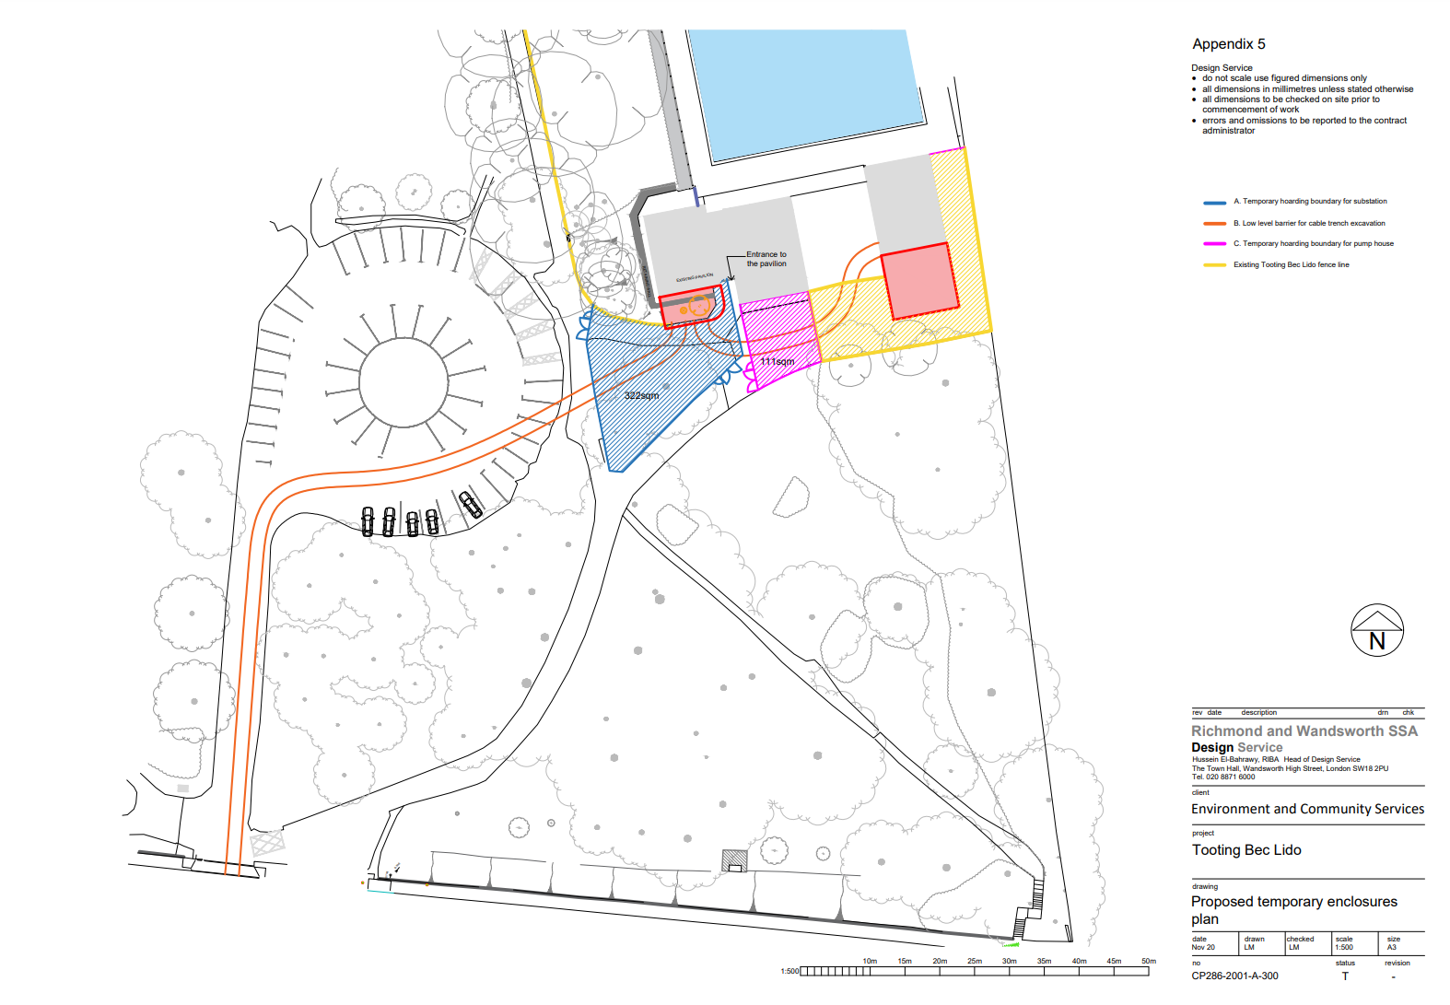

Section 39(2) of the 2006 Act provides that the public interest includes the public interest in; nature conservation; the conservation of the landscape; the protection of public rights of access to any area of land; and the protection of archaeological remains and features of historic interest.
Common Land Consents Policy (Defra November 2015)
Ref: 2019/2987 for the Erection of replacement of south room of pump house and excavation to south room to house mechanical equipment. Ref: 2020/1826 for the Erection of a single storey electrical substation with green roof adjacent to the Tooting Bec Lido Pavilion, to upgrade the electrical supply serving Tooting Bec Lido. Installation of six new bicycle racks
Phase 1 & 2 – 5 months duration; Phase 3 – 9 months after completion of Phase 1 and 2 works.

