Application Decision
Site visit made on 24 December 2020
by Alan Beckett BA MSc MIPROW
an Inspector appointed by the Secretary of State for Environment, Food and Rural Affairs
Decision date: 22 February 2021

Application Ref: COM 3257245
Keskadale Wood, Brackenthwaite Fell, Newlands, Cumbria
Register Unit: CL 11
Commons Registration Authority: Cumbria County Council
- The application, dated 17 July 2020, is made under section 23 of the National Trust Act 1971 (’the 1971 Act’) for consent to the retention of restricted works on common land previously consented to on 17 August 2006.
- The application is made by Victoria Lancaster on behalf of the National Trust (‘the Trust’).
- The works previously consented comprises 3,800 metres of post and wire fence which enclosed 50 Ha of common land. Consent is sought for the retention and repair of the fence and access points for a further period of 15 years.

Decision
- Consent is granted for the works above in accordance with the application dated 17 July 2020 and the plans submitted with it subject to the following condition:
- the works (3800 metres of fencing and access points) shall be removed by the National Trust not later than 28 February 2026.
- The gates at the access points shall comply with BS 5709:2018

Preliminary Matters
- Keskadale Wood lies within the Derwent and Buttermere Fells Common and within the Lake District National Park and World Heritage Site, the Buttermere Fells Site of Special Scientific Interest (SSSI) and the Lake District High Fells Special Area of Conservation (SAC). Keskadale Wood lies at an altitude of between 300 metres and 460 metres above sea level and is one of the two highest altitude oak woodlands within the UK. The woodland is dominated by low growing scrubby oak with other species also present as the components of a woodland at this altitude.
- Initial consent for the erection of fencing around Keskadale Wood to exclude grazing livestock was granted in 2006 with the fence being erected in 2007. It is submitted that grazing levels toward the end of the twentieth century had resulted in an almost total lack of regeneration within the wood itself with the exception of a small enclosure which had been created in the 1960s and from which livestock had been effectively excluded. The woodland and some additional land were fenced in 2007 with the aim of encouraging natural regeneration of scrubby woodland within the whole of the fenced area and to assist with the gathering of sheep from the fell by preventing them from becoming lost within the wood.

Procedural Matters
- I carried out an unaccompanied site inspection on 24 December 2020. My decision has been made on the basis of my observations on this visit, taking account of the application and representations received in response to the advertisement of the application.
- Consent is sought for the retention of fencing erected in 2007 under a previous consent granted in 2006. Consent is sought for a further period of 15 years as the process of natural regeneration of woodland at its altitudinal limit is slow. Whereas surveys conducted by Natural England (NE) during the current period of consent have shown that regeneration is occurring both within the woodland and in the wider area enclosed by the fence, the Trust considers that the fence should remain for a further 15 year period to protect the woodland from grazing or browsing livestock and other animals and to restore the oak woodland SSSI to favourable condition in accordance with Government policy.
- The objectors question the need for the fence to be retained for a further 15 years. Whilst it is accepted that there has been some natural regeneration within the fenced area, it is submitted that there has also been regeneration outside that area. It is also submitted that there has been no indication from the Trust as to the level of regeneration which should or must be reached before grazing to be resumed within the woodland and the fence removed.
- The objectors note that the active commoners have participated in a Higher Level Environment Stewardship (‘HLES’) scheme which had a scheduled termination date of September 2020, but which has been rolled over for an additional year. It is suggested that if consent for the retention of the fence were to be granted, the consent should be tied to the life of the agri-environment scheme; if this were not possible, then consent should be limited to 5 years. Once the availability or applicability of future agri-environment schemes were known, and if surveys concluded that further protection of the woodland from grazing animals was required, a further application for the retention of the fence could be made.
- Other objectors noted that the Trust considered that the woodland may require a further period of protection from grazing after the end of the second 15 year period and suggested that if consent were to be granted it should be limited to 10 years to provide for periodic assessments of the extent of regeneration and for thorough consultation with all interested parties.
- NE submits that in this case, it is not possible to tie the end date of the consent sought to the end date of the agri-environment scheme the commoners are participating in. This is because the current HLES expired in September 2020 but has been rolled over for a further 12 months until 21 September 2021. As yet no decision has been made as to whether to allow HLES schemes to roll over for a further year annually. NE submits that there is no certainty as to when the land will cease to be subject to the HLES scheme and there would therefore be no definite end date to tie the consent to. It is noted however, that all necessary consents are required to be in place before the parties enter into a new agri-environment scheme and for those consents to cover the duration of the scheme. In NE’s view, the 15-year period sought under the current application would prevent consent for retention of the fence to have to be sought within a short timescale should a new agri-environment scheme be considered.
- In many cases where section 38 consent is sought for the erection or retention of fencing on common land, the application forms part of an agri-environment scheme entered into by the commoners. Such schemes are designed to strike a balance between biodiversity and landscape conservation and the ability of the commoners to exercise their rights as part of earning a living from the land. In this case forgoing the opportunity to graze within Keskadale Wood is offset by the payments arising under the HLES scheme. It is therefore appropriate for section 38 consent to be granted for the duration of any associated agri-environment scheme. That does not appear to be possible in this case as the current HLES scheme has now ended and is being rolled forward (for this year at least) on an annual basis. There is therefore a degree of uncertainty as to when a new scheme might be entered into or what the duration of any new scheme may be.
- Consent for the retention of the current fence for a further 15 years as requested may therefore disadvantage active commoners if a new scheme is not entered into or is of short duration. Similarly, it would impose a disproportionate burden on the Trust to tie consent to the end date of the current HLES rollover and to require it to seek to renew consent on an annual basis if the current scheme is subject to further annual rollovers.
- I consider there to be some merit in the submission made by the objectors that consent, if granted, should be limited to five years in this instance. This would provide a degree of continuity if, in the short term, the current HLES rolls over for the next few years whilst a decision is made on what scheme or schemes will replace the current HLES arrangements. The granting of consent for a further five years would not preclude the Trust from making a further application should the position regarding future agri-environment schemes become clearer within that five-year period. Consent for a further five years is also likely to coincide with the end of the useful life of the fence which has already been in in place for 15 years.
- I therefore consider that as it is not possible to tie consent to the expiry date of the current HLES scheme, if consent were to be granted, it should be limited to a period of not more than five years.
- I have had regard to the Department for the Environment, Food and Rural Affairs Common Land Consents Policy Guidance, published in November 2015, which sets out the benefits which common land should deliver, and the outcomes that it considers must be ensured by the consents process. This document has been published for the guidance of both the Planning Inspectorate and applicants. However, the application will be considered on its merits and a determination will depart from the published policy if it appears appropriate to do so. In such cases, the decision will explain why it has departed from the policy.

The Main Issues
- Section 23 of the 1971 Act provides that the Trust (if the Trust is to carry out the proposed works), or a third party, (if the third party is to carry out the proposed works under an express or implied right), may apply for consent to carry out works which prevent or impede access on any National Trust owned land which is registered as common land under the Commons Registration Act 1965. The National Trust owns the land which is subject to this application.
- Applications under section 23 are determined using the same procedure and criteria as for applications made under section 38 of the Commons Act 2006 (the 2006 act). Section 38 of the 2006 Act provides that a person may apply for consent to carry out restricted works on land registered as common land. Restricted works are any that prevent or impede access over the land, including the erection of fencing. Therefore, in considering an application made under section 23 of the 1971 Act, I am required by section 39 of the 2006 Act to have regard to the following:

(a) the interests of persons having rights in relation to, or occupying, the land (and in particular persons exercising rights of common over it);

(b) the interests of the neighbourhood;

(c) the public interest which includes the interest in nature conservation, the conservation of the landscape, the protection of public rights of access and the protection of archaeological remains and features of historic interest;

(d) any other matters considered to be relevant.

Assessment

The interests of those occupying or having rights over the land
- Keskadale Wood is part of Brackenthwaite Fell which is registered as common land (CL 11) under the Commons Registration Act 1965. There are rights of common of pasture, estovers, turbary and common in soil registered in respect of the common. The Trust states that the active commoners who exercise their rights participate in a HLES scheme which was due to terminate on 30 September 2020, but which has been extended for one year.
- The Trust submits that the commoners are fully supportive of the retention of the fence as it contributes towards the fulfilment of their responsibilities under the current HLES scheme. The application has been made on behalf of the Trust which is the owner of the land at issue. In such circumstances, it is unlikely that the landowner’s ability to exercise its rights over the property would be adversely affected.
- Given that the active commoners are, via their Commons Association, entered into a HLES scheme which aims to help maintain an living for commoners while balancing the historic management of the common for the benefit of nature conservation, biodiversity and landscape protection, I consider that the proposed retention of the existing works would not have any adverse effect upon their interests.

Interest of the neighbourhood
- The 2015 guidance indicates that the issues to be considered in this context include whether or not the proposal will offer a positive benefit to the neighbourhood, whether or not the works would prevent local people from using the common in the way they are used to, and whether or not there would be an interference with the future use and enjoyment of the common, whether by commoners, the public or others. For example, would the fencing sterilise part of the land rendering it inaccessible.

Positive benefit
- Consent for the retention of the existing fencing around Keskadale Wood is sought to enable the continued regeneration of the wood. The Trust seeks to encourage the regeneration of Keskadale Wood through the exclusion of grazing animals and to facilitate the conditions that would allow trees, scrub, and ground flora to grow and flourish where the soil and climatic conditions are suitable. Other objectives include the conservation and enhancement of the landscape, to increase carbon sequestration and to slow the flow of water from the fells.
- NE had made formal assessments of the condition of the woodland in March 2014 and September 2019 and noted that the ground flora within the fenced area has increased significantly inside and outside the area of the tree canopy with a thicker, denser ground flora having the ability to retain water and slow the flow of water from the fells. Tree regeneration was found to be occurring within the fenced area with early colonisers such as rowan, birch and hawthorn being the most frequent. It was also noted that there had been some oak regeneration, both from suckers and from seed.
- It appears that the fence has facilitated natural regeneration of Keskadale Wood and the area beyond the tree canopy but within the confines of the fence. It is also evident from the submissions made by the Trust and NE that there has been some browsing of the trees within the fenced area by sheep and deer. The Trust submits that it has a Deer Management Plan in place for the Keskadale area which includes a zero-tolerance approach to any species of deer found within the fenced area and is working closely with the graziers regarding the swift removal of any sheep which stray into it.
- The objectors question whether it would be possible to achieve ‘zero-tolerance’ of deer within the fenced area as the sheep fence (1.2 metres in height) is no deterrent to deer. I understand that the Trust engages in an annual culling programme across the wider common and the farmland surrounding Keskadale to manage deer numbers. Although the height of the fence would appear to present no barrier to entry, such a culling programme is likely to contribute towards reducing the extent of browsing and may result in the trees within the wood attaining sufficient size to withstand occasional browsing. Regeneration is likely to be more effective if all browsing and grazing animals could be excluded, however it is evident that the presence of the fence has reduced the incidence of grazing and allowed some natural regeneration of the wood to take place.
- As noted above Keskadale Wood is one of the two highest altitude oak woods in the UK and is at the altitudinal limit for such woodlands. Natural regeneration in such conditions is likely to be slow but will assist in the continuation of the woodland as a prominent feature within the area.
- The objectors questioned the extent to which the regeneration of Keskadale Wood could contribute to carbon sequestration or the slowing of water run-off from the fells, given the nature and size of the site. Whilst these would be valuable potential benefits which may result from the scheme, any contribution made to these objectives by the scheme are unlikely to become evident in the short term due to the slow pace of regeneration within the woodland. Further study and long-term monitoring of these matters is likely to be required before any conclusions could be drawn as to the impact the regeneration of the wood can or will have on such matters.
- The fence has been present for fifteen years and there is very little evidence before me that its presence has had a significant adverse effect upon the ability of residents in the neighbourhood to enjoy the area for informal outdoor recreation or that the interests of the neighbourhood would be unduly harmed by the retention of the fence for a further period of time.

The public interest

The protection of public rights of access
- In relation to public rights of way, the preferred means of access through any boundary is a gap. In the absence of the possibility of a gap (because of the need for stock control) a gate is preferable to a stile in the light of the requirements of the Equality Act 2010. There is no reason why the same principles cannot apply to access to common land.
- There are no public rights of way running through Keskadale Wood or the wider area currently enclosed by the fence. The wood forms part of registered Open Access Land under the Countryside and Rights of Way Act 2000. The Trust states in its application that there are five stiles and gates within the existing fence line which provide access to the land enclosed by the fence and provided a plan showing the locations of these access points which were all on the southern fence line.
- The objectors contend that when the fence was originally constructed there was no provision of any access points and that due to the vegetation regrowth within the vicinity of the fence access into the wood was difficult and problematic. Without suitable access provision, it would not be possible for the scheme to achieve its aim of providing a ‘wild and beautiful place for public enjoyment’.
- The Trust responds that the specified access points were created when the fence was erected, but that they may have been damaged over time due to the harsh climatic conditions. The Trust submits that one gate and one stile was usable at the present time. In addition, the Trust stated that repair to the gates and stiles would be undertaken as part of the annual maintenance programme.
- I saw at my site visit that there was a gate and a stile within the fence line which provided a means of access to the enclosed area. The unavailability (or absence) of the remaining three access points is a matter of concern as public access to the site should remain available in accordance with the consent granted for the duration of that consent. An undertaking to repair and maintain the access points is welcomed, but such maintenance and repair should have been undertaken during the period of the current consent.
- Public access to the enclosed area is therefore available although not in accordance with the current consent. The Trust acknowledges that gates are preferable to stiles but submits that gates are not felt to be appropriate at Keskadale due to the steep and unstable terrain. However, the plan submitted by the Trust identifies the locations at which gates are, or have previously, been installed. I take this to indicate that the Trust has identified locations at which it is possible for such structures to be erected. Although there will be a risk that gates may be inadvertently left open and allow ingress by sheep, the very nature of the steep and unstable terrain requires, in my view, that the least restrictive means of public access should be provided. All gates should be to the current standard of BS 5709.
- The renewal of the access points as shown in the plan appended to this decision will ensure that public access to this part of the common would not be prevented, and that the public’s use of this part of the common for informal recreation and access would not be adversely affected.

Nature conservation
- Several of the objectors questioned the need for the fenced area to be larger than the area of the established woodland which it surrounds. It has been suggested that as natural regeneration has taken place outside the fenced area in addition to within the fenced area there is little need for the retention of the fence.
- NE are of the view that this additional regeneration may have occurred as the fence presents a barrier to sheep movements in some areas. The additional natural regeneration of the woodland is to be welcomed, irrespective of the cause, but does not in my view indicate that the fence is unnecessary to the expansion of the woodland. That regeneration outside the wood may succumb to browsing by sheep or deer whereas that within the fenced area has a degree of protection from grazing animals.
- The surveys of the site by NE note that the areas where natural regeneration is most evident are to the west of the wood and on the slopes above the existing tree line. Whilst it may be possible for the woodland to expand its area via natural processes alone, the exclusion of grazing from the land in close proximity to it is more likely to result in an expansion of the tree cover than if grazing were to continue up to the existing tree line.
- The surveys conducted by NE provide evidence of the expansion of a thicker, denser ground flora within the fenced area in addition to the regeneration of oak and other species. The increase in ground flora observable on the ground is likely to provide suitable habitat for insect and bird species and contribute toward the aim of returning the woodland to a good condition.
- Upland Atlantic Oak woodland is listed as a priority habitat under the provisions of section 41 of the Natural Environment and Rural Communities Act 2006. The Trust seeks to expand the area of this rare habitat through a process of natural regeneration and temporary livestock exclusion. These appear to be reasonably practicable steps which can be taken to further the conservation of this priority habitat.
- The retention of the fence for an additional period, together with the exclusion of grazing will allow for the natural regeneration already observed to continue, which will assist in securing the wider conservation benefits sought by the Trust.

Conservation of the landscape
- The retention of the fence is proposed to facilitate the regeneration of the upland oak woodland habitat of Keskadale Wood. The wood is a prominent feature within the valley and contributes to the sense of place. A period of 15 years has now passed since the fence was erected and the exclusion of grazing from Keskadale appears to have assisted the process of natural regeneration. It is recognised that the altitude at which the wood stands provides a challenging environment for oak and other woody species to grow and that any natural regeneration which occurs is likely to be slow. The retention of the fence for a further period is likely to assist with the regeneration of the wood and the conservation of this important landscape feature.
- The visual impact of the fence on the landscape is limited due to the use of post and wire and due to its positioning away from skylines or other vantage points. Stands of bracken and gorse on the lower slopes between the woodland and the valley floor assist in reducing the visual impact of the fence. Clearly there will be a greater visual impact when close to the fence although the height of the fence is such that there is a generally unobstructed view over the top of it. The inclosure is 50Ha in total; consequently, the generally ‘open’ character of the land outside the canopy of the wood is retained for anyone venturing into the fenced area.
- Concerns were expressed regarding the impact the retention of the fence would have upon the viability of sheep hefting on the common and on the ability of graziers to manage their flocks. Whilst the maintenance of hefted flocks on the common is an important cultural aspect of the Lake District as a World Heritage Site (‘WHS’), the fence at issue does not appear to interfere with that practice. Whilst the potential impact on traditional hefting may be a valid concern, the inclosure was designed in consultation with the grazier and has been devised to work alongside his existing hefting practice.
- Whilst the fence has been present for the past 15 years, in the fullness of time it will be removed, and the existing flock will once more be able to graze within the wood. I am not persuaded that granting consent for the retention of the fence will have an adverse impact upon the hefting of sheep on the common. I do not consider that the retention of the fence will have any adverse impact upon the agro-pastoral landscape for which the Lake District WHS is celebrated.
- Taking account of the overall purpose of the works and the intended outcomes I consider that whilst there will be a visual impact arising from the fence and the access gates, this will be for a limited period in landscape terms. I am satisfied that any short-term visual impact is outweighed by the long-term conservation objectives for this rare and important upland habitat, which will deliver landscape improvements over a much longer period.

Loss of existing use or interference with future use
- The proposed works are unlikely to interfere with the current or future use of the common by residents, commoners, or visitors. There are no internal fences proposed which would sterilise any part of the common or prevent access by the public or the commoners.
- I consider that the proposed works will enable the traditional management of the common to continue and that the retention of the fence will deliver biodiversity and landscape benefits which will be enjoyed by by those resident within the neighbourhood and those who visit.

Protection of archaeological remains and features of historic interest
- Historic England commented that there were no designated heritage assets within or near the enclosure at Keskadale Wood.
- I am satisfied that the proposed works would not harm any archaeological remains or features of historic interest.

Other relevant matters
- The published guidance encourages temporary fencing to be considered, rather than permanent fencing, where the objectives sought will be achieved through a reasonably predictable timescale and where its use can be reviewed from time to time. In addition, the guidance advises that commons should be maintained or improved as a result of the works being proposed and that the works are consistent with the use of the land as common land. I am satisfied that the proposed retention of the fence is consistent with these objectives.
- I consider that the proposals are consistent with the Secretary of State’s duty to conserve biodiversity and his duty to further the conservation of the section 41 list of features of principal importance for conserving biodiversity; his duty to further the conservation and enhancement of the features of the Buttermere Fells SSSI and the conservation of the Lake District National Park.

Conclusions
- Having regard to the interests set out in paragraph 16 above, I find that the retention of the existing works would not adversely affect those interests and that it is expedient that consent for the retention of the works should be given.
- For the purposes of identification only, the locations of the works being retained are shown edged red on the attached plan.

Alan Beckett

Inspector

APPENDIX
- 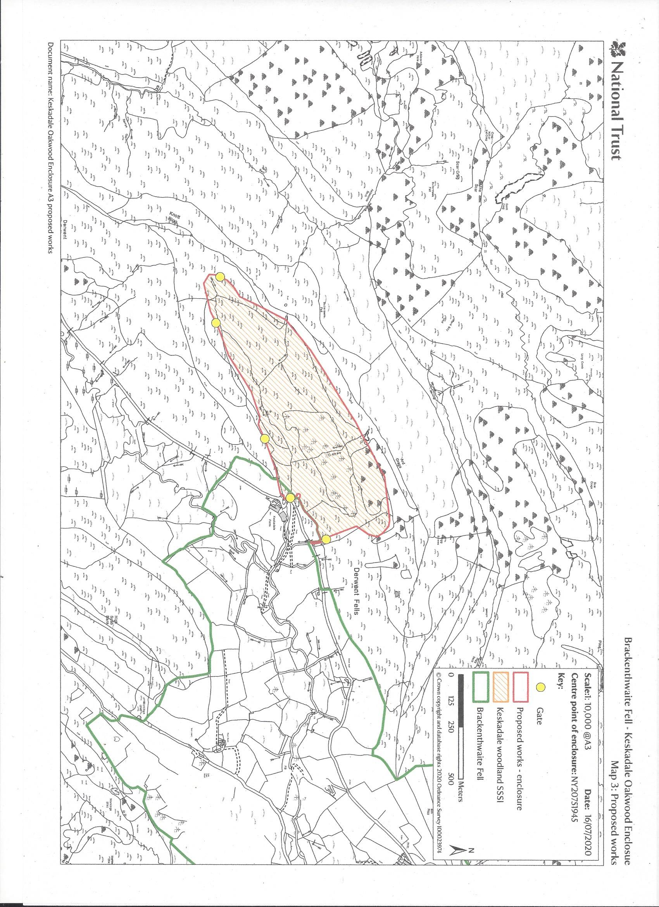

Section 40 of the natural Environment and Rural Communities Act 2006
Section 28G of the Wildlife and Countryside Act 1981
Section 11A of the National Parks and Access to the Countryside Act 1949

