Application Decision
by Richard Holland
Appointed by the Secretary of State for Environment, Food and Rural Affairs
Decision date: 10 March 2021

Application Ref: COM 3255577
The Quantock Hills, Somerset
Register Unit No: CL 10
Commons Registration Authority: Somerset County Council.
- The application dated 19 June 2020 is made under Section 38 of Commons Act 2006 (the 2006 Act) for consent to carry out restricted works on common land.
- The application is made by The Quantock Hills Area of Outstanding Natural Beauty.
- The works comprise:
- creation of a new 1550m² car park along the track leading from Crowcombe Park Gate towards the The Lodge with an informal crushed inert stone surface;
- creation of a new buff coloured tarmac access track to the new car park from the first pull-in north of the cattle grid (included in the total 1550m² above);
- restoration to heathland of 2377m² of the existing nearby parking area either side of the bridleway and two redundant tracks to the north using Capton quarry spoil in-fill, coir matting and heather cuttings as a seed source; and
- retention, repair and resurfacing of 724m² of the flat bottom area of the existing parking area with tarmac (5m nearest the road only) and crushed inert stone.

Decision
  - Consent is granted for the works in accordance with the application dated 19 June 2020 and accompanying plan, subject to the following conditions:-
  - the works shall begin no later than three years from the date of this decision; and
  - the common shall be fully restored within one month from the completion of the works.
  - For the purposes of identification only the location of the works is shown in red on the attached plan.
Preliminary Matters

- I have had regard to Defra’s Common Land Consents Policy in determining this application under section 38, which has been published for the guidance of both the Planning Inspectorate and applicants. However, every application will be considered on its merits and a determination will depart from the policy if it appears appropriate to do so. In such cases, the decision will explain why it has departed from the policy.

- Planning permission for ‘restoration of eroded car parking area to heathland and creation of a flat level car park with tarmac entrance’ was granted on 25 November 2019 by Somerset West and Taunton Council (Application 3/16/19/004).

- This application has been determined solely on the basis of written evidence.

- I have taken account of the representations by J H Waterman & Sons (JHW) and the Open Spaces Society (OSS).
- I am required by section 39 of the 2006 Act to have regard to the following in determining this application:-
- the interests of persons having rights in relation to, or occupying, the land (and in particular persons exercising rights of common over it);
- the interests of the neighbourhood;
- the public interest; and
- any other matter considered to be relevant.

Reasons

The interests of those occupying or having rights over the land
- The land is owned by Mr Anthony Trollope-Bellow of Hurley Farm, Crowcombe, who was consulted by the applicant about the proposals but has not commented. However, the applicant has advised that the landowner and his domestic tenant at The Lodge are supportive of the proposals and I have no reason to think otherwise.
- The common land register records extensive rights of grazing, estovers, turbury, pannage, quarry and the cutting and taking of bracken. As the proposals involve returning a larger area of land to heathland than will be taken by the new car park there will be a small increase in the available area of the common over which these rights can be exercised.
- The applicant advises that there are about six active commercial graziers of sheep and cattle represented by the Quantock Commoners Association (QCA) and a further 15 or so people represented by the Quantock Pony Breeders (QPB), who exercise or lease rights to graze ponies. QCA and the individual sheep and cattle graziers were consulted about the proposals but have not commented. QPB was also consulted and forwarded details to the individual breeders, including JHW, which has raised some concerns.
- JHW is concerned that the proposed new car park will funnel wild hill ponies onto the busy road from Crowcombe to Nether Stowey. This will increase the likelihood of an accident in the new car park or on the road, for which the breeders should not have to be liable. Whilst the applicant will close the car park for the yearly pony gather each September to avoid such a risk, JHW is also concerned that there may be other times when it might be necessary to close the car park at short notice to accommodate unplanned pony movements. JHW is further concerned that closing the car park will not in any case prevent such funnelling so the risk of accidents remains.
- In response the applicant says the ponies are well used to a changing environment and the new car park is unlikely to have a uniquely disturbing impact on their behaviour. Its surface will be well within the normal range of surfaces the ponies are used to walking on and they are used to the sudden appearance of people and vehicles. The applicant is nevertheless content to provide both QPB and QCA with a key to the car park bollard so that they may close the car park themselves at short notice should it be necessary. The applicant has also agreed to cover any increase in insurance costs that might arise within the first five years should any commoner wish to report the new car park to their insurer.
- I am not persuaded that the proposed works will endanger QPB’s ponies (or indeed road users generally) in the way that JHW fears. Whilst I recognise that JHW may still have some concerns, I am satisfied that the applicant has, so far as is practically possible, addressed the issues raised about pony safety in and around the new car park and that the works will not seriously harm the interests of those occupying or having rights over the land.

The interests of the neighbourhood and the protection of public rights of access
- The applicant seeks a new free of charge parking area to replace the nearby existing one, which was never designed to be a formal car park. It began as a recovery site for a crashed RAF aircraft in 1946 and has been used informally as a car park ever since. It is in a state of disrepair, slopes steeply and is not in the best place. The applicant does not wish to refurbish it as this would formalise its use for parking when it is not suitable as such for the reasons above.
- The interests of the neighbourhood test relates to whether the works will unacceptably interfere with the way the land is used by local people and is closely linked with public rights of access. The applicant advises that the common is well-used by walkers, riders and cyclists, some of whom travel by vehicle to the site. On hunt days up to three dozen hunt followers’ vehicles can be found in the area as well as 4x4 vehicles belonging to commoners, landowners and AONB Rangers. I am satisfied that there is a need for parking spaces to serve the interests of local people and visitors to the common.
- The applicant advises that no fencing is proposed and, other than by the lockable bollard, the car park will be delineated only by an existing ditch. The car park will not interfere with the adjacent bridleway, which runs just to the west, and it will be smaller, safer (because it is flatter) and more accessible for visitors than the existing parking area, which will be mostly restored to heathland and will remain publicly accessible. I am satisfied that the proposed new car park will not harm public access interests.

Nature conservation
- The land lies within the Quantocks Site of Special Scientific Interest (SSSI). Natural England (NE) was formally consulted by the applicant but has not commented on the application. However, the applicant advises that the final plan for the car park works evolved through extensive consultations with a variety of parties, including NE, and I am satisfied that NE has had a full opportunity to raise any concerns it may have had.
- Condition 8 of the planning permission prescribes working practices to be adopted under the supervision of a competent ecologist to protect any reptiles that may be present. Condition 9 requires working practices to be adopted in the interests of protecting nesting wild birds. I am satisfied that suitable measures will be put in place to protect nature conservation interests during the works.
- I consider that moving the car park will be of some nature conservation benefit insomuch as a larger area of land will be returned to heathland than will be taken. In addition, the applicant says the sensitive mire on the opposite side of the road will be protected from damage caused by current unauthorised off-road parking. I conclude that there is likely to be a small benefit to nature conservation from the works.

Conservation of the landscape
- The land lies within the Quantock Hills Area of Outstanding Natural Beauty (AONB). As the applicant, the AONB Board says the existing car park is in an intrusive location and that returning the majority of it to heathland will heal a very visible scar. I am satisfied that this is likely to be the case and that works will enhance the natural beauty of the AONB.

Archaeological remains and features of historic interest
- The applicant advises that the area has no known specific archaeological interests but that finds have been made nearby and that an archaeological watching brief will be undertaken during the works, as required by Condition 7 of the planning permission. I am satisfied that suitable measures will be put in place during the works to protect the above interests.

Conclusion
- I conclude that the proposed works will not harm the interests set out in paragraph 7 above. Indeed, they will assist and promote responsible parking at Crowcombe Park Gate and be of some benefit to nature conservation and the AONB landscape. Consent is therefore granted for the works subject to the conditions set out in paragraph 1.

Richard Holland

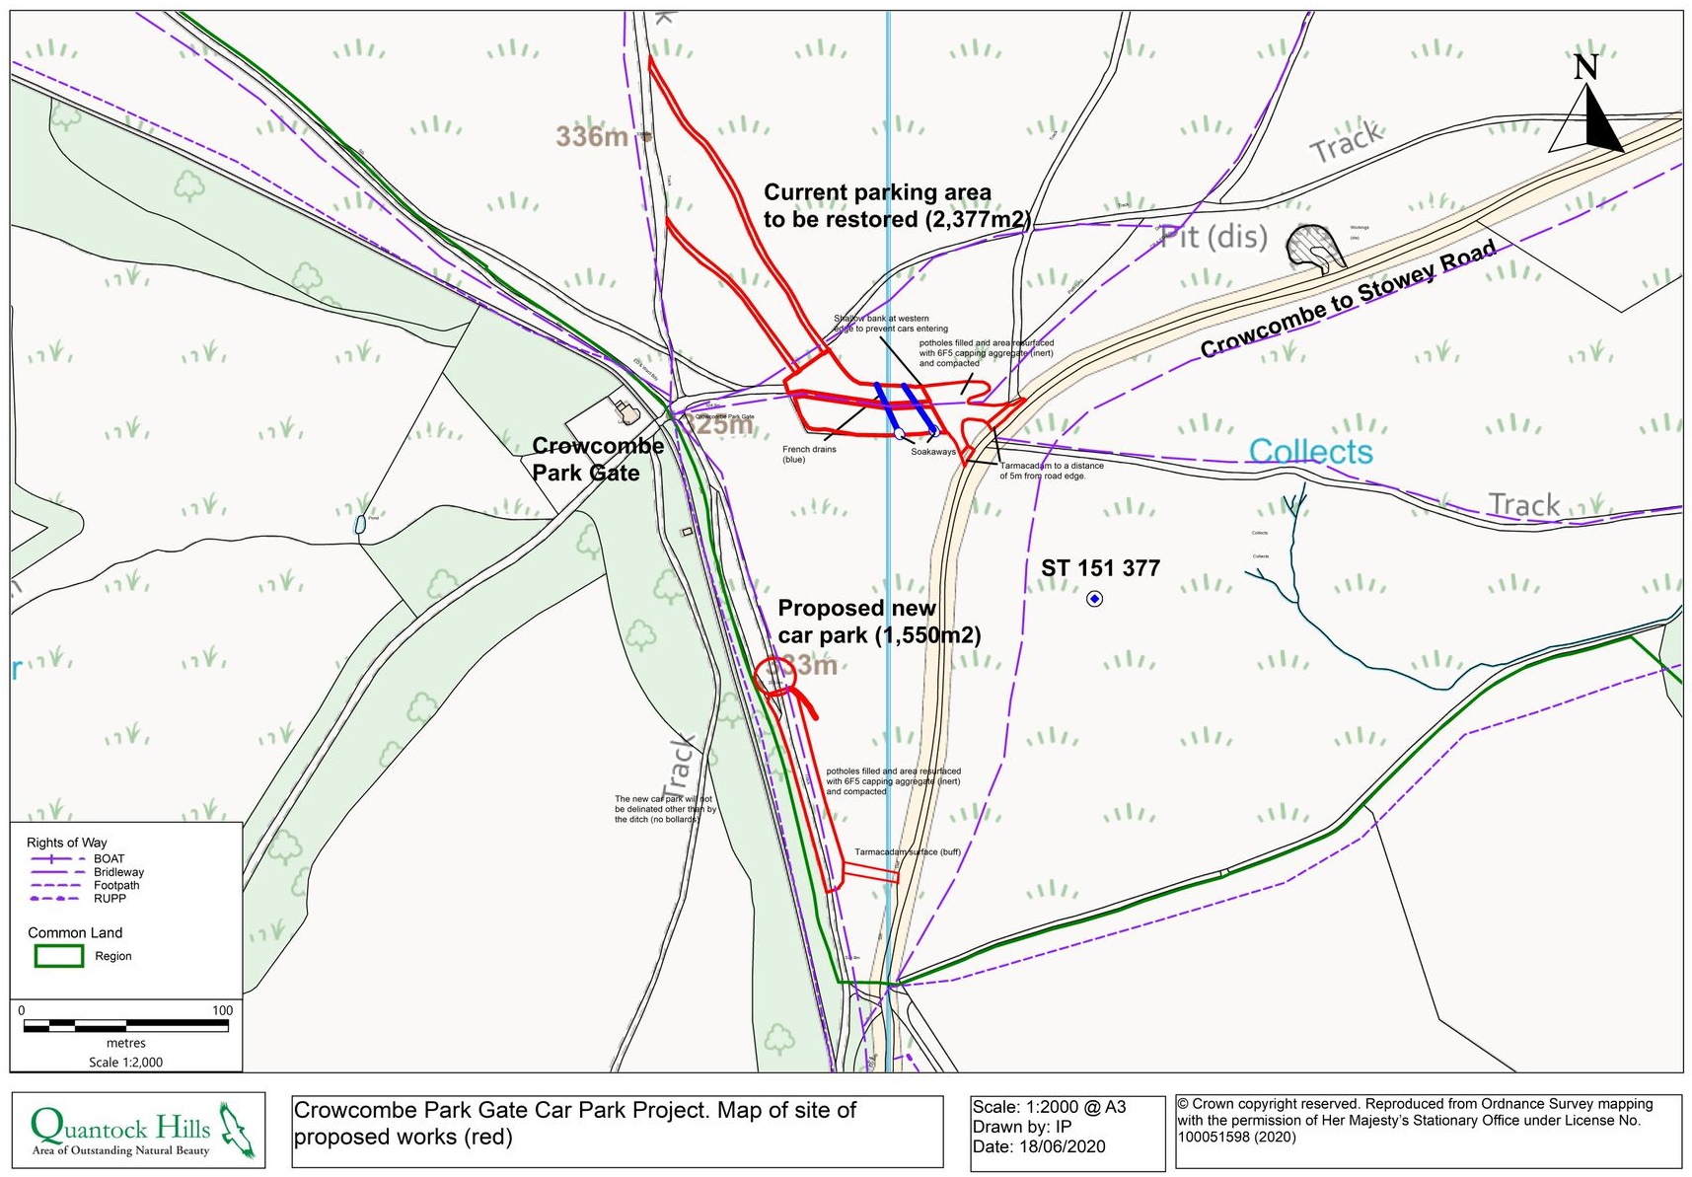

Common Land Consents Policy (Defra November 2015)
Section 39(2) of the 2006 Act provides that the public interest includes the public interest in; nature conservation; the conservation of the landscape; the protection of public rights of access to any area of land; and the protection of archaeological remains and features of historic interest.

