Application Decision
by Richard Holland
Appointed by the Secretary of State for Environment, Food and Rural Affairs
Decision date: 21 January 2021
Application Ref: COM/3247027
Blindley Heath, Godstone, Surrey
Register Unit No: CL15
Commons Registration Authority: Surrey County Council
- The application, dated 4 February 2020, is made under Section 38 of the Commons Act 2006 (the 2006 Act) for consent to carry out restricted works on common land.
- The application is made by Surrey Wildlife Trust.
- The works comprise the erection of 166m of approx. 1.1m high wooden post and wire stock fencing.

Decision
- Consent is granted for the works in accordance with the application dated 4 February 2020 and the plan submitted with it subject to the following conditions:
- the works shall begin no later than 3 years from the date of this decision;
- the fencing shall comply with British Standard BS1722; and
- all works shall be removed on or before 31 December 2029.
- For the purposes of identification only the location of the proposed works is shown as a pink line on the attached plan.
Preliminary Matters
- I have had regard to Defra’s Common Land consents policy in determining this application under section 38, which has been published for the guidance of both the Planning Inspectorate and applicants. However, every application will be considered on its merits and a determination will depart from the policy if it appears appropriate to do so. In such cases, the decision will explain why it has departed from the policy.

- This application has been determined solely on the basis of written evidence. I have taken account of the representations made by Natural England (NE).

- I am required by section 39 of the 2006 Act to have regard to the following in determining this application:-
- the interests of persons having rights in relation to, or occupying, the land (and in particular persons exercising rights of common over it);
- the interests of the neighbourhood;
- the public interest; and
- any other matter considered to be relevant.

Reasons

The interests of those occupying or having rights over the land
- The land is owned by Godstone Parish Council (GPC). Whilst it has not commented on the application, the applicant (Surrey Wildlife Trust) has advised that it has been contracted by GPC to carry out specified works and take on certain responsibilities including those relating to fencing on the common.
- The common land register records that all provisionally registered rights were disputed and became void. The register also records a claimed right of access over the common from Homers Cottage to Godstone Road but any such access would be to the north of the application land and would not be affected by the proposed works.
- There is no evidence before me to suggest that the proposed works will harm the interests of persons having rights in relation to, or occupying, the land.

The interests of the neighbourhood and public rights of access

- The interests of the neighbourhood test relates to whether the works will unacceptably interfere with the way the land is used by local people and is closely linked with public rights of access. The common is bisected by Ray Brook running east to west. The proposed fence will run to the south of the brook and link the common’s eastern and western boundaries. The purpose of the fence is to contain livestock within a grazing area covered by a 10-year Countryside Stewardship (CS) Agreement so that animals do not cross the brook and stray onto Ray Lane to the north. The applicant had initially hoped that the waist-high and steeply banked brook would be sufficient to contain grazing animals but that has proved not to be the case.
- A footpath crosses the brook via a stile and gate, which will remain once the fence is in place to allow continued public access between the northern and southern portions of the common. The applicant has advised that it is not possible to jump over the brook and I consider that walkers will not wish to cross it other than by the stile and gate. The fence will not therefore in practice reduce public access between the two areas of common. I am satisfied that the fence will not harm public access or people’s enjoyment of the common.

The public interest

Nature conservation
- The common lies within the Blindley Heath Site of Special Scientific Interest (SSSI), which the applicant has advised is the best-known example of relict damp grassland on Weald Clay in Surrey. The grassland supports a rich flora of typical 'Wealden plants', some of which have a restricted distribution in Surrey.
- The objectives of the CS Agreement, which runs until 31 December 2029, are to maintain and improve the sward diversity through grazing. Managing the site through grazing is essential to maintain and improve the current species diversity and distribution across the site. Managing the grassland will maintain its interest for birds, invertebrates and reptiles. Scrub management will improve the mosaic of habitats and create more glades, connecting up the habitats. Altering the age diversity of the scrub will also provide additional shelter and nectar sources for the wide variety of invertebrates.
- NE is a party to the CS Agreement, has given its consent for the fencing under section 28 of the Wildlife and Countryside Act 1981, and has separately advised that the proposed fence is likely to be beneficial to nature conservation.
- The proposed fencing will keep grazing animals within the area needing to be grazed and I conclude that the proposed fencing will assist in delivering the objectives of the CS Agreement for the benefit of nature conservation interests within the SSSI.

Conservation of the landscape
- The fencing is proposed in an area that has no formal landscape designation. The applicant has proposed no measures to disguise or hide the fence and in the absence of such measures I conclude that it will cause some harm to the landscape. However, the harm will not be serious and will be outweighed by benefits to nature conservation to which the fence will contribute by helping to facilitate the CS Agreement grazing regime.

Archaeological remains and features of historic interest
- There is no evidence before me to suggest that the fencing will harm any designated archaeological remains or features of historic interest.

Other relevant matters
- Defra’s common land consents policy says, “The Secretary of State will wish to know whether the objectives motivating an application can be achieved within a predictable time frame, or should be reviewed from time to time, and if so, whether any consent to works should be time limited”. Although the application seeks permanent consent, I consider that a review at the end of the CS Agreement period is appropriate and that consent for the proposed fence should be time-limited to 31 December 2029. The works should also meet British Standard BS1722 so that they are safe and suitable for perimeter fencing.

Conclusion
- I conclude that the proposed works will not significantly harm the interests set out in paragraph 5 above; indeed, they will be in the long-term interests of nature conservation by facilitating a CS Agreement grazing regime and will prevent grazing animals from straying onto the highway. Consent is therefore granted for the works subject to the conditions set out in paragraph 1.

Richard Holland

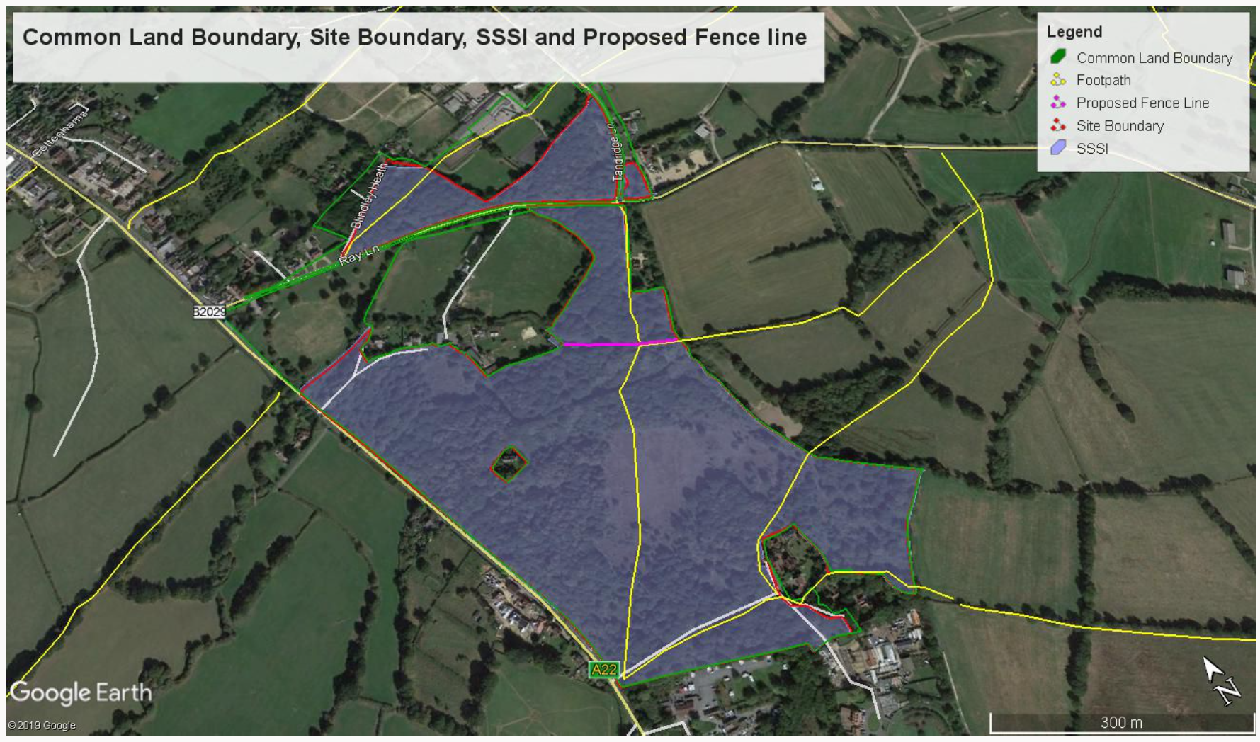

Common Land consents policy (Defra November 2015)
Section 39(2) of the 2006 Act provides that the public interest includes the public interest in; nature conservation; the conservation of the landscape; the protection of public rights of access to any area of land; and the protection of archaeological remains and features of historic interest.

