Application Decision
by Richard Holland
Appointed by the Secretary of State for Environment, Food and Rural Affairs
Decision date: 12 March 2021
Application Ref: COM/3255572
Barnham Cross Common, Thetford, Norfolk
Register Unit No: CL76
Commons Registration Authority: Norfolk County Council
- The application, dated 3 June 2020, is made under Section 38 of the Commons Act 2006 (the 2006 Act) for consent to carry out restricted works on common land.
- The application is made by Parker Planning Services Ltd for Balfour Beatty.
- The works within an existing car park comprise:
- the erection of 165.5m of temporary Heras fencing to enclose 370m² of the car park for 18 months to create a storage, welfare and works compound; and
- the resurfacing of the whole car park with tarmac once the compound has been removed.

Decision
- Consent is granted for the works in accordance with the application dated 3 June 2020 and submitted plans subject to the following conditions:
- the works shall begin no later than 3 years from the date of this decision; and
- the temporary fencing shall be removed and the land shall be fully reinstated within one month from the completion of the works.
- For the purposes of identification only, the location of the proposed works is shown on the attached plan.
Preliminary Matters
- I have had regard to Defra’s Common Land consents policy in determining this application under section 38, which has been published for the guidance of both the Planning Inspectorate and applicants. However, every application will be considered on its merits and a determination will depart from the policy if it appears appropriate to do so. In such cases, the decision will explain why it has departed from the policy.
- This application has been determined solely on the basis of written evidence.
- I have taken account of the representations made by Historic England (HE) and the Open Spaces Society (OSS), neither of which object to the proposed works.
- I am required by section 39 of the 2006 Act to have regard to the following in determining this application:-
- the interests of persons having rights in relation to, or occupying, the land (and in particular persons exercising rights of common over it);
- the interests of the neighbourhood;
- the public interest; and
- any other matter considered to be relevant.

Reasons

The interests of those occupying or having rights over the land
- The land is owned by Thetford Town Council, which was consulted by the applicant about the application but has not commented. However, the applicant advises that the Town Council’s permission has been given for the works and I have no reason to think otherwise. The common land register records no rights of common. I am satisfied that the works will not harm the interests of those occupying or having rights over the land.

The interests of the neighbourhood and public rights of access

- The temporary compound will serve as a storage and welfare location during works to install a 33kV cable off of the common to supply a new substation to the north east of Thetford. The car park was selected as the preferred site as it will allow for the storage of materials at a safe location close to the cable route, thus keeping transport movement between the two to a minimum to reduce health and safety risks and environmental concerns.

- The interests of the neighbourhood test relates to whether the works will impact on the way the common land is used by local people and is closely linked with interests of public access. The application land is a public car park accessed directly from the adjacent A134 Bury Road. I consider it is likely to be mainly used by visitors to the common.

- The application indicates that parking space within the car park will be reduced by more than half whilst the temporary compound is in place and that only one of the two entrances/exits will be in public use during that time. However, no representations have been received to suggest that the car park routinely operates at more than 50% capacity such that demand for spaces would exceed availability whilst the compound is in place.

- The applicant says the car park’s current loose chippings surface is suffering from excessive wear and that vehicle movements leaves the surface dusty and liable to the formation of potholes. As compensation in kind for the proposed compound, the applicant will provide a new tarmac sealed surface over the whole of the car park once the compound has been removed. The surface will be feathered at the grass perimeter and saw cut and sealed at the entrances. I consider that providing a better surface will be in the interests of people using the car park to visit the common.

- I am satisfied that the compound is unlikely to have an unacceptable impact on access rights over the common during the 18 months it will be in place and I conclude that resurfacing the car park with tarmac is in the long-term interests of those visiting the common by car.

The public interest

Nature Conservation
- Much of the common lies within the Barnham Cross Common Site of Special Scientific Interest (SSSI). However, the application land does not fall within the SSSI and as it is already used for car parking, I consider it unlikely that the proposed works will cause unacceptable harm to nature conservation interests.

Conservation of the landscape

- The common has no special designated landscape value but the compound (consisting of a welfare unit, parking spaces for contractors and two storage areas) and the Heras fencing will nevertheless be somewhat intrusive visually. However, all will be removed after 18 months and the land will be restored, which can be secured by attaching a suitable condition to the consent. I consider that a new tarmac surface will give the car park a tidier appearance compared with the current worn loose surface which is unsightly. I am satisfied that the works will be of some long-term visual benefit, which will outweigh the temporary visual harm.

Archaeological remains and features of historic interest
- HE advised that it has no objections to the proposals on heritage grounds as there are no Scheduled Ancient Monuments or Listed Buildings situated within or adjacent to the application site and therefore no issues relating to any designated or statutorily protected heritage assets arise. I am satisfied that the works are unlikely to harm any archaeological remains or features of historic interest.

Conclusion
- I conclude that the proposed works will not unacceptably harm the interests set out in paragraph 6 above. Indeed, the re-surfacing works will be of practical benefit to those visiting the common by car and a visual improvement over the current worn loose surface. Consent is therefore granted for the works subject to the conditions set out in paragraph 1.

Richard Holland

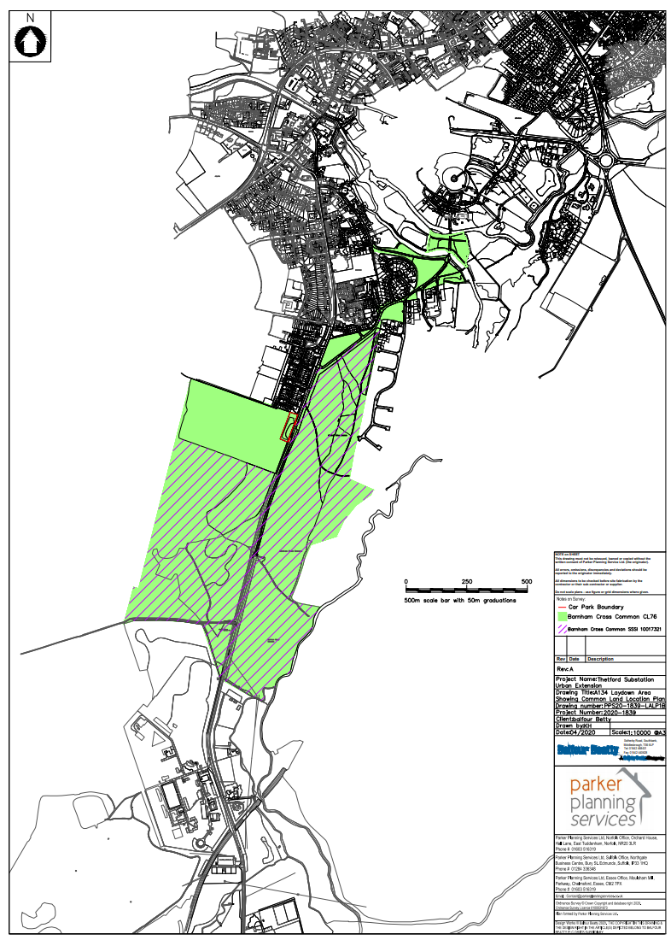

Common Land consents policy (Defra November 2015)
Section 39(2) of the 2006 Act provides that the public interest includes the public interest in; nature conservation; the conservation of the landscape; the protection of public rights of access to any area of land; and the protection of archaeological remains and features of historic interest.

