Room G07

Committee on Standards in Public Life

1 Horse Guards Road
London
SW1A 2HQ

Email: public@public-standards.gov.uk

Rt Hon Angela Rayner MP
Deputy Leader and Chair of the Labour Party

By email

6 April 2021

Dear Ms Rayner,

Thank you for your letter of 1 April 2021 regarding press coverage alleging that the Prime Minister failed to declare legal costs. You asked that the Committee on Standards in Public Life looks into this as a possible breach of the Ministerial Code.

The Committee is an advisory body and has no remit to investigate individual cases. We wrote very recently to Anneliese Dodds MP and Rachel Reeves MP explaining this. As you will be aware, Rt Hon Dame Margaret Beckett MP is of course the Labour Party representative on the Committee, one of three political members of the Committee.

As we said in that letter, the Committee is currently undertaking a landscape review of the institutions, procedures and policies in place to uphold high standards of conduct, Standards Matter 2. As part of the review we are looking at the current rules and arrangements to assess what is working well and where there are gaps and weaknesses.

We would welcome any detailed written evidence from the Labour Party on proposals for reforms to the regulation of ethics and integrity in government. I would welcome a meeting with you to discuss your suggestions and evidence on how we can help promote the highest standards of conduct across public life.

I am copying this letter to the Cabinet Secretary and the Director General of Propriety and Ethics in the Cabinet Office. We will publish this letter on the Committee’s website.

Yours sincerely.

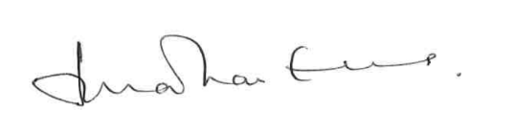

Lord Evans of Weardale KCB DL
Chair, Committee on Standards in Public Life

