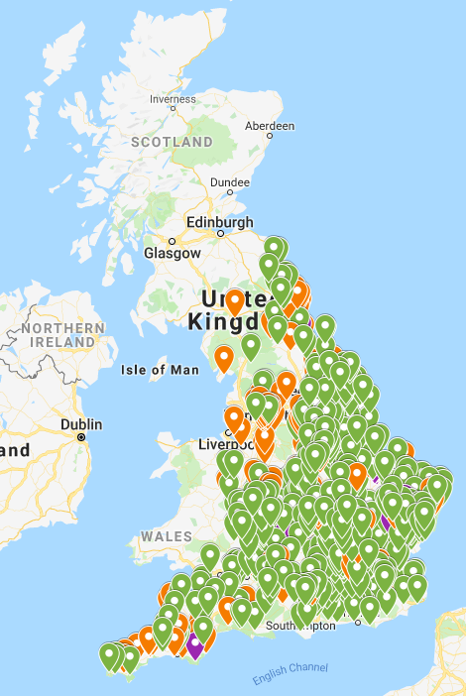  All Crown and Lord Chancellor Livings in England.  Green – Lord Chancellor  Orange – Crown  Purple – Crown & Lord Chancellor | Meet the Team | Contact Us  Honours and Appointments Secretariat,  Room G39,  1 Horse Guards Road,  London,  SW1A 2HQ  Email: crownandlordchancellorpatronage@cabinetoffice.gov.uk  To sign up to our newsletter email:  helen.dimmock@cabinetoffice.gov.uk  Phone: 020 7276 1675  Sylvia Geraghty:  Assistant Head of Church Appointments | Where can I find vacancies?  - Diocesan website  - Church Times Newspaper  - Church of England Pathways  https://pathways.churchofengland.org/search | Helen Dimmock:  Ecclesiastical Secretary to the Crown and Lord Chancellor | Church Appointments  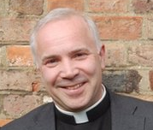  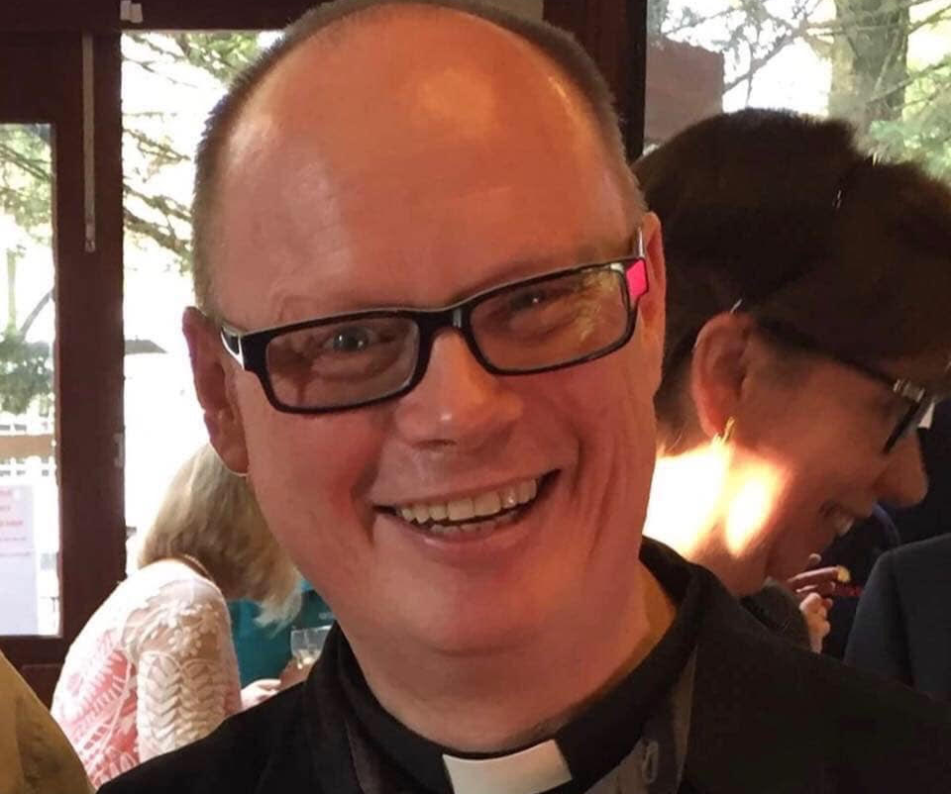  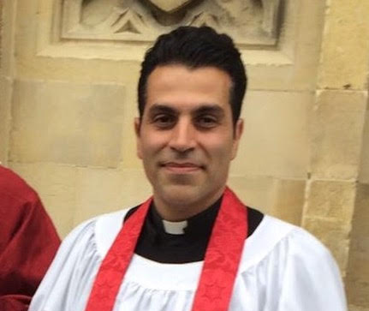  Could this be you?  Recent Crown and Lord Chancellor Appointees

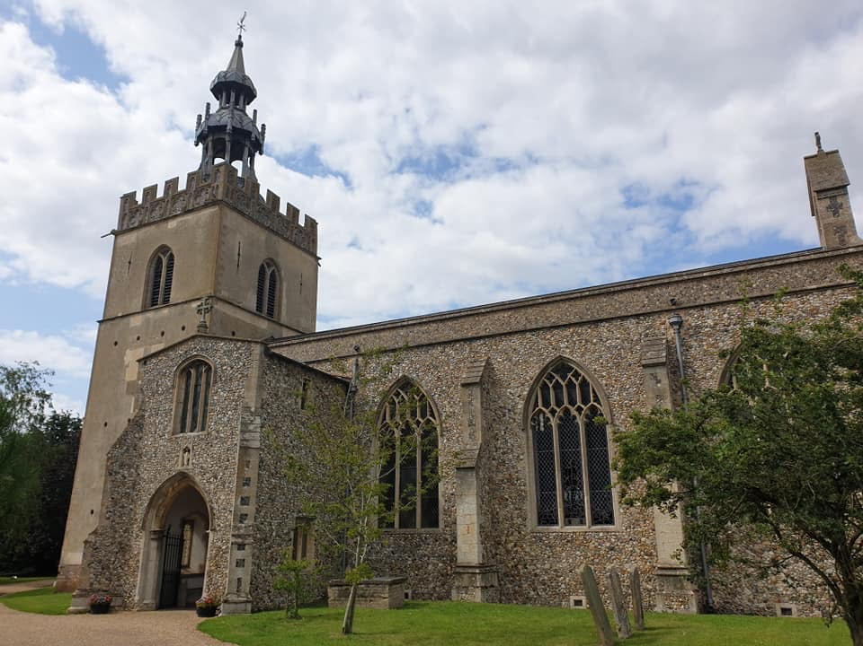  Shipdham  Introduction to Church Appointments  The Crown is responsible for a range of ecclesiastical appointments in the Church of England, as The Queen is the Supreme Governor. Appointments are approved by the Queen on the recommendation of the Prime Minister or the Lord Chancellor on The Queen’s behalf.  Who does the Church appoint?  The Crown is responsible for the appointments of the two Archbishops (Canterbury and York), the remaining Diocesan Bishops, Suffragan Bishops, 28 Cathedral Deans, 20 Residentiary and Cathedral Canons and incumbents to over 650 Benefices. | Who decides?  The Ecclesiastical Secretary represents the Crown and Lord Chancellor at interviews to appoint future incumbents.  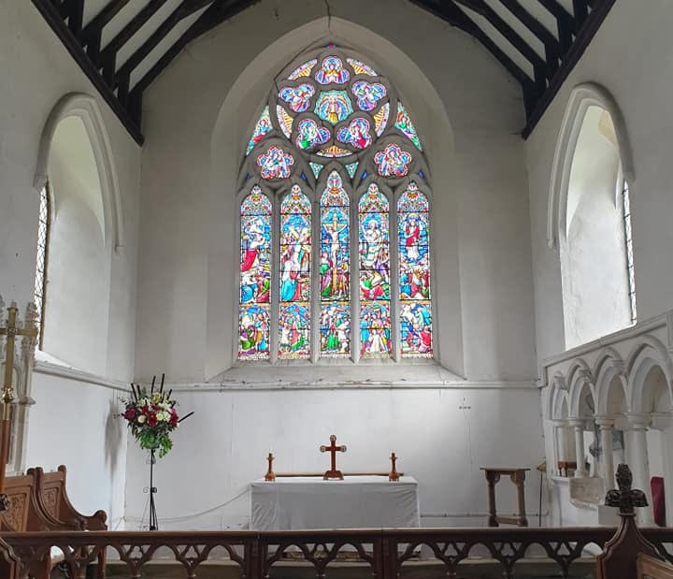  Once a candidate has been chosen and accepted the post, we will obtain approval directly from the Prime Minister and The Queen or the Lord Chancellor for your appointment.  Bradenham  Where do we appoint?  The Crown holds patronage rights across England, in all 42 Dioceses across the country. Please see our benefice map on the central page for benefices where the Crown has interest. | Why should I apply to a Crown vacancy?  - We are responsible for patronage across the country and can suggest roles suited to you  - We provide a list of upcoming vacancies to give you time to consider if a post is right for you  - We will provide comprehensive feedback following interview  - If you are successful you may receive an invite to a Royal Garden Party  - Helen will provide coaching sessions after your appointment to help your ministerial development  - You will be given the opportunity to join a closed Facebook group to share experiences and connect with other Crown appointees across the country  What do I need to know?  We require all appointees to undertake an enhanced DBS check before any appointment can be announced.

