

Information Rights Unit
WH 2.177
King Charles Street
London
SW1A 2AH
Email: information.rights@fcdo.gov.uk

11th March 2021

FREEDOM OF INFORMATION ACT 2000 - REQUEST REF: FOI2021/03273

Thank you for your email of 9/02/2021 asking for information under the Freedom of Information Act (FOIA) 2000. You asked:

This is a request under the Freedom of Information Act 2000.
You released details of spending over £500 on the GPC:
https://www.gov.uk/government/publications/fcdo-services-spending-over-500-december-2020

I have a number of questions over these lines in the data:

• I require full breakdown of what items were purchased
• Any itemised receipts
• Which offices these items were placed/used in
• An on the record comment of why the department chose designer shops rather than cheaper alternatives
Separately there are also a number of entries simply labelled as “Paypal” in the supplier name. Can I get an itemised breakdown of what exactly these goods and services were please. If this additional request would take you over the time/cost exemptions, please treat this as a separate FOI inquiry.
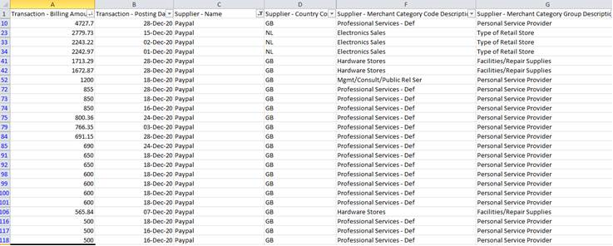

I would like to receive the information in an electronic format. If you feel a substantive response to this request is not possible within a reasonable timeframe, or the request is too broad, I would be grateful if you could contact me by telephone (redacted) and provide assistance as to how I could refine the request.

I am writing to confirm that we have now completed the search for the information which you requested. I can confirm that the Foreign, Commonwealth & Development Office Services (FCDO Services) does hold information relevant to your request.

One of the services that FCDO Services provides is that of an Interior Design team. The purchases at Heathfield and Co, Osborne & Little and Vaughan Ltd were made by that team and were as follows.

Heathfield and Co. - £ 3,469.08 (Inclusive of VAT and packaging)

The purchase was made to meet the requirements of the brief for the High Commissioner’s Residence in Nairobi.

The items purchased were:

- 2 Ceiling lights with shades
- 5 Table lamps with shades
- 10 light shades

Osborne & Little £2272.59 (Inclusive of VAT and carriage)

This cost relates to two invoices. The items were purchased and invoiced separately. The purchase was made to meet the requirements of the brief for the High Commissioner’s Residence in Nairobi.

The items purchased were:
- Curtain fabric and tie backs

Vaughan Ltd - £3576 (inclusive of carriage and VAT)

These items were purchased to meet the requirements of the brief for the Ambassador’s Residence in Mexico.

The items purchased was:

- LED Ceiling Lights

The invoices themselves have been withheld under s43 of the Freedom of Information Act, which relates to Commercial interests. Additional information on this exemption is provided below.

The items referred to have been placed in public-facing premises that host many thousands of visitors annually. The products are carefully selected by the Design Team to meet the requirements of the brief and to showcase British design and British manufacturing.

With regards to the expenditure via PayPal in part 2 of your request:

FCDO Services also provides a Translation and Interpretation service. All lines with the exception of Lines 23, 33 and 34, were for payments to our specialist Freelance Translators and Interpreters for their services.

Lines 23, 33 and 34 were for purchase of equipment to carry out our commercial operations. Further clarification of these purchases are withheld under s24 of the Freedom of Information Act, which relates to national security. Additional information on this exemption can be found below.

Section 24
Section 24 is a qualified exemption, which means that it is subject to a public interest test. We acknowledge the public interest in openness and transparency, but we consider that there is also a public interest in FCDO Services protecting national security. To provide details of the equipment purchased and any use of that equipment may adversely impact on the UK’s security. We have therefore concluded that the exemption applies and that non-disclosure serves the public interest better than release in this instance. For these reasons, we consider that the public interest in maintaining this exemption outweighs the public interest in disclosure.

Section 43
Section 43(2) of FOIA exempts from disclosure information which would be likely to prejudice the commercial interests of any person. It is a prejudice-based exemption, so the test for exemption is whether or not the individual’s commercial interests would be prejudiced by disclosure and it is subject to balancing the public interest. It is recognised that there is a general public interest in the disclosure of commercial information to ensure, for example: transparency in the accountability of public funds; proper scrutiny of government action; and the effective use of public money. However, where disclosure would make it less likely that companies or individuals would provide the department with information in the future or where disclosure would make it more difficult for individuals to be able to conduct commercial transactions, or have future dealings with public bodies, without fear of suffering commercially as a result, these are factors that may weigh in favour of non-disclosure.

We considered the commercial interests of third parties and the benefit to the public for the release of this information. We also considered the impact that this may also have on our future business relationships. In considering this case and the details required, we consider that the public interest in favour of disclosing such information is outweighed by the obligation to protect the commercial interests of third parties. We have therefore taken the decision to withhold the information.

Once an FOI request is answered, it is considered to be in the public domain. To promote transparency, we may now publish the response and any material released on gov.uk in the FOI releases section. All personal information in the letter will be removed before publishing.

The copies of information being supplied to you continue to be protected by the Copyright, Designs and Patents Act 1988. You are free to use it for your own purposes, including any non-commercial research you are doing and for the purposes of news reporting. Any other re-use, for example commercial publication, would require the permission of the copyright holder. Most documents supplied by the FCDO will have been produced by government officials and will be protected by Crown Copyright. To re-use Crown Copyright documents please consult the Open Government Licence v3 on the National Archives website.

Information you receive which is not subject to Crown Copyright continues to be protected by the copyright of the person, or organisation, from which the information originated. You must ensure that you gain their permission before reproducing any third party (non-Crown Copyright) information.

If you wish to make a complaint or if you would like a review of our decision, please write to the Information Rights Unit, Foreign, Commonwealth & Development Office, Room WH 2.177, King Charles Street, London, SW1A 2AH. E-mail: information.rights@fcdo.gov.uk You have 40 working days to do so from the date of this letter.

If you are not content with the outcome of your complaint, you may then apply directly to the Information Commissioner for a decision. Generally, the Information Commissioner cannot make a decision unless you have exhausted the complaints procedure provided by the FCDO. The Information Commissioner can be contacted at: Information Commissioner's Office, Wycliffe House, Water Lane, Wilmslow, Cheshire SK9 5AF, or online at: https://ico.org.uk/make-a-complaint/

Yours sincerely,

FCDO Services

For information about how the FCDO handles personal information please see our Personal Information Charter

