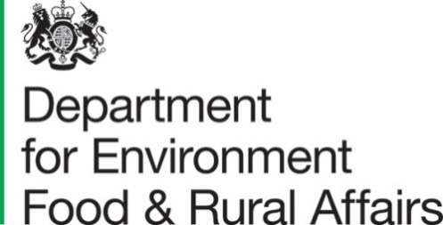

Published 25 March 2021

Farming Statistics - Livestock Populations at 1 December 2020, UK

This release contains livestock numbers on agricultural holdings in the United Kingdom for cattle, pigs and sheep. Data come from various different sources, full details of which are provided in the methodological notes on page 10. Northern Ireland have been unable to provide data for all livestock categories. Therefore livestock numbers for 2019 (with the exception of cattle) have been carried forward for Northern Ireland to allow UK totals to be calculated for 2020.

Key Messages
In December 2020 in the United Kingdom there were:
- 9.4 million total cattle and calves, a decrease of 1.0% since December 2019
- 3.3 million cattle in the breeding herd, a decrease of 0.9% since December 2019
- 4.8 million total pigs, an increase of 0.3% since December 2019
- 4.3 million fattening pigs, an increase of 0.3% since December 2019
- 21.8 million total sheep and lambs, a decrease of 4.1% since December 2019
- 13.9 million breeding ewes, remaining almost unchanged since December 2019

Contents
Farming Statistics - Livestock Populations at 1 December 2020, UK 1
Key Messages 1
Contents 2
What you need to know about this release 3
Contact details 3
National Statistics Status 3
Section 1 – Detailed results 4
1.1 - Cattle 4
1.2 - Pigs 6
1.3 - Sheep 8
Section 2 – About these Statistics 10
2.1 Survey methodology: 10
England 10
Wales 11
Scotland 11
Northern Ireland 11
2.2 Data notes 12
2.3 Data uses and users 12
2.4 Other survey results and publications 12
2.5 Feedback 12

What you need to know about this release

This section ensures any important information is clearly explained so users do not misunderstand the data.

Contact details

Responsible statistician: Emma Howat (cattle), Jayne Brigham (pigs) or Ruth Ireson (sheep)
Team: Farming Statistics, Department for Environment, Food and Rural Affairs
Email: farming-statistics@defra.gov.uk
Tel: 03000 600 170

National Statistics Status
National Statistics status means that our statistics meet the highest standards of trustworthiness, quality and public value, and it is our responsibility to maintain compliance with these standards.
The continued designation of these statistics as National Statistics was confirmed in 2014 following a full assessment by the UK Statistics Authority against the Code of Practice for Statistics.
Since the last review of these statistics in 2014, we have continued to comply with the Code of Practice for Statistics, and have made improvements including:
- Improved data visualisations throughout the statistical release.
- Adding Table 4: Effect of revisions to Sheep figures for the previous year to the release.
- Improved coverage of the pig sector by running a special data collection exercise each year to collect data from a central point for some of the largest companies.
- Improved quality of sheep data by working closely with the data owners, APHA, to improve the form and population list.

For general enquiries about National Statistics, contact the National Statistics Public Enquiry Service:

Tel: 0845 601 3034
Email: info@statistics.gov.uk.
You can find National Statistics on the internet on the Gov.uk website.

Section 1 – Detailed results

1.1 - Cattle
The total number of cattle and calves in the UK decreased by 1.0% between December 2019 and December 2020 and now stands at 9.4 million animals.

The UK breeding herd, which is made up of dairy and beef cows over two years old with offspring, accounts for just over a third of total cattle and 48% of all female cattle. It too has decreased by 0.9% since last year and totals 3.3 million. The beef breeding herd showed the larger decrease at 1.3% and stands at almost 1.5 million while the dairy breeding herd showed a 0.6% decrease and stands at just under 1.9 million.

Figure 1: Female dairy and beef herds at 1 December 2016 to 2020

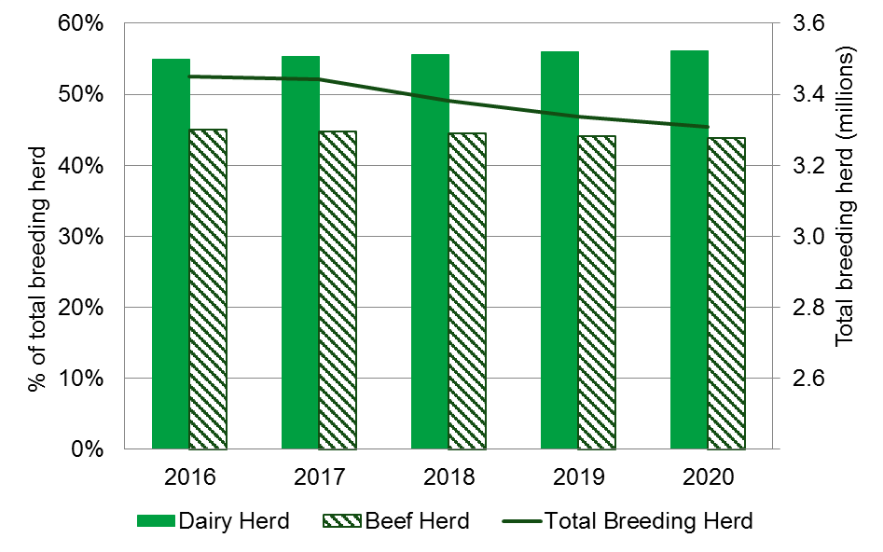

Table 1: Cattle and calves on UK agricultural holdings on 1 December (a)
Thousands
 | 2018 | 2019 | 2020 | % change 2020/19
Total cattle and calves | 9,610 | 9,459 | 9,366 | -1.0%
All female cattle | 7,033 | 6,954 | 6,906 | -0.7%
Aged 2 years or more | 4,041 | 3,975 | 3,877 | -2.5%
Total breeding herd | 3,382 | 3,337 | 3,307 | -0.9%
Beef herd | 1,503 | 1,470 | 1,451 | -1.3%
Dairy herd | 1,879 | 1,867 | 1,856 | -0.6%
Other female cattle | 659 | 637 | 570 | -10.6%
Beef | 335 | 338 | 305 | -9.7%
Dairy | 324 | 299 | 265 | -11.5%
Aged between 1 and 2 years | 1,427 | 1,405 | 1,408 | 0.2%
Beef | 903 | 886 | 881 | -0.6%
Dairy | 524 | 519 | 527 | 1.6%
Less than 1 year | 1,564 | 1,574 | 1,621 | 3.0%
All male cattle | 2,578 | 2,504 | 2,460 | -1.8%
Aged 2 years or more | 295 | 289 | 247 | -14.4%
Aged between 1 and 2 years | 977 | 929 | 912 | -1.9%
Less than 1 year | 1,305 | 1,286 | 1,300 | 1.1%
- Figures are sourced from the Cattle Tracing System (CTS) in England, Wales and Scotland and the equivalent APHIS system in Northern Ireland. The data include returns from all holdings with cattle so are not subject to survey error.

1.2 - Pigs
The total number of pigs in the UK is an estimated 4.8 million at 1 December 2020, an increase of 0.3% from December 2019. The number of breeding pigs increased by 0.5% since December 2019 to 504 thousand and the fattening pigs rose by 0.3% (14 thousand animals) to 4.3 million pigs in December 2020.
The female pig breeding herd saw a small increase of 0.3% from 404 thousand pigs in December 2019 to 406 thousand in December 2020. This increase was driven by the 2.8% rise in the number of sows in pig which more than offset the decreases seen in other sows (either being suckled or dry sows kept for further breeding) and gilts in pig, which were 10% and 1.2% respectively.

Figure 2: Proportion of pigs in the breeding herd and total number of fattening pigs UK at 1 December 2016 to 2020

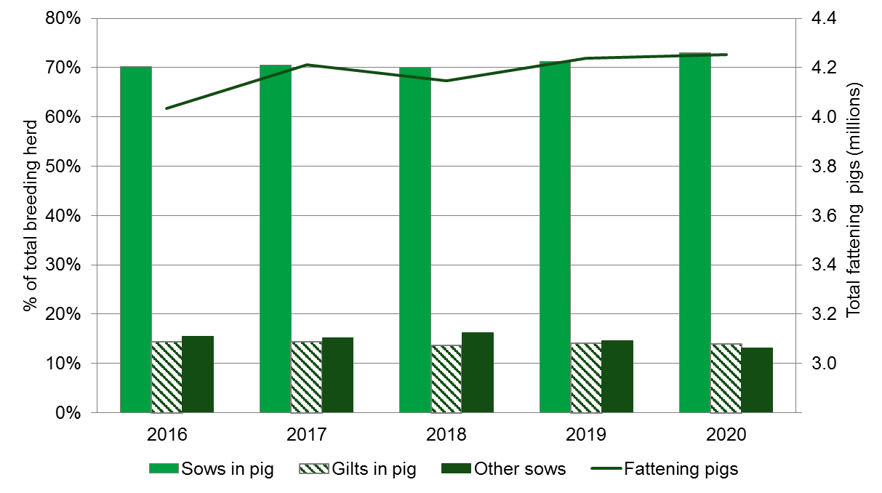

Table 2: Pigs on commercial agricultural holdings on 1 December(b)
Thousands
 | 2018 | 2019 | 2020(c) | % change 2020/19
Total pigs | 4,648 | 4,741 | 4,758 | 0.3%
Breeding pigs | 502 | 502 | 504 | 0.5%
Female breeding herd | 406 | 404 | 406 | 0.3%
Sows in pig | 284 | 288 | 296 | 2.8%
Gilts in pig | 55 | 57 | 57 | -1.2%
Other sows(a) | 66 | 59 | 53 | -10.1%
Other breeding pigs | 96 | 97 | 99 | 1.3%
Boars being used for service | 12 | 12 | 11 | -4.0%
Gilts intended for first time breeding | 84 | 85 | 87 | 2.1%
Fattening pigs (incl. barren sows) | 4,146 | 4,239 | 4,253 | 0.3%
- Either being suckled or dry sows kept for further breeding.
- Wales do not produce figures in December. These are estimated using the English percentage change.
- Northern Ireland have not produced livestock numbers for 2020. Therefore 2019 figures for Northern Ireland are used to calculate UK totals for 2020.

1.3 - Sheep
The total number of sheep and lambs in the UK decreased by 4.1% between December 2019 and December 2020 and now stands at over 21.8 million. Over the same period the female breeding flock remained almost unchanged at 13.9 million while other sheep and lambs showed a decrease of 10.5% and fell to just under 8 million animals.

Figure 3: Total sheep and lambs in the UK at 1 December 2016 to 2020
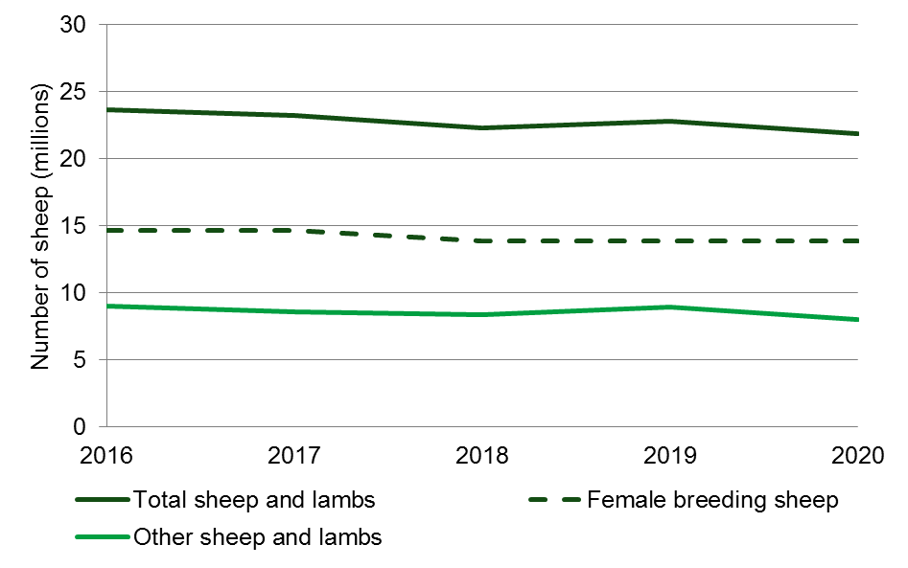

Figures for England for 2019 have been revised to take into account late inventory returns and data cleansing. The figures in table 3 have been updated as a result. Table 4 shows the effect of the revisions.

Table 3: Sheep and lambs on agricultural holdings on 1 December
Thousands
 | 2018 | 2019 | 2020(a)(b) | % change 2020/19
Total sheep and lambs | 22,283 | 22,779 | 21,845 | -4.1
Female breeding sheep | 13,898 | 13,857 | 13,863 | -0.0
Other sheep and lambs | 8,385 | 8,921 | 7,982 | -10.5
- 2020 results are provisional.
- Northern Ireland have not produced livestock numbers for 2020. Therefore 2019 figures for Northern Ireland are used to calculate UK totals for 2020.

Table 4: Effect of revisions to Sheep figures for 2019
Thousands
 | 2019
 | Original | Revised | % change
Total sheep and lambs | 22,756 | 22,779 | 0.1
Female breeding sheep | 13,841 | 13,857 | 0.1
Other sheep and lambs | 8,915 | 8,921 | 0.1

Section 2 – About these Statistics

2.1 Survey methodology:

England
Data for this 2020 December livestock publication comes from a number of different sources.

Cattle
Cattle results are sourced from the Cattle Tracing System (CTS). The data include returns from all holdings with cattle so are not subject to survey error. More information on the use of this administrative data can be found on the survey notes and guidance web page.

Pigs
Pig data came from the December survey of Pigs, which is a small sample survey of farms that keep over 750 pigs. It is used to estimate the size of the pig herd in England at 1 December each year.
To improve the coverage of the pig sector, a special data collection exercise was run to collect data from a central point for some of the largest companies. This brought the total sample size to 778 holdings, achieving a response rate of 85%, so the results for pigs are subject to a degree of sampling error.
Pig data relates to commercial holdings only. Commercial holdings are defined as those with significant levels of farming activity, i.e. holdings with more than five hectares of agricultural land, or one hectare of orchards, or 0.5 hectares of vegetables or 0.1 hectares of protected crops, or more than 10 cows, or 50 pigs, or 20 sheep, or 20 goats or 1,000 poultry.
The June Survey of Agriculture and Horticulture Methodology Notes provides further detail on why data is provided for commercial holdings only (see section 3.3 on thresholds).

Sheep
Sheep data came from the Sheep and Goat Inventory (an annual exercise requiring all sheep and goat keepers to record animals under their keepership at 1 December). It is a requirement to hold the inventory for livestock tracing and identification purposes. Sheep and goat keepers will receive either a paper form or an email request to complete their inventory in late November. Since 2010 the information collected by the inventory is used to estimate the size of the English sheep flock at 1 December. More information is available at Use of the sheep and goat inventory for estimating sheep populations (PDF, 114KB, 6 pages)
Data analysis
The data for pigs and sheep are subject to rigorous validation checks which identify inconsistencies within the data or large year-on-year changes.

Wales
Until 2012 sheep numbers were collected via the Welsh December survey of agriculture. Since 2013 the sheep data has been sourced from the Welsh Sheep and Goats Inventory, which is an annual exercise requiring all sheep and goat keepers to record animals under their keepership as at 1 January. The Inventory figures are adjusted to take account of the number of sheep slaughtered during December in order to produce an equivalent figure. Cattle data are taken from the Cattle Tracing System (an administrative system primarily set up for animal health monitoring purposes). Since 2013 Wales has not produced pig data in December. These are estimated using the English percentage change.
Further details of agricultural statistics in Wales can be found on the Welsh Government website.

Scotland
The December agricultural survey is based on a sample of main holdings and covers crops, livestock and machinery. From a population of 24,600 main holdings, 14,900 holdings were sampled and 9,200 responses received, giving a response rate of 61%. Since 2015, data for the sheep and goat inventory has been collected as part of the December Survey and informed the sheep figures in the publication. To this end, a further 13,600 forms were sent requesting sheep and goat data only, with 8,900 forms being returned (a response rate of 65%). Estimates are made for non-responses.
Final results for Scotland were published on 23 March 2021 by the Scottish Government, Rural and Environment Science and Analytical Services, Q Spur, Saughton House, Broomhouse Drive, Edinburgh, EH11 3XD (e-mail agric.stats@gov.scot ) and are available online (search for “December Agricultural Survey”) at the Scottish Government website

Northern Ireland
Northern Ireland information is compiled from a number of administrative data sources. Cattle data is taken from the Animal and Public Health Information System (APHIS), Sheep data is taken from the NI Sheep and Goat Inventory and Pig data is from the NI Pig inventory. This administrative data is supplemented by the June and Agricultural and Horticultural Census in order to create representative estimates for all of Northern Ireland as at December. Data is not yet available for sheep and pigs for 2020 but will be available from the contact below.
Full results from the Agricultural and Horticultural Census Northern Ireland are published by the Department of Agriculture, Environment and Rural Affairs for Northern Ireland, Dundonald House, Belfast, BT4 3SB (telephone: Belfast (02890) 525450) and will be available in the Agriculture in Northern Ireland Census results

.

2.2 Data notes
- All percentage changes are based on unrounded figures.
- Totals may not necessarily agree with the sum of their components due to rounding.

2.3 Data uses and users
- This data helps us monitor changes in livestock populations over time.
- The numbers are used to make forecasts of meat and milk production to inform industry of the availability of supply which affects prices.
- Livestock distributions across the UK also help assess the risk of animal diseases and to control outbreaks.

2.4 Other survey results and publications
Next publication: March 2022: Farming Statistics Livestock Populations at 1 December 2021, United Kingdom
More detailed results can be found at the Structure of the livestock industry in England and the UK at December. These data series include annual statistics on the number of cattle, sheep and pigs in England and the UK as at 1 December each year from 1996.

2.5 Feedback
We welcome feedback and any thoughts to improve the publication further. Please send any feedback to: farming-statistics@defra.gov.uk. Suggested questions to help you structure your feedback are below but all feedback is welcome:
- How relevant is the current content of the publication to your needs as a user?
- What purpose do you require the data for?
- Which data do you find most useful?
- Is there any content that you did not find useful?
- Do you have any suggestions for further development of this release; including additional content, presentation and any other thoughts?

